UNITED STATES
SECURITIES AND EXCHANGE COMMISSION
Washington, D.C. 20549
Form 10-Q
__________________
☒ QUARTERLY REPORT PURSUANT TO SECTION 13 OR 15(d)
OF THE SECURITIES EXCHANGE ACT OF 1934
For the quarterly period ended June 30, 2026
OR
☐ TRANSITION REPORT PURSUANT TO SECTION 13 OR 15(d)
OF THE SECURITIES EXCHANGE ACT OF 1934
For the transition period from ______ to _____
Commission file number 1-8974

Honeywell International Inc.
(Exact name of registrant as specified in its charter)
Delaware |  |  |  |  |  |  |  |  | 22-2640650
(State or other jurisdiction of  incorporation or organization) |  |  |  |  |  |  |  |  | (I.R.S. Employer  Identification No.)
855 South Mint Street |  |  |  |  |  |  |  |  | 28202
Charlotte, |  |  | North Carolina
(Address of principal executive offices) |  |  |  |  |  |  |  |  | (Zip Code)
 |  |  | (704) |  |  | 627-6200
 |  |  | (Registrant’s telephone number, including area code)
Securities registered pursuant to Section 12(b) of the Act:
Title of each class |  |  |  |  |  | Trading Symbol(s) |  |  |  |  |  | Name of each exchange on which registered
Common Stock, par value $1 per share |  |  |  |  |  | HON |  |  |  |  |  | The Nasdaq Stock Market LLC
3.375% Senior Notes due 2030 |  |  |  |  |  | HON 30 |  |  |  |  |  | The Nasdaq Stock Market LLC
0.750% Senior Notes due 2032 |  |  |  |  |  | HON 32 |  |  |  |  |  | The Nasdaq Stock Market LLC
3.750% Senior Notes due 2032 |  |  |  |  |  | HON 32A |  |  |  |  |  | The Nasdaq Stock Market LLC
4.125% Senior Notes due 2034 |  |  |  |  |  | HON 34 |  |  |  |  |  | The Nasdaq Stock Market LLC
3.750% Senior Notes due 2036 |  |  |  |  |  | HON 36 |  |  |  |  |  | The Nasdaq Stock Market LLC
Indicate by check mark whether the Registrant (1) has filed all reports required to be filed by Section 13 or 15(d) of the Securities Exchange Act of 1934 during the preceding 12 months (or for such shorter period that the Registrant was required to file such reports), and (2) has been subject to such filing requirements for the past 90 days. Yes x No ☐
Indicate by check mark whether the Registrant has submitted electronically every Interactive Data File required to be submitted pursuant to Rule 405 of Regulation S-T (§232.405 of this chapter) during the preceding 12 months (or for such shorter period that the Registrant was required to submit such files). Yes x No ☐
Indicate by check mark whether the Registrant is a large accelerated filer, an accelerated filer, a non-accelerated filer, a smaller reporting company, or an emerging growth company. See definitions of “large accelerated filer,” “accelerated filer,” “smaller reporting company,” and “emerging growth company” in Rule 12b-2 of the Exchange Act.
Large accelerated filer |  |  | x |  |  | Accelerated filer |  |  | ☐
Non-accelerated filer |  |  | ☐ |  |  | Smaller reporting company |  |  | ☐
 |  |  |  |  |  | Emerging growth company |  |  | ☐
If an emerging growth company, indicate by check mark if the Registrant has elected not to use the extended transition period for complying with any new or revised financial accounting standards provided pursuant to Section 13(a) of the Exchange Act. ☐
Indicate by check mark whether the Registrant is a shell company (as defined in Rule 12b-2 of the Exchange Act). Yes ☐ No x
There were 316,940,010 shares of Common Stock outstanding at June 30, 2026.

TABLE OF CONTENTS
 |  |  |  | Cautionary Statement about Forward-Looking Statements |  |  | 1
 |  |  |  | About Honeywell Technologies |  |  | 2
PART I |  |  |  | Financial Information
ITEM 1 |  |  |  | Financial Statements and Supplementary Data (unaudited): |  |  | 3
 |  |  |  | Consolidated Statement of Operations (unaudited) – Three and Six Months Ended June 30, 2026, and 2025 |  |  | 3
 |  |  |  | Consolidated Statement of Comprehensive Income (unaudited) – Three and Six Months Ended June 30, 2026, and 2025 |  |  | 4
 |  |  |  | Consolidated Balance Sheet (unaudited) – June 30, 2026, and December 31, 2025 |  |  | 5
 |  |  |  | Consolidated Statement of Cash Flows (unaudited) – Six Months Ended June 30, 2026, and 2025 |  |  | 6
 |  |  |  | Consolidated Statement of Shareowners’ Equity (unaudited) – Three and Six Months Ended June 30, 2026, and 2025 |  |  | 8
 |  |  |  | Note 1 – Basis of Presentation |  |  | 9
 |  |  |  | Note 2 – Summary of Significant Accounting Policies |  |  | 9
 |  |  |  | Note 3 – Acquisitions, Divestitures, and Discontinued Operations |  |  | 10
 |  |  |  | Note 4 – Revenue Recognition and Contracts with Customers |  |  | 14
 |  |  |  | Note 5 – Repositioning and Other Charges |  |  | 17
 |  |  |  | Note 6 – Income Taxes |  |  | 18
 |  |  |  | Note 7 – Inventories |  |  | 19
 |  |  |  | Note 8 – Goodwill and Other Intangible Assets—Net |  |  | 19
 |  |  |  | Note 9 – Debt and Credit Agreements |  |  | 19
 |  |  |  | Note 10 – Leases |  |  | 23
 |  |  |  | Note 11 – Derivative Instruments and Hedging Transactions |  |  | 24
 |  |  |  | Note 12 – Fair Value Measurements |  |  | 27
 |  |  |  | Note 13 – Earnings Per Share |  |  | 28
 |  |  |  | Note 14 – Accumulated Other Comprehensive Loss |  |  | 29
 |  |  |  | Note 15 – Commitments and Contingencies |  |  | 29
 |  |  |  | Note 16 – Pension Benefits |  |  | 31
 |  |  |  | Note 17 – Other (Income) Expense |  |  | 32
 |  |  |  | Note 18 – Segment Financial Data |  |  | 32
 |  |  |  | Note 19 – Subsequent Events |  |  | 35
ITEM 2 |  |  |  | Management’s Discussion and Analysis of Financial Condition and Results of Operations |  |  | 36
ITEM 3 |  |  |  | Quantitative and Qualitative Disclosures about Market Risks |  |  | 57
ITEM 4 |  |  |  | Controls and Procedures |  |  | 58
PART II |  |  |  | Other Information
ITEM 1 |  |  |  | Legal Proceedings |  |  | 59
ITEM 1A |  |  |  | Risk Factors |  |  | 59
ITEM 2 |  |  |  | Unregistered Sales of Equity Securities and Use of Proceeds |  |  | 67
ITEM 4 |  |  |  | Mine Safety Disclosures |  |  | 68
ITEM 5 |  |  |  | Other Information |  |  | 68
ITEM 6 |  |  |  | Exhibits |  |  | 69
 |  |  |  | Signatures |  |  | 70

TABLE OF CONTENTS
CAUTIONARY STATEMENT ABOUT FORWARD-LOOKING STATEMENTS
We describe many of the trends and other factors that drive our business and future results in the section titled Management’s Discussion and Analysis of Financial Condition and Results of Operations and in other parts of this report (including Part II, Item 1A Risk Factors). Such discussions contain forward-looking statements within the meaning of Section 21E of the Securities Exchange Act of 1934, as amended (the Exchange Act), including statements related to the planned sales of the Productivity Solutions and Services and Warehouse and Workflow Solutions businesses. Forward-looking statements are those that address activities, events, or developments that we or our management intend, expect, project, believe, or anticipate will or may occur in the future. They are based on management’s assumptions and assessments in light of past experience and trends, current economic and industry conditions, expected future developments, and other relevant factors, many of which are difficult to predict and outside of our control, including Honeywell Technologies’ current expectations, estimates, and projections regarding the planned sales of the Productivity Solutions and Services and Warehouse and Workflow Solutions businesses. They are not guarantees of future performance, and actual results, developments, and business decisions may differ significantly from those envisaged by our forward-looking statements, including the planned sales of the Productivity Solutions and Services and Warehouse and Workflow Solutions businesses, and the anticipated benefits of each. We do not undertake to update or revise any of our forward-looking statements, except as required by applicable securities law. Our forward-looking statements are also subject to material risks and uncertainties, including ongoing macroeconomic and geopolitical risks, such as changes in or application of trade and tax laws and policies, including the impacts of tariffs and other trade barriers and restrictions, lower GDP growth or recession in the U.S. or globally, supply chain disruptions, capital markets volatility, inflation, and certain regional conflicts, including ongoing conflicts in the Middle East, which can affect our performance in both the near- and long-term. In addition, no assurance can be given that any plan, initiative, projection, goal, commitment, expectation, or prospect set forth in this Form 10-Q can or will be achieved. These forward-looking statements should be considered in light of the information included in this report and our other filings with the Securities and Exchange Commission (SEC), including, without limitation, the Risk Factors, as well as the description of trends and other factors in Management’s Discussion and Analysis of Financial Condition and Results of Operations, set forth in this report and our 2025 Annual Report on Form 10-K. Any forward-looking plans described herein are not final and may be modified or abandoned at any time.

1 Honeywell International Inc.
TABLE OF CONTENTS
ABOUT HONEYWELL TECHNOLOGIES
In the third quarter, Honeywell International Inc. (we, us, our, Honeywell Technologies, or the Company) completed the previously-announced separation (the “Aerospace Spin-Off”) of Honeywell Aerospace Inc. (“Honeywell Aerospace”) into an independent publicly-traded company. Honeywell Technologies separated Honeywell Aerospace from the rest of Honeywell by distributing all of the issued and outstanding shares of common stock of Honeywell Aerospace to the holders of common stock of the Company. The separation of Honeywell Aerospace from Honeywell is intended, among other things, to better position the management of both companies to pursue opportunities for long-term growth and profitability unique to each company's business. Following the Aerospace Spin-Off, Honeywell International Inc. now operates as Honeywell Technologies. The Aerospace Spin-Off is intended to be a tax-free separation to Honeywell Technologies for U.S. federal income tax purposes.

Prior to the Aerospace Spin-Off, we globally managed our business operations through four reportable business segments: Aerospace Technologies, Building Automation, Process Automation and Technology, and Industrial Automation. Following the Aerospace Spin-Off, the historical financial results of Honeywell Aerospace will be reflected in Honeywell Technologies’ consolidated financial statements as discontinued operations. For purposes of this report, which covers the quarterly period prior to the completion of the Aerospace Spin-Off, our financial results include the assets, liabilities, and operating results of Honeywell Aerospace as continuing operations. In connection with and following completion of the Aerospace Spin-Off, we now manage our businesses through three reportable business segments: Building Automation, Process Automation and Technology, and Industrial Automation. See Note 18 Segment Financial Data for further information.

Honeywell Technologies is a global, pure-play automation company with a legacy of innovating to help solve the world’s most mission-critical challenges, enhancing the quality of life for people and communities around the world. We serve the building, industrial, and process sectors with a broad portfolio of services, solutions, and products, underpinned by our Honeywell Technologies Accelerator operating system and Honeywell Technologies Forge intelligence layer. By combining the deep domain expertise of our more than 50,000 employees with decades of data from our global installed base, we are uniquely positioned to lead the industrial sector’s transition from automation to autonomy. The Honeywell brand dates back to 1906, and the Company was incorporated in Delaware in 1985.

Our Annual Report on Form 10-K, Quarterly Reports on Form 10-Q, Current Reports on Form 8-K, and any amendments to those reports, are available free of charge on our Investor Relations website (investor.honeywell.com) under the heading Results & Filings (see SEC Filings) immediately after they are filed with, or furnished to, the SEC. Honeywell Technologies uses our Investor Relations website, along with press releases on our primary Honeywell Technologies website (honeywell.com) under the heading Newsroom, as a means of disclosing information which may be of interest or material to our investors and for complying with disclosure obligations under Regulation FD. Accordingly, investors should monitor our Investor Relations website and Honeywell Technologies News feed, in addition to following our press releases, SEC filings, public conference calls, webcasts, and social media. Information contained on or accessible through, including any reports available on, our website is not a part of, and is not incorporated by reference into, this Quarterly Report on Form 10-Q or any other report or document we file with the SEC. Any reference to our website in this Form 10-Q is intended to be an inactive textual reference only.

2 Honeywell International Inc.
TABLE OF CONTENTS
PART I. FINANCIAL INFORMATION
The financial statements and related notes as of June 30, 2026, should be read in conjunction with the financial statements for the year ended December 31, 2025, contained in the Company’s 2025 Annual Report on Form 10-K.

FINANCIAL STATEMENTS AND SUPPLEMENTARY DATA

HONEYWELL INTERNATIONAL INC.
CONSOLIDATED STATEMENT OF OPERATIONS
(Unaudited)
 |  |  | Three Months Ended June 30, |  |  |  |  |  |  |  |  |  |  |  | Six Months Ended June 30,
 |  |  | 20261 |  |  |  |  |  | 20251 |  |  |  |  |  | 20261 |  |  |  |  |  | 20251
 |  |  | (Dollars in millions, except per share amounts)
Product sales |  |  | $ | 6,374 |  |  |  |  | $ | 6,177 |  |  |  |  | $ | 12,241 |  |  |  |  | $ | 11,984
Service sales |  |  | 3,345 |  |  |  |  |  | 3,145 |  |  |  |  |  | 6,621 |  |  |  |  |  | 6,263
Net sales |  |  | 9,719 |  |  |  |  |  | 9,322 |  |  |  |  |  | 18,862 |  |  |  |  |  | 18,247
Costs, expenses and other
Cost of products sold |  |  | 4,205 |  |  |  |  |  | 3,947 |  |  |  |  |  | 8,068 |  |  |  |  |  | 7,670
Cost of services sold |  |  | 1,861 |  |  |  |  |  | 1,711 |  |  |  |  |  | 3,602 |  |  |  |  |  | 3,451
Total Cost of products and services sold |  |  | 6,066 |  |  |  |  |  | 5,658 |  |  |  |  |  | 11,670 |  |  |  |  |  | 11,121
Research and development expenses |  |  | 524 |  |  |  |  |  | 459 |  |  |  |  |  | 1,016 |  |  |  |  |  | 875
Selling, general and administrative expenses |  |  | 1,344 |  |  |  |  |  | 1,362 |  |  |  |  |  | 2,654 |  |  |  |  |  | 2,672
Impairment of assets held for sale |  |  | 48 |  |  |  |  |  | — |  |  |  |  |  | 311 |  |  |  |  |  | 15
Loss on debt extinguishment |  |  | 2 |  |  |  |  |  | — |  |  |  |  |  | 241 |  |  |  |  |  | —
Gain on deconsolidation of subsidiary |  |  | (6,629) |  |  |  |  |  | — |  |  |  |  |  | (6,629) |  |  |  |  |  | —
Other (income) expense |  |  | 472 |  |  |  |  |  | (113) |  |  |  |  |  | 465 |  |  |  |  |  | (342)
Interest and other financial charges |  |  | 363 |  |  |  |  |  | 329 |  |  |  |  |  | 719 |  |  |  |  |  | 614
Total costs, expenses and other |  |  | 2,190 |  |  |  |  |  | 7,695 |  |  |  |  |  | 10,447 |  |  |  |  |  | 14,955
Income from continuing operations before taxes and equity losses |  |  | 7,529 |  |  |  |  |  | 1,627 |  |  |  |  |  | 8,415 |  |  |  |  |  | 3,292
Tax expense |  |  | 1,578 |  |  |  |  |  | 244 |  |  |  |  |  | 1,669 |  |  |  |  |  | 613
Equity loss |  |  | 265 |  |  |  |  |  | — |  |  |  |  |  | 265 |  |  |  |  |  | —
Net income from continuing operations |  |  | 5,686 |  |  |  |  |  | 1,383 |  |  |  |  |  | 6,481 |  |  |  |  |  | 2,679
Net income from discontinued operations |  |  | — |  |  |  |  |  | 186 |  |  |  |  |  | — |  |  |  |  |  | 357
Net income |  |  | 5,686 |  |  |  |  |  | 1,569 |  |  |  |  |  | 6,481 |  |  |  |  |  | 3,036
Less: Net income (loss) attributable to noncontrolling interest |  |  | 4 |  |  |  |  |  | (1) |  |  |  |  |  | (22) |  |  |  |  |  | 17
Net income attributable to Honeywell Technologies |  |  | $ | 5,682 |  |  |  |  | $ | 1,570 |  |  |  |  | $ | 6,503 |  |  |  |  | $ | 3,019
Earnings per share of common stock—basic:
Earnings per share of common stock from continuing operations—basic1 |  |  | $ | 17.92 |  |  |  |  | $ | 4.35 |  |  |  |  | $ | 20.50 |  |  |  |  | $ | 8.31
Earnings per share of common stock from discontinued operations—basic1 |  |  | $ | — |  |  |  |  | $ | 0.57 |  |  |  |  | $ | — |  |  |  |  | $ | 1.08
Total earnings per share of common stock—basic1 |  |  | $ | 17.92 |  |  |  |  | $ | 4.92 |  |  |  |  | $ | 20.50 |  |  |  |  | $ | 9.39
Earnings per share of common stock—assuming dilution:
Earnings per share of common stock from continuing operations—assuming dilution1 |  |  | $ | 17.83 |  |  |  |  | $ | 4.33 |  |  |  |  | $ | 20.39 |  |  |  |  | $ | 8.26
Earnings per share of common stock from discontinued operations—assuming dilution1 |  |  | $ | — |  |  |  |  | $ | 0.57 |  |  |  |  | $ | — |  |  |  |  | $ | 1.08
Total earnings per share of common stock—assuming dilution1 |  |  | $ | 17.83 |  |  |  |  | $ | 4.90 |  |  |  |  | $ | 20.39 |  |  |  |  | $ | 9.34
1 |  |  |  |  |  | All share and per share amounts have been retrospectively adjusted to reflect the Reverse Stock Split. See Note 1 Basis of Presentation for additional information.

The Notes to Consolidated Financial Statements are an integral part of this statement.
3 Honeywell International Inc.
TABLE OF CONTENTS
HONEYWELL INTERNATIONAL INC.
CONSOLIDATED STATEMENT OF COMPREHENSIVE INCOME
(Unaudited)
 |  |  | Three Months Ended June 30, |  |  |  |  |  |  |  |  |  |  |  | Six Months Ended June 30,
 |  |  | 2026 |  |  |  |  |  | 2025 |  |  |  |  |  | 2026 |  |  |  |  |  | 2025
 |  |  | (Dollars in millions)
Net income |  |  | $ | 5,686 |  |  |  |  | $ | 1,569 |  |  |  |  | $ | 6,481 |  |  |  |  | $ | 3,036
Other comprehensive income (loss), net of tax
Foreign exchange translation adjustment |  |  | (64) |  |  |  |  |  | (503) |  |  |  |  |  | 80 |  |  |  |  |  | (781)
Pension and other postretirement benefit adjustments |  |  | (2) |  |  |  |  |  | (95) |  |  |  |  |  | (4) |  |  |  |  |  | (84)
Changes in fair value of available for sale investments |  |  | — |  |  |  |  |  | 5 |  |  |  |  |  | (1) |  |  |  |  |  | 5
Changes in fair value of cash flow hedges |  |  | 5 |  |  |  |  |  | (14) |  |  |  |  |  | 45 |  |  |  |  |  | (32)
Other comprehensive income (loss), net of tax |  |  | (61) |  |  |  |  |  | (607) |  |  |  |  |  | 120 |  |  |  |  |  | (892)
Comprehensive income |  |  | 5,625 |  |  |  |  |  | 962 |  |  |  |  |  | 6,601 |  |  |  |  |  | 2,144
Less: Comprehensive (loss) income attributable to the noncontrolling interest |  |  | (10) |  |  |  |  |  | 17 |  |  |  |  |  | (28) |  |  |  |  |  | 47
Comprehensive income attributable to Honeywell Technologies |  |  | $ | 5,635 |  |  |  |  | $ | 945 |  |  |  |  | $ | 6,629 |  |  |  |  | $ | 2,097

The Notes to Consolidated Financial Statements are an integral part of this statement.
4 Honeywell International Inc.
TABLE OF CONTENTS
HONEYWELL INTERNATIONAL INC.
CONSOLIDATED BALANCE SHEET
(Unaudited)
 |  |  | June 30, 2026 |  |  |  |  |  | December 31, 2025
 |  |  | (Dollars in millions)
ASSETS
Current assets
Cash and cash equivalents |  |  | $ | 8,751 |  |  |  |  | $ | 12,487
Short-term investments |  |  | 445 |  |  |  |  |  | 443
Accounts receivable, less allowances of $172 and $202, respectively |  |  | 8,337 |  |  |  |  |  | 7,621
Inventories |  |  | 6,401 |  |  |  |  |  | 6,162
Assets held for sale |  |  | 2,366 |  |  |  |  |  | 2,492
Other current assets |  |  | 1,779 |  |  |  |  |  | 1,182
Total current assets |  |  | 28,079 |  |  |  |  |  | 30,387
Equity method investments |  |  | 7,459 |  |  |  |  |  | 206
Long-term receivables and other investments |  |  | 1,167 |  |  |  |  |  | 1,198
Property, plant and equipment—net |  |  | 4,594 |  |  |  |  |  | 4,629
Goodwill |  |  | 19,967 |  |  |  |  |  | 21,079
Other intangible assets—net |  |  | 6,413 |  |  |  |  |  | 6,736
Deferred income taxes |  |  | 199 |  |  |  |  |  | 199
Other assets |  |  | 9,466 |  |  |  |  |  | 9,247
Total assets |  |  | $ | 77,344 |  |  |  |  | $ | 73,681
LIABILITIES
Current liabilities
Accounts payable |  |  | $ | 6,390 |  |  |  |  | $ | 6,315
Commercial paper and other short-term borrowings |  |  | 2,478 |  |  |  |  |  | 5,893
Current maturities of long-term debt |  |  | 5,282 |  |  |  |  |  | 1,546
Accrued liabilities |  |  | 7,769 |  |  |  |  |  | 8,462
Liabilities held for sale |  |  | 1,275 |  |  |  |  |  | 1,198
Total current liabilities |  |  | 23,194 |  |  |  |  |  | 23,414
Long-term debt |  |  | 26,228 |  |  |  |  |  | 27,141
Deferred income taxes |  |  | 2,695 |  |  |  |  |  | 1,577
Postretirement benefit obligations other than pensions |  |  | 106 |  |  |  |  |  | 111
Other liabilities |  |  | 6,264 |  |  |  |  |  | 6,408
SHAREOWNERS’ EQUITY
Capital—common stock issued |  |  | 958 |  |  |  |  |  | 958
—additional paid-in capital |  |  | 10,535 |  |  |  |  |  | 10,157
Common stock held in treasury, at cost |  |  | (43,893) |  |  |  |  |  | (43,029)
Accumulated other comprehensive loss |  |  | (5,020) |  |  |  |  |  | (5,146)
Retained earnings |  |  | 55,957 |  |  |  |  |  | 50,964
Total Honeywell Technologies shareowners’ equity |  |  | 18,537 |  |  |  |  |  | 13,904
Noncontrolling interest |  |  | 320 |  |  |  |  |  | 1,126
Total shareowners’ equity |  |  | 18,857 |  |  |  |  |  | 15,030
Total liabilities and shareowners’ equity |  |  | $ | 77,344 |  |  |  |  | $ | 73,681

The Notes to Consolidated Financial Statements are an integral part of this statement.
5 Honeywell International Inc.
TABLE OF CONTENTS
HONEYWELL INTERNATIONAL INC.
CONSOLIDATED STATEMENT OF CASH FLOWS
(Unaudited)
 |  |  | Six Months Ended June 30,
 |  |  | 2026 |  |  |  |  |  |  |  |  | 2025
 |  |  | (Dollars in millions)
Cash flows from operating activities
Net income |  |  |  |  |  | $ | 6,481 |  |  |  |  | $ | 3,036
Less: Net income from discontinued operations |  |  |  |  |  | — |  |  |  |  |  | 357
Net income from continuing operations |  |  |  |  |  | 6,481 |  |  |  |  |  | 2,679
Adjustments to reconcile net income from continuing operations to net cash (used for) provided by operating activities
Depreciation |  |  |  |  |  | 290 |  |  |  |  |  | 269
Amortization |  |  |  |  |  | 379 |  |  |  |  |  | 404
Gain on deconsolidation of subsidiary |  |  |  |  |  | (6,629) |  |  |  |  |  | —
Equity loss of affiliated companies |  |  |  |  |  | 240 |  |  |  |  |  | (23)
(Gain) loss on sale of non-strategic businesses and assets |  |  |  |  |  | (6) |  |  |  |  |  | 29
Impairment of assets held for sale |  |  |  |  |  | 311 |  |  |  |  |  | 15
Loss on debt extinguishment |  |  |  |  |  | 241 |  |  |  |  |  | —
Repositioning and other charges |  |  |  |  |  | 159 |  |  |  |  |  | 84
Net payments for repositioning and other charges |  |  |  |  |  | (145) |  |  |  |  |  | (195)
Pension and other postretirement income |  |  |  |  |  | (336) |  |  |  |  |  | (233)
Pension and other postretirement benefit payments |  |  |  |  |  | (11) |  |  |  |  |  | (12)
Stock compensation expense |  |  |  |  |  | 108 |  |  |  |  |  | 114
Deferred income taxes |  |  |  |  |  | 962 |  |  |  |  |  | (31)
Other |  |  |  |  |  | 252 |  |  |  |  |  | (317)
Changes in assets and liabilities, net of the effects of acquisitions and divestitures:
Accounts receivable |  |  |  |  |  | (718) |  |  |  |  |  | (853)
Inventories |  |  |  |  |  | (234) |  |  |  |  |  | (438)
Other current assets |  |  |  |  |  | (449) |  |  |  |  |  | (154)
Accounts payable |  |  |  |  |  | 89 |  |  |  |  |  | 112
Accrued liabilities |  |  |  |  |  | 70 |  |  |  |  |  | 412
Income taxes |  |  |  |  |  | (428) |  |  |  |  |  | (420)
Net cash provided by operating activities from continuing operations |  |  |  |  |  | 626 |  |  |  |  |  | 1,442
Net cash provided by operating activities from discontinued operations |  |  |  |  |  | — |  |  |  |  |  | 474
Net cash provided by operating activities |  |  |  |  |  | 626 |  |  |  |  |  | 1,916
Cash flows from investing activities
Capital expenditures |  |  |  |  |  | (538) |  |  |  |  |  | (416)
Increase in investments |  |  |  |  |  | (505) |  |  |  |  |  | (681)
Decrease in investments |  |  |  |  |  | 513 |  |  |  |  |  | 753
Receipts (payments) from settlements of derivative contracts |  |  |  |  |  | 127 |  |  |  |  |  | (415)
Deconsolidation of subsidiary cash |  |  |  |  |  | (623) |  |  |  |  |  | —
Cash paid for acquisitions, net of cash acquired |  |  |  |  |  | (28) |  |  |  |  |  | (2,163)
Proceeds from sale of business, net of cash transferred |  |  |  |  |  | 6 |  |  |  |  |  | 1,157
Net cash used for investing activities from continuing operations |  |  |  |  |  | (1,048) |  |  |  |  |  | (1,765)
Net cash used for investing activities from discontinued operations |  |  |  |  |  | — |  |  |  |  |  | (115)
Net cash used for investing activities |  |  |  |  |  | (1,048) |  |  |  |  |  | (1,880)
The Notes to Consolidated Financial Statements are an integral part of this statement.
6 Honeywell International Inc.
TABLE OF CONTENTS
 |  |  | Six Months Ended June 30,
 |  |  | 2026 |  |  |  |  |  |  |  |  | 2025
 |  |  | (Dollars in millions)
Cash flows from financing activities
Proceeds from issuance of commercial paper and other short-term borrowings |  |  |  |  |  | 7,911 |  |  |  |  |  | 11,863
Payments of commercial paper and other short-term borrowings |  |  |  |  |  | (11,324) |  |  |  |  |  | (9,990)
Proceeds from issuance of common stock |  |  |  |  |  | 199 |  |  |  |  |  | 98
Proceeds from issuance of long-term debt |  |  |  |  |  | — |  |  |  |  |  | 4,035
Payments of long-term debt |  |  |  |  |  | (13,187) |  |  |  |  |  | (1,309)
Repurchases of common stock |  |  |  |  |  | (1,000) |  |  |  |  |  | (3,604)
Cash dividends paid |  |  |  |  |  | (1,576) |  |  |  |  |  | (1,479)
Pre-separation funding |  |  |  |  |  | 15,835 |  |  |  |  |  | —
Other |  |  |  |  |  | (104) |  |  |  |  |  | (35)
Net cash used for financing activities |  |  |  |  |  | (3,246) |  |  |  |  |  | (421)
Effect of foreign exchange rate changes on cash and cash equivalents |  |  |  |  |  | (68) |  |  |  |  |  | 167
Net decrease in cash and cash equivalents |  |  |  |  |  | (3,736) |  |  |  |  |  | (218)
Cash and cash equivalents at beginning of period |  |  |  |  |  | 12,487 |  |  |  |  |  | 10,567
Cash and cash equivalents at end of period |  |  |  |  |  | 8,751 |  |  |  |  |  | 10,349
Non-cash financing activities
Transfer of Exchange Notes to terminate the Term Loan Agreement |  |  |  |  |  | $ | 6,000 |  |  |  |  | $ | —

The Notes to Consolidated Financial Statements are an integral part of this statement.
7 Honeywell International Inc.
TABLE OF CONTENTS
HONEYWELL INTERNATIONAL INC.
CONSOLIDATED STATEMENT OF SHAREOWNERS’ EQUITY
(Unaudited)
 |  |  | Three Months Ended June 30, |  |  |  |  |  |  |  |  |  |  |  |  |  |  |  |  |  |  |  |  |  |  |  | Six Months Ended June 30,
 |  |  | 2026 |  |  |  |  |  |  |  |  |  |  |  | 2025 |  |  |  |  |  |  |  |  |  |  |  | 2026 |  |  |  |  |  |  |  |  |  |  |  | 2025
 |  |  | Shares1 |  |  |  |  |  | $ |  |  |  |  |  | Shares1 |  |  |  |  |  | $ |  |  |  |  |  | Shares1 |  |  |  |  |  | $ |  |  |  |  |  | Shares1 |  |  |  |  |  | $
 |  |  | (In millions, except per share amounts)
Common stock, par value |  |  | 478.8 |  |  |  |  |  | 958 |  |  |  |  |  | 478.8 |  |  |  |  |  | 958 |  |  |  |  |  | 478.8 |  |  |  |  |  | 958 |  |  |  |  |  | 478.8 |  |  |  |  |  | 958
Additional paid-in capital
Beginning balance |  |  |  |  |  |  |  |  | 10,480 |  |  |  |  |  |  |  |  |  |  |  | 9,943 |  |  |  |  |  |  |  |  |  |  |  | 10,157 |  |  |  |  |  |  |  |  |  |  |  | 9,695
Issued for employee savings and option plans |  |  |  |  |  |  |  |  | 4 |  |  |  |  |  |  |  |  |  |  |  | 48 |  |  |  |  |  |  |  |  |  |  |  | 307 |  |  |  |  |  |  |  |  |  |  |  | 235
Stock compensation expense |  |  |  |  |  |  |  |  | 51 |  |  |  |  |  |  |  |  |  |  |  | 57 |  |  |  |  |  |  |  |  |  |  |  | 108 |  |  |  |  |  |  |  |  |  |  |  | 118
Other |  |  |  |  |  |  |  |  | — |  |  |  |  |  |  |  |  |  |  |  | — |  |  |  |  |  |  |  |  |  |  |  | (37) |  |  |  |  |  |  |  |  |  |  |  | —
Ending balance |  |  |  |  |  |  |  |  | 10,535 |  |  |  |  |  |  |  |  |  |  |  | 10,048 |  |  |  |  |  |  |  |  |  |  |  | 10,535 |  |  |  |  |  |  |  |  |  |  |  | 10,048
Treasury stock
Beginning balance |  |  | (162.0) |  |  |  |  |  | (43,904) |  |  |  |  |  | (157.5) |  |  |  |  |  | (41,200) |  |  |  |  |  | (161.2) |  |  |  |  |  | (43,029) |  |  |  |  |  | (153.9) |  |  |  |  |  | (39,378)
Reacquired stock or repurchases of common stock |  |  | — |  |  |  |  |  | — |  |  |  |  |  | (4.1) |  |  |  |  |  | (1,719) |  |  |  |  |  | (2.2) |  |  |  |  |  | (1,004) |  |  |  |  |  | (8.6) |  |  |  |  |  | (3,621)
Issued for employee savings and option plans |  |  | 0.1 |  |  |  |  |  | 11 |  |  |  |  |  | 0.2 |  |  |  |  |  | 22 |  |  |  |  |  | 1.5 |  |  |  |  |  | 140 |  |  |  |  |  | 1.1 |  |  |  |  |  | 102
Ending balance |  |  | (161.9) |  |  |  |  |  | (43,893) |  |  |  |  |  | (161.4) |  |  |  |  |  | (42,897) |  |  |  |  |  | (161.9) |  |  |  |  |  | (43,893) |  |  |  |  |  | (161.4) |  |  |  |  |  | (42,897)
Retained earnings
Beginning balance |  |  |  |  |  |  |  |  | 51,029 |  |  |  |  |  |  |  |  |  |  |  | 51,550 |  |  |  |  |  |  |  |  |  |  |  | 50,964 |  |  |  |  |  |  |  |  |  |  |  | 50,835
Net income attributable to Honeywell Technologies |  |  |  |  |  |  |  |  | 5,682 |  |  |  |  |  |  |  |  |  |  |  | 1,570 |  |  |  |  |  |  |  |  |  |  |  | 6,503 |  |  |  |  |  |  |  |  |  |  |  | 3,019
Dividends on common stock |  |  |  |  |  |  |  |  | (754) |  |  |  |  |  |  |  |  |  |  |  | (721) |  |  |  |  |  |  |  |  |  |  |  | (1,510) |  |  |  |  |  |  |  |  |  |  |  | (1,455)
Ending balance |  |  |  |  |  |  |  |  | 55,957 |  |  |  |  |  |  |  |  |  |  |  | 52,399 |  |  |  |  |  |  |  |  |  |  |  | 55,957 |  |  |  |  |  |  |  |  |  |  |  | 52,399
Accumulated other comprehensive loss
Beginning balance |  |  |  |  |  |  |  |  | (4,973) |  |  |  |  |  |  |  |  |  |  |  | (3,788) |  |  |  |  |  |  |  |  |  |  |  | (5,146) |  |  |  |  |  |  |  |  |  |  |  | (3,491)
Foreign exchange translation adjustment |  |  |  |  |  |  |  |  | (50) |  |  |  |  |  |  |  |  |  |  |  | (521) |  |  |  |  |  |  |  |  |  |  |  | 86 |  |  |  |  |  |  |  |  |  |  |  | (811)
Pension and other postretirement benefit adjustments |  |  |  |  |  |  |  |  | (2) |  |  |  |  |  |  |  |  |  |  |  | (95) |  |  |  |  |  |  |  |  |  |  |  | (4) |  |  |  |  |  |  |  |  |  |  |  | (84)
Changes in fair value of available for sale investments |  |  |  |  |  |  |  |  | — |  |  |  |  |  |  |  |  |  |  |  | 5 |  |  |  |  |  |  |  |  |  |  |  | (1) |  |  |  |  |  |  |  |  |  |  |  | 5
Changes in fair value of cash flow hedges |  |  |  |  |  |  |  |  | 5 |  |  |  |  |  |  |  |  |  |  |  | (14) |  |  |  |  |  |  |  |  |  |  |  | 45 |  |  |  |  |  |  |  |  |  |  |  | (32)
Ending balance |  |  |  |  |  |  |  |  | (5,020) |  |  |  |  |  |  |  |  |  |  |  | (4,413) |  |  |  |  |  |  |  |  |  |  |  | (5,020) |  |  |  |  |  |  |  |  |  |  |  | (4,413)
Noncontrolling interest
Beginning balance |  |  |  |  |  |  |  |  | 1,077 |  |  |  |  |  |  |  |  |  |  |  | 561 |  |  |  |  |  |  |  |  |  |  |  | 1,126 |  |  |  |  |  |  |  |  |  |  |  | 535
Acquisitions, divestitures, and other |  |  |  |  |  |  |  |  | — |  |  |  |  |  |  |  |  |  |  |  | 2 |  |  |  |  |  |  |  |  |  |  |  | — |  |  |  |  |  |  |  |  |  |  |  | 2
Net income attributable to noncontrolling interest |  |  |  |  |  |  |  |  | 4 |  |  |  |  |  |  |  |  |  |  |  | (1) |  |  |  |  |  |  |  |  |  |  |  | (22) |  |  |  |  |  |  |  |  |  |  |  | 17
Foreign exchange translation adjustment |  |  |  |  |  |  |  |  | (14) |  |  |  |  |  |  |  |  |  |  |  | 18 |  |  |  |  |  |  |  |  |  |  |  | (6) |  |  |  |  |  |  |  |  |  |  |  | 30
Dividends paid |  |  |  |  |  |  |  |  | (44) |  |  |  |  |  |  |  |  |  |  |  | (28) |  |  |  |  |  |  |  |  |  |  |  | (75) |  |  |  |  |  |  |  |  |  |  |  | (32)
Loss of control of Quantinuum |  |  |  |  |  |  |  |  | (703) |  |  |  |  |  |  |  |  |  |  |  | — |  |  |  |  |  |  |  |  |  |  |  | (703) |  |  |  |  |  |  |  |  |  |  |  | —
Ending balance |  |  |  |  |  |  |  |  | 320 |  |  |  |  |  |  |  |  |  |  |  | 552 |  |  |  |  |  |  |  |  |  |  |  | 320 |  |  |  |  |  |  |  |  |  |  |  | 552
Total shareowners’ equity |  |  | 316.9 |  |  |  |  |  | 18,857 |  |  |  |  |  | 317.5 |  |  |  |  |  | 16,647 |  |  |  |  |  | 316.9 |  |  |  |  |  | 18,857 |  |  |  |  |  | 317.5 |  |  |  |  |  | 16,647
Cash dividends per share of common stock1 |  |  |  |  |  |  |  |  | $ | 2.38 |  |  |  |  |  |  |  |  |  |  | $ | 2.26 |  |  |  |  |  |  |  |  |  |  | $ | 4.76 |  |  |  |  |  |  |  |  |  |  | $ | 4.52
1 |  |  |  |  |  | All share and per share amounts have been retrospectively adjusted to reflect the Reverse Stock Split. See Note 1 Basis of Presentation for additional information.

The Notes to Consolidated Financial Statements are an integral part of this statement.

8 Honeywell International Inc.
TABLE OF CONTENTS
HONEYWELL INTERNATIONAL INC.
NOTES TO CONSOLIDATED FINANCIAL STATEMENTS
(Unaudited)
(Dollars in tables in millions, except per share amounts)
NOTE 1. BASIS OF PRESENTATION

In the opinion of management, the accompanying unaudited Consolidated Financial Statements reflect all adjustments necessary to present fairly the financial position, results of operations, cash flows, and shareowners’ equity of Honeywell International Inc. and its consolidated subsidiaries (Honeywell Technologies or the Company) for the periods presented. The interim results of operations and cash flows should not necessarily be taken as indicative of the entire year.
Honeywell Technologies reports its quarterly financial information using a calendar convention; the first, second, and third quarters are consistently reported as ending on March 31, June 30, and September 30, respectively. It is Honeywell Technologies’ practice to establish actual quarterly closing dates using a predetermined fiscal calendar, which requires Honeywell Technologies’ businesses to close their books on a Saturday in order to minimize the potentially disruptive effects of quarterly closing on the Company’s business processes. The effects of this practice are generally not significant to reported results for any quarter and only exist within a reporting year. In the event differences in actual closing dates are material to year-over-year comparisons of quarterly or year-to-date results, Honeywell Technologies will provide appropriate disclosures. Honeywell Technologies’ closing dates for the three and six months ended June 30, 2026 and 2025, were June 27, 2026 and June 28, 2025, respectively.
During the second quarter of 2026, the Company’s Board of Directors approved a one-for-two reverse stock split (the Reverse Stock Split) and proportionate reduction in the number of authorized shares of common stock, subject to and contingent upon the completion of the separation of the Aerospace Technologies business (the Aerospace Spin-Off). In the third quarter on June 29, 2026, following the Aerospace Spin-Off as discussed in Note 3 Acquisitions, Divestitures, and Discontinued Operations, the Reverse Stock Split became effective. As a result of the Reverse Stock Split, every two shares of common stock issued and outstanding or held by Honeywell Technologies as treasury shares were automatically combined into one share of common stock, and the number of authorized shares of common stock was reduced from 2 billion to 1 billion with no change in par value. Any fractional shares were settled in cash. All share and per share amounts have been retrospectively adjusted to reflect the Reverse Stock Split for all periods presented.

NOTE 2. SUMMARY OF SIGNIFICANT ACCOUNTING POLICIES
The accounting policies of the Company are set forth in Note 1 Summary of Significant Accounting Policies of Notes to Consolidated Financial Statements in the Company’s 2025 Annual Report on Form 10-K. The Company includes herein certain updates to those policies.
RECLASSIFICATIONS
Certain prior year amounts are reclassified to conform to the current year presentation.
On October 30, 2025, the Company completed the spin-off of its Advanced Materials business into an independent, publicly traded company named Solstice Advanced Materials Inc. (Solstice). Results of operations, financial position, and cash flows for the Advanced Materials business are reported as discontinued operations for all periods presented. Unless otherwise noted, information in these notes to consolidated financial statements relates to continuing operations.
Effective beginning in the first quarter of 2026, the Company realigned certain of its business units as reflected in Note 18 Segment Financial Data, which impacted the composition of its reportable segments. The Company recast historical periods to reflect this change in segment presentation, including the reallocation of goodwill on a relative fair value basis as discussed in Note 8 Goodwill and Other Intangible Assets—Net.
SUPPLY CHAIN FINANCING
Amounts outstanding related to supply chain financing programs are included in Accounts payable in the Consolidated Balance Sheet. Accounts payable included approximately $1,039 million and $1,141 million as of June 30, 2026 and December 31, 2025, respectively, related to these programs. The impact of these programs is not material to the Company’s overall liquidity.
EQUITY METHOD INVESTMENTS
The Company accounts for investments under the equity method of accounting when it has the ability to exercise significant influence, but not control, over an investee. Significant influence is generally considered to exist when the Company holds an ownership interest in the voting stock of an investee of between 20% and 50%, although other factors may also be considered.
9 Honeywell International Inc.
TABLE OF CONTENTS
HONEYWELL INTERNATIONAL INC.
NOTES TO CONSOLIDATED FINANCIAL STATEMENTS
(Unaudited)
(Dollars in tables in millions, except per share amounts)
Equity method investments are recorded within Equity Method Investments in the Consolidated Balance Sheet. Differences between the carrying amount of the investment and the Company’s proportionate share of the investee’s net assets are attributed to identifiable assets and liabilities, with any residual recorded as goodwill. Basis differences are amortized over their estimated useful lives. Intercompany profits and losses are eliminated to the extent of the Company’s ownership interest, and dividends received reduce the carrying amount of the investment.
The Company recognizes its proportionate share of the investee’s earnings or losses in the Consolidated Statement of Operations. Equity income and loss are classified based on the nature of the investment. Results from strategically aligned investments are recorded in Other (income) expense, while results from non-strategic investments are recorded in Equity loss.
As of June 30, 2026, the carrying amount of the Company’s equity method investment in Quantinuum Inc. (Quantinuum) was $7,260 million. During the three and six months ended June 30, 2026, the Company recognized equity losses of $265 million related to this investment.
ENVIRONMENTAL
The Company accrues costs for environmental matters when it is probable that a liability has been incurred for a contaminated site and the amount can be reasonably estimated. These estimates are informed by a range of data inputs and analytical tools, including historical remediation data, ongoing refinements to remediation strategies and centralized data aggregation tools that allow the Company to compare site characteristics and expected remediation activities across similar sites in its portfolio. Recorded liabilities are evaluated regularly and adjusted as remediation efforts progress or as additional technical, regulatory or legal information becomes available; such adjustments are accounted for as changes in estimates in the period identified.
RECENT ACCOUNTING PRONOUNCEMENTS
The Company considers the applicability and impact of all Accounting Standards Updates (ASUs) issued by the Financial Accounting Standards Board (FASB). ASUs not listed below were assessed and determined to be either not applicable or are expected to have minimal impact on the Company’s Consolidated Financial Statements.
In September 2025, the FASB issued ASU 2025-06, Intangibles—Goodwill and Other—Internal-Use Software (Subtopic 350-40): Targeted Improvements to the Accounting for Internal-Use Software, which modernizes the accounting for internal-use software costs by removing all references to prescriptive and sequential software development stages. The new standard requires entities to consider whether significant development uncertainty has been resolved before starting to capitalize software costs and aligns disclosure requirements with Accounting Standards Codification (ASC) 360, Property, Plant, and Equipment. This ASU is effective for annual and interim reporting periods beginning after December 15, 2027, and can be applied prospectively, retrospectively, or using a modified transition method, with early adoption permitted. The Company is currently evaluating the impacts of this guidance on the Company’s Consolidated Financial Statements.
In November 2024, the FASB issued ASU 2024-03, Income Statement—Reporting Comprehensive Income—Expense Disaggregation Disclosures (Subtopic 220-40): Disaggregation of Income Statement Expenses, which requires companies to disclose additional information about the types of expenses in commonly presented expense captions. The new standard requires tabular disclosure of specified natural expenses in certain expense captions, a qualitative description of amounts that are not separately disaggregated, and disclosure of the Company’s definition and total amount of selling expenses. The ASU should be applied prospectively for annual reporting periods beginning after December 15, 2026, with retrospective application and early adoption permitted. The Company is currently evaluating the impacts of this guidance on the Company’s Consolidated Financial Statements.

NOTE 3. ACQUISITIONS, DIVESTITURES, AND DISCONTINUED OPERATIONS
ACQUISITIONS
Johnson Matthey’s Catalyst Technologies Business
On July 17, 2026, the Company acquired 100% of the outstanding equity interests of Johnson Matthey’s Catalyst Technologies business segment (Johnson Matthey), for total consideration of $1,750 million, net of cash acquired. The business will be included within the Process Automation and Technology reportable business segment. The Company is in the process of completing its valuation of the acquired assets and assumed liabilities. Therefore, the preliminary purchase price allocation required by ASC 805, Business Combinations, will be disclosed within the financial statements for the period ending September 30, 2026.
Sundyne
10 Honeywell International Inc.
TABLE OF CONTENTS
HONEYWELL INTERNATIONAL INC.
NOTES TO CONSOLIDATED FINANCIAL STATEMENTS
(Unaudited)
(Dollars in tables in millions, except per share amounts)
On June 6, 2025, the Company acquired 100% of the outstanding equity interests of Sundyne, a leader in the design manufacturing, and aftermarket support of highly-engineered pumps and gas compressors for process industries, for total consideration of $2,160 million, net of cash acquired. The business is part of the Process Automation and Technology reportable business segment. The Company finalized the evaluation for the fair value of all the assets acquired and liabilities assumed with Sundyne during the second quarter of 2026. The following table summarizes the determination of the fair value of identifiable assets acquired and liabilities assumed that are included in the Consolidated Balance Sheet as of June 30, 2026:
Current assets |  |  |  |  |  | $ | 276
Intangible assets |  |  |  |  |  | 1,070
Other noncurrent assets |  |  |  |  |  | 119
Current liabilities |  |  |  |  |  | (103)
Noncurrent liabilities |  |  |  |  |  | (240)
Net assets acquired |  |  |  |  |  | 1,122
Goodwill |  |  |  |  |  | 1,148
Purchase price |  |  |  |  |  | $ | 2,270
The Sundyne identifiable intangible assets primarily include customer relationships, technology, and trademarks which will amortize over their estimated useful lives ranging from one to 15 years using straight-line and accelerated amortization methods. The goodwill is not deductible for tax purposes.
DIVESTITURES AND ASSETS AND LIABILITIES HELD FOR SALE
Quantinuum
On June 4, 2026, the Company’s former consolidated subsidiary Quantinuum completed its initial public offering (IPO). Prior to the IPO, the Company consolidated Quantinuum under the Variable Interest Entity consolidation model as it had both the power to direct activities and the obligation to absorb losses of the entity. Upon completion of the IPO, the Company retained a 48% noncontrolling ownership interest in Quantinuum and accounts for its Quantinuum investment as an equity method investment. No cash contributions were made or cash distributions received by the Company as part of the IPO.
The Company recognized a gain of $6,629 million during the three and six months ended June 30, 2026, as a result of the deconsolidation of Quantinuum. The gain was calculated as the difference between (i) the aggregate of the fair value of the retained interest in the former subsidiaries and the carrying value of the non-controlling interest in the former subsidiaries; and (ii) the carrying value of the assets and liabilities of the former subsidiaries.
The initial fair value of the retained investment of $7,525 million at the date of deconsolidation was determined using a market approach based on the observable quoted market price of Quantinuum’s common stock. At the date of deconsolidation, the carrying value of the non-controlling interest in the former subsidiary was $703 million and the carrying value of Quantinuum’s net assets was $1,599 million.
Differences between the carrying amount of the retained equity method investment and the Company’s proportionate share of Quantinuum’s net assets were attributed to identifiable assets and liabilities utilizing purchase accounting principles, with the residual amount recorded as equity method goodwill. The Company identified basis differences related to intangible assets of $1.1 billion and equity method goodwill of $6.1 billion. Basis differences related to intangibles assets will be amortized over their estimated useful lives and are recorded within Equity loss in the Consolidated Statement of Operations. The weighted-average life of the Quantinuum intangible assets is 8 years and will be amortized using a straight-line method. Basis differences related to equity method goodwill will not be amortized.

Productivity Solutions and Services and Warehouse and Workflow Solutions Businesses
During the fourth quarter of 2025, the Company concluded the assets and liabilities of each of the Productivity Solutions and Services and Warehouse and Workflow Solutions businesses, which are part of the Productivity goodwill reporting unit within the Industrial Automation reportable business segment, met the held for sale criteria, and the Company presented the associated assets and liabilities of each business as held for sale beginning December 31, 2025. The disposal groups, consisting of the associated assets and liabilities, are measured at the lower of carrying value or fair value, less costs to sell. The carrying value of any assets, including goodwill, that are part of the disposal groups, but not in the scope of ASC 360-10, Property, Plant, and Equipment, are tested for impairment under the relevant guidance prior to measuring the disposal groups at fair value, less costs to sell. The fair value is based on the use of estimates and is subject to change based on future developments and actual amounts realized upon sale may vary from those recorded as of June 30, 2026.
11 Honeywell International Inc.
TABLE OF CONTENTS
HONEYWELL INTERNATIONAL INC.
NOTES TO CONSOLIDATED FINANCIAL STATEMENTS
(Unaudited)
(Dollars in tables in millions, except per share amounts)
The Company performed an evaluation as of June 30, 2026, to assess the recoverability of the carrying value of the assets held for sale. The Company recognized a $311 million increase to the valuation allowance during the six months ended June 30, 2026, to write down the disposal groups to fair value, less costs to sell, as applicable. Gains resulting from the fair value, less costs to sell, exceeding the carrying value of the disposal groups are not recognized until realized at the completion of the sale. In April 2026, the Company announced it has reached agreements to sell the businesses in two separate transactions, both of which are expected to close in the third quarter of 2026 and are subject to customary closing conditions, including receipt of certain regulatory approvals.

The following table summarizes the assets and liabilities classified as held for sale in the Consolidated Balance Sheet:

 |  |  | June 30, 2026 |  |  |  |  |  | December 31, 2025
Assets held for sale
Accounts receivable |  |  | $ | 476 |  |  |  |  | $ | 489
Inventories |  |  | 477 |  |  |  |  |  | 394
Other current assets |  |  | 61 |  |  |  |  |  | 47
Equity method investments |  |  | 14 |  |  |  |  |  | 15
Long-term receivables and other investments |  |  | 14 |  |  |  |  |  | 14
Property, plant and equipment—net |  |  | 165 |  |  |  |  |  | 153
Goodwill |  |  | 1,139 |  |  |  |  |  | 1,138
Other intangible assets—net |  |  | 259 |  |  |  |  |  | 262
Deferred income taxes |  |  | 217 |  |  |  |  |  | 136
Other assets |  |  | 110 |  |  |  |  |  | 99
Valuation allowance on assets held for sale |  |  | (566) |  |  |  |  |  | (255)
Total Assets held for sale |  |  | $ | 2,366 |  |  |  |  | $ | 2,492
Liabilities held for sale
Accounts payable |  |  | $ | 646 |  |  |  |  | $ | 532
Accrued liabilities |  |  | 444 |  |  |  |  |  | 484
Other liabilities |  |  | 185 |  |  |  |  |  | 182
Total Liabilities held for sale |  |  | $ | 1,275 |  |  |  |  | $ | 1,198

SPIN-OFFS AND DISCONTINUED OPERATIONS
Advanced Materials Business
On October 30, 2025, the Company completed the spin-off of its Advanced Materials business into an independent, publicly traded company named Solstice Advanced Materials Inc. (Solstice). In connection with the spin-off of the Advanced Materials business into Solstice, the results of operations, financial position, and cash flows for the Advanced Materials business are reported as discontinued operations for all periods presented in the consolidated financial statements. The following table summarizes the key components of net income from discontinued operations:
12 Honeywell International Inc.
TABLE OF CONTENTS
HONEYWELL INTERNATIONAL INC.
NOTES TO CONSOLIDATED FINANCIAL STATEMENTS
(Unaudited)
(Dollars in tables in millions, except per share amounts)
 |  |  | Three Months Ended  June 30, 2025 |  |  |  |  |  | Six Months Ended  June 30, 2025
Product Sales |  |  | $ | 942 |  |  |  |  | $ | 1,780
Service Sales |  |  | 88 |  |  |  |  |  | 147
Net Sales |  |  | 1,030 |  |  |  |  |  | 1,927
Costs, expenses and other
Cost of products sold |  |  | 601 |  |  |  |  |  | 1,129
Cost of services sold |  |  | 71 |  |  |  |  |  | 116
Total Cost of products and services sold |  |  | 672 |  |  |  |  |  | 1,245
Research and development expenses |  |  | 23 |  |  |  |  |  | 45
Selling, general and administrative expenses |  |  | 65 |  |  |  |  |  | 117
Interest and other financial charges |  |  | 1 |  |  |  |  |  | 2
Other (income) expense |  |  | 25 |  |  |  |  |  | 55
Income from discontinued operations before taxes |  |  | 244 |  |  |  |  |  | 463
Tax expense |  |  | 58 |  |  |  |  |  | 106
Net income from discontinued operations |  |  | $ | 186 |  |  |  |  | $ | 357
Aerospace Technologies Business
In the third quarter on June 29, 2026, the Company completed the previously announced separation of its Aerospace Technologies business (the Aerospace Spin-Off) into an independent, publicly traded company named Honeywell Aerospace Inc. (Honeywell Aerospace). The Company completed the Aerospace Spin-off, through a pro rata distribution of all of the issued and outstanding shares of common stock of Honeywell Aerospace to the holders of common stock of the Company. Each Honeywell Technologies shareowner received one share of Honeywell Aerospace common stock for every two shares of Honeywell Technologies common stock held of record as of the close of business on June 15, 2026, except that they received cash in lieu of any fractional shares of Aerospace common stock that they would have received after application of such distribution ratio. The Aerospace Spin-Off is intended to be a tax-free separation to Honeywell Technologies for U.S. federal income tax purposes. Honeywell Aerospace is now an independent publicly-traded company under the symbol “HONA” on the Nasdaq Stock Market LLC.
After the date of the Aerospace Spin-Off, Honeywell Technologies no longer consolidates Honeywell Aerospace into its financial results. The historical financial results of Honeywell Aerospace will be reflected in Honeywell Technologies’ consolidated financial statements as discontinued operations under generally accepted accounting principles in the United States of America (GAAP) beginning in the third quarter of 2026.
We have continuing involvement with Honeywell Aerospace primarily through a transition services agreement, through which Honeywell Technologies and Honeywell Aerospace will continue to provide certain services to each other for a period of time following the separation, a tax matters agreement, and a trademark license agreement, among others.
Pursuant to the trademark license agreement, Honeywell Technologies granted to Honeywell Aerospace an exclusive license to use “Honeywell Aerospace” and other trademarks, subject to certain restrictions and exceptions. The trademark license agreement includes customary quality control provisions to protect and preserve the goodwill associated with “Honeywell” and the other licensed marks. In exchange, Honeywell Aerospace will pay Honeywell Technologies an aggregate amount of $1.125 billion over a period of less than five years, with an initial payment of $18.75 million due within five days of the distribution date followed by 59 equal monthly payments of $18.75 million. The initial term of the trademark license agreement will end on the 6th anniversary of the distribution date, with additional renewal options totaling a maximum of 69 additional years following the initial six-year term, unless otherwise terminated in accordance with the terms of the trademark license agreement. If Honeywell Aerospace elects not to renew the trademark license agreement for any remaining renewal period of the agreement, Honeywell Technologies is obligated to reimburse Honeywell Aerospace $50 million unless certain exceptions apply. Honeywell Technologies may unilaterally terminate the trademark license agreement under certain conditions, including, without limitation, (1) on the 6th anniversary of the distribution date, in which case Honeywell Technologies is obligated to reimburse Honeywell Aerospace $250 million of the license fees Honeywell Aerospace paid to Honeywell Technologies during the first five years of the license term, or (2) in connection with certain uncured breach events or following a change of control to which Honeywell Technologies has not provided prior consent.

13 Honeywell International Inc.
TABLE OF CONTENTS
HONEYWELL INTERNATIONAL INC.
NOTES TO CONSOLIDATED FINANCIAL STATEMENTS
(Unaudited)
(Dollars in tables in millions, except per share amounts)
NOTE 4. REVENUE RECOGNITION AND CONTRACTS WITH CUSTOMERS
The Company has a comprehensive offering of products and services, including software and technologies, that are sold to a variety of customers in multiple end markets. Beginning in 2026, the disaggregation of revenue within its Building Automation, Process Automation and Technology, and Industrial Automation segments is reported based on business model. See the following disaggregated revenue table and related discussions by reportable business segment for details:
 |  |  | Three Months Ended June 30, |  |  |  |  |  |  |  |  |  |  |  | Six Months Ended June 30,
 |  |  | 2026 |  |  |  |  |  | 2025 |  |  |  |  |  | 2026 |  |  |  |  |  | 2025
Aerospace Technologies
Commercial Aviation Original Equipment |  |  | $ | 686 |  |  |  |  | $ | 586 |  |  |  |  | $ | 1,334 |  |  |  |  | $ | 1,213
Commercial Aviation Aftermarket |  |  | 2,048 |  |  |  |  |  | 1,916 |  |  |  |  |  | 4,007 |  |  |  |  |  | 3,815
Defense and Space |  |  | 1,798 |  |  |  |  |  | 1,805 |  |  |  |  |  | 3,513 |  |  |  |  |  | 3,451
Net Aerospace Technologies sales |  |  | 4,532 |  |  |  |  |  | 4,307 |  |  |  |  |  | 8,854 |  |  |  |  |  | 8,479
Building Automation
Products |  |  | 1,092 |  |  |  |  |  | 985 |  |  |  |  |  | 2,097 |  |  |  |  |  | 1,890
Solutions |  |  | 910 |  |  |  |  |  | 841 |  |  |  |  |  | 1,787 |  |  |  |  |  | 1,628
Net Building Automation sales |  |  | 2,002 |  |  |  |  |  | 1,826 |  |  |  |  |  | 3,884 |  |  |  |  |  | 3,518
Process Automation and Technology
Projects |  |  | 753 |  |  |  |  |  | 667 |  |  |  |  |  | 1,439 |  |  |  |  |  | 1,269
Aftermarket |  |  | 926 |  |  |  |  |  | 946 |  |  |  |  |  | 1,753 |  |  |  |  |  | 1,789
Net Process Automation and Technology sales |  |  | 1,679 |  |  |  |  |  | 1,613 |  |  |  |  |  | 3,192 |  |  |  |  |  | 3,058
Industrial Automation
Products |  |  | 1,015 |  |  |  |  |  | 1,138 |  |  |  |  |  | 1,973 |  |  |  |  |  | 2,311
Solutions |  |  | 486 |  |  |  |  |  | 436 |  |  |  |  |  | 949 |  |  |  |  |  | 860
Net Industrial Automation sales |  |  | 1,501 |  |  |  |  |  | 1,574 |  |  |  |  |  | 2,922 |  |  |  |  |  | 3,171
Corporate and All Other |  |  | 5 |  |  |  |  |  | 2 |  |  |  |  |  | 10 |  |  |  |  |  | 21
Total Net sales |  |  | $ | 9,719 |  |  |  |  | $ | 9,322 |  |  |  |  | $ | 18,862 |  |  |  |  | $ | 18,247
Aerospace Technologies – A global supplier of products, software, and services for aircrafts that it sells to original equipment manufacturers (OEM) and other customers in a variety of end markets including air transport, regional, business and general aviation aircraft, airlines, aircraft operators, and defense and space contractors. Aerospace Technologies products and services include auxiliary power units, propulsion engines, environmental control systems, integrated avionics, wireless connectivity services, electric power systems, engine controls, flight safety, communications, navigation hardware, data and software applications, radar and surveillance systems, aircraft lighting, management and technical services, advanced systems and instruments, satellite and space components, aircraft wheels and brakes, and thermal systems. Aerospace Technologies also provides spare parts, repair, overhaul, and maintenance services (principally to aircraft operators), and sells licenses or intellectual property to other parties. Honeywell Technologies Forge solutions enable customers to turn data into predictive maintenance and predictive analytics to enable better fleet management and make flight operations more efficient.
On June 29, 2026, the Company completed the Aerospace Spin-Off. See Note 3 Acquisitions, Divestitures, and Discontinued Operations for more information.
Building Automation – A global provider of unified building automation solutions across products, hardware, software, and analytics, which help our customers convert buildings into safe, sustainable, and integrated assets. Building Automation offerings include fire detection, building controls and optimization software, energy management systems, access control, and video management software, complemented by installation, maintenance, and upgrades. The reportable business segment is comprised of the Products and Solutions business models. The Products business is a leading provider of multi-domain controls and software offerings, primarily through an industry-leading, highly capable, channel partner network. The Solutions business is a leading provider of integrated systems and differentiated automation technologies. Honeywell Technologies Forge integrates hardware, software and services—enhanced by AI-enabled solutions—to support revenue generation and performance over the lifecycle of a building.
14 Honeywell International Inc.
TABLE OF CONTENTS
HONEYWELL INTERNATIONAL INC.
NOTES TO CONSOLIDATED FINANCIAL STATEMENTS
(Unaudited)
(Dollars in tables in millions, except per share amounts)
Process Automation and Technology – A global provider of end-to-end solutions that drive automation throughout the industrial lifecycle, develop and innovate advanced process technology solutions, and help accelerate customers’ digital transformations. The business segment delivers to multiple sectors, including energy, mining and minerals, industrials, power generation, and life sciences. The reportable business segment is comprised of the Projects and Aftermarket business models. The Projects business offers automation solutions for new and existing industrial plants, solutions for critical turbomachinery control applications, licensing, engineering of new and existing energy facilities, and energy solutions including separation and purification, gas, renewable fuels, blue H2 / blue NH3, green H2, carbon capture, plastics circularity, and energy storage. The Aftermarket business offers solutions that improve safety, reliability, sustainability, and operations excellence and delivers licensed process technology, equipment, engineering catalyst, adsorbents, and services to enable the energy transition. Honeywell Technologies Forge connects and contextualizes assets to enhance productivity, efficiency and operational performance, helping customers realize greater value from their operations.
Industrial Automation – A global provider of sensing and measurement solutions serving mission critical applications across diversified verticals, including energy, power and utilities, aerospace and defense, medical devices, and semiconductors. Across these verticals, customers desire similar outcomes, such as operational efficiency, asset effectiveness, people performance, and safety. The reportable business segment is comprised of the Products and Solutions business models. The Products business offerings include fiscal custody transfer solutions, fixed and portable gas detection, safety solutions for semiconductor manufacturing, terminal operations, sensors, switches and controls, burner management systems, and fuel and air delivery. Industrial Automation offers a comprehensive suite of solutions through aftermarket services, as well as through expanding its high-value digital services and connected solutions, all of which are anchored in Honeywell Technologies Forge.
Corporate and All Other – Corporate and All Other includes revenue from Honeywell Technologies’ former majority-owned investment in Quantinuum prior to deconsolidation in the second quarter of 2026.
See Note 18 Segment Financial Data for a summary by disaggregated product and services sales for each reportable business segment.
The Company recognizes revenue arising from performance obligations outlined in contracts with its customers that are satisfied at a point in time and over time. The disaggregation of the Company’s revenue based on timing of recognition is as follows:
 |  |  | Three Months Ended June 30, |  |  |  |  |  |  |  |  |  |  |  | Six Months Ended June 30,
 |  |  | 2026 |  |  |  |  |  | 2025 |  |  |  |  |  | 2026 |  |  |  |  |  | 2025
Products, transferred point in time |  |  | 51 |  | % |  |  |  | 52 |  | % |  |  |  | 50 |  | % |  |  |  | 53 |  | %
Products, transferred over time |  |  | 15 |  |  |  |  |  | 14 |  |  |  |  |  | 15 |  |  |  |  |  | 13
Net product sales |  |  | 66 |  |  |  |  |  | 66 |  |  |  |  |  | 65 |  |  |  |  |  | 66
Services, transferred point in time |  |  | 6 |  |  |  |  |  | 5 |  |  |  |  |  | 6 |  |  |  |  |  | 5
Services, transferred over time |  |  | 28 |  |  |  |  |  | 29 |  |  |  |  |  | 29 |  |  |  |  |  | 29
Net service sales |  |  | 34 |  |  |  |  |  | 34 |  |  |  |  |  | 35 |  |  |  |  |  | 34
Net sales |  |  | 100 |  | % |  |  |  | 100 |  | % |  |  |  | 100 |  | % |  |  |  | 100 |  | %
CONTRACT BALANCES
The Company tracks progress on satisfying performance obligations under contracts with customers. The related billings and cash collections are recorded in the Consolidated Balance Sheet in Accounts receivable—net and Other assets (unbilled receivables (contract assets) and billed receivables), and Accrued liabilities and Other liabilities (customer advances and deposits (contract liabilities)). Unbilled receivables arise when the timing of cash collected from customers differs from the timing of revenue recognition, such as when contract provisions require specific milestones to be met before a customer can be billed. Contract assets are recognized when the revenue associated with the contract is recognized prior to billing and derecognized when billed in accordance with the terms of the contract. Contract liabilities are recorded when customers remit contractual cash payments in advance of the Company satisfying performance obligations under contractual arrangements, including those with performance obligations to be satisfied over a period of time. Contract liabilities are derecognized when revenue is recorded.
Contract balances are classified as assets or liabilities on a contract-by-contract basis at the end of each reporting period.
15 Honeywell International Inc.
TABLE OF CONTENTS
HONEYWELL INTERNATIONAL INC.
NOTES TO CONSOLIDATED FINANCIAL STATEMENTS
(Unaudited)
(Dollars in tables in millions, except per share amounts)
The following table summarizes the Company’s contract assets and liabilities balances:
 |  |  | 2026 |  |  |  |  |  | 2025
Contract assets—January 1 |  |  | $ | 2,403 |  |  |  |  | $ | 2,155
Contract assets—June 30 |  |  | 2,564 |  |  |  |  |  | 2,528
Change in contract assets - increase (decrease) |  |  | $ | 161 |  |  |  |  | $ | 373
Contract liabilities—January 1 |  |  | $ | (3,839) |  |  |  |  | $ | (4,120)
Contract liabilities—June 30 |  |  | (4,362) |  |  |  |  |  | (4,333)
Change in contract liabilities - (increase) decrease |  |  | $ | (523) |  |  |  |  | $ | (213)
Net change |  |  | $ | (362) |  |  |  |  | $ | 160
For the three and six months ended June 30, 2026, the Company recognized revenue of $511 million and $1,575 million, respectively, that was previously included in the beginning balance of contract liabilities. For the three and six months ended June 30, 2025, the Company recognized revenue of $442 million and $1,442 million, respectively, that was previously included in the beginning balance of contract liabilities.
Contract assets included $2,516 million and $2,424 million of current unbilled balances under long-term contracts as of June 30, 2026 and December 31, 2025, respectively. These amounts are billed in accordance with the terms of customer contracts to which they relate.
When contracts are modified to account for changes in contract specifications and requirements, the Company considers whether the modification either creates new or changes the existing enforceable rights and obligations. Contract modifications for goods or services and not distinct from the existing contract, due to the significant integration with the original good or service provided, are accounted for as if they were part of that existing contract. The effect of a contract modification on the transaction price and the Company’s measure of progress for the performance obligation to which it relates, is recognized as an adjustment to revenue (either as an increase in or a reduction of revenue) on a cumulative catch-up basis. When the modifications include additional performance obligations that are distinct and at relative stand-alone selling price, they are accounted for as a new contract and performance obligation, which are recognized prospectively.
PERFORMANCE OBLIGATIONS
A performance obligation is a promise in a contract to transfer a distinct good or service to the customer and is defined as the unit of account. A contract’s transaction price is allocated to each distinct performance obligation and recognized as revenue when, or as, the performance obligation is satisfied. When the contracts with customers require highly complex integration or manufacturing services that are not separately identifiable from other promises in the contracts and, therefore, not distinct, then the entire contract is accounted for as a single performance obligation. In situations when the Company’s contracts include distinct goods or services that are substantially the same and have the same pattern of transfer to the customer over time, they are recognized as a series of distinct goods or services. For any contracts with multiple performance obligations, the Company allocates the contract’s transaction price to each performance obligation based on the estimated relative stand-alone selling price of each distinct good or service in the contract. For product sales, each product sold to a customer typically represents a distinct performance obligation. In such cases, the observable stand-alone sales are used to determine the stand-alone selling price.
Performance obligations are satisfied as of a point in time or over time. Performance obligations are supported by contracts with customers, providing a framework for the nature of the distinct goods, services, or bundle of goods and services. The timing of satisfying the performance obligation is typically indicated by the terms of the contract. The Company’s remaining performance obligations as of June 30, 2026, are $38,008 million.
Performance obligations recognized as of June 30, 2026, will be satisfied over the course of future periods. The Company’s disclosure of the timing for satisfying the performance obligation is based on the requirements of contracts with customers. However, from time to time, these contracts may be subject to modifications, impacting the timing of satisfying the performance obligations. Performance obligations expected to be satisfied within one year and greater than one year are 55% and 45%, respectively.
The timing of satisfaction of the Company’s performance obligations does not significantly vary from the typical timing of payment. Typical payment terms of the Company’s fixed price over time contracts include progress payments based on specified events or milestones or based on project progress. For some contracts, the Company may be entitled to receive an advance payment.
The Company applied the practical expedient for certain revenue streams to exclude the value of remaining performance obligations for (i) contracts with an original expected term of one year or less or (ii) contracts for which the Company recognizes revenue in proportion to the amount the Company has the right to invoice for services performed.

16 Honeywell International Inc.
TABLE OF CONTENTS
HONEYWELL INTERNATIONAL INC.
NOTES TO CONSOLIDATED FINANCIAL STATEMENTS
(Unaudited)
(Dollars in tables in millions, except per share amounts)
NOTE 5. REPOSITIONING AND OTHER CHARGES
A summary of net repositioning and other charges follows:
 |  |  | Three Months Ended June 30, |  |  |  |  |  |  |  |  |  |  |  | Six Months Ended June 30,
 |  |  | 2026 |  |  |  |  |  | 2025 |  |  |  |  |  | 2026 |  |  |  |  |  | 2025
Severance |  |  | $ | 7 |  |  |  |  | $ | 3 |  |  |  |  | $ | 43 |  |  |  |  | $ | 27
Asset impairments |  |  | 49 |  |  |  |  |  | 1 |  |  |  |  |  | 52 |  |  |  |  |  | 2
Exit costs |  |  | 15 |  |  |  |  |  | 17 |  |  |  |  |  | 26 |  |  |  |  |  | 28
Reserve adjustments |  |  | (7) |  |  |  |  |  | (11) |  |  |  |  |  | (15) |  |  |  |  |  | (40)
Total net repositioning charges |  |  | 64 |  |  |  |  |  | 10 |  |  |  |  |  | 106 |  |  |  |  |  | 17
Asbestos-related charges, net of insurance and reimbursements |  |  | 1 |  |  |  |  |  | 21 |  |  |  |  |  | 2 |  |  |  |  |  | 41
Probable and reasonably estimable environmental liabilities, net of reimbursements |  |  | 26 |  |  |  |  |  | 8 |  |  |  |  |  | 51 |  |  |  |  |  | 24
Total net repositioning and other charges |  |  | $ | 91 |  |  |  |  | $ | 39 |  |  |  |  | $ | 159 |  |  |  |  | $ | 82
The following table summarizes the pre-tax distribution of total net repositioning and other charges by classification in the Consolidated Statement of Operations:
 |  |  | Three Months Ended June 30, |  |  |  |  |  |  |  |  |  |  |  | Six Months Ended June 30,
 |  |  | 2026 |  |  |  |  |  | 2025 |  |  |  |  |  | 2026 |  |  |  |  |  | 2025
Cost of products and services sold |  |  | $ | 80 |  |  |  |  | $ | 30 |  |  |  |  | $ | 128 |  |  |  |  | $ | 65
Selling, general and administrative expenses |  |  | 11 |  |  |  |  |  | 9 |  |  |  |  |  | 31 |  |  |  |  |  | 17
Total net repositioning and other charges |  |  | $ | 91 |  |  |  |  | $ | 39 |  |  |  |  | $ | 159 |  |  |  |  | $ | 82
The following table summarizes the pre-tax amount of total net repositioning and other charges by reportable business segment. These amounts are excluded from segment profit as described in Note 18 Segment Financial Data:
 |  |  | Three Months Ended June 30, |  |  |  |  |  |  |  |  |  |  |  | Six Months Ended June 30,
 |  |  | 2026 |  |  |  |  |  | 2025 |  |  |  |  |  | 2026 |  |  |  |  |  | 2025
Aerospace Technologies |  |  | $ | — |  |  |  |  | $ | 1 |  |  |  |  | $ | 1 |  |  |  |  | $ | (6)
Building Automation |  |  | 5 |  |  |  |  |  | 1 |  |  |  |  |  | 10 |  |  |  |  |  | 12
Process Automation and Technology |  |  | 49 |  |  |  |  |  | (5) |  |  |  |  |  | 65 |  |  |  |  |  | (10)
Industrial Automation |  |  | 7 |  |  |  |  |  | 9 |  |  |  |  |  | 10 |  |  |  |  |  | 20
Corporate and All Other |  |  | 30 |  |  |  |  |  | 33 |  |  |  |  |  | 73 |  |  |  |  |  | 66
Total net repositioning and other charges |  |  | $ | 91 |  |  |  |  | $ | 39 |  |  |  |  | $ | 159 |  |  |  |  | $ | 82
NET REPOSITIONING CHARGES
In the three months ended June 30, 2026, the Company recognized gross repositioning charges totaling $71 million, including severance costs of $7 million related to workforce reductions of 387 manufacturing and administrative positions primarily in the Company’s Process Automation and Technology reportable business segment. These workforce reductions related to productivity and ongoing functional transformation initiatives. The repositioning charges included asset impairments of $50 million related to the write-down of certain assets within the Company’s Process Automation and Technology reportable business segment. The repositioning charges also included exit costs of $15 million related to current period costs incurred for closure obligations associated with site transitions primarily in the Company’s Industrial Automation reportable business segment and corporate function. Also, $9 million of previously established reserves, primarily for severance, were returned to income due to higher-than-expected voluntary exits and adjustments to the scope of previously announced repositioning actions.
17 Honeywell International Inc.
TABLE OF CONTENTS
HONEYWELL INTERNATIONAL INC.
NOTES TO CONSOLIDATED FINANCIAL STATEMENTS
(Unaudited)
(Dollars in tables in millions, except per share amounts)
In the three months ended June 30, 2025, the Company recognized gross repositioning charges totaling $21 million, including severance costs of $3 million related to workforce reductions of 149 manufacturing and administrative positions primarily in the Company’s Industrial Automation reportable business segment. These workforce reductions related to productivity and ongoing functional transformation initiatives. The repositioning charges included asset impairments of $1 million related to the write-down of certain assets within the corporate function. The repositioning charges also included exit costs of $17 million related to current period costs incurred for closure obligations associated with site transitions primarily in the Company’s Industrial Automation reportable business segment and corporate function. Also, $11 million of previously established reserves, primarily for severance, were returned to income due to higher-than-expected voluntary exits and adjustments to the scope of previously announced repositioning actions.
In the six months ended June 30, 2026, the Company recognized gross repositioning charges totaling $121 million, including severance costs of $43 million related to workforce reductions of 949 manufacturing and administrative positions primarily in the Company’s Process Automation and Technology reportable business segment and corporate function. The workforce reductions related to productivity and ongoing functional transformation initiatives. The repositioning charges also included asset impairments of $52 million for the write-down of certain assets within the Company’s Process Automation and Technology and Industrial Automation reportable business segments. The repositioning charges also included exit costs of $26 million primarily related to current period costs incurred for closure obligations associated with site transitions primarily in the Company’s Industrial Automation reportable business segment and corporate function. Also, $17 million of previously established reserves, primarily for severance, were returned to income due to higher-than-expected voluntary exits and adjustments to the scope of previously announced repositioning actions.
In the six months ended June 30, 2025, the Company recognized gross repositioning charges totaling $57 million, including severance costs of $27 million related to workforce reductions of 862 manufacturing and administrative positions primarily in the Company’s Building Automation and Industrial Automation reportable business segments. The workforce reductions related to productivity and ongoing functional transformation initiatives. The repositioning charges included asset impairments of $2 million related to the write-down of certain assets within the Company’s Industrial Automation reportable business segment and corporate function. The repositioning charges also included exit costs of $28 million related to current period costs incurred for closure obligations associated with site transitions primarily in the Company’s Industrial Automation and Building Automation reportable business segments and corporate function. Also, $40 million of previously established reserves, primarily for severance, were returned to income due to adjustments to the scope of previously announced repositioning actions.
The following table summarizes the status of the Company’s repositioning reserves, excluding amounts included in Liabilities held for sale in the Consolidated Balance Sheet:
 |  |  | Severance  Costs |  |  |  |  |  | Asset  Impairments |  |  |  |  |  | Exit  Costs |  |  |  |  |  | Total
Balance at December 31, 2025 |  |  | $ | 170 |  |  |  |  | $ | — |  |  |  |  | $ | 2 |  |  |  |  | $ | 172
Charges |  |  | 43 |  |  |  |  |  | 52 |  |  |  |  |  | 26 |  |  |  |  |  | 121
Usage—cash |  |  | (64) |  |  |  |  |  | — |  |  |  |  |  | (27) |  |  |  |  |  | (91)
Usage—noncash |  |  | — |  |  |  |  |  | (52) |  |  |  |  |  | — |  |  |  |  |  | (52)
Foreign currency translation |  |  | 1 |  |  |  |  |  | — |  |  |  |  |  | — |  |  |  |  |  | 1
Adjustments |  |  | (7) |  |  |  |  |  | — |  |  |  |  |  | — |  |  |  |  |  | (7)
Balance at June 30, 2026 |  |  | $ | 143 |  |  |  |  | $ | — |  |  |  |  | $ | 1 |  |  |  |  | $ | 144
Certain repositioning projects will recognize exit costs in future periods when the actual liability is incurred. Such exit costs incurred in the six months ended June 30, 2026 and 2025, were $26 million and $29 million, respectively.

NOTE 6. INCOME TAXES
The effective tax rate was higher than the U.S. federal statutory rate of 21% and increased during 2026 compared to 2025 as a result of changes in accruals on foreign tax matters and transaction related tax costs, primarily related to the Quantinuum deconsolidation and Aerospace Spin-Off, partially offset by changes in valuation allowance.

18 Honeywell International Inc.
TABLE OF CONTENTS
HONEYWELL INTERNATIONAL INC.
NOTES TO CONSOLIDATED FINANCIAL STATEMENTS
(Unaudited)
(Dollars in tables in millions, except per share amounts)
NOTE 7. INVENTORIES
 |  |  | June 30, 2026 |  |  |  |  |  | December 31, 2025
Raw materials |  |  | $ | 1,760 |  |  |  |  | $ | 1,638
Work in process |  |  | 1,235 |  |  |  |  |  | 1,203
Finished products |  |  | 3,406 |  |  |  |  |  | 3,321
Total Inventories |  |  | $ | 6,401 |  |  |  |  | $ | 6,162

NOTE 8. GOODWILL AND OTHER INTANGIBLE ASSETS—NET
As part of the segment realignment discussed in Note 18 Segment Financial Data, the Company performed a reallocation of goodwill on a relative fair value basis as of the first quarter of 2026, with goodwill in prior periods recast on a consistent basis. This resulted in a reallocation of goodwill between the Industrial Automation and Process Automation and Technology reportable business segments. We performed interim impairment tests in the first quarter of 2026 for reporting units impacted and determined there was no goodwill impairment.
The following table summarizes the change in the carrying amount of goodwill for the six months ended June 30, 2026, by reportable business segment:
 |  |  | December 31, 2025 |  |  |  |  |  | Acquisitions |  |  |  |  |  | Divestitures |  |  |  |  |  | Currency  Translation  Adjustment |  |  |  |  |  |  |  | June 30, 2026
Aerospace Technologies |  |  | $ | 3,025 |  |  |  |  | $ | — |  |  |  |  | $ | — |  |  |  |  | $ | (12) |  |  |  |  |  |  | $ | 3,013
Building Automation |  |  | 6,439 |  |  |  |  |  | — |  |  |  |  |  | — |  |  |  |  |  | (44) |  |  |  |  |  |  |  | 6,395
Process Automation and Technology |  |  | 7,140 |  |  |  |  |  | (93) |  |  |  |  |  | — |  |  |  |  |  | (11) |  |  |  |  |  |  |  | 7,036
Industrial Automation |  |  | 3,526 |  |  |  |  |  | 8 |  |  |  |  |  | — |  |  |  |  |  | (11) |  |  |  |  |  |  |  | 3,523
Corporate and All Other |  |  | 949 |  |  |  |  |  | — |  |  |  |  |  | (949) |  |  |  |  |  | — |  |  |  |  |  |  |  | —
Total Goodwill |  |  | $ | 21,079 |  |  |  |  | $ | (85) |  |  |  |  | $ | (949) |  |  |  |  | $ | (78) |  |  |  |  |  |  | $ | 19,967

Other intangible assets are comprised of:
 |  |  | June 30, 2026 |  |  |  |  |  |  |  |  |  |  |  |  |  |  |  |  |  | December 31, 2025
 |  |  | Gross  Carrying  Amount |  |  |  |  |  | Accumulated  Amortization |  |  |  |  |  | Net  Carrying  Amount |  |  |  |  |  | Gross  Carrying  Amount |  |  |  |  |  | Accumulated  Amortization |  |  |  |  |  | Net  Carrying  Amount
Definite-life intangibles
Patents and technology |  |  | $ | 3,151 |  |  |  |  | $ | (1,742) |  |  |  |  | $ | 1,409 |  |  |  |  | $ | 3,354 |  |  |  |  | $ | (1,714) |  |  |  |  | $ | 1,640
Customer relationships |  |  | 6,374 |  |  |  |  |  | (2,144) |  |  |  |  |  | 4,230 |  |  |  |  |  | 6,325 |  |  |  |  |  | (2,008) |  |  |  |  |  | 4,317
Trademarks |  |  | 296 |  |  |  |  |  | (235) |  |  |  |  |  | 61 |  |  |  |  |  | 297 |  |  |  |  |  | (232) |  |  |  |  |  | 65
Other |  |  | 611 |  |  |  |  |  | (279) |  |  |  |  |  | 332 |  |  |  |  |  | 592 |  |  |  |  |  | (272) |  |  |  |  |  | 320
Total definite-life intangibles—net |  |  | 10,432 |  |  |  |  |  | (4,400) |  |  |  |  |  | 6,032 |  |  |  |  |  | 10,568 |  |  |  |  |  | (4,226) |  |  |  |  |  | 6,342
Indefinite-life intangibles
Trademarks |  |  | 381 |  |  |  |  |  | — |  |  |  |  |  | 381 |  |  |  |  |  | 394 |  |  |  |  |  | — |  |  |  |  |  | 394
Total Other intangible assets—net |  |  | $ | 10,813 |  |  |  |  | $ | (4,400) |  |  |  |  | $ | 6,413 |  |  |  |  | $ | 10,962 |  |  |  |  | $ | (4,226) |  |  |  |  | $ | 6,736
Intangible assets amortization expense was $116 million and $269 million for the three and six months ended June 30, 2026, respectively, and $132 million and $267 million for the three and six months ended June 30, 2025, respectively.

NOTE 9. DEBT AND CREDIT AGREEMENTS
 |  |  | June 30, 2026 |  |  |  |  |  | December 31, 2025
2.50% notes due 2026 |  |  | $ | 1,500 |  |  |  |  | $ | 1,500
19 Honeywell International Inc.
TABLE OF CONTENTS
HONEYWELL INTERNATIONAL INC.
NOTES TO CONSOLIDATED FINANCIAL STATEMENTS
(Unaudited)
(Dollars in tables in millions, except per share amounts)
 |  |  | June 30, 2026 |  |  |  |  |  | December 31, 2025
1.10% notes due 2027 |  |  | 1,000 |  |  |  |  |  | 1,000
3.50% euro notes due 2027 |  |  | — |  |  |  |  |  | 763
4.65% notes due 2027 |  |  | — |  |  |  |  |  | 1,150
4.95% notes due 2028 |  |  | — |  |  |  |  |  | 500
3.90% notes due 2028 |  |  | 1,250 |  |  |  |  |  | —
2.25% euro notes due 2028 |  |  | — |  |  |  |  |  | 881
4.00% notes due 2029 |  |  | 1,250 |  |  |  |  |  | —
SOFR plus 0.63% notes due 2029 |  |  | 500 |  |  |  |  |  | —
4.25% notes due 2029 |  |  | — |  |  |  |  |  | 750
2.70% notes due 2029 |  |  | 750 |  |  |  |  |  | 750
4.875% notes due 2029 |  |  | — |  |  |  |  |  | 500
4.70% notes due 2030 |  |  | — |  |  |  |  |  | 1,000
3.375% euro notes due 2030 |  |  | 405 |  |  |  |  |  | 881
1.95% notes due 2030 |  |  | 949 |  |  |  |  |  | 949
4.30% notes due 2031 |  |  | 2,000 |  |  |  |  |  | —
4.95% notes due 2031 |  |  | 226 |  |  |  |  |  | 500
1.75% notes due 2031 |  |  | 1,496 |  |  |  |  |  | 1,496
4.75% notes due 2032 |  |  | 281 |  |  |  |  |  | 650
0.75% euro notes due 2032 |  |  | 567 |  |  |  |  |  | 587
3.75% euro notes due 2032 |  |  | 202 |  |  |  |  |  | 587
4.60% notes due 2033 |  |  | 1,750 |  |  |  |  |  | —
5.00% notes due 2033 |  |  | 460 |  |  |  |  |  | 1,100
4.50% notes due 2034 |  |  | 1,000 |  |  |  |  |  | 1,000
4.125% euro notes due 2034 |  |  | 606 |  |  |  |  |  | 1,174
5.00% notes due 2035 |  |  | 517 |  |  |  |  |  | 1,450
4.95% notes due 2036 |  |  | 3,250 |  |  |  |  |  | —
3.75% euro notes due 2036 |  |  | 426 |  |  |  |  |  | 881
5.70% notes due 2036 |  |  | 226 |  |  |  |  |  | 441
5.70% notes due 2037 |  |  | 220 |  |  |  |  |  | 462
5.375% notes due 2041 |  |  | 196 |  |  |  |  |  | 417
5.622% notes due 2046 |  |  | 1,000 |  |  |  |  |  | —
3.812% notes due 2047 |  |  | 442 |  |  |  |  |  | 442
2.80% notes due 2050 |  |  | 701 |  |  |  |  |  | 701
5.25% notes due 2054 |  |  | 537 |  |  |  |  |  | 1,750
5.732% notes due 2056 |  |  | 3,500 |  |  |  |  |  | —
5.35% notes due 2064 |  |  | 189 |  |  |  |  |  | 650
5.852% notes due 2066 |  |  | 1,500 |  |  |  |  |  | —
4.37% term loan due 2027 |  |  | — |  |  |  |  |  | 1,000
One month term SOFR plus 0.875% term loan due 2027 |  |  | 2,750 |  |  |  |  |  | 2,750
6.625% debentures due 2028 |  |  | 141 |  |  |  |  |  | 201
9.065% debentures due 2033 |  |  | 40 |  |  |  |  |  | 51
Industrial development bond obligations, floating rate maturing at various dates through 2037 |  |  | 12 |  |  |  |  |  | 22
Other (including finance leases), 2.7% weighted average interest rate maturing at various dates through 2040 |  |  | 93 |  |  |  |  |  | 110
Fair value of hedging instruments |  |  | (75) |  |  |  |  |  | (79)
Debt issuance costs |  |  | (347) |  |  |  |  |  | (280)
20 Honeywell International Inc.
TABLE OF CONTENTS
HONEYWELL INTERNATIONAL INC.
NOTES TO CONSOLIDATED FINANCIAL STATEMENTS
(Unaudited)
(Dollars in tables in millions, except per share amounts)
 |  |  | June 30, 2026 |  |  |  |  |  | December 31, 2025
Total Long-term debt and current related maturities |  |  | 31,510 |  |  |  |  |  | 28,687
Less: Current maturities of long-term debt |  |  | 5,282 |  |  |  |  |  | 1,546
Total Long-term debt |  |  | $ | 26,228 |  |  |  |  | $ | 27,141
Commercial Paper and Other Short-Term Borrowings
As of June 30, 2026, the Company had $2.5 billion of Commercial paper and other short-term borrowings outstanding at a weighted average interest rate of 3.85%. As of December 31, 2025, the Company had $5.9 billion of Commercial paper and other short-term borrowings outstanding at a weighted average interest rate of 3.68%.
Pre-Separation Funding
In March 2026, the Company entered into a series of debt transactions in anticipation of the Aerospace Spin-Off. The Company entered into a term loan credit agreement (the 2026 Term Loan Agreement), which provided for term loans in an aggregate principal amount of $6.0 billion. Interest rates on the term loans under each tranche were based on prevailing market rates, plus a margin.
Honeywell Aerospace issued an aggregate of $16.0 billion principal amount senior notes (the Aerospace Senior Notes), as listed below:
Principal Amount |  |  |  |  |  | Maturity Date |  |  |  |  |  | Interest Rate
$1,250 |  |  |  |  |  | March 2028 |  |  |  |  |  | 3.900%
$1,250 |  |  |  |  |  | March 2029 |  |  |  |  |  | 4.000%
$500 |  |  |  |  |  | March 2029 |  |  |  |  |  | SOFR plus 0.630%
$2,000 |  |  |  |  |  | March 2031 |  |  |  |  |  | 4.300%
$1,750 |  |  |  |  |  | March 2033 |  |  |  |  |  | 4.600%
$3,250 |  |  |  |  |  | March 2036 |  |  |  |  |  | 4.950%
$1,000 |  |  |  |  |  | March 2046 |  |  |  |  |  | 5.620%
$3,500 |  |  |  |  |  | March 2056 |  |  |  |  |  | 5.730%
$1,500 |  |  |  |  |  | March 2066 |  |  |  |  |  | 5.850%
Honeywell Aerospace will pay interest on the fixed rate notes on March 16 and September 16 of each year, with the first payment due on September 16, 2026. Honeywell Aerospace will pay interest on the 2029 floating rate notes on March 16, June 16, September 16, and December 16 of each year, with the first payment on June 16, 2026. The Honeywell Aerospace Senior Notes are senior unsecured obligations of Honeywell Aerospace, and were guaranteed on a senior unsecured basis by the Company until the spin-off was completed. Upon completion of the Aerospace Spin-Off, the Company was automatically and unconditionally released from all obligations under the guarantee.
The Senior Notes due 2046, 2056, and 2066 (collectively, the Exchange Notes) were issued by Honeywell Aerospace to the Company as partial consideration for the contribution of assets by the Company to Honeywell Aerospace in connection with the Aerospace Spin-Off. In March 2026, the Company satisfied and terminated the Term Loan Agreement, in exchange for the Company’s transfer and delivery of the Exchange Notes.
Honeywell Aerospace also entered into a $1.0 billion 364-day credit agreement (the Aerospace 364-Day Credit Agreement). Amounts borrowed under the Aerospace 364-Day Credit Agreement are due no later than March 5, 2027, unless (i) Honeywell Aerospace elects to convert all then outstanding amounts into a term loan, upon which such amounts shall be repaid in full on March 5, 2028, or (ii) the Aerospace 364-Day Credit Agreement is terminated earlier pursuant to its terms.
Honeywell Aerospace also entered into a $3.0 billion five-year credit agreement (the Aerospace Five-Year Credit Agreement). Amounts borrowed under the Aerospace Five-Year Credit Agreement are required to be repaid no later than March 6, 2031, unless such date is extended pursuant to the terms of the Aerospace Five-Year Credit Agreement.
The Aerospace 364-Day Credit Agreement and Aerospace Five-Year Credit Agreement are maintained for general corporate purposes. The Aerospace 364-Day Credit Agreement and Aerospace Five-Year Credit Agreement were each guaranteed on a senior unsecured basis by the Company until the Aerospace Spin-Off was completed. Upon completion of the Aerospace Spin-Off, the Company was automatically and unconditionally released from all obligations under the guarantees.
The revolving credit commitments under the Aerospace 364-Day Credit Agreement and Aerospace Five-Year Credit Agreement became available upon completion of the Aerospace Spin-Off.
21 Honeywell International Inc.
TABLE OF CONTENTS
HONEYWELL INTERNATIONAL INC.
NOTES TO CONSOLIDATED FINANCIAL STATEMENTS
(Unaudited)
(Dollars in tables in millions, except per share amounts)
Other Term Loan Agreements
In March 2026, the Company repaid its $1.0 billion 4.37% term loan due 2027.
Revolving Credit Agreements
In March 2026, the Company entered into a $3.0 billion 364-day credit agreement (the 364-Day Credit Agreement). The 364-Day Credit Agreement replaced the Company’s $3.0 billion 364-day credit agreement dated as of March 17, 2025, which was terminated in accordance with its terms effective March 6, 2026. Amounts borrowed under the 364-Day Credit Agreement are due no later than March 5, 2027, unless (i) the Company elects to convert all then outstanding amounts into a term loan, upon which such amounts shall be repaid in full on March 5, 2028, or (ii) the 364-Day Credit Agreement is terminated earlier pursuant to its terms.
In March 2026, the Company entered into a $4.0 billion five-year credit agreement (the Five-Year Credit Agreement). The Five-Year Credit Agreement replaced the Company’s $4.0 billion five-year credit agreement dated as of March 18, 2024, which was terminated in accordance with its terms effective March 6, 2026. Commitments under the Five-Year Credit Agreement can be increased pursuant to the terms of the Five-Year Credit Agreement to an aggregate amount not to exceed $3.5 billion. Amounts borrowed under the Five-Year Credit Agreement are required to be repaid no later than March 6, 2031, unless such date is extended pursuant to the terms of the Five-Year Credit Agreement.
The 364-Day Credit Agreement and the Five-Year Credit Agreement are maintained for general corporate purposes.
Upon completion of the Aerospace Spin-Off, the aggregate revolving credit commitments under the 364-Day Credit Agreement were reduced to $2.0 billion and the aggregate revolving credit commitments under the Five-Year Credit Agreement were reduced to $3.0 billion.
As of June 30, 2026, there were no outstanding borrowings under the 364-Day Credit Agreement or the Five-Year Credit Agreement.
Debt Tender Offers and Debt Redemption
In March 2026, the Company commenced a series of debt tender offers to purchase certain of its existing debt securities. On March 24, 2026, the Company purchased the following notes for an aggregate principal amount of $7.5 billion at early settlement of the debt tender offers:
 |  |  |  |  |  | Principal Amount
3.50% euro notes due 2027 |  |  |  |  |  | $ | 529
2.25% euro notes due 2028 |  |  |  |  |  | 528
3.375% euro notes due 2030 |  |  |  |  |  | 455
4.95% notes due 2031 |  |  |  |  |  | 274
4.75% notes due 2032 |  |  |  |  |  | 369
3.75% euro notes due 2032 |  |  |  |  |  | 373
5.0% notes due 2033 |  |  |  |  |  | 640
4.125% euro notes due 2034 |  |  |  |  |  | 539
5.0% notes due 2035 |  |  |  |  |  | 933
3.75% euro notes due 2036 |  |  |  |  |  | 434
5.70% notes due 2036 |  |  |  |  |  | 215
5.70% notes due 2037 |  |  |  |  |  | 241
5.375% notes due 2041 |  |  |  |  |  | 221
5.250% notes due 2054 |  |  |  |  |  | 1,213
5.350% notes due 2064 |  |  |  |  |  | 461
6.625% debentures due 2028 |  |  |  |  |  | 60
9.065% debentures due 2033 |  |  |  |  |  | 11
22 Honeywell International Inc.
TABLE OF CONTENTS
HONEYWELL INTERNATIONAL INC.
NOTES TO CONSOLIDATED FINANCIAL STATEMENTS
(Unaudited)
(Dollars in tables in millions, except per share amounts)
In addition, in March and April 2026, the Company fully redeemed the following notes:
 |  |  |  |  |  | Principal Amount
4.65% notes due 2027 |  |  |  |  |  | $ | 1,150
4.95% notes due 2028 |  |  |  |  |  | 500
4.25% notes due 2029 |  |  |  |  |  | 750
4.875% notes due 2029 |  |  |  |  |  | 500
4.70% notes due 2030 |  |  |  |  |  | 1,000
3.50% euro notes due 2027 |  |  |  |  |  | 224
2.25% euro notes due 2028 |  |  |  |  |  | 342
As a result of the debt tender offers and debt redemptions, the Company incurred a $241 million Loss on debt extinguishment and an additional $44 million of debt restructuring costs included in Other (income) expense in the Consolidated Statement of Operations during the six months ended June 30, 2026.

NOTE 10. LEASES
The Company’s operating and finance lease portfolio is described in Note 10 Leases of Notes to Consolidated Financial Statements in the Company’s 2025 Annual Report on Form 10-K.
Supplemental cash flow information related to leases was as follows:
 |  |  |  |  | Six Months Ended June 30,
 |  |  |  |  |  |  |  | 2026 |  |  |  |  |  | 2025
Right-of-use assets obtained in exchange for lease obligations
Operating leases |  |  |  |  |  |  |  | $ | 75 |  |  |  |  | $ | 123
Finance leases |  |  |  |  |  |  |  | 20 |  |  |  |  |  | 10
Supplemental balance sheet information related to leases was as follows:
 |  |  | June 30, 2026 |  |  |  |  |  | December 31, 2025
Operating leases
Other assets |  |  | $ | 862 |  |  |  |  | $ | 876
Accrued liabilities |  |  | $ | 176 |  |  |  |  | $ | 174
Other liabilities |  |  | 791 |  |  |  |  |  | 809
Total operating lease liabilities |  |  | $ | 967 |  |  |  |  | $ | 983
Finance leases
Property, plant and equipment |  |  | $ | 138 |  |  |  |  | $ | 171
Accumulated depreciation |  |  | (84) |  |  |  |  |  | (110)
Property, plant and equipment—net |  |  | $ | 54 |  |  |  |  | $ | 61
Current maturities of long-term debt |  |  | $ | 32 |  |  |  |  | $ | 37
Long-term debt |  |  | 25 |  |  |  |  |  | 27
Total finance lease liabilities |  |  | $ | 57 |  |  |  |  | $ | 64

23 Honeywell International Inc.
TABLE OF CONTENTS
HONEYWELL INTERNATIONAL INC.
NOTES TO CONSOLIDATED FINANCIAL STATEMENTS
(Unaudited)
(Dollars in tables in millions, except per share amounts)
NOTE 11. DERIVATIVE INSTRUMENTS AND HEDGING TRANSACTIONS
Honeywell Technologies’ foreign currency, interest rate, credit, and commodity price risk management policies are described in Note 11 Derivative Instruments and Hedging Transactions of Notes to Consolidated Financial Statements in the Company’s 2025 Annual Report on Form 10-K.
The following table summarizes the notional amounts and fair values of the Company’s outstanding derivatives by risk category and instrument type within the Consolidated Balance Sheet:
 |  |  | Notional |  |  |  |  |  |  |  |  |  |  |  | Fair Value Asset |  |  |  |  |  |  |  |  |  |  |  | Fair Value Liability
 |  |  | June 30, 2026 |  |  |  |  |  | December 31, 2025 |  |  |  |  |  | June 30, 2026 |  |  |  |  |  | December 31, 2025 |  |  |  |  |  | June 30, 2026 |  |  |  |  |  | December 31, 2025
Derivatives in fair value hedging relationships
Interest rate swap agreements |  |  | $ | 2,067 |  |  |  |  | $ | 4,068 |  |  |  |  | $ | — |  |  |  |  | $ | 14 |  |  |  |  | $ | (81) |  |  |  |  | $ | (93)
Derivatives in cash flow hedging relationships
Foreign currency exchange contracts |  |  | 283 |  |  |  |  |  | 509 |  |  |  |  |  | 3 |  |  |  |  |  | — |  |  |  |  |  | (10) |  |  |  |  |  | (6)
Derivatives in net investment hedging relationships
Cross currency swap agreements |  |  | 6,139 |  |  |  |  |  | 6,139 |  |  |  |  |  | — |  |  |  |  |  | — |  |  |  |  |  | (666) |  |  |  |  |  | (801)
Total derivatives designated as hedging instruments |  |  | 8,489 |  |  |  |  |  | 10,716 |  |  |  |  |  | 3 |  |  |  |  |  | 14 |  |  |  |  |  | (757) |  |  |  |  |  | (900)
Derivatives not designated as hedging instruments
Foreign currency exchange contracts |  |  | 12,904 |  |  |  |  |  | 9,682 |  |  |  |  |  | 10 |  |  |  |  |  | 4 |  |  |  |  |  | (9) |  |  |  |  |  | (5)
Total derivative instruments |  |  | $ | 21,393 |  |  |  |  | $ | 20,398 |  |  |  |  | $ | 13 |  |  |  |  | $ | 18 |  |  |  |  | $ | (766) |  |  |  |  | $ | (905)
All derivative assets are presented in Other current assets or Other assets. All derivative liabilities are presented in Accrued liabilities or Other liabilities.
In addition to the foreign currency derivative contracts designated as net investment hedges, certain of the Company’s foreign currency denominated debt instruments are designated as net investment hedges. The carrying value of those debt instruments designated as net investment hedges, which includes the adjustment for the foreign currency transaction gain or loss on those instruments, was $2,206 million and $6,962 million as of June 30, 2026 and December 31, 2025, respectively.
The following table sets forth the amounts recorded in the Consolidated Balance Sheet related to cumulative basis adjustments for fair value hedges:
 |  |  | Carrying Amount  of Hedged Item |  |  |  |  |  |  |  |  |  |  |  | Cumulative Amount of Fair Value Hedging Adjustment Included in the Carrying Amount of Hedged Item
 |  |  | June 30, 2026 |  |  |  |  |  | December 31, 2025 |  |  |  |  |  | June 30, 2026 |  |  |  |  |  | December 31, 2025
Long-term debt |  |  | $ | 1,986 |  |  |  |  | $ | 3,989 |  |  |  |  | $ | (81) |  |  |  |  | $ | (79)
24 Honeywell International Inc.
TABLE OF CONTENTS
HONEYWELL INTERNATIONAL INC.
NOTES TO CONSOLIDATED FINANCIAL STATEMENTS
(Unaudited)
(Dollars in tables in millions, except per share amounts)
The following tables summarize the location and impact to the Consolidated Statement of Operations related to derivative instruments:
 |  |  | Three Months Ended June 30, 2026
 |  |  | Net Sales |  |  |  |  |  | Cost of  Products Sold |  |  |  |  |  | Cost of  Services Sold |  |  |  |  |  | Selling,  General and  Administrative  Expenses |  |  |  |  |  | Other  Income (Expense) |  |  |  |  |  | Interest and Other  Financial Charges
 |  |  | $ | 9,719 |  |  |  |  | $ | 4,205 |  |  |  |  | $ | 1,861 |  |  |  |  | $ | 1,344 |  |  |  |  | $ | (472) |  |  |  |  | $ | 363
Gain (loss) on cash flow hedges
Foreign currency exchange contracts
Amount reclassified from accumulated other comprehensive loss into income |  |  | — |  |  |  |  |  | 1 |  |  |  |  |  | 1 |  |  |  |  |  | (5) |  |  |  |  |  | — |  |  |  |  |  | —
Gain (loss) on fair value hedges
Interest rate swap agreements
Hedged items |  |  | — |  |  |  |  |  | — |  |  |  |  |  | — |  |  |  |  |  | — |  |  |  |  |  | — |  |  |  |  |  | (7)
Derivatives designated as hedges |  |  | — |  |  |  |  |  | — |  |  |  |  |  | — |  |  |  |  |  | — |  |  |  |  |  | — |  |  |  |  |  | 7
Gain (loss) on derivatives not designated as hedging instruments
Foreign currency exchange contracts |  |  | — |  |  |  |  |  | — |  |  |  |  |  | — |  |  |  |  |  | — |  |  |  |  |  | 57 |  |  |  |  |  | —
 |  |  | Three Months Ended June 30, 2025
 |  |  | Net Sales |  |  |  |  |  | Cost of  Products Sold |  |  |  |  |  | Cost of  Services Sold |  |  |  |  |  | Selling,  General and  Administrative  Expenses |  |  |  |  |  | Other  Income (Expense) |  |  |  |  |  | Interest and Other  Financial Charges
 |  |  | $ | 9,322 |  |  |  |  | $ | 3,947 |  |  |  |  | $ | 1,711 |  |  |  |  | $ | 1,362 |  |  |  |  | $ | 113 |  |  |  |  | $ | 329
Gain (loss) on cash flow hedges
Foreign currency exchange contracts
Amount reclassified from accumulated other comprehensive loss into income |  |  | (1) |  |  |  |  |  | (1) |  |  |  |  |  | — |  |  |  |  |  | 1 |  |  |  |  |  | — |  |  |  |  |  | —
Gain (loss) on fair value hedges
Interest rate swap agreements
Hedged items |  |  | — |  |  |  |  |  | — |  |  |  |  |  | — |  |  |  |  |  | — |  |  |  |  |  | — |  |  |  |  |  | (25)
Derivatives designated as hedges |  |  | — |  |  |  |  |  | — |  |  |  |  |  | — |  |  |  |  |  | — |  |  |  |  |  | — |  |  |  |  |  | 25
Gain (loss) on derivatives not designated as hedging instruments
Foreign currency exchange contracts |  |  | — |  |  |  |  |  | — |  |  |  |  |  | — |  |  |  |  |  | — |  |  |  |  |  | (248) |  |  |  |  |  | —

25 Honeywell International Inc.
TABLE OF CONTENTS
HONEYWELL INTERNATIONAL INC.
NOTES TO CONSOLIDATED FINANCIAL STATEMENTS
(Unaudited)
(Dollars in tables in millions, except per share amounts)
 |  |  | Six Months Ended June 30, 2026
 |  |  | Net Sales |  |  |  |  |  | Cost of  Products Sold |  |  |  |  |  | Cost of  Services Sold |  |  |  |  |  | Selling,  General and  Administrative  Expenses |  |  |  |  |  | Other  Income  (Expense) |  |  |  |  |  | Interest and Other  Financial Charges
 |  |  | $ | 18,862 |  |  |  |  | $ | 8,068 |  |  |  |  | $ | 3,602 |  |  |  |  | $ | 2,654 |  |  |  |  | $ | (465) |  |  |  |  | $ | 719
Gain (loss) on cash flow hedges
Foreign currency exchange contracts
Amount reclassified from accumulated other comprehensive loss into income |  |  | — |  |  |  |  |  | 1 |  |  |  |  |  | 1 |  |  |  |  |  | (6) |  |  |  |  |  | — |  |  |  |  |  | —
Gain (loss) on fair value hedges
Interest rate swap agreements
Hedged items |  |  | — |  |  |  |  |  | — |  |  |  |  |  | — |  |  |  |  |  | — |  |  |  |  |  | — |  |  |  |  |  | 2
Derivatives designated as hedges |  |  | — |  |  |  |  |  | — |  |  |  |  |  | — |  |  |  |  |  | — |  |  |  |  |  | — |  |  |  |  |  | (2)
Gain (loss) on derivatives not designated as hedging instruments
Foreign currency exchange contracts |  |  | — |  |  |  |  |  | — |  |  |  |  |  | — |  |  |  |  |  | — |  |  |  |  |  | 143 |  |  |  |  |  | —
Reverse treasury lock contracts |  |  | — |  |  |  |  |  | — |  |  |  |  |  | — |  |  |  |  |  | — |  |  |  |  |  | (26) |  |  |  |  |  | —
 |  |  | Six Months Ended June 30, 2025
 |  |  | Net Sales |  |  |  |  |  | Cost of  Products Sold |  |  |  |  |  | Cost of  Services Sold |  |  |  |  |  | Selling,  General and  Administrative  Expenses |  |  |  |  |  | Other  Income  (Expense) |  |  |  |  |  | Interest and Other  Financial Charges
 |  |  | $ | 18,247 |  |  |  |  | $ | 7,670 |  |  |  |  | $ | 3,451 |  |  |  |  | $ | 2,672 |  |  |  |  | $ | 342 |  |  |  |  | $ | 614
Gain (loss) on cash flow hedges
Foreign currency exchange contracts
Amount reclassified from accumulated other comprehensive loss into income |  |  | — |  |  |  |  |  | (1) |  |  |  |  |  | — |  |  |  |  |  | (1) |  |  |  |  |  | — |  |  |  |  |  | —
Gain (loss) on fair value hedges
Interest rate swap agreements
Hedged items |  |  | — |  |  |  |  |  | — |  |  |  |  |  | — |  |  |  |  |  | — |  |  |  |  |  | — |  |  |  |  |  | (49)
Derivatives designated as hedges |  |  | — |  |  |  |  |  | — |  |  |  |  |  | — |  |  |  |  |  | — |  |  |  |  |  | — |  |  |  |  |  | 49
Gain (loss) on derivatives not designated as hedging instruments
Foreign currency exchange contracts |  |  | — |  |  |  |  |  | — |  |  |  |  |  | — |  |  |  |  |  | — |  |  |  |  |  | (392) |  |  |  |  |  | —

The following table summarizes the amounts of gain or (loss) on net investment hedges recognized in Accumulated other comprehensive loss:
 |  |  | Three Months Ended June 30, |  |  |  |  |  |  |  |  | Six Months Ended June 30,
 |  |  | 2026 |  |  |  |  |  | 2025 |  |  | 2026 |  |  |  |  |  | 2025
Euro-denominated long-term debt |  |  | $ | 47 |  |  |  |  | $ | (395) |  | $ | 118 |  |  |  |  | $ | (593)
Euro-denominated commercial paper |  |  | (2) |  |  |  |  |  | (83) |  |  | — |  |  |  |  |  | (125)
Cross currency swap agreements |  |  | 34 |  |  |  |  |  | (591) |  |  | 123 |  |  |  |  |  | (838)

26 Honeywell International Inc.
TABLE OF CONTENTS
HONEYWELL INTERNATIONAL INC.
NOTES TO CONSOLIDATED FINANCIAL STATEMENTS
(Unaudited)
(Dollars in tables in millions, except per share amounts)
NOTE 12. FAIR VALUE MEASUREMENTS
The accounting guidance for fair value measurements and disclosures establishes a three-level fair value hierarchy:
•Level 1 - Inputs are based on quoted prices in active markets for identical assets and liabilities.
•Level 2 - Inputs are based on observable inputs other than quoted prices in active markets for identical or similar assets and liabilities.
•Level 3 - One or more inputs are unobservable and significant.
The Company classifies financial and nonfinancial assets and liabilities in their entirety based on the lowest level of input that is significant to the fair value measurement.
The following table sets forth the Company’s financial assets and liabilities accounted for at fair value on a recurring basis:
 |  |  | June 30, 2026 |  |  |  |  |  |  |  |  |  |  |  |  |  |  |  |  |  |  |  |  |  |  |  | December 31, 2025
 |  |  | Level 1 |  |  |  |  |  | Level 2 |  |  |  |  |  | Level 3 |  |  |  |  |  | Total |  |  |  |  |  | Level 1 |  |  |  |  |  | Level 2 |  |  |  |  |  | Level 3 |  |  |  |  |  | Total
Assets
Foreign currency exchange contracts |  |  | $ | — |  |  |  |  | $ | 13 |  |  |  |  | $ | — |  |  |  |  | $ | 13 |  |  |  |  | $ | — |  |  |  |  | $ | 4 |  |  |  |  | $ | — |  |  |  |  | $ | 4
Available for sale investments |  |  | 48 |  |  |  |  |  | 483 |  |  |  |  |  | 14 |  |  |  |  |  | 545 |  |  |  |  |  | 50 |  |  |  |  |  | 481 |  |  |  |  |  | — |  |  |  |  |  | 531
Interest rate swap agreements |  |  | — |  |  |  |  |  | — |  |  |  |  |  | — |  |  |  |  |  | — |  |  |  |  |  | — |  |  |  |  |  | 14 |  |  |  |  |  | — |  |  |  |  |  | 14
Investments in equity securities |  |  | 2 |  |  |  |  |  | — |  |  |  |  |  | — |  |  |  |  |  | 2 |  |  |  |  |  | 3 |  |  |  |  |  | — |  |  |  |  |  | — |  |  |  |  |  | 3
Right to HWI Net Sale Proceeds |  |  | — |  |  |  |  |  | — |  |  |  |  |  | — |  |  |  |  |  | — |  |  |  |  |  | — |  |  |  |  |  | — |  |  |  |  |  | 4 |  |  |  |  |  | 4
Total assets |  |  | $ | 50 |  |  |  |  | $ | 496 |  |  |  |  | $ | 14 |  |  |  |  | $ | 560 |  |  |  |  | $ | 53 |  |  |  |  | $ | 499 |  |  |  |  | $ | 4 |  |  |  |  | $ | 556
Liabilities
Foreign currency exchange contracts |  |  | $ | — |  |  |  |  | $ | 19 |  |  |  |  | $ | — |  |  |  |  | $ | 19 |  |  |  |  | $ | — |  |  |  |  | $ | 11 |  |  |  |  | $ | — |  |  |  |  | $ | 11
Interest rate swap agreements |  |  | — |  |  |  |  |  | 81 |  |  |  |  |  | — |  |  |  |  |  | 81 |  |  |  |  |  | — |  |  |  |  |  | 93 |  |  |  |  |  | — |  |  |  |  |  | 93
Cross currency swap agreements |  |  | — |  |  |  |  |  | 666 |  |  |  |  |  | — |  |  |  |  |  | 666 |  |  |  |  |  | — |  |  |  |  |  | 801 |  |  |  |  |  | — |  |  |  |  |  | 801
Total liabilities |  |  | $ | — |  |  |  |  | $ | 766 |  |  |  |  | $ | — |  |  |  |  | $ | 766 |  |  |  |  | $ | — |  |  |  |  | $ | 905 |  |  |  |  | $ | — |  |  |  |  | $ | 905
The Company values foreign currency exchange contracts, interest rate swap agreements, and cross currency swap agreements using broker quotations, or market transactions in either the listed or over-the-counter markets. These derivative instruments are classified within level 2. The Company also holds investments in commercial paper, certificates of deposits, time deposits, and corporate debt securities that are designated as available for sale. These investments are valued using published prices based on observable market data. These investments are classified within level 2.
The Company holds certain available for sale investments in U.S. government securities and investments in equity securities. The Company values these investments utilizing published prices based on quoted market pricing, which are classified within level 1.
The carrying value of cash and cash equivalents, trade accounts and notes receivables, payables, commercial paper, and other short-term borrowings contained in the Consolidated Balance Sheet approximates fair value.
The following table sets forth the Company’s financial assets and liabilities that were not carried at fair value:
 |  |  | June 30, 2026 |  |  |  |  |  |  |  |  |  |  |  | December 31, 2025
 |  |  | Carrying  Value |  |  |  |  |  | Fair  Value |  |  |  |  |  | Carrying  Value |  |  |  |  |  | Fair  Value
Assets
Long-term receivables |  |  | $ | 953 |  |  |  |  | $ | 936 |  |  |  |  | $ | 992 |  |  |  |  | $ | 961
Equity method investment in Quantinuum |  |  | 7,260 |  |  |  |  |  | 9,418 |  |  |  |  |  | — |  |  |  |  |  | —
Liabilities
Long-term debt and related current maturities |  |  | $ | 31,510 |  |  |  |  | $ | 30,739 |  |  |  |  | $ | 28,688 |  |  |  |  | $ | 28,144
The Company determined the fair value of the long-term receivables by utilizing transactions in the listed markets for identical or similar assets. As such, the fair value of these receivables is considered level 2.
The Company determined the fair value of its equity method investment in Quantinuum utilizing published prices based on quoted market prices. As such, the fair value of these investments is considered level 1.
27 Honeywell International Inc.
TABLE OF CONTENTS
HONEYWELL INTERNATIONAL INC.
NOTES TO CONSOLIDATED FINANCIAL STATEMENTS
(Unaudited)
(Dollars in tables in millions, except per share amounts)
The Company determined the fair value of the long-term debt and related current maturities by utilizing transactions in the listed markets for identical or similar liabilities. As such, the fair value of the long-term debt and related current maturities is considered level 2.
As of June 30, 2026 and December 31, 2025, the Company measured the disposal group of the Productivity Solutions and Services and Warehouse and Workflow Solutions businesses at fair value, less costs to sell. The fair value of the disposal group was determined using significant unobservable inputs based on expected proceeds to be received upon the sale of the businesses. As such, the fair value of the disposal group was considered level 3. See Note 3 Acquisitions, Divestitures, and Discontinued Operations for more information on the disposal group.

NOTE 13. EARNINGS PER SHARE
The details of the earnings per share calculations for the three and six months ended June 30, 2026 and 2025, are as follows (shares in millions):
Basic |  |  | Three Months Ended June 30, |  |  |  |  |  |  |  |  |  |  |  | Six Months Ended June 30,
 |  |  | 2026 |  |  |  |  |  | 2025 |  |  |  |  |  | 2026 |  |  |  |  |  | 2025
Net income from continuing operations attributable to Honeywell Technologies |  |  | $ | 5,682 |  |  |  |  | $ | 1,386 |  |  |  |  | $ | 6,503 |  |  |  |  | $ | 2,670
Net income from discontinued operations attributable to Honeywell Technologies |  |  | — |  |  |  |  |  | 184 |  |  |  |  |  | — |  |  |  |  |  | 349
Net income attributable to Honeywell Technologies |  |  | $ | 5,682 |  |  |  |  | $ | 1,570 |  |  |  |  | $ | 6,503 |  |  |  |  | $ | 3,019
Weighted average shares outstanding |  |  | 317.1 |  |  |  |  |  | 318.8 |  |  |  |  |  | 317.2 |  |  |  |  |  | 321.4
Earnings per share of common stock from continuing operations—basic |  |  | $ | 17.92 |  |  |  |  | $ | 4.35 |  |  |  |  | $ | 20.50 |  |  |  |  | $ | 8.31
Earnings per share of common stock from discontinued operations—basic |  |  | — |  |  |  |  |  | 0.57 |  |  |  |  |  | — |  |  |  |  |  | 1.08
Earnings per share of common stock—basic |  |  | $ | 17.92 |  |  |  |  | $ | 4.92 |  |  |  |  | $ | 20.50 |  |  |  |  | $ | 9.39
 |  |  | Three Months Ended June 30, |  |  |  |  |  |  |  |  |  |  |  | Six Months Ended June 30,
Assuming Dilution |  |  | 2026 |  |  |  |  |  | 2025 |  |  |  |  |  | 2026 |  |  |  |  |  | 2025
Net income from continuing operations attributable to Honeywell Technologies |  |  | $ | 5,682 |  |  |  |  | $ | 1,386 |  |  |  |  | $ | 6,503 |  |  |  |  | $ | 2,670
Net income from discontinued operations attributable to Honeywell Technologies |  |  | — |  |  |  |  |  | 184 |  |  |  |  |  | — |  |  |  |  |  | 349
Net income attributable to Honeywell Technologies |  |  | $ | 5,682 |  |  |  |  | $ | 1,570 |  |  |  |  | $ | 6,503 |  |  |  |  | $ | 3,019
Average shares
Weighted average shares outstanding |  |  | 317.1 |  |  |  |  |  | 318.8 |  |  |  |  |  | 317.2 |  |  |  |  |  | 321.4
Dilutive securities issuable—stock plans |  |  | 1.5 |  |  |  |  |  | 1.7 |  |  |  |  |  | 1.8 |  |  |  |  |  | 1.8
Total weighted average diluted shares outstanding |  |  | 318.6 |  |  |  |  |  | 320.5 |  |  |  |  |  | 319.0 |  |  |  |  |  | 323.2
Earnings per share of common stock from continuing operations—assuming dilution |  |  | $ | 17.83 |  |  |  |  | $ | 4.33 |  |  |  |  | $ | 20.39 |  |  |  |  | $ | 8.26
Earnings per share of common stock from discontinued operations—assuming dilution |  |  | — |  |  |  |  |  | 0.57 |  |  |  |  |  | — |  |  |  |  |  | 1.08
Earnings per share of common stock—assuming dilution |  |  | $ | 17.83 |  |  |  |  | $ | 4.90 |  |  |  |  | $ | 20.39 |  |  |  |  | $ | 9.34
All share and per share amounts have been retrospectively adjusted to reflect the Reverse Stock Split. See Note 1 Basis of Presentation for additional information.
The diluted earnings per share calculations exclude the effect of stock options when the cost to exercise an option exceeds the average market price of the common shares during the period. For the three and six months ended June 30, 2026, the weighted average number of stock options excluded from the computations were 1.6 million and 1.3 million, respectively. For the three and six months ended June 30, 2025, the weighted average number of stock options excluded from the computations were 1.7 million and 1.5 million, respectively.
As of June 30, 2026 and 2025, the total shares outstanding were 316.9 million and 317.5 million, respectively, and as of both June 30, 2026 and 2025, total shares issued were 478.8 million.

28 Honeywell International Inc.
TABLE OF CONTENTS
HONEYWELL INTERNATIONAL INC.
NOTES TO CONSOLIDATED FINANCIAL STATEMENTS
(Unaudited)
(Dollars in tables in millions, except per share amounts)
NOTE 14. ACCUMULATED OTHER COMPREHENSIVE LOSS
CHANGES IN ACCUMULATED OTHER COMPREHENSIVE LOSS BY COMPONENT
 |  |  | Foreign  Exchange  Translation  Adjustment |  |  |  |  |  | Pension  and Other  Postretirement  Benefit  Adjustments |  |  |  |  |  | Changes in Fair  Value of  Available for Sale  Investments |  |  |  |  |  | Changes in  Fair Value  of Cash Flow  Hedges |  |  |  |  |  | Total
Balance at December 31, 2025 |  |  | $ | (3,779) |  |  |  |  | $ | (1,378) |  |  |  |  | $ | 5 |  |  |  |  | $ | 6 |  |  |  |  | $ | (5,146)
Other comprehensive income (loss) before reclassifications |  |  | 86 |  |  |  |  |  | — |  |  |  |  |  | (1) |  |  |  |  |  | 40 |  |  |  |  |  | 125
Amounts reclassified from accumulated other comprehensive loss |  |  | — |  |  |  |  |  | (4) |  |  |  |  |  | — |  |  |  |  |  | 5 |  |  |  |  |  | 1
Net current period other comprehensive income (loss) |  |  | 86 |  |  |  |  |  | (4) |  |  |  |  |  | (1) |  |  |  |  |  | 45 |  |  |  |  |  | 126
Balance at June 30, 2026 |  |  | $ | (3,693) |  |  |  |  | $ | (1,382) |  |  |  |  | $ | 4 |  |  |  |  | $ | 51 |  |  |  |  | $ | (5,020)
 |  |  | Foreign  Exchange  Translation  Adjustment |  |  |  |  |  | Pension  and Other  Postretirement  Benefit  Adjustments |  |  |  |  |  | Changes in Fair  Value of  Available for Sale  Investments |  |  |  |  |  | Changes in  Fair Value  of Cash Flow  Hedges |  |  |  |  |  | Total
Balance at December 31, 2024 |  |  | $ | (2,872) |  |  |  |  | $ | (642) |  |  |  |  | $ | (1) |  |  |  |  | $ | 24 |  |  |  |  | $ | (3,491)
Other comprehensive loss before reclassifications |  |  | (964) |  |  |  |  |  | — |  |  |  |  |  | 5 |  |  |  |  |  | (37) |  |  |  |  |  | (996)
Amounts reclassified from accumulated other comprehensive loss |  |  | 153 |  |  |  |  |  | (84) |  |  |  |  |  | — |  |  |  |  |  | 5 |  |  |  |  |  | 74
Net current period other comprehensive (loss) income |  |  | (811) |  |  |  |  |  | (84) |  |  |  |  |  | 5 |  |  |  |  |  | (32) |  |  |  |  |  | (922)
Balance at June 30, 2025 |  |  | $ | (3,683) |  |  |  |  | $ | (726) |  |  |  |  | $ | 4 |  |  |  |  | $ | (8) |  |  |  |  | $ | (4,413)

NOTE 15. COMMITMENTS AND CONTINGENCIES
ENVIRONMENTAL MATTERS
The Company is subject to various federal, state, local, and foreign government requirements relating to the protection of the environment. With respect to environmental matters involving site contamination, the Company continually conducts studies, individually or jointly with other potentially responsible parties, to determine the feasibility of various remedial techniques. It is the Company’s policy to record liabilities for environmental matters when remedial efforts or damage claim payments are probable and the costs can be reasonably estimated. Such liabilities are based on the Company’s best estimate of the undiscounted future costs required to complete the remedial work. The recorded liabilities are adjusted periodically as remediation efforts progress or as additional technical, regulatory, or legal information becomes available.
Honeywell Technologies’ environmental matters are further described in Note 19 Commitments and Contingencies of Notes to Consolidated Financial Statements in the Company’s 2025 Annual Report on Form 10-K.
The following table summarizes information concerning the Company’s recorded liabilities for environmental costs:
Balance at December 31, 2025 |  |  | $ | 894
Accruals for environmental matters deemed probable and reasonably estimable |  |  | 50
Environmental liability payments |  |  | (52)
Balance at June 30, 2026 |  |  | $ | 892
29 Honeywell International Inc.
TABLE OF CONTENTS
HONEYWELL INTERNATIONAL INC.
NOTES TO CONSOLIDATED FINANCIAL STATEMENTS
(Unaudited)
(Dollars in tables in millions, except per share amounts)
Environmental liabilities are included in the following balance sheet accounts:
 |  |  | June 30, 2026 |  |  |  |  |  | December 31, 2025
Accrued liabilities |  |  | $ | 161 |  |  |  |  | $ | 180
Other liabilities |  |  | 731 |  |  |  |  |  | 714
Total environmental liabilities |  |  | $ | 892 |  |  |  |  | $ | 894
The Company does not currently possess sufficient additional information to reasonably estimate the amounts of environmental liabilities to be recorded upon future completion of studies, litigation, or settlements, and neither the timing nor the amount of the ultimate costs associated with environmental matters can be determined, although they could be material to the Company’s consolidated results of operations and operating cash flows in the periods recognized or paid. However, considering the Company’s past experience and existing reserves, the Company does not expect that environmental matters will have a material adverse effect on its consolidated financial position.
SEC MATTER
The Company is cooperating with a formal investigation by the SEC which is focused on certain financial reporting matters, including with respect to the Company’s former Performance Materials and Technologies segment. At this time, the Company does not expect the outcome of this matter to have a material adverse effect on the Company’s consolidated results of operations, cash flows, or financial position.
LITIGATION MATTERS
Flexjet v. Honeywell International Inc.
Flexjet, LLC (Flexjet) provides private jet services to customers. The Company maintains aircraft engine maintenance service contracts with Flexjet. During the COVID-19 pandemic, a customer dispute arose over delayed engine deliveries and specified engine enrollments under these maintenance service contracts. In 2021, the Company notified Flexjet that it was invoking force majeure provisions in response to the pandemic. On March 1, 2023, Flexjet brought suit against the Company, alleging breach of the parties’ aircraft engine maintenance service agreement (the MSA), seeking liquidated damages for delayed engine repairs, and claiming that its liquidated damages continue to accrue related to engines awaiting repair. Additionally, two third-party aircraft repair and services companies, Duncan Aviation, Inc. (Duncan) and StandardAero Business Aviation Services, LLC (StandardAero) each sued Flexjet for amounts allegedly owed for services provided, and Flexjet filed third-party complaints in those cases on January 10, 2025 and June 10, 2025, respectively, purporting to join the Company as a third-party defendant.
The Company recorded accruals in accordance with ASC 450, Contingencies, with respect to the Flexjet-related matters. In December 2025, the Company announced it was in ongoing settlement negotiations with Flexjet and the other parties to the litigation matters.
On January 16, 2026, the Company completed a comprehensive settlement relating to its lawsuit with Flexjet. As part of this comprehensive settlement, the Company entered into settlement agreements with Duncan, StandardAero, and Flexjet. As of January 21, 2026, each of these cases have been dismissed. These settlements resolve all legal disputes among the parties arising out of the alleged breach of the MSA.
In connection with these settlements, the Company paid $59 million in December 2025 associated with the Duncan and StandardAero settlements. The Company paid $375 million in the first quarter of 2026 associated with a settlement payment to Flexjet.
Contemporaneous with the Company’s entry into the settlement agreement with Flexjet, Flexjet and the Company amended the MSA to extend the term through 2035.
OTHER MATTERS
The Company is subject to a number of other lawsuits, investigations, and disputes (some of which involve substantial amounts claimed) arising out of the conduct of its business operations or those of previously owned entities, including matters relating to commercial transactions, government contracts, product liability, the integration of emerging technologies (such as, but not limited to, artificial intelligence and machine learning), prior acquisitions and divestitures, employment, employee benefit plans, intellectual property, legal, and environmental, health, and safety matters. The Company recognizes liabilities for any contingency that is probable of occurrence and reasonably estimable. The Company continually assesses the likelihood of adverse judgments or outcomes in such matters, as well as potential ranges of probable losses (taking into consideration any insurance recoveries), based on a careful analysis of each matter with the assistance of outside legal counsel and, if applicable, other experts.
30 Honeywell International Inc.
TABLE OF CONTENTS
HONEYWELL INTERNATIONAL INC.
NOTES TO CONSOLIDATED FINANCIAL STATEMENTS
(Unaudited)
(Dollars in tables in millions, except per share amounts)
Given the uncertainty inherent in litigation and investigations, including those discussed in this Note 15, the Company cannot predict when or how these matters will be resolved and does not believe it is possible to develop estimates of reasonably possible loss (or a range of possible loss) in excess of current accruals for commitment and contingency matters. Considering the Company’s past experience and existing accruals, the Company does not expect the outcome of such matters, either individually or in the aggregate, to have a material adverse effect on the Company’s consolidated financial position. Because most contingencies are resolved over long periods of time, potential liabilities are subject to change due to new developments (including new discovery of facts, changes in legislation, and outcomes of similar cases through the judicial system), changes in assumptions or changes in settlement strategy, which could cause the Company to pay damage awards or settlements (or become subject to equitable remedies) that could have a material adverse effect on the Company’s consolidated results of operations or operating cash flows in the periods recognized or paid.

NOTE 16. PENSION BENEFITS
Net periodic pension benefit (income) cost for the Company’s significant pension plans included the following components:
 |  |  | U.S. Plans
 |  |  | Three Months Ended June 30, |  |  |  |  |  |  |  |  |  |  |  | Six Months Ended June 30,
 |  |  | 2026 |  |  |  |  |  | 2025 |  |  |  |  |  | 2026 |  |  |  |  |  | 2025
Service cost |  |  | $ | 6 |  |  |  |  | $ | 7 |  |  |  |  | $ | 12 |  |  |  |  | $ | 14
Interest cost |  |  | 131 |  |  |  |  |  | 147 |  |  |  |  |  | 262 |  |  |  |  |  | 294
Expected return on plan assets |  |  | (282) |  |  |  |  |  | (289) |  |  |  |  |  | (564) |  |  |  |  |  | (578)
Net periodic benefit (income) cost |  |  | $ | (145) |  |  |  |  | $ | (135) |  |  |  |  | $ | (290) |  |  |  |  | $ | (270)
Net periodic benefit (income) cost - continuing operations |  |  | $ | (145) |  |  |  |  | $ | (134) |  |  |  |  | $ | (290) |  |  |  |  | $ | (268)
Net periodic benefit (income) cost - discontinued operations |  |  | — |  |  |  |  |  | (1) |  |  |  |  |  | — |  |  |  |  |  | (2)
 |  |  | Non-U.S. Plans
 |  |  | Three Months Ended June 30, |  |  |  |  |  |  |  |  |  |  |  | Six Months Ended June 30,
 |  |  | 2026 |  |  |  |  |  | 2025 |  |  |  |  |  | 2026 |  |  |  |  |  | 2025
Service cost |  |  | $ | — |  |  |  |  | $ | 1 |  |  |  |  | $ | 1 |  |  |  |  | $ | 2
Interest cost |  |  | 42 |  |  |  |  |  | 45 |  |  |  |  |  | 84 |  |  |  |  |  | 92
Expected return on plan assets |  |  | (70) |  |  |  |  |  | (69) |  |  |  |  |  | (141) |  |  |  |  |  | (142)
Amortization of prior service (credit) |  |  | — |  |  |  |  |  | — |  |  |  |  |  | 1 |  |  |  |  |  | —
Recognition of actuarial (gains) losses |  |  | — |  |  |  |  |  | — |  |  |  |  |  | — |  |  |  |  |  | 14
Settlements and curtailments |  |  | — |  |  |  |  |  | 68 |  |  |  |  |  | — |  |  |  |  |  | 68
Net periodic benefit (income) cost |  |  | $ | (28) |  |  |  |  | $ | 45 |  |  |  |  | $ | (55) |  |  |  |  | $ | 34
Net periodic benefit (income) cost - continuing operations |  |  | $ | (28) |  |  |  |  | $ | 44 |  |  |  |  | $ | (55) |  |  |  |  | $ | 33
Net periodic benefit (income) cost - discontinued operations |  |  | — |  |  |  |  |  | 1 |  |  |  |  |  | — |  |  |  |  |  | 1
The Company completed no repurchases of outstanding Honeywell Technologies shares of common stock from the Honeywell Technologies U.S. Pension Plan Master Trust during the three months ended June 30, 2026. The Company repurchased $100 million of outstanding Honeywell Technologies shares of common stock from the Honeywell Technologies U.S. Pension Plan Master Trust during the six months ended June 30, 2026. The Company repurchased $100 million and $300 million of outstanding Honeywell Technologies shares of common stock from the Honeywell Technologies U.S. Pension Plan Master Trust during the three and six months ended June 30, 2025, respectively.

31 Honeywell International Inc.
TABLE OF CONTENTS
HONEYWELL INTERNATIONAL INC.
NOTES TO CONSOLIDATED FINANCIAL STATEMENTS
(Unaudited)
(Dollars in tables in millions, except per share amounts)
NOTE 17. OTHER (INCOME) EXPENSE
 |  |  | Three Months Ended June 30, |  |  |  |  |  |  |  |  |  |  |  | Six Months Ended June 30,
 |  |  | 2026 |  |  |  |  |  | 2025 |  |  |  |  |  | 2026 |  |  |  |  |  | 2025
Interest income |  |  | $ | (79) |  |  |  |  | $ | (79) |  |  |  |  | $ | (169) |  |  |  |  | $ | (170)
Pension income—non-service |  |  | (181) |  |  |  |  |  | (99) |  |  |  |  |  | (362) |  |  |  |  |  | (253)
Other postretirement income—non-service |  |  | (2) |  |  |  |  |  | (4) |  |  |  |  |  | (4) |  |  |  |  |  | (8)
Equity income of affiliated companies |  |  | (9) |  |  |  |  |  | (12) |  |  |  |  |  | (25) |  |  |  |  |  | (23)
Gain on sale of non-strategic businesses and assets |  |  | — |  |  |  |  |  | 30 |  |  |  |  |  | (6) |  |  |  |  |  | 30
Foreign exchange loss (gain) |  |  | 17 |  |  |  |  |  | (23) |  |  |  |  |  | 22 |  |  |  |  |  | (19)
Divestiture-related costs1 |  |  | 708 |  |  |  |  |  | 56 |  |  |  |  |  | 947 |  |  |  |  |  | 67
Acquisition-related costs |  |  | 5 |  |  |  |  |  | 5 |  |  |  |  |  | 8 |  |  |  |  |  | 11
Debt restructuring costs |  |  | — |  |  |  |  |  | — |  |  |  |  |  | 44 |  |  |  |  |  | —
Expense related to Russia-Ukraine conflict |  |  | 8 |  |  |  |  |  | — |  |  |  |  |  | 8 |  |  |  |  |  | —
Other, net |  |  | 5 |  |  |  |  |  | 13 |  |  |  |  |  | 2 |  |  |  |  |  | 23
Total Other (income) expense |  |  | $ | 472 |  |  |  |  | $ | (113) |  |  |  |  | $ | 465 |  |  |  |  | $ | (342)
1 |  |  |  |  |  | Includes divestiture, spin-off, and separation costs.

NOTE 18. SEGMENT FINANCIAL DATA
Through June 29, 2026, the date of the Aerospace Spin-Off, Honeywell Technologies globally managed its business operations through four reportable business segments. Segment information is consistent with how the Chairman and Chief Executive Officer, who is the Company’s chief operating decision maker, and management reviews the businesses, makes investing and resource allocation decisions, and assesses operating performance.
Honeywell Technologies’ senior management evaluates segment performance based on segment profit. Each segment’s profit is measured as segment income (loss) before taxes excluding general corporate unallocated expense, interest and other financial charges, interest income, amortization of acquisition-related intangibles, certain acquisition- and divestiture-related costs, impairment of goodwill, impairment of assets held for sale, stock compensation expense, pension and other postretirement income (expense), repositioning and other (gains) charges, loss on debt extinguishment, gain on deconsolidation of subsidiary, and other items within Other (income) expense.
Effective during the first quarter of 2026, the Company realigned certain of its business units comprising the Industrial Automation and Energy and Sustainability Solutions reportable business segments. This realignment formed a new reportable business segment, Process Automation and Technology, and resulted in a new composition of the Industrial Automation reportable business segment. Process Automation and Technology is comprised of UOP, which was previously in Energy and Sustainability Solutions, and the core portion of the Process Solutions business, which was previously in Industrial Automation. The new composition of Industrial Automation continues to include the smart energy, thermal solutions, and process measurement and control businesses, previously included in the Process Solutions business, as well as the Sensing and Safety Technologies, Warehouse and Workflow Solutions, and Productivity Solutions and Services businesses. Following the realignment, the Company’s reportable business segments were Aerospace Technologies, Building Automation, Process Automation and Technology, and Industrial Automation. The realignment had no impact on the Company’s historical consolidated financial position, results of operations, or cash flows. Prior period amounts have been recast.

Effective during the second quarter of 2026, the Company updated its calculation of segment profit to exclude the results of Quantinuum previously included in Corporate and All Other, as Quantinuum no longer meets the definition of an operating segment following the deconsolidation of Quantinuum. The Company recast historical periods to reflect segment profit under the new basis to facilitate comparability.
32 Honeywell International Inc.
TABLE OF CONTENTS
HONEYWELL INTERNATIONAL INC.
NOTES TO CONSOLIDATED FINANCIAL STATEMENTS
(Unaudited)
(Dollars in tables in millions, except per share amounts)
Three Months Ended June 30, 2026 |  |  | Aerospace Technologies |  |  |  |  |  | Building Automation |  |  |  |  |  | Process Automation and Technology |  |  |  |  |  | Industrial Automation |  |  |  |  |  | Corporate and All Other |  |  |  |  |  | Total Honeywell Technologies
Net sales
Products |  |  | $ | 2,620 |  |  |  |  | $ | 1,413 |  |  |  |  | $ | 1,088 |  |  |  |  | $ | 1,253 |  |  |  |  | $ | — |  |  |  |  | $ | 6,374
Services |  |  | 1,912 |  |  |  |  |  | 589 |  |  |  |  |  | 591 |  |  |  |  |  | 248 |  |  |  |  |  | — |  |  |  |  |  | 3,340
Total Segment sales |  |  | $ | 4,532 |  |  |  |  | $ | 2,002 |  |  |  |  | $ | 1,679 |  |  |  |  | $ | 1,501 |  |  |  |  | $ | — |  |  |  |  | $ | 9,714
Quantinuum |  |  | — |  |  |  |  |  | — |  |  |  |  |  | — |  |  |  |  |  | — |  |  |  |  |  | 5 |  |  |  |  |  | 5
Total Net sales |  |  | $ | 4,532 |  |  |  |  | $ | 2,002 |  |  |  |  | $ | 1,679 |  |  |  |  | $ | 1,501 |  |  |  |  | $ | 5 |  |  |  |  | $ | 9,719
Less
Cost of products and services sold |  |  | 2,889 |  |  |  |  |  | 1,065 |  |  |  |  |  | 985 |  |  |  |  |  | 933
Selling, general and administrative expenses |  |  | 204 |  |  |  |  |  | 265 |  |  |  |  |  | 207 |  |  |  |  |  | 192
Other segment items1 |  |  | 313 |  |  |  |  |  | 130 |  |  |  |  |  | 116 |  |  |  |  |  | 118
Total Segment profit |  |  | $ | 1,126 |  |  |  |  | $ | 542 |  |  |  |  | $ | 371 |  |  |  |  | $ | 258 |  |  |  |  | $ | (57) |  |  |  |  | $ | 2,240
Depreciation and amortization |  |  | $ | 116 |  |  |  |  | $ | 57 |  |  |  |  | $ | 38 |  |  |  |  | $ | 36 |  |  |  |  | $ | 65 |  |  |  |  | $ | 312
Capital expenditures |  |  | 118 |  |  |  |  |  | 35 |  |  |  |  |  | 73 |  |  |  |  |  | 35 |  |  |  |  |  | 54 |  |  |  |  |  | 315
Three Months Ended June 30, 2025 |  |  | Aerospace Technologies |  |  |  |  |  | Building Automation |  |  |  |  |  | Process Automation and Technology |  |  |  |  |  | Industrial Automation |  |  |  |  |  | Corporate and All Other |  |  |  |  |  | Total Honeywell Technologies
Net sales
Products |  |  | $ | 2,468 |  |  |  |  | $ | 1,333 |  |  |  |  | $ | 1,048 |  |  |  |  | $ | 1,328 |  |  |  |  | $ | — |  |  |  |  | $ | 6,177
Services |  |  | 1,839 |  |  |  |  |  | 493 |  |  |  |  |  | 565 |  |  |  |  |  | 246 |  |  |  |  |  | — |  |  |  |  |  | 3,143
Total Segment sales |  |  | $ | 4,307 |  |  |  |  | $ | 1,826 |  |  |  |  | $ | 1,613 |  |  |  |  | $ | 1,574 |  |  |  |  | $ | — |  |  |  |  | $ | 9,320
Quantinuum |  |  | — |  |  |  |  |  | — |  |  |  |  |  | — |  |  |  |  |  | — |  |  |  |  |  | 2 |  |  |  |  |  | 2
Total Net sales |  |  | $ | 4,307 |  |  |  |  | $ | 1,826 |  |  |  |  | $ | 1,613 |  |  |  |  | $ | 1,574 |  |  |  |  | $ | 2 |  |  |  |  | $ | 9,322
Less
Cost of products and services sold |  |  | 2,718 |  |  |  |  |  | 944 |  |  |  |  |  | 896 |  |  |  |  |  | 957
Selling, general and administrative expenses |  |  | 181 |  |  |  |  |  | 282 |  |  |  |  |  | 206 |  |  |  |  |  | 219
Other segment items1 |  |  | 310 |  |  |  |  |  | 121 |  |  |  |  |  | 125 |  |  |  |  |  | 142
Total Segment profit |  |  | $ | 1,098 |  |  |  |  | $ | 479 |  |  |  |  | $ | 386 |  |  |  |  | $ | 256 |  |  |  |  | $ | (91) |  |  |  |  | $ | 2,128
Depreciation and amortization |  |  | $ | 100 |  |  |  |  | $ | 57 |  |  |  |  | $ | 79 |  |  |  |  | $ | 58 |  |  |  |  | $ | 54 |  |  |  |  | $ | 348
Capital expenditures |  |  | 97 |  |  |  |  |  | 24 |  |  |  |  |  | 39 |  |  |  |  |  | 32 |  |  |  |  |  | 34 |  |  |  |  |  | 226
33 Honeywell International Inc.
TABLE OF CONTENTS
HONEYWELL INTERNATIONAL INC.
NOTES TO CONSOLIDATED FINANCIAL STATEMENTS
(Unaudited)
(Dollars in tables in millions, except per share amounts)
Six Months Ended June 30, 2026 |  |  | Aerospace Technologies |  |  |  |  |  | Building Automation |  |  |  |  |  | Process Automation and Technology |  |  |  |  |  | Industrial Automation |  |  |  |  |  | Corporate and All Other |  |  |  |  |  | Total Honeywell Technologies
Net sales
Products |  |  | $ | 5,013 |  |  |  |  | $ | 2,735 |  |  |  |  | $ | 2,046 |  |  |  |  | $ | 2,447 |  |  |  |  | $ | — |  |  |  |  | $ | 12,241
Services |  |  | 3,841 |  |  |  |  |  | 1,149 |  |  |  |  |  | 1,146 |  |  |  |  |  | 475 |  |  |  |  |  | — |  |  |  |  |  | 6,611
Total Segment sales |  |  | $ | 8,854 |  |  |  |  | $ | 3,884 |  |  |  |  | $ | 3,192 |  |  |  |  | $ | 2,922 |  |  |  |  | $ | — |  |  |  |  | $ | 18,852
Quantinuum |  |  | — |  |  |  |  |  | — |  |  |  |  |  | — |  |  |  |  |  | — |  |  |  |  |  | 10 |  |  |  |  |  | 10
Total Net sales |  |  | $ | 8,854 |  |  |  |  | $ | 3,884 |  |  |  |  | $ | 3,192 |  |  |  |  | $ | 2,922 |  |  |  |  | $ | 10 |  |  |  |  | $ | 18,862
Less
Cost of products and services sold |  |  | 5,564 |  |  |  |  |  | 2,058 |  |  |  |  |  | 1,841 |  |  |  |  |  | 1,797
Selling, general and administrative expenses |  |  | 400 |  |  |  |  |  | 538 |  |  |  |  |  | 381 |  |  |  |  |  | 388
Other segment items1 |  |  | 620 |  |  |  |  |  | 250 |  |  |  |  |  | 240 |  |  |  |  |  | 238
Total Segment profit |  |  | $ | 2,270 |  |  |  |  | $ | 1,038 |  |  |  |  | $ | 730 |  |  |  |  | $ | 499 |  |  |  |  | $ | (105) |  |  |  |  | $ | 4,432
Depreciation and amortization |  |  | $ | 223 |  |  |  |  | $ | 121 |  |  |  |  | $ | 138 |  |  |  |  | $ | 73 |  |  |  |  | $ | 114 |  |  |  |  | $ | 669
Capital expenditures |  |  | 216 |  |  |  |  |  | 52 |  |  |  |  |  | 127 |  |  |  |  |  | 50 |  |  |  |  |  | 93 |  |  |  |  |  | 538
Six Months Ended June 30, 2025 |  |  | Aerospace Technologies |  |  |  |  |  | Building Automation |  |  |  |  |  | Process Automation and Technology |  |  |  |  |  | Industrial Automation |  |  |  |  |  | Corporate and All Other |  |  |  |  |  | Total Honeywell Technologies
Net sales
Products |  |  | $ | 4,833 |  |  |  |  | $ | 2,541 |  |  |  |  | $ | 1,939 |  |  |  |  | $ | 2,671 |  |  |  |  | $ | — |  |  |  |  | $ | 11,984
Services |  |  | 3,646 |  |  |  |  |  | 977 |  |  |  |  |  | 1,119 |  |  |  |  |  | 500 |  |  |  |  |  | — |  |  |  |  |  | 6,242
Total Segment sales |  |  | $ | 8,479 |  |  |  |  | $ | 3,518 |  |  |  |  | $ | 3,058 |  |  |  |  | $ | 3,171 |  |  |  |  | $ | — |  |  |  |  | $ | 18,226
Quantinuum |  |  | — |  |  |  |  |  | — |  |  |  |  |  | — |  |  |  |  |  | — |  |  |  |  |  | 21 |  |  |  |  |  | 21
Total Net sales |  |  | $ | 8,479 |  |  |  |  | $ | 3,518 |  |  |  |  | $ | 3,058 |  |  |  |  | $ | 3,171 |  |  |  |  | $ | 21 |  |  |  |  | $ | 18,247
Less
Cost of products and services sold |  |  | 5,310 |  |  |  |  |  | 1,812 |  |  |  |  |  | 1,705 |  |  |  |  |  | 1,946
Selling, general and administrative expenses |  |  | 369 |  |  |  |  |  | 557 |  |  |  |  |  | 414 |  |  |  |  |  | 458
Other segment items1 |  |  | 603 |  |  |  |  |  | 230 |  |  |  |  |  | 240 |  |  |  |  |  | 281
Total Segment profit |  |  | $ | 2,197 |  |  |  |  | $ | 919 |  |  |  |  | $ | 699 |  |  |  |  | $ | 486 |  |  |  |  | $ | (144) |  |  |  |  | $ | 4,157
Depreciation and amortization |  |  | $ | 194 |  |  |  |  | $ | 117 |  |  |  |  | $ | 147 |  |  |  |  | $ | 114 |  |  |  |  | $ | 101 |  |  |  |  | $ | 673
Capital expenditures |  |  | 170 |  |  |  |  |  | 47 |  |  |  |  |  | 79 |  |  |  |  |  | 54 |  |  |  |  |  | 66 |  |  |  |  |  | 416
1 |  |  |  |  |  | For each reportable segment, the other segment items category includes research and development expenses, equity income of affiliated companies from strategically aligned investments and certain allocated overhead expenses, which are comprised of salaries and fringe benefits, professional & purchased services, and other indirect spend across core corporate functions such as central IT, corporate finance, human resources, supply chain, legal, government relations, and other corporate functions.
 |  |  | June 30, 2026 |  |  |  |  |  | December 31, 2025
Aerospace Technologies |  |  | $ | 21,538 |  |  |  |  | $ | 17,920
Building Automation |  |  | 10,724 |  |  |  |  |  | 10,883
Process Automation and Technology |  |  | 17,512 |  |  |  |  |  | 17,572
Industrial Automation |  |  | 10,419 |  |  |  |  |  | 10,712
Corporate and All Other |  |  | 17,151 |  |  |  |  |  | 16,594
Total assets |  |  | $ | 77,344 |  |  |  |  | $ | 73,681
34 Honeywell International Inc.
TABLE OF CONTENTS
HONEYWELL INTERNATIONAL INC.
NOTES TO CONSOLIDATED FINANCIAL STATEMENTS
(Unaudited)
(Dollars in tables in millions, except per share amounts)
A reconciliation of segment profit to consolidated income before taxes are as follows:
 |  |  | Three Months Ended June 30, |  |  |  |  |  |  |  |  |  |  |  | Six Months Ended June 30,
 |  |  | 2026 |  |  |  |  |  | 2025 |  |  |  |  |  | 2026 |  |  |  |  |  | 2025
Segment profit |  |  | $ | 2,240 |  |  |  |  | $ | 2,128 |  |  |  |  | $ | 4,432 |  |  |  |  | $ | 4,157
Interest and other financial charges |  |  | (363) |  |  |  |  |  | (329) |  |  |  |  |  | (719) |  |  |  |  |  | (614)
Interest income1 |  |  | 79 |  |  |  |  |  | 79 |  |  |  |  |  | 169 |  |  |  |  |  | 170
Amortization of acquisition-related intangibles2 |  |  | (116) |  |  |  |  |  | (132) |  |  |  |  |  | (269) |  |  |  |  |  | (267)
Impairment of assets held for sale |  |  | (48) |  |  |  |  |  | — |  |  |  |  |  | (311) |  |  |  |  |  | (15)
Stock compensation expense3 |  |  | (51) |  |  |  |  |  | (55) |  |  |  |  |  | (108) |  |  |  |  |  | (114)
Pension ongoing income4 |  |  | 168 |  |  |  |  |  | 85 |  |  |  |  |  | 332 |  |  |  |  |  | 225
Other postretirement income4 |  |  | 2 |  |  |  |  |  | 4 |  |  |  |  |  | 4 |  |  |  |  |  | 8
Repositioning and other charges5 |  |  | (91) |  |  |  |  |  | (30) |  |  |  |  |  | (159) |  |  |  |  |  | (78)
Loss on debt extinguishment |  |  | (2) |  |  |  |  |  | — |  |  |  |  |  | (241) |  |  |  |  |  | —
Divestiture-related costs6 |  |  | (820) |  |  |  |  |  | (56) |  |  |  |  |  | (1,134) |  |  |  |  |  | (67)
Gain on deconsolidation of subsidiary |  |  | 6,629 |  |  |  |  |  | — |  |  |  |  |  | 6,629 |  |  |  |  |  | —
Equity loss |  |  | (265) |  |  |  |  |  | — |  |  |  |  |  | (265) |  |  |  |  |  | —
Other expense7 |  |  | (30) |  |  |  |  |  | (16) |  |  |  |  |  | (70) |  |  |  |  |  | (33)
Loss on Quantinuum8 |  |  | (68) |  |  |  |  |  | (51) |  |  |  |  |  | (140) |  |  |  |  |  | (80)
Income before taxes |  |  | $ | 7,264 |  |  |  |  | $ | 1,627 |  |  |  |  | $ | 8,150 |  |  |  |  | $ | 3,292
1 |  |  |  |  |  | Amounts included in Other (income) expense.
2 |  |  |  |  |  | Amounts included in Cost of products and services sold.
3 |  |  |  |  |  | Amounts included in Selling, general and administrative expenses.
4 |  |  |  |  |  | Amounts included in Cost of products and services sold (service cost component), Selling, general and administrative expenses (service cost component), Research and development expenses (service cost component), and Other (income) expense (non-service cost component).
5 |  |  |  |  |  | Amounts included in Cost of products and services sold, Selling, general and administrative expenses, repositioning, asbestos, and environmental gains (expenses).
6 |  |  |  |  |  | Amounts included in Selling, general and administrative expenses, Research and development expenses, and Other (income) expense.
7 |  |  |  |  |  | Amounts include the other components of Selling, general and administrative expenses and Other (income) expense not included within other categories in this reconciliation. Equity income of affiliated companies from strategically aligned investments is included in segment profit.
8 |  |  |  |  |  | Includes consolidated losses of Quantinuum prior to the deconsolidation of the Company’s investment in Quantinuum, which does not meet the definition of an operating segment. Included in Net sales, Cost of products and services sold, Research and development expenses, Selling, general and administrative expenses, and Other (income) expense.

NOTE 19. SUBSEQUENT EVENTS
In the third quarter on June 29, 2026, the Company completed the Aerospace Spin-Off. See Note 3 Acquisitions, Divestitures, and Discontinued Operations for more information.
On June 29, 2026, following the Aerospace Spin-Off, the Reverse Stock Split became effective. See Note 1 Basis of Presentation for more information.
On July 17, 2026, the Company acquired Johnson Matthey’s Catalyst Technologies business segment for total consideration of $1,750 million, net of cash acquired. See Note 3 Acquisitions, Divestitures, and Discontinued Operations for more information.

35 Honeywell International Inc.
TABLE OF CONTENTS
ITEM 2. MANAGEMENT’S DISCUSSION AND ANALYSIS OF FINANCIAL CONDITION AND RESULTS OF OPERATIONS
(Dollars in tables and graphs in millions, except per share amounts)
The following Management’s Discussion and Analysis of Financial Condition and Results of Operations is intended to help the reader understand the results of operations and financial condition of Honeywell International Inc. and its consolidated subsidiaries (Honeywell Technologies, we, us, our, or the Company) for the three and six months ended June 30, 2026. The financial information as of June 30, 2026, should be read in conjunction with the Consolidated Financial Statements for the year ended December 31, 2025, contained in our 2025 Annual Report on Form 10-K. Certain prior year amounts are reclassified to conform to the current year presentation. Discussions throughout the Management’s Discussion and Analysis of Financial Condition and Results of Operations are based on continuing operations unless otherwise noted.

BUSINESS UPDATE
MACROECONOMIC CONDITIONS
We continue to operate in a challenging macroeconomic and geopolitical environment, including ongoing conflict in the Middle East and its impact on energy markets, trade flows, and shipping. Global growth expectations moderated, while inflationary pressures and market volatility remain elevated. In response, we remain focused on disciplined supplier engagement and proactive actions to manage critical material availability, logistics conditions, and input cost volatility across our network.
Mitigation strategies are an important component of our approach to managing these risks, including portfolio and supply chain simplification, alignment to local and regional supply sources, pricing actions, dual-source strategies, and longer-term approaches for constrained materials. These efforts include direct engagement with key suppliers, new supplier development, and, where appropriate, design modifications. We maintain relationships with both primary and secondary suppliers to support sourcing continuity and operational flexibility. Due to stringent quality controls and product qualification processes, these strategies have not impacted, and are not expected to impact, product quality or reliability.
To date, our strategies have helped manage our exposure to these supply chain and cost-related conditions. However, continued volatility driven by geopolitical conflict, evolving trade policies, and persistent inflationary pressures may have a material adverse effect on our consolidated results of operations, cash flows, or financial condition.
PORTFOLIO TRANSFORMATION
We continually assess the relative strength of each business in our portfolio as to strategic fit, market position, profit, and cash flow contribution in order to identify target investment and acquisition opportunities in order to upgrade our combined portfolio. We also identify businesses that do not fit into our long-term strategic plan based on their market position, relative profitability, or growth potential.
In 2025, we announced we were evaluating strategic alternatives for our Productivity Solutions and Services and Warehouse and Workflow Solutions businesses within the Industrial Automation reportable segment to further simplify Honeywell Technologies’ portfolio and accelerate shareowner value creation ahead of the Aerospace Spin-Off. Beginning December 31, 2025, the assets and liabilities of these businesses were classified as held for sale. In April 2026, we announced that we reached agreements to sell the businesses in two separate transactions, both of which are expected to close in the third quarter of 2026 and are subject to customary closing conditions, including receipt of certain regulatory approvals.
On June 4, 2026, the Company’s former consolidated subsidiary Quantinuum completed its IPO. Upon completion of the IPO, the Company retained a 48% noncontrolling ownership interest in Quantinuum and accounts for its Quantinuum investment as an equity method investment.
36 Honeywell International Inc.
TABLE OF CONTENTS
In the third quarter on June 29, 2026, the Company completed the Aerospace Spin-Off. Each Honeywell Technologies shareowner received one share of Honeywell Aerospace common stock for every two shares of Honeywell Technologies common stock held of record as of the close of business on June 15, 2026, except that they received cash in lieu of any fractional shares of Honeywell Aerospace common stock that they would have received after application of such distribution ratio. After the date of the Aerospace Spin-Off, Honeywell Technologies does not beneficially own any shares of Honeywell Aerospace common stock and no longer consolidates Honeywell Aerospace into its financial results. The historical financial results of Honeywell Aerospace will be reflected in Honeywell Technologies’ consolidated financial statements as discontinued operations under GAAP for all periods beginning in the third quarter of 2026. In addition, following completion of the Aerospace Spin-Off, we now manage our businesses through three reportable business segments: Building Automation, Process Automation and Technology, and Industrial Automation.
On July 17, 2026, we acquired Johnson Matthey’s Catalyst Technologies business segment for total consideration of $1,750 million, net of cash acquired.
SEGMENT REALIGNMENT
Effective in the first quarter of 2026, we realigned certain of our business units comprising our Industrial Automation and Energy and Sustainability Solutions reportable business segments. This realignment formed a new reportable business segment, Process Automation and Technology, and resulted in a new composition of our Industrial Automation reportable business segment. Process Automation and Technology is comprised of UOP, which was previously in Energy and Sustainability Solutions, and the core portion of the Process Solutions business, which was previously in Industrial Automation. The new composition of Industrial Automation continues to include the smart energy, thermal solutions, and process measurement and control businesses, previously included in the Process Solutions business, as well as the Sensing and Safety Technologies, Warehouse and Workflow Solutions, and Productivity Solutions and Services businesses. Following the realignment, our reportable business segments were Aerospace Technologies, Building Automation, Process Automation and Technology, and Industrial Automation. In addition to the realignment, also beginning in 2026, we report the disaggregation of revenue within our Building Automation, Process Automation and Technology, and Industrial Automation segments based on business models. The realignment had no impact on our historical consolidated financial position, results of operations, or cash flows. Prior period amounts have been recast to reflect this change.
OTHER MATTERS
On June 29, 2026, following completion of the Aerospace Spin-Off as described above, the Company effected a one-for-two reverse stock split (the Reverse Stock Split) and proportionate reduction in the number of authorized shares of common stock. As a result of the Reverse Stock Split, every two shares of common stock issued and outstanding or held by Honeywell Technologies as treasury shares were automatically combined into one share of common stock, and the number of authorized shares of common stock was reduced from 2 billion to 1 billion with no change in par value. Any fractional shares were settled in cash. All share and per share amounts have been retrospectively adjusted to reflect the Reverse Stock Split for all periods presented.

RESULTS OF OPERATIONS
37 Honeywell International Inc.
TABLE OF CONTENTS
Consolidated Financial Results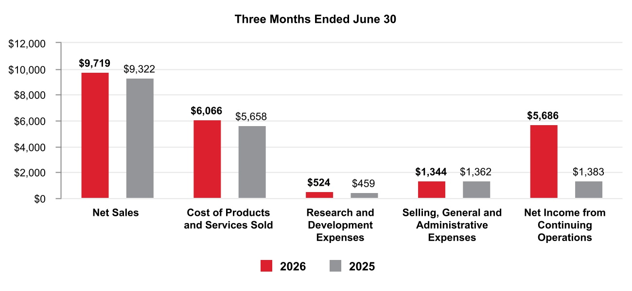
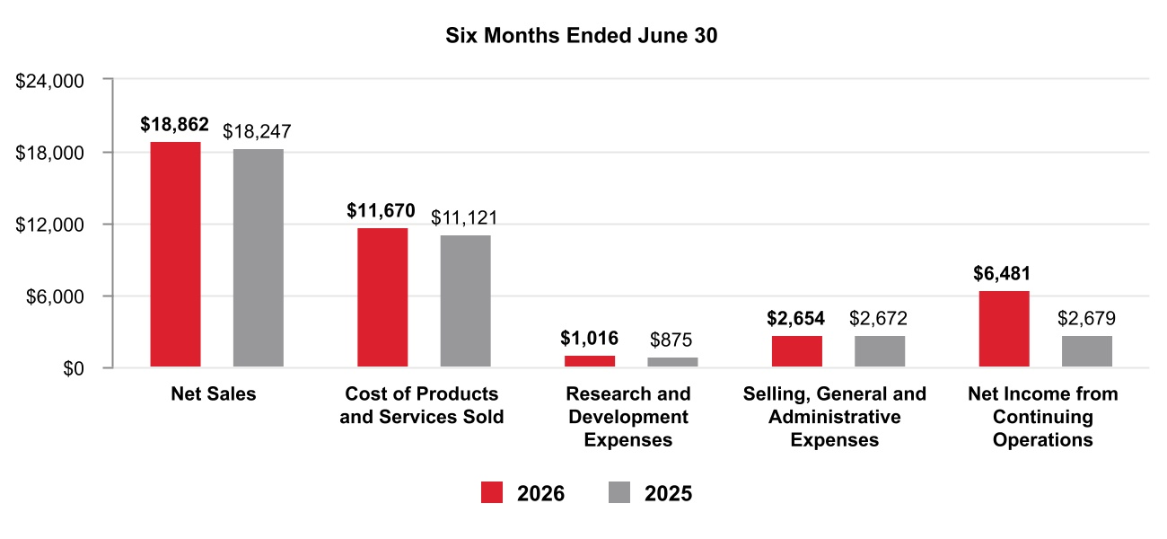
Net Sales by Segment
38 Honeywell International Inc.
TABLE OF CONTENTS
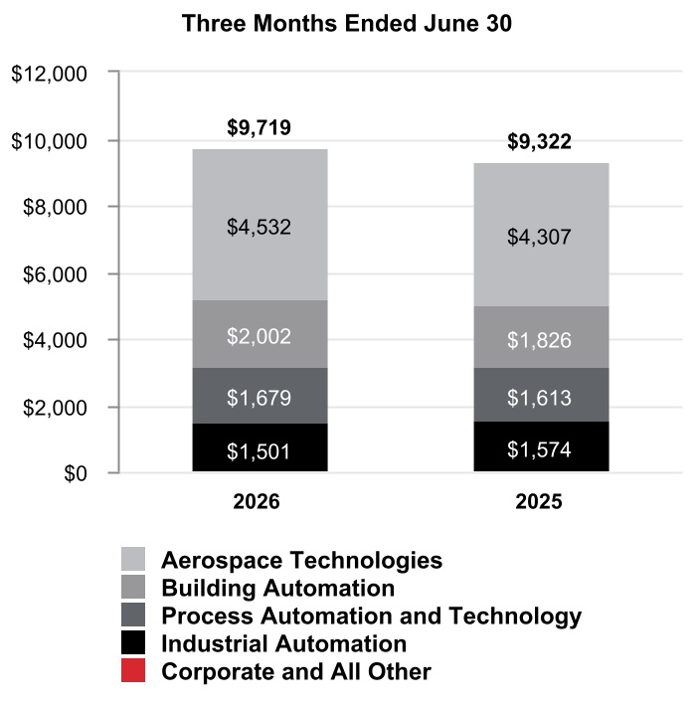
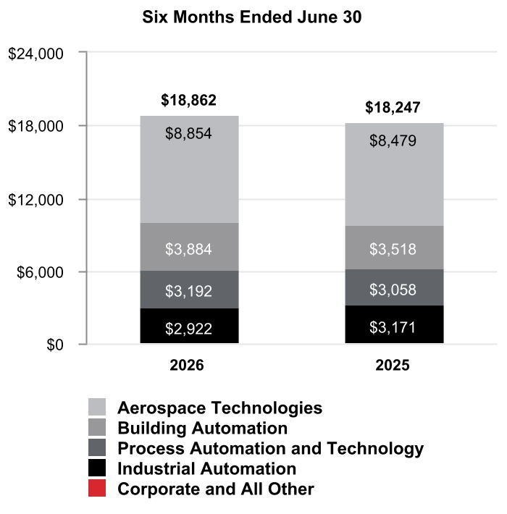
39 Honeywell International Inc.
TABLE OF CONTENTS
Segment Profit by Segment
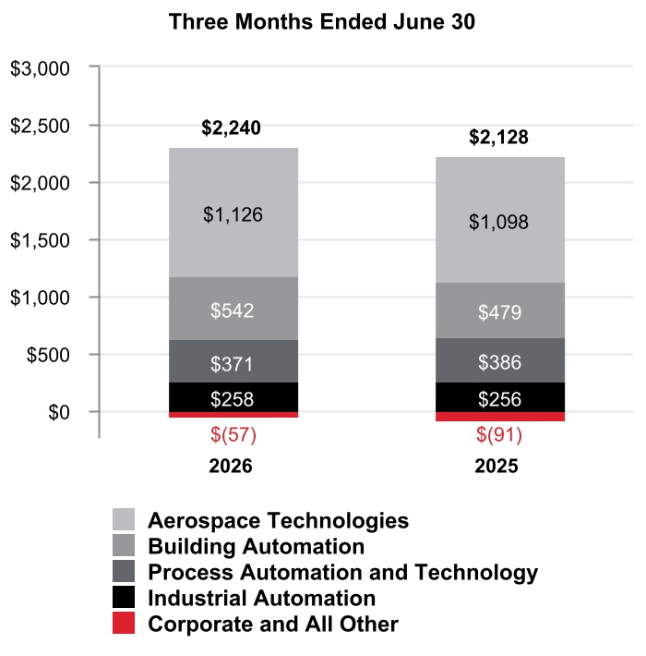
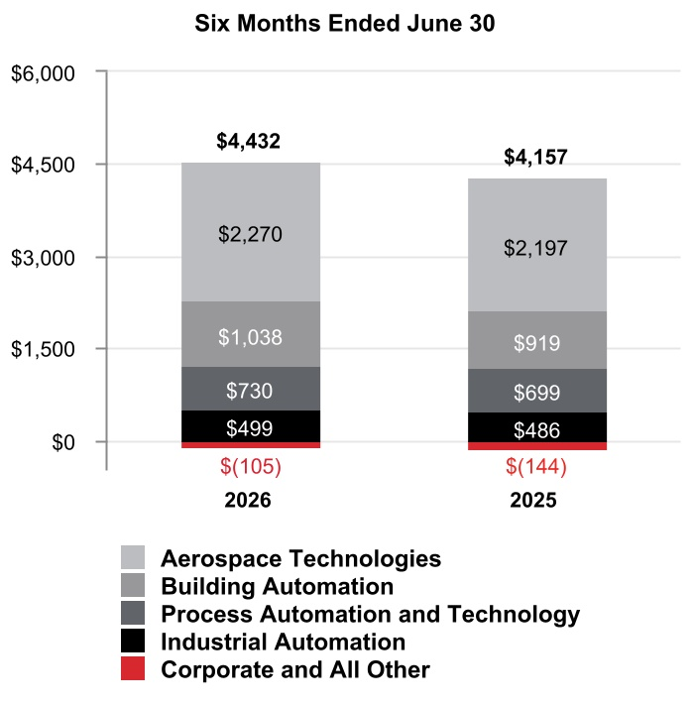

40 Honeywell International Inc.
TABLE OF CONTENTS
CONSOLIDATED OPERATING RESULTS
Net Sales
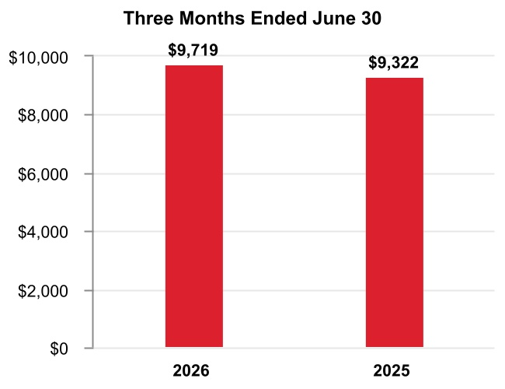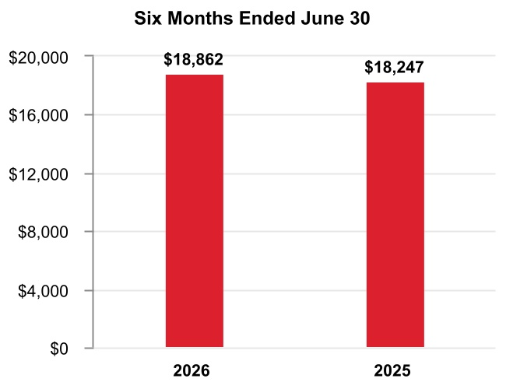
The change in Net sales was attributable to the following:
 |  |  |  | Q2 2026 vs. Q2 2025 |  |  |  |  |  | Year to Date
Volume |  |  |  | — % |  |  |  |  |  | (1 %)
Price |  |  |  | 4 % |  |  |  |  |  | 4 %
Foreign currency translation |  |  |  | 1 % |  |  |  |  |  | 1 %
Acquisitions |  |  |  | 1 % |  |  |  |  |  | 1 %
Divestitures |  |  |  | (2 %) |  |  |  |  |  | (2 %)
Other |  |  |  | — % |  |  |  |  |  | — %
Total % change in Net sales |  |  |  | 4 % |  |  |  |  |  | 3 %
A discussion of Net sales by reportable business segment can be found in the Review of Business Segments section of this Management’s Discussion and Analysis.
Q2 2026 compared with Q2 2025
Net sales increased due to the following:
•Increased pricing and price adjustments to offset inflation,
•Favorable impact of foreign currency translation, driven by the weakening of the U.S. dollar against the currencies in certain of our international markets, primarily the Australian dollar and Chinese renminbi, and
•Incremental sales from recent acquisitions,
•Partially offset by lower sales from the divestiture of the personal protective equipment (PPE) business.
YTD 2026 compared with YTD 2025
Net sales increased due to the following:
•Increased pricing and price adjustments to offset inflation, and
•Incremental sales from recent acquisitions,
•Partially offset by lower sales from the divestiture of the PPE business, and
•Lower sales volumes.

41 Honeywell International Inc.
TABLE OF CONTENTS
Cost of Products and Services Sold
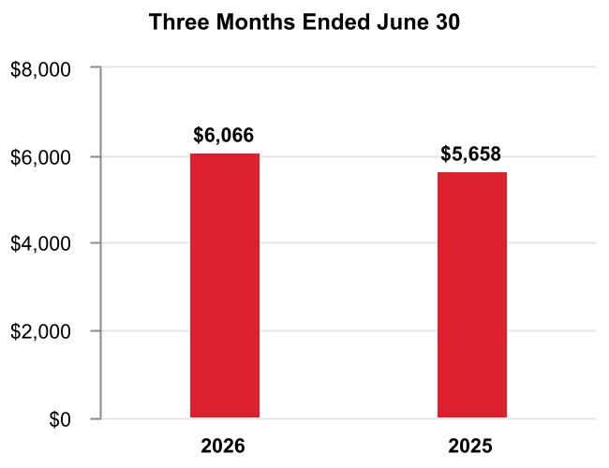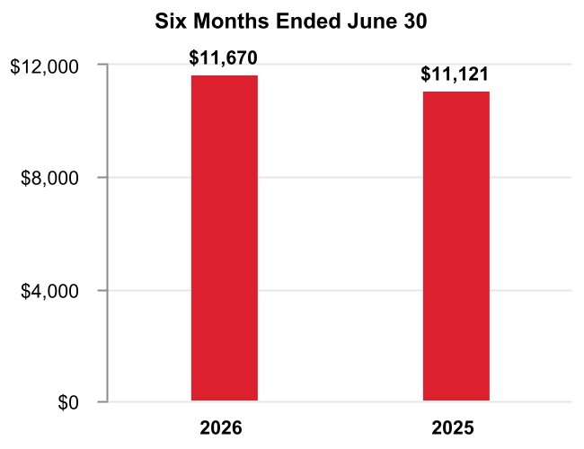
Q2 2026 compared with Q2 2025
Cost of products and services sold increased due to higher direct and indirect material costs and higher labor costs.
YTD 2026 compared with YTD 2025
Cost of products and services sold increased due to the following:
•Higher direct and indirect material costs and higher labor costs of approximately $0.4 billion or 4%, and
•Incremental costs from recent acquisitions of approximately $0.2 billion or 2%.
Gross Margin
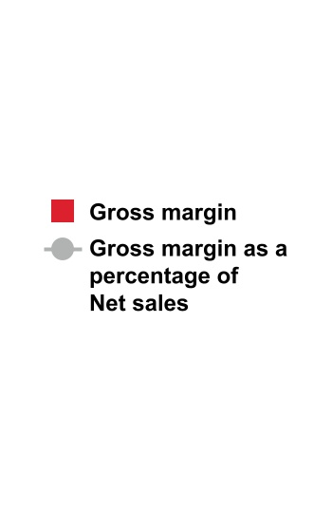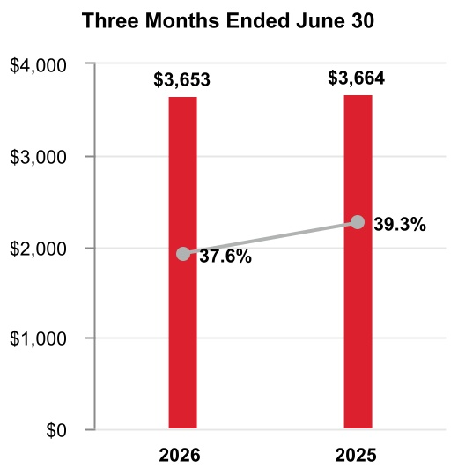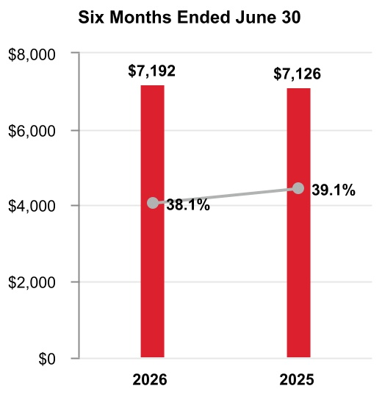

Q2 2026 compared with Q2 2025
Gross margin was flat and gross margin percentage decreased 170 basis points to 37.6% compared to 39.3% for the same period of 2025.
YTD 2026 compared with YTD 2025
Gross margin increased by approximately $0.1 billion and gross margin percentage decreased 100 basis points to 38.1% compared to 39.1% for the same period of 2025.
42 Honeywell International Inc.
TABLE OF CONTENTS
Research and Development Expenses
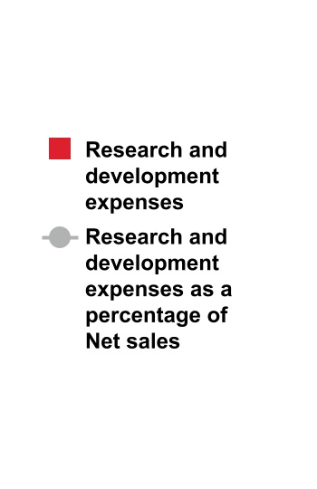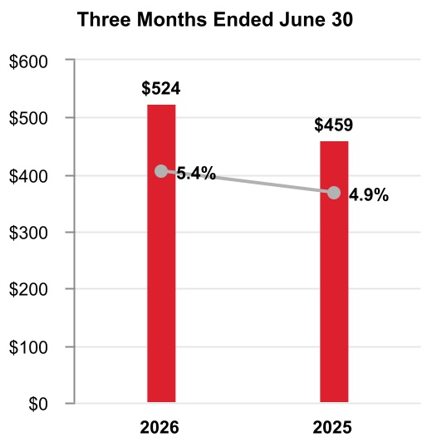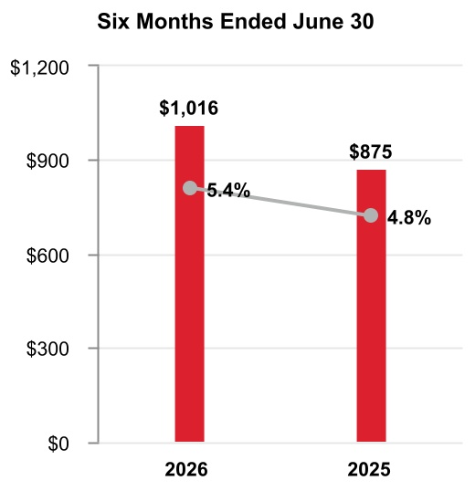
Q2 2026 compared with Q2 2025
Research and development expenses increased as a percentage of net sales due to increased investment in new product development in our Aerospace Technologies business.
YTD 2026 compared with YTD 2025
Research and development expenses increased as a percentage of net sales due to increased investment in new product development in our Aerospace Technologies business.
A summary of our research and development costs is as follows:
 |  |  | Three Months Ended June 30, |  |  |  |  |  |  |  |  |  |  |  | Six Months Ended June 30,
 |  |  | 2026 |  |  |  |  |  | 2025 |  |  |  |  |  | 2026 |  |  |  |  |  | 2025
Company funded research and development expenses |  |  | $ | 524 |  |  |  |  | $ | 459 |  |  |  |  | $ | 1,016 |  |  |  |  | $ | 875
Customer-sponsored research and development1 |  |  | 304 |  |  |  |  |  | 260 |  |  |  |  |  | 570 |  |  |  |  |  | 527
Total research and development costs |  |  | $ | 828 |  |  |  |  | $ | 719 |  |  |  |  | $ | 1,586 |  |  |  |  | $ | 1,402
1 |  |  | Includes deferred customer funded nonrecurring engineering and development activities and expenditures on customer programs with a significant engineering performance obligation, included in Cost of products and services sold in the Consolidated Statement of Operations.
43 Honeywell International Inc.
TABLE OF CONTENTS
Selling, General and Administrative Expenses
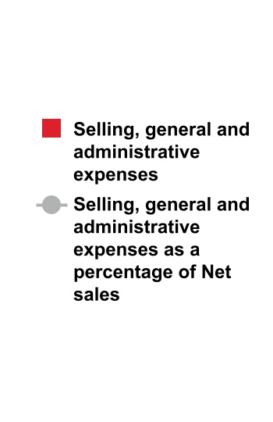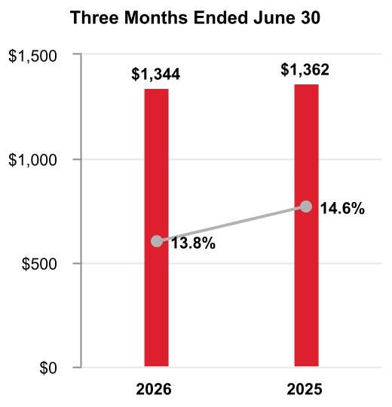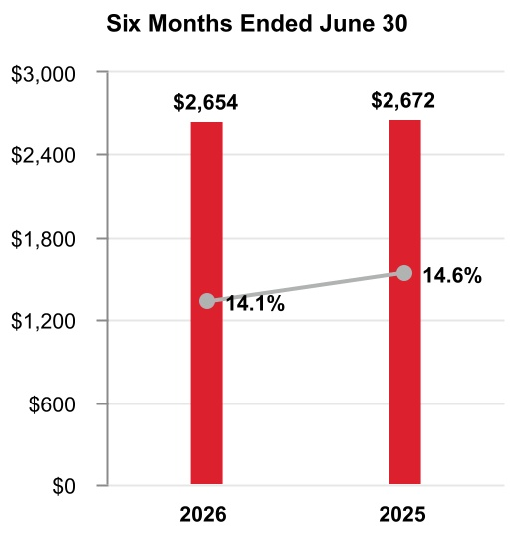
Q2 2026 compared with Q2 2025
Selling, general and administrative expenses were flat compared to the same period in 2025.
YTD 2026 compared to YTD 2025
Selling, general and administrative expenses were flat compared to the same period in 2025.
Impairment of Assets Held for Sale
 |  |  | Three Months Ended June 30, |  |  |  |  |  |  |  |  |  |  |  | Six Months Ended June 30,
 |  |  | 2026 |  |  |  |  |  | 2025 |  |  |  |  |  | 2026 |  |  |  |  |  | 2025
Impairment of assets held for sale |  |  | $ | 48 |  |  |  |  | $ | — |  |  |  |  | $ | 311 |  |  |  |  | $ | 15
Q2 2026 compared with Q2 2025
Impairment of assets held for sale increased due to an impairment charge recorded on the assets held for sale related to the Productivity Solutions and Services and Warehouse and Workflow Solutions businesses for the three months ended June 30, 2026.
YTD 2026 compared to YTD 2025
Impairment of assets held for sale increased due to impairment charges recorded on the assets held for sale related to the Productivity Solutions and Services and Warehouse and Workflow Solutions businesses for the six months ended June 30, 2026.
Loss on Debt Extinguishment
 |  |  | Three Months Ended June 30, |  |  |  |  |  |  |  |  |  |  |  | Six Months Ended June 30,
 |  |  | 2026 |  |  |  |  |  | 2025 |  |  |  |  |  | 2026 |  |  |  |  |  | 2025
Loss on debt extinguishment |  |  | $ | 2 |  |  |  |  | $ | — |  |  |  |  | $ | 241 |  |  |  |  | $ | —
Q2 2026 compared with Q2 2025
Loss on debt extinguishment in the three months ended June 30, 2026 was due to the debt redemptions.
YTD 2026 compared to YTD 2025
Loss on debt extinguishment in the six months ended June 30, 2026 was due to the debt tender offers and redemptions.
44 Honeywell International Inc.
TABLE OF CONTENTS
Gain on Deconsolidation of Subsidiary
 |  |  | Three Months Ended June 30, |  |  |  |  |  |  |  |  |  |  |  | Six Months Ended June 30,
 |  |  | 2026 |  |  |  |  |  | 2025 |  |  |  |  |  | 2026 |  |  |  |  |  | 2025
Gain on deconsolidation of subsidiary |  |  | $ | (6,629) |  |  |  |  | $ | — |  |  |  |  | $ | (6,629) |  |  |  |  | $ | —
Q2 2026 compared with Q2 2025
Gain on deconsolidation of subsidiary in the three months ended June 30, 2026 was due to the deconsolidation of Quantinuum.
YTD 2026 compared to YTD 2025
Gain on deconsolidation of subsidiary in the six months ended June 30, 2026 was due to the deconsolidation of Quantinuum.
Other (Income) Expense
 |  |  | Three Months Ended June 30, |  |  |  |  |  |  |  |  |  |  |  | Six Months Ended June 30,
 |  |  | 2026 |  |  |  |  |  | 2025 |  |  |  |  |  | 2026 |  |  |  |  |  | 2025
Other (income) expense |  |  | $ | 472 |  |  |  |  | $ | (113) |  |  |  |  | $ | 465 |  |  |  |  | $ | (342)
Q2 2026 compared with Q2 2025
Other income decreased due to the following:
•Higher divestiture-related costs related to the Aerospace Spin-Off of approximately $0.7 billion,
•Partially offset by higher pension income of approximately $0.1 billion.
YTD 2026 compared to YTD 2025
Other income decreased due to the following:
•Higher divestiture-related costs related to the Aerospace Spin-Off of approximately $0.9 billion,
•Partially offset by higher pension income of approximately $0.1 billion.
Interest and Other Financial Charges
 |  |  | Three Months Ended June 30, |  |  |  |  |  |  |  |  |  |  |  | Six Months Ended June 30,
 |  |  | 2026 |  |  |  |  |  | 2025 |  |  |  |  |  | 2026 |  |  |  |  |  | 2025
Interest and other financial charges |  |  | $ | 363 |  |  |  |  | $ | 329 |  |  |  |  | $ | 719 |  |  |  |  | $ | 614
Q2 2026 compared with Q2 2025
Interest and other financial charges increased due to the increase in debt from pre-separation debt financing in advance of the Aerospace Spin-Off net of debt tender offers and redemptions.
YTD 2026 compared to YTD 2025
Interest and other financial charges increased due to the increase in debt from pre-separation debt financing in advance of the Aerospace Spin-Off net of debt tender offers and redemptions.

45 Honeywell International Inc.
TABLE OF CONTENTS
Tax Expense
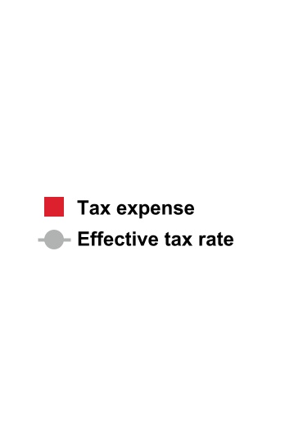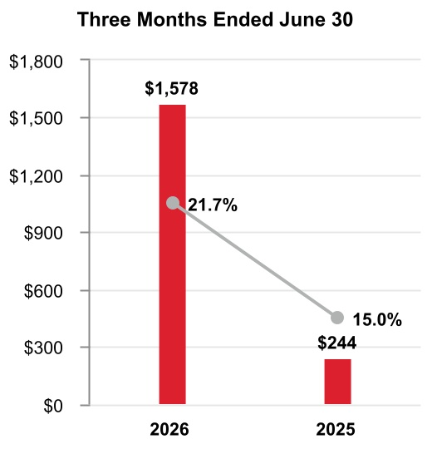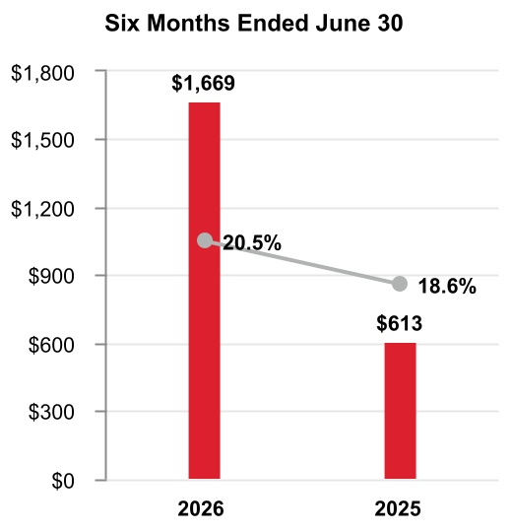
Q2 2026 compared with Q2 2025
The effective tax rate increased 670 basis points due to the following:
•Changes in accruals on foreign tax matters and transaction related tax costs primarily related to the Quantinuum deconsolidation and Aerospace Spin-Off of 1,020 basis points,
•Partially offset by changes in valuation allowance of 380 basis points.

YTD 2026 compared with YTD 2025
The effective tax rate increased 190 basis points due to the following:
•Changes in accruals on foreign tax matters of 560 basis points,
•Partially offset by changes in valuation allowance of 340 basis points.

Equity Loss
 |  |  | Three Months Ended June 30, |  |  |  |  |  |  |  |  |  |  |  | Six Months Ended June 30,
 |  |  | 2026 |  |  |  |  |  | 2025 |  |  |  |  |  | 2026 |  |  |  |  |  | 2025
Equity loss |  |  | $ | 265 |  |  |  |  | $ | — |  |  |  |  | $ | 265 |  |  |  |  | $ | —
Q2 2026 compared with Q2 2025
Equity loss in the three months ended June 30, 2026 was due to equity losses on Quantinuum following the deconsolidation of Quantinuum in the second quarter of 2026.
YTD 2026 compared to YTD 2025
Equity loss in the six months ended June 30, 2026 was due to equity losses on Quantinuum following the deconsolidation of Quantinuum in the second quarter of 2026.

46 Honeywell International Inc.
TABLE OF CONTENTS

Net Income from Continuing Operations
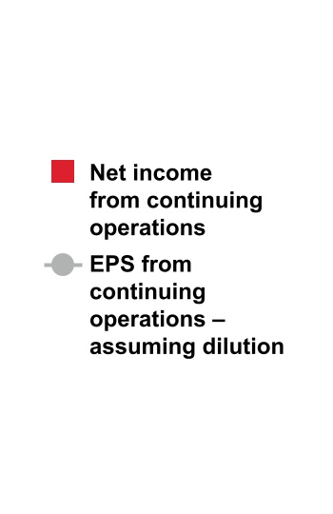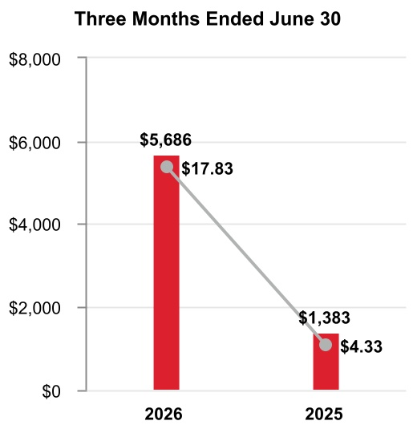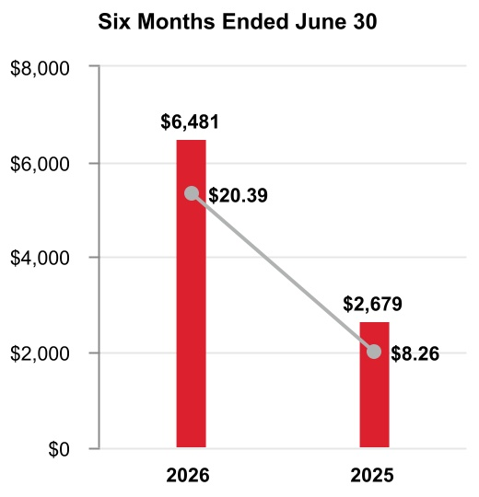
Q2 2026 compared to Q2 2025
Earnings per share of common stock–assuming dilution increased due to the following:
•Gain on deconsolidation of Quantinuum ($15.78 after tax),
•Partially offset by higher divestiture-related costs ($1.54 after tax).
YTD 2026 compared with YTD 2025
Earnings per share of common stock–assuming dilution increased due to the following:
•Gain on deconsolidation of Quantinuum ($15.65 after tax),
•Partially offset by higher divestiture-related costs ($2.05 after tax), and
•Higher debt restructuring costs ($0.80 after tax).

BACKLOG
Our backlog of orders increased 12% to $38.0 billion as of June 30, 2026, compared to June 30, 2025. Backlog represents the estimated remaining value of work to be performed or products to be shipped under firm contracts. Backlog is equal to our remaining performance obligations under the contracts that meet the guidance on revenue from contracts with customers as discussed in Note 4 Revenue Recognition and Contracts with Customers of Notes to Consolidated Financial Statements. Our backlog by reportable business segment is as follows:
 |  |  | June 30, 2026
Aerospace Technologies |  |  | $ | 18,435
Building Automation |  |  | 2,675
Process Automation and Technology |  |  | 9,258
Industrial Automation |  |  | 7,640
Total backlog |  |  | $ | 38,008

47 Honeywell International Inc.
TABLE OF CONTENTS
REVIEW OF BUSINESS SEGMENTS
During the first quarter of 2026, the Company realigned certain of its business units as reflected in Note 18 Segment Financial Data, which impacts the composition of its reportable segments. The Company recast historical periods to reflect this change in segment presentation. See Note 18 Segment Financial Data to Notes to Consolidated Financial Statements for further discussion.
During the period reflected in the Quarterly Report on Form 10-Q, we globally managed our business operations through four reportable business segments: Aerospace Technologies, Building Automation, Process Automation and Technology, and Industrial Automation. Upon the Aerospace Spin-Off, we now manage our businesses through three reportable business segments: Building Automation, Process Automation and Technology, and Industrial Automation.

AEROSPACE TECHNOLOGIES
Effective the third quarter of 2026, the results of Aerospace Technologies will be reported within discontinued operations.

Net Sales
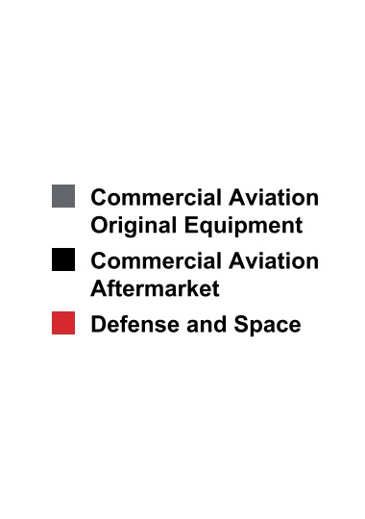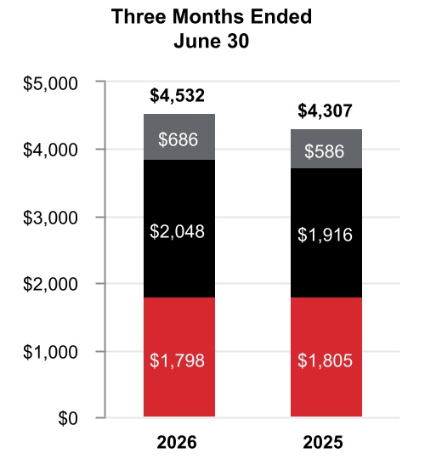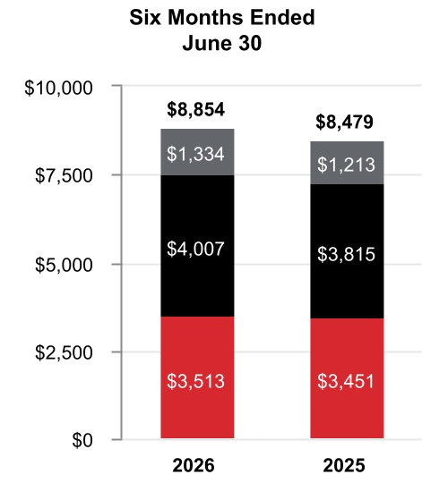
 |  |  | Three Months Ended  June 30, |  |  |  |  |  |  |  |  |  |  |  |  |  |  |  |  |  | Six Months Ended  June 30,
 |  |  | 2026 |  |  |  |  |  | 2025 |  |  |  |  |  | %  Change |  |  |  |  |  | 2026 |  |  |  |  |  | 2025 |  |  |  |  |  | %  Change
Net sales |  |  | $ | 4,532 |  |  |  |  | $ | 4,307 |  |  |  |  | 5 |  | % |  |  |  | $ | 8,854 |  |  |  |  | $ | 8,479 |  |  |  |  | 4 |  | %
Cost of products and services sold |  |  | 2,889 |  |  |  |  |  | 2,718 |  |  |  |  |  |  |  |  |  |  |  | 5,564 |  |  |  |  |  | 5,310
Selling, general and administrative and other expenses |  |  | 517 |  |  |  |  |  | 491 |  |  |  |  |  |  |  |  |  |  |  | 1,020 |  |  |  |  |  | 972
Segment profit |  |  | $ | 1,126 |  |  |  |  | $ | 1,098 |  |  |  |  | 2 |  | % |  |  |  | $ | 2,270 |  |  |  |  | $ | 2,197 |  |  |  |  | 3 |  | %
48 Honeywell International Inc.
TABLE OF CONTENTS
 |  |  | 2026 vs. 2025
 |  |  | Three Months Ended  June 30, |  |  |  |  |  |  |  |  |  |  |  | Six Months Ended  June 30,
Factors Contributing to Year-Over-Year Change |  |  | Net  Sales |  |  |  |  |  | Segment  Profit |  |  |  |  |  | Net  Sales |  |  |  |  |  | Segment  Profit
Reported percent change |  |  | 5 |  | % |  |  |  | 2 |  | % |  |  |  | 4 |  | % |  |  |  | 3 |  | %
Less: Impact of divestitures to the prior period |  |  | — |  | % |  |  |  | — |  | % |  |  |  | — |  | % |  |  |  | — |  | %
Reported percent change, adjusted for impact of divestitures |  |  | 5 |  | % |  |  |  | 2 |  | % |  |  |  | 4 |  | % |  |  |  | 3 |  | %
Less: Foreign currency translation |  |  | — |  | % |  |  |  | — |  | % |  |  |  | — |  | % |  |  |  | — |  | %
Less: Acquisitions |  |  | — |  | % |  |  |  | — |  | % |  |  |  | — |  | % |  |  |  | — |  | %
Less: Other |  |  | — |  | % |  |  |  | — |  | % |  |  |  | — |  | % |  |  |  | — |  | %
Organic percent change1 |  |  | 5 |  | % |  |  |  | 2 |  | % |  |  |  | 4 |  | % |  |  |  | 3 |  | %
1 |  |  |  |  |  | Organic sales % change, presented for all of our reportable business segments, is defined as the change in Net sales, adjusted for the impact of divestitures to the prior period, and excluding the impact on sales from foreign currency translation, acquisitions for the first 12 months following the transaction date, and certain other items that are unusual or non-recurring in nature. We believe this non-GAAP measure is useful to investors and management in understanding the ongoing operations and analysis of ongoing operating trends.
Q2 2026 compared to Q2 2025
Sales increased $225 million due to higher organic sales of $128 million in Commercial Aviation Aftermarket driven by increased pricing and higher organic sales of $100 million in Commercial Aviation Original Equipment driven by increased volume.
Segment profit increased $28 million and segment margin percentage decreased 70 basis points to 24.8% compared to 25.5% for the same period of 2025.
YTD 2026 compared to YTD 2025
Sales increased $375 million due to higher organic sales of $182 million in Commercial Aviation Aftermarket and higher organic sales of $118 million in Commercial Aviation Original Equipment, both driven by increased pricing.
Segment profit increased $73 million and segment margin percentage decreased 30 basis points to 25.6% compared to 25.9% for the same period of 2025. Segment profit benefitted from higher organic sales driven by increased pricing, offset by an increase in inventory obsolescence charges of approximately $60 million, partially attributable to higher inventory balances.

BUILDING AUTOMATION
Net Sales
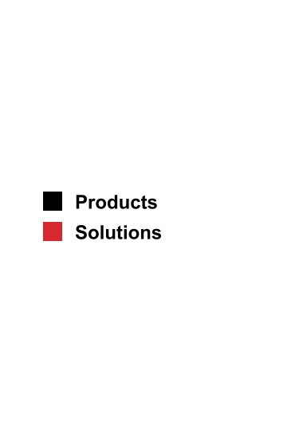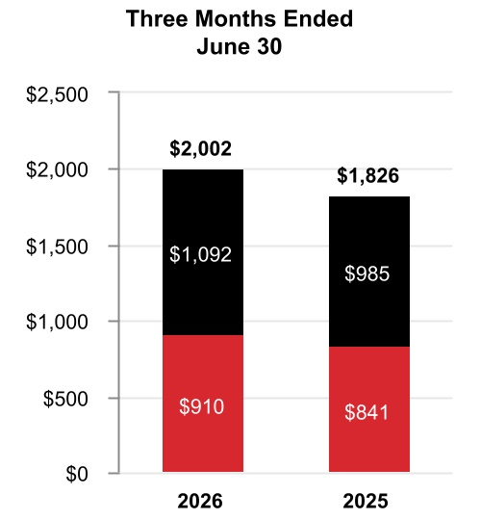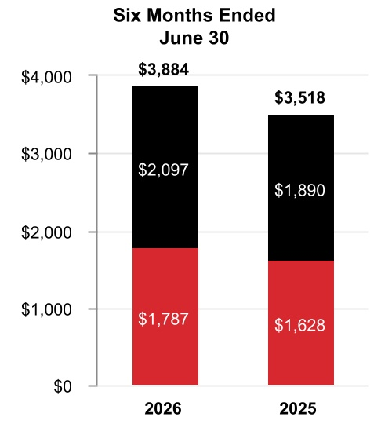
49 Honeywell International Inc.
TABLE OF CONTENTS
 |  |  | Three Months Ended  June 30, |  |  |  |  |  |  |  |  |  |  |  |  |  |  |  |  |  | Six Months Ended  June 30,
 |  |  | 2026 |  |  |  |  |  | 2025 |  |  |  |  |  | %  Change |  |  |  |  |  | 2026 |  |  |  |  |  | 2025 |  |  |  |  |  | %  Change
Net sales |  |  | $ | 2,002 |  |  |  |  | $ | 1,826 |  |  |  |  | 10 |  | % |  |  |  | $ | 3,884 |  |  |  |  | $ | 3,518 |  |  |  |  | 10 |  | %
Cost of products and services sold |  |  | 1,065 |  |  |  |  |  | 944 |  |  |  |  |  |  |  |  |  |  |  | 2,058 |  |  |  |  |  | 1,812
Selling, general and administrative and other expenses |  |  | 395 |  |  |  |  |  | 403 |  |  |  |  |  |  |  |  |  |  |  | 788 |  |  |  |  |  | 787
Segment profit |  |  | $ | 542 |  |  |  |  | $ | 479 |  |  |  |  | 13 |  | % |  |  |  | $ | 1,038 |  |  |  |  | $ | 919 |  |  |  |  | 13 |  | %
 |  |  | 2026 vs. 2025
 |  |  | Three Months Ended  June 30, |  |  |  |  |  |  |  |  |  |  |  | Six Months Ended  June 30,
Factors Contributing to Year-Over-Year Change |  |  | Net  Sales |  |  |  |  |  | Segment  Profit |  |  |  |  |  | Net  Sales |  |  |  |  |  | Segment  Profit
Reported percent change |  |  | 10 |  | % |  |  |  | 13 |  | % |  |  |  | 10 |  | % |  |  |  | 13 |  | %
Less: Impact of divestitures to the prior period |  |  | — |  | % |  |  |  | — |  | % |  |  |  | — |  | % |  |  |  | — |  | %
Reported percent change, adjusted for impact of divestitures |  |  | 10 |  | % |  |  |  | 13 |  | % |  |  |  | 10 |  | % |  |  |  | 13 |  | %
Less: Foreign currency translation |  |  | 1 |  | % |  |  |  | 1 |  | % |  |  |  | 2 |  | % |  |  |  | 3 |  | %
Less: Acquisitions |  |  | — |  | % |  |  |  | — |  | % |  |  |  | — |  | % |  |  |  | — |  | %
Less: Other |  |  | — |  | % |  |  |  | — |  | % |  |  |  | — |  | % |  |  |  | — |  | %
Organic percent change |  |  | 9 |  | % |  |  |  | 12 |  | % |  |  |  | 8 |  | % |  |  |  | 10 |  | %
Q2 2026 compared to Q2 2025
Sales increased $176 million due to higher organic sales of $103 million in Products and higher organic sales of $59 million in Solutions, both driven by higher demand.
Segment profit increased $63 million and segment margin percentage increased 90 basis points to 27.1% compared to 26.2% for the same period of 2025.
YTD 2026 compared to YTD 2025
Sales increased $366 million due to higher organic sales of $174 million in Products and higher organic sales of $120 million in Building Solutions, both driven by higher demand.
Segment profit increased $119 million and segment margin percentage increased 60 basis points to 26.7% compared to 26.1% for the same period of 2025.

50 Honeywell International Inc.
TABLE OF CONTENTS
PROCESS AUTOMATION AND TECHNOLOGY
Net Sales
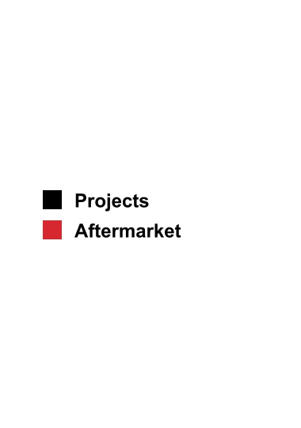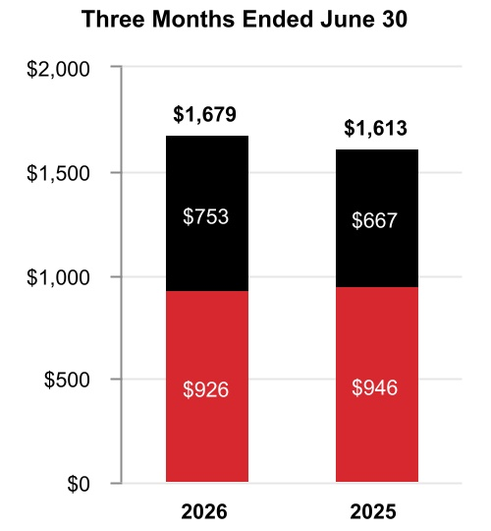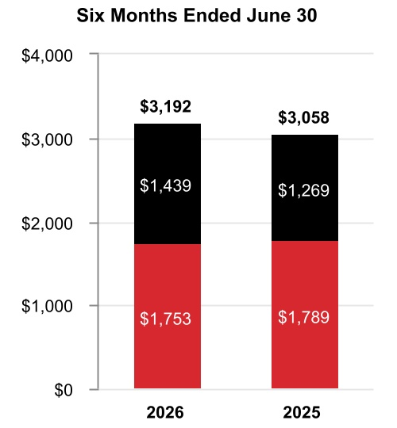
 |  |  | Three Months Ended  June 30, |  |  |  |  |  |  |  |  |  |  |  |  |  |  |  |  |  | Six Months Ended  June 30,
 |  |  | 2026 |  |  |  |  |  | 2025 |  |  |  |  |  | %  Change |  |  |  |  |  | 2026 |  |  |  |  |  | 2025 |  |  |  |  |  | %  Change
Net sales |  |  | $ | 1,679 |  |  |  |  | $ | 1,613 |  |  |  |  | 4 |  | % |  |  |  | $ | 3,192 |  |  |  |  | $ | 3,058 |  |  |  |  | 4 |  | %
Cost of products and services sold |  |  | 985 |  |  |  |  |  | 896 |  |  |  |  |  |  |  |  |  |  |  | 1,841 |  |  |  |  |  | 1,705
Selling, general and administrative and other expenses |  |  | 323 |  |  |  |  |  | 331 |  |  |  |  |  |  |  |  |  |  |  | 621 |  |  |  |  |  | 654
Segment profit |  |  | $ | 371 |  |  |  |  | $ | 386 |  |  |  |  | (4) |  | % |  |  |  | $ | 730 |  |  |  |  | $ | 699 |  |  |  |  | 4 |  | %
 |  |  | 2026 vs. 2025
 |  |  | Three Months Ended  June 30, |  |  |  |  |  |  |  |  |  |  |  | Six Months Ended  June 30,
Factors Contributing to Year-Over-Year Change |  |  | Net  Sales |  |  |  |  |  | Segment  Profit |  |  |  |  |  | Net  Sales |  |  |  |  |  | Segment  Profit
Reported percent change |  |  | 4 |  | % |  |  |  | (4) |  | % |  |  |  | 4 |  | % |  |  |  | 4 |  | %
Less: Impact of divestitures to the prior period |  |  | — |  | % |  |  |  | — |  | % |  |  |  | — |  | % |  |  |  | — |  | %
Reported percent change, adjusted for impact of divestitures |  |  | 4 |  | % |  |  |  | (4) |  | % |  |  |  | 4 |  | % |  |  |  | 4 |  | %
Less: Foreign currency translation |  |  | — |  | % |  |  |  | 1 |  | % |  |  |  | 1 |  | % |  |  |  | 1 |  | %
Less: Acquisitions |  |  | 5 |  | % |  |  |  | 5 |  | % |  |  |  | 6 |  | % |  |  |  | 8 |  | %
Less: Other |  |  | — |  | % |  |  |  | — |  | % |  |  |  | — |  | % |  |  |  | — |  | %
Organic percent change |  |  | (1) |  | % |  |  |  | (10) |  | % |  |  |  | (3) |  | % |  |  |  | (5) |  | %
Q2 2026 compared to Q2 2025
Sales increased $66 million due to inorganic sales of $78 million in Sundyne during the three months ended June 30, 2026 and higher organic sales of $54 million in Projects driven by increased volume, partially offset by lower organic sales of $77 million in Aftermarket driven by a decline in catalyst shipments.
Segment profit decreased $15 million and segment margin percentage decreased 180 basis points to 22.1% compared to 23.9% for the same period of 2025.
51 Honeywell International Inc.
TABLE OF CONTENTS
YTD 2026 compared to YTD 2025
Sales increased $134 million due to inorganic sales of $199 million in Sundyne during the six months ended June 30, 2026 and higher organic sales of $53 million in Projects driven by increased volume, partially offset by lower organic sales of $159 million in Aftermarket driven by a decline in catalyst shipments.
Segment profit increased $31 million and segment margin percentage remained flat at 22.9% compared to 22.9% for the same period of 2025.

INDUSTRIAL AUTOMATION
Net Sales
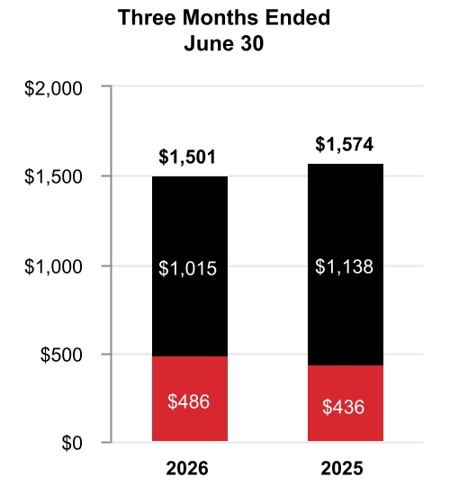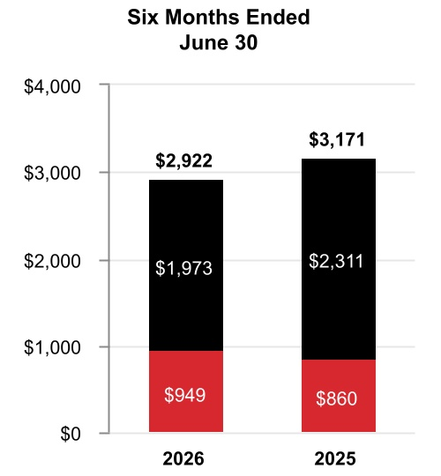

 |  |  | Three Months Ended  June 30, |  |  |  |  |  |  |  |  |  |  |  |  |  |  |  |  |  | Six Months Ended  June 30,
 |  |  | 2026 |  |  |  |  |  | 2025 |  |  |  |  |  | %  Change |  |  |  |  |  | 2026 |  |  |  |  |  | 2025 |  |  |  |  |  | %  Change
Net sales |  |  | $ | 1,501 |  |  |  |  | $ | 1,574 |  |  |  |  | (5) |  | % |  |  |  | $ | 2,922 |  |  |  |  | $ | 3,171 |  |  |  |  | (8) |  | %
Cost of products and services sold |  |  | 933 |  |  |  |  |  | 957 |  |  |  |  |  |  |  |  |  |  |  | 1,797 |  |  |  |  |  | 1,946
Selling, general and administrative and other expenses |  |  | 310 |  |  |  |  |  | 361 |  |  |  |  |  |  |  |  |  |  |  | 626 |  |  |  |  |  | 739
Segment profit |  |  | $ | 258 |  |  |  |  | $ | 256 |  |  |  |  | 1 |  | % |  |  |  | $ | 499 |  |  |  |  | $ | 486 |  |  |  |  | 3 |  | %
 |  |  | 2026 vs. 2025
 |  |  | Three Months Ended  June 30, |  |  |  |  |  |  |  |  |  |  |  | Six Months Ended  June 30,
Factors Contributing to Year-Over-Year Change |  |  | Net  Sales |  |  |  |  |  | Segment  Profit |  |  |  |  |  | Net  Sales |  |  |  |  |  | Segment  Profit
Reported percent change |  |  | (5) |  | % |  |  |  | 1 |  | % |  |  |  | (8) |  | % |  |  |  | 3 |  | %
Less: Impact of divestitures to the prior period |  |  | (9) |  | % |  |  |  | (2) |  | % |  |  |  | (12) |  | % |  |  |  | (6) |  | %
Reported percent change, adjusted for impact of divestitures |  |  | 4 |  | % |  |  |  | 3 |  | % |  |  |  | 4 |  | % |  |  |  | 9 |  | %
Less: Foreign currency translation |  |  | — |  | % |  |  |  | 2 |  | % |  |  |  | 1 |  | % |  |  |  | 2 |  | %
Less: Acquisitions |  |  | — |  | % |  |  |  | — |  | % |  |  |  | — |  | % |  |  |  | — |  | %
Less: Other |  |  | — |  | % |  |  |  | — |  | % |  |  |  | — |  | % |  |  |  | — |  | %
Organic percent change |  |  | 4 |  | % |  |  |  | 1 |  | % |  |  |  | 3 |  | % |  |  |  | 7 |  | %
52 Honeywell International Inc.
TABLE OF CONTENTS
Q2 2026 compared to Q2 2025
Sales decreased $73 million due to lower sales of $145 million driven by the sale of our PPE business on May 21, 2025, partially offset by higher organic sales of $47 million in Solutions driven by project timing.
Segment profit increased $2 million and segment margin percentage increased 90 basis points to 17.2% compared to 16.3% for the same period in 2025.
YTD 2026 compared to YTD 2025
Sales decreased $249 million due to lower sales of $381 million driven by the sale of our PPE business on May 21, 2025, partially offset by higher organic sales of $78 million in Solutions driven by project timing.
Segment profit increased $13 million and segment margin percentage increased 180 basis points to 17.1% compared to 15.3% for the same period of 2025.
On July 8, 2025, the Company announced it was evaluating strategic alternatives for its Productivity Solutions and Services and Warehouse and Workflow Solutions businesses. Following the Company’s strategic review, the assets and liabilities of these businesses were classified as held for sale beginning December 31, 2025. In April 2026, the Company announced it has reached agreements to sell the businesses in two transactions, both of which are expected to close in the third quarter of 2026 and are subject to customary closing conditions, including receipt of certain regulatory approvals.

CORPORATE AND ALL OTHER
Corporate and All Other primarily includes unallocated corporate costs, interest expense on holding-company debt, and the former controlling majority-owned interest in Quantinuum prior to deconsolidation in the second quarter of 2026. Corporate expenses historically allocated to the Advanced Materials business prior to it being spun off in the fourth quarter of 2025 and not eligible to be part of discontinued operations are now included in Corporate and All Other. Corporate and All Other is not a separate reportable business segment as segment reporting criteria is not met. The Company continues to monitor the activities in Corporate and All Other to determine the need for further reportable business segment disaggregation.

REPOSITIONING CHARGES
See Note 5 Repositioning and Other Charges of Notes to Consolidated Financial Statements for a discussion of our repositioning actions and related charges incurred in the six months ended June 30, 2026 and 2025. Cash spending related to our repositioning actions was $91 million in the six months ended June 30, 2026, and was funded through operating cash flows.

53 Honeywell International Inc.
TABLE OF CONTENTS
LIQUIDITY AND CAPITAL RESOURCES
(Dollars in tables in millions)
We leverage operating cash flows as the primary source of liquidity. Each of our businesses focuses on increasing operating cash flows through revenue growth, margin expansion, and improved working capital turnover. We also maintain other key sources of liquidity, including U.S. cash balances, and the ability to access non-U.S. cash balances, short-term debt from the commercial paper market, long-term borrowings, committed credit lines, and access to the public debt and equity markets.

CASH
As of June 30, 2026 and December 31, 2025, we held $9.2 billion and $12.9 billion, respectively, of cash and cash equivalents, including our short-term investments. We monitor third-party depository institutions that hold our cash and cash equivalents on a daily basis. Our emphasis is primarily safety of principal and secondarily maximizing yield of those funds. We diversify our cash and cash equivalents among counterparties to minimize exposure to any one counterparty.
As of June 30, 2026, we held $6.7 billion of the Company’s cash, cash equivalents, and short-term investments in non-U.S. subsidiaries. We do not have material amounts related to any jurisdiction subject to currency control restrictions that impact our ability to access and repatriate such amounts. Under current laws, we do not expect taxes on repatriation or restrictions on amounts held outside of the U.S. to have a material effect on our overall liquidity.

CASH FLOW SUMMARY
Our cash flows from operating, investing, and financing activities, as reflected in the Consolidated Statement of Cash Flows, are summarized as follows:
 |  |  | Six Months Ended June 30,
 |  |  | 2026 |  |  |  |  |  | 2025 |  |  |  |  |  | Variance
Cash and cash equivalents at beginning of period |  |  | $ | 12,487 |  |  |  |  | $ | 10,567 |  |  |  |  | $ | 1,920
Operating activities
Net income from continuing operations |  |  | 6,481 |  |  |  |  |  | 2,679 |  |  |  |  |  | 3,802
Noncash adjustments |  |  | (4,281) |  |  |  |  |  | 628 |  |  |  |  |  | (4,909)
Changes in working capital |  |  | (863) |  |  |  |  |  | (1,179) |  |  |  |  |  | 316
Other operating activities |  |  | (711) |  |  |  |  |  | (686) |  |  |  |  |  | (25)
Net cash provided by operating activities from discontinued operations |  |  | — |  |  |  |  |  | 474 |  |  |  |  |  | (474)
Net cash provided by operating activities |  |  | 626 |  |  |  |  |  | 1,916 |  |  |  |  |  | (1,290)
Net cash used for investing activities from continuing operations |  |  | (1,048) |  |  |  |  |  | (1,765) |  |  |  |  |  | 717
Net cash used for investing activities from discontinued operations |  |  | — |  |  |  |  |  | (115) |  |  |  |  |  | 115
Net cash used for financing activities |  |  | (3,246) |  |  |  |  |  | (421) |  |  |  |  |  | (2,825)
Effect of foreign exchange rate changes on cash and cash equivalents |  |  | (68) |  |  |  |  |  | 167 |  |  |  |  |  | (235)
Net decrease in cash and cash equivalents |  |  | (3,736) |  |  |  |  |  | (218) |  |  |  |  |  | (3,518)
Cash and cash equivalents at end of period |  |  | $ | 8,751 |  |  |  |  | $ | 10,349 |  |  |  |  | $ | (1,598)
Six months ended June 30, 2026
Net cash provided by operating activities from continuing operations was driven by operating income from continuing operations of $3,211 million, partially offset by changes in working capital of $863 million due to timing of customer cash collections, payments for divestiture-related costs of approximately $800 million, net interest payments of $482 million, and the Flexjet litigation settlement payment of $375 million.
Net cash used for investing activities from continuing operations was driven by $538 million of capital expenditures and the deconsolidation of $623 million of Quantinuum cash, partially offset by $127 million of net cash receipts from settlements of derivative contracts.
54 Honeywell International Inc.
TABLE OF CONTENTS
Net cash used for financing activities was driven by $13,187 million of payments of long-term debt, $3,413 million of net payments of commercial paper, $1,576 million of cash dividends paid, and $1,000 million of repurchases of common stock, partially offset by $15,835 million of pre-separation funding related to the Aerospace Spin-Off.
Six months ended June 30, 2026 compared with six months ended June 30, 2025
Net cash provided by operating activities from continuing operations decreased by $816 million, driven by cash payments resulting from an approximately $800 million increase in payments for divestiture-related costs.
Net cash used for investing activities from continuing operations decreased by $717 million, driven by a $2,135 million decrease in cash paid for acquisitions and a $542 million net increase in cash receipts from settlement of derivative contracts, partially offset by a $1,151 million decrease in proceeds from sale of businesses, the deconsolidation of $623 million of Quantinuum cash and a $122 million increase in capital expenditures.
Net cash used for financing activities increased by $2,825 million, driven by an $11,878 million increase of payments of long-term debt, a $5,286 million increase of net payments of commercial paper, and a decrease in proceeds from issuance of long-term debt of $4,035 million, partially offset by $15,835 million of pre-separation funding related to the Aerospace Spin-Off and a $2,604 million decrease in repurchases of common stock.

ASSESSMENT OF CURRENT LIQUIDITY AND CASH REQUIREMENTS
Based on past performance and current expectations, we believe our operating cash flows will be sufficient to meet our future operating cash needs for at least the next twelve months. If necessary, our available cash, committed credit lines, and access to the public debt and equity markets provide additional sources of short-term and long-term liquidity to fund current operations, debt maturities, and future investment opportunities.
See Note 9 Debt and Credit Agreements of Notes to Consolidated Financial Statements for additional discussion of items impacting our liquidity.
In addition to normal operating cash requirements, our principal future cash requirements include funding capital expenditures, share repurchases, dividends, strategic acquisitions, and debt repayments. During the six months ended June 30, 2026, we repurchased common stock of $1.0 billion. Refer to the section titled Liquidity and Capital Resources of our 2025 Form 10-K for a discussion of our expected capital expenditures, share repurchases, mergers and acquisitions activity, and dividends for 2026.
We continually assess the relative strength of each business in our portfolio as to strategic fit, market position, profit, and cash flow contribution in order to identify target investment and acquisition opportunities in order to upgrade our combined portfolio. We seek to identify acquisition candidates that will further our strategic plan and strengthen our existing core businesses. During the third quarter of 2026, we acquired Johnson Matthey’s Catalyst Technologies business segment for total consideration of $1,750 million, net of cash acquired. We also identify businesses that do not fit into our long-term strategic plan based on their market position, relative profitability, or growth potential. These businesses are considered for potential divestiture, restructuring, or other repositioning actions, subject to regulatory constraints. On July 8, 2025, we announced we are evaluating strategic alternatives for our Productivity Solutions and Services and Warehouse and Workflow Solutions businesses within the Industrial Automation reportable business segment and classified the assets and liabilities of the businesses as held for sale beginning December 31, 2025. In April 2026, the Company announced it has reached agreements to sell the businesses in two transactions, both of which are expected to close in the third quarter of 2026 and are subject to customary closing conditions, including receipt of certain regulatory approvals. On June 29, 2026, we completed the Aerospace Spin-Off. See Note 3 Acquisitions, Divestitures, and Discontinued Operations of Notes to Consolidated Financial Statements for additional discussion.
We continually seek opportunities to improve our liquidity and working capital efficiency, which includes the extension of payment terms with our suppliers and transfer of our trade receivables to unaffiliated financial institutions on a true sale basis. The impact of these programs is not material to our overall liquidity.

55 Honeywell International Inc.
TABLE OF CONTENTS
BORROWINGS
We leverage a variety of debt instruments to manage our overall borrowing costs. As of June 30, 2026, and December 31, 2025, our total borrowings were $34.0 billion and $34.6 billion, respectively.
 |  |  | June 30, 2026 |  |  |  |  |  | December 31, 2025
Fixed rate notes |  |  | $ | 28,577 |  |  |  |  | $ | 25,164
Commercial paper |  |  | 2,477 |  |  |  |  |  | 5,892
Term loans |  |  | 2,750 |  |  |  |  |  | 3,750
Variable rate notes |  |  | 512 |  |  |  |  |  | 22
Other |  |  | 94 |  |  |  |  |  | 111
Fair value of hedging instruments |  |  | (75) |  |  |  |  |  | (79)
Debt issuance costs |  |  | (347) |  |  |  |  |  | (280)
Total borrowings |  |  | $ | 33,988 |  |  |  |  | $ | 34,580
A key source of liquidity is our ability to access the corporate bond markets. Through these markets, we issue a variety of long-term fixed rate notes to manage our overall funding costs.
Another key source of liquidity is our ability to access the commercial paper market. Commercial paper notes are sold at a discount or premium and have a maturity of not more than 365 days from date of issuance. Borrowings under the commercial paper program are available for general corporate purposes as well as for financing acquisitions.
In addition, we have the following loan and revolving credit agreements:
•A $6.0 billion Delayed Draw Term Loan Agreement (the 2025 Term Loan Agreement), dated as of May 7, 2025. The 2025 Term Loan Agreement is comprised of two tranches: (i) commitments to provide loans in an aggregate principal amount of up to $4.0 billion, which was fully drawn effective May 30, 2025, and (ii) commitments to provide loans in an aggregate amount of up to $2.0 billion, which expired on December 19, 2025. Amounts borrowed under the 2025 Term Loan Agreement are required to be paid no later than May 7, 2027, unless the 2025 Term Loan Agreement is terminated earlier pursuant to its terms. As of June 30, 2026, there were $2.75 billion of borrowings outstanding on the 2025 Term Loan Agreement.
•A $3.0 billion 364-day credit agreement (the 364-Day Credit Agreement) with a syndicate of banks, dated as of March 6, 2026. Upon completion of the Aerospace Spin-Off, the aggregate revolving credit commitments under the 364-Day Credit Agreement were reduced to $2.0 billion. Amounts borrowed under the 364-Day Credit Agreement are required to be repaid no later than March 5, 2027, unless (i) we elect to convert all then outstanding amounts into a term loan, upon which such amounts shall be repaid in full on March 5, 2028, or (ii) the 364-Day Credit Agreement is terminated earlier pursuant to its terms. As of June 30, 2026, there were no outstanding borrowings under the 364-Day Credit Agreement.
•A $4.0 billion five-year credit agreement (the Five-Year Credit Agreement) with a syndicate of banks, dated as of March 6, 2026. Upon completion of the Aerospace Spin-Off, the aggregate revolving credit commitments under the Five-Year Credit Agreement were reduced to $3.0 billion. Commitments under the Five-Year Credit Agreement can be increased pursuant to the terms of the Five-Year Credit Agreement to an aggregate amount not to exceed $3.5 billion. Amounts borrowed under the Five-Year Credit Agreement are required to be repaid no later than March 6, 2031, unless such date is extended pursuant to the terms of the Five-Year Credit Agreement. As of June 30, 2026, there were no outstanding borrowings under the Five-Year Credit Agreement.
See Note 9 Debt and Credit Agreements of Notes to Consolidated Financial Statements for additional information regarding our debt instruments.
We also maintain a current shelf registration statement filed with the SEC under which we may issue additional debt securities, common stock, and preferred stock that may be offered in one or more offerings on terms to be determined at the time of the offering. We anticipate that net proceeds of any offering would be used for general corporate purposes, including repayment of existing indebtedness, share repurchases, capital expenditures, and acquisitions.

56 Honeywell International Inc.
TABLE OF CONTENTS
CREDIT RATINGS
Our ability to access the global debt capital markets and the related cost of these borrowings is affected by the strength of our credit rating and market conditions. Our credit ratings are periodically reviewed by the major independent debt-rating agencies. As of June 30, 2026, S&P Global Inc. (S&P), Fitch Ratings Inc. (Fitch), and Moody’s Investor Service (Moody’s) have ratings on our debt set forth in the table below:
 |  |  | S&P |  |  |  |  |  | Fitch |  |  |  |  |  | Moody’s
Outlook |  |  | Negative |  |  |  |  |  | Stable |  |  |  |  |  | Negative
Short-term |  |  | A-1 |  |  |  |  |  | F1 |  |  |  |  |  | P1
Long-term |  |  | A |  |  |  |  |  | A |  |  |  |  |  | A2
On June 25, 2026, Moody’s revised their credit rating outlook from review for downgrade to negative.

OTHER MATTERS
LITIGATION
See Note 15 Commitments and Contingencies of Notes to Consolidated Financial Statements for further discussion of environmental and other litigation matters.
CRITICAL ACCOUNTING ESTIMATES
There have been no material changes to our Critical Accounting Estimates presented in our 2025 Annual Report on Form 10-K. For a discussion of the Company’s Critical Accounting Estimates, see the section titled Critical Accounting Estimates in our 2025 Annual Report on Form 10-K.
RECENT ACCOUNTING PRONOUNCEMENTS
See Note 2 Summary of Significant Accounting Policies of Notes to Consolidated Financial Statements for a discussion of recent accounting pronouncements.

ITEM 3. QUANTITATIVE AND QUALITATIVE DISCLOSURES ABOUT MARKET RISKS
For a discussion of the Company’s quantitative and qualitative disclosures about market risks, see the section titled Quantitative and Qualitative Disclosures About Market Risks in our 2025 Annual Report on Form 10-K. As of June 30, 2026, there has been no material change in this information.

57 Honeywell International Inc.
TABLE OF CONTENTS
ITEM 4. CONTROLS AND PROCEDURES
Honeywell Technologies management, including the Chairman and Chief Executive Officer (CEO) and Chief Financial Officer (CFO), conducted an evaluation of the effectiveness of our disclosure controls and procedures (as defined in Rules 13a-15(e) or 15d-15(e) promulgated under the Securities Exchange Act of 1934, as amended (Exchange Act)) as of the end of the period covered by this Quarterly Report on Form 10-Q. Based upon that evaluation, the Chairman and CEO and the CFO concluded that such disclosure controls and procedures were effective as of the end of the period covered by this Quarterly Report on Form 10-Q to ensure information required to be disclosed in the reports that Honeywell Technologies files or submits under the Exchange Act is recorded, processed, summarized, and reported within the time periods specified in the SEC’s rules and forms, and that it is accumulated and communicated to our management, including our Chairman and CEO, our CFO, and our Controller, as appropriate, to allow timely decisions regarding required disclosure. There were no changes that materially affected, or are reasonably likely to materially affect, Honeywell Technologies’ internal control over financial reporting that occurred during the period covered by this Quarterly Report on Form 10-Q.

58 Honeywell International Inc.
TABLE OF CONTENTS
PART II. OTHER INFORMATION

ITEM 1. LEGAL PROCEEDINGS
We are subject to a number of lawsuits, investigations, and claims (some of which involve substantial amounts) arising out of the conduct of our business. See a discussion of environmental and other litigation matters in Note 15 Commitments and Contingencies of Notes to Consolidated Financial Statements.
There were no matters requiring disclosure pursuant to the requirement to disclose certain environmental matters involving potential monetary sanctions in excess of $300,000.

ITEM 1A. RISK FACTORS
The risk factors set forth below update the risk factors included in our Annual Report on Form 10-K for the year ended December 31, 2025 to reflect risks for Honeywell Technologies following completion of the Aerospace Spin-Off on June 29, 2026. Our business, operating results, cash flows, and financial condition are subject to the material risks and uncertainties set forth below, any one of which could cause our actual results to vary materially from recent results or from our anticipated future results. Disclosures of risks should not be interpreted to imply that the risks have not already materialized, and there may be additional risks that are not presently material or known.
MACROECONOMIC AND INDUSTRY RISKS
The Company and each of our businesses is subject to unique industry and economic conditions that may adversely affect the markets and operating conditions of our customers, which in turn can affect demand for our products and services and our results of operations.
•Building Automation—Operating results may be adversely impacted by downturns in the level of global buildings and infrastructure construction activity (including retrofits and upgrades), lower capital spending and operating expenditures on projects, changes in the competitive landscape, including new market entrants and new technologies, and fluctuations in inventory levels in distribution channels.
•Process Automation and Technology—Operating results may be adversely impacted by reduced investments in process automation and downturns in capacity utilization for chemical, industrial, refining and petrochemical plants, our customers’ availability of capital for refinery construction and expansion, raw material demand and supply, product commoditization, and our ability to maximize our facilities’ production capacity and minimize downtime. Periods of increased volatility in oil and natural gas prices may result in less investment by our customers and therefore, lower demand for our products and services.
•Industrial Automation—Operating results may be adversely impacted by reduced investments in safety monitoring, industrial plants, utilities and plant capacity utilization initiatives, fluctuations in retail, energy and semiconductor markets, changes in the competitive landscape, including new market entrants and new technologies that may lead to product commoditization, and adverse industry economic conditions, all of which could result in lower market share, reduced selling prices, and lower margins.
In addition, the Company and each of its businesses has been, and may continue to be, negatively affected by global macroeconomic conditions, including the impacts of inflation, high interest rates, supply chain and labor disruptions, unemployment rates, geopolitical instability and regional conflicts, the adoption and expansion of, and other changes to, trade restrictions and tariffs, quotas, embargoes, and other related actions, and the occurrence or threat of a trade war or other governmental action related to tariffs or trade agreements or policies. Such factors could adversely impact, demand for our products, our costs, our customers, our suppliers, and the world and U.S. economies. The impact of such factors could have a material adverse effect on our business, operating results, cash flows, and financial condition.
A significant percentage of our sales and operations is in non-U.S. jurisdictions and is subject to the economic, political, regulatory, foreign exchange, and other risks of international operations.
Our international operations, including U.S. exports, represent more than half of the Company’s sales. Risks related to international operations include exchange control regulations, wage and price controls, fluctuations in foreign currency exchange rates, antitrust regulations, employment regulations, foreign investment laws, import, export, and other trade restrictions and barriers (such as tariffs, sanctions, and embargoes), differing levels of protection of intellectual property, acts of industrial espionage, violations by our employees or business partners of anti-corruption or anti-money-laundering laws (despite our efforts to mitigate such risk),
59 Honeywell International Inc.
TABLE OF CONTENTS
changes in regulations regarding transactions with state-owned enterprises, nationalization of private enterprises, acts of terrorism, acts of war, civil strife, and our ability to hire and maintain qualified staff and maintain the safety of our employees in these regions. Instability and uncertainties arising from the global geopolitical environment and the evolving international and domestic political, regulatory, and economic landscape, including the potential for changes in global trade policies, such as sanctions and trade barriers, and trends such as populism, economic nationalism, and negative sentiment toward multinational companies, as well as the cost of compliance with increasingly complex and often conflicting regulations worldwide, can impair our flexibility in modifying product, marketing, pricing, or other strategies for growing our businesses, as well as our ability to improve productivity and maintain acceptable operating margins.
Existing free trade laws and regulations provide certain beneficial duties and tariffs for qualifying imports and exports. Changes in laws or policies governing the terms of foreign trade, and in particular increased trade restrictions, tariffs, or taxes on imports from countries where we manufacture products or from where we import products or raw materials, either directly or through our suppliers, could have an impact on our competitive position and financial results.
The U.S. continues to implement certain trade actions, including imposing tariffs on certain goods imported from China and other countries, which has resulted in retaliatory tariffs by China and other countries. Ongoing changes in U.S. trade policy involving the application or increase of tariffs and the subsequent retaliatory measures against the U.S. have created a dynamic environment that may have a material adverse impact on our business. While we have deployed strategies to mitigate the impact of these dynamic trade policies, there is no assurance that we will be able to mitigate the full impact of all such tariffs, retaliatory tariffs or other trade policies that have or may develop in this rapidly changing environment. Increasing trade tensions and changes in trade policies have the potential to adversely impact our costs, the demand for our products, our supply chain and the global economy, and could result in fines and penalties or reputational harm if we are found not to be in compliance, which may have an adverse impact on our business, including operating and financial results and conditions.
In response to the conflict between Russia and Ukraine, the U.S. and other countries imposed actions including sanctions, export and import controls, and trade restrictions with respect to Russian and Belarusian governments, government-related entities, and other entities and individuals. Further, the Russian government implemented retaliatory actions against the U.S. and other nation members of the North Atlantic Treaty Organization (NATO) as well as certain other nations. Given the uncertainty inherent in our remaining obligations related to our contracts with Russian counterparties, we do not believe it is possible to develop estimates of reasonably possible loss in excess of current accruals for these matters. As the conflict continues to evolve, existing conditions may worsen, or other impacts, including escalation of the conflict in other regions of Europe where there is a material portion of our business, increased tension between Russia and the U.S. and other NATO members and other countries, or other impacts that are unknown at this time, could lead to increased charges and could have a material adverse effect on our consolidated financial position. These impacts may result in increased costs or additional impacts on our operations and may adversely affect our ability to meet contractual and financial obligations, results of operations, and financial condition.
To the extent the current conflict between Russia and Ukraine persists, it may also negatively impact other risk factors disclosed in this report and further impact our financial results. Such risks include, but are not limited to, adverse effects on macroeconomic conditions, including inflation and consumer spending; cybersecurity incidents and other disruptions to our information technology (IT) infrastructure or that of our customers and suppliers, including disruptions at our cloud computing, server, systems, and other third party IT service providers; adverse changes in international trade policies and relations; our ability to implement and execute our business strategy, particularly in Eastern Europe and surrounding regions; disruptions in global supply chains; energy shortages; terrorist activities targeting U.S. government contractors and/or critical infrastructure; our exposure to foreign currency fluctuations; and constraints, volatility, or disruption in the capital markets.
Operating outside of the U.S. also exposes us to foreign exchange risk, which we monitor and seek to reduce through hedging activities. However, foreign exchange hedging activities bear a financial cost and may not always be available to us or be successful in eliminating such volatility. Finally, we generate significant amounts of cash outside of the U.S. that is invested with financial and non-financial counterparties. While we employ comprehensive controls regarding global cash management to guard against cash or investment loss and to ensure our ability to fund our operations and commitments, a material disruption to the counterparties with whom we transact business could expose Honeywell Technologies to financial loss.
Operating outside the U.S. also exposes us to additional intellectual property risk. The laws and enforcement practices of certain jurisdictions in which we operate may not protect our intellectual property rights to the same extent as in the U.S. and may impose joint venture, technology transfer, local service or other foreign investment requirements, and restrictions that potentially compromise control over our technology and proprietary information. Failure of foreign jurisdictions to protect our intellectual property rights, an inability to effectively enforce such rights in foreign jurisdictions, or the imposition of foreign jurisdiction investment or sourcing restrictions or requirements could result in loss of valuable proprietary information and could impact our competitive position and financial results.
Risks related to our defined benefit pension plans may adversely impact our results of operations and cash flow.
Significant changes in actual investment return on pension assets, discount rates, and other factors could adversely affect our results of operations and require cash pension contributions in future periods. Changes in discount rates and actual asset returns different than our anticipated asset returns can result in significant non-cash actuarial gains or losses, which we record in the fourth quarter of each fiscal year, and, if applicable, in any quarter in which an interim remeasurement is triggered. With regard to cash
60 Honeywell International Inc.
TABLE OF CONTENTS
pension contributions, funding requirements for our pension plans are largely dependent upon interest rates, actual investment returns on pension assets, and the impact of legislative or regulatory changes related to pension funding obligations.
OPERATIONAL RISKS
Raw material price fluctuations, inflation, the ability of key suppliers to meet quality and delivery requirements, or catastrophic events can increase the cost of our products and services, impact our ability to meet commitments to customers, and cause us to incur significant liabilities.
The cost of raw materials is a key element in the cost of our products, particularly in Process Automation and Technology (copper, tungsten salts, aluminum, and molybdenum). As of December 31, 2025, the majority of the raw materials supply base of Process Automation and Technology were under contract. While we have implemented mitigation strategies to reduce the impact of supply chain disruptions, any inability to source necessary materials when and as needed, offset material price or labor inflation through increased prices to customers, formula-driven or long-term fixed price contracts with suppliers, productivity actions, or commodity hedges could adversely affect our results of operations.
Many major components, product equipment items, and raw materials are procured or subcontracted on a single or sole-source basis. Although we maintain a qualification and performance surveillance process and we believe that sources of supply for raw materials and components are generally adequate, it is difficult to predict what effects shortages or price increases, in addition to other supply chain disruptions, may have in the future. Our ability to manage inventory and meet delivery requirements may be constrained by our suppliers’ inability to scale production and adjust delivery of long-lead time products during times of volatile demand. In addition, current or future global economic uncertainty, including inflation and high interest rates, supply chain and labor disruptions, tariffs and other trade barriers and restrictions, unemployment rates, banking instability, any U.S. government shutdown, any downgrades in the U.S. government’s sovereign credit rating, public health crises, volatile financial markets, geopolitical instability and regional conflicts, including ongoing conflicts in the Middle East, and potential recession may affect the financial stability of our key suppliers or their access to financing, which may in turn affect their ability to perform their obligations to us. If one or more of our suppliers experiences financial difficulties, delivery delays, or other performance problems, our resulting inability to fill our supply needs would jeopardize our ability to fulfill obligations under commercial and government contracts, which could, in turn, result in reduced sales and profits, contract penalties or terminations, and damage to customer relationships.
In certain of our businesses, our contracts are typically awarded on a competitive basis. Our bids are based upon, among other factors, the cost to timely provide the products and services. To generate an acceptable return, we must accurately estimate our input costs and delivery schedules. If we fail to do so, the profitability of contracts may be adversely affected – including because some of our contracts provide for liquidated damages if we do not perform on time – which could have a material adverse effect on our competitive position, results of operations, cash flows or financial condition.
In an effort to reduce the impact of current and future supply chain disruptions, we have implemented short-term and long-term strategies to reduce the impact of such disruptions, including supply chain simplification, continued alignment to local supply sources, digital solutions for identifying and managing shortages, pricing actions and dual source strategies, longer-term planning for constrained materials, supply tracking tools, direct engagement with key suppliers to meet customer demand, new supplier development, and development of new or redesigned products that satisfy our product quality controls and engineering qualifications and/or any applicable regulatory requirements. We cannot provide any assurance that our mitigation strategies will continue to be successful, or that we will be able to alter our strategies or develop new strategies if and as needed.
We may be unable to successfully execute or effectively integrate acquisitions, and divestitures may not occur as planned.
We regularly review our portfolio of businesses and pursue growth through acquisitions and seek to divest non-core businesses. We may not be able to complete transactions on favorable terms, on a timely basis, or at all. In addition, our results of operations and cash flows may be adversely impacted by (i) the failure of acquired businesses to meet or exceed expected returns, including risk of impairment; (ii) the failure to integrate multiple acquired businesses into Honeywell Technologies simultaneously and on schedule and/or to achieve expected synergies; (iii) the inability to dispose of non-core assets and businesses on satisfactory terms and conditions; and (iv) the discovery of unanticipated liabilities, labor relations difficulties, cybersecurity concerns, compliance issues, or other problems in acquired businesses for which we lack contractual protections, insurance or indemnities, or, with regard to divested businesses, claims by purchasers to whom we have provided contractual indemnification.
We have divested a number of businesses, including as part of spin-offs. With respect to some of these former businesses, we have contractually agreed to indemnify the counterparties against, or otherwise retain, certain liabilities, including certain lawsuits, product liability claims, and environmental matters. Even without ongoing contractual indemnification obligations, we could be exposed to liabilities arising out of such divestitures. In addition, the counterparties to those divestitures or spun-off businesses may have agreed to indemnify us or assume certain liabilities relating to those divestitures. However, there can be no assurance that the indemnity or assumption of liability by the counterparties will be sufficient to protect us against the full amount of these liabilities, or that a counterparty will be able to fully satisfy its obligations. Third parties also could seek to hold us responsible for any of the liabilities that a counterparty agreed to assume. Even if we ultimately succeed in recovering any amounts for which we were initially held liable, we may be temporarily required to bear these losses ourselves.
61 Honeywell International Inc.
TABLE OF CONTENTS
The Company is subject to risks related to the recently completed separation of Honeywell Aerospace, into a standalone, publicly traded company.
On June 29, 2026, the Company completed the previously announced separation of its Aerospace Technologies business from Honeywell Technologies (the “Aerospace Spin-Off”). Although the Aerospace Spin-Off was completed, there is no guarantee that the Aerospace Spin-Off will be successful in meeting its objectives or achieving its intended benefits. Further, the Company and our business may face challenges, including as a result of actions or challenges from shareowners, including activist shareowners, that may not be aligned with our business strategies or the interests of our other shareowners, including potential business disruption; the diversion of management’s time; and potential negative impacts on the Company’s relationships with its customers, employees, regulators, and other counterparties. Additionally, the Company is a smaller, less diversified company than it was prior to the Aerospace Spin-Off, which could amplify the impact of factors affecting its performance, such as changing market conditions and market volatility. Any of these factors could negatively impact our business, financial condition, results of operations, cash flows, and the price of our common stock, which may exhibit significant fluctuations based on temporary or speculative market perceptions or other factors that do not necessarily reflect the fundamental underlying value of the Company following the Aerospace Spin-Off.
Our future growth is largely dependent upon our ability to develop new technologies and introduce new products that achieve market acceptance in increasingly competitive markets with acceptable margins.
Our future growth rate depends upon a number of factors, including our ability to (i) identify and evolve with emerging technological and broader industry trends, including technologies such as artificial intelligence and machine learning in our target end markets; (ii) develop and maintain competitive products; (iii) defend our market share against an ever-expanding number of competitors, including many new and non-traditional competitors; (iv) enhance our products by adding innovative features that differentiate our products from those of our competitors and prevent commoditization of our products; (v) develop, manufacture, and bring compelling new products to market quickly and cost-effectively; (vi) adequately protect the intellectual property associated with our inventions; (vii) monitor disruptive technologies and business models; (viii) achieve sufficient return on investment for new products introduced based on capital expenditures and research and development spending; (ix) respond to changes in overall trends related to end market demand; and (x) attract, develop, and retain individuals with the requisite technical expertise and understanding of customers’ needs to develop new technologies and introduce new products. Competitors may also develop after-market services and parts for our products which attract customers and adversely affect our return on investment for new products. The failure of our technologies or products to gain market acceptance due to more attractive offerings by our competitors or the failure to address any of the above factors could significantly reduce our revenues and adversely affect our competitive standing and prospects. Emerging technology, such as generative and agentic artificial intelligence, is complex and rapidly evolving, and while we aim to develop and use artificial intelligence responsibly, we may ultimately be unsuccessful in identifying or resolving all problems, and the technologies that we develop or use may ultimately be flawed, which could harm our reputation and expose us to risks related to potential infringement of others’ intellectual property, biases, inaccuracies or errors in outputs from these technologies. Furthermore, any integration of third-party artificial intelligence models with our products and solutions relies on certain safeguards implemented by the third-party developers of the models, and there can be no guarantee that those safeguards are adequate to protect against the risks associated with their deployment.
Failure to increase productivity or enhance operations through sustainable operational improvements, as well as an inability to successfully execute repositioning projects or to effectively manage our workforce, may reduce our profitability or adversely impact our businesses.
Our profitability and margin growth are dependent upon our ability to drive sustainable improvements. We seek productivity and cost savings benefits through repositioning actions and projects, such as consolidation of manufacturing facilities, transitions to cost-competitive regions, and product line rationalizations. Risks associated with these actions include delays in execution, additional unexpected costs, realization of fewer than estimated productivity improvements, and adverse effects on employee morale. We may not realize the full operational or financial benefits we expect, the recognition of these benefits may be delayed, and these actions may potentially disrupt our operations. In addition, organizational changes, increased attrition, failure to create and implement a succession plan for key Company positions, not retaining key talent, inability to attract new employees with unique skills, trends in rising labor costs and labor availability, labor relations difficulties, or workforce stoppage could have a material adverse effect on our business, reputation, financial position, and results of operations. Additionally, certain personnel may be required to receive various immigration visas, clearances and substantial training in order to work in certain geographies on certain programs or perform certain tasks. Necessary visas and security clearances may be delayed, or become increasingly expensive, which may impact our ability to perform on our contracts. We also may not be successful in training or developing qualified personnel with the requisite relevant skills or security clearances.
As a supplier to the U.S. government, we are subject to unique risks, such as the right of the U.S. government to terminate contracts for convenience and to conduct audits and investigations of our operations and performance.
U.S. government contracts are subject to termination by the government, either for the convenience of the government or for our failure to perform consistent with the terms of the applicable contract. Our contracts with the U.S. government are also subject to government audits that may recommend downward price adjustments and other changes. When appropriate and prudent, we made adjustments and paid voluntary refunds in the past and may do so in the future. In addition, U.S. government contracts are subject to congressional funding, which may be unavailable due to changes in priorities or subject to continuing resolution, which
62 Honeywell International Inc.
TABLE OF CONTENTS
may result in funding reductions, eliminations, or other effects that could impact our business. Furthermore, any U.S. federal government shutdown could result in us experiencing delays or decreases in the number of purchase orders issued under our contracts with government agencies or with our prime contractor customers, incurring substantial labor or other costs without reimbursement under our customer contracts, or the suspension of work on contracts in progress or in payment delays.
We are also subject to government investigations of business practices and compliance with government procurement and security regulations. If, as a result of any such investigation or other government investigations (including investigation of violations of certain environmental, employment, or export laws), Honeywell Technologies or one of its businesses were found to have violated applicable law, then it could be suspended from bidding on or receiving awards of new government contracts, suspended from contract performance pending the completion of legal proceedings, and/or have its export privileges suspended.
Our operations and the prior operations of predecessor companies expose us to the risk of material environmental liabilities.
Mainly because of past operations and operations of predecessor companies, we are subject to potentially material liabilities related to the remediation of environmental hazards and to claims of personal injuries or property damages that may be caused by hazardous substance releases and exposures. We continue to incur remedial response and voluntary clean-up costs for site contamination and are a party to lawsuits and claims associated with environmental and safety matters, including past production of products containing hazardous substances. Additional lawsuits, claims, and costs involving environmental matters are likely to continue to arise in the future. Various federal, state, local, and foreign governments regulate the use of certain materials, the discharge of materials into the environment, and/or communications respecting certain materials in our products, and can impose substantial fines and criminal sanctions for violations, and require injunctive relief measures, including installation of costly equipment, implementation of operational changes to limit emissions and/or decrease the likelihood of accidental hazardous substance releases, or limiting access of our products to markets, among others. In addition, changes in laws, regulations and enforcement of policies, the discovery of previously unknown contamination or new technology or information related to individual sites, the establishment of stricter toxicity standards with respect to certain contaminants, or the imposition of new clean-up requirements or remedial techniques could require us to incur additional costs in the future that would have a negative effect on our financial condition or results of operations.
Our business, reputation, and financial performance may be materially impacted by cybersecurity attacks on our IT infrastructure and products.
Cybersecurity is a critical component of the Company’s enterprise risk management program. Global cybersecurity threats and incidents can range from uncoordinated individual attempts to gain unauthorized access to IT, operational technology, and online services infrastructure to sophisticated and targeted measures known as advanced persistent threats, directed at the Company, its products, its customers, and/or its third-party software and service providers, including cloud providers. Our customers, including the U.S. government, are increasingly requiring cybersecurity protections and mandating cybersecurity standards in our products, and we may incur additional costs to comply with such demands. While we have experienced, and expect to continue to experience, these types of threats and incidents, none of them to date have been material to the Company. We seek to deploy comprehensive measures to deter, prevent, detect, respond to, and mitigate these threats, including identity and access controls, data protection, vulnerability assessments, continuous monitoring of our IT networks and systems, and maintenance of backup and protective systems. Despite these efforts, cybersecurity incidents (against us, parties with whom we contract, or software used in our business), including incidents due to human error, third-party action, including actions of foreign actors, which risk may be exacerbated by the current geopolitical conflicts and U.S. and international response, insider attacks, the introduction of computer viruses and/or malicious or destructive code, phishing or denial-of-service attacks, the introduction of computer viruses and/or malicious or destructive code, ransomware or other malware, social engineering, malfeasance, other unauthorized physical or electronic access, or other vulnerabilities, depending on their nature and scope, could potentially result in the misappropriation, destruction, corruption or unavailability of critical data and confidential or proprietary information (our own or that of third parties), theft of funds, and the disruption of business operations. We face an increased level of risk during significant IT infrastructure transitions, such as those we are undertaking in connection with our spin-offs of Solstice and Honeywell Aerospace. In addition, the techniques used to obtain unauthorized access to sensitive data continue to evolve and become more sophisticated and may not be recognized until launched against a target; accordingly, we may be unable to anticipate these techniques or implement adequate preventative measures, and future cybersecurity incidents could go undetected and persist for an extended period of time. Furthermore, to the extent artificial intelligence capabilities continue to improve and are increasingly adopted, they may be used to identify vulnerabilities and craft increasingly sophisticated cybersecurity attacks, including the use of generative artificial intelligence to conduct more sophisticated social engineering attacks on the Company, suppliers, or customers. In addition, vulnerabilities may be introduced from the use of artificial intelligence by us, our financial services providers and other vendors and third-party providers.
Our customers, partners (including our suppliers), subcontractors, and other third parties to whom we entrust confidential data, and on whom we rely on to provide products and services, face similar threats and growing requirements. While we aim to perform cybersecurity due diligence on our key vendors and service providers, we do not control such third parties, and our ability to monitor their cybersecurity-related controls, safeguards and processes is limited. Further, we cannot ensure the cybersecurity measures they take will be sufficient to protect any information we share with them or prevent any disruption arising from a technology failure, cyber-attack, or other information or security breach. We depend on such parties to implement adequate controls and safeguards to protect against and report cyber incidents. If such parties fail to deter, detect, or report cybersecurity
63 Honeywell International Inc.
TABLE OF CONTENTS
incidents in a timely manner, we may suffer from financial and other harm, including to our information, operations, performance, employees, and reputation.
The potential consequences of a material cybersecurity incident and its effects include financial loss, reputational damage, litigation with third parties, theft of intellectual property, fines levied by the Federal Trade Commission or other government agencies, diminution in the value of our investment in research, development, and engineering, and increased cybersecurity protection and remediation costs due to the increasing sophistication and proliferation of threats, which in turn could have a material impact on our competitiveness, business, financial condition, and results of operations. In addition, cybersecurity laws and regulations continue to evolve, and are increasingly demanding, both in the U.S. and globally, which adds compliance complexity and may increase our costs of compliance and expose us to reputational damage or litigation, monetary damages, regulatory enforcement actions, or fines in one or more jurisdictions. We cannot be certain that our cybersecurity insurance coverage will be adequate for liabilities actually incurred, that insurance will continue to be available to us on economically reasonable terms, or at all, or that any insurer will not deny coverage as to any future claim.
The development of technology products and services presents security and safety risks.
An increasing number of our products, services, and technologies are delivered with IoT capabilities and the accompanying interconnected device networks, which include sensors, data, and advanced computing capabilities. We have developed product software designs that we believe are less susceptible to cyber-attacks, but despite these efforts, if our products and services that include IoT solutions, inclusive of artificial intelligence and machine learning technologies, do not work as intended or are compromised, the possible consequences include financial loss, reputational damage, exposure to legal claims or enforcement actions, theft of intellectual property, and diminution in the value of our investment in research, development, and engineering, which in turn could adversely affect our competitiveness and results of operations. Additionally, our ability to continue to develop or use certain technologies may depend on our access to technology offered by third-party software and infrastructure providers, including those that provide hardware or artificial intelligence models, and we cannot control the quality, availability, or cost of these offerings.
Emerging cybersecurity regulations (including the EU Cyber Resilience Act) increasingly mandate rigorous cybersecurity standards for our products and services. These mandates may increase our operational costs by requiring additional investment in secure product development, vulnerability management, and product lifecycle management. Adapting our diverse portfolio to meet these requirements may require costly product redesigns, delay market entry for new solutions, or necessitate strategic retirement of legacy offerings. Failure to meet these standards could result in significant financial penalties, restricted market access, and reputational harm that could adversely affect our competitive position and financial results.
Moreover, beyond the regulations generally applicable to data collection and use, technologies such as artificial intelligence and machine learning may introduce novel compliance, security, and operational risks due to the rapidly evolving legal and regulatory environment, both in the United States and internationally, surrounding the development, sale and use of these technologies. Governments globally—including through frameworks such as the EU AI Act, the Colorado Artificial Intelligence Act, and the California AI Transparency Act—are adopting rules that impose heightened transparency, risk-management, monitoring, and human-oversight obligations. As these frameworks develop, we may be required to modify our practices, contracts, or products. Their ultimate impact is uncertain, and additional jurisdictions may adopt similar requirements. Failure to comply could result in regulatory scrutiny, fines, or reputational harm.
Data privacy, data protection, and information security may require significant resources and present certain risks.
We collect, store, have access to, and otherwise process certain confidential or sensitive data, including proprietary business information, personal data, or other information that is subject to data privacy and security laws, regulations, and/or contractual obligations with third parties. Despite our efforts to protect such data, we may be vulnerable to material security breaches, theft, misplaced or lost data, artificial intelligence-related data leaks, programming errors, or human errors that could potentially lead to the compromise of such data, improper use of our products, systems, software solutions, or networks, unauthorized access, use, disclosure, modification, or destruction of data, defective products, production downtimes, and operational disruptions. A significant actual or perceived risk of theft, loss, fraudulent use or misuse of customer, employee, or other data, including misuse of artificial intelligence features, whether by us, our suppliers, channel partners, customers, or other third parties, as a result of employee error or malfeasance, or as a result of the imaging, software, security, and other products we incorporate into our products, as well as non-compliance with applicable industry standards or our contractual or other legal obligations or privacy and information security policies regarding such data, could result in costs, fines, litigation, or regulatory actions, or could lead customers to select the products and services of our competitors. In addition, we operate in an environment in which there are different and potentially conflicting laws in effect in the U.S. and foreign jurisdictions in which we operate, and we must understand and comply with each law and standard in these jurisdictions while also ensuring the data is secure. Many of these laws impose stringent requirements as to how we collect, store, maintain, transfer, and otherwise process personal data and provide significant or material penalties for noncompliance. Many jurisdictions have passed or are considering laws that require personal data relating to their residents or citizens to be maintained or replicated on local servers or impose specific obligations related to extraterritorial data transfers. Government enforcement actions can be costly and interrupt the regular operation of our business, and actual or alleged violations of such laws, including in relation to the Company’s processing of personal data or adoption of emerging technologies such as artificial intelligence and machine learning, can result in fines, reputational damage, and civil lawsuits, any of which may adversely affect our business, reputation, and financial statements.
64 Honeywell International Inc.
TABLE OF CONTENTS
A material disruption of our operations, particularly at our manufacturing facilities or within our IT infrastructure, could adversely affect our business.
Our facilities, supply chains, distribution systems, and IT systems are subject to catastrophic loss due to natural disasters or other weather-related disruptions, including hurricanes and floods, which may be exacerbated by the effects of climate change, power outages, fires, explosions, terrorism, equipment failures, sabotage, cyber incidents, any potential effects of climate change and adverse weather conditions, including water scarcity and rising sea levels, labor disputes and shortages, critical supply failure, inaccurate downtime forecast, political disruption and regional conflicts, public health crises, like a regional or global pandemic, and other reasons, which can result in undesirable consequences, including financial losses and damaged relationships with customers. We employ IT systems and networks to support the business and rely on them to process, transmit and store electronic information, and to manage or support a variety of business processes and activities. Although preventative measures may help to mitigate damage, such measures could be costly, and disruptions to our manufacturing facilities or IT infrastructure from system failures, shutdowns, power outages and energy shortages, telecommunication or utility failures, cybersecurity incidents, and other events, including disruptions at our cloud computing, server, systems, and other third party IT service providers, could interfere with our operations, interrupt production and shipments, damage customer and business partner relationships, and negatively impact our reputation. In addition, the insurance we maintain may not be adequate to cover our losses resulting from any business interruption, including those resulting from a natural disaster or other severe weather event, and recurring extreme weather events or other adverse events could reduce the availability or increase the cost of insurance.
Concentrations of credit, counterparty, and market risk, and limitations in our ability to access the capital markets may adversely affect our results of operations and financial condition.
We maintain long-term contractual relationships with many of our customers, suppliers, and other counterparties. While we monitor the financial health of these counterparties, we are exposed to credit and market risks of such counterparties, including those concentrated in the same or similar industries and geographic regions. Changes in political and economic conditions could also lead to concerns about the creditworthiness of counterparties and their ability to pay in the same or similar industry or geography, impacting our ability to renew our long-term contractual arrangements or collect amounts due under these arrangements. Among other factors, geopolitical events, inflation, high interest rates, banking instability, and changes in economic conditions, including an economic downturn or recession, could also result in the credit deterioration or insolvency of a significant counterparty.
Additionally, instability in U.S. and global capital and credit markets, including market disruptions, limited liquidity and interest rate volatility, or reductions in the credit ratings assigned to us by independent rating agencies could reduce our access to capital markets, or increase the cost of funding our short- and long-term credit requirements. In particular, if we are unable to access capital and credit markets on terms that are acceptable to us, or at all, we may not be able to make certain investments or fully execute our business plans and strategies. If we were to raise funding through the issuance of equity securities, our shareowners would experience dilution of their existing ownership interest. If we were to raise significant additional funds by issuing debt, rating agencies could downgrade our credit ratings or put them on negative watch.
We are impacted by stakeholder interest in public company performance, disclosure, and goal-setting with respect to environmental, social, and governance (ESG) matters.
In response to customer, investor, employee, governmental, and other stakeholder interest in our ESG practices, including our procedures, standards, performance metrics, and goals, we have increased reporting of our ESG programs and performance and have established and announced goals and other objectives related to ESG matters. These goal statements reflect our current plans and aspirations and are not guarantees that we will be able to achieve them. Our ability to achieve any goal or objective, including with respect to ESG initiatives, is subject to numerous risks, many of which are outside of our control. Examples of such risks include: (i) the availability and cost of low- or non-carbon-based energy sources and technologies, (ii) evolving regulatory requirements affecting ESG standards or disclosures, (iii) the availability of suppliers that can meet our sustainability and other standards, (iv) our ability to recruit, develop, and retain talent in our labor markets, and (v) the impact of our organic growth and acquisitions or dispositions of businesses or operations. In addition, standards for tracking and reporting on ESG matters have not been harmonized and continue to evolve. Our processes and controls for reporting of ESG matters may not always comply with evolving and disparate standards for identifying, measuring, and reporting ESG metrics, our interpretation of reporting standards may differ from those of others, and such standards may change over time, any of which could result in significant revisions to our performance metrics, goals, or reported progress in achieving such goals. In addition, certain of our products and services are unattractive to certain investors and may cause us to be increasingly subject to ESG-driven investment practices that preclude investment in our debt and equity. On the other hand, some investors have a negative response to ESG practices as a result of anti-ESG sentiment and may choose not to invest in us, or divest in their holdings of us, as a result of our ESG practices and initiatives. Furthermore, there is also an increasing number of state-level anti-ESG initiatives in the U.S. that may conflict with other regulatory requirements, resulting in regulatory uncertainty.
If our ESG practices or business portfolio do not meet evolving investor or other stakeholder expectations and standards, then our reputation, our ability to attract or retain employees, and our attractiveness as an investment, supplier, business partner, or acquiror could be negatively impacted. Our failure or perceived failure to pursue or fulfill our goals, targets, and objectives or to satisfy various reporting standards within the timelines we announce, or at all, could have similar negative impacts and expose us to government enforcement actions and private litigation.
65 Honeywell International Inc.
TABLE OF CONTENTS
Global climate change and related regulations and changes in customer demand could negatively affect our operations and our business.
The effects of climate change could create financial risks to our business. For example, the effects of physical impacts of climate change could disrupt our operations by impacting the availability and cost of materials needed for manufacturing, exacerbate existing risks to our supply chain, disrupt our operations, and increase insurance and other operating costs. These factors may impact our decisions to construct new facilities or maintain existing facilities in areas most prone to physical climate risks. We could also face indirect financial risks passed through the supply chain and disruptions that could result in increased prices for our products and the resources needed to produce them.
The growing focus on addressing global climate change has resulted in more regulations designed to reduce GHG emissions and more customer demand for products and services that have a lower carbon footprint or that help businesses and consumers reduce carbon emissions throughout their value chains. These regulations tend to be implemented under global, national and sub-national climate objectives or policies, and target the global warming potential of refrigerants, energy efficiency, and the combustion of fossil fuels. Although we offer and continue to invest in developing solutions that help our customers meet their carbon reduction and sustainability goals, many of our products combust fossil fuels, consume energy, and use refrigerants. Regulations and carbon reduction goals which seek to reduce GHG emissions could reduce demand for such products and present a risk to our business. We may be required to further increase research and development and other capital expenditures in order to develop offerings that meet these new regulations, standards, and customer demands. There can be no assurance that our new product development efforts will be successful, that our products will be accepted by the market, or that economic returns will reflect our investments in new product development.
LEGAL AND REGULATORY RISKS
Our U.S. and non-U.S. tax liabilities are dependent, in part, upon the distribution of income among various jurisdictions in which we operate, as well as changes in tax law or regulation.
Our future results of operations could be adversely affected by changes in the effective tax rate as a result of a change in the mix of earnings in countries with differing statutory tax rates, changes in tax laws, regulations and judicial rulings (or changes in the interpretation thereof), potential taxation of digital services, changes in generally accepted accounting principles, changes in the valuation of deferred tax assets and liabilities, changes in the amount of earnings permanently reinvested offshore, the results of audits and examinations of previously filed tax returns and continuing assessments of our tax exposures, and various other governmental enforcement initiatives. Our tax expense includes estimates of tax reserves and reflects other estimates and assumptions, including assessments of our future earnings, which could impact the valuation of our deferred tax assets. In addition, our future effective tax rates could be subject to volatility or adversely affected by changes in tax laws, regulations, accounting principles, or interpretations thereof.
The Organisation for Economic Co-operation and Development (OECD)/G20 and other invited countries, developed a global tax framework inclusive of a 15% global minimum tax under the Pillar Two Global Anti-Base Erosion Rules (Pillar Two). On December 15, 2022, the Council of the European Union (EU) formally adopted the OECD’s framework to achieve a coordinated implementation amongst EU Member States consistent with EU law. All aspects of the EU’s Pillar Two Directive were fully effective on January 1, 2025. Other major jurisdictions are actively considering and implementing changes to their tax laws to adopt certain parts of the OECD’s proposals. On January 5, 2026, the OECD announced a new package of administrative guidance under the Pillar Two rules, the “side-by-side” framework allows for additional safe harbors for US multinationals reducing the Pillar Two impact. We have assessed this framework and determined, based upon available guidance, that these changes will not have a material impact to our results of operations. Any future changes in OECD guidance or interpretations, including local country tax legislative changes thereof, could impact our initial assessment; therefore, we will continue to monitor and refine our assessment as further guidance is made available.
Changes in legislation or government regulations or policies can have a significant impact on our results of operations.
The sales and margins of each of our reportable business segments are directly impacted by government regulations, including environmental, safety, performance, and product certification regulations. Within Building Automation and Industrial Automation, the demand for and cost of providing products, services and solutions can be impacted by fire, security, safety, health care, environmental, and energy efficiency standards and regulations. Process Automation and Technology’s results of operations can be impacted by environmental and health standards, regulations, and judicial determinations. Growth in all our businesses within emerging markets may be adversely impacted by the inability to acquire and retain qualified employees where local employment law mandates may be restrictive. Changes in such regulations and government policies could negatively impact us; for instance, noncompliance with legislation and regulations can result in fines and penalties, and compliance with any new regulations or policies may be burdensome and/or require significant expenditures.
Increased focus and evolving views of lawmakers on climate change and other ESG issues could have a long-term impact on our business and result of operations.
66 Honeywell International Inc.
TABLE OF CONTENTS
Increased public awareness and concern regarding global climate change and other ESG matters may result in more international, regional, and/or federal regulatory or other stakeholder requirements or expectations that could mandate more restrictive or expansive standards, such as stricter limits on GHG emissions or more prescriptive reporting of ESG metrics, practices, and targets, than the voluntary commitments that the Company has adopted or require such changes on a more accelerated time frame. There continues to be a lack of consistent climate and other ESG legislation, which creates economic and regulatory uncertainty; however, there has been an increasing amount of legislative and regulatory activity, particularly in the European Union, the United Kingdom, and the U.S. In addition, there is also an increasing number of state-level anti-ESG initiatives in the U.S. that may conflict with other regulatory requirements, resulting in regulatory uncertainty. New or revised legal and regulatory requirements could impose significant operational restrictions and compliance requirements upon the Company or its products, and could negatively impact the Company’s business, capital expenditures, results of operations, financial condition, and competitive position.
We cannot predict with certainty the outcome of litigation matters, government proceedings and other contingencies and uncertainties.
We are currently, and may in the future become, subject to lawsuits, fines, investigations, and disputes (some of which involve substantial amounts claimed) arising out of the conduct of our business, or those of previously-owned entities, including matters relating to commercial transactions, government contracts, product liability, the integration of emerging technologies (such as, but not limited to, artificial intelligence and machine learning), prior acquisitions and divestitures, employment, employee benefits plans, intellectual property, antitrust, anti-corruption, accounting, import and export, and environmental, health, and safety matters. Our potential liabilities are subject to change over time due to new developments, changes in settlement strategy or the impact of evidentiary requirements, and we may become subject to or be required to pay damage awards or settlements that could have a material adverse effect on our results of operations, reputation, cash flows, and financial condition. While we maintain insurance for certain risks, the amount of our insurance coverage may not be adequate to cover the total amount of all insured claims and liabilities. The incurrence of significant liabilities for which there is no or insufficient insurance coverage could adversely affect our results of operations, cash flows, liquidity, and financial condition.

ITEM 2. UNREGISTERED SALES OF EQUITY SECURITIES AND USE OF PROCEEDS
On April 24, 2023, the Company’s Board of Directors authorized the repurchase of up to $10 billion of the Company’s common stock, including approximately $2.1 billion of remaining availability under the previously announced $10 billion share repurchase authorization. The repurchase authorization does not have an expiration date and may be amended or terminated by the Company’s Board of Directors at any time without prior notice.
Repurchases may be made through a variety of methods, which could include open market purchases, accelerated share repurchase transactions, negotiated block transactions, 10b5-1 plans, other transactions that may be structured through investment banking institutions or privately negotiated, or a combination of the foregoing. Honeywell Technologies presently expects to repurchase outstanding shares from time to time (i) to offset the dilutive impact of employee stock-based compensation plans, including option exercises, restricted unit vesting, and matching contributions under our savings plans, and (ii) to reduce share count via share repurchases as and when attractive opportunities arise. The amount and timing of future repurchases may vary depending on market conditions and the level of operating, financing, and other investing activities.
67 Honeywell International Inc.
TABLE OF CONTENTS
During the three months ended June 30, 2026, no shares were repurchased by the Company. As of June 30, 2026, $679 million remained available under the share repurchase authorization for additional share repurchases. The following table summarizes our purchases of Honeywell Technologies’ common stock for the three months ended June 30, 2026:
Issuer Purchases of Equity Securities
Period |  |  |  | Total  Number of  Shares  Purchased |  |  |  | Average  Price Paid  per Share1 |  |  |  | Total Number  of Shares  Purchased as  Part of Publicly  Announced  Plans  or Programs |  |  |  | Approximate Dollar  Value of Shares that  May Yet Be  Purchased Under Plans or  Programs  (Dollars in millions)1
March 29, 2026 - April 25, 2026 |  |  |  | — |  |  |  | — |  |  |  | — |  |  |  | $679
April 26, 2026 - May 23, 2026 |  |  |  | — |  |  |  | — |  |  |  | — |  |  |  | $679
May 24, 2026 - June 27, 2026 |  |  |  | — |  |  |  | — |  |  |  | — |  |  |  | $679
1 |  |  |  |  |  | Excludes excise tax on net share repurchases.

ITEM 4. MINE SAFETY DISCLOSURES
One of our wholly-owned subsidiaries has a placer claim for and operates a chabazite ore surface mine in Arizona. Information concerning mine safety and other regulatory matters associated with this mine is required by Section 1503(a) of the Dodd-Frank Wall Street Reform and Consumer Protection Act and Item 104 of Regulation S-K and is included in Exhibit 95 to this quarterly report.

ITEM 5. OTHER INFORMATION
EQUITY TRADING ARRANGEMENTS ELECTIONS
Certain executive officers and directors of the Company may execute purchases and sales of the Company’s common stock through Rule 10b5-1 and non-Rule 10b5-1 equity trading arrangements.
During the three months ended June 30, 2026, none of our executive officers or directors adopted, terminated or modified a “Rule 10b5-1 trading arrangement,” or adopted, terminated, or modified any “non-Rule 10b5-1 trading arrangement” (each as defined in Item 408 of Regulation S-K).

68 Honeywell International Inc.
TABLE OF CONTENTS
ITEM 6. EXHIBITS
Exhibit No. |  |  |  |  |  | Description
2.1+ |  |  |  |  |  | Separation and Distribution Agreement, dated as of June 29, 2026, by and between Honeywell International Inc. and Honeywell Aerospace Inc. (incorporated by reference to Exhibit 2.1 to Honeywell Technologies' Form 8-K filed June 29, 2026)
3.1 |  |  |  |  |  | Amended and Restated Certificate of Incorporation of Honeywell International Inc., dated June 23, 2025 (incorporated by reference to Exhibit 3.1 to Honeywell Technologies’ Form 8-K filed June 24, 2025)
3.2 |  |  |  |  |  | Certificate of Amendment to the Amended and Restated Certificate of Incorporation of Honeywell International Inc. (incorporated by reference to Exhibit 3.1 to Honeywell Technologies’ Form 8-K filed June 29, 2026)
10.1+ |  |  |  |  |  | Tax Matters Agreement, dated as of June 29, 2026, by and between Honeywell International Inc. and Honeywell Aerospace Inc. (effective as of June 29, 2026) (incorporated by reference to Exhibit 10.1 to Honeywell Technologies' Form 8-K filed June 29, 2026)
10.2+ |  |  |  |  |  | Trademark License Agreement, dated as of June 25, 2026, by and between Honeywell International Inc., Honeywell Aerospace IP Holdings Inc., and Honeywell Aerospace Inc. (incorporated by reference to Exhibit 10.2 to Honeywell Technologies' Form 8-K filed June 29, 2026)
31.1 |  |  |  |  |  | Certification of Principal Executive Officer Pursuant to Section 302 of the Sarbanes-Oxley Act of 2002 (filed herewith)
31.2 |  |  |  |  |  | Certification of Principal Financial Officer Pursuant to Section 302 of the Sarbanes-Oxley Act of 2002 (filed herewith)
32.1 |  |  |  |  |  | Certification of Principal Executive Officer Pursuant to 18 U.S.C. Section 1350, as Adopted Pursuant to Section 906 of the Sarbanes-Oxley Act of 2002 (furnished herewith)
32.2 |  |  |  |  |  | Certification of Principal Financial Officer Pursuant to 18 U.S.C. Section 1350, as Adopted Pursuant to Section 906 of the Sarbanes-Oxley Act of 2002 (furnished herewith)
95 |  |  |  |  |  | Mine Safety Disclosures (filed herewith)
101.INS |  |  |  |  |  | Inline XBRL Instance Document (the instance document does not appear in the Interactive Data File because its XBRL tags are embedded within the Inline XBRL document)
101.SCH |  |  |  |  |  | Inline XBRL Taxonomy Extension Schema (filed herewith)
101.CAL |  |  |  |  |  | Inline XBRL Taxonomy Extension Calculation Linkbase (filed herewith)
101.DEF |  |  |  |  |  | Inline XBRL Taxonomy Extension Definition Linkbase (filed herewith)
101.LAB |  |  |  |  |  | Inline XBRL Taxonomy Extension Label Linkbase (filed herewith)
101.PRE |  |  |  |  |  | Inline XBRL Taxonomy Extension Presentation Linkbase (filed herewith)
104 |  |  |  |  |  | Cover Page Interactive Data File (formatted as inline XBRL and contained in Exhibit 101)
+ Certain schedules and exhibits to this agreement have been omitted pursuant to Item 601(a)(5) of Regulation S-K. The Company agrees to furnish supplementally a copy of any omitted schedule or exhibit to the SEC upon its request.

Exhibits identified above with an asterisk (*) are management contracts or compensatory plans or arrangements.

69 Honeywell International Inc.
TABLE OF CONTENTS
SIGNATURES
Pursuant to the requirements of the Securities Exchange Act of 1934, the Registrant has duly caused this report to be signed on its behalf by the undersigned thereunto duly authorized.

 |  |  | HONEYWELL INTERNATIONAL INC.
Date: July 23, 2026 |  |  | By: |  |  | /s/ Robert D. Mailloux
Robert D. Mailloux
Vice President and Controller
(on behalf of the Registrant
and as the Registrant’s
Principal Accounting Officer)

70 Honeywell International Inc.
EXHIBIT 31.1

CERTIFICATION PURSUANT TO
SECTION 302
OF THE SARBANES-OXLEY ACT OF 2002

I, Vimal Kapur, certify that:

1. |  |  | I have reviewed this Quarterly Report on Form 10-Q of Honeywell International Inc.;
2. |  |  | Based on my knowledge, this report does not contain any untrue statement of a material fact or omit to state a material fact necessary to make the statements made, in light of the circumstances under which such statements were made, not misleading with respect to the period covered by this report;
3. |  |  | Based on my knowledge, the financial statements, and other financial information included in this report, fairly present in all material respects the financial condition, results of operations and cash flows of the registrant as of, and for, the periods presented in this report;
4. |  |  | The registrant’s other certifying officer and I are responsible for establishing and maintaining disclosure controls and procedures (as defined in Exchange Act Rules 13a-15(e) and 15d-15(e)) and internal control over financial reporting (as defined in Exchange Act Rules 13a-15(f) and 15d-15(f)) for the registrant and have:
 |  |  | a) |  |  | designed such disclosure controls and procedures, or caused such disclosure controls and procedures to be designed under our supervision, to ensure that material information relating to the registrant, including its consolidated subsidiaries, is made known to us by others within those entities, particularly during the period in which this report is being prepared;
 |  |  | b) |  |  | designed such internal control over financial reporting, or caused such internal control over financial reporting to be designed under our supervision, to provide reasonable assurance regarding the reliability of financial reporting and the preparation of financial statements for external purposes in accordance with generally accepted accounting principles;
 |  |  | c) |  |  | evaluated the effectiveness of the registrant’s disclosure controls and procedures and presented in this report our conclusions about the effectiveness of the disclosure controls and procedures, as of the end of the period covered by this report based on such evaluation; and
 |  |  | d) |  |  | disclosed in this report any change in the registrant’s internal control over financial reporting that occurred during the registrant’s most recent fiscal quarter (the registrant’s fourth fiscal quarter in the case of an annual report) that has materially affected, or is reasonably likely to materially affect, the registrant’s internal control over financial reporting;
5. |  |  | The registrant’s other certifying officer and I have disclosed, based on our most recent evaluation of internal control over financial reporting, to the registrant’s auditors and the audit committee of the registrant’s board of directors (or persons performing the equivalent functions):
 |  |  | a) |  |  | all significant deficiencies and material weaknesses in the design or operation of internal control over financial reporting which are reasonably likely to adversely affect the registrant’s ability to record, process, summarize and report financial information; and
 |  |  | b) |  |  | any fraud, whether or not material, that involves management or other employees who have a significant role in the registrant’s internal control over financial reporting.
Date: July 23, 2026 |  |  | By: |  |  | /s/ Vimal Kapur
 |  |  |  |  |  | Vimal Kapur
 |  |  |  |  |  | Chairman and Chief Executive Officer

EXHIBIT 31.2

CERTIFICATION PURSUANT TO
SECTION 302
OF THE SARBANES-OXLEY ACT OF 2002

I, Michal Stepniak, certify that:

1. |  |  | I have reviewed this Quarterly Report on Form 10-Q of Honeywell International Inc.;
2. |  |  | Based on my knowledge, this report does not contain any untrue statement of a material fact or omit to state a material fact necessary to make the statements made, in light of the circumstances under which such statements were made, not misleading with respect to the period covered by this report;
3. |  |  | Based on my knowledge, the financial statements, and other financial information included in this report, fairly present in all material respects the financial condition, results of operations and cash flows of the registrant as of, and for, the periods presented in this report;
4. |  |  | The registrant’s other certifying officer and I are responsible for establishing and maintaining disclosure controls and procedures (as defined in Exchange Act Rules 13a-15(e) and 15d-15(e)) and internal control over financial reporting (as defined in Exchange Act Rules 13a-15(f) and 15d-15(f)) for the registrant and have:
 |  |  | a) |  |  | designed such disclosure controls and procedures, or caused such disclosure controls and procedures to be designed under our supervision, to ensure that material information relating to the registrant, including its consolidated subsidiaries, is made known to us by others within those entities, particularly during the period in which this report is being prepared;
 |  |  | b) |  |  | designed such internal control over financial reporting, or caused such internal control over financial reporting to be designed under our supervision, to provide reasonable assurance regarding the reliability of financial reporting and the preparation of financial statements for external purposes in accordance with generally accepted accounting principles;
 |  |  | c) |  |  | evaluated the effectiveness of the registrant’s disclosure controls and procedures and presented in this report our conclusions about the effectiveness of the disclosure controls and procedures, as of the end of the period covered by this report based on such evaluation; and
 |  |  | d) |  |  | disclosed in this report any change in the registrant’s internal control over financial reporting that occurred during the registrant’s most recent fiscal quarter (the registrant’s fourth fiscal quarter in the case of an annual report) that has materially affected, or is reasonably likely to materially affect, the registrant’s internal control over financial reporting;
5. |  |  | The registrant’s other certifying officer and I have disclosed, based on our most recent evaluation of internal control over financial reporting, to the registrant’s auditors and the audit committee of the registrant’s board of directors (or persons performing the equivalent functions):
 |  |  | a) |  |  | all significant deficiencies and material weaknesses in the design or operation of internal control over financial reporting which are reasonably likely to adversely affect the registrant’s ability to record, process, summarize and report financial information; and
 |  |  | b) |  |  | any fraud, whether or not material, that involves management or other employees who have a significant role in the registrant’s internal control over financial reporting.
Date: July 23, 2026 |  |  | By: |  |  | /s/ Michal Stepniak
 |  |  |  |  |  | Michal Stepniak
 |  |  |  |  |  | Senior Vice President and Chief Financial Officer

EXHIBIT 32.1

CERTIFICATION PURSUANT TO
18 U.S.C. SECTION 1350,
AS ADOPTED PURSUANT TO
SECTION 906 OF THE SARBANES-OXLEY ACT OF 2002

In connection with the Quarterly Report of Honeywell International Inc. (the Company) on Form 10-Q for the period ended June 30, 2026 as filed with the Securities and Exchange Commission on the date hereof (the Report), I, Vimal Kapur, Chairman and Chief Executive Officer of the Company, certify, pursuant to 18 U.S.C. Section 1350, as adopted pursuant to Section 906 of the Sarbanes-Oxley Act of 2002, that:

(1)The Report fully complies with the requirements of Section 13(a) or 15(d) of the Securities Exchange Act of 1934; and
(2)The information contained in the Report fairly presents, in all material respects, the financial condition and results of operations of the Company.

Date: July 23, 2026 |  |  | By: |  |  | /s/ Vimal Kapur
 |  |  |  |  |  | Vimal Kapur
 |  |  |  |  |  | Chairman and Chief Executive Officer

EXHIBIT 32.2

CERTIFICATION PURSUANT TO
18 U.S.C. SECTION 1350,
AS ADOPTED PURSUANT TO
SECTION 906 OF THE SARBANES-OXLEY ACT OF 2002

In connection with the Quarterly Report of Honeywell International Inc. (the Company) on Form 10-Q for the period ended June 30, 2026 as filed with the Securities and Exchange Commission on the date hereof (the Report), I, Michal Stepniak, Senior Vice President and Chief Financial Officer of the Company, certify, pursuant to 18 U.S.C. Section 1350, as adopted pursuant to Section 906 of the Sarbanes-Oxley Act of 2002, that:

(1)The Report fully complies with the requirements of Section 13(a) or 15(d) of the Securities Exchange Act of 1934; and
(2)The information contained in the Report fairly presents, in all material respects, the financial condition and results of operations of the Company.

Date: July 23, 2026 |  |  | By: |  |  | /s/ Michal Stepniak
 |  |  |  |  |  | Michal Stepniak
 |  |  |  |  |  | Senior Vice President and Chief Financial Officer

EXHIBIT 95
Mine Safety Disclosures
The following disclosures are provided pursuant to Section 1503(a) of the Dodd-Frank Wall Street Reform and Consumer Protection Act and Item 104 of Regulation S-K, which require certain disclosures by companies required to file periodic reports under the Securities Exchange Act of 1934, as amended, that operate mines regulated under the Federal Mine Safety and Health Act of 1977 (the "Mine Safety Act"). One of the subsidiaries of Honeywell International Inc. (the "Company") has placer claims for and operates a surface mine for chabazite ore in Arizona.
During the quarter ended June 30, 2026, the Company did not receive any of the following: (a) a citation from the U.S. Mine Safety and Health Administration (“MSHA”) for a violation of mandatory health or safety standards that could significantly and substantially contribute to the cause and effect of a coal or other mine safety or health hazard under section 104 of the Mine Safety Act; (b) an order issued under section 104(b) of the Mine Safety Act; (c) a citation or order for unwarrantable failure of the mine operator to comply with mandatory health or safety standards under section 104(d) of the Mine Safety Act; (d) a flagrant violation under section 110(b)(2) of the Mine Safety Act; (e) an imminent danger order under section 107(a) of the Mine Safety Act; or (f) a proposed assessment from the MSHA.
In addition, during the quarter ended June 30, 2026, the Company had no mining-related fatalities, had no pending legal actions before the Federal Mine Safety and Health Review Commission involving a coal or other mine, and did not receive any written notice from the MSHA involving a pattern of violations, or the potential to have such a pattern, of mandatory health or safety standards that are of such nature as could have significantly and substantially contributed to the cause and effect of coal or other mine health or safety hazards under section 104(e) of the Mine Safety Act.

