UNITED STATES
SECURITIES AND EXCHANGE COMMISSION
Washington, D.C. 20549
Form 10-Q
__________________
☒ QUARTERLY REPORT PURSUANT TO SECTION 13 OR 15(d)
OF THE SECURITIES EXCHANGE ACT OF 1934
For the quarterly period ended September 30, 2026
OR
☐ TRANSITION REPORT PURSUANT TO SECTION 13 OR 15(d)
OF THE SECURITIES EXCHANGE ACT OF 1934
For the transition period from ______ to _____
Commission file number 1-8974

Honeywell International Inc.
(Exact name of registrant as specified in its charter)
Delaware |  |  |  |  |  |  |  |  | 22-2640650
(State or other jurisdiction of  incorporation or organization) |  |  |  |  |  |  |  |  | (I.R.S. Employer  Identification No.)
855 South Mint Street |  |  |  |  |  |  |  |  | 28202
Charlotte, |  |  | North Carolina
(Address of principal executive offices) |  |  |  |  |  |  |  |  | (Zip Code)
 |  |  | (704) |  |  | 627-6200
 |  |  | (Registrant’s telephone number, including area code)
Securities registered pursuant to Section 12(b) of the Act:
Title of each class |  |  |  |  |  | Trading Symbol(s) |  |  |  |  |  | Name of each exchange on which registered
Common Stock, par value $1 per share |  |  |  |  |  | HON |  |  |  |  |  | The Nasdaq Stock Market LLC
3.375% Senior Notes due 2030 |  |  |  |  |  | HON 30 |  |  |  |  |  | The Nasdaq Stock Market LLC
0.750% Senior Notes due 2032 |  |  |  |  |  | HON 32 |  |  |  |  |  | The Nasdaq Stock Market LLC
3.750% Senior Notes due 2032 |  |  |  |  |  | HON 32A |  |  |  |  |  | The Nasdaq Stock Market LLC
4.125% Senior Notes due 2034 |  |  |  |  |  | HON 34 |  |  |  |  |  | The Nasdaq Stock Market LLC
3.750% Senior Notes due 2036 |  |  |  |  |  | HON 36 |  |  |  |  |  | The Nasdaq Stock Market LLC
Indicate by check mark whether the Registrant (1) has filed all reports required to be filed by Section 13 or 15(d) of the Securities Exchange Act of 1934 during the preceding 12 months (or for such shorter period that the Registrant was required to file such reports), and (2) has been subject to such filing requirements for the past 90 days. Yes x No ☐
Indicate by check mark whether the Registrant has submitted electronically every Interactive Data File required to be submitted pursuant to Rule 405 of Regulation S-T (§232.405 of this chapter) during the preceding 12 months (or for such shorter period that the Registrant was required to submit such files). Yes x No ☐
Indicate by check mark whether the Registrant is a large accelerated filer, an accelerated filer, a non-accelerated filer, a smaller reporting company, or an emerging growth company. See definitions of “large accelerated filer,” “accelerated filer,” “smaller reporting company,” and “emerging growth company” in Rule 12b-2 of the Exchange Act.
Large accelerated filer |  |  | x |  |  | Accelerated filer |  |  | ☐
Non-accelerated filer |  |  | ☐ |  |  | Smaller reporting company |  |  | ☐
 |  |  |  |  |  | Emerging growth company |  |  | ☐
If an emerging growth company, indicate by check mark if the Registrant has elected not to use the extended transition period for complying with any new or revised financial accounting standards provided pursuant to Section 13(a) of the Exchange Act. ☐
Indicate by check mark whether the Registrant is a shell company (as defined in Rule 12b-2 of the Exchange Act). Yes ☐ No x
There were 317,358,518 shares of Common Stock outstanding at September 30, 2026.

Table of Contents
 |  |  |  | Cautionary Statement about Forward-Looking Statements |  |  | 1
 |  |  |  | About Honeywell Technologies |  |  | 2
Part I |  |  |  | Financial Information
Item 1 |  |  |  | Financial Statements and Supplementary Data (unaudited): |  |  | 7
 |  |  |  | Consolidated Statement of Operations (unaudited) – Three and Nine Months Ended September 30, 2026, and 2025 |  |  | 7
 |  |  |  | Consolidated Statement of Comprehensive Income (unaudited) – Three and Nine Months Ended September 30, 2026, and 2025 |  |  | 8
 |  |  |  | Consolidated Balance Sheet (unaudited) – September 30, 2026, and December 31, 2025 |  |  | 9
 |  |  |  | Consolidated Statement of Cash Flows (unaudited) – Nine Months Ended September 30, 2026, and 2025 |  |  | 10
 |  |  |  | Consolidated Statement of Shareowners’ Equity (unaudited) – Three and Nine Months Ended September 30, 2026, and 2025 |  |  | 12
 |  |  |  | Note 1 – Basis of Presentation |  |  | 13
 |  |  |  | Note 2 – Summary of Significant Accounting Policies |  |  | 13
 |  |  |  | Note 3 – Acquisitions, Divestitures, and Discontinued Operations |  |  | 14
 |  |  |  | Note 4 – Revenue Recognition and Contracts with Customers |  |  | 19
 |  |  |  | Note 5 – Repositioning and Other Charges |  |  | 21
 |  |  |  | Note 6 – Income Taxes |  |  | 23
 |  |  |  | Note 7 – Inventories |  |  | 23
 |  |  |  | Note 8 – Goodwill and Other Intangible Assets—Net |  |  | 24
 |  |  |  | Note 9 – Debt and Credit Agreements |  |  | 25
 |  |  |  | Note 10 – Leases |  |  | 27
 |  |  |  | Note 11 – Derivative Instruments and Hedging Transactions |  |  | 28
 |  |  |  | Note 12 – Fair Value Measurements |  |  | 31
 |  |  |  | Note 13 – Earnings Per Share |  |  | 32
 |  |  |  | Note 14 – Accumulated Other Comprehensive Loss |  |  | 33
 |  |  |  | Note 15 – Commitments and Contingencies |  |  | 33
 |  |  |  | Note 16 – Pension Benefits |  |  | 35
 |  |  |  | Note 17 – Other (Income) Expense |  |  | 36
 |  |  |  | Note 18 – Segment Financial Data |  |  | 36
Item 2 |  |  |  | Management’s Discussion and Analysis of Financial Condition and Results of Operations |  |  | 40
Item 3 |  |  |  | Quantitative and Qualitative Disclosures about Market Risks |  |  | 59
Item 4 |  |  |  | Controls and Procedures |  |  | 60
Part II |  |  |  | Other Information
Item 1 |  |  |  | Legal Proceedings |  |  | 61
Item 1A |  |  |  | Risk Factors |  |  | 61
Item 2 |  |  |  | Unregistered Sales of Equity Securities and Use of Proceeds |  |  | 61
Item 4 |  |  |  | Mine Safety Disclosures |  |  | 62
Item 5 |  |  |  | Other Information |  |  | 62
Item 6 |  |  |  | Exhibits |  |  | 63
 |  |  |  | Signatures |  |  | 64

TABLE OF CONTENTS
Cautionary Statement About Forward-looking Statements
We describe many of the trends and other factors that drive our business and future results in the section titled Management’s Discussion and Analysis of Financial Condition and Results of Operations and in other parts of this report (including Part II, Item 1A Risk Factors). Such discussions contain forward-looking statements within the meaning of Section 21E of the Securities Exchange Act of 1934, as amended (the Exchange Act), including statements regarding estimates of the addressable market for our offerings, which may prove to be incorrect and could materially differ from actual demand. Forward-looking statements are those that address activities, events, or developments that we or our management intend, expect, project, believe, or anticipate will or may occur in the future. They are based on management’s assumptions and assessments in light of past experience and trends, current economic and industry conditions, expected future developments, and other relevant factors, many of which are difficult to predict and outside of our control. They are not guarantees of future performance, and actual results, developments, and business decisions may differ significantly from those envisaged by our forward-looking statements. We do not undertake to update or revise any of our forward-looking statements, except as required by applicable securities law. Our forward-looking statements are also subject to material risks and uncertainties, including ongoing macroeconomic and geopolitical risks, such as changes in or application of trade and tax laws and policies, including the impacts of tariffs and other trade barriers and restrictions, lower GDP growth or recession in the U.S. or globally, supply chain disruptions, capital markets volatility, inflation, and certain regional conflicts, including ongoing conflicts in the Middle East, which can affect our performance in both the near- and long-term. In addition, no assurance can be given that any plan, initiative, projection, goal, commitment, expectation, or prospect set forth in this Form 10-Q can or will be achieved. These forward-looking statements should be considered in light of the information included in this report and our other filings with the Securities and Exchange Commission (SEC), including, without limitation, the Risk Factors, as well as the description of trends and other factors in Management’s Discussion and Analysis of Financial Condition and Results of Operations, set forth in this report and our 2025 Annual Report on Form 10-K. Any forward-looking plans described herein are not final and may be modified or abandoned at any time.

1 Honeywell International Inc.
TABLE OF CONTENTS
About Honeywell Technologies
In the third quarter of 2026, Honeywell International Inc. (we, us, our, Honeywell Technologies, or the Company) completed the previously-announced separation (the Aerospace Spin-Off) of Honeywell Aerospace Inc. (Honeywell Aerospace) into an independent publicly-traded company. Honeywell Technologies separated Honeywell Aerospace from the Company by distributing all of the issued and outstanding shares of common stock of Honeywell Aerospace to the holders of common stock of Honeywell Technologies.

The separation of Honeywell Aerospace from Honeywell Technologies is intended, among other things, to better position both companies to focus on and pursue opportunities for long-term growth and profitability unique to each company's sector. Following the Aerospace Spin-Off, Honeywell International Inc. now operates as Honeywell Technologies. Honeywell Technologies continues to trade on the Nasdaq exchange under the ticker symbol “HON”.

Prior to the Aerospace Spin-Off, we globally managed our business operations through four reportable business segments: Aerospace Technologies, Building Automation, Process Automation and Technology, and Industrial Automation. Following the Aerospace Spin-Off, the historical financial results of Honeywell Aerospace are reflected in Honeywell Technologies’ consolidated financial statements as discontinued operations. In connection with and following completion of the Aerospace Spin-Off, we now manage our businesses through three reportable business segments: Building Automation, Process Automation and
Technology, and Industrial Automation. See Note 18 Segment Financial Data to Notes to Consolidated Financial Statements for further information.

Our Annual Report on Form 10-K, Quarterly Reports on Form 10-Q, Current Reports on Form 8-K, and any amendments to those reports, are available free of charge on our Investor Relations website (investor.honeywell.com) under the heading Results & Filings (see SEC Filings) immediately after they are filed with, or furnished to, the SEC. Honeywell Technologies uses our Investor Relations website, along with press releases on our primary Honeywell Technologies website (honeywell.com) under the heading Newsroom, as a means of disclosing information which may be of interest or material to our investors and for complying with disclosure obligations under Regulation FD. Accordingly, investors should monitor our Investor Relations website and Honeywell Technologies News feed, in addition to following our press releases, SEC filings, public conference calls, webcasts, and social media. Information contained on or accessible through, including any reports available on, our website is not a part of, and is not incorporated by reference into, this Quarterly Report on Form 10-Q or any other report or document we file with the SEC. Any reference to our website in this Form 10-Q is intended to be an inactive textual reference only.
Business Update
Following the completion of the Aerospace Spin-Off and our divestitures, Honeywell Technologies completed its portfolio transformation. We now operate as a global, pure-play automation company, providing mission-critical solutions across the buildings, industrial, and process sectors with a broad portfolio of services, solutions and products underpinned by our Honeywell Technologies Accelerator operating system and Honeywell Technologies Forge intelligence layer. As a trusted partner to our customers, we help organizations solve the world’s toughest, most complex challenges, while providing products, services, and software that enhance the quality of life for people and communities around the world. Building on our decades-long technology leadership positions, deep domain experience, and substantial installed base, Honeywell Technologies connects assets, people, and processes to power the transition from automation to autonomy. Our comprehensive portfolio of leading, mission-critical products and solutions is organized into the following segments: Building Automation, Process Automation and Technology, and Industrial Automation.

Our iconic heritage traces its origins to the late nineteenth century with the development of early temperature control technologies and the formation of the original Honeywell Heating Specialty Company in 1906. Honeywell Technologies introduced the first electronic control system in 1974, marking the beginning of modern distributed control systems, which enabled large complex plants to be controlled by a network of distributed controllers. At around the same time, in the 1970s, the debut of Honeywell Technologies’ Alpha 1000 and Delta systems brought a novel convergence of building management solutions that integrated fire, security, and energy systems into a unified platform. Through organic innovations as well as numerous strategic acquisitions, Honeywell Technologies has taken a software-first approach to increasing customer productivity and operational efficiency with forward-looking technology. Our rich history of innovation and technology leadership has cemented our long-standing reputation for driving significant productivity and enabling better outcomes for customers, ultimately making Honeywell Technologies instrumental to the future of critical industries.

Through our three operating segments, we provide mission-critical solutions in industries where reliability is paramount and sustainable competitive advantages can be established. Honeywell Technologies focuses on critical control points that often represent only a single-digit percentage of a project’s spend but deliver outsized value to our customers, creating aftermarket opportunities that enable us to add substantial value over the life of their assets. Our decades of deep domain expertise combined
2 Honeywell International Inc.
TABLE OF CONTENTS
with our cutting-edge technologies enable us to offer value-based solutions that span a complementary set of business models, including products, projects, services, and software.

Our strategy is firmly rooted in the application of core competencies and our mature Accelerator operating system to meet industry demands for high return on investment (ROI) outcomes that build on integrated, enterprise-level solutions for customers. Honeywell Technologies has a substantial installed base of differentiated and critical equipment across Building Automation, Process Automation and Technology, and Industrial Automation.

We collaborate closely with top-tier partners that strengthen our go-to-market strategies by expanding our reach within existing verticals and enabling us to serve new customer segments in industries undergoing meaningful transformation, such as data centers, liquefied natural gas (LNG), semiconductors, and life sciences. These relationships provide us with valuable insights and broad end-customer access, which in turn solidifies our reputation as a leader across our sectors.
Enablers And Growth Strategies
Apply proprietary enablers to deliver high-value solutions
The key enablers of our business model are our proprietary Honeywell Technologies Accelerator operating system and our Honeywell Technologies Forge intelligence layer. Accelerator is our comprehensive management and operational framework that leverages decades of development to drive growth and competitive advantages through increased efficiency, manufacturing productivity, value-based pricing, customer problem solving, and innovation. This system is designed to enhance enterprise collaboration and accelerate decision-making, while optimizing our workforce. Our Accelerator operating system has matured over decades, using Lean, Six Sigma, and digital tools to provide real-time visibility into supply chain, production, and operational performance.

Our Honeywell Technologies Forge intelligence layer is a hardware-agnostic and open-architecture platform, which allows us to combine deep domain expertise and vast quantities of data in order to provide critical insights and outcomes for customers. This platform helps improve client processes, enhance productivity, support sustainability initiatives, and empower workers across all our business segments. By integrating Honeywell Technologies Forge into our portfolio and combining it with our leading-edge artificial intelligence (AI) capabilities, we enable customers to unlock greater value from their assets and operations and deliver enterprise-level outcomes.

To accelerate growth, we monetize our installed base with software, services and aftermarket offerings to generate incremental revenue streams that achieve consistent and reliable growth and recurring revenue streams. While there has been a significant push to digitize the industrial space, we believe significant opportunities remain for Honeywell Technologies to transform how organizations leverage technologies to automate complex operations, improve performance, and proactively respond to challenges faced by our customers.

Drive innovation through focus on research and development (R&D) and new product introductions
Our R&D investments are pivotal in driving strong organic growth from new product introductions that not only sustain our core business but also generate incremental revenue streams. Our commitment to drive a continuous cycle of product innovation leads to value-added product refreshments built on deep, trusted relationships. Our high level of customer focus provides us with prospects for co-innovation that benefit not only our existing customer base but also new customers by solving their most pressing challenges.

We focus our R&D investments on establishing a refreshed pipeline of solutions that create significant incremental outcomes to extend asset life, improve operational efficiency, and enhance customer decision-making across our segments. Across our portfolio, we continue to improve our strategic focus by developing new solutions that aim to transform customer operations through product upgrades, data analytics, and AI-based offerings. Our holistic, disciplined approach focuses on every element from accelerating ideation through to the commercialization phase. Over the last several years, we transformed our innovation process, working to ensure increased growth and ROI across our portfolio through strategic portfolio planning and building a culture of customer centricity.

As we consider opportunities to invest in technology, we target investments that we can use across our entire portfolio, further strengthening our single platform cross-selling model. Across our businesses, we developed and commercialized multiple vendor-agnostic innovations that increase customer productivity and operational efficiency, ensuring that we deliver quality solutions faster and at a reduced cost. As we continue to execute our own digital transformation, we are committed to embedding innovation into every aspect of our operations. Our mission is as much about setting new industry standards and anticipating future needs as it is about delivering today’s solutions.

3 Honeywell International Inc.
TABLE OF CONTENTS
Pursue disciplined acquisition and portfolio-optimization strategy
We complement our organic growth strategy with a disciplined mergers and acquisitions (M&A) strategy, regularly identifying and evaluating a robust pipeline of acquisition opportunities across all businesses as part of our efforts to broaden our portfolio, access differentiated technologies and innovations and expand our exposure to high-growth verticals and regions. Our recent acquisitions focused on high-growth verticals and strategically expanded our existing portfolio, enabling us to create end-to-end, integrated offerings in attractive segments. Specifically, we believe that the acquisitions of Carrier Access Solutions, Air Products' LNG business, Compressor Controls Corporation (CCC), Sundyne, and Johnson Matthey’s Catalyst Technologies business will notably increase annualized revenue across our Building Automation and Process Automation and Technology portfolios. We apply a rigorous evaluation process designed to align each opportunity with our strategic objectives, financial criteria, and operational requirements, with the goal of ultimately supporting value creation.

Expand in targeted high-growth verticals
Our business model is designed to sustain growth that is less dependent on business cycles. We refer to this as “decoupled” growth: revenue that is not tied to the capital equipment lifecycle, unlike most traditional aftermarket sales. Decoupled growth creates new industry segments, such as connected buildings, and new offerings, such as cybersecurity, which expand the total addressable market and provide platforms for integrated solutions that combine multiple offerings in our broad portfolio.

In addition to growing in our core end-markets, we are concentrating on additional expansion in four “high-growth vertical” areas: data centers, semiconductors, life sciences, and LNG, where we bring our portfolio together around customer outcomes that matter most. In each vertical, we aim to build scale through vertical-specific offerings, a tailored commercial approach, and targeted acquisitions and partnerships. By way of example, in data centers, we help operators maximize uptime and energy efficiency by integrating building management, power and cooling controls, fire safety, and security. In our semiconductor vertical we help fabrication facilities protect yield and operate safely through environmental controls, gas detection, and process automation. And in LNG, we help producers improve throughput, reliability, and safety across liquefaction and export operations through process control, safety systems, and operations software.

For example, for pharmaceutical and biotechnology manufacturers, one of our core focuses is on improving manufacturing quality: small deviations in temperature, humidity, pressure, or contamination control can compromise a batch and create regulatory exposure. We address this by integrating our process automation software and controls, building management systems, and fire and security solutions into a seamless solution for our customers. Building controls hold the precise environmental conditions production requires; process automation provides real-time visibility into production data across the manufacturing lifecycle; and fire and security systems protect people, facilities, and product while supporting compliance with stringent regulations. Together, these capabilities help customers improve product quality, simplify regulatory compliance, and lower operating costs. Because our capabilities apply across verticals, lessons from one domain carry into others, which we believe deepens our relationships with existing customers.

Capitalize on our extensive global footprint as an automation leader
As a pure-play automation company, we have global scale with over half of our total annual sales from outside of the United States, and approximately one-third of total annual sales from high-growth regions. As reshoring investments remain strong, we believe this global mix positions us well to meet the local needs of customers for longevity of human life, energy demand / security, and increased energy consumption. Our global scale and reach are bolstered by the strength of our trusted brand and the depth of our channel partnerships. Our local-for-local strategy applies across all our regions and our global engineering services model, which enables us to both maintain customer focus and deliver on precise requirements and specifications that differ from country to country with speed and agility.

Honeywell Technologies is a global, pure-play automation business that brings together proprietary operating disciplines, deep domain expertise, and AI-enabled Forge solutions to boost customer productivity, drive growth across our installed base and high-growth markets and help address the world's most mission-critical challenges. Underpinned by our Accelerator operating system,
4 Honeywell International Inc.
TABLE OF CONTENTS
our growth strategies work together to translate our installed base and domain expertise into actionable paths to develop and grow consistent, recurring revenue in new and existing segments.
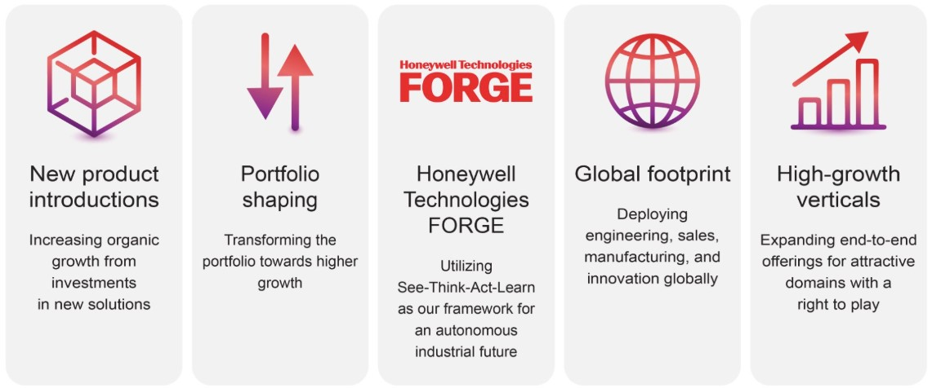
Major Businesses
We manage our businesses through three reportable business segments: Building Automation, Process Automation and
Technology, and Industrial Automation. See Note 18 Segment Financial Data to Notes to Consolidated Financial Statements for further information.

Building Automation
Building Automation is a leading global provider of unified building automation solutions across products, hardware, software, and analytics, which help our customers convert buildings into safe, sustainable, and integrated assets. Building Automation offerings include fire detection, building controls and optimization software, energy management systems, access control, and video management software, complemented by installation, maintenance, and upgrades. Our equipment-agnostic approach creates a large aftermarket opportunity. The reportable business segment is comprised of the Products and Solutions business models. The Products business is a leading provider of multi-domain controls and software offerings, primarily through an industry-leading, highly capable, channel partner network. The Solutions business is a leading provider of integrated systems and differentiated automation technologies.

Within Building Automation, our Honeywell Technologies Forge solutions enable channel partners and end-users to digitally manage buildings, through asset onboarding, self-service capabilities, and applications. Digitalization, coupled with cloud transformation, creates the capability to connect assets, visualize data that provides actionable insights through intuitive dashboards, manage systems remotely, and leverage AI to facilitate installation, commissioning, and life-time service.

Process Automation and Technology
Process Automation and Technology offers a comprehensive portfolio of end-to-end solutions that drive automation throughout the industrial lifecycle, develop and innovate advanced process technology solutions, and help accelerate customers' digital transformations. The business segment delivers to multiple sectors, including energy, mining and minerals, industrials, power generation, and life sciences. The reportable business segment is comprised of the Projects and Aftermarket business models. The Projects business offers automation solutions for new and existing industrial plants, solutions for critical turbomachinery control applications, licensing, engineering of new and existing energy facilities, and energy solutions including separation and purification, gas, renewable fuels, blue H2 / blue NH3, green H2, carbon capture, plastics circularity, and energy storage. The Aftermarket business offers solutions that improve safety, reliability, sustainability, and operations excellence and delivers licensed process technology, equipment, engineering catalyst, adsorbents, and services to enable the energy transition.

Operating our Process Automation and Technology business as a single segment enables us to unlock significant customer efficiency benefits, since we believe we are singularly positioned to deliver end-to-end solutions combining our molecule expertise with our controls and software. For example, through the acquisition of Air Products' LNG business in 2024, we now provide
5 Honeywell International Inc.
TABLE OF CONTENTS
customers with a full-service set of solutions consisting of natural gas pre-treatment, liquefaction, and enterprise-level digital automation technologies unified under the Honeywell Technologies Forge and Experion platforms.

Industrial Automation
Industrial Automation is a global at-scale provider of sensing and measurement solutions serving mission-critical applications across diversified verticals, including energy, power and utilities, aerospace and defense, medical devices, and semiconductors. Across these verticals, customers desire similar outcomes, such as operational efficiency, asset effectiveness, people performance, and safety. The reportable business segment is comprised of the Products and Solutions business models. The Products business offerings include fiscal custody transfer solutions, fixed and portable gas detection, safety solutions for semiconductor manufacturing, terminal operations, sensors, switches and controls, burner management systems, and fuel and air delivery. Industrial Automation offers a comprehensive suite of solutions through aftermarket services, as well as through expanding its high-value digital services and connected solutions, anchored in Honeywell Technologies Forge.

Our extensive installed base of sensing and measurement offerings, combined with vertical domain expertise and deep integration with Honeywell Technologies' Forge platform, delivers distinctive, value-accretive outcomes that address evolving customer needs. The combination of data, cloud and smarter edge solutions allows Industrial Automation to deliver enterprise level outcomes rather than just point solutions at each asset or site.

6 Honeywell International Inc.
TABLE OF CONTENTS
Part I. Financial Information
The financial statements and related notes as of September 30, 2026, should be read in conjunction with the financial statements for the year ended December 31, 2025, contained in the Company’s 2025 Annual Report on Form 10-K.

Financial Statements and Supplementary Data

Honeywell International Inc.
Consolidated Statement of Operations
(Unaudited)
 |  |  | Three Months Ended September 30, |  |  |  |  |  |  |  |  |  |  |  | Nine Months Ended September 30,
 |  |  | 2026 |  |  |  |  |  | 2025 |  |  |  |  |  | 2026 |  |  |  |  |  | 2025
 |  |  | (Dollars in millions, except per share amounts)
Product sales |  |  | $ | 3,628 |  |  |  |  | $ | 3,573 |  |  |  |  | $ | 10,856 |  |  |  |  | $ | 10,724
Service sales |  |  | 1,366 |  |  |  |  |  | 1,356 |  |  |  |  |  | 4,148 |  |  |  |  |  | 3,979
Net sales |  |  | 4,994 |  |  |  |  |  | 4,929 |  |  |  |  |  | 15,004 |  |  |  |  |  | 14,703
Costs, expenses and other
Cost of products sold |  |  | 2,127 |  |  |  |  |  | 2,041 |  |  |  |  |  | 6,421 |  |  |  |  |  | 6,179
Cost of services sold |  |  | 849 |  |  |  |  |  | 1,114 |  |  |  |  |  | 2,593 |  |  |  |  |  | 2,749
Total Cost of products and services sold |  |  | 2,976 |  |  |  |  |  | 3,155 |  |  |  |  |  | 9,014 |  |  |  |  |  | 8,928
Research and development expenses |  |  | 239 |  |  |  |  |  | 268 |  |  |  |  |  | 825 |  |  |  |  |  | 774
Selling, general and administrative expenses |  |  | 1,039 |  |  |  |  |  | 1,093 |  |  |  |  |  | 3,078 |  |  |  |  |  | 3,372
Impairment of assets held for sale |  |  | — |  |  |  |  |  | — |  |  |  |  |  | 311 |  |  |  |  |  | 15
Loss on debt extinguishment |  |  | — |  |  |  |  |  | — |  |  |  |  |  | 241 |  |  |  |  |  | —
Gain on deconsolidation of subsidiary |  |  | — |  |  |  |  |  | — |  |  |  |  |  | (6,629) |  |  |  |  |  | —
Other (income) expense |  |  | (389) |  |  |  |  |  | (957) |  |  |  |  |  | (301) |  |  |  |  |  | (1,124)
Interest and other financial charges |  |  | 143 |  |  |  |  |  | 263 |  |  |  |  |  | 579 |  |  |  |  |  | 715
Total costs, expenses and other |  |  | 4,008 |  |  |  |  |  | 3,822 |  |  |  |  |  | 7,118 |  |  |  |  |  | 12,680
Income from continuing operations before taxes and equity losses |  |  | 986 |  |  |  |  |  | 1,107 |  |  |  |  |  | 7,886 |  |  |  |  |  | 2,023
Tax expense |  |  | 60 |  |  |  |  |  | 153 |  |  |  |  |  | 1,378 |  |  |  |  |  | 427
Equity loss |  |  | 147 |  |  |  |  |  | — |  |  |  |  |  | 412 |  |  |  |  |  | —
Net income from continuing operations |  |  | 779 |  |  |  |  |  | 954 |  |  |  |  |  | 6,096 |  |  |  |  |  | 1,596
Net (loss) income from discontinued operations |  |  | (103) |  |  |  |  |  | 905 |  |  |  |  |  | 1,061 |  |  |  |  |  | 3,299
Net income |  |  | 676 |  |  |  |  |  | 1,859 |  |  |  |  |  | 7,157 |  |  |  |  |  | 4,895
Less: Net income (loss) attributable to noncontrolling interest |  |  | 12 |  |  |  |  |  | 34 |  |  |  |  |  | (10) |  |  |  |  |  | 51
Net income attributable to Honeywell Technologies |  |  | $ | 664 |  |  |  |  | $ | 1,825 |  |  |  |  | $ | 7,167 |  |  |  |  | $ | 4,844
Earnings (loss) per share of common stock—basic:
Earnings per share of common stock from continuing operations—basic1 |  |  | $ | 2.42 |  |  |  |  | $ | 3.01 |  |  |  |  | $ | 19.30 |  |  |  |  | $ | 5.02
(Loss) earnings per share of common stock from discontinued operations—basic1 |  |  | (0.33) |  |  |  |  |  | 2.73 |  |  |  |  |  | 3.29 |  |  |  |  |  | 10.11
Total earnings per share of common stock—basic1 |  |  | $ | 2.09 |  |  |  |  | $ | 5.74 |  |  |  |  | $ | 22.59 |  |  |  |  | $ | 15.13
Earnings (loss) per share of common stock—assuming dilution:
Earnings per share of common stock from continuing operations—assuming dilution1 |  |  | $ | 2.40 |  |  |  |  | $ | 2.99 |  |  |  |  | $ | 19.19 |  |  |  |  | $ | 4.99
Earnings per share of common stock from discontinued operations—assuming dilution1 |  |  | (0.32) |  |  |  |  |  | 2.72 |  |  |  |  |  | 3.27 |  |  |  |  |  | 10.05
Total earnings per share of common stock—assuming dilution1 |  |  | $ | 2.08 |  |  |  |  | $ | 5.71 |  |  |  |  | $ | 22.46 |  |  |  |  | $ | 15.04
1 |  |  |  |  |  | All share and per share amounts have been retrospectively adjusted to reflect the Reverse Stock Split. See Note 1 Basis of Presentation for additional information.

The Notes to Consolidated Financial Statements are an integral part of this statement.
7 Honeywell International Inc.
TABLE OF CONTENTS
Honeywell International Inc.
Consolidated Statement of Comprehensive Income
(Unaudited)
 |  |  | Three Months Ended September 30, |  |  |  |  |  |  |  |  |  |  |  | Nine Months Ended September 30,
 |  |  | 2026 |  |  |  |  |  | 2025 |  |  |  |  |  | 2026 |  |  |  |  |  | 2025
 |  |  | (Dollars in millions)
Net income |  |  | $ | 676 |  |  |  |  | $ | 1,859 |  |  |  |  | $ | 7,157 |  |  |  |  | $ | 4,895
Other comprehensive income (loss), net of tax
Foreign exchange translation adjustment |  |  | 297 |  |  |  |  |  | (229) |  |  |  |  |  | 377 |  |  |  |  |  | (1,010)
Pension and other postretirement benefit adjustments |  |  | 667 |  |  |  |  |  | (3) |  |  |  |  |  | 663 |  |  |  |  |  | (87)
Changes in fair value of available for sale investments |  |  | (1) |  |  |  |  |  | — |  |  |  |  |  | (2) |  |  |  |  |  | 5
Changes in fair value of cash flow hedges |  |  | (46) |  |  |  |  |  | 2 |  |  |  |  |  | (1) |  |  |  |  |  | (30)
Other comprehensive income (loss), net of tax |  |  | 917 |  |  |  |  |  | (230) |  |  |  |  |  | 1,037 |  |  |  |  |  | (1,122)
Comprehensive income |  |  | 1,593 |  |  |  |  |  | 1,629 |  |  |  |  |  | 8,194 |  |  |  |  |  | 3,773
Less: Comprehensive income (loss) attributable to the noncontrolling interest |  |  | 8 |  |  |  |  |  | 30 |  |  |  |  |  | (20) |  |  |  |  |  | 77
Comprehensive income attributable to Honeywell Technologies |  |  | $ | 1,585 |  |  |  |  | $ | 1,599 |  |  |  |  | $ | 8,214 |  |  |  |  | $ | 3,696

The Notes to Consolidated Financial Statements are an integral part of this statement.
8 Honeywell International Inc.
TABLE OF CONTENTS
Honeywell International Inc.
Consolidated Balance Sheet
(Unaudited)
 |  |  | September 30, 2026 |  |  |  |  |  | December 31, 2025
 |  |  | (Dollars in millions)
Assets
Current assets
Cash and cash equivalents |  |  | $ | 5,694 |  |  |  |  | $ | 12,273
Short-term investments |  |  | 492 |  |  |  |  |  | 443
Accounts receivable, less allowances of $155 and $167, respectively |  |  | 5,086 |  |  |  |  |  | 4,429
Inventories |  |  | 2,056 |  |  |  |  |  | 1,677
Assets held for sale |  |  | — |  |  |  |  |  | 2,492
Other current assets |  |  | 988 |  |  |  |  |  | 841
Current assets of discontinued operations |  |  | — |  |  |  |  |  | 8,232
Total current assets |  |  | 14,316 |  |  |  |  |  | 30,387
Equity method investments |  |  | 7,273 |  |  |  |  |  | 195
Long-term receivables and other investments |  |  | 1,114 |  |  |  |  |  | 1,113
Property, plant and equipment—net |  |  | 2,706 |  |  |  |  |  | 2,466
Goodwill |  |  | 17,561 |  |  |  |  |  | 18,054
Other intangible assets—net |  |  | 5,442 |  |  |  |  |  | 5,161
Deferred income taxes |  |  | 199 |  |  |  |  |  | 156
Other assets |  |  | 4,487 |  |  |  |  |  | 4,537
Assets of discontinued operations |  |  | — |  |  |  |  |  | 11,612
Total assets |  |  | $ | 53,098 |  |  |  |  | $ | 73,681
Liabilities
Current liabilities
Accounts payable |  |  | $ | 3,592 |  |  |  |  | $ | 3,434
Commercial paper and other short-term borrowings |  |  | 2,424 |  |  |  |  |  | 5,893
Current maturities of long-term debt |  |  | 3,783 |  |  |  |  |  | 1,541
Accrued liabilities |  |  | 5,112 |  |  |  |  |  | 5,063
Liabilities held for sale |  |  | — |  |  |  |  |  | 1,198
Current liabilities of discontinued operations |  |  | — |  |  |  |  |  | 6,285
Total current liabilities |  |  | 14,911 |  |  |  |  |  | 23,414
Long-term debt |  |  | 10,386 |  |  |  |  |  | 27,137
Deferred income taxes |  |  | 1,561 |  |  |  |  |  | 815
Postretirement benefit obligations other than pensions |  |  | 80 |  |  |  |  |  | 111
Other liabilities |  |  | 3,506 |  |  |  |  |  | 3,986
Liabilities of discontinued operations |  |  | — |  |  |  |  |  | 3,188
Shareowners’ Equity
Capital—common stock issued1 |  |  | 479 |  |  |  |  |  | 479
—additional paid-in capital1 |  |  | 11,133 |  |  |  |  |  | 10,636
Common stock held in treasury, at cost |  |  | (43,854) |  |  |  |  |  | (43,029)
Accumulated other comprehensive loss |  |  | (4,099) |  |  |  |  |  | (5,146)
Retained earnings |  |  | 58,758 |  |  |  |  |  | 50,964
Total Honeywell Technologies shareowners’ equity |  |  | 22,417 |  |  |  |  |  | 13,904
Noncontrolling interest |  |  | 237 |  |  |  |  |  | 1,126
Total shareowners’ equity |  |  | 22,654 |  |  |  |  |  | 15,030
Total liabilities and shareowners’ equity |  |  | $ | 53,098 |  |  |  |  | $ | 73,681
1 |  |  |  |  |  | Balances as of December 31, 2025 have been retrospectively adjusted to reflect Reverse Stock Split. See Note 1 Basis of Presentation for additional information.

The Notes to Consolidated Financial Statements are an integral part of this statement.
9 Honeywell International Inc.
TABLE OF CONTENTS
Honeywell International Inc.
Consolidated Statement of Cash Flows
(Unaudited)
 |  |  | Nine Months Ended September 30,
 |  |  | 2026 |  |  |  |  |  |  |  |  | 2025
 |  |  | (Dollars in millions)
Cash flows from operating activities
Net income |  |  |  |  |  | $ | 7,157 |  |  |  |  | $ | 4,895
Less: Net income from discontinued operations |  |  |  |  |  | 1,061 |  |  |  |  |  | 3,299
Net income from continuing operations |  |  |  |  |  | 6,096 |  |  |  |  |  | 1,596
Adjustments to reconcile net income from continuing operations to net cash provided by operating activities
Depreciation |  |  |  |  |  | 215 |  |  |  |  |  | 206
Amortization |  |  |  |  |  | 483 |  |  |  |  |  | 510
Gain on deconsolidation of subsidiary |  |  |  |  |  | (6,629) |  |  |  |  |  | —
Equity loss (income) of affiliated companies |  |  |  |  |  | 397 |  |  |  |  |  | (14)
(Gain) loss on sale of non-strategic businesses and assets |  |  |  |  |  | (351) |  |  |  |  |  | 29
Impairment of assets held for sale |  |  |  |  |  | 311 |  |  |  |  |  | 15
Loss on debt extinguishment |  |  |  |  |  | 241 |  |  |  |  |  | —
Repositioning and other charges |  |  |  |  |  | 133 |  |  |  |  |  | (516)
Net payments for repositioning and other charges |  |  |  |  |  | (119) |  |  |  |  |  | (307)
Resideo indemnification and reimbursement agreement termination payment |  |  |  |  |  | — |  |  |  |  |  | 1,590
Pension and other postretirement income |  |  |  |  |  | (268) |  |  |  |  |  | (164)
Pension and other postretirement benefit payments |  |  |  |  |  | (6) |  |  |  |  |  | (13)
Stock compensation expense |  |  |  |  |  | 182 |  |  |  |  |  | 115
Deferred income taxes |  |  |  |  |  | 687 |  |  |  |  |  | (248)
Other |  |  |  |  |  | (2) |  |  |  |  |  | (362)
Changes in assets and liabilities, net of the effects of acquisitions and divestitures:
Accounts receivable |  |  |  |  |  | (546) |  |  |  |  |  | (344)
Inventories |  |  |  |  |  | (50) |  |  |  |  |  | (297)
Other current assets |  |  |  |  |  | (206) |  |  |  |  |  | (168)
Accounts payable |  |  |  |  |  | 44 |  |  |  |  |  | 376
Accrued liabilities |  |  |  |  |  | 567 |  |  |  |  |  | 510
Income taxes |  |  |  |  |  | (247) |  |  |  |  |  | 96
Net cash provided by operating activities from continuing operations |  |  |  |  |  | 932 |  |  |  |  |  | 2,610
Net cash (used for) provided by operating activities - discontinued operations |  |  |  |  |  | (189) |  |  |  |  |  | 2,594
Net cash provided by operating activities |  |  |  |  |  | 743 |  |  |  |  |  | 5,204
Cash flows from investing activities
Capital expenditures |  |  |  |  |  | (369) |  |  |  |  |  | (375)
Increase in investments |  |  |  |  |  | (771) |  |  |  |  |  | (1,064)
Decrease in investments |  |  |  |  |  | 728 |  |  |  |  |  | 1,047
Receipts (payments) from settlements of derivative contracts |  |  |  |  |  | 123 |  |  |  |  |  | (403)
Deconsolidation of subsidiary cash |  |  |  |  |  | (623) |  |  |  |  |  | —
Cash paid for acquisitions, net of cash acquired |  |  |  |  |  | (1,763) |  |  |  |  |  | (2,201)
Proceeds from sale of business, net of cash transferred |  |  |  |  |  | 1,454 |  |  |  |  |  | 1,157
Net cash used for investing activities from continuing operations |  |  |  |  |  | (1,221) |  |  |  |  |  | (1,839)
Net cash used for investing activities from discontinued operations |  |  |  |  |  | (252) |  |  |  |  |  | (529)
Net cash used for investing activities |  |  |  |  |  | (1,473) |  |  |  |  |  | (2,368)
The Notes to Consolidated Financial Statements are an integral part of this statement.
10 Honeywell International Inc.
TABLE OF CONTENTS
 |  |  | Nine Months Ended September 30,
 |  |  | 2026 |  |  |  |  |  |  |  |  | 2025
 |  |  | (Dollars in millions)
Cash flows from financing activities
Proceeds from issuance of commercial paper and other short-term borrowings |  |  |  |  |  | 12,413 |  |  |  |  |  | 19,171
Payments of commercial paper and other short-term borrowings |  |  |  |  |  | (15,882) |  |  |  |  |  | (16,711)
Proceeds from issuance of common stock |  |  |  |  |  | 246 |  |  |  |  |  | 140
Proceeds from issuance of long-term debt |  |  |  |  |  | — |  |  |  |  |  | 4,035
Payments of long-term debt |  |  |  |  |  | (14,688) |  |  |  |  |  | (1,555)
Repurchases of common stock |  |  |  |  |  | (1,000) |  |  |  |  |  | (3,704)
Cash dividends paid |  |  |  |  |  | (1,816) |  |  |  |  |  | (2,214)
Pre-separation funding |  |  |  |  |  | 15,835 |  |  |  |  |  | —
Spin-off cash |  |  |  |  |  | (1,000) |  |  |  |  |  | —
Other |  |  |  |  |  | (125) |  |  |  |  |  | 198
Net cash used for financing activities |  |  |  |  |  | (6,017) |  |  |  |  |  | (640)
Effect of foreign exchange rate changes on cash and cash equivalents |  |  |  |  |  | (46) |  |  |  |  |  | 167
Net (decrease) increase in cash and cash equivalents |  |  |  |  |  | (6,793) |  |  |  |  |  | 2,363
Cash and cash equivalents at beginning of period |  |  |  |  |  | 12,487 |  |  |  |  |  | 10,567
Cash and cash equivalents at end of period |  |  |  |  |  | 5,694 |  |  |  |  |  | 12,930

The Notes to Consolidated Financial Statements are an integral part of this statement.
11 Honeywell International Inc.
TABLE OF CONTENTS
Honeywell International Inc.
Consolidated Statement of Shareowners’ Equity
(Unaudited)
 |  |  | Three Months Ended September 30, |  |  |  |  |  |  |  |  |  |  |  |  |  |  |  |  |  |  |  |  |  |  |  | Nine Months Ended September 30,
 |  |  | 2026 |  |  |  |  |  |  |  |  |  |  |  | 2025 |  |  |  |  |  |  |  |  |  |  |  | 2026 |  |  |  |  |  |  |  |  |  |  |  | 2025
 |  |  | Shares1 |  |  |  |  |  | $1 |  |  |  |  |  | Shares1 |  |  |  |  |  | $1 |  |  |  |  |  | Shares1 |  |  |  |  |  | $1 |  |  |  |  |  | Shares1 |  |  |  |  |  | $1
 |  |  | (In millions, except per share amounts)
Common stock, par value |  |  | 478.8 |  |  |  |  |  | 479 |  |  |  |  |  | 478.8 |  |  |  |  |  | 479 |  |  |  |  |  | 478.8 |  |  |  |  |  | 479 |  |  |  |  |  | 478.8 |  |  |  |  |  | 479
Additional paid-in capital
Beginning balance |  |  |  |  |  |  |  |  | 11,014 |  |  |  |  |  |  |  |  |  |  |  | 10,527 |  |  |  |  |  |  |  |  |  |  |  | 10,636 |  |  |  |  |  |  |  |  |  |  |  | 10,174
Issued for employee savings and option plans |  |  |  |  |  |  |  |  | 7 |  |  |  |  |  |  |  |  |  |  |  | 17 |  |  |  |  |  |  |  |  |  |  |  | 314 |  |  |  |  |  |  |  |  |  |  |  | 252
Stock compensation expense |  |  |  |  |  |  |  |  | 112 |  |  |  |  |  |  |  |  |  |  |  | 36 |  |  |  |  |  |  |  |  |  |  |  | 220 |  |  |  |  |  |  |  |  |  |  |  | 154
Impact of Quantinuum contribution |  |  |  |  |  |  |  |  | — |  |  |  |  |  |  |  |  |  |  |  | (160) |  |  |  |  |  |  |  |  |  |  |  | — |  |  |  |  |  |  |  |  |  |  |  | (160)
Other |  |  |  |  |  |  |  |  | — |  |  |  |  |  |  |  |  |  |  |  | — |  |  |  |  |  |  |  |  |  |  |  | (37) |  |  |  |  |  |  |  |  |  |  |  | —
Ending balance |  |  |  |  |  |  |  |  | 11,133 |  |  |  |  |  |  |  |  |  |  |  | 10,420 |  |  |  |  |  |  |  |  |  |  |  | 11,133 |  |  |  |  |  |  |  |  |  |  |  | 10,420
Treasury stock
Beginning balance |  |  | (161.9) |  |  |  |  |  | (43,893) |  |  |  |  |  | (161.4) |  |  |  |  |  | (42,897) |  |  |  |  |  | (161.2) |  |  |  |  |  | (43,029) |  |  |  |  |  | (153.9) |  |  |  |  |  | (39,378)
Reacquired stock or repurchases of common stock |  |  | — |  |  |  |  |  | — |  |  |  |  |  | (0.2) |  |  |  |  |  | (98) |  |  |  |  |  | (2.2) |  |  |  |  |  | (1,004) |  |  |  |  |  | (8.8) |  |  |  |  |  | (3,719)
Issued for employee savings and option plans |  |  | 0.5 |  |  |  |  |  | 39 |  |  |  |  |  | 0.3 |  |  |  |  |  | 13 |  |  |  |  |  | 2.0 |  |  |  |  |  | 179 |  |  |  |  |  | 1.4 |  |  |  |  |  | 115
Ending balance |  |  | (161.4) |  |  |  |  |  | (43,854) |  |  |  |  |  | (161.3) |  |  |  |  |  | (42,982) |  |  |  |  |  | (161.4) |  |  |  |  |  | (43,854) |  |  |  |  |  | (161.3) |  |  |  |  |  | (42,982)
Retained earnings
Beginning balance |  |  |  |  |  |  |  |  | 55,957 |  |  |  |  |  |  |  |  |  |  |  | 52,399 |  |  |  |  |  |  |  |  |  |  |  | 50,964 |  |  |  |  |  |  |  |  |  |  |  | 50,835
Net income attributable to Honeywell Technologies |  |  |  |  |  |  |  |  | 664 |  |  |  |  |  |  |  |  |  |  |  | 1,825 |  |  |  |  |  |  |  |  |  |  |  | 7,167 |  |  |  |  |  |  |  |  |  |  |  | 4,844
Dividends on common stock |  |  |  |  |  |  |  |  | (226) |  |  |  |  |  |  |  |  |  |  |  | (720) |  |  |  |  |  |  |  |  |  |  |  | (1,736) |  |  |  |  |  |  |  |  |  |  |  | (2,175)
Other transactions with shareowners2 |  |  |  |  |  |  |  |  | 2,363 |  |  |  |  |  |  |  |  |  |  |  | — |  |  |  |  |  |  |  |  |  |  |  | 2,363 |  |  |  |  |  |  |  |  |  |  |  | —
Ending balance |  |  |  |  |  |  |  |  | 58,758 |  |  |  |  |  |  |  |  |  |  |  | 53,504 |  |  |  |  |  |  |  |  |  |  |  | 58,758 |  |  |  |  |  |  |  |  |  |  |  | 53,504
Accumulated other comprehensive loss
Beginning balance |  |  |  |  |  |  |  |  | (5,020) |  |  |  |  |  |  |  |  |  |  |  | (4,413) |  |  |  |  |  |  |  |  |  |  |  | (5,146) |  |  |  |  |  |  |  |  |  |  |  | (3,491)
Foreign exchange translation adjustment |  |  |  |  |  |  |  |  | 301 |  |  |  |  |  |  |  |  |  |  |  | (225) |  |  |  |  |  |  |  |  |  |  |  | 387 |  |  |  |  |  |  |  |  |  |  |  | (1,036)
Pension and other postretirement benefit adjustments |  |  |  |  |  |  |  |  | 667 |  |  |  |  |  |  |  |  |  |  |  | (3) |  |  |  |  |  |  |  |  |  |  |  | 663 |  |  |  |  |  |  |  |  |  |  |  | (87)
Changes in fair value of available for sale investments |  |  |  |  |  |  |  |  | (1) |  |  |  |  |  |  |  |  |  |  |  | — |  |  |  |  |  |  |  |  |  |  |  | (2) |  |  |  |  |  |  |  |  |  |  |  | 5
Changes in fair value of cash flow hedges |  |  |  |  |  |  |  |  | (46) |  |  |  |  |  |  |  |  |  |  |  | 2 |  |  |  |  |  |  |  |  |  |  |  | (1) |  |  |  |  |  |  |  |  |  |  |  | (30)
Ending balance |  |  |  |  |  |  |  |  | (4,099) |  |  |  |  |  |  |  |  |  |  |  | (4,639) |  |  |  |  |  |  |  |  |  |  |  | (4,099) |  |  |  |  |  |  |  |  |  |  |  | (4,639)
Noncontrolling interest
Beginning balance |  |  |  |  |  |  |  |  | 320 |  |  |  |  |  |  |  |  |  |  |  | 552 |  |  |  |  |  |  |  |  |  |  |  | 1,126 |  |  |  |  |  |  |  |  |  |  |  | 535
Acquisitions, divestitures, and other |  |  |  |  |  |  |  |  | — |  |  |  |  |  |  |  |  |  |  |  | — |  |  |  |  |  |  |  |  |  |  |  | — |  |  |  |  |  |  |  |  |  |  |  | 2
Net income (loss) attributable to noncontrolling interest |  |  |  |  |  |  |  |  | 12 |  |  |  |  |  |  |  |  |  |  |  | 34 |  |  |  |  |  |  |  |  |  |  |  | (10) |  |  |  |  |  |  |  |  |  |  |  | 51
Foreign exchange translation adjustment |  |  |  |  |  |  |  |  | (4) |  |  |  |  |  |  |  |  |  |  |  | (4) |  |  |  |  |  |  |  |  |  |  |  | (10) |  |  |  |  |  |  |  |  |  |  |  | 26
Dividends paid |  |  |  |  |  |  |  |  | (17) |  |  |  |  |  |  |  |  |  |  |  | (21) |  |  |  |  |  |  |  |  |  |  |  | (92) |  |  |  |  |  |  |  |  |  |  |  | (53)
Contributions from noncontrolling interest holders |  |  |  |  |  |  |  |  | — |  |  |  |  |  |  |  |  |  |  |  | 404 |  |  |  |  |  |  |  |  |  |  |  | — |  |  |  |  |  |  |  |  |  |  |  | 404
Loss of control of Quantinuum |  |  |  |  |  |  |  |  | — |  |  |  |  |  |  |  |  |  |  |  | — |  |  |  |  |  |  |  |  |  |  |  | (703) |  |  |  |  |  |  |  |  |  |  |  | —
Other transactions with shareowners2 |  |  |  |  |  |  |  |  | (74) |  |  |  |  |  |  |  |  |  |  |  | — |  |  |  |  |  |  |  |  |  |  |  | (74) |  |  |  |  |  |  |  |  |  |  |  | —
Ending balance |  |  |  |  |  |  |  |  | 237 |  |  |  |  |  |  |  |  |  |  |  | 965 |  |  |  |  |  |  |  |  |  |  |  | 237 |  |  |  |  |  |  |  |  |  |  |  | 965
Total shareowners' equity |  |  | 317.4 |  |  |  |  |  | 22,654 |  |  |  |  |  | 317.5 |  |  |  |  |  | 17,747 |  |  |  |  |  | 317.4 |  |  |  |  |  | 22,654 |  |  |  |  |  | 317.5 |  |  |  |  |  | 17,747
Cash dividends per share of common stock1 |  |  |  |  |  |  |  |  | $ | 0.70 |  |  |  |  |  |  |  |  |  |  | $ | 2.26 |  |  |  |  |  |  |  |  |  |  | $ | 5.46 |  |  |  |  |  |  |  |  |  |  | $ | 6.78
1 |  |  |  |  |  | Share and per share amounts have been retrospectively adjusted to reflect the Reverse Stock Split, including retrospective adjustment to beginning balances of Common stock, par value and Additional paid-in capital. See Note 1 Basis of Presentation for additional information.
2 |  |  |  |  |  | Other transactions with shareowners includes an increase in Retained earnings related to the pro rata distribution of all of the issued and outstanding shares of common stock of Honeywell Aerospace. In connection with the Aerospace Spin-Off, the Company derecognized assets of $21.9 billion and liabilities of $24.9 billion, including the Aerospace Senior Notes as discussed in Note 9 Debt and Credit Agreements. Additionally, the Company reclassified $74 million of Noncontrolling interest attributable to Honeywell Aerospace to Retained earnings.

The Notes to Consolidated Financial Statements are an integral part of this statement.
12 Honeywell International Inc.
TABLE OF CONTENTS
Honeywell International Inc.
Notes to Consolidated Financial Statements
(Unaudited)
(Dollars in tables in millions, except per share amounts)
Note 1. Basis of Presentation

In the opinion of management, the accompanying unaudited Consolidated Financial Statements reflect all adjustments necessary to present fairly the financial position, results of operations, cash flows, and shareowners’ equity of Honeywell International Inc. and its consolidated subsidiaries (Honeywell Technologies or the Company) for the periods presented. The interim results of operations and cash flows should not necessarily be taken as indicative of the entire year.
Honeywell Technologies reports its quarterly financial information using a calendar convention; the first, second, and third quarters are consistently reported as ending on March 31, June 30, and September 30, respectively. It is Honeywell Technologies’ practice to establish actual quarterly closing dates using a predetermined fiscal calendar, which requires Honeywell Technologies’ businesses to close their books on a Saturday in order to minimize the potentially disruptive effects of quarterly closing on the Company’s business processes. The effects of this practice are generally not significant to reported results for any quarter and only exist within a reporting year. In the event differences in actual closing dates are material to year-over-year comparisons of quarterly or year-to-date results, Honeywell Technologies will provide appropriate disclosures. Honeywell Technologies’ closing dates for the three and nine months ended September 30, 2026 and 2025, were September 26, 2026 and September 27, 2025, respectively.
Honeywell Technologies reports all share and per share amounts and beginning balances of Common stock and Additional paid-in capital on a retrospective adjusted basis to reflect reverse stock splits for all periods presented, as applicable. During the second quarter of 2026, the Company’s Board of Directors approved a one-for-two reverse stock split (the Reverse Stock Split) and proportionate reduction in the number of authorized shares of common stock, subject to and contingent upon the completion of the separation of the Aerospace Technologies business (the Aerospace Spin-Off). In the third quarter on June 29, 2026, following the Aerospace Spin-Off as discussed in Note 3 Acquisitions, Divestitures, and Discontinued Operations, the Reverse Stock Split became effective. As a result of the Reverse Stock Split, every two shares of common stock issued and outstanding or held by Honeywell Technologies as treasury shares were automatically combined into one share of common stock, and the number of authorized shares of common stock was reduced from 2 billion to 1 billion with no change in par value. Any fractional shares were settled in cash.

Note 2. Summary of Significant Accounting Policies
The accounting policies of the Company are set forth in Note 1 Summary of Significant Accounting Policies of Notes to Consolidated Financial Statements in the Company’s 2025 Annual Report on Form 10-K. The Company includes herein certain updates to those policies.
Reclassifications
Certain prior year amounts are reclassified to conform to the current year presentation.
In the third quarter on June 29, 2026, the Company completed the previously announced separation of its Aerospace Technologies business into an independent, publicly traded company named Honeywell Aerospace Inc. (Honeywell Aerospace). On October 30, 2025, the Company completed the spin-off of its Advanced Materials business into an independent, publicly traded company named Solstice Advanced Materials Inc. (Solstice). Results of operations, financial position, and cash flows for the Aerospace Technologies and Advanced Materials businesses are reported as discontinued operations for all periods presented. Unless otherwise noted, information in these notes to consolidated financial statements relates to continuing operations.
Effective beginning in the first quarter of 2026, the Company realigned certain of its business units as reflected in Note 18 Segment Financial Data, which impacted the composition of its reportable segments. The Company recast historical periods to reflect this change in segment presentation, including the reallocation of goodwill on a relative fair value basis as discussed in Note 8 Goodwill and Other Intangible Assets—Net. Additionally, in conjunction with the Aerospace Spin-Off, the Company transferred assets of $26 million from the former Aerospace Technologies reportable business segment to the Industrial Automation reportable business segment. Prior period amounts have been recast.
Supply Chain Financing
Amounts outstanding related to supply chain financing programs are included in Accounts payable in the Consolidated Balance Sheet. Accounts payable included approximately $433 million and $620 million as of September 30, 2026 and December 31, 2025, respectively, related to these programs. The impact of these programs is not material to the Company’s overall liquidity.
13 Honeywell International Inc.
TABLE OF CONTENTS
Honeywell International Inc.
Notes to Consolidated Financial Statements
(Unaudited)
(Dollars in tables in millions, except per share amounts)
Equity Method Investments
The Company accounts for investments under the equity method of accounting when it has the ability to exercise significant influence, but not control, over an investee. Significant influence is generally considered to exist when the Company holds an ownership interest in the voting stock of an investee of between 20% and 50%, although other factors may also be considered.
Equity method investments are recorded within Equity Method Investments in the Consolidated Balance Sheet. Differences between the carrying amount of the investment and the Company’s proportionate share of the investee’s net assets are attributed to identifiable assets and liabilities, with any residual recorded as goodwill. Basis differences are amortized over their estimated useful lives. Equity method investments are assessed for other-than-temporary impairment when events occur, or circumstances change, that indicate it is more likely than not the fair value of the asset is below its carrying value. If there is an other-than-temporary decline in the value of an equity method investment, it is recognized as an impairment loss in the current period.
The Company recognizes its proportionate share of the investee’s earnings or losses in the Consolidated Statement of Operations. Equity income and loss are classified based on the nature of the investment. Results from strategically aligned investments are recorded in Other (income) expense, while results from non-strategic investments are recorded in Equity loss.
As of September 30, 2026, the carrying amount of the Company’s equity method investment in Quantinuum Inc. (Quantinuum) was $7,113 million. During the three and nine months ended September 30, 2026, the Company recognized equity losses of $147 million and $412 million, respectively, related to this investment.
Environmental
The Company accrues costs for environmental matters when it is probable that a liability has been incurred for a contaminated site and the amount can be reasonably estimated. These estimates are informed by a range of data inputs and analytical tools, including historical remediation data, ongoing refinements to remediation strategies and centralized data aggregation tools that allow the Company to compare site characteristics and expected remediation activities across similar sites in its portfolio. Recorded liabilities are evaluated regularly and adjusted as remediation efforts progress or as additional technical, regulatory or legal information becomes available; such adjustments are accounted for as changes in estimates in the period identified.
Recent Accounting Pronouncements
The Company considers the applicability and impact of all Accounting Standards Updates (ASUs) issued by the Financial Accounting Standards Board (FASB). ASUs not listed below were assessed and determined to be either not applicable or are expected to have minimal impact on the Company’s Consolidated Financial Statements.
In September 2025, the FASB issued ASU 2025-06, Intangibles—Goodwill and Other—Internal-Use Software (Subtopic 350-40): Targeted Improvements to the Accounting for Internal-Use Software, which modernizes the accounting for internal-use software costs by removing all references to prescriptive and sequential software development stages. The new standard requires entities to consider whether significant development uncertainty has been resolved before starting to capitalize software costs and aligns disclosure requirements with Accounting Standards Codification (ASC) 360, Property, Plant, and Equipment. This ASU is effective for annual and interim reporting periods beginning after December 15, 2027, and can be applied prospectively, retrospectively, or using a modified transition method, with early adoption permitted. The Company is currently evaluating the impacts of this guidance on the Company’s Consolidated Financial Statements.
In November 2024, the FASB issued ASU 2024-03, Income Statement—Reporting Comprehensive Income—Expense Disaggregation Disclosures (Subtopic 220-40): Disaggregation of Income Statement Expenses, which requires companies to disclose additional information about the types of expenses in commonly presented expense captions. The new standard requires tabular disclosure of specified natural expenses in certain expense captions, a qualitative description of amounts that are not separately disaggregated, and disclosure of the Company’s definition and total amount of selling expenses. The ASU should be applied prospectively for annual reporting periods beginning after December 15, 2026, with retrospective application and early adoption permitted. The Company is currently evaluating the impacts of this guidance on the Company’s Consolidated Financial Statements.

Note 3. Acquisitions, Divestitures, and Discontinued Operations
Acquisitions
Johnson Matthey’s Catalyst Technologies Business
On July 17, 2026, the Company acquired 100% of the outstanding equity interests of Johnson Matthey’s Catalyst Technologies business, a leading provider of catalyst manufacturing and process technology licensing, for total consideration of $1,743 million,
14 Honeywell International Inc.
TABLE OF CONTENTS
Honeywell International Inc.
Notes to Consolidated Financial Statements
(Unaudited)
(Dollars in tables in millions, except per share amounts)
net of cash acquired. The business is part of the Process Automation and Technology reportable business segment. The following table summarizes the determination of the fair value of identifiable assets acquired and liabilities assumed that are included in the Consolidated Balance Sheet as of September 30, 2026:
Current assets |  |  |  |  |  | $ | 510
Intangible assets |  |  |  |  |  | 691
Other noncurrent assets |  |  |  |  |  | 453
Current liabilities |  |  |  |  |  | (231)
Noncurrent liabilities |  |  |  |  |  | (210)
Net assets acquired |  |  |  |  |  | 1,213
Goodwill |  |  |  |  |  | 578
Purchase price |  |  |  |  |  | $ | 1,791
The Johnson Matthey's Catalyst Technologies business' identifiable intangible assets primarily include customer relationships and technology which will amortize over their estimated useful lives ranging from two to 15 years using straight-line and accelerated amortization methods. The goodwill is not deductible for tax purposes. As of the end of the third quarter of 2026, the purchase accounting is subject to final adjustment, primarily for the valuation of long-lived and intangible assets, amounts allocated to goodwill, working capital adjustments, and tax balances.

Sundyne
On June 6, 2025, the Company acquired 100% of the outstanding equity interests of Sundyne, a leader in the design manufacturing, and aftermarket support of highly-engineered pumps and gas compressors for process industries, for total consideration of $2,160 million, net of cash acquired. The business is part of the Process Automation and Technology reportable business segment. The Company finalized the evaluation for the fair value of all the assets acquired and liabilities assumed with Sundyne during the second quarter of 2026. The following table summarizes the determination of the fair value of identifiable assets acquired and liabilities assumed that are included in the Consolidated Balance Sheet as of September 30, 2026:
Current assets |  |  |  |  |  | $ | 276
Intangible assets |  |  |  |  |  | 1,070
Other noncurrent assets |  |  |  |  |  | 119
Current liabilities |  |  |  |  |  | (103)
Noncurrent liabilities |  |  |  |  |  | (240)
Net assets acquired |  |  |  |  |  | 1,122
Goodwill |  |  |  |  |  | 1,148
Purchase price |  |  |  |  |  | $ | 2,270
The Sundyne identifiable intangible assets primarily include customer relationships, technology, and trademarks which will amortize over their estimated useful lives ranging from one to 15 years using straight-line and accelerated amortization methods. The goodwill is not deductible for tax purposes.
Divestitures and Assets and Liabilities Held for Sale
Quantinuum
On June 4, 2026, the Company’s former consolidated subsidiary Quantinuum completed its initial public offering (IPO). Prior to the IPO, the Company consolidated Quantinuum under the Variable Interest Entity consolidation model as it had both the power to direct activities and the obligation to absorb losses of the entity. Upon completion of the IPO, the Company retained a 48% noncontrolling ownership interest in Quantinuum and accounts for its Quantinuum investment as an equity method investment. No cash contributions were made or cash distributions received by the Company as part of the IPO.
The Company recognized a gain of $6,629 million during the second quarter of 2026 as a result of the deconsolidation of Quantinuum. The gain was calculated as the difference between (i) the aggregate fair value of the retained interests in the former subsidiaries and (ii) the carrying value of the assets and liabilities of the former subsidiaries, less the carrying value of the non-controlling interest in the former subsidiaries.
15 Honeywell International Inc.
TABLE OF CONTENTS
Honeywell International Inc.
Notes to Consolidated Financial Statements
(Unaudited)
(Dollars in tables in millions, except per share amounts)
The initial fair value of the retained investment of $7,525 million at the date of deconsolidation was determined using a market approach based on the observable quoted market price of Quantinuum’s common stock. At the date of deconsolidation, the carrying value of Quantinuum’s net assets was $1,599 million and the carrying value of the noncontrolling interest was $703 million.
Differences between the carrying amount of the retained equity method investment and the Company’s proportionate share of Quantinuum’s net assets were attributed to identifiable assets and liabilities utilizing purchase accounting principles, with the residual amount recorded as equity method goodwill. The Company identified basis differences related to intangible assets of $1.1 billion and equity method goodwill of $6.1 billion. Basis differences related to intangible assets will be amortized over their estimated useful lives and are recorded within Equity loss in the Consolidated Statement of Operations. The weighted-average life of the Quantinuum intangible assets is 8 years and will be amortized using a straight-line method. Basis differences related to equity method goodwill will not be amortized.

Productivity Solutions and Services and Warehouse and Workflow Solutions Businesses
As of December 31, 2025, the Company concluded the assets and liabilities of each of the Productivity Solutions and Services (PSS) and Warehouse and Workflow Solutions (WWS) businesses, which were a part of the Productivity goodwill reporting unit within the Industrial Automation reportable business segment, met the held for sale criteria, and the Company presented the associated assets and liabilities of each business as held for sale beginning December 31, 2025. On July 27, 2026, the Company completed the sale of its WWS business in exchange for total consideration of $157 million, net of cash transferred. On August 3, 2026, the Company completed the sale of its PSS business for total consideration of $1,370 million, net of cash transferred.
During the third quarter, the Company recognized a pre-tax gain on the sale of the businesses of $339 million, primarily attributed to a gain on the sale of the PSS business, which was recorded in Other (income) expense in the Consolidated Statement of Operations. During the nine months ended September 30, 2026, the Company recognized a $311 million increase to the valuation allowance to write down the WWS disposal group to fair value, less costs to sell.
The following table summarizes the assets and liabilities classified as held for sale in the Consolidated Balance Sheet as of December 31, 2025:
 |  |  | December 31, 2025
Assets held for sale
Accounts receivable |  |  | $ | 489
Inventories |  |  | 394
Other current assets |  |  | 47
Equity method investments |  |  | 15
Long-term receivables and other investments |  |  | 14
Property, plant and equipment—net |  |  | 153
Goodwill |  |  | 1,138
Other intangible assets—net |  |  | 262
Deferred income taxes |  |  | 136
Other assets |  |  | 99
Valuation allowance on assets held for sale |  |  | (255)
Total Assets held for sale |  |  | $ | 2,492
Liabilities held for sale
Accounts payable |  |  | $ | 532
Accrued liabilities |  |  | 484
Other liabilities |  |  | 182
Total Liabilities held for sale |  |  | $ | 1,198
Spin-offs and Discontinued Operations
Our former Aerospace Technologies and Advanced Materials businesses are included in discontinued operations. Results of operations, financial position, and cash flows are reported as discontinued operations for all periods presented and the notes to the consolidated financial statements have been adjusted on a retrospective basis.
Aerospace Technologies Business
16 Honeywell International Inc.
TABLE OF CONTENTS
Honeywell International Inc.
Notes to Consolidated Financial Statements
(Unaudited)
(Dollars in tables in millions, except per share amounts)
In the third quarter on June 29, 2026 (the Distribution Date), the Company completed the Aerospace Spin-Off through a pro rata distribution of all of the issued and outstanding shares of common stock of Honeywell Aerospace to the holders of common stock of the Company. Each Honeywell Technologies shareowner received one share of Honeywell Aerospace common stock for every two shares of Honeywell Technologies common stock held of record as of the close of business on June 15, 2026, except that they received cash in lieu of any fractional shares of Honeywell Aerospace common stock that they would have received after application of such distribution ratio. The Company structured the transaction to be a tax-free separation to Honeywell Technologies for U.S. federal income tax purposes. Honeywell Aerospace is now an independent publicly traded company under the symbol “HONA” on the Nasdaq Stock Market LLC. After the date of the Aerospace Spin-Off, the Company no longer consolidates Honeywell Aerospace into its financial results.
We have continuing involvement with Honeywell Aerospace primarily through a transition services agreement, through which Honeywell Technologies and Honeywell Aerospace will continue to provide certain services to each other for a period of time following the separation, a tax matters agreement, and a trademark license agreement, among others.
Pursuant to the trademark license agreement, the Company granted to Honeywell Aerospace an exclusive license to use “Honeywell Aerospace” and other trademarks, subject to certain restrictions and exceptions. The trademark license agreement includes customary quality control provisions to protect and preserve the goodwill associated with “Honeywell” and the other licensed marks. In exchange, Honeywell Aerospace will pay Honeywell Technologies an aggregate amount of $1.125 billion over approximately five years, including an initial payment of $18.75 million due within five days of the Distribution Date followed by 59 equal monthly payments of $18.75 million. The term of the license agreement is 75 years, including an initial term of six years and additional renewal options totaling a maximum of 69 additional years. If Honeywell Aerospace elects not to renew the trademark license agreement, the Company is obligated to reimburse Honeywell Aerospace $50 million unless certain exceptions apply. Honeywell Technologies may unilaterally terminate the trademark license agreement under certain conditions, including, without limitation, (1) on the 6th anniversary of the distribution date, in which case the Company is obligated to reimburse Honeywell Aerospace $250 million of the license fees Honeywell Aerospace paid to Honeywell Technologies during the first five years of the license term, or (2) in connection with certain uncured breach events or following a change of control to which Honeywell Technologies has not provided prior consent.
Advanced Materials Business
On October 30, 2025, the Company completed the spin-off of its Advanced Materials business into an independent, publicly traded company named Solstice. The Company structured the transaction as a tax-free separation for U.S. federal income tax purposes, providing shareowners of record with one share of Solstice stock for every four shares of Honeywell common stock.
The following table summarizes the key components of net income (loss) from discontinued operations:
 |  |  | Three months ended September 30,
 |  |  | 2026 |  |  |  | 2025
 |  |  | Aerospace Technologies |  |  |  |  |  |  |  | Aerospace Technologies |  |  | Advanced Materials |  |  | Total
Product sales |  |  | $ | — |  |  |  |  |  |  | $ | 2,606 |  | $ | 907 |  | $ | 3,513
Service sales |  |  | — |  |  |  |  |  |  |  | 1,902 |  |  | 64 |  |  | 1,966
Net Sales |  |  | — |  |  |  |  |  |  |  | 4,508 |  |  | 971 |  |  | 5,479
Costs, expenses and other
Cost of products sold |  |  | — |  |  |  |  |  |  |  | 2,081 |  |  | 612 |  |  | 2,693
Cost of services sold |  |  | — |  |  |  |  |  |  |  | 968 |  |  | 45 |  |  | 1,013
Total Cost of products and services sold |  |  | — |  |  |  |  |  |  |  | 3,049 |  |  | 657 |  |  | 3,706
Research and development expenses |  |  | (28) |  |  |  |  |  |  |  | 204 |  |  | 25 |  |  | 229
Selling, general and administrative expenses |  |  | 11 |  |  |  |  |  |  |  | 184 |  |  | 19 |  |  | 203
Interest and other financial charges |  |  | — |  |  |  |  |  |  |  | 90 |  |  | 1 |  |  | 91
Other (income) expense |  |  | 117 |  |  |  |  |  |  |  | 53 |  |  | 82 |  |  | 135
Income from discontinued operations before taxes |  |  | (100) |  |  |  |  |  |  |  | 928 |  |  | 187 |  |  | 1,115
Tax expense |  |  | 3 |  |  |  |  |  |  |  | (13) |  |  | 223 |  |  | 210
Net (loss) income from discontinued operations |  |  | $ | (103) |  |  |  |  |  |  | $ | 941 |  | $ | (36) |  | $ | 905
17 Honeywell International Inc.
TABLE OF CONTENTS
Honeywell International Inc.
Notes to Consolidated Financial Statements
(Unaudited)
(Dollars in tables in millions, except per share amounts)
 |  |  | Nine months ended September 30,
 |  |  | 2026 |  |  |  | 2025
 |  |  | Aerospace Technologies |  |  |  |  |  |  |  | Aerospace Technologies |  |  | Advanced Materials |  |  | Total
Product sales |  |  | $ | 5,013 |  |  |  |  |  |  | $ | 7,439 |  | $ | 2,687 |  | $ | 10,126
Service sales |  |  | 3,839 |  |  |  |  |  |  |  | 5,542 |  |  | 211 |  |  | 5,753
Net sales |  |  | 8,852 |  |  |  |  |  |  |  | 12,981 |  |  | 2,898 |  |  | 15,879
Costs, expenses and other
Cost of products sold |  |  | 3,773 |  |  |  |  |  |  |  | 5,613 |  |  | 1,741 |  |  | 7,354
Cost of services sold |  |  | 1,857 |  |  |  |  |  |  |  | 2,784 |  |  | 161 |  |  | 2,945
Total Cost of products and services sold |  |  | 5,630 |  |  |  |  |  |  |  | 8,397 |  |  | 1,902 |  |  | 10,299
Research and development expenses |  |  | 402 |  |  |  |  |  |  |  | 573 |  |  | 70 |  |  | 643
Selling, general and administrative expenses |  |  | 625 |  |  |  |  |  |  |  | 576 |  |  | 137 |  |  | 713
Interest and other financial charges |  |  | 283 |  |  |  |  |  |  |  | 252 |  |  | 3 |  |  | 255
Other (income) expense |  |  | 497 |  |  |  |  |  |  |  | (122) |  |  | 137 |  |  | 15
Income from discontinued operations before taxes |  |  | 1,415 |  |  |  |  |  |  |  | 3,305 |  |  | 649 |  |  | 3,954
Tax expense |  |  | 354 |  |  |  |  |  |  |  | 326 |  |  | 329 |  |  | 655
Net income from discontinued operations |  |  | $ | 1,061 |  |  |  |  |  |  | $ | 2,979 |  | $ | 320 |  | $ | 3,299
The following table summarizes major classes of assets and liabilities of discontinued operations of the Aerospace Technologies business:
 |  |  | December 31, 2025
Assets
Cash and cash equivalents |  |  | $ | 214
Accounts receivable |  |  | 3,192
Inventories |  |  | 4,485
Other current assets |  |  | 341
Current assets of discontinued operations |  |  | 8,232
Equity method investments |  |  | 11
Long-term receivables and other investments |  |  | 85
Property, plant and equipment—net |  |  | 2,163
Goodwill |  |  | 3,025
Other intangible assets—net |  |  | 1,575
Deferred income taxes |  |  | 43
Other assets |  |  | 4,710
Total assets of discontinued operations |  |  | $ | 19,844
Liabilities
Accounts payable |  |  | $ | 2,881
Current maturities of long-term debt |  |  | 5
Accrued liabilities |  |  | 3,399
Current liabilities of discontinued operations |  |  | 6,285
Long-term debt |  |  | 4
Deferred income taxes |  |  | 762
Other liabilities |  |  | 2,422
Total liabilities of discontinued operations |  |  | $ | 9,473

18 Honeywell International Inc.
TABLE OF CONTENTS
Honeywell International Inc.
Notes to Consolidated Financial Statements
(Unaudited)
(Dollars in tables in millions, except per share amounts)
Note 4. Revenue Recognition and Contracts with Customers
The Company has a comprehensive offering of products and services, including software and technologies, that are sold to a variety of customers in multiple end markets. Beginning in 2026, the disaggregation of revenue within its Building Automation, Process Automation and Technology, and Industrial Automation segments is reported based on business model. See the following disaggregated revenue table and related discussions by reportable business segment for details:
 |  |  | Three Months Ended September 30, |  |  |  |  |  |  |  |  |  |  |  | Nine Months Ended September 30,
 |  |  | 2026 |  |  |  |  |  | 2025 |  |  |  |  |  | 2026 |  |  |  |  |  | 2025
Building Automation
Products |  |  | $ | 1,113 |  |  |  |  | $ | 1,009 |  |  |  |  | $ | 3,210 |  |  |  |  | $ | 2,899
Solutions |  |  | 907 |  |  |  |  |  | 869 |  |  |  |  |  | 2,694 |  |  |  |  |  | 2,497
Net Building Automation sales |  |  | 2,020 |  |  |  |  |  | 1,878 |  |  |  |  |  | 5,904 |  |  |  |  |  | 5,396
Process Automation and Technology
Projects |  |  | 797 |  |  |  |  |  | 687 |  |  |  |  |  | 2,236 |  |  |  |  |  | 1,956
Aftermarket |  |  | 1,062 |  |  |  |  |  | 911 |  |  |  |  |  | 2,815 |  |  |  |  |  | 2,700
Net Process Automation and Technology sales |  |  | 1,859 |  |  |  |  |  | 1,598 |  |  |  |  |  | 5,051 |  |  |  |  |  | 4,656
Industrial Automation
Products |  |  | 833 |  |  |  |  |  | 983 |  |  |  |  |  | 2,806 |  |  |  |  |  | 3,294
Solutions |  |  | 282 |  |  |  |  |  | 467 |  |  |  |  |  | 1,233 |  |  |  |  |  | 1,333
Net Industrial Automation sales |  |  | 1,115 |  |  |  |  |  | 1,450 |  |  |  |  |  | 4,039 |  |  |  |  |  | 4,627
Corporate and All Other |  |  | — |  |  |  |  |  | 3 |  |  |  |  |  | 10 |  |  |  |  |  | 24
Net sales |  |  | $ | 4,994 |  |  |  |  | $ | 4,929 |  |  |  |  | $ | 15,004 |  |  |  |  | $ | 14,703
Building Automation – A global provider of unified building automation solutions across products, hardware, software, and analytics, which help our customers convert buildings into safe, sustainable, and integrated assets. Building Automation offerings include fire detection, building controls and optimization software, energy management systems, access control, and video management software, complemented by installation, maintenance, and upgrades. Our equipment-agnostic approach creates a large aftermarket opportunity. The reportable business segment is comprised of the Products and Solutions business models. The Products business is a leading provider of multi-domain controls and software offerings, primarily through an industry-leading, highly capable, channel partner network. The Solutions business is a leading provider of integrated systems and differentiated automation technologies. Within Building Automation, our Honeywell Technologies Forge solutions enable channel partners and end-users to digitally manage buildings, through asset onboarding, self-service capabilities, and applications. Digitalization, coupled with cloud transformation, creates the capability to connect assets, visualize data that provides actionable insights through intuitive dashboards, manage systems remotely, and leverage AI to facilitate installation, commissioning, and life-time service.
Process Automation and Technology – A global provider of end-to-end solutions that drive automation throughout the industrial lifecycle, develop and innovate advanced process technology solutions, and help accelerate customers' digital transformations. The business segment delivers to multiple sectors, including energy, mining and minerals, industrials, power generation, and life sciences. The reportable business segment is comprised of the Projects and Aftermarket business models. The Projects business offers automation solutions for new and existing industrial plants, solutions for critical turbomachinery control applications, licensing, engineering of new and existing energy facilities, and energy solutions including separation and purification, gas, renewable fuels, blue H2 / blue NH3, green H2, carbon capture, plastics circularity, and energy storage. The Aftermarket business offers solutions that improve safety, reliability, sustainability, and operations excellence and delivers licensed process technology, equipment, engineering catalyst, adsorbents, and services to enable the energy transition.
Industrial Automation – A global provider of sensing and measurement solutions serving mission-critical applications across diversified verticals, including energy, power and utilities, aerospace and defense, medical devices, and semiconductors. Across these verticals, customers desire similar outcomes, such as operational efficiency, asset effectiveness, people performance, and safety. The reportable business segment is comprised of the Products and Solutions business models. The Products business offerings include fiscal custody transfer solutions, fixed and portable gas detection, safety solutions for semiconductor manufacturing, terminal operations, sensors, switches and controls, burner management systems, and fuel and air delivery. Industrial Automation offers a comprehensive suite of solutions through aftermarket services, as well as through expanding its high-value digital services and connected solutions, anchored in Honeywell Forge. Our extensive installed base of sensing and measurement offerings, combined with vertical domain expertise and deep integration with Honeywell Technologies' Forge platform, delivers distinctive, value-accretive outcomes that address evolving customer needs. The combination of data, cloud and
19 Honeywell International Inc.
TABLE OF CONTENTS
Honeywell International Inc.
Notes to Consolidated Financial Statements
(Unaudited)
(Dollars in tables in millions, except per share amounts)
smarter edge solutions allows Industrial Automation to deliver enterprise level outcomes rather than just point solutions at each asset/site.
Corporate and All Other – Corporate and All Other includes revenue from Honeywell Technologies’ former majority-owned investment in Quantinuum prior to deconsolidation in the second quarter of 2026.
See Note 18 Segment Financial Data for a summary by disaggregated product and services sales for each reportable business segment.
The Company recognizes revenue arising from performance obligations outlined in contracts with its customers that are satisfied at a point in time and over time. The disaggregation of the Company’s revenue based on timing of recognition is as follows:
 |  |  | Three Months Ended September 30, |  |  |  |  |  |  |  |  |  |  |  | Nine Months Ended September 30,
 |  |  | 2026 |  |  |  |  |  | 2025 |  |  |  |  |  | 2026 |  |  |  |  |  | 2025
Products, transferred point in time |  |  | 52 |  | % |  |  |  | 53 |  | % |  |  |  | 52 |  | % |  |  |  | 55 |  | %
Products, transferred over time |  |  | 21 |  |  |  |  |  | 19 |  |  |  |  |  | 21 |  |  |  |  |  | 18
Net product sales |  |  | 73 |  |  |  |  |  | 72 |  |  |  |  |  | 73 |  |  |  |  |  | 73
Services, transferred point in time |  |  | 9 |  |  |  |  |  | 6 |  |  |  |  |  | 9 |  |  |  |  |  | 6
Services, transferred over time |  |  | 18 |  |  |  |  |  | 22 |  |  |  |  |  | 18 |  |  |  |  |  | 21
Net service sales |  |  | 27 |  |  |  |  |  | 28 |  |  |  |  |  | 27 |  |  |  |  |  | 27
Net sales |  |  | 100 |  | % |  |  |  | 100 |  | % |  |  |  | 100 |  | % |  |  |  | 100 |  | %
Contract Balances
The Company tracks progress on satisfying performance obligations under contracts with customers. The related billings and cash collections are recorded in the Consolidated Balance Sheet in Accounts receivable—net and Other assets (unbilled receivables (contract assets) and billed receivables), and Accrued liabilities and Other liabilities (customer advances and deposits (contract liabilities)). Unbilled receivables arise when the timing of cash collected from customers differs from the timing of revenue recognition, such as when contract provisions require specific milestones to be met before a customer can be billed. Contract assets are recognized when the revenue associated with the contract is recognized prior to billing and derecognized when billed in accordance with the terms of the contract. Contract liabilities are recorded when customers remit contractual cash payments in advance of the Company satisfying performance obligations under contractual arrangements, including those with performance obligations to be satisfied over a period of time. Contract liabilities are derecognized when revenue is recorded.
Contract balances are classified as assets or liabilities on a contract-by-contract basis at the end of each reporting period.
The following table summarizes the Company’s contract assets and liabilities balances:
 |  |  | 2026 |  |  |  |  |  | 2025
Contract assets—January 1 |  |  | $ | 1,301 |  |  |  |  | $ | 1,337
Contract assets—September 30 |  |  | 1,484 |  |  |  |  |  | 1,590
Change in contract assets - increase (decrease) |  |  | $ | 183 |  |  |  |  | $ | 253
Contract liabilities—January 1 |  |  | $ | (1,159) |  |  |  |  | $ | (1,719)
Contract liabilities—September 30 |  |  | (1,883) |  |  |  |  |  | (1,902)
Change in contract liabilities - (increase) decrease |  |  | $ | (724) |  |  |  |  | $ | (183)
Net change |  |  | $ | (541) |  |  |  |  | $ | 70
For the three and nine months ended September 30, 2026, the Company recognized revenue of $124 million and $1,030 million, respectively, that was previously included in the beginning balance of contract liabilities. For the three and nine months ended September 30, 2025, the Company recognized revenue of $158 million and $990 million, respectively, that was previously included in the beginning balance of contract liabilities.
Contract assets included $1,440 million and $1,263 million of current unbilled balances under long-term contracts as of September 30, 2026 and December 31, 2025, respectively. These amounts are billed in accordance with the terms of customer contracts to which they relate.
20 Honeywell International Inc.
TABLE OF CONTENTS
Honeywell International Inc.
Notes to Consolidated Financial Statements
(Unaudited)
(Dollars in tables in millions, except per share amounts)
When contracts are modified to account for changes in contract specifications and requirements, the Company considers whether the modification either creates new or changes the existing enforceable rights and obligations. Contract modifications for goods or services that are not distinct from the existing contract, due to the significant integration with the original good or service provided, are accounted for as if they were part of that existing contract. The effect of a contract modification on the transaction price and the Company’s measure of progress for the performance obligation to which it relates, is recognized as an adjustment to revenue (either as an increase in or a reduction of revenue) on a cumulative catch-up basis. When the modifications include additional performance obligations that are distinct and at relative stand-alone selling price, they are accounted for as a new contract and performance obligation, which are recognized prospectively.
Performance Obligations
A performance obligation is a promise in a contract to transfer a distinct good or service to the customer and is defined as the unit of account. A contract’s transaction price is allocated to each distinct performance obligation and recognized as revenue when, or as, the performance obligation is satisfied. When the contracts with customers require highly complex integration or manufacturing services that are not separately identifiable from other promises in the contracts and, therefore, not distinct, then the entire contract is accounted for as a single performance obligation. In situations when the Company’s contracts include distinct goods or services that are substantially the same and have the same pattern of transfer to the customer over time, they are recognized as a series of distinct goods or services. For any contracts with multiple performance obligations, the Company allocates the contract’s transaction price to each performance obligation based on the estimated relative stand-alone selling price of each distinct good or service in the contract. For product sales, each product sold to a customer typically represents a distinct performance obligation. In such cases, the observable stand-alone sales are used to determine the stand-alone selling price.
Performance obligations are satisfied as of a point in time or over time. Performance obligations are supported by contracts with customers, providing a framework for the nature of the distinct goods, services, or bundle of goods and services. The timing of satisfying the performance obligation is typically indicated by the terms of the contract. The Company’s remaining performance obligations as of September 30, 2026, are $18,798 million.
Performance obligations recognized as of September 30, 2026, will be satisfied over the course of future periods. The Company’s disclosure of the timing for satisfying the performance obligation is based on the requirements of contracts with customers. However, from time to time, these contracts may be subject to modifications, impacting the timing of satisfying the performance obligations. Performance obligations expected to be satisfied within one year and greater than one year are 49% and 51%, respectively.
The timing of satisfaction of the Company’s performance obligations does not significantly vary from the typical timing of payment. Typical payment terms of the Company’s fixed price over time contracts include progress payments based on specified events or milestones or based on project progress. For some contracts, the Company may be entitled to receive an advance payment.
The Company applied the practical expedient for certain revenue streams to exclude the value of remaining performance obligations for (i) contracts with an original expected term of one year or less or (ii) contracts for which the Company recognizes revenue in proportion to the amount the Company has the right to invoice for services performed.

Note 5. Repositioning and Other Charges
A summary of net repositioning and other charges follows:
 |  |  | Three Months Ended September 30, |  |  |  |  |  |  |  |  |  |  |  | Nine Months Ended September 30,
 |  |  | 2026 |  |  |  |  |  | 2025 |  |  |  |  |  | 2026 |  |  |  |  |  | 2025
Severance |  |  | $ | 8 |  |  |  |  | $ | 40 |  |  |  |  | $ | 50 |  |  |  |  | $ | 67
Asset impairments |  |  | 2 |  |  |  |  |  | 2 |  |  |  |  |  | 53 |  |  |  |  |  | 4
Exit costs |  |  | 6 |  |  |  |  |  | 16 |  |  |  |  |  | 29 |  |  |  |  |  | 42
Reserve adjustments |  |  | (5) |  |  |  |  |  | (11) |  |  |  |  |  | (15) |  |  |  |  |  | (42)
Total net repositioning charges |  |  | 11 |  |  |  |  |  | 47 |  |  |  |  |  | 117 |  |  |  |  |  | 71
Asbestos-related charges, net of insurance and reimbursements |  |  | — |  |  |  |  |  | 169 |  |  |  |  |  | 2 |  |  |  |  |  | 210
Probable and reasonably estimable environmental liabilities, net of reimbursements |  |  | 6 |  |  |  |  |  | 5 |  |  |  |  |  | 14 |  |  |  |  |  | 5
Gain on Resideo indemnification and reimbursement agreement termination1 |  |  | — |  |  |  |  |  | (802) |  |  |  |  |  | — |  |  |  |  |  | (802)
Total net repositioning and other charges |  |  | $ | 17 |  |  |  |  | $ | (581) |  |  |  |  | $ | 133 |  |  |  |  | $ | (516)
21 Honeywell International Inc.
TABLE OF CONTENTS
Honeywell International Inc.
Notes to Consolidated Financial Statements
(Unaudited)
(Dollars in tables in millions, except per share amounts)
1 |  |  |  |  |  | Refer to Note 15 Commitments and Contingencies for further discussion of the gain related to the Resideo indemnification and reimbursement agreement termination.
The following table summarizes the pre-tax distribution of total net repositioning and other charges by classification in the Consolidated Statement of Operations:
 |  |  | Three Months Ended September 30, |  |  |  |  |  |  |  |  |  |  |  | Nine Months Ended September 30,
 |  |  | 2026 |  |  |  |  |  | 2025 |  |  |  |  |  | 2026 |  |  |  |  |  | 2025
Cost of products and services sold |  |  | $ | 15 |  |  |  |  | $ | 181 |  |  |  |  | $ | 100 |  |  |  |  | $ | 228
Selling, general and administrative expenses |  |  | 2 |  |  |  |  |  | 40 |  |  |  |  |  | 33 |  |  |  |  |  | 58
Other (income) expense |  |  | — |  |  |  |  |  | (802) |  |  |  |  |  | — |  |  |  |  |  | (802)
Total net repositioning and other charges |  |  | $ | 17 |  |  |  |  | $ | (581) |  |  |  |  | $ | 133 |  |  |  |  | $ | (516)
The following table summarizes the pre-tax amount of total net repositioning and other charges by reportable business segment. These amounts are excluded from segment profit as described in Note 18 Segment Financial Data:
 |  |  | Three Months Ended September 30, |  |  |  |  |  |  |  |  |  |  |  | Nine Months Ended September 30,
 |  |  | 2026 |  |  |  |  |  | 2025 |  |  |  |  |  | 2026 |  |  |  |  |  | 2025
Building Automation |  |  | $ | 2 |  |  |  |  | $ | 5 |  |  |  |  | $ | 12 |  |  |  |  | $ | 17
Process Automation and Technology |  |  | 1 |  |  |  |  |  | 9 |  |  |  |  |  | 66 |  |  |  |  |  | (1)
Industrial Automation |  |  | 9 |  |  |  |  |  | 17 |  |  |  |  |  | 19 |  |  |  |  |  | 38
Corporate and All Other |  |  | 5 |  |  |  |  |  | (612) |  |  |  |  |  | 36 |  |  |  |  |  | (570)
Total net repositioning and other charges |  |  | $ | 17 |  |  |  |  | $ | (581) |  |  |  |  | $ | 133 |  |  |  |  | $ | (516)
Net Repositioning Charges
In the three months ended September 30, 2026, the Company recognized gross repositioning charges totaling $16 million, including severance costs of $8 million related to workforce reductions of 38 manufacturing and administrative positions primarily in the Company's Industrial Automation reportable business segment. These workforce reductions related to productivity and ongoing functional transformation initiatives. The repositioning charges included asset impairments of $2 million related to the write-down of certain assets within the Company’s Process Automation and Technology and Industrial Automation reportable business segments. The repositioning charges also included exit costs of $6 million related to current period costs incurred for closure obligations associated with site transitions primarily in the Company’s Industrial Automation reportable business segment and corporate function. Also, $5 million of previously established reserves, primarily for severance, were returned to income due to higher-than-expected voluntary exits and adjustments to the scope of previously announced repositioning actions.
In the three months ended September 30, 2025, the Company recognized gross repositioning charges totaling $58 million, including severance costs of $40 million related to workforce reductions of 1,055 manufacturing and administrative positions primarily in the Company’s Industrial Automation and Building Automation reportable business segments. These workforce reductions related to productivity and ongoing functional transformation initiatives. The repositioning charges included asset impairments of $2 million related to the write-down of certain assets within the Company's Industrial Automation reportable business segment. The repositioning charges also included exit costs of $16 million related to current period costs incurred for closure obligations associated with site transitions primarily in the Company’s Industrial Automation reportable business segment and corporate function. Also, $11 million of previously established reserves, primarily for severance, were returned to income due to higher-than-expected voluntary exits and adjustments to the scope of previously announced repositioning actions.
22 Honeywell International Inc.
TABLE OF CONTENTS
Honeywell International Inc.
Notes to Consolidated Financial Statements
(Unaudited)
(Dollars in tables in millions, except per share amounts)
In the nine months ended September 30, 2026, the Company recognized gross repositioning charges totaling $132 million, including severance costs of $50 million related to workforce reductions of 961 manufacturing and administrative positions primarily in the Company’s Process Automation and Technology reportable business segment and corporate function. The workforce reductions related to productivity and ongoing functional transformation initiatives. The repositioning charges also included asset impairments of $53 million for the write-down of certain assets within the Company’s Process Automation and Technology and Industrial Automation reportable business segments. The repositioning charges also included exit costs of $29 million primarily related to current period costs incurred for closure obligations associated with site transitions primarily in the Company’s Industrial Automation reportable business segment and corporate function. Also, $15 million of previously established reserves, primarily for severance, were returned to income due to higher-than-expected voluntary exits and adjustments to the scope of previously announced repositioning actions.
In the nine months ended September 30, 2025, the Company recognized gross repositioning charges totaling $113 million, including severance costs of $67 million related to workforce reductions of 1,896 manufacturing and administrative positions primarily in the Company’s Industrial Automation and Building Automation reportable business segments. The workforce reductions related to productivity and ongoing functional transformation initiatives. The repositioning charges included asset impairments of $4 million related to the write-down of certain assets within the Company’s Industrial Automation reportable business segment and corporate function. The repositioning charges also included exit costs of $42 million related to current period costs incurred for closure obligations associated with site transitions primarily in the Company’s Industrial Automation and Building Automation reportable business segments and corporate function. Also, $42 million of previously established reserves, primarily for severance, were returned to income due to adjustments to the scope of previously announced repositioning actions.
The following table summarizes the status of the Company’s repositioning reserves, excluding amounts included in Liabilities held for sale in the Consolidated Balance Sheet:
 |  |  | Severance  Costs |  |  |  |  |  | Asset  Impairments |  |  |  |  |  | Exit  Costs |  |  |  |  |  | Total
Balance at December 31, 2025 |  |  | $ | 152 |  |  |  |  | $ | — |  |  |  |  | $ | 3 |  |  |  |  | $ | 155
Charges |  |  | 50 |  |  |  |  |  | 53 |  |  |  |  |  | 29 |  |  |  |  |  | 132
Usage—cash |  |  | (84) |  |  |  |  |  | — |  |  |  |  |  | (31) |  |  |  |  |  | (115)
Usage—noncash |  |  | — |  |  |  |  |  | (53) |  |  |  |  |  | — |  |  |  |  |  | (53)
Foreign currency translation |  |  | 1 |  |  |  |  |  | — |  |  |  |  |  | — |  |  |  |  |  | 1
Adjustments |  |  | 15 |  |  |  |  |  | — |  |  |  |  |  | 2 |  |  |  |  |  | 17
Balance at September 30, 2026 |  |  | $ | 134 |  |  |  |  | $ | — |  |  |  |  | $ | 3 |  |  |  |  | $ | 137
Certain repositioning projects will recognize exit costs in future periods when the actual liability is incurred. Such exit costs incurred in the nine months ended September 30, 2026 and 2025, were $30 million and $39 million, respectively.

Note 6. Income Taxes
The effective tax rate was lower than the U.S. federal statutory rate of 21% and decreased during 2026 compared to 2025 primarily as a result of changes in accruals on U.S. federal, state, and foreign tax matters, partially offset by transaction related tax costs associated with the Aerospace Spin-Off and other divestiture activity and changes in estimates on prior tax positions.

Note 7. Inventories
 |  |  | September 30, 2026 |  |  |  |  |  | December 31, 2025
Raw materials |  |  | $ | 753 |  |  |  |  | $ | 639
Work in process |  |  | 231 |  |  |  |  |  | 207
Finished products |  |  | 1,072 |  |  |  |  |  | 831
Total Inventories |  |  | $ | 2,056 |  |  |  |  | $ | 1,677

23 Honeywell International Inc.
TABLE OF CONTENTS
Honeywell International Inc.
Notes to Consolidated Financial Statements
(Unaudited)
(Dollars in tables in millions, except per share amounts)
Note 8. Goodwill and Other Intangible Assets— Net
As part of the segment realignment discussed in Note 18 Segment Financial Data, the Company performed a reallocation of goodwill on a relative fair value basis as of the first quarter of 2026, with goodwill in prior periods recast on a consistent basis. This resulted in a reallocation of goodwill between the Industrial Automation and Process Automation and Technology reportable business segments. We performed interim impairment tests in the first quarter of 2026 for reporting units impacted and determined there was no goodwill impairment.
The following table summarizes the change in the carrying amount of goodwill for the nine months ended September 30, 2026, by reportable business segment:
 |  |  | December 31, 2025 |  |  |  |  |  | Acquisitions |  |  |  |  |  | Divestitures |  |  |  |  |  | Currency  Translation  Adjustment |  |  |  |  |  |  |  | September 30, 2026
Building Automation |  |  | $ | 6,439 |  |  |  |  | $ | — |  |  |  |  | $ | — |  |  |  |  | $ | (33) |  |  |  |  |  |  | $ | 6,406
Process Automation and Technology |  |  | 7,140 |  |  |  |  |  | 485 |  |  |  |  |  | — |  |  |  |  |  | (4) |  |  |  |  |  |  |  | 7,621
Industrial Automation |  |  | 3,526 |  |  |  |  |  | 9 |  |  |  |  |  | — |  |  |  |  |  | (1) |  |  |  |  |  |  |  | 3,534
Corporate and All Other |  |  | 949 |  |  |  |  |  | — |  |  |  |  |  | (949) |  |  |  |  |  | — |  |  |  |  |  |  |  | —
Total Goodwill |  |  | $ | 18,054 |  |  |  |  | $ | 494 |  |  |  |  | $ | (949) |  |  |  |  | $ | (38) |  |  |  |  |  |  | $ | 17,561

Other intangible assets are comprised of:
 |  |  | September 30, 2026 |  |  |  |  |  |  |  |  |  |  |  |  |  |  |  |  |  | December 31, 2025
 |  |  | Gross  Carrying  Amount |  |  |  |  |  | Accumulated  Amortization |  |  |  |  |  | Net  Carrying  Amount |  |  |  |  |  | Gross  Carrying  Amount |  |  |  |  |  | Accumulated  Amortization |  |  |  |  |  | Net  Carrying  Amount
Definite-life intangibles
Patents and technology |  |  | $ | 3,319 |  |  |  |  | $ | (1,555) |  |  |  |  | $ | 1,764 |  |  |  |  | $ | 2,975 |  |  |  |  | $ | (1,485) |  |  |  |  | $ | 1,490
Customer relationships |  |  | 5,215 |  |  |  |  |  | (2,057) |  |  |  |  |  | 3,158 |  |  |  |  |  | 5,041 |  |  |  |  |  | (1,880) |  |  |  |  |  | 3,161
Trademarks |  |  | 268 |  |  |  |  |  | (216) |  |  |  |  |  | 52 |  |  |  |  |  | 260 |  |  |  |  |  | (205) |  |  |  |  |  | 55
Other |  |  | 294 |  |  |  |  |  | (208) |  |  |  |  |  | 86 |  |  |  |  |  | 260 |  |  |  |  |  | (199) |  |  |  |  |  | 61
Total definite-life intangibles—net |  |  | 9,096 |  |  |  |  |  | (4,036) |  |  |  |  |  | 5,060 |  |  |  |  |  | 8,536 |  |  |  |  |  | (3,769) |  |  |  |  |  | 4,767
Indefinite-life intangibles
Trademarks |  |  | 382 |  |  |  |  |  | — |  |  |  |  |  | 382 |  |  |  |  |  | 394 |  |  |  |  |  | — |  |  |  |  |  | 394
Total Other intangible assets—net |  |  | $ | 9,478 |  |  |  |  | $ | (4,036) |  |  |  |  | $ | 5,442 |  |  |  |  | $ | 8,930 |  |  |  |  | $ | (3,769) |  |  |  |  | $ | 5,161
Intangible assets amortization expense was $131 million and $352 million for the three and nine months ended September 30, 2026, respectively, and $135 million and $364 million for the three and nine months ended September 30, 2025, respectively.

24 Honeywell International Inc.
TABLE OF CONTENTS
Honeywell International Inc.
Notes to Consolidated Financial Statements
(Unaudited)
(Dollars in tables in millions, except per share amounts)
Note 9. Debt and Credit Agreements
 |  |  | September 30, 2026 |  |  |  |  |  | December 31, 2025
2.50% notes due 2026 |  |  | $ | 1,500 |  |  |  |  | $ | 1,500
1.10% notes due 2027 |  |  | 1,000 |  |  |  |  |  | 1,000
3.50% euro notes due 2027 |  |  | — |  |  |  |  |  | 763
4.65% notes due 2027 |  |  | — |  |  |  |  |  | 1,150
4.95% notes due 2028 |  |  | — |  |  |  |  |  | 500
2.25% euro notes due 2028 |  |  | — |  |  |  |  |  | 881
4.25% notes due 2029 |  |  | — |  |  |  |  |  | 750
2.70% notes due 2029 |  |  | 750 |  |  |  |  |  | 750
4.875% notes due 2029 |  |  | — |  |  |  |  |  | 500
4.70% notes due 2030 |  |  | — |  |  |  |  |  | 1,000
3.375% euro notes due 2030 |  |  | 408 |  |  |  |  |  | 881
1.95% notes due 2030 |  |  | 949 |  |  |  |  |  | 949
4.95% notes due 2031 |  |  | 226 |  |  |  |  |  | 500
1.75% notes due 2031 |  |  | 1,496 |  |  |  |  |  | 1,496
4.75% notes due 2032 |  |  | 281 |  |  |  |  |  | 650
0.75% euro notes due 2032 |  |  | 571 |  |  |  |  |  | 587
3.75% euro notes due 2032 |  |  | 203 |  |  |  |  |  | 587
5.00% notes due 2033 |  |  | 460 |  |  |  |  |  | 1,100
4.50% notes due 2034 |  |  | 1,000 |  |  |  |  |  | 1,000
4.125% euro notes due 2034 |  |  | 610 |  |  |  |  |  | 1,174
5.00% notes due 2035 |  |  | 517 |  |  |  |  |  | 1,450
3.75% euro notes due 2036 |  |  | 429 |  |  |  |  |  | 881
5.70% notes due 2036 |  |  | 226 |  |  |  |  |  | 441
5.70% notes due 2037 |  |  | 220 |  |  |  |  |  | 462
5.375% notes due 2041 |  |  | 196 |  |  |  |  |  | 417
3.812% notes due 2047 |  |  | 442 |  |  |  |  |  | 442
2.80% notes due 2050 |  |  | 701 |  |  |  |  |  | 701
5.25% notes due 2054 |  |  | 537 |  |  |  |  |  | 1,750
5.35% notes due 2064 |  |  | 189 |  |  |  |  |  | 650
4.37% term loan due 2027 |  |  | — |  |  |  |  |  | 1,000
One month term SOFR plus 0.875% term loan due 2027 |  |  | 1,250 |  |  |  |  |  | 2,750
6.625% debentures due 2028 |  |  | 141 |  |  |  |  |  | 201
9.065% debentures due 2033 |  |  | 40 |  |  |  |  |  | 51
Industrial development bond obligations, floating rate maturing at various dates through 2037 |  |  | 12 |  |  |  |  |  | 22
Other (including finance leases), 2.9% weighted average interest rate maturing at various dates through 2040 |  |  | 109 |  |  |  |  |  | 101
Fair value of hedging instruments |  |  | (105) |  |  |  |  |  | (79)
Debt issuance costs |  |  | (189) |  |  |  |  |  | (280)
Total Long-term debt and current related maturities |  |  | 14,169 |  |  |  |  |  | 28,678
Less: Current maturities of long-term debt |  |  | 3,783 |  |  |  |  |  | 1,541
Total Long-term debt |  |  | $ | 10,386 |  |  |  |  | $ | 27,137
25 Honeywell International Inc.
TABLE OF CONTENTS
Honeywell International Inc.
Notes to Consolidated Financial Statements
(Unaudited)
(Dollars in tables in millions, except per share amounts)
Commercial Paper and Other Short-Term Borrowings
As of September 30, 2026, the Company had $2.4 billion of Commercial paper and other short-term borrowings outstanding at a weighted average interest rate of 3.85%. As of December 31, 2025, the Company had $5.9 billion of Commercial paper and other short-term borrowings outstanding at a weighted average interest rate of 3.68%.
Pre-Separation Funding
In March 2026, the Company entered into a series of debt transactions in anticipation of the Aerospace Spin-Off, in which Honeywell Aerospace issued an aggregate of $16.0 billion principal amount senior notes (the Aerospace Senior Notes). The Aerospace Senior Notes are senior unsecured obligations of Honeywell Aerospace, and were guaranteed on a senior unsecured basis by the Company until the Aerospace Spin-Off was completed. In connection with the Aerospace Spin-Off, the Aerospace Senior Notes were distributed to Honeywell Aerospace, and the Company was automatically and unconditionally released from all obligations under the guarantee.
Term Loan Agreements
In March 2026, the Company repaid its $1.0 billion 4.37% term loan due 2027. In August 2026, the Company made a partial prepayment of $1.5 billion on the $2.75 billion of borrowings outstanding under the 2025 term loan due 2027. As of September 30, 2026, there were $1.25 billion of borrowings outstanding under this term loan.
Revolving Credit Agreements
In March 2026, the Company entered into a $3.0 billion 364-day credit agreement (the 364-Day Credit Agreement). Upon completion of the Aerospace Spin-Off on June 29, 2026, the aggregate commitments thereunder were automatically reduced to $2.0 billion. The 364-Day Credit Agreement replaced the Company’s $3.0 billion 364-day credit agreement dated as of March 17, 2025, which was terminated in accordance with its terms effective March 6, 2026. Amounts borrowed under the 364-Day Credit Agreement are due no later than March 5, 2027, unless (i) the Company elects to convert all then outstanding amounts into a term loan, upon which such amounts shall be repaid in full on March 5, 2028, or (ii) the 364-Day Credit Agreement is terminated earlier pursuant to its terms.
In March 2026, the Company entered into a $4.0 billion five-year credit agreement (the Five-Year Credit Agreement). Upon completion of the Aerospace Spin-Off on June 29, 2026, the aggregate commitments thereunder were automatically reduced to $3.0 billion. The Five-Year Credit Agreement replaced the Company’s $4.0 billion five-year credit agreement dated as of March 18, 2024, which was terminated in accordance with its terms effective March 6, 2026. Commitments under the Five-Year Credit Agreement can be increased pursuant to the terms of the Five-Year Credit Agreement to an aggregate amount not to exceed $3.5 billion. Amounts borrowed under the Five-Year Credit Agreement are required to be repaid no later than March 6, 2031, unless such date is extended pursuant to the terms of the Five-Year Credit Agreement.
The 364-Day Credit Agreement and the Five-Year Credit Agreement are maintained for general corporate purposes.
As of September 30, 2026, there were no outstanding borrowings under the 364-Day Credit Agreement or the Five-Year Credit Agreement.
Debt Tender Offers and Debt Redemption
In March 2026, the Company commenced a series of debt tender offers to purchase certain of its existing debt securities. On March 24, 2026, the Company purchased the following notes for an aggregate principal amount of $7.5 billion at early settlement of the debt tender offers:
26 Honeywell International Inc.
TABLE OF CONTENTS
Honeywell International Inc.
Notes to Consolidated Financial Statements
(Unaudited)
(Dollars in tables in millions, except per share amounts)
 |  |  |  |  |  | Principal Amount
3.50% euro notes due 2027 |  |  |  |  |  | $ | 529
2.25% euro notes due 2028 |  |  |  |  |  | 528
3.375% euro notes due 2030 |  |  |  |  |  | 455
4.95% notes due 2031 |  |  |  |  |  | 274
4.75% notes due 2032 |  |  |  |  |  | 369
3.75% euro notes due 2032 |  |  |  |  |  | 373
5.0% notes due 2033 |  |  |  |  |  | 640
4.125% euro notes due 2034 |  |  |  |  |  | 539
5.0% notes due 2035 |  |  |  |  |  | 933
3.75% euro notes due 2036 |  |  |  |  |  | 434
5.70% notes due 2036 |  |  |  |  |  | 215
5.70% notes due 2037 |  |  |  |  |  | 241
5.375% notes due 2041 |  |  |  |  |  | 221
5.250% notes due 2054 |  |  |  |  |  | 1,213
5.350% notes due 2064 |  |  |  |  |  | 461
6.625% debentures due 2028 |  |  |  |  |  | 60
9.065% debentures due 2033 |  |  |  |  |  | 11
In addition, in March and April 2026, the Company fully redeemed the following notes:
 |  |  |  |  |  | Principal Amount
4.65% notes due 2027 |  |  |  |  |  | $ | 1,150
4.95% notes due 2028 |  |  |  |  |  | 500
4.25% notes due 2029 |  |  |  |  |  | 750
4.875% notes due 2029 |  |  |  |  |  | 500
4.70% notes due 2030 |  |  |  |  |  | 1,000
3.50% euro notes due 2027 |  |  |  |  |  | 224
2.25% euro notes due 2028 |  |  |  |  |  | 342
As a result of the debt tender offers and debt redemptions, the Company incurred a $241 million Loss on debt extinguishment and an additional $44 million of debt restructuring costs included in Other (income) expense in the Consolidated Statement of Operations during the nine months ended September 30, 2026.

Note 10. Leases
The Company’s operating and finance lease portfolio is described in Note 10 Leases of Notes to Consolidated Financial Statements in the Company’s 2025 Annual Report on Form 10-K.
Supplemental cash flow information related to leases was as follows:
 |  |  |  |  | Nine Months Ended September 30,
 |  |  |  |  |  |  |  | 2026 |  |  |  |  |  | 2025
Right-of-use assets obtained in exchange for lease obligations
Operating leases |  |  |  |  |  |  |  | $ | 63 |  |  |  |  | $ | 144
Finance leases |  |  |  |  |  |  |  | 30 |  |  |  |  |  | 12
27 Honeywell International Inc.
TABLE OF CONTENTS
Honeywell International Inc.
Notes to Consolidated Financial Statements
(Unaudited)
(Dollars in tables in millions, except per share amounts)
Supplemental balance sheet information related to leases was as follows:
 |  |  | September 30, 2026 |  |  |  |  |  | December 31, 2025
Operating leases
Other assets |  |  | $ | 563 |  |  |  |  | $ | 630
Accrued liabilities |  |  | $ | 135 |  |  |  |  | $ | 141
Other liabilities |  |  | 512 |  |  |  |  |  | 581
Total operating lease liabilities |  |  | $ | 647 |  |  |  |  | $ | 722
Finance leases
Property, plant and equipment |  |  | $ | 137 |  |  |  |  | $ | 150
Accumulated depreciation |  |  | (67) |  |  |  |  |  | (97)
Property, plant and equipment—net |  |  | $ | 70 |  |  |  |  | $ | 53
Current maturities of long-term debt |  |  | $ | 29 |  |  |  |  | $ | 32
Long-term debt |  |  | 43 |  |  |  |  |  | 23
Total finance lease liabilities |  |  | $ | 72 |  |  |  |  | $ | 55

Note 11. Derivative Instruments and Hedging Transactions
Honeywell Technologies’ foreign currency, interest rate, credit, and commodity price risk management policies are described in Note 11 Derivative Instruments and Hedging Transactions of Notes to Consolidated Financial Statements in the Company’s 2025 Annual Report on Form 10-K.
The following table summarizes the notional amounts and fair values of the Company’s outstanding derivatives by risk category and instrument type within the Consolidated Balance Sheet:
 |  |  | Notional |  |  |  |  |  |  |  |  |  |  |  | Fair Value Asset |  |  |  |  |  |  |  |  |  |  |  | Fair Value Liability
 |  |  | September 30, 2026 |  |  |  |  |  | December 31, 2025 |  |  |  |  |  | September 30, 2026 |  |  |  |  |  | December 31, 2025 |  |  |  |  |  | September 30, 2026 |  |  |  |  |  | December 31, 2025
Derivatives in fair value hedging relationships
Interest rate swap agreements |  |  | $ | 2,071 |  |  |  |  | $ | 4,068 |  |  |  |  | $ | — |  |  |  |  | $ | 14 |  |  |  |  | $ | (111) |  |  |  |  | $ | (93)
Derivatives in cash flow hedging relationships
Foreign currency exchange contracts |  |  | 234 |  |  |  |  |  | 353 |  |  |  |  |  | 1 |  |  |  |  |  | — |  |  |  |  |  | (5) |  |  |  |  |  | (3)
Derivatives in net investment hedging relationships
Cross currency swap agreements |  |  | 6,139 |  |  |  |  |  | 6,139 |  |  |  |  |  | — |  |  |  |  |  | — |  |  |  |  |  | (648) |  |  |  |  |  | (801)
Total derivatives designated as hedging instruments |  |  | 8,444 |  |  |  |  |  | 10,560 |  |  |  |  |  | 1 |  |  |  |  |  | 14 |  |  |  |  |  | (764) |  |  |  |  |  | (897)
Derivatives not designated as hedging instruments
Foreign currency exchange contracts |  |  | 10,868 |  |  |  |  |  | 7,055 |  |  |  |  |  | 5 |  |  |  |  |  | 3 |  |  |  |  |  | (6) |  |  |  |  |  | (5)
Total derivative instruments |  |  | $ | 19,312 |  |  |  |  | $ | 17,615 |  |  |  |  | $ | 6 |  |  |  |  | $ | 17 |  |  |  |  | $ | (770) |  |  |  |  | $ | (902)
All derivative assets are presented in Other current assets or Other assets. All derivative liabilities are presented in Accrued liabilities or Other liabilities.
In addition to the foreign currency derivative contracts designated as net investment hedges, certain of the Company’s foreign currency denominated debt instruments are designated as net investment hedges. The carrying value of those debt instruments designated as net investment hedges, which includes the adjustment for the foreign currency transaction gain or loss on those instruments, was $2,220 million and $6,962 million as of September 30, 2026 and December 31, 2025, respectively.
28 Honeywell International Inc.
TABLE OF CONTENTS
Honeywell International Inc.
Notes to Consolidated Financial Statements
(Unaudited)
(Dollars in tables in millions, except per share amounts)
The following table sets forth the amounts recorded in the Consolidated Balance Sheet related to cumulative basis adjustments for fair value hedges:
 |  |  | Carrying Amount  of Hedged Item |  |  |  |  |  |  |  |  |  |  |  | Cumulative Amount of Fair Value Hedging Adjustment Included in the Carrying Amount of Hedged Item
 |  |  | September 30, 2026 |  |  |  |  |  | December 31, 2025 |  |  |  |  |  | September 30, 2026 |  |  |  |  |  | December 31, 2025
Long-term debt |  |  | $ | 1,960 |  |  |  |  | $ | 3,989 |  |  |  |  | $ | (111) |  |  |  |  | $ | (79)
The following tables summarize the location and impact to the Consolidated Statement of Operations related to derivative instruments:
 |  |  | Three Months Ended September 30, 2026
 |  |  | Net Sales |  |  |  |  |  | Cost of  Products Sold |  |  |  |  |  | Cost of  Services Sold |  |  |  |  |  | Selling,  General and  Administrative  Expenses |  |  |  |  |  | Other  Income (Expense) |  |  |  |  |  | Interest and Other  Financial Charges
 |  |  | $ | 4,994 |  |  |  |  | $ | 2,127 |  |  |  |  | $ | 849 |  |  |  |  | $ | 1,039 |  |  |  |  | $ | 389 |  |  |  |  | $ | 143
Gain (loss) on cash flow hedges
Foreign currency exchange contracts
Amount reclassified from accumulated other comprehensive loss into income |  |  | — |  |  |  |  |  | (1) |  |  |  |  |  | — |  |  |  |  |  | (3) |  |  |  |  |  | — |  |  |  |  |  | —
Gain (loss) on fair value hedges
Interest rate swap agreements
Hedged items |  |  | — |  |  |  |  |  | — |  |  |  |  |  | — |  |  |  |  |  | — |  |  |  |  |  | — |  |  |  |  |  | 30
Derivatives designated as hedges |  |  | — |  |  |  |  |  | — |  |  |  |  |  | — |  |  |  |  |  | — |  |  |  |  |  | — |  |  |  |  |  | (30)
Gain (loss) on derivatives not designated as hedging instruments
Foreign currency exchange contracts |  |  | — |  |  |  |  |  | — |  |  |  |  |  | — |  |  |  |  |  | — |  |  |  |  |  | (11) |  |  |  |  |  | —
 |  |  | Three Months Ended September 30, 2025
 |  |  | Net Sales |  |  |  |  |  | Cost of  Products Sold |  |  |  |  |  | Cost of  Services Sold |  |  |  |  |  | Selling,  General and  Administrative  Expenses |  |  |  |  |  | Other  Income (Expense) |  |  |  |  |  | Interest and Other  Financial Charges
 |  |  | $ | 4,929 |  |  |  |  | $ | 2,041 |  |  |  |  | $ | 1,114 |  |  |  |  | $ | 1,093 |  |  |  |  | $ | 957 |  |  |  |  | $ | 263
Gain (loss) on cash flow hedges
Foreign currency exchange contracts
Amount reclassified from accumulated other comprehensive loss into income |  |  | — |  |  |  |  |  | (3) |  |  |  |  |  | (1) |  |  |  |  |  | — |  |  |  |  |  | — |  |  |  |  |  | —
Gain (loss) on fair value hedges
Interest rate swap agreements
Hedged items |  |  | — |  |  |  |  |  | — |  |  |  |  |  | — |  |  |  |  |  | — |  |  |  |  |  | — |  |  |  |  |  | (4)
Derivatives designated as hedges |  |  | — |  |  |  |  |  | — |  |  |  |  |  | — |  |  |  |  |  | — |  |  |  |  |  | — |  |  |  |  |  | 4
Gain (loss) on derivatives not designated as hedging instruments
Foreign currency exchange contracts |  |  | — |  |  |  |  |  | — |  |  |  |  |  | — |  |  |  |  |  | — |  |  |  |  |  | 35 |  |  |  |  |  | —

29 Honeywell International Inc.
TABLE OF CONTENTS
Honeywell International Inc.
Notes to Consolidated Financial Statements
(Unaudited)
(Dollars in tables in millions, except per share amounts)
 |  |  | Nine Months Ended September 30, 2026
 |  |  | Net Sales |  |  |  |  |  | Cost of  Products Sold |  |  |  |  |  | Cost of  Services Sold |  |  |  |  |  | Selling,  General and  Administrative  Expenses |  |  |  |  |  | Other  Income  (Expense) |  |  |  |  |  | Interest and Other  Financial Charges
 |  |  | $ | 15,004 |  |  |  |  | $ | 6,421 |  |  |  |  | $ | 2,593 |  |  |  |  | $ | 3,078 |  |  |  |  | $ | 301 |  |  |  |  | $ | 579
Gain (loss) on cash flow hedges
Foreign currency exchange contracts
Amount reclassified from accumulated other comprehensive loss into income |  |  | — |  |  |  |  |  | 1 |  |  |  |  |  | — |  |  |  |  |  | (9) |  |  |  |  |  | — |  |  |  |  |  | —
Gain (loss) on fair value hedges
Interest rate swap agreements
Hedged items |  |  | — |  |  |  |  |  | — |  |  |  |  |  | — |  |  |  |  |  | — |  |  |  |  |  | — |  |  |  |  |  | 32
Derivatives designated as hedges |  |  | — |  |  |  |  |  | — |  |  |  |  |  | — |  |  |  |  |  | — |  |  |  |  |  | — |  |  |  |  |  | (32)
Gain (loss) on derivatives not designated as hedging instruments
Foreign currency exchange contracts |  |  | — |  |  |  |  |  | — |  |  |  |  |  | — |  |  |  |  |  | — |  |  |  |  |  | 123 |  |  |  |  |  | —
Reverse treasury lock contracts |  |  | — |  |  |  |  |  | — |  |  |  |  |  | — |  |  |  |  |  | — |  |  |  |  |  | (26) |  |  |  |  |  | —
 |  |  | Nine Months Ended September 30, 2025
 |  |  | Net Sales |  |  |  |  |  | Cost of  Products Sold |  |  |  |  |  | Cost of  Services Sold |  |  |  |  |  | Selling,  General and  Administrative  Expenses |  |  |  |  |  | Other  Income  (Expense) |  |  |  |  |  | Interest and Other  Financial Charges
 |  |  | $ | 14,703 |  |  |  |  | $ | 6,179 |  |  |  |  | $ | 2,749 |  |  |  |  | $ | 3,372 |  |  |  |  | $ | 1,124 |  |  |  |  | $ | 715
Gain (loss) on cash flow hedges
Foreign currency exchange contracts
Amount reclassified from accumulated other comprehensive loss into income |  |  | — |  |  |  |  |  | (3) |  |  |  |  |  | (2) |  |  |  |  |  | (1) |  |  |  |  |  | — |  |  |  |  |  | —
Gain (loss) on fair value hedges
Interest rate swap agreements
Hedged items |  |  | — |  |  |  |  |  | — |  |  |  |  |  | — |  |  |  |  |  | — |  |  |  |  |  | — |  |  |  |  |  | (53)
Derivatives designated as hedges |  |  | — |  |  |  |  |  | — |  |  |  |  |  | — |  |  |  |  |  | — |  |  |  |  |  | — |  |  |  |  |  | 53
Gain (loss) on derivatives not designated as hedging instruments
Foreign currency exchange contracts |  |  | — |  |  |  |  |  | — |  |  |  |  |  | — |  |  |  |  |  | — |  |  |  |  |  | (146) |  |  |  |  |  | —

The following table summarizes the amounts of gain or (loss) on net investment hedges recognized in Accumulated other comprehensive loss:
 |  |  | Three Months Ended September 30, |  |  |  |  |  |  |  |  | Nine Months Ended September 30,
 |  |  | 2026 |  |  |  |  |  | 2025 |  |  | 2026 |  |  |  |  |  | 2025
Euro-denominated long-term debt |  |  | $ | (14) |  |  |  |  | $ | (73) |  | $ | 104 |  |  |  |  | $ | (666)
Euro-denominated commercial paper |  |  | — |  |  |  |  |  | (15) |  |  | — |  |  |  |  |  | (140)
Cross currency swap agreements |  |  | 18 |  |  |  |  |  | (7) |  |  | 141 |  |  |  |  |  | (843)

30 Honeywell International Inc.
TABLE OF CONTENTS
Honeywell International Inc.
Notes to Consolidated Financial Statements
(Unaudited)
(Dollars in tables in millions, except per share amounts)
Note 12. Fair Value Measurements
The accounting guidance for fair value measurements and disclosures establishes a three-level fair value hierarchy:
•Level 1 - Inputs are based on quoted prices in active markets for identical assets and liabilities.
•Level 2 - Inputs are based on observable inputs other than quoted prices in active markets for identical or similar assets and liabilities.
•Level 3 - One or more inputs are unobservable and significant.
The Company classifies financial and nonfinancial assets and liabilities in their entirety based on the lowest level of input that is significant to the fair value measurement.
The following table sets forth the Company’s financial assets and liabilities accounted for at fair value on a recurring basis:
 |  |  | September 30, 2026 |  |  |  |  |  |  |  |  |  |  |  |  |  |  |  |  |  |  |  |  |  |  |  | December 31, 2025
 |  |  | Level 1 |  |  |  |  |  | Level 2 |  |  |  |  |  | Level 3 |  |  |  |  |  | Total |  |  |  |  |  | Level 1 |  |  |  |  |  | Level 2 |  |  |  |  |  | Level 3 |  |  |  |  |  | Total
Assets
Foreign currency exchange contracts |  |  | $ | — |  |  |  |  | $ | 6 |  |  |  |  | $ | — |  |  |  |  | $ | 6 |  |  |  |  | $ | — |  |  |  |  | $ | 3 |  |  |  |  | $ | — |  |  |  |  | $ | 3
Available for sale investments |  |  | 48 |  |  |  |  |  | 531 |  |  |  |  |  | 15 |  |  |  |  |  | 594 |  |  |  |  |  | 50 |  |  |  |  |  | 481 |  |  |  |  |  | — |  |  |  |  |  | 531
Interest rate swap agreements |  |  | — |  |  |  |  |  | — |  |  |  |  |  | — |  |  |  |  |  | — |  |  |  |  |  | — |  |  |  |  |  | 14 |  |  |  |  |  | — |  |  |  |  |  | 14
Investments in equity securities |  |  | — |  |  |  |  |  | — |  |  |  |  |  | — |  |  |  |  |  | — |  |  |  |  |  | 2 |  |  |  |  |  | — |  |  |  |  |  | — |  |  |  |  |  | 2
Right to HWI Net Sale Proceeds |  |  | — |  |  |  |  |  | — |  |  |  |  |  | — |  |  |  |  |  | — |  |  |  |  |  | — |  |  |  |  |  | — |  |  |  |  |  | 4 |  |  |  |  |  | 4
Total assets |  |  | $ | 48 |  |  |  |  | $ | 537 |  |  |  |  | $ | 15 |  |  |  |  | $ | 600 |  |  |  |  | $ | 52 |  |  |  |  | $ | 498 |  |  |  |  | $ | 4 |  |  |  |  | $ | 554
Liabilities
Foreign currency exchange contracts |  |  | $ | — |  |  |  |  | $ | 11 |  |  |  |  | $ | — |  |  |  |  | $ | 11 |  |  |  |  | $ | — |  |  |  |  | $ | 8 |  |  |  |  | $ | — |  |  |  |  | $ | 8
Interest rate swap agreements |  |  | — |  |  |  |  |  | 111 |  |  |  |  |  | — |  |  |  |  |  | 111 |  |  |  |  |  | — |  |  |  |  |  | 93 |  |  |  |  |  | — |  |  |  |  |  | 93
Cross currency swap agreements |  |  | — |  |  |  |  |  | 648 |  |  |  |  |  | — |  |  |  |  |  | 648 |  |  |  |  |  | — |  |  |  |  |  | 801 |  |  |  |  |  | — |  |  |  |  |  | 801
Total liabilities |  |  | $ | — |  |  |  |  | $ | 770 |  |  |  |  | $ | — |  |  |  |  | $ | 770 |  |  |  |  | $ | — |  |  |  |  | $ | 902 |  |  |  |  | $ | — |  |  |  |  | $ | 902
The Company values foreign currency exchange contracts, interest rate swap agreements, and cross currency swap agreements using broker quotations, or market transactions in either the listed or over-the-counter markets. These derivative instruments are classified within level 2. The Company also holds investments in commercial paper, certificates of deposit, time deposits, and corporate debt securities that are designated as available for sale. These investments are valued using published prices based on observable market data. These investments are classified within level 2.
The Company holds certain available for sale investments in U.S. government securities and investments in equity securities. The Company values these investments utilizing published prices based on quoted market pricing, which are classified within level 1.
The carrying value of cash and cash equivalents, trade accounts and notes receivables, payables, commercial paper, and other short-term borrowings contained in the Consolidated Balance Sheet approximates fair value.
The following table sets forth the Company’s financial assets and liabilities that were not carried at fair value:
 |  |  | September 30, 2026 |  |  |  |  |  |  |  |  |  |  |  | December 31, 2025
 |  |  | Carrying  Value |  |  |  |  |  | Fair  Value |  |  |  |  |  | Carrying  Value |  |  |  |  |  | Fair  Value
Assets
Long-term receivables |  |  | $ | 991 |  |  |  |  | $ | 965 |  |  |  |  | $ | 984 |  |  |  |  | $ | 952
Equity method investment in Quantinuum |  |  | 7,113 |  |  |  |  |  | 6,173 |  |  |  |  |  | — |  |  |  |  |  | —
Liabilities
Long-term debt and related current maturities |  |  | $ | 14,169 |  |  |  |  | $ | 13,019 |  |  |  |  | $ | 28,678 |  |  |  |  | $ | 28,134
The Company determined the fair value of the long-term receivables by utilizing transactions in the listed markets for identical or similar assets. As such, the fair value of these receivables is considered level 2.
The Company determined the fair value of its equity method investment in Quantinuum utilizing published prices based on quoted market prices. As such, the fair value of these investments is considered level 1.
31 Honeywell International Inc.
TABLE OF CONTENTS
Honeywell International Inc.
Notes to Consolidated Financial Statements
(Unaudited)
(Dollars in tables in millions, except per share amounts)
The Company determined the fair value of the long-term debt and related current maturities by utilizing transactions in the listed markets for identical or similar liabilities. As such, the fair value of the long-term debt and related current maturities is considered level 2.
As of December 31, 2025, the Company measured the disposal group of the Productivity Solutions and Services and Warehouse and Workflow Solutions businesses at fair value, less costs to sell. The fair value of the disposal group was determined using significant unobservable inputs based on expected proceeds to be received upon the sale of the businesses. As such, the fair value of the disposal group was considered level 3. See Note 3 Acquisitions, Divestitures, and Discontinued Operations for more information on the disposal group.

Note 13. Earnings Per Share
The details of the earnings (loss) per share calculations for the three and nine months ended September 30, 2026 and 2025, are as follows (shares in millions):
Basic |  |  | Three Months Ended September 30, |  |  |  |  |  |  |  |  |  |  |  | Nine Months Ended September 30,
 |  |  | 2026 |  |  |  |  |  | 2025 |  |  |  |  |  | 2026 |  |  |  |  |  | 2025
Net income from continuing operations attributable to Honeywell Technologies |  |  | $ | 767 |  |  |  |  | $ | 956 |  |  |  |  | $ | 6,125 |  |  |  |  | $ | 1,606
Net (loss) income from discontinued operations attributable to Honeywell Technologies |  |  | (103) |  |  |  |  |  | 869 |  |  |  |  |  | 1,042 |  |  |  |  |  | 3,238
Net income attributable to Honeywell Technologies |  |  | $ | 664 |  |  |  |  | $ | 1,825 |  |  |  |  | $ | 7,167 |  |  |  |  | $ | 4,844
Weighted average shares outstanding |  |  | 317.5 |  |  |  |  |  | 317.7 |  |  |  |  |  | 317.3 |  |  |  |  |  | 320.2
Earnings per share of common stock from continuing operations—basic |  |  | $ | 2.42 |  |  |  |  | $ | 3.01 |  |  |  |  | $ | 19.30 |  |  |  |  | $ | 5.02
(Loss) earnings per share of common stock from discontinued operations—basic |  |  | (0.33) |  |  |  |  |  | 2.73 |  |  |  |  |  | 3.29 |  |  |  |  |  | 10.11
Earnings per share of common stock—basic |  |  | $ | 2.09 |  |  |  |  | $ | 5.74 |  |  |  |  | $ | 22.59 |  |  |  |  | $ | 15.13
 |  |  | Three Months Ended September 30, |  |  |  |  |  |  |  |  |  |  |  | Nine Months Ended September 30,
Assuming Dilution |  |  | 2026 |  |  |  |  |  | 2025 |  |  |  |  |  | 2026 |  |  |  |  |  | 2025
Net income from continuing operations attributable to Honeywell Technologies |  |  | $ | 767 |  |  |  |  | $ | 956 |  |  |  |  | $ | 6,125 |  |  |  |  | $ | 1,606
Net (loss) income from discontinued operations attributable to Honeywell Technologies |  |  | (103) |  |  |  |  |  | 869 |  |  |  |  |  | 1,042 |  |  |  |  |  | 3,238
Net income attributable to Honeywell Technologies |  |  | $ | 664 |  |  |  |  | $ | 1,825 |  |  |  |  | $ | 7,167 |  |  |  |  | $ | 4,844
Average shares
Weighted average shares outstanding |  |  | 317.5 |  |  |  |  |  | 317.7 |  |  |  |  |  | 317.3 |  |  |  |  |  | 320.2
Dilutive securities issuable—stock plans |  |  | 1.7 |  |  |  |  |  | 1.7 |  |  |  |  |  | 1.8 |  |  |  |  |  | 1.8
Total weighted average diluted shares outstanding |  |  | 319.2 |  |  |  |  |  | 319.4 |  |  |  |  |  | 319.1 |  |  |  |  |  | 322.0
Earnings per share of common stock from continuing operations—assuming dilution |  |  | $ | 2.40 |  |  |  |  | $ | 2.99 |  |  |  |  | $ | 19.19 |  |  |  |  | $ | 4.99
(Loss) earnings per share of common stock from discontinued operations—assuming dilution |  |  | (0.32) |  |  |  |  |  | 2.72 |  |  |  |  |  | 3.27 |  |  |  |  |  | 10.05
Earnings per share of common stock—assuming dilution |  |  | $ | 2.08 |  |  |  |  | $ | 5.71 |  |  |  |  | $ | 22.46 |  |  |  |  | $ | 15.04
Share and per share amounts have been retrospectively adjusted to reflect the Reverse Stock Split, as applicable. See Note 1 Basis of Presentation for additional information.
The diluted earnings per share calculations exclude the effect of stock options when the cost to exercise an option exceeds the average market price of the common shares during the period. For the three and nine months ended September 30, 2026, the weighted average number of stock options excluded from the computations were 1.8 million and 1.5 million, respectively. For the three and nine months ended September 30, 2025, the weighted average number of stock options excluded from the computations were 0.9 million and 1.3 million, respectively.
As of September 30, 2026 and 2025, the total shares outstanding were 317.4 million and 317.5 million, respectively, and as of both September 30, 2026 and 2025, total shares issued were 478.8 million.

32 Honeywell International Inc.
TABLE OF CONTENTS
Honeywell International Inc.
Notes to Consolidated Financial Statements
(Unaudited)
(Dollars in tables in millions, except per share amounts)
Note 14. Accumulated Other Comprehensive Loss
Changes in Accumulated Other Comprehensive Loss by Component
 |  |  | Foreign  Exchange  Translation  Adjustment |  |  |  |  |  | Pension  and Other  Postretirement  Benefit  Adjustments |  |  |  |  |  | Changes in Fair  Value of  Available for Sale  Investments |  |  |  |  |  | Changes in  Fair Value  of Cash Flow  Hedges |  |  |  |  |  | Total
Balance at December 31, 2025 |  |  | $ | (3,779) |  |  |  |  | $ | (1,378) |  |  |  |  | $ | 5 |  |  |  |  | $ | 6 |  |  |  |  | $ | (5,146)
Other comprehensive income (loss) before reclassifications |  |  | 174 |  |  |  |  |  | — |  |  |  |  |  | (2) |  |  |  |  |  | 37 |  |  |  |  |  | 209
Amounts reclassified from accumulated other comprehensive loss |  |  | 50 |  |  |  |  |  | (5) |  |  |  |  |  | — |  |  |  |  |  | 7 |  |  |  |  |  | 52
Other transactions with shareowners |  |  | 163 |  |  |  |  |  | 668 |  |  |  |  |  | — |  |  |  |  |  | (45) |  |  |  |  |  | 786
Net current period other comprehensive (loss) income |  |  | 387 |  |  |  |  |  | 663 |  |  |  |  |  | (2) |  |  |  |  |  | (1) |  |  |  |  |  | 1,047
Balance at September 30, 2026 |  |  | $ | (3,392) |  |  |  |  | $ | (715) |  |  |  |  | $ | 3 |  |  |  |  | $ | 5 |  |  |  |  | $ | (4,099)
 |  |  | Foreign  Exchange  Translation  Adjustment |  |  |  |  |  | Pension  and Other  Postretirement  Benefit  Adjustments |  |  |  |  |  | Changes in Fair  Value of  Available for Sale  Investments |  |  |  |  |  | Changes in  Fair Value  of Cash Flow  Hedges |  |  |  |  |  | Total
Balance at December 31, 2024 |  |  | $ | (2,872) |  |  |  |  | $ | (642) |  |  |  |  | $ | (1) |  |  |  |  | $ | 24 |  |  |  |  | $ | (3,491)
Other comprehensive (loss) income before reclassifications |  |  | (1,189) |  |  |  |  |  | — |  |  |  |  |  | 5 |  |  |  |  |  | (44) |  |  |  |  |  | (1,228)
Amounts reclassified from accumulated other comprehensive loss |  |  | 153 |  |  |  |  |  | (87) |  |  |  |  |  | — |  |  |  |  |  | 14 |  |  |  |  |  | 80
Net current period other comprehensive (loss) income |  |  | (1,036) |  |  |  |  |  | (87) |  |  |  |  |  | 5 |  |  |  |  |  | (30) |  |  |  |  |  | (1,148)
Balance at September 30, 2025 |  |  | $ | (3,908) |  |  |  |  | $ | (729) |  |  |  |  | $ | 4 |  |  |  |  | $ | (6) |  |  |  |  | $ | (4,639)

Note 15. Commitments and Contingencies
Environmental Matters
The Company is subject to various federal, state, local, and foreign government requirements relating to the protection of the environment. With respect to environmental matters involving site contamination, the Company continually conducts studies, individually or jointly with other potentially responsible parties, to determine the feasibility of various remedial techniques. It is the Company’s policy to record liabilities for environmental matters when remedial efforts or damage claim payments are probable and the costs can be reasonably estimated. Such liabilities are based on the Company’s best estimate of the undiscounted future costs required to complete the remedial work. The recorded liabilities are adjusted periodically as remediation efforts progress or as additional technical, regulatory, or legal information becomes available.
In conjunction with the Honeywell Aerospace Spin-Off, the Company entered into the Separation and Distribution Agreement with Honeywell Aerospace and underwent a separation, pursuant to which certain businesses and entities with associated environmental liabilities were transferred to Honeywell Aerospace. Honeywell Aerospace assumed responsibility for those environmental liabilities and agreed to indemnify the Company for any losses, costs, or liabilities incurred by the Company in connection with such environmental liabilities. In addition, the Company received acknowledgements from environmental agencies which established that Honeywell Aerospace would be obligated to remediate these environmental liabilities, and the Company may be looked to, for remediation if Honeywell Aerospace does not satisfy its remediation obligations. Accordingly, in connection with the Aerospace Spin-Off transaction, the Company derecognized $828 million of environmental liabilities through equity as part of the transferred businesses and recognized its residual obligation as a stand-ready obligation in accordance with ASC 460, Guarantees.
33 Honeywell International Inc.
TABLE OF CONTENTS
Honeywell International Inc.
Notes to Consolidated Financial Statements
(Unaudited)
(Dollars in tables in millions, except per share amounts)
The Company is unable to estimate the maximum potential amount of any payments in the event Honeywell Aerospace does not satisfy its environmental liabilities obligations because the scope, timing, and ultimate cost of future remediation activities depend on site-specific conditions, regulatory requirements, and other factors that cannot currently be estimated. The Company would not be responsible for any assumed obligations unless (i) Honeywell Aerospace was financially or legally incapable of satisfying its remediation or indemnification obligations and (ii) all available defenses of the Company to liability were finally (and without further right of appeal) determined by a court of competent jurisdiction to be invalid. The Company evaluates this scenario as a loss contingency at each reporting date. At September 30, 2026, the Company concluded that no additional accrual for liability was required under ASC 450-20 because a loss was remote.
The Company continues to be responsible for environmental liabilities related to properties and operations retained by the Company following the Aerospace Spin-Off, as set forth in the Separation and Distribution Agreement.
Environmental matters are further described in Note 19 Commitments and Contingencies of Notes to Consolidated Financial Statements in the Company’s 2025 Annual Report on Form 10-K.
The following table summarizes information concerning the Company’s recorded liabilities for environmental costs:
Balance at December 31, 2025 |  |  | $ | 58
Accruals for environmental matters deemed probable and reasonably estimable |  |  | 14
Environmental liability payments |  |  | (4)
Balance at September 30, 2026 |  |  | $ | 68
In conjunction with the Resideo Technologies, Inc. (Resideo) spin-off, the Company entered into an indemnification and reimbursement agreement with a Resideo subsidiary, pursuant to which Resideo’s subsidiary had an ongoing obligation to make cash payments to Honeywell Technologies in amounts equal to 90% of Honeywell Technologies’ annual net spending for environmental matters at certain sites as defined in the agreement. As the Company incurred costs for environmental matters deemed probable and reasonably estimable related to the sites covered by the indemnification and reimbursement agreement, a corresponding receivable from Resideo for 90% of such costs was also recorded. The amount payable to Honeywell Technologies in any given year was subject to a cap of $140 million, and the payment obligation was to continue until the earlier of December 31, 2043, or December 31 of the third consecutive year during which the annual payment obligation was less than $25 million. Reimbursements associated with this agreement were collected from Resideo quarterly and were $105 million in the nine months ended September 30, 2025.
In the third quarter of 2025, the Company and Resideo entered into a termination agreement for the accelerated monetization of the indemnification and reimbursement agreement. Upon closing of the transactions contemplated pursuant to the termination agreement, the Company received a one-time cash payment of $1,590 million in lieu of all future payments to which the Company was entitled pursuant to the indemnification and reimbursement agreement. Additionally, Resideo paid the quarterly payment of $35 million for the quarter ending September 30, 2025 due under the indemnification and reimbursement agreement. The Company applied the one-time cash payment and quarterly reimbursement payment against the outstanding receivable balance due from Resideo, inclusive of expenses incurred in the third quarter of 2025. The Company recognized a gain of $802 million in Other (income) expense for the cash proceeds received in excess of the receivables due from Resideo as of the third quarter of 2025.
As a result of the termination agreement, Resideo no longer has any obligation to make cash payments to Honeywell Technologies in respect of Honeywell Technologies’ net spending for environmental matters.
SEC Matter
The Company is cooperating with a formal investigation by the SEC which is focused on certain financial reporting matters, including with respect to the Company’s former Performance Materials and Technologies segment. At this time, the Company does not expect the outcome of this matter to have a material adverse effect on the Company’s consolidated results of operations, cash flows, or financial position.
34 Honeywell International Inc.
TABLE OF CONTENTS
Honeywell International Inc.
Notes to Consolidated Financial Statements
(Unaudited)
(Dollars in tables in millions, except per share amounts)
Other Matters
The Company is subject to a number of other lawsuits, investigations, and disputes (some of which involve substantial amounts claimed) arising out of the conduct of its business operations or those of previously owned entities, including matters relating to commercial transactions, government contracts, product liability, the integration of emerging technologies (such as, but not limited to, artificial intelligence and machine learning), prior acquisitions and divestitures, employment, employee benefit plans, intellectual property, legal, and environmental, health, and safety matters. The Company recognizes liabilities for any contingency that is probable of occurrence and reasonably estimable. The Company continually assesses the likelihood of adverse judgments or outcomes in such matters, as well as potential ranges of probable losses (taking into consideration any insurance recoveries), based on a careful analysis of each matter with the assistance of outside legal counsel and, if applicable, other experts.
Given the uncertainty inherent in litigation and investigations, including those discussed in this Note 15, the Company cannot predict when or how these matters will be resolved and does not believe it is possible to develop estimates of reasonably possible loss (or a range of possible loss) in excess of current accruals for commitment and contingency matters. Considering the Company’s past experience and existing accruals, the Company does not expect the outcome of such matters, either individually or in the aggregate, to have a material adverse effect on the Company’s consolidated financial position. Because most contingencies are resolved over long periods of time, potential liabilities are subject to change due to new developments (including new discovery of facts, changes in legislation, and outcomes of similar cases through the judicial system), changes in assumptions or changes in settlement strategy, which could cause the Company to pay damage awards or settlements (or become subject to equitable remedies) that could have a material adverse effect on the Company’s consolidated results of operations or operating cash flows in the periods recognized or paid.

Note 16. Pension Benefits
Net periodic pension benefit (income) cost for the Company’s significant pension plans included the following components:
 |  |  | U.S. Plans
 |  |  | Three Months Ended September 30, |  |  |  |  |  |  |  |  |  |  |  | Nine Months Ended September 30,
 |  |  | 2026 |  |  |  |  |  | 2025 |  |  |  |  |  | 2026 |  |  |  |  |  | 2025
Service cost |  |  | $ | 2 |  |  |  |  | $ | 7 |  |  |  |  | $ | 14 |  |  |  |  | $ | 21
Interest cost |  |  | 59 |  |  |  |  |  | 147 |  |  |  |  |  | 321 |  |  |  |  |  | 441
Expected return on plan assets |  |  | (125) |  |  |  |  |  | (289) |  |  |  |  |  | (689) |  |  |  |  |  | (867)
Net periodic benefit (income) cost |  |  | $ | (64) |  |  |  |  | $ | (135) |  |  |  |  | $ | (354) |  |  |  |  | $ | (405)
Net periodic benefit (income) cost - continuing operations |  |  | $ | (64) |  |  |  |  | $ | (60) |  |  |  |  | $ | (195) |  |  |  |  | $ | (178)
Net periodic benefit (income) cost - discontinued operations |  |  | — |  |  |  |  |  | (75) |  |  |  |  |  | (159) |  |  |  |  |  | (227)
 |  |  | Non-U.S. Plans
 |  |  | Three Months Ended September 30, |  |  |  |  |  |  |  |  |  |  |  | Nine Months Ended September 30,
 |  |  | 2026 |  |  |  |  |  | 2025 |  |  |  |  |  | 2026 |  |  |  |  |  | 2025
Service cost |  |  | $ | 1 |  |  |  |  | $ | 1 |  |  |  |  | $ | 2 |  |  |  |  | $ | 3
Interest cost |  |  | 41 |  |  |  |  |  | 46 |  |  |  |  |  | 125 |  |  |  |  |  | 138
Expected return on plan assets |  |  | (71) |  |  |  |  |  | (69) |  |  |  |  |  | (212) |  |  |  |  |  | (211)
Amortization of prior service (credit) |  |  | 1 |  |  |  |  |  | — |  |  |  |  |  | 2 |  |  |  |  |  | —
Recognition of actuarial (gains) losses |  |  | — |  |  |  |  |  | — |  |  |  |  |  | — |  |  |  |  |  | 14
Settlements and curtailments |  |  | — |  |  |  |  |  | — |  |  |  |  |  | — |  |  |  |  |  | 68
Net periodic benefit (income) cost |  |  | $ | (28) |  |  |  |  | $ | (22) |  |  |  |  | $ | (83) |  |  |  |  | $ | 12
Net periodic benefit (income) cost - continuing operations |  |  | $ | (28) |  |  |  |  | $ | (25) |  |  |  |  | $ | (86) |  |  |  |  | $ | 5
Net periodic benefit (income) cost - discontinued operations |  |  | — |  |  |  |  |  | 3 |  |  |  |  |  | 3 |  |  |  |  |  | 7
35 Honeywell International Inc.
TABLE OF CONTENTS
Honeywell International Inc.
Notes to Consolidated Financial Statements
(Unaudited)
(Dollars in tables in millions, except per share amounts)
The Company completed no repurchases of outstanding Honeywell Technologies shares of common stock from the Honeywell Technologies U.S. Pension Plan Master Trust during the three months ended September 30, 2026. The Company repurchased $100 million of outstanding Honeywell Technologies shares of common stock from the Honeywell Technologies U.S. Pension Plan Master Trust during the nine months ended September 30, 2026. The Company repurchased $100 million and $400 million of outstanding Honeywell Technologies shares of common stock from the Honeywell Technologies U.S. Pension Plan Master Trust during the three and nine months ended September 30, 2025, respectively.
In connection with the Aerospace Spin-Off, Honeywell Technologies transferred $6.4 billion of pension benefit obligations and $9.0 billion of plan assets for certain pension plans to Honeywell Aerospace.

Note 17. Other (Income) Expense
 |  |  | Three Months Ended September 30, |  |  |  |  |  |  |  |  |  |  |  | Nine Months Ended September 30,
 |  |  | 2026 |  |  |  |  |  | 2025 |  |  |  |  |  | 2026 |  |  |  |  |  | 2025
Interest income |  |  | $ | (50) |  |  |  |  | $ | (85) |  |  |  |  | $ | (207) |  |  |  |  | $ | (247)
Pension income—non-service |  |  | (103) |  |  |  |  |  | (89) |  |  |  |  |  | (299) |  |  |  |  |  | (184)
Other postretirement income—non-service |  |  | (2) |  |  |  |  |  | (3) |  |  |  |  |  | (6) |  |  |  |  |  | (11)
Equity income of affiliated companies |  |  | (3) |  |  |  |  |  | (2) |  |  |  |  |  | (15) |  |  |  |  |  | (14)
Gain on Resideo indemnification and reimbursement agreement termination |  |  | — |  |  |  |  |  | (802) |  |  |  |  |  | — |  |  |  |  |  | (802)
(Gain) loss on sale of non-strategic businesses and assets |  |  | (339) |  |  |  |  |  | — |  |  |  |  |  | (345) |  |  |  |  |  | 30
Foreign exchange loss (gain) |  |  | 5 |  |  |  |  |  | (7) |  |  |  |  |  | 6 |  |  |  |  |  | (13)
Divestiture-related costs1 |  |  | 92 |  |  |  |  |  | 25 |  |  |  |  |  | 487 |  |  |  |  |  | 70
Acquisition-related costs |  |  | 33 |  |  |  |  |  | 13 |  |  |  |  |  | 41 |  |  |  |  |  | 26
Debt restructuring costs |  |  | — |  |  |  |  |  | — |  |  |  |  |  | 44 |  |  |  |  |  | —
Expense related to Russia-Ukraine conflict |  |  | — |  |  |  |  |  | — |  |  |  |  |  | 8 |  |  |  |  |  | —
Trademark licensing income |  |  | (36) |  |  |  |  |  | — |  |  |  |  |  | (36) |  |  |  |  |  | —
Other, net |  |  | 14 |  |  |  |  |  | (7) |  |  |  |  |  | 21 |  |  |  |  |  | 21
Total Other (income) expense |  |  | $ | (389) |  |  |  |  | $ | (957) |  |  |  |  | $ | (301) |  |  |  |  | $ | (1,124)
1 |  |  |  |  |  | Includes divestiture and separation costs.

Note 18. Segment Financial Data
Following the Aerospace Spin-Off, Honeywell Technologies globally manages its business operations through three reportable business segments. Segment information is consistent with how the Chairman and Chief Executive Officer, who is the Company’s chief operating decision maker, and management review the businesses, make investing and resource allocation decisions, and assess operating performance.
Honeywell Technologies’ senior management evaluates segment performance based on segment profit. Each segment’s profit is measured as segment income (loss) before taxes excluding general corporate unallocated expense, interest and other financial charges, interest income, amortization of acquisition-related intangibles, certain acquisition- and divestiture-related costs, impairment of goodwill, impairment of assets held for sale, stock compensation expense, pension and other postretirement income (expense), repositioning and other (gains) charges, loss on debt extinguishment, gain on deconsolidation of subsidiary, and other items within Other (income) expense.
36 Honeywell International Inc.
TABLE OF CONTENTS
Honeywell International Inc.
Notes to Consolidated Financial Statements
(Unaudited)
(Dollars in tables in millions, except per share amounts)
Effective during the first quarter of 2026, the Company realigned certain of its business units comprising the Industrial Automation and Energy and Sustainability Solutions reportable business segments. This realignment formed a new reportable business segment, Process Automation and Technology, and resulted in a new composition of the Industrial Automation reportable business segment. Process Automation and Technology is comprised of UOP, which was previously in Energy and Sustainability Solutions, and the core portion of the Process Solutions business, which was previously in Industrial Automation. The new composition of Industrial Automation continues to include the smart energy, thermal solutions, and process measurement and control businesses, previously included in the Process Solutions business, as well as the Sensing and Safety Technologies, Warehouse and Workflow Solutions, and Productivity Solutions and Services businesses. Following the realignment, the Company’s reportable business segments are Building Automation, Process Automation and Technology, and Industrial Automation. The realignment had no impact on the Company’s historical consolidated financial position, results of operations, or cash flows. Additionally, in conjunction with the Aerospace Spin-Off, the Company transferred assets of $26 million from the former Aerospace Technologies reportable business segment to the Industrial Automation reportable business segment. Prior period amounts have been recast.

Effective during the second quarter of 2026, the Company updated its calculation of segment profit to exclude the results of Quantinuum previously included in Corporate and All Other, as Quantinuum no longer meets the definition of an operating segment following the deconsolidation of Quantinuum. The Company recast historical periods to reflect segment profit under the new basis to facilitate comparability.

Three Months Ended September 30, 2026 |  |  |  |  | Building Automation |  |  |  |  |  | Process Automation and Technology |  |  |  |  |  | Industrial Automation |  |  |  |  |  | Corporate and All Other |  |  |  |  |  | Total Honeywell Technologies
Net sales
Products |  |  |  |  | $ | 1,441 |  |  |  |  | $ | 1,273 |  |  |  |  | $ | 914 |  |  |  |  | $ | — |  |  |  |  | $ | 3,628
Services |  |  |  |  | 579 |  |  |  |  |  | 586 |  |  |  |  |  | 201 |  |  |  |  |  | — |  |  |  |  |  | 1,366
Total Net sales |  |  |  |  | $ | 2,020 |  |  |  |  | $ | 1,859 |  |  |  |  | $ | 1,115 |  |  |  |  | $ | — |  |  |  |  | $ | 4,994
Less
Cost of products and services sold |  |  |  |  | 1,068 |  |  |  |  |  | 1,069 |  |  |  |  |  | 671
Selling, general and administrative expenses |  |  |  |  | 271 |  |  |  |  |  | 241 |  |  |  |  |  | 137
Other segment items1 |  |  |  |  | 135 |  |  |  |  |  | 137 |  |  |  |  |  | 102
Total Segment profit |  |  |  |  | $ | 546 |  |  |  |  | $ | 412 |  |  |  |  | $ | 205 |  |  |  |  | $ | (101) |  |  |  |  | $ | 1,062
Depreciation and amortization |  |  |  |  | $ | 63 |  |  |  |  | $ | 149 |  |  |  |  | $ | 31 |  |  |  |  | $ | 13 |  |  |  |  | $ | 256
Capital expenditures |  |  |  |  | 33 |  |  |  |  |  | 21 |  |  |  |  |  | 25 |  |  |  |  |  | (2) |  |  |  |  |  | 77
Three Months Ended September 30, 2025 |  |  |  |  | Building Automation |  |  |  |  |  | Process Automation and Technology |  |  |  |  |  | Industrial Automation |  |  |  |  |  | Corporate and All Other |  |  |  |  |  | Total Honeywell Technologies
Net sales
Products |  |  |  |  | $ | 1,369 |  |  |  |  | $ | 1,024 |  |  |  |  | $ | 1,180 |  |  |  |  | $ | — |  |  |  |  | $ | 3,573
Services |  |  |  |  | 509 |  |  |  |  |  | 574 |  |  |  |  |  | 270 |  |  |  |  |  | — |  |  |  |  |  | 1,353
Total Segment sales |  |  |  |  | $ | 1,878 |  |  |  |  | $ | 1,598 |  |  |  |  | $ | 1,450 |  |  |  |  | $ | — |  |  |  |  | $ | 4,926
Quantinuum |  |  |  |  | — |  |  |  |  |  | — |  |  |  |  |  | — |  |  |  |  |  | 3 |  |  |  |  |  | 3
Total Net sales |  |  |  |  | $ | 1,878 |  |  |  |  | $ | 1,598 |  |  |  |  | $ | 1,450 |  |  |  |  | $ | 3 |  |  |  |  | $ | 4,929
Less
Cost of products and services sold |  |  |  |  | 990 |  |  |  |  |  | 896 |  |  |  |  |  | 913
Selling, general and administrative expenses |  |  |  |  | 265 |  |  |  |  |  | 188 |  |  |  |  |  | 193
Other segment items1 |  |  |  |  | 121 |  |  |  |  |  | 125 |  |  |  |  |  | 128
Total Segment profit |  |  |  |  | $ | 502 |  |  |  |  | $ | 389 |  |  |  |  | $ | 216 |  |  |  |  | $ | (241) |  |  |  |  | $ | 866
Depreciation and amortization |  |  |  |  | $ | 63 |  |  |  |  | $ | 94 |  |  |  |  | $ | 57 |  |  |  |  | $ | 34 |  |  |  |  | $ | 248
Capital expenditures |  |  |  |  | 22 |  |  |  |  |  | 59 |  |  |  |  |  | 45 |  |  |  |  |  | 24 |  |  |  |  |  | 150
37 Honeywell International Inc.
TABLE OF CONTENTS
Honeywell International Inc.
Notes to Consolidated Financial Statements
(Unaudited)
(Dollars in tables in millions, except per share amounts)
Nine Months Ended September 30, 2026 |  |  |  |  | Building Automation |  |  |  |  |  | Process Automation and Technology |  |  |  |  |  | Industrial Automation |  |  |  |  |  | Corporate and All Other |  |  |  |  |  | Total Honeywell Technologies
Net sales
Products |  |  |  |  | $ | 4,176 |  |  |  |  | $ | 3,319 |  |  |  |  | $ | 3,361 |  |  |  |  | $ | — |  |  |  |  | $ | 10,856
Services |  |  |  |  | 1,728 |  |  |  |  |  | 1,732 |  |  |  |  |  | 678 |  |  |  |  |  | — |  |  |  |  |  | 4,138
Total Segment sales |  |  |  |  | $ | 5,904 |  |  |  |  | $ | 5,051 |  |  |  |  | $ | 4,039 |  |  |  |  | $ | — |  |  |  |  | $ | 14,994
Quantinuum |  |  |  |  | — |  |  |  |  |  | — |  |  |  |  |  | — |  |  |  |  |  | 10 |  |  |  |  |  | 10
Total Net sales |  |  |  |  | $ | 5,904 |  |  |  |  | $ | 5,051 |  |  |  |  | $ | 4,039 |  |  |  |  | $ | 10 |  |  |  |  | $ | 15,004
Less
Cost of products and services sold |  |  |  |  | 3,126 |  |  |  |  |  | 2,910 |  |  |  |  |  | 2,471
Selling, general and administrative expenses |  |  |  |  | 809 |  |  |  |  |  | 622 |  |  |  |  |  | 525
Other segment items1 |  |  |  |  | 385 |  |  |  |  |  | 377 |  |  |  |  |  | 340
Total Segment profit |  |  |  |  | $ | 1,584 |  |  |  |  | $ | 1,142 |  |  |  |  | $ | 703 |  |  |  |  | $ | (438) |  |  |  |  | $ | 2,991
Depreciation and amortization |  |  |  |  | $ | 184 |  |  |  |  | $ | 287 |  |  |  |  | $ | 104 |  |  |  |  | $ | 123 |  |  |  |  | $ | 698
Capital expenditures |  |  |  |  | 85 |  |  |  |  |  | 148 |  |  |  |  |  | 75 |  |  |  |  |  | 61 |  |  |  |  |  | 369
Nine Months Ended September 30, 2025 |  |  |  |  | Building Automation |  |  |  |  |  | Process Automation and Technology |  |  |  |  |  | Industrial Automation |  |  |  |  |  | Corporate and All Other |  |  |  |  |  | Total Honeywell Technologies
Net sales
Products |  |  |  |  | $ | 3,910 |  |  |  |  | $ | 2,963 |  |  |  |  | $ | 3,851 |  |  |  |  | $ | — |  |  |  |  | $ | 10,724
Services |  |  |  |  | 1,486 |  |  |  |  |  | 1,693 |  |  |  |  |  | 776 |  |  |  |  |  | — |  |  |  |  |  | 3,955
Total Segment sales |  |  |  |  | $ | 5,396 |  |  |  |  | $ | 4,656 |  |  |  |  | $ | 4,627 |  |  |  |  | $ | — |  |  |  |  | $ | 14,679
Quantinuum |  |  |  |  | — |  |  |  |  |  | — |  |  |  |  |  | — |  |  |  |  |  | 24 |  |  |  |  |  | 24
Total Net sales |  |  |  |  | $ | 5,396 |  |  |  |  | $ | 4,656 |  |  |  |  | $ | 4,627 |  |  |  |  | $ | 24 |  |  |  |  | $ | 14,703
Less
Cost of products and services sold |  |  |  |  | 2,802 |  |  |  |  |  | 2,601 |  |  |  |  |  | 2,865
Selling, general and administrative expenses |  |  |  |  | 822 |  |  |  |  |  | 602 |  |  |  |  |  | 651
Other segment items1 |  |  |  |  | 351 |  |  |  |  |  | 365 |  |  |  |  |  | 407
Total Segment profit |  |  |  |  | $ | 1,421 |  |  |  |  | $ | 1,088 |  |  |  |  | $ | 704 |  |  |  |  | $ | (650) |  |  |  |  | $ | 2,563
Depreciation and amortization |  |  |  |  | $ | 180 |  |  |  |  | $ | 241 |  |  |  |  | $ | 171 |  |  |  |  | $ | 124 |  |  |  |  | $ | 716
Capital expenditures |  |  |  |  | 69 |  |  |  |  |  | 138 |  |  |  |  |  | 99 |  |  |  |  |  | 69 |  |  |  |  |  | 375
1 |  |  |  |  |  | For each reportable segment, the other segment items category includes research and development expenses, equity income of affiliated companies from strategically aligned investments and certain allocated overhead expenses, which are comprised of salaries and fringe benefits, professional & purchased services, and other indirect spend across core corporate functions such as central IT, corporate finance, human resources, supply chain, legal, government relations, and other corporate functions.
 |  |  | September 30, 2026 |  |  |  |  |  | December 31, 2025
Building Automation |  |  | $ | 10,717 |  |  |  |  | $ | 10,883
Process Automation and Technology |  |  | 20,192 |  |  |  |  |  | 17,572
Industrial Automation |  |  | 8,040 |  |  |  |  |  | 10,738
Corporate and All Other |  |  | 14,149 |  |  |  |  |  | 14,644
Total assets |  |  | $ | 53,098 |  |  |  |  | $ | 53,837

38 Honeywell International Inc.
TABLE OF CONTENTS
Honeywell International Inc.
Notes to Consolidated Financial Statements
(Unaudited)
(Dollars in tables in millions, except per share amounts)
A reconciliation of segment profit to consolidated income from continuing operations before taxes is as follows:
 |  |  | Three Months Ended September 30, |  |  |  |  |  |  |  |  |  |  |  | Nine Months Ended September 30,
 |  |  | 2026 |  |  |  |  |  | 2025 |  |  |  |  |  | 2026 |  |  |  |  |  | 2025
Segment profit |  |  | $ | 1,062 |  |  |  |  | $ | 866 |  |  |  |  | $ | 2,991 |  |  |  |  | $ | 2,563
Interest and other financial charges |  |  | (143) |  |  |  |  |  | (263) |  |  |  |  |  | (579) |  |  |  |  |  | (715)
Interest income1 |  |  | 50 |  |  |  |  |  | 85 |  |  |  |  |  | 207 |  |  |  |  |  | 247
Amortization of acquisition-related intangibles2 |  |  | (131) |  |  |  |  |  | (135) |  |  |  |  |  | (352) |  |  |  |  |  | (364)
Impairment of assets held for sale |  |  | — |  |  |  |  |  | — |  |  |  |  |  | (311) |  |  |  |  |  | (15)
Stock compensation expense3 |  |  | (104) |  |  |  |  |  | (22) |  |  |  |  |  | (182) |  |  |  |  |  | (115)
Pension ongoing income4 |  |  | 90 |  |  |  |  |  | 75 |  |  |  |  |  | 263 |  |  |  |  |  | 151
Other postretirement income4 |  |  | 2 |  |  |  |  |  | 3 |  |  |  |  |  | 6 |  |  |  |  |  | 11
Repositioning and other (charges) gains5 |  |  | (17) |  |  |  |  |  | 581 |  |  |  |  |  | (133) |  |  |  |  |  | 516
Loss on debt extinguishment |  |  | — |  |  |  |  |  | — |  |  |  |  |  | (241) |  |  |  |  |  | —
Divestiture-related costs6 |  |  | (94) |  |  |  |  |  | (25) |  |  |  |  |  | (489) |  |  |  |  |  | (70)
Gain on deconsolidation of subsidiary |  |  | — |  |  |  |  |  | — |  |  |  |  |  | 6,629 |  |  |  |  |  | —
Gain (loss) on sale of non-strategic businesses and assets1 |  |  | 339 |  |  |  |  |  | — |  |  |  |  |  | 345 |  |  |  |  |  | (30)
Other (expense) income7 |  |  | (68) |  |  |  |  |  | (18) |  |  |  |  |  | (128) |  |  |  |  |  | (36)
Loss on Quantinuum8 |  |  | — |  |  |  |  |  | (40) |  |  |  |  |  | (140) |  |  |  |  |  | (120)
Income from continuing operations before taxes and equity losses |  |  | $ | 986 |  |  |  |  | $ | 1,107 |  |  |  |  | $ | 7,886 |  |  |  |  | $ | 2,023
Equity loss |  |  | (147) |  |  |  |  |  | — |  |  |  |  |  | (412) |  |  |  |  |  | —
Income from continuing operations before taxes |  |  | $ | 839 |  |  |  |  | $ | 1,107 |  |  |  |  | $ | 7,474 |  |  |  |  | $ | 2,023
1 |  |  |  |  |  | Amounts included in Other (income) expense.
2 |  |  |  |  |  | Amounts included in Cost of products and services sold.
3 |  |  |  |  |  | Amounts included in Selling, general and administrative expenses.
4 |  |  |  |  |  | Amounts included in Cost of products and services sold (service cost component), Selling, general and administrative expenses (service cost component), Research and development expenses (service cost component), and Other (income) expense (non-service cost component).
5 |  |  |  |  |  | Amounts included in Cost of products and services sold, Selling, general and administrative expenses, and Other (income) expense.
6 |  |  |  |  |  | Amounts included in Selling, general and administrative expenses, Research and development expenses, and Other (income) expense.
7 |  |  |  |  |  | Amounts include the other components of Selling, general and administrative expenses and Other (income) expense not included within other categories in this reconciliation. Equity income of affiliated companies from strategically aligned investments and trademark licensing income are included in segment profit.
8 |  |  |  |  |  | Includes consolidated losses of Quantinuum prior to the deconsolidation of the Company’s investment in Quantinuum, which does not meet the definition of an operating segment. Included in Net sales, Cost of products and services sold, Research and development expenses, Selling, general and administrative expenses, and Other (income) expense.

39 Honeywell International Inc.
TABLE OF CONTENTS
Item 2. Management’s Discussion and Analysis of Financial Condition and Results Of Operations
(Dollars in tables and graphs in millions, except per share amounts)
The following Management’s Discussion and Analysis of Financial Condition and Results of Operations is intended to help the reader understand the results of operations and financial condition of Honeywell International Inc. and its consolidated subsidiaries (Honeywell Technologies, we, us, our, or the Company) for the three and nine months ended September 30, 2026. The financial information as of September 30, 2026, should be read in conjunction with the Consolidated Financial Statements for the year ended December 31, 2025, contained in our 2025 Annual Report on Form 10-K. Certain prior year amounts are reclassified to conform to the current year presentation. Discussions throughout the Management’s Discussion and Analysis of Financial Condition and Results of Operations are based on continuing operations unless otherwise noted.

Business Update
Macroeconomic Conditions
We continue to operate in a challenging macroeconomic and geopolitical environment, including ongoing conflict in the Middle East and its impact on energy markets, trade flows, and shipping. Global growth expectations have moderated, while inflationary pressures and market volatility remain elevated. In response, we remain focused on disciplined supplier engagement and proactive actions to manage critical material availability, logistics conditions, and input cost volatility across our network.
Mitigation strategies are an important component of our approach to managing these risks, including portfolio and supply chain simplification, alignment to local and regional supply sources, pricing actions, dual-source strategies, and longer-term approaches for constrained materials. These efforts include direct engagement with key suppliers, new supplier development, and, where appropriate, design modifications. We maintain relationships with both primary and secondary suppliers to support sourcing continuity and operational flexibility. Due to stringent quality controls and product qualification processes, these strategies have not impacted, and are not expected to impact, product quality or reliability.
To date, our strategies have helped manage our exposure to these supply chain and cost-related conditions. However, continued volatility driven by geopolitical conflict, evolving trade policies, and persistent inflationary pressures may have a material adverse effect on our consolidated results of operations, cash flows, or financial condition.
Portfolio Transformation
We continually assess the relative strength of each business in our portfolio as to strategic fit, market position, profit, and cash flow contribution in order to identify target investment and acquisition opportunities in order to upgrade our combined portfolio. We also identify businesses that do not fit into our long-term strategic plan based on their market position, relative profitability, or growth potential.
On June 4, 2026, the Company’s former consolidated subsidiary Quantinuum completed its IPO. Upon completion of the IPO, the Company retained a 48% noncontrolling ownership interest in Quantinuum and accounts for its Quantinuum investment as an equity method investment.
In the third quarter on June 29, 2026, the Company completed the Aerospace Spin-Off. Each Honeywell Technologies shareowner received one share of Honeywell Aerospace common stock for every two shares of Honeywell Technologies common stock held of record as of the close of business on June 15, 2026, except that they received cash in lieu of any fractional shares of Honeywell Aerospace common stock that they would have received after application of such distribution ratio. After the date of the Aerospace Spin-Off, Honeywell Technologies does not beneficially own any shares of Honeywell Aerospace common stock and no longer consolidates Honeywell Aerospace into its financial results. The historical financial results of Honeywell Aerospace are reflected as discontinued operations under GAAP for all periods. In addition, following completion of the Aerospace Spin-Off, we now manage our businesses through three reportable business segments: Building Automation, Process Automation and Technology, and Industrial Automation.
On July 17, 2026, we acquired Johnson Matthey’s Catalyst Technologies business segment for total consideration of $1,743 million, net of cash acquired. On July 27, 2026, and August 3, 2026, we completed the divestitures of the Warehouse and Workflow Solutions (WWS) and Productivity Solutions and Services (PSS) businesses, respectively.
40 Honeywell International Inc.
TABLE OF CONTENTS
Segment Realignment
Effective in the first quarter of 2026, we realigned certain of our business units comprising our Industrial Automation and Energy and Sustainability Solutions reportable business segments. This realignment formed a new reportable business segment, Process Automation and Technology, and resulted in a new composition of our Industrial Automation reportable business segment. Process Automation and Technology is comprised of UOP, which was previously in Energy and Sustainability Solutions, and the core portion of the Process Solutions business, which was previously in Industrial Automation. The new composition of Industrial Automation continues to include the smart energy, thermal solutions, and process measurement and control businesses, previously included in the Process Solutions business, as well as the Sensing and Safety Technologies businesses and the WWS and PSS businesses, prior to divestiture of the WWS and PSS businesses during the third quarter of 2026. Following the realignment, our reportable business segments were Aerospace Technologies, Building Automation, Process Automation and Technology, and Industrial Automation. In addition to the realignment, also beginning in 2026, we report the disaggregation of revenue within our Building Automation, Process Automation and Technology, and Industrial Automation segments based on business models. The realignment had no impact on our historical consolidated financial position, results of operations, or cash flows. Prior period amounts have been recast to reflect this change.
Additionally, in conjunction with the Aerospace Spin-Off, the Company transferred assets of $26 million from the former Aerospace Technologies reportable business segment to the Industrial Automation reportable business segment. Prior period amounts have been recast.
Other Matters
On June 29, 2026, following completion of the Aerospace Spin-Off as described above, the Company effected a one-for-two reverse stock split (the Reverse Stock Split) and proportionate reduction in the number of authorized shares of common stock. As a result of the Reverse Stock Split, every two shares of common stock issued and outstanding or held by Honeywell Technologies as treasury shares were automatically combined into one share of common stock, and the number of authorized shares of common stock was reduced from 2 billion to 1 billion with no change in par value. Any fractional shares were settled in cash. All share and per share amounts have been retrospectively adjusted to reflect the Reverse Stock Split for all periods presented.

Results Of Operations
Consolidated Financial Results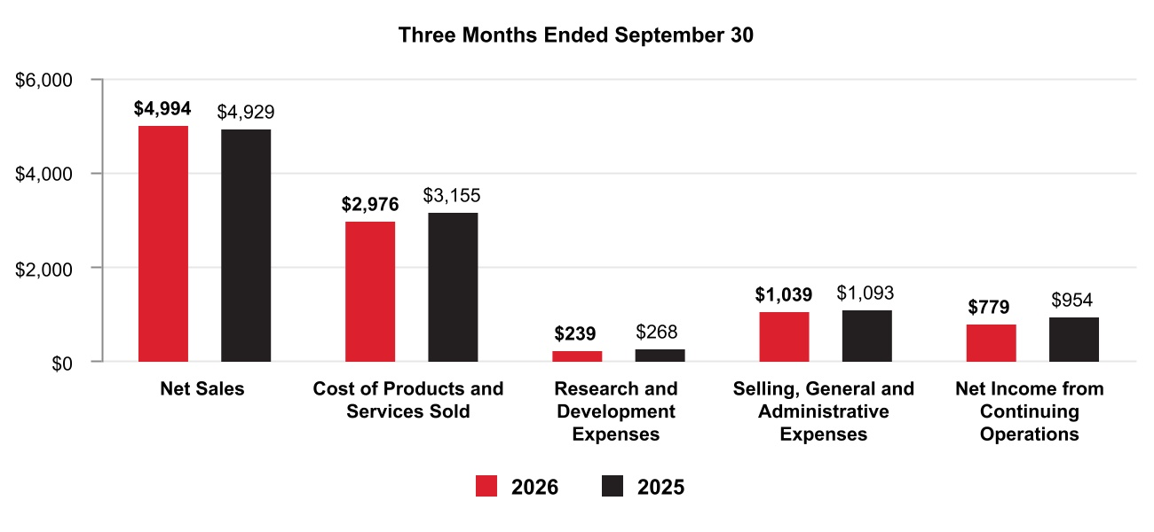
41 Honeywell International Inc.
TABLE OF CONTENTS
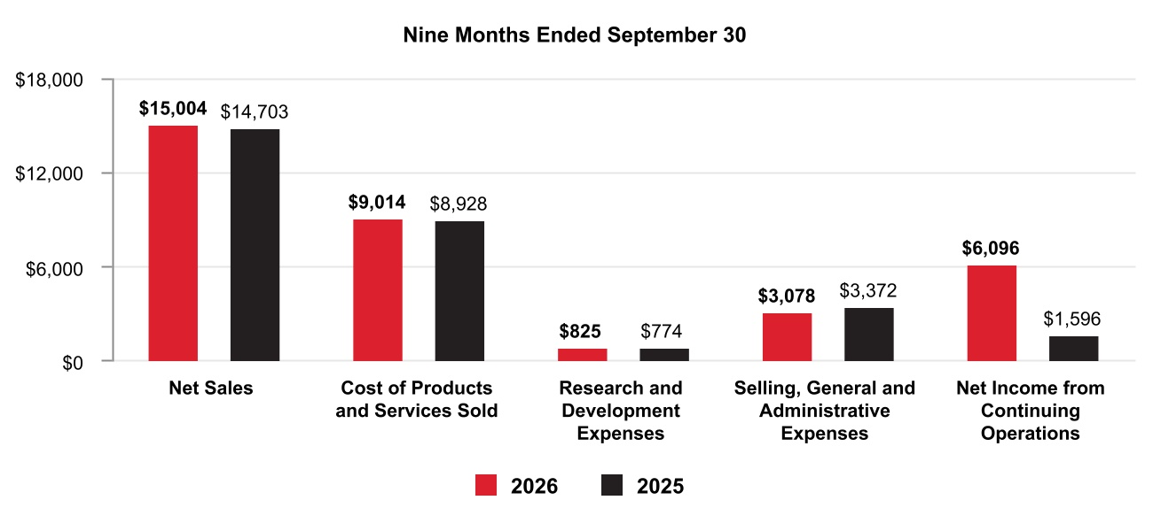
Net Sales by Segment
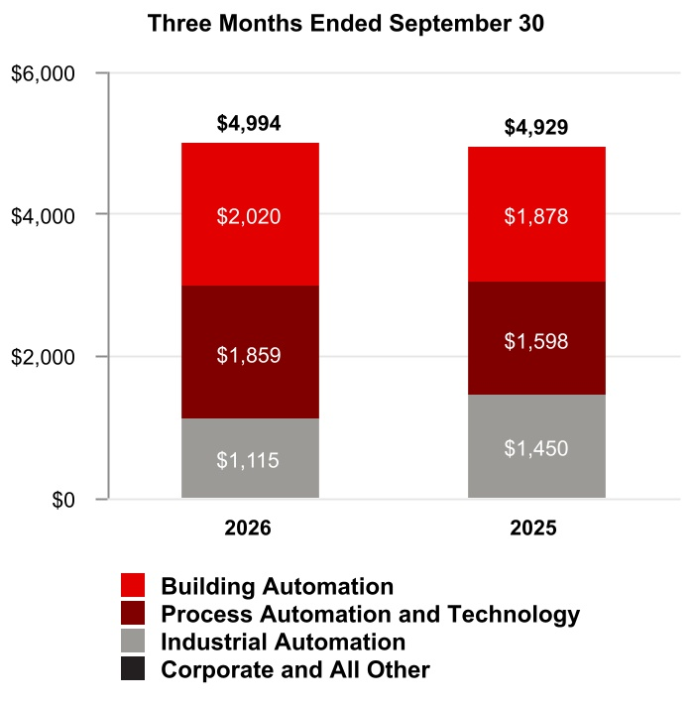
42 Honeywell International Inc.
TABLE OF CONTENTS
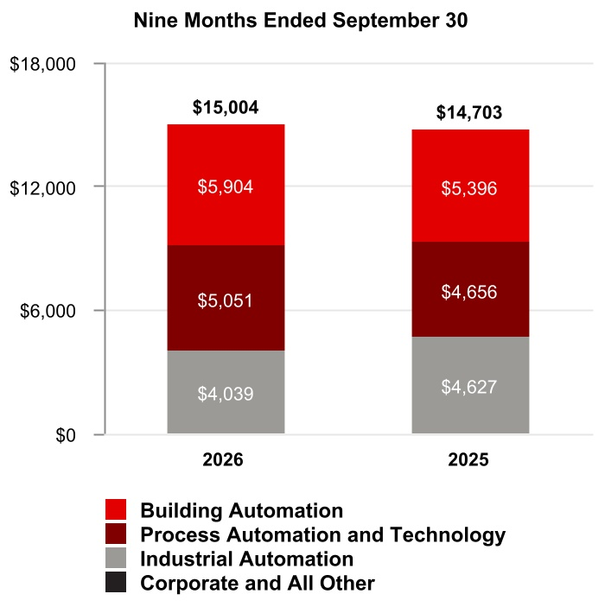
Segment Profit by Segment
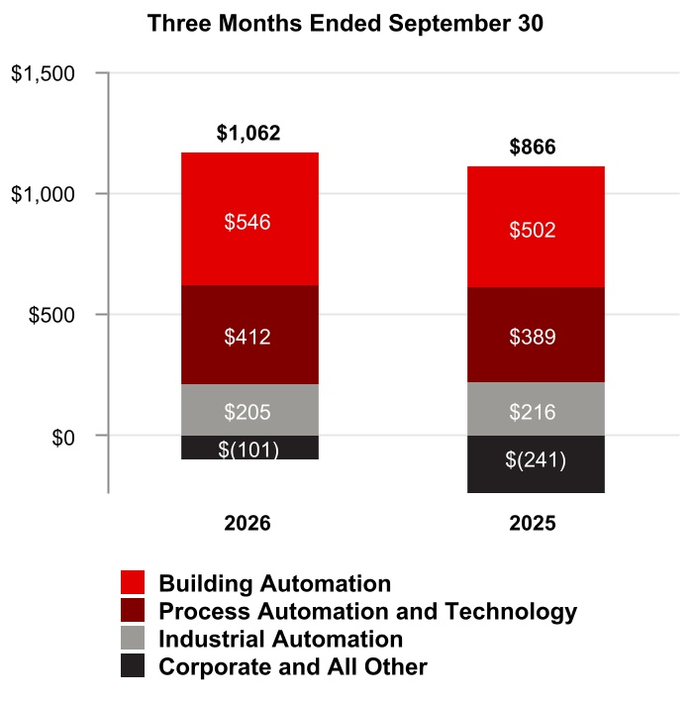
43 Honeywell International Inc.
TABLE OF CONTENTS
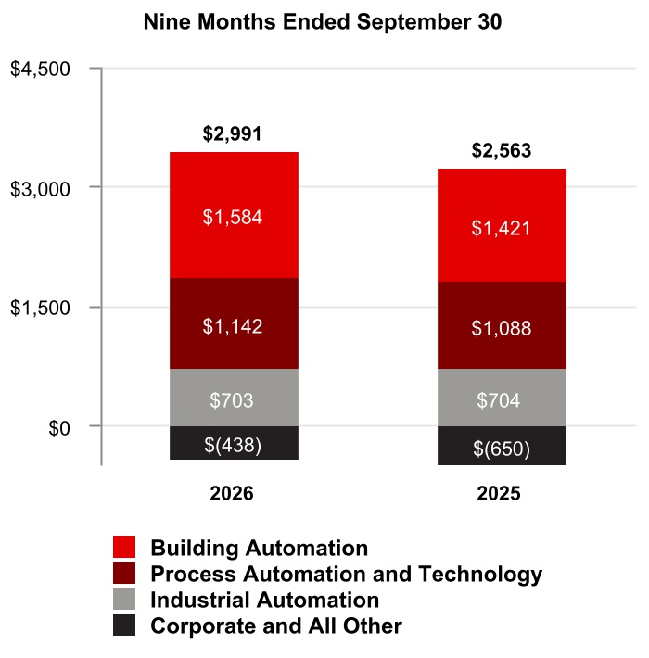

44 Honeywell International Inc.
TABLE OF CONTENTS
Consolidated Operating Results
Net Sales
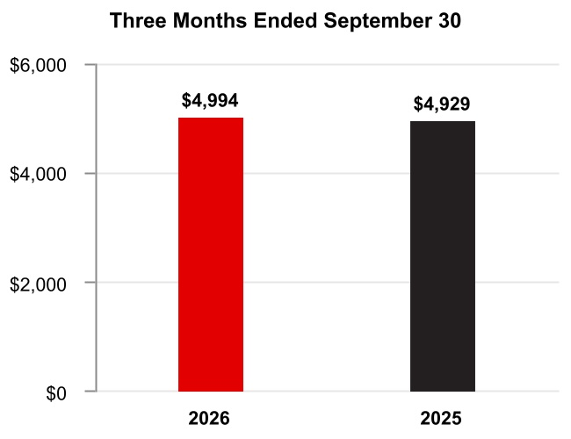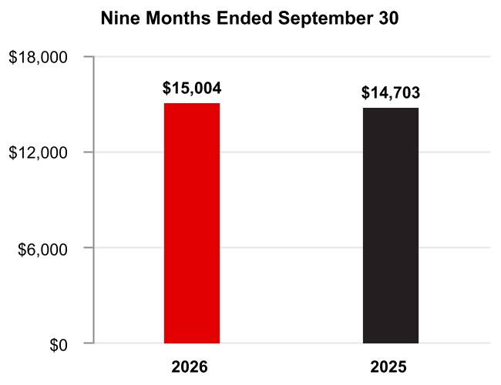

The change in Net sales was attributable to the following:
 |  |  |  | Q3 2026 vs. Q3 2025 |  |  |  |  |  | Year to Date
Volume |  |  |  | 2 % |  |  |  |  |  | — %
Price |  |  |  | 5 % |  |  |  |  |  | 4 %
Foreign currency translation |  |  |  | — % |  |  |  |  |  | 1 %
Acquisitions |  |  |  | 3 % |  |  |  |  |  | 2 %
Divestitures |  |  |  | (9 %) |  |  |  |  |  | (5 %)
Other |  |  |  | — % |  |  |  |  |  | — %
Total % change in Net sales |  |  |  | 1 % |  |  |  |  |  | 2 %
A discussion of Net sales by reportable business segment can be found in the Review of Business Segments section of this Management’s Discussion and Analysis.
Q3 2026 compared with Q3 2025
Net sales increased due to the following:
•Increased pricing and price adjustments to offset inflation,
•Incremental sales from recent acquisitions, and
•Higher sales volumes,
•Largely offset by lower sales from the divestiture of the WWS and PSS businesses.
YTD 2026 compared with YTD 2025
Net sales increased due to the following:
•Increased pricing and price adjustments to offset inflation, and
•Incremental sales from recent acquisitions,
•Partially offset by lower sales from the divestiture of the WWS, PSS and personal protective equipment (PPE) businesses.

45 Honeywell International Inc.
TABLE OF CONTENTS
Cost of Products and Services Sold
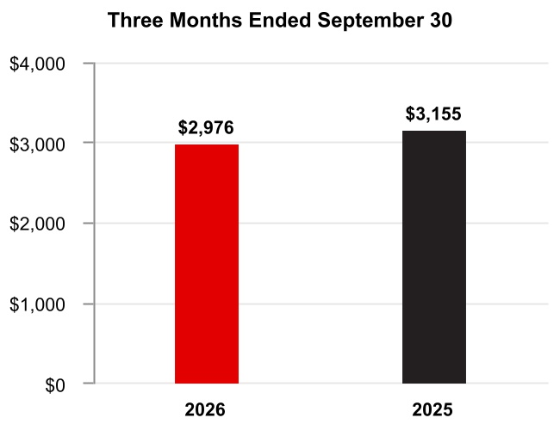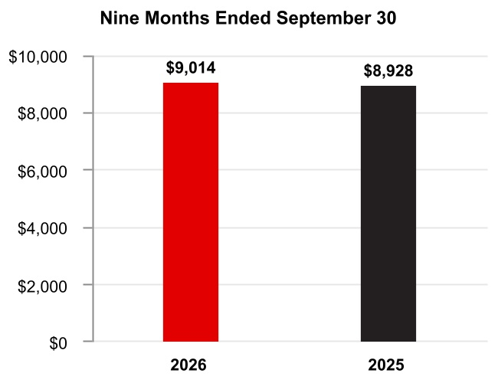

Q3 2026 compared with Q3 2025
Cost of products and services sold decreased due to lower costs from recent divestitures.
YTD 2026 compared with YTD 2025
Cost of products and services sold increased due to the following:
•Higher direct and indirect material costs and higher labor costs of approximately $0.3 billion or 3%, and
•Incremental costs from recent acquisitions of approximately $0.3 billion or 3%,
•Largely offset by lower costs from recent divestitures of approximately $0.5 billion or 6%.
Gross Margin
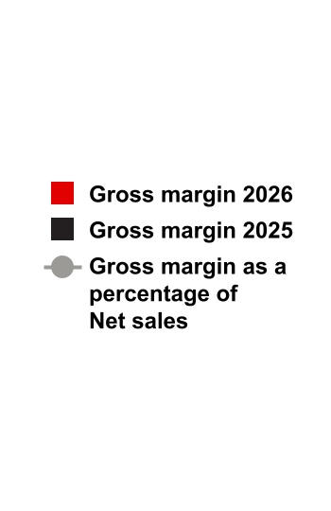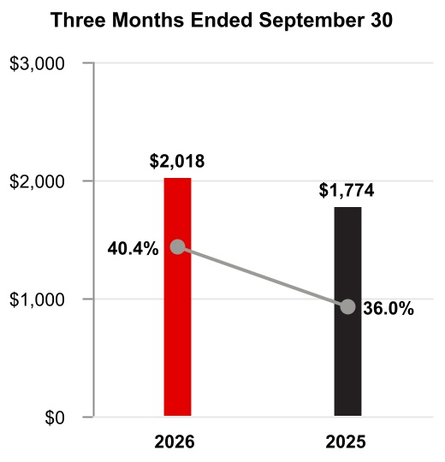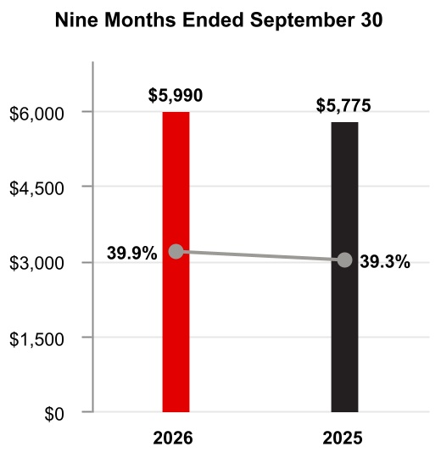
Q3 2026 compared with Q3 2025
Gross margin increased by approximately $0.2 billion and gross margin percentage increased 440 basis points to 40.4% compared to 36.0% for the same period of 2025.
YTD 2026 compared with YTD 2025
Gross margin increased by approximately $0.2 billion and gross margin percentage increased 60 basis points to 39.9% compared to 39.3% for the same period of 2025.
46 Honeywell International Inc.
TABLE OF CONTENTS
Research and Development Expenses
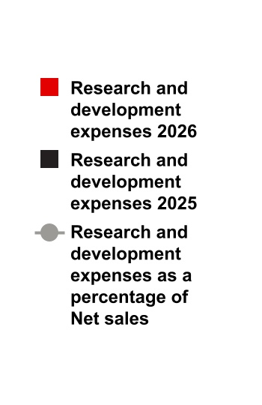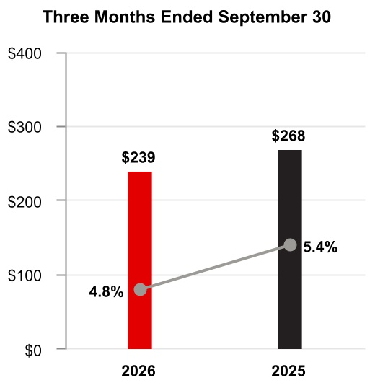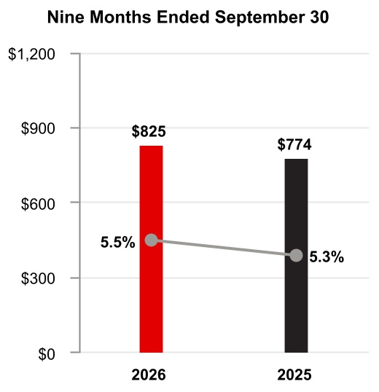

Q3 2026 compared with Q3 2025
Research and development expenses declined slightly as a percentage of net sales due to decreased investment in new product development in our Industrial Automation business.
YTD 2026 compared with YTD 2025
Research and development expenses remained flat as a percentage of net sales due to consistent levels of investment in new product development.
Selling, General and Administrative Expenses
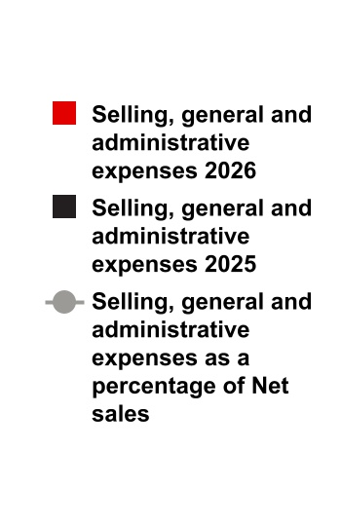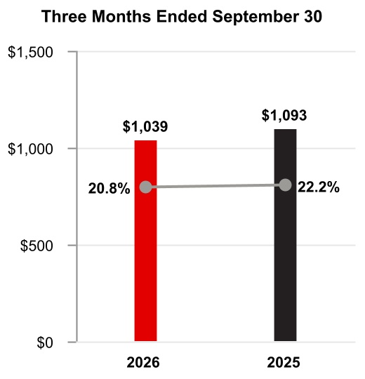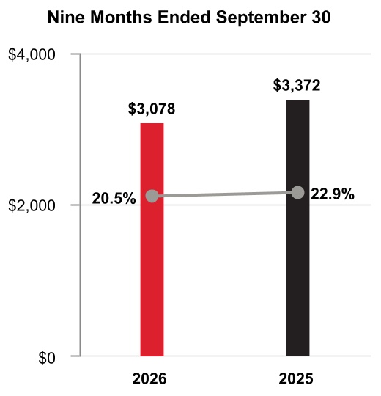

Q3 2026 compared with Q3 2025
Selling, general and administrative expenses remained flat compared to the same period in 2025.
47 Honeywell International Inc.
TABLE OF CONTENTS
YTD 2026 compared to YTD 2025
Selling, general and administrative expenses decreased due to lower Corporate overhead costs in connection with the Aerospace Spin-Off.
Impairment of Assets Held for Sale
 |  |  | Three Months Ended September 30, |  |  |  |  |  |  |  |  |  |  |  | Nine Months Ended September 30,
 |  |  | 2026 |  |  |  |  |  | 2025 |  |  |  |  |  | 2026 |  |  |  |  |  | 2025
Impairment of assets held for sale |  |  | $ | — |  |  |  |  | $ | — |  |  |  |  | $ | 311 |  |  |  |  | $ | 15
YTD 2026 compared to YTD 2025
Impairment of assets held for sale increased due to impairment charges recorded on the assets held for sale related to the WWS and PSS businesses for the nine months ended September 30, 2026.
Loss on Debt Extinguishment
 |  |  | Three Months Ended September 30, |  |  |  |  |  |  |  |  |  |  |  | Nine Months Ended September 30,
 |  |  | 2026 |  |  |  |  |  | 2025 |  |  |  |  |  | 2026 |  |  |  |  |  | 2025
Loss on debt extinguishment |  |  | $ | — |  |  |  |  | $ | — |  |  |  |  | $ | 241 |  |  |  |  | $ | —
YTD 2026 compared to YTD 2025
Loss on debt extinguishment in the nine months ended September 30, 2026 due to debt tender offers and redemptions.
Gain on Deconsolidation of Subsidiary
 |  |  | Three Months Ended September 30, |  |  |  |  |  |  |  |  |  |  |  | Nine Months Ended September 30,
 |  |  | 2026 |  |  |  |  |  | 2025 |  |  |  |  |  | 2026 |  |  |  |  |  | 2025
Gain on deconsolidation of subsidiary |  |  | $ | — |  |  |  |  | $ | — |  |  |  |  | $ | (6,629) |  |  |  |  | $ | —
YTD 2026 compared to YTD 2025
Gain on deconsolidation of subsidiary in the nine months ended September 30, 2026 due to deconsolidation of Quantinuum.
Other (Income) Expense
 |  |  | Three Months Ended September 30, |  |  |  |  |  |  |  |  |  |  |  | Nine Months Ended September 30,
 |  |  | 2026 |  |  |  |  |  | 2025 |  |  |  |  |  | 2026 |  |  |  |  |  | 2025
Other (income) expense |  |  | $ | (389) |  |  |  |  | $ | (957) |  |  |  |  | $ | (301) |  |  |  |  | $ | (1,124)
Q3 2026 compared with Q3 2025
Other income decreased due to the following:
•Nonrecurring gain recognized on Resideo termination agreement in the three months ended September 30, 2025 of approximately $0.8 billion, and
•Higher divestiture-related costs of approximately $0.1 billion,
•Partially offset by gain on sale of the WWS and PSS businesses of approximately $0.3 billion.
YTD 2026 compared to YTD 2025
Other income decreased due to the following:
•Nonrecurring gain recognized on Resideo termination agreement in the nine months ended September 30, 2025 of approximately $0.8 billion, and
•Higher divestiture-related costs of approximately $0.4 billion,
•Partially offset by gain on sale of the WWS and PSS businesses of approximately $0.4 billion.
48 Honeywell International Inc.
TABLE OF CONTENTS
Interest and Other Financial Charges
 |  |  | Three Months Ended September 30, |  |  |  |  |  |  |  |  |  |  |  | Nine Months Ended September 30,
 |  |  | 2026 |  |  |  |  |  | 2025 |  |  |  |  |  | 2026 |  |  |  |  |  | 2025
Interest and other financial charges |  |  | $ | 143 |  |  |  |  | $ | 263 |  |  |  |  | $ | 579 |  |  |  |  | $ | 715
Q3 2026 compared with Q3 2025
Interest and other financial charges decreased due to $7.5 billion of debt tender offers and redemptions in 2026.
YTD 2026 compared to YTD 2025
Interest and other financial charges decreased due to $7.5 billion of debt tender offers and redemptions in 2026.

Tax Expense
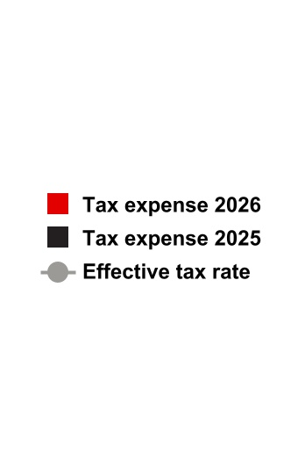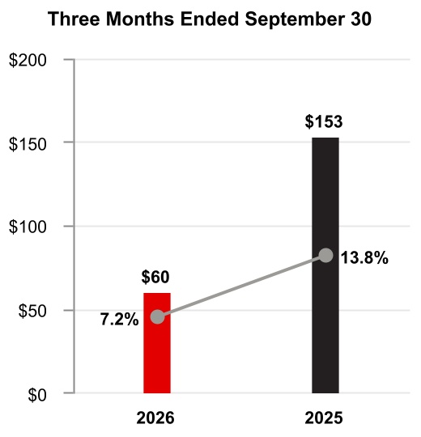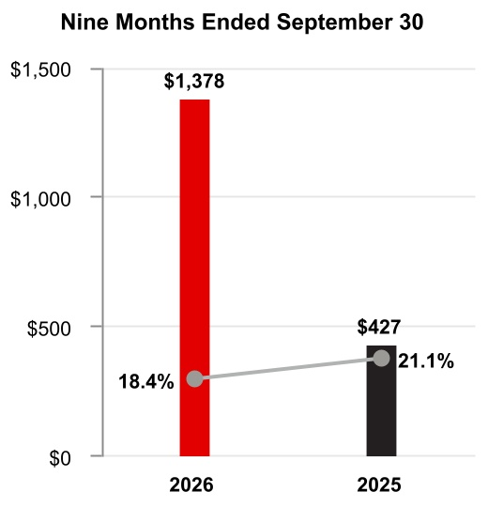

Q3 2026 compared with Q3 2025
The effective tax rate decreased 660 basis points due to the following:
•Changes in accruals on U.S. federal, state, and foreign tax matters of 3,950 basis points,
•Partially offset by transaction related tax costs, changes in estimate on prior tax positions and other tax accruals of 3,290 basis points.

YTD 2026 compared with YTD 2025
The effective tax rate decreased 270 basis points due to the following:
•Transaction related tax impacts of 890 basis points,
•Partially offset by changes in estimate on prior tax positions of 740 basis points.

Equity Loss
 |  |  | Three Months Ended September 30, |  |  |  |  |  |  |  |  |  |  |  | Nine Months Ended September 30,
 |  |  | 2026 |  |  |  |  |  | 2025 |  |  |  |  |  | 2026 |  |  |  |  |  | 2025
Equity loss |  |  | $ | 147 |  |  |  |  | $ | — |  |  |  |  | $ | 412 |  |  |  |  | $ | —
Q3 2026 compared with Q3 2025
Equity loss in the three months ended September 30, 2026 was due to equity losses on Quantinuum following the deconsolidation of Quantinuum in the second quarter of 2026.
49 Honeywell International Inc.
TABLE OF CONTENTS
YTD 2026 compared to YTD 2025
Equity loss in the nine months ended September 30, 2026 was due to equity losses on Quantinuum following the deconsolidation of Quantinuum in the second quarter of 2026.
Net Income from Continuing Operations
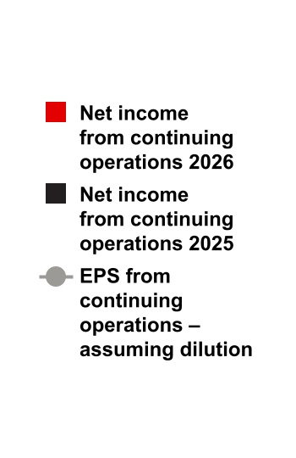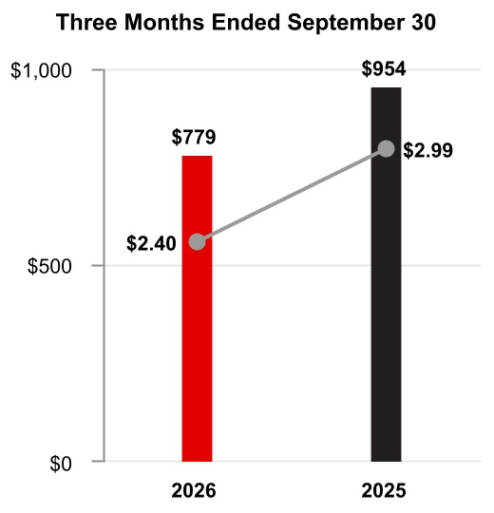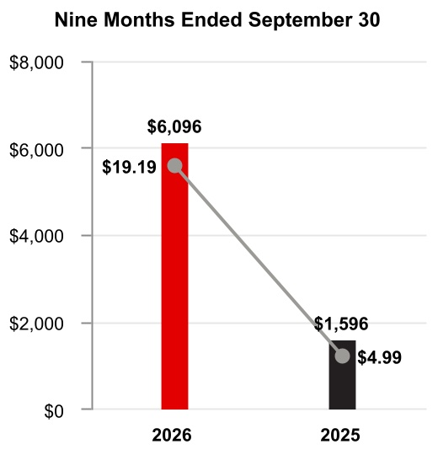

Q3 2026 compared to Q3 2025
Earnings per share of common stock–assuming dilution decreased due to the following:
•Nonrecurring gain recognized on Resideo termination agreement in the three months ended September 30, 2025 ($2.51 after tax),
•Partially offset by gain recognized on sale of WWS and PSS businesses ($0.70 after tax),
•Higher tax benefits driven by U.S. federal, and state matters ($0.58 after tax), and
•Higher segment profit ($0.52 after tax).
YTD 2026 compared with YTD 2025
Earnings per share of common stock–assuming dilution increased due to the following:
•Gain on deconsolidation of Quantinuum ($15.70 after tax), and
•Higher segment profit ($1.07 after tax),
•Partially offset by nonrecurring gain recognized on Resideo termination agreement in the nine months ended September 30, 2025 ($2.49 after tax).

50 Honeywell International Inc.
TABLE OF CONTENTS

Backlog
Our backlog of orders increased 1% to $18.8 billion as of September 30, 2026, compared to September 30, 2025. Backlog represents the estimated remaining value of work to be performed or products to be shipped under firm contracts. Backlog is equal to our remaining performance obligations under the contracts that meet the guidance on revenue from contracts with customers as discussed in Note 4 Revenue Recognition and Contracts with Customers of Notes to Consolidated Financial Statements. Our backlog by reportable business segment is as follows:
 |  |  | September 30, 2026
Building Automation |  |  | $ | 9,194
Process Automation and Technology |  |  | 7,971
Industrial Automation |  |  | 1,633
Total backlog |  |  | $ | 18,798

51 Honeywell International Inc.
TABLE OF CONTENTS
Review of Business Segments
During the first quarter of 2026, the Company realigned certain of its business units as reflected in Note 18 Segment Financial Data, which impacts the composition of its reportable segments. The Company recast historical periods to reflect this change in segment presentation. See Note 18 Segment Financial Data to Notes to Consolidated Financial Statements for further discussion.
We previously globally managed our business operations through four reportable business segments: Aerospace Technologies, Building Automation, Process Automation and Technology, and Industrial Automation. Following completion of the Aerospace Spin-Off, we now manage our businesses through three reportable business segments: Building Automation, Process Automation and Technology, and Industrial Automation. The historical financial results of Honeywell Aerospace are reflected as discontinued operations under GAAP for all periods.

Building Automation
Net Sales
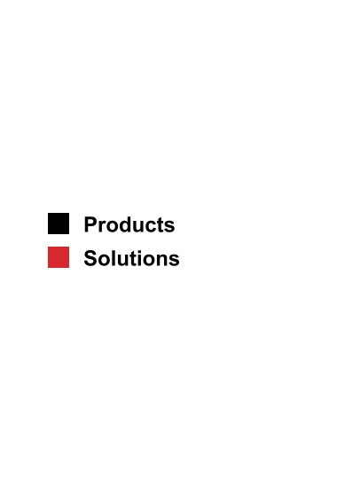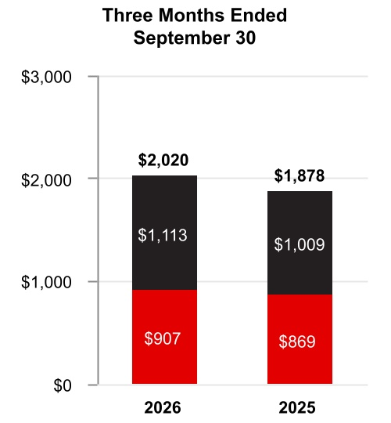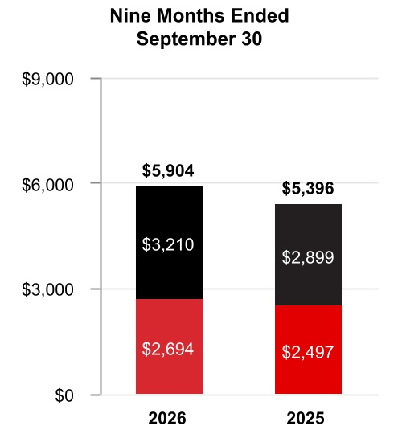

 |  |  | Three Months Ended  September 30, |  |  |  |  |  |  |  |  |  |  |  |  |  |  |  |  |  | Nine Months Ended  September 30,
 |  |  | 2026 |  |  |  |  |  | 2025 |  |  |  |  |  | %  Change |  |  |  |  |  | 2026 |  |  |  |  |  | 2025 |  |  |  |  |  | %  Change
Net sales |  |  | $ | 2,020 |  |  |  |  | $ | 1,878 |  |  |  |  | 8 |  | % |  |  |  | $ | 5,904 |  |  |  |  | $ | 5,396 |  |  |  |  | 9 |  | %
Cost of products and services sold |  |  | 1,068 |  |  |  |  |  | 990 |  |  |  |  |  |  |  |  |  |  |  | 3,126 |  |  |  |  |  | 2,802
Selling, general and administrative and other expenses |  |  | 406 |  |  |  |  |  | 386 |  |  |  |  |  |  |  |  |  |  |  | 1,194 |  |  |  |  |  | 1,173
Segment profit |  |  | $ | 546 |  |  |  |  | $ | 502 |  |  |  |  | 9 |  | % |  |  |  | $ | 1,584 |  |  |  |  | $ | 1,421 |  |  |  |  | 11 |  | %
52 Honeywell International Inc.
TABLE OF CONTENTS
 |  |  | 2026 vs. 2025
 |  |  | Three Months Ended  September 30, |  |  |  |  |  |  |  |  |  |  |  | Nine Months Ended  September 30,
Factors Contributing to Year-Over-Year Change |  |  | Net  Sales |  |  |  |  |  | Segment  Profit |  |  |  |  |  | Net  Sales |  |  |  |  |  | Segment  Profit
Reported percent change |  |  | 8 |  | % |  |  |  | 9 |  | % |  |  |  | 9 |  | % |  |  |  | 11 |  | %
Less: Impact of divestitures to the prior period |  |  | — |  | % |  |  |  | — |  | % |  |  |  | — |  | % |  |  |  | — |  | %
Reported percent change, adjusted for impact of divestitures |  |  | 8 |  | % |  |  |  | 9 |  | % |  |  |  | 9 |  | % |  |  |  | 11 |  | %
Less: Foreign currency translation |  |  | — |  | % |  |  |  | — |  | % |  |  |  | 1 |  | % |  |  |  | 1 |  | %
Less: Acquisitions |  |  | — |  | % |  |  |  | — |  | % |  |  |  | — |  | % |  |  |  | — |  | %
Less: Other |  |  | — |  | % |  |  |  | — |  | % |  |  |  | — |  | % |  |  |  | — |  | %
Organic percent change1 |  |  | 8 |  | % |  |  |  | 9 |  | % |  |  |  | 8 |  | % |  |  |  | 10 |  | %
1 |  |  |  |  |  | Organic sales % change, presented for all of our reportable business segments, is defined as the change in Net sales, adjusted for the impact of divestitures to the prior period, and excluding the impact on sales from foreign currency translation, acquisitions for the first 12 months following the transaction date, and certain other items that are unusual or non-recurring in nature. We believe this non-GAAP measure is useful to investors and management in understanding the ongoing operations and analysis of ongoing operating trends.
Q3 2026 compared to Q3 2025
Sales increased $142 million due to higher organic sales of $110 million in Products and higher organic sales of $38 million in Solutions, both driven by higher demand.
Segment profit increased $44 million and segment margin percentage increased 30 basis points to 27.0% compared to 26.7% for the same period of 2025.
YTD 2026 compared to YTD 2025
Sales increased $508 million due to higher organic sales of $284 million in Products and higher organic sales of $158 million in Building Solutions, both driven by higher demand.
Segment profit increased $163 million and segment margin percentage increased 50 basis points to 26.8% compared to 26.3% for the same period of 2025.

53 Honeywell International Inc.
TABLE OF CONTENTS
Process Automation and Technology
Net Sales
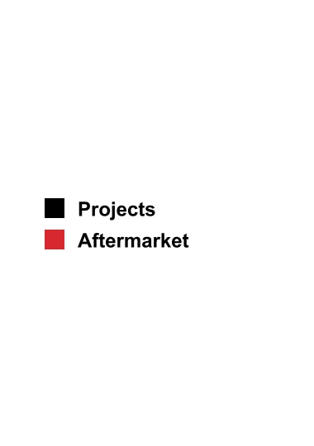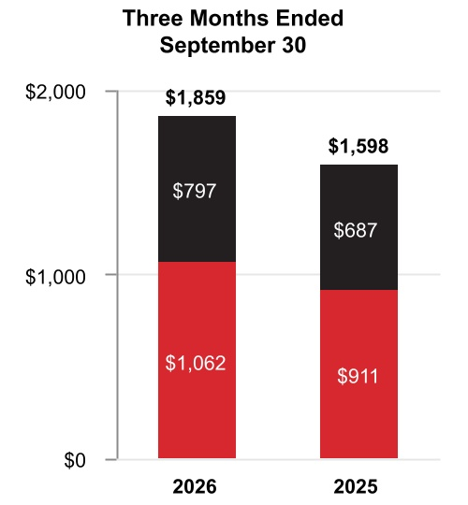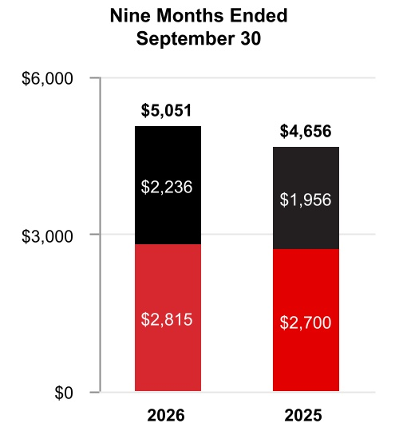

 |  |  | Three Months Ended  September 30, |  |  |  |  |  |  |  |  |  |  |  |  |  |  |  |  |  | Nine Months Ended  September 30,
 |  |  | 2026 |  |  |  |  |  | 2025 |  |  |  |  |  | %  Change |  |  |  |  |  | 2026 |  |  |  |  |  | 2025 |  |  |  |  |  | %  Change
Net sales |  |  | $ | 1,859 |  |  |  |  | $ | 1,598 |  |  |  |  | 16 |  | % |  |  |  | $ | 5,051 |  |  |  |  | $ | 4,656 |  |  |  |  | 8 |  | %
Cost of products and services sold |  |  | 1,069 |  |  |  |  |  | 896 |  |  |  |  |  |  |  |  |  |  |  | 2,910 |  |  |  |  |  | 2,601
Selling, general and administrative and other expenses |  |  | 378 |  |  |  |  |  | 313 |  |  |  |  |  |  |  |  |  |  |  | 999 |  |  |  |  |  | 967
Segment profit |  |  | $ | 412 |  |  |  |  | $ | 389 |  |  |  |  | 6 |  | % |  |  |  | $ | 1,142 |  |  |  |  | $ | 1,088 |  |  |  |  | 5 |  | %
 |  |  | 2026 vs. 2025
 |  |  | Three Months Ended  September 30, |  |  |  |  |  |  |  |  |  |  |  | Nine Months Ended  September 30,
Factors Contributing to Year-Over-Year Change |  |  | Net  Sales |  |  |  |  |  | Segment  Profit |  |  |  |  |  | Net  Sales |  |  |  |  |  | Segment  Profit
Reported percent change |  |  | 16 |  | % |  |  |  | 6 |  | % |  |  |  | 8 |  | % |  |  |  | 5 |  | %
Less: Impact of divestitures to the prior period |  |  | — |  | % |  |  |  | — |  | % |  |  |  | — |  | % |  |  |  | — |  | %
Reported percent change, adjusted for impact of divestitures |  |  | 16 |  | % |  |  |  | 6 |  | % |  |  |  | 8 |  | % |  |  |  | 5 |  | %
Less: Foreign currency translation |  |  | — |  | % |  |  |  | — |  | % |  |  |  | 1 |  | % |  |  |  | 1 |  | %
Less: Acquisitions |  |  | 8 |  | % |  |  |  | — |  | % |  |  |  | 6 |  | % |  |  |  | 5 |  | %
Less: Other |  |  | — |  | % |  |  |  | — |  | % |  |  |  | — |  | % |  |  |  | — |  | %
Organic percent change |  |  | 8 |  | % |  |  |  | 6 |  | % |  |  |  | 1 |  | % |  |  |  | (1) |  | %
Q3 2026 compared to Q3 2025
Sales increased $261 million due to higher organic sales of $98 million in Projects driven by increased volume and higher organic sales of $26 million in Aftermarket driven by refining demand. Additionally, the acquisition of Johnson Matthey's Catalyst Technologies business contributed $131 million of inorganic sales during the three months ended September 30, 2026.
Segment profit increased $23 million and segment margin percentage decreased 210 basis points to 22.2% compared to 24.3% for the same period of 2025.
54 Honeywell International Inc.
TABLE OF CONTENTS
YTD 2026 compared to YTD 2025
Sales increased $395 million as the acquisitions of Sundyne and Johnson Matthey's Catalyst Technologies business contributed $330 million of inorganic sales during the nine months ended September 30, 2026. In addition, organic sales increased $132 million in Projects driven by increased volume, partially offset by lower organic sales of $114 million in Aftermarket driven by a decline in catalyst shipments.
Segment profit increased $54 million and segment margin percentage decreased 80 basis points to 22.6% compared to 23.4% for the same period of 2025.

Industrial Automation
Net Sales
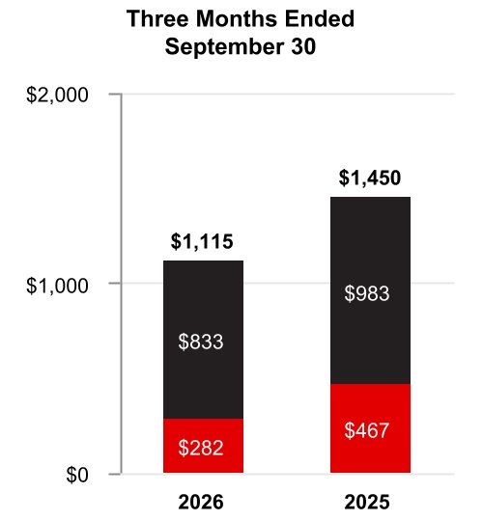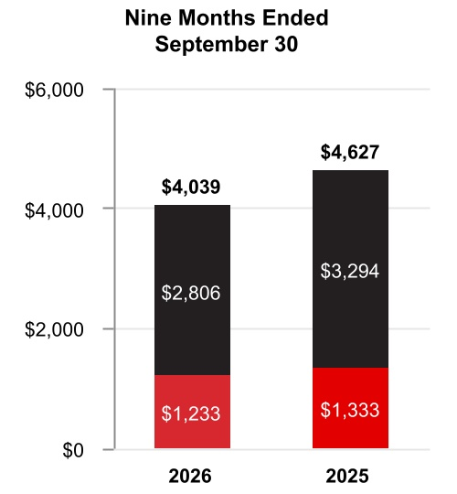

 |  |  | Three Months Ended  September 30, |  |  |  |  |  |  |  |  |  |  |  |  |  |  |  |  |  | Nine Months Ended  September 30,
 |  |  | 2026 |  |  |  |  |  | 2025 |  |  |  |  |  | %  Change |  |  |  |  |  | 2026 |  |  |  |  |  | 2025 |  |  |  |  |  | %  Change
Net sales |  |  | $ | 1,115 |  |  |  |  | $ | 1,450 |  |  |  |  | (23) |  | % |  |  |  | $ | 4,039 |  |  |  |  | $ | 4,627 |  |  |  |  | (13) |  | %
Cost of products and services sold |  |  | 671 |  |  |  |  |  | 913 |  |  |  |  |  |  |  |  |  |  |  | 2,471 |  |  |  |  |  | 2,865
Selling, general and administrative and other expenses |  |  | 239 |  |  |  |  |  | 321 |  |  |  |  |  |  |  |  |  |  |  | 865 |  |  |  |  |  | 1,058
Segment profit |  |  | $ | 205 |  |  |  |  | $ | 216 |  |  |  |  | (5) |  | % |  |  |  | $ | 703 |  |  |  |  | $ | 704 |  |  |  |  | — |  | %
 |  |  | 2026 vs. 2025
 |  |  | Three Months Ended  September 30, |  |  |  |  |  |  |  |  |  |  |  | Nine Months Ended  September 30,
Factors Contributing to Year-Over-Year Change |  |  | Net  Sales |  |  |  |  |  | Segment  Profit |  |  |  |  |  | Net  Sales |  |  |  |  |  | Segment  Profit
Reported percent change |  |  | (23) |  | % |  |  |  | (5) |  | % |  |  |  | (13) |  | % |  |  |  | — |  | %
Less: Impact of divestitures to the prior period |  |  | (27) |  | % |  |  |  | (15) |  | % |  |  |  | (17) |  | % |  |  |  | (9) |  | %
Reported percent change, adjusted for impact of divestitures |  |  | 4 |  | % |  |  |  | 10 |  | % |  |  |  | 4 |  | % |  |  |  | 9 |  | %
Less: Foreign currency translation |  |  | — |  | % |  |  |  | (1) |  | % |  |  |  | 1 |  | % |  |  |  | 2 |  | %
Less: Acquisitions |  |  | — |  | % |  |  |  | — |  | % |  |  |  | — |  | % |  |  |  | — |  | %
Less: Other |  |  | — |  | % |  |  |  | — |  | % |  |  |  | — |  | % |  |  |  | — |  | %
Organic percent change |  |  | 4 |  | % |  |  |  | 11 |  | % |  |  |  | 3 |  | % |  |  |  | 7 |  | %
55 Honeywell International Inc.
TABLE OF CONTENTS
Q3 2026 compared to Q3 2025
Sales decreased $335 million driven by a decline in sales of $375 million due to the sale of our WWS and PSS businesses on July 27, 2026 and August 3, 2026, respectively, partially offset by higher organic sales of $40 million in Solutions driven by project timing.
Segment profit decreased $11 million and segment margin percentage increased 350 basis points to 18.4% compared to 14.9% for the same period in 2025.
YTD 2026 compared to YTD 2025
Sales decreased $588 million driven by a decline in sales of $755 million due to the sale of our PPE, WWS, and PSS businesses on May 21, 2025, July 27, 2026 and August 3, 2026, respectively, partially offset by higher organic sales of $114 million in Solutions driven by increased demand.
Segment profit decreased $1 million and segment margin percentage increased 220 basis points to 17.4% compared to 15.2% for the same period of 2025.

Corporate and All Other
Corporate and All Other primarily includes unallocated corporate costs, interest expense on holding-company debt, and the former controlling majority-owned interest in Quantinuum prior to deconsolidation in the second quarter of 2026. Corporate expenses historically allocated to the Honeywell Aerospace and Advanced Materials businesses prior to being spun off and not eligible to be part of discontinued operations are now included in Corporate and All Other. Corporate and All Other is not a separate reportable business segment as segment reporting criteria is not met. The Company continues to monitor the activities in Corporate and All Other to determine the need for further reportable business segment disaggregation.

Repositioning Charges
See Note 5 Repositioning and Other Charges of Notes to Consolidated Financial Statements for a discussion of our repositioning actions and related charges incurred in the nine months ended September 30, 2026 and 2025. Cash spending related to our repositioning actions was $115 million in the nine months ended September 30, 2026, and was funded through operating cash flows.

56 Honeywell International Inc.
TABLE OF CONTENTS
Liquidity and Capital Resources
(Dollars in tables in millions)
We leverage operating cash flows as the primary source of liquidity. Each of our businesses focuses on increasing operating cash flows through revenue growth, margin expansion, and improved working capital turnover. We also maintain other key sources of liquidity, including U.S. cash balances, and the ability to access non-U.S. cash balances, short-term debt from the commercial paper market, long-term borrowings, committed credit lines, and access to the public debt and equity markets.

Cash
As of September 30, 2026 and December 31, 2025, we held $6.2 billion and $12.7 billion, respectively, of cash and cash equivalents, including our short-term investments. We monitor third-party depository institutions that hold our cash and cash equivalents on a daily basis. Our emphasis is primarily safety of principal and secondarily maximizing yield of those funds. We diversify our cash and cash equivalents among counterparties to minimize exposure to any one counterparty.
As of September 30, 2026, we held $4.5 billion of the Company’s cash, cash equivalents, and short-term investments in non-U.S. subsidiaries. We do not have material amounts related to any jurisdiction subject to currency control restrictions that impact our ability to access and repatriate cash. Under current laws, we do not expect taxes on repatriation or restrictions on amounts held outside of the U.S. to have a material effect on our overall liquidity.

Cash Flow Summary
Our cash flows from operating, investing, and financing activities, as reflected in the Consolidated Statement of Cash Flows, are summarized as follows:
 |  |  | Nine Months Ended September 30,
 |  |  | 2026 |  |  |  |  |  | 2025 |  |  |  |  |  | Variance
Cash and cash equivalents at beginning of period |  |  | $ | 12,487 |  |  |  |  | $ | 10,567 |  |  |  |  | $ | 1,920
Operating activities
Net income from continuing operations |  |  | 6,096 |  |  |  |  |  | 1,596 |  |  |  |  |  | 4,500
Gain on deconsolidation of subsidiary |  |  | (6,629) |  |  |  |  |  | — |  |  |  |  |  | (6,629)
Other noncash adjustments |  |  | 2,030 |  |  |  |  |  | (67) |  |  |  |  |  | 2,097
Changes in working capital |  |  | (552) |  |  |  |  |  | (265) |  |  |  |  |  | (287)
Resideo indemnification and reimbursement agreement termination payment |  |  | — |  |  |  |  |  | 1,590 |  |  |  |  |  | (1,590)
Other operating activities |  |  | (13) |  |  |  |  |  | (244) |  |  |  |  |  | 231
Net cash (used for) provided by operating activities from discontinued operations |  |  | (189) |  |  |  |  |  | 2,594 |  |  |  |  |  | (2,783)
Net cash provided by operating activities |  |  | 743 |  |  |  |  |  | 5,204 |  |  |  |  |  | (4,461)
Net cash used for investing activities from continuing operations |  |  | (1,221) |  |  |  |  |  | (1,839) |  |  |  |  |  | 618
Net cash used for investing activities from discontinued operations |  |  | (252) |  |  |  |  |  | (529) |  |  |  |  |  | 277
Net cash used for financing activities |  |  | (6,017) |  |  |  |  |  | (640) |  |  |  |  |  | (5,377)
Effect of foreign exchange rate changes on cash and cash equivalents |  |  | (46) |  |  |  |  |  | 167 |  |  |  |  |  | (213)
Net (decrease) increase in cash and cash equivalents |  |  | (6,793) |  |  |  |  |  | 2,363 |  |  |  |  |  | (9,156)
Cash and cash equivalents at end of period |  |  | $ | 5,694 |  |  |  |  | $ | 12,930 |  |  |  |  | $ | (7,236)
Nine months ended September 30, 2026
Net cash provided by operating activities was driven by Net Income, adjusted for the $6,629 million gain on deconsolidation of subsidiary, net of tax of $1,572 million, $698 million of depreciation and amortization, and $552 million of changes in working capital, partially offset by $351 million gain on sale of non-strategic businesses and assets and $268 million of pension income.
Net cash used for investing activities from continuing operations was driven by $1,763 million of cash paid for acquisitions, the deconsolidation of $623 million of Quantinuum cash and $369 million of capital expenditures, partially offset by $1,454 million of proceeds from sale of businesses.
Net cash used for financing activities was driven by $14,688 million of payments of long-term debt, $3,469 million of net payments of commercial paper, $1,816 million of cash dividends paid, $1,000 million of repurchases of common stock and $1,000 million of Spin-Off cash, partially offset by $15,835 million of pre-separation funding related to the Aerospace Spin-Off.
Nine months ended September 30, 2026 compared with nine months ended September 30, 2025
Net cash provided by operating activities decreased by $4,461 million, driven by the change in classification of Honeywell Aerospace cash used by operations of $189 million in 2026 and provided by operations of $2,594 million in 2025 to discontinued operations, and the receipt of the Resideo indemnification and reimbursement agreement termination payment of $1,590 million in 2025.
Net cash used for investing activities from continuing operations decreased by $618 million, driven by a $526 million net increase in cash receipts from settlement of derivative contracts, a $438 million decrease in cash paid for acquisitions, and a $297 million increase in proceeds from sale of businesses, partially offset by the deconsolidation of $623 million of Quantinuum cash in the nine months ended September 30, 2026.
Net cash used for financing activities increased by $5,377 million, driven by a $13,133 million increase of payments of long-term debt, a $5,929 million increase of net payments of commercial paper, a decrease in proceeds from issuance of long-term debt of $4,035 million, and a $1,000 million increase of Spin-Off cash partially offset by $15,835 million of pre-separation funding related to the Aerospace Spin-Off and a $2,704 million decrease in repurchases of common stock.

Assessment of Current Liquidity and Cash Requirements
Based on past performance and current expectations, we believe our operating cash flows will be sufficient to meet our future operating cash needs for at least the next twelve months. If necessary, our available cash, committed credit lines, and access to the public debt and equity markets provide additional sources of short-term and long-term liquidity to fund current operations, debt maturities, and future investment opportunities.
See Note 9 Debt and Credit Agreements of Notes to Consolidated Financial Statements for additional discussion of items impacting our liquidity.
In addition to normal operating cash requirements, our principal future cash requirements include funding capital expenditures, share repurchases, dividends, strategic acquisitions, and debt repayments. During the nine months ended September 30, 2026, we repurchased common stock of $1.0 billion. Refer to the section titled Liquidity and Capital Resources of our 2025 Annual Report on Form 10-K for a discussion of our expected capital expenditures, share repurchases, mergers and acquisitions activity, and dividends for 2026.
We continually assess the relative strength of each business in our portfolio as to strategic fit, market position, profit, and cash flow contribution in order to identify target investment and acquisition opportunities in order to upgrade our combined portfolio. We seek to identify acquisition candidates that will further our strategic plan and strengthen our existing core businesses. During the third quarter of 2026, we acquired Johnson Matthey’s Catalyst Technologies business for total consideration of $1,743 million, net of cash acquired. We also identify businesses that do not fit into our long-term strategic plan based on their market position, relative profitability, or growth potential. These businesses are considered for potential divestiture, restructuring, or other repositioning actions, subject to regulatory constraints. During the third quarter, we completed the divestitures of our PSS and WWS businesses within the Industrial Automation reportable business segment for total consideration of $1,527 million, net of cash transferred. See Note 3 Acquisitions, Divestitures, and Discontinued Operations of Notes to Consolidated Financial Statements for additional discussion.
We continually seek opportunities to improve our liquidity and working capital efficiency, which includes the extension of payment terms with our suppliers and transfer of our trade receivables to unaffiliated financial institutions on a true sale basis. The impact of these programs is not material to our overall liquidity.

57 Honeywell International Inc.
TABLE OF CONTENTS
Borrowings
We leverage a variety of debt instruments to manage our overall borrowing costs. As of September 30, 2026, and December 31, 2025, our total borrowings were $16.6 billion and $34.6 billion, respectively.
 |  |  | September 30, 2026 |  |  |  |  |  | December 31, 2025
Fixed rate notes |  |  | $ | 13,092 |  |  |  |  | $ | 25,164
Commercial paper |  |  | 2,422 |  |  |  |  |  | 5,892
Term loans |  |  | 1,250 |  |  |  |  |  | 3,750
Variable rate notes |  |  | 12 |  |  |  |  |  | 22
Other |  |  | 111 |  |  |  |  |  | 102
Fair value of hedging instruments |  |  | (105) |  |  |  |  |  | (79)
Debt issuance costs |  |  | (189) |  |  |  |  |  | (280)
Total borrowings |  |  | $ | 16,593 |  |  |  |  | $ | 34,571
A key source of liquidity is our ability to access the corporate bond markets. Through these markets, we issue a variety of long-term fixed rate notes to manage our overall funding costs.
Another key source of liquidity is our ability to access the commercial paper market. Commercial paper notes are sold at a discount or premium and have a maturity of not more than 365 days from date of issuance. Borrowings under the commercial paper program are available for general corporate purposes as well as for financing acquisitions.
In addition, we have the following loan and revolving credit agreements:
•A $6.0 billion Delayed Draw Term Loan Agreement (the 2025 Term Loan Agreement), dated as of May 7, 2025. The 2025 Term Loan Agreement is comprised of two tranches: (i) commitments to provide loans in an aggregate principal amount of up to $4.0 billion, which was fully drawn effective May 30, 2025, and (ii) commitments to provide loans in an aggregate amount of up to $2.0 billion, which expired on December 19, 2025. Amounts borrowed under the 2025 Term Loan Agreement are required to be paid no later than May 7, 2027, unless the 2025 Term Loan Agreement is terminated earlier pursuant to its terms. As of September 30, 2026, there were $1.25 billion of borrowings outstanding on the 2025 Term Loan Agreement.
•A $3.0 billion 364-day credit agreement (the 364-Day Credit Agreement) with a syndicate of banks, dated as of March 6, 2026. Upon completion of the Aerospace Spin-Off, the aggregate revolving credit commitments under the 364-Day Credit Agreement were reduced to $2.0 billion. Amounts borrowed under the 364-Day Credit Agreement are required to be repaid no later than March 5, 2027, unless (i) we elect to convert all then outstanding amounts into a term loan, upon which such amounts shall be repaid in full on March 5, 2028, or (ii) the 364-Day Credit Agreement is terminated earlier pursuant to its terms. As of September 30, 2026, there were no outstanding borrowings under the 364-Day Credit Agreement.
•A $4.0 billion five-year credit agreement (the Five-Year Credit Agreement) with a syndicate of banks, dated as of March 6, 2026. Upon completion of the Aerospace Spin-Off, the aggregate revolving credit commitments under the Five-Year Credit Agreement were reduced to $3.0 billion. Commitments under the Five-Year Credit Agreement can be increased pursuant to the terms of the Five-Year Credit Agreement to an aggregate amount not to exceed $3.5 billion. Amounts borrowed under the Five-Year Credit Agreement are required to be repaid no later than March 6, 2031, unless such date is extended pursuant to the terms of the Five-Year Credit Agreement. As of September 30, 2026, there were no outstanding borrowings under the Five-Year Credit Agreement.
See Note 9 Debt and Credit Agreements of Notes to Consolidated Financial Statements for additional information regarding our debt instruments.
We also maintain a current shelf registration statement filed with the SEC under which we may issue additional debt securities, common stock, and preferred stock that may be offered in one or more offerings on terms to be determined at the time of the offering. We anticipate that net proceeds of any offering would be used for general corporate purposes, including repayment of existing indebtedness, share repurchases, capital expenditures, and acquisitions.

58 Honeywell International Inc.
TABLE OF CONTENTS
Credit Ratings
Our ability to access the global debt capital markets and the related cost of these borrowings is affected by the strength of our credit rating and market conditions. Our credit ratings are periodically reviewed by the major independent debt-rating agencies. As of September 30, 2026, S&P Global Inc. (S&P), Fitch Ratings Inc. (Fitch), and Moody’s Investor Service (Moody’s) have ratings on our debt set forth in the table below:
 |  |  | S&P |  |  |  |  |  | Fitch |  |  |  |  |  | Moody’s
Outlook |  |  | Negative |  |  |  |  |  | Stable |  |  |  |  |  | Negative
Short-term |  |  | A-1 |  |  |  |  |  | F1 |  |  |  |  |  | P1
Long-term |  |  | A |  |  |  |  |  | A |  |  |  |  |  | A2

Other Matters
Litigation
See Note 15 Commitments and Contingencies of Notes to Consolidated Financial Statements for further discussion of environmental and other litigation matters.
Critical Accounting Estimates
There have been no material changes to our Critical Accounting Estimates presented in our 2025 Annual Report on Form 10-K. For a discussion of the Company’s Critical Accounting Estimates, see the section titled Critical Accounting Estimates in our 2025 Annual Report on Form 10-K.
Recent Accounting Pronouncements
See Note 2 Summary of Significant Accounting Policies of Notes to Consolidated Financial Statements for a discussion of recent accounting pronouncements.

Item 3. Quantitative and Qualitative Disclosures About Market Risks
For a discussion of the Company’s quantitative and qualitative disclosures about market risks, see the section titled Quantitative and Qualitative Disclosures About Market Risks in our 2025 Annual Report on Form 10-K. As of September 30, 2026, there has been no material change in this information.

59 Honeywell International Inc.
TABLE OF CONTENTS
Item 4. Controls and Procedures
Honeywell Technologies management, including the Chairman and Chief Executive Officer (CEO) and Chief Financial Officer (CFO), conducted an evaluation of the effectiveness of our disclosure controls and procedures (as defined in Rules 13a-15(e) or 15d-15(e) promulgated under the Securities Exchange Act of 1934, as amended (Exchange Act)) as of the end of the period covered by this Quarterly Report on Form 10-Q. Based upon that evaluation, the Chairman and CEO and the CFO concluded that such disclosure controls and procedures were effective as of the end of the period covered by this Quarterly Report on Form 10-Q to ensure information required to be disclosed in the reports that Honeywell Technologies files or submits under the Exchange Act is recorded, processed, summarized, and reported within the time periods specified in the SEC’s rules and forms, and that it is accumulated and communicated to our management, including our Chairman and CEO, our CFO, and our Controller, as appropriate, to allow timely decisions regarding required disclosure. There were no changes that materially affected, or are reasonably likely to materially affect, Honeywell Technologies’ internal control over financial reporting that occurred during the period covered by this Quarterly Report on Form 10-Q.

60 Honeywell International Inc.
TABLE OF CONTENTS
Part II. Other Information

Item 1. Legal Proceedings
We are subject to a number of lawsuits, investigations, and claims (some of which involve substantial amounts) arising out of the conduct of our business. See a discussion of environmental and other litigation matters in Note 15 Commitments and Contingencies of Notes to Consolidated Financial Statements.
There were no matters requiring disclosure pursuant to the requirement to disclose certain environmental matters involving potential monetary sanctions in excess of $300,000.

Item 1A. Risk Factors
In our Quarterly Report on Form 10-Q for the second quarter of 2026, we updated our risk factors included in our Annual Report on Form 10-K for the year ended December 31, 2025 to reflect risks for Honeywell Technologies following completion of the Aerospace Spin-Off on June 29, 2026. Other than as noted below, there have been no material changes to our Risk Factors presented in our Quarterly Report on Form 10-Q for the second quarter of 2026 under the section titled Risk Factors.
We may be unable to successfully execute or effectively integrate acquisitions, and divestitures may not occur as planned.
We regularly review our portfolio of businesses and pursue growth through acquisitions and seek to divest non-core businesses. We may not be able to complete transactions on favorable terms, on a timely basis, or at all. In addition, our results of operations and cash flows may be adversely impacted by (i) the failure of acquired businesses to meet or exceed expected returns, including risk of impairment; (ii) the failure to integrate multiple acquired businesses into Honeywell Technologies simultaneously and on schedule and/or to achieve expected synergies; (iii) the inability to dispose of non-core assets and businesses on satisfactory terms and conditions; and (iv) the discovery of unanticipated liabilities, labor relations difficulties, cybersecurity concerns, compliance issues, or other problems in acquired businesses for which we lack contractual protections, insurance or indemnities, or, with regard to divested businesses, claims by purchasers to whom we have provided contractual indemnification.
We divested a number of businesses, including as part of spin-offs. With respect to some of these former businesses, we contractually agreed to indemnify the counterparties against, or otherwise retain, certain liabilities, including, certain lawsuits, product liability claims, and environmental matters. In addition, in some cases the counterparties to our divestitures or spun-off businesses agreed to indemnify us or assume certain liabilities relating to those divestitures. By virtue of these contractual indemnifications and liability arrangements, we could be exposed to liabilities arising out of these divestitures. Also, there can be no assurance that the indemnity or assumption of liability by the counterparties will be sufficient to protect us against the full amount of liabilities that were indemnified or assumed, or that a counterparty will be able to fully satisfy its obligations. Third parties could seek to hold us responsible for any of the liabilities that a counterparty agreed to assume. Even if we ultimately succeed in recovering any amounts for which we were initially held liable, we may be temporarily required to bear these losses ourselves.

Item 2. Unregistered Sales of Equity Securities and Use of Proceeds
On April 24, 2023, the Company’s Board of Directors authorized the repurchase of up to $10 billion of the Company’s common stock, including approximately $2.1 billion of remaining availability under the previously announced $10 billion share repurchase authorization. The repurchase authorization does not have an expiration date and may be amended or terminated by the Company’s Board of Directors at any time without prior notice.
61 Honeywell International Inc.
TABLE OF CONTENTS
Repurchases may be made through a variety of methods, which could include open market purchases, accelerated share repurchase transactions, negotiated block transactions, 10b5-1 plans, other transactions that may be structured through investment banking institutions or privately negotiated, or a combination of the foregoing. Honeywell Technologies presently expects to repurchase outstanding shares from time to time (i) to offset the dilutive impact of employee stock-based compensation plans, including option exercises, restricted unit vesting, and matching contributions under our savings plans, and (ii) to reduce share count via share repurchases as and when attractive opportunities arise. The amount and timing of future repurchases may vary depending on market conditions and the level of operating, financing, and other investing activities.
During the three months ended September 30, 2026, no shares were repurchased by the Company. As of September 30, 2026, $679 million remained available under the share repurchase authorization for additional share repurchases.

Item 4. Mine Safety Disclosures
One of our wholly-owned subsidiaries has a placer claim for and operates a chabazite ore surface mine in Arizona. Information concerning mine safety and other regulatory matters associated with this mine is required by Section 1503(a) of the Dodd-Frank Wall Street Reform and Consumer Protection Act and Item 104 of Regulation S-K and is included in Exhibit 95 to this quarterly report.

Item 5. Other Information
Equity Trading Arrangements Elections
Certain executive officers and directors of the Company may execute purchases and sales of the Company’s common stock through Rule 10b5-1 and non-Rule 10b5-1 equity trading arrangements.
During the three months ended September 30, 2026, none of our executive officers or directors adopted, terminated or modified a “Rule 10b5-1 trading arrangement,” or adopted, terminated, or modified any “non-Rule 10b5-1 trading arrangement” (each as defined in Item 408 of Regulation S-K). During the three months ended September 30, 2026, outstanding 10b5-1 plans were continued after being temporarily paused solely to recalibrate so as to give effect to our one-for-two reverse stock split and the Aerospace Spin-Off, both effected on June 29, 2026.

62 Honeywell International Inc.
TABLE OF CONTENTS
Item 6. Exhibits
Exhibit No. |  |  |  |  |  | Description
2.1+ |  |  |  |  |  | Separation and Distribution Agreement, dated as of June 29, 2026, by and between Honeywell International Inc. and Honeywell Aerospace Inc. (incorporated by reference to Exhibit 2.1 to Honeywell Technologies' Form 8-K filed June 29, 2026)
3.1 |  |  |  |  |  | Amended and Restated Certificate of Incorporation of Honeywell International Inc., dated June 23, 2025 (incorporated by reference to Exhibit 3.1 to Honeywell Technologies’ Form 8-K filed June 24, 2025)
3.2 |  |  |  |  |  | Certificate of Amendment to the Amended and Restated Certificate of Incorporation of Honeywell International Inc. (incorporated by reference to Exhibit 3.1 to Honeywell Technologies’ Form 8-K filed June 29, 2026)
10.1+ |  |  |  |  |  | Tax Matters Agreement, dated as of June 29, 2026, by and between Honeywell International Inc. and Honeywell Aerospace Inc. (effective as of June 29, 2026) (incorporated by reference to Exhibit 10.1 to Honeywell Technologies' Form 8-K filed June 29, 2026)
10.2* |  |  |  |  |  | Offer Letter dated August 17, 2026 from Honeywell International Inc. to Billal Hammoud (filed herewith)
31.1 |  |  |  |  |  | Certification of Principal Executive Officer Pursuant to Section 302 of the Sarbanes-Oxley Act of 2002 (filed herewith)
31.2 |  |  |  |  |  | Certification of Principal Financial Officer Pursuant to Section 302 of the Sarbanes-Oxley Act of 2002 (filed herewith)
32.1 |  |  |  |  |  | Certification of Principal Executive Officer Pursuant to 18 U.S.C. Section 1350, as Adopted Pursuant to Section 906 of the Sarbanes-Oxley Act of 2002 (furnished herewith)
32.2 |  |  |  |  |  | Certification of Principal Financial Officer Pursuant to 18 U.S.C. Section 1350, as Adopted Pursuant to Section 906 of the Sarbanes-Oxley Act of 2002 (furnished herewith)
95 |  |  |  |  |  | Mine Safety Disclosures (filed herewith)
101.INS |  |  |  |  |  | Inline XBRL Instance Document (the instance document does not appear in the Interactive Data File because its XBRL tags are embedded within the Inline XBRL document)
101.SCH |  |  |  |  |  | Inline XBRL Taxonomy Extension Schema (filed herewith)
101.CAL |  |  |  |  |  | Inline XBRL Taxonomy Extension Calculation Linkbase (filed herewith)
101.DEF |  |  |  |  |  | Inline XBRL Taxonomy Extension Definition Linkbase (filed herewith)
101.LAB |  |  |  |  |  | Inline XBRL Taxonomy Extension Label Linkbase (filed herewith)
101.PRE |  |  |  |  |  | Inline XBRL Taxonomy Extension Presentation Linkbase (filed herewith)
104 |  |  |  |  |  | Cover Page Interactive Data File (formatted as inline XBRL and contained in Exhibit 101)
+ Certain schedules and exhibits to this agreement have been omitted pursuant to Item 601(a)(5) of Regulation S-K. The Company agrees to furnish supplementally a copy of any omitted schedule or exhibit to the SEC upon its request.

Exhibits identified above with an asterisk (*) are management contracts or compensatory plans or arrangements.

63 Honeywell International Inc.
TABLE OF CONTENTS
Signatures
Pursuant to the requirements of the Securities Exchange Act of 1934, the Registrant has duly caused this report to be signed on its behalf by the undersigned thereunto duly authorized.

 |  |  | HONEYWELL INTERNATIONAL INC.
Date: October 22, 2026 |  |  | By: |  |  | /s/ Robert D. Mailloux
Robert D. Mailloux
Vice President and Controller
(on behalf of the Registrant
and as the Registrant’s
Principal Accounting Officer)

64 Honeywell International Inc.

EXHIBIT 10.2


August 17, 2026

Billal Hammoud
715 Peachtree Street, N.E.
Atlanta, Georgia 30308

Re: Offer Letter

Dear Billal:

I am pleased to confirm our offer to you to become President and Chief Executive Officer, Process Technology (Executive Band), reporting directly to Chairman and Chief Executive Officer, Vimal Kapur. The effective date of your new role will be October 1, 2026 (“Effective Date”), subject to the terms and conditions of this offer letter. In this position, you will remain an Executive Officer of Honeywell.

In connection with your new role, you will be entitled to the following compensation and benefits package:

COMPENSATION

Base Salary: As of the Effective Date, your annual base salary will be increased to $800,000. Base salary reviews occur annually, and any adjustments are generally at the end of the first quarter of the calendar year. Adjustments are based on your performance and other relevant factors. You will next be eligible for a base salary review in March of 2027.

Annual Incentive Compensation: Your target incentive compensation opportunity will remain at 100% of your annual cash base salary earnings during the year. Incentive compensation awards are paid in the first quarter of the following year.

Annual Long-Term Incentive Awards: Beginning in 2027, you will be eligible for annual long-term incentive (“LTI”) awards with a target grant date value of $3,250,000. Your LTI awards shall consist of stock options, restricted stock units, performance stock units or cash-based awards, or some combination thereof, as determined by the Company in its discretion. The actual size and mix of your annual LTI awards will be determined by the Board’s Management Development and Compensation Committee (“MDCC”) based on your performance and future career potential with Honeywell. The terms of all LTI awards are governed by the terms of the applicable stock plan and the relevant award agreements. Moreover, Honeywell and the MDCC reserve the right to modify the design or mix of the LTI award program in the future.

OTHER EXECUTIVE BENEFITS

You will also be entitled to the following Executive Benefits: Excess Liability Insurance: Honeywell will pay the annual premium for an Excess Liability Insurance policy that provides $20,000,000 of personal liability umbrella coverage per occurrence. Executive Severance: The Officer Severance Plan currently provides for 12 months of base salary continuation and target bonus if your employment is involuntarily terminated for a reason other than Cause (as defined in the severance plan document in effect when you terminate employment). You will be required to execute a release of claims against Honeywell and its affiliates and related parties and you may be required to agree to certain non-solicitation, non-disclosure and non-competition covenants as a condition of receiving executive severance benefits. For additional information, please consult the actual plan document.

STOCK OWNERSHIP GUIDELINES FOR HONEYWELL OFFICERS

Page 1 of 2
As an Executive Officer of the Company, you will be required to hold Honeywell shares in accordance with the Company’s Stock Ownership Guidelines, as amended from time to time. A copy of the Stock Ownership Guidelines will be separately provided to you.

INTELLECTUAL PROPERTY AND NON-COMPETITION AGREEMENTS

As a condition of this employment offer, you are required to execute (i) Honeywell’s “Employee Agreement Relating to Trade Secrets, Proprietary and Confidential Information” (“IP Agreement”), and (ii) the “Honeywell International Inc. Noncompete Agreement for Select Management Employees” (“Noncompete Agreement”), both of which are attached hereto.

ACCEPTANCE OF OFFER

Please indicate your acceptance of this offer by electronically signing this offer letter, as well as the IP Agreement and Noncompete Agreement via Docusign.

Honeywell Technologies has a long and distinguished history. But, more importantly, we are a company with a terrific future and a great place to work. Our performance culture drives growth for us and competitive advantage for our customers. We hire the best people; give them every possible opportunity to learn, grow, and develop; and reward them for their contributions. We offer career paths that span product lines, job types, businesses, and countries.

Billal, we are excited to be extending this offer to you and look forward to working with you in your new role. Your experience and background are an asset to our Company.

If you have any questions or need any further information about our offer, please contact me directly.

Congratulations,

Jennifer Reilly
Senior Vice President and CHRO
Honeywell International Inc.

Read and Accepted:

/s/Billal Hammoud____________________
BILLAL HAMMOUD (E323384)

All businesses experience changing conditions. Accordingly, we reserve the right to change work assignments, reporting relationships and staffing levels to meet business needs, and your employment with Honeywell will be on an “at will” basis. This means that there is no guarantee of employment for any specific period, and either you or Honeywell may terminate your employment at any time.

The descriptions of benefits and perquisites described in this offer letter are for general information purposes only and are not intended to modify any plan document, summary plan description (“SPD”) or prospectus. For a complete description of any benefit or perquisite, you may request a copy of the applicable plan document, SPD or prospectus. The Company reserves the right to modify, amend or terminate any benefit plan or perquisite in its sole and absolute discretion.

Page 2 of 2
EXHIBIT 31.1

CERTIFICATION PURSUANT TO
SECTION 302
OF THE SARBANES-OXLEY ACT OF 2002

I, Vimal Kapur, certify that:

1. |  |  | I have reviewed this Quarterly Report on Form 10-Q of Honeywell International Inc.;
2. |  |  | Based on my knowledge, this report does not contain any untrue statement of a material fact or omit to state a material fact necessary to make the statements made, in light of the circumstances under which such statements were made, not misleading with respect to the period covered by this report;
3. |  |  | Based on my knowledge, the financial statements, and other financial information included in this report, fairly present in all material respects the financial condition, results of operations and cash flows of the registrant as of, and for, the periods presented in this report;
4. |  |  | The registrant’s other certifying officer and I are responsible for establishing and maintaining disclosure controls and procedures (as defined in Exchange Act Rules 13a-15(e) and 15d-15(e)) and internal control over financial reporting (as defined in Exchange Act Rules 13a-15(f) and 15d-15(f)) for the registrant and have:
 |  |  | a) |  |  | designed such disclosure controls and procedures, or caused such disclosure controls and procedures to be designed under our supervision, to ensure that material information relating to the registrant, including its consolidated subsidiaries, is made known to us by others within those entities, particularly during the period in which this report is being prepared;
 |  |  | b) |  |  | designed such internal control over financial reporting, or caused such internal control over financial reporting to be designed under our supervision, to provide reasonable assurance regarding the reliability of financial reporting and the preparation of financial statements for external purposes in accordance with generally accepted accounting principles;
 |  |  | c) |  |  | evaluated the effectiveness of the registrant’s disclosure controls and procedures and presented in this report our conclusions about the effectiveness of the disclosure controls and procedures, as of the end of the period covered by this report based on such evaluation; and
 |  |  | d) |  |  | disclosed in this report any change in the registrant’s internal control over financial reporting that occurred during the registrant’s most recent fiscal quarter (the registrant’s fourth fiscal quarter in the case of an annual report) that has materially affected, or is reasonably likely to materially affect, the registrant’s internal control over financial reporting;
5. |  |  | The registrant’s other certifying officer and I have disclosed, based on our most recent evaluation of internal control over financial reporting, to the registrant’s auditors and the audit committee of the registrant’s board of directors (or persons performing the equivalent functions):
 |  |  | a) |  |  | all significant deficiencies and material weaknesses in the design or operation of internal control over financial reporting which are reasonably likely to adversely affect the registrant’s ability to record, process, summarize and report financial information; and
 |  |  | b) |  |  | any fraud, whether or not material, that involves management or other employees who have a significant role in the registrant’s internal control over financial reporting.
Date: October 22, 2026 |  |  | By: |  |  | /s/ Vimal Kapur
 |  |  |  |  |  | Vimal Kapur
 |  |  |  |  |  | Chairman and Chief Executive Officer

EXHIBIT 31.2

CERTIFICATION PURSUANT TO
SECTION 302
OF THE SARBANES-OXLEY ACT OF 2002

I, Michal Stepniak, certify that:

1. |  |  | I have reviewed this Quarterly Report on Form 10-Q of Honeywell International Inc.;
2. |  |  | Based on my knowledge, this report does not contain any untrue statement of a material fact or omit to state a material fact necessary to make the statements made, in light of the circumstances under which such statements were made, not misleading with respect to the period covered by this report;
3. |  |  | Based on my knowledge, the financial statements, and other financial information included in this report, fairly present in all material respects the financial condition, results of operations and cash flows of the registrant as of, and for, the periods presented in this report;
4. |  |  | The registrant’s other certifying officer and I are responsible for establishing and maintaining disclosure controls and procedures (as defined in Exchange Act Rules 13a-15(e) and 15d-15(e)) and internal control over financial reporting (as defined in Exchange Act Rules 13a-15(f) and 15d-15(f)) for the registrant and have:
 |  |  | a) |  |  | designed such disclosure controls and procedures, or caused such disclosure controls and procedures to be designed under our supervision, to ensure that material information relating to the registrant, including its consolidated subsidiaries, is made known to us by others within those entities, particularly during the period in which this report is being prepared;
 |  |  | b) |  |  | designed such internal control over financial reporting, or caused such internal control over financial reporting to be designed under our supervision, to provide reasonable assurance regarding the reliability of financial reporting and the preparation of financial statements for external purposes in accordance with generally accepted accounting principles;
 |  |  | c) |  |  | evaluated the effectiveness of the registrant’s disclosure controls and procedures and presented in this report our conclusions about the effectiveness of the disclosure controls and procedures, as of the end of the period covered by this report based on such evaluation; and
 |  |  | d) |  |  | disclosed in this report any change in the registrant’s internal control over financial reporting that occurred during the registrant’s most recent fiscal quarter (the registrant’s fourth fiscal quarter in the case of an annual report) that has materially affected, or is reasonably likely to materially affect, the registrant’s internal control over financial reporting;
5. |  |  | The registrant’s other certifying officer and I have disclosed, based on our most recent evaluation of internal control over financial reporting, to the registrant’s auditors and the audit committee of the registrant’s board of directors (or persons performing the equivalent functions):
 |  |  | a) |  |  | all significant deficiencies and material weaknesses in the design or operation of internal control over financial reporting which are reasonably likely to adversely affect the registrant’s ability to record, process, summarize and report financial information; and
 |  |  | b) |  |  | any fraud, whether or not material, that involves management or other employees who have a significant role in the registrant’s internal control over financial reporting.
Date: October 22, 2026 |  |  | By: |  |  | /s/ Michal Stepniak
 |  |  |  |  |  | Michal Stepniak
 |  |  |  |  |  | Senior Vice President and Chief Financial Officer

EXHIBIT 32.1

CERTIFICATION PURSUANT TO
18 U.S.C. SECTION 1350,
AS ADOPTED PURSUANT TO
SECTION 906 OF THE SARBANES-OXLEY ACT OF 2002

In connection with the Quarterly Report of Honeywell International Inc. (the Company) on Form 10-Q for the period ended September 30, 2026 as filed with the Securities and Exchange Commission on the date hereof (the Report), I, Vimal Kapur, Chairman and Chief Executive Officer of the Company, certify, pursuant to 18 U.S.C. Section 1350, as adopted pursuant to Section 906 of the Sarbanes-Oxley Act of 2002, that:

(1)The Report fully complies with the requirements of Section 13(a) or 15(d) of the Securities Exchange Act of 1934; and
(2)The information contained in the Report fairly presents, in all material respects, the financial condition and results of operations of the Company.

Date: October 22, 2026 |  |  | By: |  |  | /s/ Vimal Kapur
 |  |  |  |  |  | Vimal Kapur
 |  |  |  |  |  | Chairman and Chief Executive Officer

EXHIBIT 32.2

CERTIFICATION PURSUANT TO
18 U.S.C. SECTION 1350,
AS ADOPTED PURSUANT TO
SECTION 906 OF THE SARBANES-OXLEY ACT OF 2002

In connection with the Quarterly Report of Honeywell International Inc. (the Company) on Form 10-Q for the period ended September 30, 2026 as filed with the Securities and Exchange Commission on the date hereof (the Report), I, Michal Stepniak, Senior Vice President and Chief Financial Officer of the Company, certify, pursuant to 18 U.S.C. Section 1350, as adopted pursuant to Section 906 of the Sarbanes-Oxley Act of 2002, that:

(1)The Report fully complies with the requirements of Section 13(a) or 15(d) of the Securities Exchange Act of 1934; and
(2)The information contained in the Report fairly presents, in all material respects, the financial condition and results of operations of the Company.

Date: October 22, 2026 |  |  | By: |  |  | /s/ Michal Stepniak
 |  |  |  |  |  | Michal Stepniak
 |  |  |  |  |  | Senior Vice President and Chief Financial Officer

EXHIBIT 95
Mine Safety Disclosures
The following disclosures are provided pursuant to Section 1503(a) of the Dodd-Frank Wall Street Reform and Consumer Protection Act and Item 104 of Regulation S-K, which require certain disclosures by companies required to file periodic reports under the Securities Exchange Act of 1934, as amended, that operate mines regulated under the Federal Mine Safety and Health Act of 1977 (the "Mine Safety Act"). One of the subsidiaries of Honeywell International Inc. (the "Company") has placer claims for and operates a surface mine for chabazite ore in Arizona.
During the quarter ended September 30, 2026, the Company did not receive any of the following: (a) a citation from the U.S. Mine Safety and Health Administration (“MSHA”) for a violation of mandatory health or safety standards that could significantly and substantially contribute to the cause and effect of a coal or other mine safety or health hazard under section 104 of the Mine Safety Act; (b) an order issued under section 104(b) of the Mine Safety Act; (c) a citation or order for unwarrantable failure of the mine operator to comply with mandatory health or safety standards under section 104(d) of the Mine Safety Act; (d) a flagrant violation under section 110(b)(2) of the Mine Safety Act; (e) an imminent danger order under section 107(a) of the Mine Safety Act; or (f) a proposed assessment from the MSHA.
In addition, during the quarter ended September 30, 2026, the Company had no mining-related fatalities, had no pending legal actions before the Federal Mine Safety and Health Review Commission involving a coal or other mine, and did not receive any written notice from the MSHA involving a pattern of violations, or the potential to have such a pattern, of mandatory health or safety standards that are of such nature as could have significantly and substantially contributed to the cause and effect of coal or other mine health or safety hazards under section 104(e) of the Mine Safety Act.

