United States

Securities and Exchange Commission

Washington, D.C. 20549

Form 10-Q

__________________

- QUARTERLY REPORT PURSUANT TO SECTION 13 OR 15(d)

OF THE SECURITIES EXCHANGE ACT OF 1934 For the quarterly period ended September 30, 2021

- TRANSITION REPORT PURSUANT TO SECTION 13 OR 15(d)

OF THE SECURITIES EXCHANGE ACT OF 1934 For the transition period from ______ to _____

Commission file number 1-8974


Honeywell International Inc.

(Exact name of registrant as specified in its charter)

 | Delaware |  |  | 22-2640650
 | (State or other jurisdiction of |  |  | (I.R.S. Employer
 | incorporation or organization) |  |  | Identification No.)
 | 855 South Mint Street
 | Charlotte, NC |  |  | 28202
 | (Address of principal executive offices) |  |  | (Zip Code)
 | (704) 627-6200
 | (Registrant’s telephone number, including area code)

(Former name, former address and former fiscal year,
if changed since last report)

Securities registered pursuant to Section 12(b) of the Act:
 |  |  | Trading
Title of each class |  |  | Symbol(s) |  | Name of each exchange on which registered
Common Stock, par value $1 per share* |  |  | HON |  | The NASDAQ Stock Market LLC
1.300% Senior Notes due 2023 |  |  | HON 23A |  | The NASDAQ Stock Market LLC
0.000% Senior Notes due 2024 |  |  | HON 24A |  | The NASDAQ Stock Market LLC
2.250% Senior Notes due 2028 |  |  | HON 28A |  | The NASDAQ Stock Market LLC
0.750% Senior Notes due 2032 |  |  | HON 32 |  | The NASDAQ Stock Market LLC

* The common stock is also listed on the London Stock Exchange

Indicate by check mark whether the registrant (1) has filed all reports required to be filed by Section 13 or 15(d) of the Securities Exchange Act of 1934 during the preceding 12 months (or for such shorter period that the registrant was required to file such reports), and (2) has been subject to such filing requirements for the past 90 days. Yes x No o

Indicate by check mark whether the registrant has submitted electronically every Interactive Data File required to be submitted pursuant to Rule 405 of Regulation S-T (§232.405 of this chapter) during the preceding 12 months (or for such shorter period that the registrant was required to submit such files). Yes x No o

Indicate by check mark whether the Registrant is a large accelerated filer, an accelerated filer, a non-accelerated filer, a smaller reporting company, or an emerging growth company. See definitions of “large accelerated filer,” “accelerated filer,” “smaller reporting company,” and “emerging growth company” in Rule 12b-2 of the Exchange Act.

Large Accelerated Filer | x | Accelerated filer | ☐
Non-Accelerated filer | ☐ | Smaller reporting company | ☐
 |  | Emerging growth company | ☐

If an emerging growth company, indicate by check mark if the registrant has elected not to use the extended transition period for complying with any new or revised financial accounting standards pursuant to Section 13(a) of the Exchange Act. ☐

Indicate by check mark whether the Registrant is a shell company (as defined in Rule 12b-2 of the Exchange Act). Yes ☐ No x There were 688,422,975 shares of Common Stock outstanding at September 30, 2021.

TABLE OF CONTENTS

PART I | Financial Information |  | Page No.
PART I | Financial Information | 1
ITEM 1 | Financial Statements: | 1
 | Consolidated Statement of Operations (unaudited) – Three and Nine Months Ended September 30, 2021 and
 | 2020 | 1
 | Consolidated Statement of Comprehensive Income (unaudited) – Three and Nine Months Ended September
 | 30, 2021 and 2020 | 2
 | Consolidated Balance Sheet (unaudited) – September 30, 2021 and December 31, 2020 | 3
 | Consolidated Statement of Cash Flows (unaudited) – Nine Months Ended September 30, 2021 and 2020 | 4
 | Consolidated Statement of Shareowners' Equity (unaudited) – Three and Nine Months Ended September 30,
 | 2021 and 2020 | 5
 | Notes to Consolidated Financial Statements (unaudited) | 6
ITEM 2 | Management’s Discussion and Analysis of Financial Condition and Results of Operations | 32
ITEM 3 | Quantitative and Qualitative Disclosures About Market Risks | 51
ITEM 4 | Controls and Procedures | 52
PART II | Other Information | 52
ITEM 1 | Legal Proceedings | 52
ITEM 1A | Risk Factors | 52
ITEM 2 | Unregistered Sales of Equity Securities and Use of Proceeds | 53
ITEM 4 | Mine Safety Disclosures | 53
ITEM 5 | Other Information | 1
ITEM 6 | Exhibits | 54
 | Signatures | 55

CAUTIONARY STATEMENT ABOUT FORWARD-LOOKING STATEMENTS

We describe many of the trends and other factors that drive our business and future results in the section titled Management’s Discussion and Analysis of Financial Condition and Results of Operations and in other parts of this report (including Part II, Item 1A Risk Factors). Such discussions contain forward-looking statements within the meaning of Section 21E of the Securities Exchange Act of 1934, as amended (the Exchange Act). Forward-looking statements are those that address activities, events or developments that management intends, expects, projects, believes or anticipates will or may occur in the future. They are based on management’s assumptions and assessments in light of past experience and trends, current economic and industry conditions, expected future developments and other relevant factors. They are not guarantees of future performance, and actual results, developments and business decisions may differ significantly from those envisaged by our forward-looking statements. We do not undertake to update or revise any of our forward-looking statements. Our forward-looking statements are also subject to risks and uncertainties, including the impact of the coronavirus pandemic (COVID-19), that can affect our performance in both the near- and long-term. These forward-looking statements should be considered in light of the information included in this report and our other filings with the Securities and Exchange Commission, including, without limitation, the Risk Factors, as well as the description of trends and other factors in Management’s Discussion and Analysis of Financial Condition and Results of Operations, set forth in this report and our 2020 Annual Report on Form 10-K.

ABOUT HONEYWELL

Honeywell International Inc. (Honeywell or the Company) invents and commercializes technologies that address some of the world’s most critical challenges around energy, safety, security, air travel, productivity and global urbanization. As a diversified technology and manufacturing company, we are uniquely positioned to blend physical products with software to serve customers worldwide with aerospace products and services, energy efficient products and solutions for businesses, specialty chemicals, electronic and advanced materials, process technology for refining and petrochemicals, and productivity, sensing, safety and security technologies for buildings and industries. Our products and solutions enable a safer, more comfortable and more productive world, enhancing the quality of life of people around the globe. The Honeywell brand dates back to 1906, and the Company was incorporated in Delaware in 1985.

Our Annual Report on Form 10-K, Quarterly Reports on Form 10-Q, Current Reports on Form 8-K and any amendments to those reports, are available free of charge on our website (honeywell.com) under the heading Investors (see SEC Filings) immediately after they are filed with, or furnished to, the SEC. Honeywell uses our Investor Relations website, investor.honeywell.com, as a means of disclosing information which may be of interest or material to our investors and for complying with disclosure obligations under Regulation FD. Accordingly, investors should monitor our Investor Relations website, in addition to following our press releases, SEC filings, public conference calls, webcasts, and social media. Information contained on or accessible through our website is not a part of, and is not incorporated by reference into, this Quarterly Report on Form 10-Q or any other report or document we file with the SEC. Any reference to our website is intended to be an inactive textual reference only.

PART I. FINANCIAL INFORMATION

The financial statements and related notes as of September 30, 2021, should be read in conjunction with the financial statements for the year ended December 31, 2020, contained in our 2020 Annual Report on Form 10-K.

ITEM 1. FINANCIAL STATEMENTS

HONEYWELL INTERNATIONAL INC.

CONSOLIDATED STATEMENT OF OPERATIONS

(Unaudited)

 | Three Months Ended September 30, |  |  |  |  |  |  | Nine Months Ended September 30,
 |  | 2021 |  |  | 2020 |  |  | 2021 |  |  | 2020
 |  | (Dollars in millions, except per share amounts)
Product sales | $ | 6,233 |  | $ | 5,885 |  | $ | 19,281 |  | $ | 17,933
Service sales |  | 2,240 |  |  | 1,912 |  |  | 6,454 |  |  | 5,804
Net sales |  | 8,473 |  |  | 7,797 |  |  | 25,735 |  |  | 23,737
Costs, expenses and other
Cost of products sold |  | 4,463 |  |  | 4,315 |  |  | 13,748 |  |  | 12,852
Cost of services sold |  | 1,283 |  |  | 1,068 |  |  | 3,710 |  |  | 3,341
 |  | 5,746 |  |  | 5,383 |  |  | 17,458 |  |  | 16,193
Selling, general and administrative expenses |  | 1,152 |  |  | 1,103 |  |  | 3,595 |  |  | 3,524
Other (income) expense |  | (215) |  |  | 62 |  |  | (1,023) |  |  | (546)
Interest and other financial charges |  | 90 |  |  | 101 |  |  | 263 |  |  | 264
 |  | 6,773 |  |  | 6,649 |  |  | 20,293 |  |  | 19,435
Income before taxes |  | 1,700 |  |  | 1,148 |  |  | 5,442 |  |  | 4,302
Tax expense |  | 427 |  |  | 367 |  |  | 1,274 |  |  | 816
Net income |  | 1,273 |  |  | 781 |  |  | 4,168 |  |  | 3,486
Less: Net income attributable to the noncontrolling interest |  | 16 |  |  | 23 |  |  | 54 |  |  | 66
Net income attributable to Honeywell | $ | 1,257 |  | $ | 758 |  | $ | 4,114 |  | $ | 3,420
Earnings per share of common stock - basic | $ | 1.82 |  | $ | 1.08 |  | $ | 5.93 |  | $ | 4.85
Earnings per share of common stock - assuming dilution | $ | 1.80 |  | $ | 1.07 |  | $ | 5.86 |  | $ | 4.81

The Notes to Consolidated Financial Statements are an integral part of this statement.

1 Honeywell International Inc.

HONEYWELL INTERNATIONAL INC.

CONSOLIDATED STATEMENT OF COMPREHENSIVE INCOME

(Unaudited)

 | Three Months Ended September 30, |  |  |  |  |  |  | Nine Months Ended September 30,
 |  | 2021 |  |  | 2020 |  |  | 2021 |  |  | 2020
 |  |  |  |  | (Dollars in millions)
Net income | $ | 1,273 |  | $ | 781 |  | $ | 4,168 |  | $ | 3,486
Other comprehensive income (loss), net of tax
Foreign exchange translation adjustment |  | (93) |  |  | (82) |  |  | 250 |  |  | (237)
Actuarial (gains) losses recognized during year |  | (1) |  |  | — |  |  | (1) |  |  | —
Prior service (credit) cost recognized |  | (21) |  |  | (20) |  |  | (64) |  |  | (60)
Pension and other postretirement benefit adjustments |  | (22) |  |  | (20) |  |  | (65) |  |  | (60)
Changes in fair value of available for sale investments |  | — |  |  | — |  |  | (3) |  |  | —
Cash flow hedges recognized in other comprehensive income
(loss) |  | 1 |  |  | (54) |  |  | 16 |  |  | 50
Less: Reclassification adjustment for gains (losses) included in
net income |  | 5 |  |  | (30) |  |  | 14 |  |  | (8)
Changes in fair value of cash flow hedges |  | (4) |  |  | (24) |  |  | 2 |  |  | 58
Other comprehensive income (loss), net of tax |  | (119) |  |  | (126) |  |  | 184 |  |  | (239)
Comprehensive income |  | 1,154 |  |  | 655 |  |  | 4,352 |  |  | 3,247
Less: Comprehensive income attributable to the noncontrolling interest |  | 15 |  |  | 29 |  |  | 54 |  |  | 68
Comprehensive income attributable to Honeywell | $ | 1,139 |  | $ | 626 |  | $ | 4,298 |  | $ | 3,179

The Notes to Consolidated Financial Statements are an integral part of this statement.

2 Honeywell International Inc.

HONEYWELL INTERNATIONAL INC.

CONSOLIDATED BALANCE SHEET

(Unaudited)

 |  | September 30, 2021 |  |  | December 31, 2020
 |  | (Dollars in millions)
ASSETS
Current assets:
Cash and cash equivalents | $ | 11,087 |  | $ | 14,275
Short-term investments |  | 1,049 |  |  | 945
Accounts receivable - net |  | 7,239 |  |  | 6,827
Inventories |  | 4,967 |  |  | 4,489
Other current assets |  | 1,691 |  |  | 1,639
Total current assets |  | 26,033 |  |  | 28,175
Investments and long-term receivables |  | 1,243 |  |  | 685
Property, plant and equipment - net |  | 5,514 |  |  | 5,570
Goodwill |  | 16,963 |  |  | 16,058
Other intangible assets - net |  | 3,637 |  |  | 3,560
Insurance recoveries for asbestos related liabilities |  | 330 |  |  | 366
Deferred income taxes |  | 760 |  |  | 760
Other assets |  | 9,711 |  |  | 9,412
Total assets | $ | 64,191 |  | $ | 64,586
LIABILITIES
Current liabilities:
Accounts payable | $ | 6,116 |  | $ | 5,750
Commercial paper and other short-term borrowings |  | 3,559 |  |  | 3,597
Current maturities of long-term debt |  | 3,344 |  |  | 2,445
Accrued liabilities |  | 7,188 |  |  | 7,405
Total current liabilities |  | 20,207 |  |  | 19,197
Long-term debt |  | 14,346 |  |  | 16,342
Deferred income taxes |  | 2,372 |  |  | 2,113
Postretirement benefit obligations other than pensions |  | 225 |  |  | 242
Asbestos-related liabilities |  | 1,765 |  |  | 1,920
Other liabilities |  | 7,155 |  |  | 6,975
Redeemable noncontrolling interest |  | 7 |  |  | 7
SHAREOWNERS’ EQUITY
Capital - common stock issued |  | 958 |  |  | 958
- additional paid-in capital |  | 7,612 |  |  | 7,292
Common stock held in treasury, at cost |  | (29,614) |  |  | (27,229)
Accumulated other comprehensive loss |  | (3,193) |  |  | (3,377)
Retained earnings |  | 42,079 |  |  | 39,905
Total Honeywell shareowners’ equity |  | 17,842 |  |  | 17,549
Noncontrolling interest |  | 272 |  |  | 241
Total shareowners’ equity |  | 18,114 |  |  | 17,790
Total liabilities, redeemable noncontrolling interest and shareowners’ equity | $ | 64,191 |  | $ | 64,586

The Notes to Consolidated Financial Statements are an integral part of this statement.

3 Honeywell International Inc.

HONEYWELL INTERNATIONAL INC.

CONSOLIDATED STATEMENT OF CASH FLOWS

(Unaudited)

 |  | Nine Months Ended September 30,
 |  | 2021 |  |  | 2020
 |  | (Dollars in millions)
Cash flows from operating activities:
Net income | $ | 4,168 |  | $ | 3,486
Less: Net income attributable to the noncontrolling interest |  | 54 |  |  | 66
Net income attributable to Honeywell |  | 4,114 |  |  | 3,420
Adjustments to reconcile net income attributable to Honeywell to net cash provided by operating
activities:
Depreciation |  | 506 |  |  | 480
Amortization |  | 427 |  |  | 268
Gain on sale of non-strategic businesses and assets |  | (95) |  |  | —
Repositioning and other charges |  | 338 |  |  | 486
Net payments for repositioning and other charges |  | (505) |  |  | (652)
Pension and other postretirement income |  | (862) |  |  | (633)
Pension and other postretirement benefit payments |  | (29) |  |  | (37)
Stock compensation expense |  | 172 |  |  | 118
Deferred income taxes |  | 189 |  |  | (289)
Reimbursement receivables charge |  | — |  |  | 350
Other |  | (106) |  |  | (369)
Changes in assets and liabilities, net of the effects of acquisitions and divestitures:
Accounts receivable |  | (419) |  |  | 615
Inventories |  | (516) |  |  | (284)
Other current assets |  | (324) |  |  | 246
Accounts payable |  | 379 |  |  | (460)
Accrued liabilities |  | 106 |  |  | 167
Net cash provided by operating activities |  | 3,375 |  |  | 3,426
Cash flows from investing activities:
Expenditures for property, plant and equipment |  | (614) |  |  | (615)
Proceeds from disposals of property, plant and equipment |  | 18 |  |  | 17
Increase in investments |  | (1,989) |  |  | (2,371)
Decrease in investments |  | 1,906 |  |  | 2,634
Receipts from Garrett Motion Inc. |  | 375 |  |  | —
Receipts (payments) from settlements of derivative contracts |  | 88 |  |  | (75)
Cash paid for acquisitions, net of cash acquired |  | (1,334) |  |  | —
Proceeds from sales of businesses, net of fees paid |  | 203 |  |  | —
Net cash used for investing activities |  | (1,347) |  |  | (410)
Cash flows from financing activities:
Proceeds from issuance of commercial paper and other short-term borrowings |  | 3,640 |  |  | 8,577
Payments of commercial paper and other short-term borrowings |  | (3,637) |  |  | (8,512)
Proceeds from issuance of common stock |  | 171 |  |  | 163
Proceeds from issuance of long-term debt |  | 2,509 |  |  | 10,105
Payments of long-term debt |  | (3,355) |  |  | (4,237)
Repurchases of common stock |  | (2,499) |  |  | (2,149)
Cash dividends paid |  | (1,950) |  |  | (1,921)
Other |  | (74) |  |  | (54)
Net cash provided by (used for) financing activities |  | (5,195) |  |  | 1,972
Effect of foreign exchange rate changes on cash and cash equivalents |  | (21) |  |  | (19)
Net increase (decrease) in cash and cash equivalents |  | (3,188) |  |  | 4,969
Cash and cash equivalents at beginning of period |  | 14,275 |  |  | 9,067
Cash and cash equivalents at end of period | $ | 11,087 |  | $ | 14,036

The Notes to Consolidated Financial Statements are an integral part of this statement.

4 Honeywell International Inc.

HONEYWELL INTERNATIONAL INC.

CONSOLIDATED STATEMENT OF SHAREOWNERS' EQUITY

(Unaudited)

 | Three Months Ended September 30, |  |  |  |  |  |  |  |  |  | Nine Months Ended September 30,
 | 2021 |  |  |  | 2020 |  |  |  |  | 2021 |  |  |  |  | 2020
 | Shares |  |  | $ |  | Shares |  |  | $ |  | Shares |  |  | $ |  | Shares |  |  | $
 |  |  |  |  |  | (In millions, except per share amounts)
Common stock, par value | 957.6 |  |  | 958 | 957.6 |  |  |  | 958 |  | 957.6 |  |  | 958 | 957.6 |  |  |  | 958
Additional paid-in capital
Beginning balance |  |  |  | 7,566 |  |  |  |  | 7,104 |  |  |  |  | 7,292 |  |  |  |  | 6,876
Issued for employee savings and option
plans |  |  |  | (10) |  |  |  |  | 11 |  |  |  |  | 148 |  |  |  |  | 161
Stock-based compensation expense |  |  |  | 56 |  |  |  |  | 40 |  |  |  |  | 172 |  |  |  |  | 118
Ending balance |  |  |  | 7,612 |  |  |  |  | 7,155 |  |  |  |  | 7,612 |  |  |  |  | 7,155
Treasury stock
Beginning balance | (267.2) |  |  | (28,978) | (255.8) |  |  |  | (25,685) | (260.8) |  |  |  | (27,229) | (246.5) |  |  |  | (23,836)
Reacquired stock or repurchases of
common stock | (2.9) |  |  | (650) | (1.0) |  |  |  | (164) | (11.5) |  |  |  | (2,499) | (13.1) |  |  |  | (2,149)
Issued for employee savings and option
plans | 0.9 |  |  | 14 |  | 0.9 |  |  | 43 |  | 3.1 |  |  | 114 |  | 3.7 |  |  | 179
Ending balance | (269.2) |  |  | (29,614) | (255.9) |  |  |  | (25,806) | (269.2) |  |  |  | (29,614) | (255.9) |  |  |  | (25,806)
Retained earnings
Beginning balance |  |  |  | 41,467 |  |  |  |  | 39,080 |  |  |  |  | 39,905 |  |  |  |  | 37,693
Net income attributable to Honeywell |  |  |  | 1,257 |  |  |  |  | 758 |  |  |  |  | 4,114 |  |  |  |  | 3,420
Dividends on common stock |  |  |  | (645) |  |  |  |  | (635) |  |  |  |  | (1,940) |  |  |  |  | (1,910)
Ending balance |  |  |  | 42,079 |  |  |  |  | 39,203 |  |  |  |  | 42,079 |  |  |  |  | 39,203
Accumulated other comprehensive
income (loss)
Beginning balance |  |  |  | (3,075) |  |  |  |  | (3,310) |  |  |  |  | (3,377) |  |  |  |  | (3,197)
Foreign exchange translation adjustment |  |  |  | (92) |  |  |  |  | (82) |  |  |  |  | 250 |  |  |  |  | (237)
Pension and other postretirement benefit
adjustments |  |  |  | (22) |  |  |  |  | (20) |  |  |  |  | (65) |  |  |  |  | (60)
Changes in fair value of available for sale
investments |  |  |  | — |  |  |  |  | — |  |  |  |  | (3) |  |  |  |  | —
Changes in fair value of cash flow
hedges |  |  |  | (4) |  |  |  |  | (24) |  |  |  |  | 2 |  |  |  |  | 58
Ending balance |  |  |  | (3,193) |  |  |  |  | (3,436) |  |  |  |  | (3,193) |  |  |  |  | (3,436)
Noncontrolling interest
Beginning balance |  |  |  | 264 |  |  |  |  | 219 |  |  |  |  | 241 |  |  |  |  | 212
Acquisitions, divestitures, and other |  |  |  | — |  |  |  |  | — |  |  |  |  | 5 |  |  |  |  | (6)
Net income attributable to noncontrolling
interest |  |  |  | 16 |  |  |  |  | 23 |  |  |  |  | 54 |  |  |  |  | 66
Foreign exchange translation adjustment |  |  |  | (1) |  |  |  |  | 6 |  |  |  |  | — |  |  |  |  | 2
Dividends paid |  |  |  | (7) |  |  |  |  | (9) |  |  |  |  | (32) |  |  |  |  | (35)
Contributions from noncontrolling interest
holders |  |  |  | — |  |  |  |  | — |  |  |  |  | 4 |  |  |  |  | —
Ending balance |  |  |  | 272 |  |  |  |  | 239 |  |  |  |  | 272 |  |  |  |  | 239
Total shareowners' equity | 688.4 |  |  | 18,114 | 701.7 |  |  |  | 18,313 | 688.4 |  |  |  | 18,114 | 701.7 |  |  |  | 18,313
Cash dividends per share of common | $ |  |  | 0.930 | $ |  |  |  | 0.900 | $ |  |  |  | 2.790 | $ |  |  |  | 2.700
stock

The Notes to Consolidated Financial Statements are an integral part of this statement.

5 Honeywell International Inc.

HONEYWELL INTERNATIONAL INC.

NOTES TO CONSOLIDATED FINANCIAL STATEMENTS

(Unaudited)

(Dollars in tables in millions, except per share amounts)

NOTE 1. BASIS OF PRESENTATION

In the opinion of management, the accompanying unaudited Consolidated Financial Statements reflect all adjustments, consisting only of normal recurring adjustments, necessary to present fairly the financial position, results of operations, cash flows and shareowners' equity of Honeywell International Inc. and its consolidated subsidiaries (Honeywell or the Company) for the periods presented. The interim results of operations and cash flows should not necessarily be taken as indicative of the entire year.

Honeywell reports its quarterly financial information using a calendar convention; the first, second and third quarters are consistently reported as ending on March 31, June 30 and September 30. It has been Honeywell's practice to establish actual quarterly closing dates using a predetermined fiscal calendar, which requires Honeywell's businesses to close their books on a Saturday in order to minimize the potentially disruptive effects of quarterly closing on our business processes. The effects of this practice are generally not significant to reported results for any quarter and only exist within a reporting year. In the event that differences in actual closing dates are material to year-over-year comparisons of quarterly or year-to-date results, Honeywell will provide appropriate disclosures. Honeywell's actual closing dates for the three and nine months ended September 30, 2021, and September 30, 2020, were October 2, 2021, and September 26, 2020, respectively.

NOTE 2. SUMMARY OF SIGNIFICANT ACCOUNTING POLICIES

The accounting policies of the Company are set forth in Note 1 to the Company's Consolidated Financial Statements contained in the Company’s 2020 Annual Report on Form 10-K. The Company includes herein certain updates to those policies.

RECLASSIFICATIONS

Certain prior year amounts have been reclassified to conform to the current year presentation.

RECENT ACCOUNTING PRONOUNCEMENTS

The Company considers the applicability and impact of all Accounting Standards Updates (ASUs) issued by the Financial Accounting Standards Board (FASB). ASUs not listed below were assessed and determined to be either not applicable or are expected to have minimal impact on our Consolidated Financial Statements.

In December 2019, the FASB issued an ASU to simplify the accounting for income taxes. The standard’s amendments include changes in various subtopics of accounting for income taxes including, but not limited to, accounting for “hybrid” tax regimes, tax basis step-up in goodwill obtained in a transaction that is not a business combination, intraperiod tax allocation exception to incremental approach, ownership changes in investments, interim-period accounting for enacted changes in tax law, and year-to-date loss limitation in interim-period tax accounting. Effective January 1, 2021, the Company adopted this standard. The adoption of this standard did not have a material impact on the Company's Consolidated Financial Statements.

In March 2020, the FASB issued guidance that provides optional expedients and exceptions for applying generally accepted accounting principles to contracts, hedging relationships, and other transactions affected by the transition away from reference rates expected to be discontinued to alternative reference rates. The guidance was effective upon issuance and may be applied prospectively to contract modifications made and hedging relationships entered into on or before December 31, 2022. The Company is currently evaluating the impacts of this guidance on the Company’s Consolidated Financial Statements. The Company does not expect the adoption of this standard to have a material impact on the Company’s Consolidated Financial Statements.

6 Honeywell International Inc.

HONEYWELL INTERNATIONAL INC.

NOTES TO CONSOLIDATED FINANCIAL STATEMENTS—(Continued)

(Unaudited)

(Dollars in tables in millions, except per share amounts)

NOTE 3. ACQUISITIONS AND DIVESTITURES

On February 12, 2021, the Company acquired 100% of the shares outstanding of Sparta Systems, a leading provider of enterprise quality management software for the life sciences industry, for $ 1,303 million. Sparta Systems is expected to further strengthen the Company's leadership in industrial automation, digital transformation solutions, and enterprise performance management software. The business is included within the Performance Materials and Technologies segment. The assets and liabilities acquired with Sparta Systems are included in the Consolidated Balance Sheet as of September 30, 2021, including $383 million of intangible assets and $1,029 million allocated to goodwill, which is non-deductible for tax purposes. The purchase accounting is subject to final adjustment, primarily for the valuation of intangible assets, amounts allocated to goodwill, tax balances, and certain pre-acquisition contingencies.

On March 15, 2021, the Company completed the sale of its retail footwear business in exchange for gross cash consideration of $230 million. The Company recognized a pre-tax gain of $ 95 million for the nine months ended September 30, 2021, which was recorded in Other (income) expense. The retail footwear business was previously included in the Safety and Productivity Solutions segment.

NOTE 4. REVENUE RECOGNITION AND CONTRACTS WITH CUSTOMERS

Honeywell generates revenue from a comprehensive offering of products and services, including software and technologies, that are sold to a variety of customers in multiple end markets. See the following table and related discussions by operating segment for details.

 |  |  |  |  |  |  | Three Months Ended September 30, |  |  |  |  |  | Nine Months Ended September 30,
 |  |  |  |  |  |  | 2021 |  |  | 2020 |  |  | 2021 |  |  | 2020
 | Aerospace
 | Commercial Aviation Original Equipment |  |  |  |  | $ | 415 |  | $ | 411 |  | $ | 1,282 |  | $ | 1,532
 | Commercial Aviation Aftermarket |  |  |  |  |  | 1,083 |  |  | 779 |  |  | 3,008 |  |  | 2,825
 | Defense and Space |  |  |  |  |  | 1,234 |  |  | 1,472 |  |  | 3,840 |  |  | 4,209
 |  |  |  |  |  |  | 2,732 |  |  | 2,662 |  |  | 8,130 |  |  | 8,566
 | Honeywell Building Technologies
 | Products |  |  |  |  |  | 805 |  |  | 745 |  |  | 2,432 |  |  | 2,145
 | Building Solutions |  |  |  |  |  | 565 |  |  | 560 |  |  | 1,703 |  |  | 1,618
 |  |  |  |  |  |  | 1,370 |  |  | 1,305 |  |  | 4,135 |  |  | 3,763
 | Performance Materials and Technologies
 | UOP |  |  |  |  |  | 600 |  |  | 461 |  |  | 1,698 |  |  | 1,572
 | Process Solutions |  |  |  |  |  | 1,160 |  |  | 1,135 |  |  | 3,422 |  |  | 3,379
 | Advanced Materials |  |  |  |  |  | 750 |  |  | 656 |  |  | 2,288 |  |  | 1,916
 |  |  |  |  |  |  | 2,510 |  |  | 2,252 |  |  | 7,408 |  |  | 6,867
 | Safety and Productivity Solutions
 | Safety and Retail |  |  |  |  |  | 525 |  |  | 599 |  |  | 1,884 |  |  | 1,612
 | Productivity Solutions and Services |  |  |  |  |  | 407 |  |  | 322 |  |  | 1,132 |  |  | 877
 | Warehouse and Workflow Solutions |  |  |  |  |  | 716 |  |  | 445 |  |  | 2,440 |  |  | 1,457
 | Advanced Sensing Technologies |  |  |  |  |  | 213 |  |  | 212 |  |  | 606 |  |  | 595
 |  |  |  |  |  |  | 1,861 |  |  | 1,578 |  |  | 6,062 |  |  | 4,541
 | Net sales |  |  |  |  | $ | 8,473 |  | $ | 7,797 |  | $ | 25,735 |  | $ | 23,737

7 Honeywell International Inc.

HONEYWELL INTERNATIONAL INC.

NOTES TO CONSOLIDATED FINANCIAL STATEMENTS—(Continued)

(Unaudited)

(Dollars in tables in millions, except per share amounts)

Aerospace – A global supplier of products, software and services for aircraft that it sells to original equipment manufacturers (OEM) and other customers in a variety of end markets including: air transport, regional, business and general aviation aircraft, airlines, aircraft operators and defense and space contractors. Aerospace products and services include auxiliary power units, propulsion engines, environmental control systems, integrated avionics, wireless connectivity services, electric power systems, engine controls, flight safety, communications, navigation hardware, data and software applications, radar and surveillance systems, aircraft lighting, management and technical services, advanced systems and instruments, satellite and space components, aircraft wheels and brakes, repair and overhaul services and thermal systems. Aerospace also provides spare parts, repair, overhaul and maintenance services (principally to aircraft operators) for the aftermarket. Honeywell Forge solutions are leveraged by our customers as tools to turn data into predictive maintenance and predictive analytics to enable better fleet management and make flight operations more efficient.

Honeywell Building Technologies – A global provider of products, software, solutions and technologies that enable building owners and occupants to ensure their facilities are safe, energy efficient, sustainable and productive. Honeywell Building Technologies products and services include advanced software applications for building control and optimization; sensors, switches, control systems and instruments for energy management; access control; video surveillance; fire products; remote patient monitoring systems; and installation, maintenance and upgrades of systems. Honeywell Forge solutions enable our customers to digitally manage buildings, connecting data from different assets to enable smart maintenance, improve building performance and protect from incoming security threats.

Performance Materials and Technologies – A global provider in developing and manufacturing high-quality performance chemicals and materials, process technologies and automation solutions. The segment is comprised of Process Solutions, UOP, and Advanced Materials. Process Solutions provides automation control, instrumentation, advanced software and related services for the oil and gas, refining, pulp and paper, industrial power generation, chemicals and petrochemicals, biofuels, life sciences, and metals, minerals and mining industries. Through its smart energy products, Process Solutions enables utilities and distribution companies to deploy advanced capabilities to improve operations, reliability, and environmental sustainability. UOP provides process technology, products, including catalysts and adsorbents, equipment, and consulting services that enable customers to efficiently produce gasoline, diesel, jet fuel, petrochemicals and renewable fuels for petroleum refining, gas processing, petrochemical, and other industries. Advanced Materials manufactures a wide variety of high-performance products, including materials used to manufacture end products such as bullet-resistant armor, nylon, computer chips, and pharmaceutical packaging, and provides reduced and low global-warming-potential materials based on hydrofluoro-olefin technology. In the industrial environment, Honeywell Forge solutions enable integration and connectivity to provide a holistic view of operations and turn data into clear actions to maximize productivity and efficiency. Honeywell Forge's cybersecurity capabilities help identify risks and act on cyber-related incidents, together enabling improved operations and protecting processes, people, and assets.

Safety and Productivity Solutions – A global provider of products and software that improve productivity, workplace safety and asset performance to customers around the globe. Safety products include personal protective equipment (PPE), apparel, gear, and footwear designed for work, play and outdoor activities; gas detection technology; and cloud-based notification and emergency messaging. Productivity Solutions products and services include mobile devices and software for computing, data collection and thermal printing; supply chain and warehouse automation equipment, software and solutions; custom-engineered sensors, switches and controls for sensing and productivity solutions; and software-based data and asset management productivity solutions. Honeywell Forge solutions digitally automate processes to improve efficiency while reducing downtime and safety costs.

For a summary by disaggregated product and services sales for each segment, refer to Note 18 Segment Financial Data.

8 Honeywell International Inc.

HONEYWELL INTERNATIONAL INC.

NOTES TO CONSOLIDATED FINANCIAL STATEMENTS—(Continued)

(Unaudited)

(Dollars in tables in millions, except per share amounts)

The Company recognizes revenue from performance obligations to customers that are satisfied at a point in time and over time. The disaggregation of the Company's revenue based off timing of recognition is as follows:

 | Three Months Ended September 30, |  |  |  | Nine Months Ended September 30,
 | 2021 |  | 2020 |  | 2021 |  | 2020
Products, transferred point in time | 58 % |  | 61 % |  | 58 % |  | 61 %
Products, transferred over time | 16 |  | 15 |  | 17 |  | 15
Net product sales | 74 |  | 76 |  | 75 |  | 76
Services, transferred point in time | 9 |  | 7 |  | 8 |  | 8
Services, transferred over time | 17 |  | 17 |  | 17 |  | 16
Net service sales | 26 |  | 24 |  | 25 |  | 24
Net sales | 100 % |  | 100 % |  | 100 % |  | 100 %

CONTRACT BALANCES

The Company records progress on satisfying performance obligations to customers, and the related billings and cash collections, on the Consolidated Balance Sheet in Accounts receivable - net and Other assets (unbilled receivables (contract assets) and billed receivables) and Accrued liabilities and Other liabilities (customer advances and deposits (contract liabilities)). Unbilled receivables (contract assets) arise when the timing of cash collected from customers differs from the timing of revenue recognition, such as when contract provisions require specific milestones to be met before a customer can be billed. Unbilled receivable balance increases when the revenue associated with the contract is recognized prior to billing and decreases when billed in accordance with the terms of the contract. Contract liabilities increase when customers remit contractual cash payments in advance of the Company satisfying performance obligations under contractual arrangements, including those with performance obligations to be satisfied over a period of time. Contract liabilities decrease when revenue is recorded, either when a milestone is met triggering the contractual right to bill or when the performance obligation is satisfied.

Contract balances are classified as assets or liabilities on a contract-by-contract basis at the end of each reporting period.

The following table summarizes the Company's contract assets and liabilities balances:

 |  | 2021 |  |  | 2020
Contract assets - January 1 | $ | 1,618 |  | $ | 1,602
Contract assets - September 30 |  | 2,087 |  |  | 1,819
Change in contract assets - increase (decrease) | $ | 469 |  | $ | 217
Contract liabilities - January 1 | $ | (4,033) |  | $ | (3,501)
Contract liabilities - September 30 |  | (3,840) |  |  | (3,666)
Change in contract liabilities - decrease (increase) | $ | 193 |  | $ | (165)
Net change | $ | 662 |  | $ | 52

For the three and nine months ended September 30, 2021, the Company recognized revenue of $225 million and $1,786 million that was previously included in the beginning balance of contract liabilities. For the three and nine months ended September 30, 2020, the Company recognized revenue of $351 million and $1,554 million that was previously included in the beginning balance of contract liabilities.

9 Honeywell International Inc.

HONEYWELL INTERNATIONAL INC.

NOTES TO CONSOLIDATED FINANCIAL STATEMENTS—(Continued)

(Unaudited)

(Dollars in tables in millions, except per share amounts)

When contracts are modified to account for changes in contract specifications and requirements, the Company considers whether the modification either creates new or changes the existing enforceable rights and obligations. Contract modifications that are for goods or services that are not distinct from the existing contract, due to the significant integration with the original good or service provided, are accounted for as if they were part of that existing contract. The effect of a contract modification on the transaction price, and the Company's measure of progress for the performance obligation to which it relates, is recognized as an adjustment to revenue (either as an increase in or a reduction of revenue) on a cumulative catch-up basis. When the modifications include additional performance obligations that are distinct and at relative stand-alone selling price, they are accounted for as a new contract and performance obligation, which are recognized prospectively.

PERFORMANCE OBLIGATIONS

A performance obligation is a promise in a contract to transfer a distinct good or service to the customer, and is defined as the unit of account. A contract’s transaction price is allocated to each distinct performance obligation and recognized as revenue when, or as, the performance obligation is satisfied. When the Company's contracts with customers require highly complex integration or manufacturing services that are not separately identifiable from other promises in the contracts and, therefore, not distinct, then the entire contract is accounted for as a single performance obligation. In situations when the Company's contract includes distinct goods or services that are substantially the same and have the same pattern of transfer to the customer over time, they are recognized as a series of distinct goods or services. For any contracts with multiple performance obligations, the Company allocates the contract’s transaction price to each performance obligation based on the estimated relative standalone selling price of each distinct good or service in the contract. For product sales, each product sold to a customer typically represents a distinct performance obligation. In such cases, the observable standalone sales are used to determine the standalone selling price.

Performance obligations are satisfied as of a point in time or over time. Performance obligations are supported by contracts with customers, providing a framework for the nature of the distinct goods, services or bundle of goods and services. The timing of satisfying the performance obligation is typically indicated by the terms of the contract.

The following table outlines the Company's remaining performance obligations disaggregated by segment:

 |  | September 30,
 |  | 2021
Aerospace | $ | 8,890
Honeywell Building Technologies |  | 6,813
Performance Materials and Technologies |  | 7,573
Safety and Productivity Solutions |  | 4,264
 | $ | 27,540

Performance obligations recognized as of September 30, 2021, will be satisfied over the course of future periods. The Company's disclosure of the timing for satisfying the performance obligation is based on the requirements of contracts with customers. However, from time to time, these contracts may be subject to modifications, impacting the timing of satisfying the performance obligations. Performance obligations expected to be satisfied within one year and greater than one year are 56% and 44%, respectively.

The timing of satisfaction of the Company's performance obligations does not significantly vary from the typical timing of payment. Typical payment terms of the Company's fixed-price over time contracts include progress payments based on specified events or milestones, or based on project progress. For some contracts we may be entitled to receive an advance payment.

The Company applied the practical expedient for certain revenue streams to exclude the value of remaining performance obligations for (i) contracts with an original expected term of one year or less or (ii) contracts for which we recognize revenue in proportion to the amount we have the right to invoice for services performed.

10 Honeywell International Inc.

HONEYWELL INTERNATIONAL INC.

NOTES TO CONSOLIDATED FINANCIAL STATEMENTS—(Continued)

(Unaudited)

(Dollars in tables in millions, except per share amounts)

NOTE 5. REPOSITIONING AND OTHER CHARGES

A summary of repositioning and other charges follows:

 | Three Months Ended September 30, |  |  |  |  |  |  | Nine Months Ended September 30,
 | 2021 |  |  |  | 2020 |  |  | 2021 |  |  | 2020
Severance | $ | 3 |  | $ | 113 |  | $ | 63 |  | $ | 433
Asset impairments |  | 20 |  |  | 5 |  |  | 107 |  |  | 11
Exit costs |  | 46 |  |  | 17 |  |  | 110 |  |  | 47
Reserve adjustments |  | 3 |  |  | (11) |  |  | (18) |  |  | (42)
Total net repositioning charge |  | 72 |  |  | 124 |  |  | 262 |  |  | 449
Asbestos related litigation charges, net of insurance and
reimbursements |  | 24 |  |  | 13 |  |  | 68 |  |  | 33
Probable and reasonably estimable environmental liabilities, net of
reimbursements |  | 3 |  |  | 6 |  |  | 14 |  |  | 20
Other |  | (3) |  |  | 1 |  |  | (6) |  |  | (16)
Total net repositioning and other charges | $ | 96 |  | $ | 144 |  | $ | 338 |  | $ | 486

The following table summarizes the pretax distribution of total net repositioning and other charges by classification:

 | Three Months Ended September 30, |  |  |  |  |  |  | Nine Months Ended September 30,
 | 2021 |  |  |  | 2020 |  |  | 2021 |  |  | 2020
Cost of products and services sold | $ | 63 |  | $ | 91 |  | $ | 248 |  | $ | 286
Selling, general and administrative expenses |  | 33 |  |  | 53 |  |  | 90 |  |  | 200
 | $ | 96 |  | $ | 144 |  | $ | 338 |  | $ | 486

The following table summarizes the pretax impact of total net repositioning and other charges by segment:

 | Three Months Ended September 30, |  |  |  |  |  |  | Nine Months Ended September 30,
 | 2021 |  |  |  | 2020 |  |  | 2021 |  |  | 2020
Aerospace | $ | (2) |  | $ | 33 |  | $ | 55 |  | $ | 151
Honeywell Building Technologies |  | 5 |  |  | 29 |  |  | 9 |  |  | 87
Performance Materials and Technologies |  | 5 |  |  | 34 |  |  | 12 |  |  | 139
Safety and Productivity Solutions |  | 40 |  |  | 15 |  |  | 136 |  |  | 32
Corporate |  | 48 |  |  | 33 |  |  | 126 |  |  | 77
 | $ | 96 |  | $ | 144 |  | $ | 338 |  | $ | 486

In the three months ended September 30, 2021, we recognized gross repositioning charges totaling $69 million including severance costs of $3 million related to workforce reductions of 603 manufacturing and administrative positions mainly in our Safety and Productivity Solutions segment. The workforce reductions were primarily related to the re-alignment of a product line in our Safety and Productivity Solutions segment and to our productivity and ongoing functional transformation initiatives. The repositioning charge included asset impairments of $20 million primarily related to the write-down of certain manufacturing equipment. The repositioning charge also included exit costs of $46 million primarily for current period exit costs incurred for previously approved repositioning projects, closure obligations associated with site transitions, and lease obligations for equipment.

In the three months ended September 30, 2020, we recognized gross repositioning charges totaling $135 million including severance costs of $113 million related to workforce reductions of 3,113 manufacturing and administrative positions across all of the Company's segments, with a majority of the workforce reductions in Aerospace and Performance Materials and Technologies. The workforce reductions primarily related to the Company aligning its cost structure with the current slowdown in demand for many of the Company's products and services due to the global recession.

11 Honeywell International Inc.

HONEYWELL INTERNATIONAL INC.

NOTES TO CONSOLIDATED FINANCIAL STATEMENTS—(Continued)

(Unaudited)

(Dollars in tables in millions, except per share amounts)

In the nine months ended September 30, 2021, we recognized gross repositioning charges totaling $ 280 million including severance costs of $63 million related to workforce reductions of 5,252 manufacturing and administrative positions mainly in our Safety and Productivity Solutions and Aerospace segments. The workforce reductions were primarily related to the re-alignment of a product line in our Safety and Productivity Solutions segment, site transitions, mainly in Aerospace, to more cost-effective locations, and our productivity and ongoing functional transformation initiatives. The repositioning charge included asset impairments of $107 million primarily related to the write-down of certain manufacturing and other equipment. The repositioning charge included exit costs of $110 million primarily for current period exit costs incurred for previously approved repositioning projects, closure obligations associated with site transitions, and lease obligations for equipment. Also, $18 million of previously established reserves, primarily for severance, were returned to income due to adjustments to the scope of previously announced repositioning actions.

In the nine months ended September 30, 2020, we recognized gross repositioning charges totaling $491 million including severance costs of $433 million related to workforce reductions of 13,042 manufacturing and administrative positions across the Company's segments, with a majority of the workforce reductions in Aerospace and Performance Materials and Technologies. The workforce reductions primarily related to the Company aligning its cost structure with the current slowdown in demand for many of the Company's products and services due to the global recession, and the Company's productivity and ongoing functional transformation initiatives. The repositioning charges included exit costs of $47 million primarily related to current period exit costs incurred for previously approved repositioning projects. Also, $42 million of previously established reserves, primarily for severance, were returned to income mainly as a result of higher attrition than anticipated in prior severance actions resulting in lower severance payments.

The following table summarizes the status of the Company's total repositioning reserves:

 |  | Severance |  |  | Asset |  |  | Exit |  |  | Total
 |  | Costs |  |  | Impairments |  |  | Costs |  |  | Total
Balance at December 31, 2020 | $ | 527 |  | $ | — |  | $ | 74 |  | $ | 601
Charges |  | 63 |  |  | 107 |  |  | 110 |  |  | 280
Usage - cash |  | (229) |  |  | — |  |  | (57) |  |  | (286)
Usage - noncash |  | — |  |  | (109) |  |  | — |  |  | (109)
Foreign currency translation |  | (2) |  |  | — |  |  | (2) |  |  | (4)
Adjustments |  | (19) |  |  | 2 |  |  | (1) |  |  | (18)
Balance at September 30, 2021 | $ | 340 |  | $ | — |  | $ | 124 |  | $ | 464

Certain repositioning projects will recognize exit costs in future periods when the actual liability is incurred. Such exit costs incurred in the nine months ended September 30, 2021 and 2020, were $30 million and $32 million, respectively.

NOTE 6. INCOME TAXES

The effective tax rate was higher than the U.S. federal statutory rate of 21% and increased during 2021 compared to 2020 primarily due to an expense related to UOP matters with no corresponding tax benefit, incremental tax reserves and state taxes, partially offset by increased tax benefits for employee share-based compensation and the favorable resolution of certain foreign tax matters in the current year, the absence of prior year items including a non-cash charge related to the reduction of the aggregate carrying value of certain receivables with no corresponding tax benefit, tax benefits realized as a result of the favorable resolution of a foreign tax matter related to the spin-off transactions, tax law changes in India and the resolution of certain U.S. tax matters.

12 Honeywell International Inc.

HONEYWELL INTERNATIONAL INC.

NOTES TO CONSOLIDATED FINANCIAL STATEMENTS—(Continued)

(Unaudited)

(Dollars in tables in millions, except per share amounts)

NOTE 7. ACCOUNTS RECEIVABLE - NET

 |  | September 30, 2021 |  |  | December 31, 2020
Trade | $ | 7,427 |  | $ | 7,029
Less - Allowance for doubtful accounts |  | (188) |  |  | (202)
 | $ | 7,239 |  | $ | 6,827

Trade receivables include $2,049 million and $1,589 million of unbilled balances under long-term contracts as of September 30, 2021, and December 31, 2020. These amounts are billed in accordance with the terms of the customer contracts to which they relate.

NOTE 8. INVENTORIES

 |  | September 30, 2021 |  |  | December 31, 2020
Raw materials | $ | 1,296 |  | $ | 1,079
Work in process |  | 848 |  |  | 798
Finished products |  | 2,823 |  |  | 2,612
 | $ | 4,967 |  | $ | 4,489

13 Honeywell International Inc.

HONEYWELL INTERNATIONAL INC.

NOTES TO CONSOLIDATED FINANCIAL STATEMENTS—(Continued)

(Unaudited)

(Dollars in tables in millions, except per share amounts)

NOTE 9. LONG-TERM DEBT AND CREDIT AGREEMENTS

 |  | September 30, 2021 |  |  | December 31, 2020
4.25% notes due 2021 | $ | — |  | $ | 800
1.85% notes due 2021 |  | 1,500 |  |  | 1,500
0.483% notes due 2022 |  | 500 |  |  | 2,500
2.15% notes due 2022 |  | 600 |  |  | 600
Floating rate notes due 2022 |  | 600 |  |  | 1,100
1.30% Euro notes due 2023 |  | 1,450 |  |  | 1,534
3.35% notes due 2023 |  | 300 |  |  | 300
0.00% Euro notes due 2024 |  | 580 |  |  | 614
2.30% notes due 2024 |  | 750 |  |  | 750
1.35% notes due 2025 |  | 1,250 |  |  | 1,250
2.50% notes due 2026 |  | 1,500 |  |  | 1,500
1.10% notes due 2027 |  | 1,000 |  |  | —
2.25% Euro notes due 2028 |  | 870 |  |  | 920
2.70% notes due 2029 |  | 750 |  |  | 750
1.95% notes due 2030 |  | 1,000 |  |  | 1,000
1.75% notes due 2031 |  | 1,500 |  |  | —
0.75% Euro notes due 2032 |  | 580 |  |  | 614
5.70% notes due 2036 |  | 441 |  |  | 441
5.70% notes due 2037 |  | 462 |  |  | 462
5.375% notes due 2041 |  | 417 |  |  | 417
3.812% notes due 2047 |  | 445 |  |  | 445
2.80% notes due 2050 |  | 750 |  |  | 750
Industrial development bond obligations, floating rate maturing at various dates through 2037 |  | 22 |  |  | 22
6.625% debentures due 2028 |  | 201 |  |  | 201
9.065% debentures due 2033 |  | 51 |  |  | 51
Other (including capitalized leases and debt issuance costs), 8.0% weighted average interest
rate maturing at various dates through 2026 |  | 171 |  |  | 266
 |  | 17,690 |  |  | 18,787
Less-current portion |  | (3,344) |  |  | (2,445)
 | $ | 14,346 |  | $ | 16,342

14 Honeywell International Inc.

HONEYWELL INTERNATIONAL INC.

NOTES TO CONSOLIDATED FINANCIAL STATEMENTS—(Continued)

(Unaudited)

(Dollars in tables in millions, except per share amounts)

On August 16, 2021 the Company issued $1.0 billion 1.10% Senior Notes due 2027 and $1.5 billion 1.75% Senior Notes due 2031 (collectively, the Notes). The Company may redeem the Notes at any time, and from time to time, in whole or in part, at the Company's option at the applicable make-whole redemption price. The Notes are senior unsecured and unsubordinated obligations of the Company and rank equally with each other and with all of the Company's existing and future senior unsecured debt and senior to all of the Company's subordinated debt. The offering provided gross proceeds of $2.5 billion, offset by $ 18.0 million in discount and closing costs related to the offering. The Company used the proceeds of the offering to redeem at par $2 billion of the $2.5 billion in outstanding principal amount of our callable 0.483% Senior Notes due 2022 and to redeem in full and at par $500 million callable Floating rate Senior Notes due 2022 that the Company issued in August 2020.

On March 31, 2021, the Company entered into a $4.0 billion Amended and Restated Five Year Credit Agreement (the 5-Year Credit Agreement) and a $1.5 billion 364-Day Credit Agreement (the 364-Day Credit Agreement). The 5-Year Credit Agreement amended and restated the previously reported $4.0 billion amended and restated five-year credit agreement dated as of April 26, 2019. Commitments under the 5-Year Credit Agreement can be increased pursuant to the terms of the 5-Year Credit Agreement to an aggregate amount not to exceed $4.5 billion. The 364-Day Credit Agreement replaced the $1.5 billion 364-day credit agreement dated as of April 10, 2020, which was terminated in accordance with its terms effective March 31, 2021. Amounts borrowed under the 364-Day Credit Agreement are required to be repaid no later than March 30, 2022, unless (i) Honeywell elects to convert all then outstanding amounts into a term loan, upon which such amounts shall be repaid in full on March 30, 2023, or (ii) the 364-Day Credit Agreement is terminated earlier pursuant to its terms. The 5-Year Credit Agreement and the 364-Day Credit Agreement are maintained for general corporate purposes.

On March 1, 2021, the Company repaid its 4.25% notes due 2021.

As of September 30, 2021, there were no outstanding borrowings under the 5-Year Credit Agreement or the 364-Day Credit Agreement.

15 Honeywell International Inc.

HONEYWELL INTERNATIONAL INC.

NOTES TO CONSOLIDATED FINANCIAL STATEMENTS—(Continued)

(Unaudited)

(Dollars in tables in millions, except per share amounts)

NOTE 10. LEASES

The Company's operating and finance lease portfolio is described in Note 11 Leases of Notes to Consolidated Financial Statements in our 2020 Annual Report on Form 10-K.

Supplemental cash flow information related to leases was as follows:

 |  | Nine Months Ended September 30,
 |  | 2021 |  |  | 2020
Net right-of-use assets obtained in exchange for lease obligations:
Operating leases | $ | 290 |  | $ | 155
Finance leases |  | 24 |  |  | 24
Supplemental balance sheet information related to leases was as follows:
 |  | September 30, 2021 |  |  | December 31, 2020
Operating leases
Other assets | $ | 936 |  | $ | 773
Accrued liabilities |  | 188 |  |  | 187
Other liabilities |  | 824 |  |  | 641
Total operating lease liabilities | $ | 1,012 |  | $ | 828
Financing leases
Property, plant and equipment | $ | 335 |  | $ | 357
Accumulated depreciation |  | (182) |  |  | (180)
Property, plant and equipment - net | $ | 153 |  | $ | 177
Current maturities of long-term debt |  | 58 |  |  | 60
Long-term debt |  | 103 |  |  | 124
Total financing lease liabilities | $ | 161 |  | $ | 184

NOTE 11. DERIVATIVE INSTRUMENTS AND HEDGING TRANSACTIONS

Our credit, market, foreign currency and interest rate risk management policies are described in Note 12 Derivative Instruments and Hedging Transactions of Notes to Consolidated Financial Statements in our 2020 Annual Report on Form 10-K. All derivative assets are presented in Other current assets or Other assets. All derivative liabilities are presented in Accrued liabilities or Other liabilities.

16 Honeywell International Inc.

HONEYWELL INTERNATIONAL INC.

NOTES TO CONSOLIDATED FINANCIAL STATEMENTS—(Continued)

(Unaudited)

(Dollars in tables in millions, except per share amounts)

The following table summarizes the notional amounts and fair values of the Company’s outstanding derivatives by risk category and instrument type within the Consolidated Balance Sheet as of September 30, 2021, and December 31, 2020:

 |  | Notional |  |  |  |  |  | Fair Value Asset |  |  |  |  |  | Fair Value (Liability)
 |  | September 30, |  |  | December 31, |  |  | September 30, |  |  | December 31, |  |  | September 30, |  |  | December 31,
 |  | 2021 |  |  | 2020 |  |  | 2021 |  |  | 2020 |  |  | 2021 |  |  | 2020
Derivatives in Fair Value Hedging
Relationships:
Interest rate swap agreements | $ | 3,150 |  | $ | 3,950 |  | $ | 100 |  | $ | 194 |  | $ | — |  | $ | —
Derivatives in Cash Flow Hedging
Relationships:
Foreign currency exchange
contracts |  | 245 |  |  | 488 |  |  | 11 |  |  | 65 |  |  | — |  |  | (58)
Derivatives in Net Investment
Hedging Relationships:
Foreign currency exchange
contracts |  | 759 |  |  | 806 |  |  | 72 |  |  | 45 |  |  | — |  |  | (1)
Cross currency swap agreements |  | 1,200 |  |  | 1,200 |  |  | 13 |  |  | — |  |  | — |  |  | (50)
Total Derivatives Designated as
Hedging Instruments |  | 5,354 |  |  | 6,444 |  |  | 196 |  |  | 304 |  |  | — |  |  | (109)
Derivatives Not Designated as
Hedging Instruments:
Foreign currency exchange
contracts |  | 11,930 |  |  | 14,829 |  |  | 220 |  |  | 92 |  |  | (219) |  |  | (91)
Total Derivatives at Fair Value | $ | 17,284 |  | $ | 21,273 |  | $ | 416 |  | $ | 396 |  | $ | (219) |  | $ | (200)

In addition to the derivative instruments listed above, certain of the Company's foreign currency denominated debt instruments are designated as net investment hedges. The carrying value of those debt instruments designated as net investment hedges, which includes the adjustment for the foreign currency transaction gain or loss on those instruments, was $4,172 million and $4,414 million as of September 30, 2021, and December 31, 2020.

The following table sets forth the amounts recorded on the Consolidated Balance Sheet related to cumulative basis adjustments for fair value hedges:

 |  |  |  |  |  |  |  | Cumulative Amount of Fair Value
 | Carrying Amount of the Hedged Item |  |  |  |  |  | Hedging Adjustment Included in the
 |  |  |  |  |  |  | Carrying Amount of the Hedged Item
Line in the Consolidated Balance |  | September 30, |  |  | December 31, |  |  | September 30, |  |  | December 31,
Sheet of Hedged Item |  | 2021 |  |  | 2020 |  |  | 2021 |  |  | 2020
Long-term debt | $ | 3,250 |  | $ | 4,144 |  | $ | 100 |  | $ | 194

17 Honeywell International Inc.

HONEYWELL INTERNATIONAL INC.

NOTES TO CONSOLIDATED FINANCIAL STATEMENTS—(Continued)

(Unaudited)

(Dollars in tables in millions, except per share amounts)

The following tables summarize the location and impact to the Consolidated Statement of Operations related to derivative instruments:

Three Months Ended September 30, 2021

 |  | Revenue |  | Cost of Products |  |  |  | SG&A |  |  | Other (Income) |  | Interest and Other
 |  | Revenue |  | and Services Sold |  |  |  | SG&A |  |  | Expense |  | Financial Charges
$ |  | 8,473 |  | $ | 5,746 |  | $ | 1,152 |  | $ | (215) |  | $ | 90
Gain or (loss) on cash flow hedges:
Foreign Currency Exchange Contracts:
Amount reclassified from accumulated other
comprehensive income into income |  | 2 |  |  | 3 |  |  | 3 |  |  | — |  |  | —
Gain or (loss) on fair value hedges:
Interest Rate Swap Agreements:
Hedged items |  | — |  |  | — |  |  | — |  |  | — |  |  | 14
Derivatives designated as hedges |  | — |  |  | — |  |  | — |  |  | — |  |  | (14)
Gain or (loss) on net investment hedges:
Foreign Currency Exchange Contracts:
Amount excluded from effectiveness testing
recognized in earnings using an amortization
approach |  | — |  |  | — |  |  | — |  |  | — |  |  | 4
Gain or (loss) on derivatives not designated as
hedging instruments:
Foreign currency exchange contracts |  | — |  |  | — |  |  | — |  |  | 103 |  |  | —

18 Honeywell International Inc.

HONEYWELL INTERNATIONAL INC.

NOTES TO CONSOLIDATED FINANCIAL STATEMENTS—(Continued)

(Unaudited)

(Dollars in tables in millions, except per share amounts)

Three Months Ended September 30, 2020

 |  | Revenue |  |  |  | Cost of Products |  |  |  |  | SG&A |  |  |  |  | Other (Income) |  | Interest and Other
 |  | Revenue |  |  |  | and Services Sold |  |  |  |  | SG&A |  |  |  |  | Expense |  | Financial Charges
$ |  | 7,797 |  |  | $ |  | 5,383 |  |  | $ | 1,103 |  |  | $ |  | 62 |  | $ | 101
Gain or (loss) on cash flow hedges:
Foreign Currency Exchange Contracts:
Amount reclassified from accumulated other
comprehensive income into income |  | (1) |  |  |  |  | (1) |  |  |  | (1) |  |  |  |  | (35) |  |  | —
Amount excluded from effectiveness testing
recognized in earnings using an amortization
approach |  | — |  |  |  |  | 4 |  |  |  | — |  |  |  |  | 8 |  |  | —
Gain or (loss) on fair value hedges:
Interest Rate Swap Agreements:
Hedged items |  | — |  |  |  |  | — |  |  |  | — |  |  |  |  | — |  |  | 13
Derivatives designated as hedges |  | — |  |  |  |  | — |  |  |  | — |  |  |  |  | — |  |  | (13)
Gain or (loss) on net investment hedges:
Foreign Currency Exchange Contracts:
Amount excluded from effectiveness testing
recognized in earnings using an amortization
approach |  | — |  |  |  |  | — |  |  |  | — |  |  |  |  | — |  |  | 4
Gain or (loss) on derivatives not designated as
hedging instruments:
Foreign currency exchange contracts |  | — |  |  |  |  | — |  |  |  | — |  |  |  |  | (136) |  |  | —
 |  |  |  |  |  |  | Nine Months Ended September 30, 2021
 |  | Revenue |  |  |  | Cost of Products |  |  |  |  | SG&A |  |  |  |  | Other (Income) |  | Interest and Other
 |  |  |  |  |  | and Services Sold |  |  |  |  |  |  |  |  |  | Expense |  | Financial Charges
$ |  | 25,735 |  |  |  |  | 17,458 |  |  | $ | 3,595 |  |  |  |  | (1,023) |  | $ | 263
Gain or (loss) on cash flow hedges:
Foreign currency exchange contracts:
Amount reclassified from accumulated other
comprehensive income into income |  | 4 |  |  |  |  | 7 |  |  |  | 7 |  |  |  |  | — |  |  | —
Gain or (loss) on fair value hedges:
Interest rate swap agreements:
Hedged items |  | — |  |  |  |  | — |  |  |  | — |  |  |  |  | — |  |  | 94
Derivatives designated as hedges |  | — |  |  |  |  | — |  |  |  | — |  |  |  |  | — |  |  | (94)
Gain or (loss) on net investment hedges:
Foreign Currency Exchange Contracts:
Amount excluded from effectiveness testing
recognized in earnings using an amortization
approach |  | — |  |  |  |  | — |  |  |  | — |  |  |  |  | — |  |  | 12
Gain or (loss) on derivatives not designated as
hedging instruments:
Foreign currency exchange contracts |  | — |  |  |  |  | — |  |  |  | — |  |  |  |  | 92 |  |  | —

19 Honeywell International Inc.

HONEYWELL INTERNATIONAL INC.

NOTES TO CONSOLIDATED FINANCIAL STATEMENTS—(Continued)

(Unaudited)

(Dollars in tables in millions, except per share amounts)

Nine Months Ended September 30, 2020

 |  | Revenue |  | Cost of Products |  |  |  | SG&A |  |  | Other (Income) |  | Interest and Other
 |  | Revenue |  | and Services Sold |  |  |  | SG&A |  |  | Expense |  | Financial Charges
$ |  | 23,737 |  | $ | 16,193 |  | $ | 3,524 |  | $ | (546) |  | $ | 264
Gain or (loss) on cash flow hedges:
Foreign currency exchange contracts:
Amount reclassified from accumulated other
comprehensive income into income |  | (2) |  |  | 29 |  |  | (4) |  |  | (37) |  |  | —
Amount excluded from effectiveness testing
recognized in earnings using an amortization
approach |  | — |  |  | 12 |  |  | — |  |  | 25 |  |  | —
Gain or (loss) on fair value hedges:
Interest rate swap agreements:
Hedged items |  | — |  |  | — |  |  | — |  |  | — |  |  | (206)
Derivatives designated as hedges |  | — |  |  | — |  |  | — |  |  | — |  |  | 206
Gain or (loss) on net investment hedges:
Foreign Currency Exchange Contracts:
Amount excluded from effectiveness testing
recognized in earnings using an amortization
approach |  | — |  |  | — |  |  | — |  |  | — |  |  | 13
Gain or (loss) on derivatives not designated as
hedging instruments:
Foreign currency exchange contracts |  | — |  |  | — |  |  | — |  |  | (69) |  |  | —

The following table summarizes the amounts of gain or (loss) on net investment hedges recognized in Accumulated other comprehensive income (loss):

 |  | Three Months Ended |  |  |  |  |  | Nine Months Ended
 |  | September 30, 2021 |  |  |  |  |  | September 30, 2021
Derivatives Net Investment Hedging Relationships |  | 2021 |  |  | 2020 |  |  | 2021 |  |  | 2020
Euro-denominated long-term debt | $ | 67 |  | $ | (126) |  | $ | 202 |  | $ | (64)
Euro-denominated commercial paper |  | 13 |  |  | (25) |  |  | 40 |  |  | 30
Cross currency swap |  | 25 |  |  | (42) |  |  | 53 |  |  | (61)
Foreign currency exchange contracts |  | 6 |  |  | (28) |  |  | 18 |  |  | (46)

20 Honeywell International Inc.

HONEYWELL INTERNATIONAL INC.

NOTES TO CONSOLIDATED FINANCIAL STATEMENTS—(Continued)

(Unaudited)

(Dollars in tables in millions, except per share amounts)

NOTE 12. FAIR VALUE MEASUREMENTS

The accounting guidance for fair value measurements and disclosures establishes a three-level fair value hierarchy:

- Level 1 - Inputs are based on quoted prices in active markets for identical assets and liabilities.

- Level 2 - Inputs are based on observable inputs other than quoted prices in active markets for identical or similar assets and liabilities.

- Level 3 - One or more inputs are unobservable and significant.

Financial and nonfinancial assets and liabilities are classified in their entirety based on the lowest level of input that is significant to the fair value measurement.

The following table sets forth the Company’s financial assets and liabilities accounted for at fair value on a recurring basis:

 |  | September 30, 2021 |  |  | December 31, 2020
Assets:
Foreign currency exchange contracts | $ | 303 |  | $ | 202
Available for sale investments |  | 994 |  |  | 1,118
Interest rate swap agreements |  | 100 |  |  | 194
Cross currency swap agreements |  | 13 |  |  | —
Investments in equity securities |  | 52 |  |  | 11
Liabilities:
Foreign currency exchange contracts | $ | 219 |  | $ | 150
Cross currency swap agreements |  | — |  |  | 50

The foreign currency exchange contracts, interest rate swap agreements, and cross currency swap agreements are valued using broker quotations or market transactions in either the listed or over-the-counter markets. As such, these derivative instruments are classified within level 2. The Company also holds investments in commercial paper, certificates of deposits, and time deposits that are designated as available for sale, as well as investments in equity securities, which are valued using published prices based off observable market data. As such, these investments are classified within level 2.

The Company holds certain available for sale investments in U.S. government and corporate debt securities, as well as investments in equity securities, which are valued utilizing published prices based on quoted market pricing, which are classified within level 1.

The carrying value of cash and cash equivalents, trade accounts and notes receivables, payables, commercial paper, and short-term borrowings approximates fair value.

The following table sets forth the Company’s financial assets and liabilities that were not carried at fair value:

 |  | September 30, 2021 |  |  |  |  |  | December 31, 2020
 |  | Carrying |  |  | Fair |  |  | Carrying |  |  | Fair
 |  | Value |  |  | Value |  |  | Value |  |  | Value
Assets
Short-term investment | $ | 242 |  | $ | 242 |  | $ | — |  | $ | —
Long-term receivables | $ | 170 |  | $ | 155 |  | $ | 137 |  | $ | 132
Long-term investment |  | 353 |  |  | 353 |  |  | — |  |  | —
Liabilities
Long-term debt and related current maturities | $ | 17,690 |  | $ | 18,888 |  | $ | 18,787 |  | $ | 20,176

The Company determined the fair value of the long-term receivables by utilizing transactions in the listed markets for identical or similar assets. As such, the fair values of these receivables are considered level 2.

21 Honeywell International Inc.

HONEYWELL INTERNATIONAL INC.

NOTES TO CONSOLIDATED FINANCIAL STATEMENTS—(Continued)

(Unaudited)

(Dollars in tables in millions, except per share amounts)

The fair value of the short-term and long-term investments are based on the present value of the mandatory redemptions as reflected within Garrett Motion Inc.'s (Garrett) Series B Preferred Stock (Series B Preferred Stock) Certificate of Designation, as amended. Fair Value of the Series B Preferred Stock is not impacted by early redemptions until receipt of payment. The investment is designated as held to maturity and was initially recognized at fair value. The fair value of Garrett's Series B Preferred Stock was determined using observable market data and is considered level 2. Refer to Note 15 Commitments and Contingencies for further discussion of the Company’s investment in Garrett's Series B Preferred Stock.

The Company determined the fair value of the long-term debt and related current maturities utilizing transactions in the listed markets for identical or similar liabilities. As such, the fair value of the long-term debt and related current maturities is considered level 2.

NOTE 13. EARNINGS PER SHARE

 |  |  |  |  | Three Months Ended September 30, |  |  |  |  |  |  | Nine Months Ended September 30,
 | Basic |  |  |  |  | 2021 |  |  | 2020 |  |  | 2021 |  |  | 2020
 | Net income attributable to Honeywell |  |  |  | $ | 1,257 |  | $ | 758 |  | $ | 4,114 |  | $ | 3,420
 | Weighted average shares outstanding |  |  |  |  | 690.6 |  |  | 702.6 |  |  | 693.6 |  |  | 704.8
 | Earnings per share of common stock - basic |  |  |  | $ | 1.82 |  | $ | 1.08 |  | $ | 5.93 |  | $ | 4.85
 |  |  |  |  | Three Months Ended September 30, |  |  |  |  |  |  | Nine Months Ended September 30,
 | Assuming Dilution |  |  |  |  | 2021 |  |  | 2020 |  |  | 2021 |  |  | 2020
 | Net income attributable to Honeywell |  |  |  | $ | 1,257 |  | $ | 758 |  | $ | 4,114 |  | $ | 3,420
 | Average Shares
 | Weighted average shares outstanding |  |  |  |  | 690.6 |  |  | 702.6 |  |  | 693.6 |  |  | 704.8
 | Dilutive securities issuable - stock plans |  |  |  |  | 8.3 |  |  | 7.0 |  |  | 8.4 |  |  | 6.8
 | Total weighted average diluted shares outstanding |  |  |  |  | 698.9 |  |  | 709.6 |  |  | 702.0 |  |  | 711.6
 | Earnings per share of common stock - assuming dilution |  |  |  | $ | 1.80 |  | $ | 1.07 |  | $ | 5.86 |  | $ | 4.81

The diluted earnings per share calculations exclude the effect of stock options when the options’ exercise price exceed the average market price of the common shares during the period. For the three and nine months ended September 30, 2021, the weighted average number of stock options excluded from the computations were 1.9 million and 1.6 million, respectively. These stock options were outstanding at the end of each of the respective periods. For the three and nine months ended September 30, 2020, the weighted average number of stock options excluded from the computations were 7.1 million and 6.4 million, respectively.

As of September 30, 2021 and 2020, total shares outstanding were 688.4 million and 701.7 million, respectively, and as of September 30, 2021 and 2020, total shares issued were 957.6 million.

22 Honeywell International Inc.

HONEYWELL INTERNATIONAL INC.

NOTES TO CONSOLIDATED FINANCIAL STATEMENTS—(Continued)

(Unaudited)

(Dollars in tables in millions, except per share amounts)

NOTE 14. ACCUMULATED OTHER COMPREHENSIVE INCOME (LOSS)

CHANGES IN ACCUMULATED OTHER COMPREHENSIVE INCOME (LOSS) BY COMPONENT

 |  |  | Foreign |  |  |  |  | Pension |  |  |  | Changes in Fair |  |  | Changes in
 |  |  |  |  |  |  |  | and Other
 |  |  | Exchange |  |  |  |  | Postretirement |  |  |  | Value of |  |  | Fair Value
 |  |  | Translation |  |  |  |  | Benefits |  |  |  | Available for Sale |  |  | of Cash Flow |  |  | Total
 |  |  | Adjustment |  |  |  |  | Adjustments |  |  |  | Investments |  |  | Hedges |  |  | Total
Balance at December 31, 2020 | $ |  | (2,780) |  |  | $ |  | (601) |  | $ |  | 4 |  | $ | — |  | $ | (3,377)
Other comprehensive income (loss) before
reclassifications |  |  | 250 |  |  |  |  | — |  |  |  | (3) |  |  | 16 |  |  | 263
Amounts reclassified from accumulated other
comprehensive income |  |  | — |  |  |  |  | (65) |  |  |  | — |  |  | (14) |  |  | (79)
Net current period other comprehensive
income (loss) |  |  | 250 |  |  |  |  | (65) |  |  |  | (3) |  |  | 2 |  |  | 184
Balance at September 30, 2021 | $ |  | (2,530) |  |  | $ |  | (666) |  | $ |  | 1 |  | $ | 2 |  | $ | (3,193)
 |  |  | Foreign |  |  |  |  | Pension |  |  |  | Changes in Fair |  |  | Changes in
 |  |  |  |  |  |  |  | and Other
 |  |  | Exchange |  |  |  |  | Postretirement |  |  |  | Value of |  |  | Fair Value
 |  |  | Translation |  |  |  |  | Benefits |  |  |  | Available for Sale |  |  | of Cash Flow |  |  | Total
 |  |  | Adjustment |  |  |  |  | Adjustments |  |  |  | Investments |  |  | Hedges |  |  | Total
Balance at December 31, 2019 | $ |  | (2,566) |  |  | $ |  | (675) |  | $ |  | — |  | $ | 44 |  | $ | (3,197)
Other comprehensive income (loss) before
reclassifications |  |  | (227) |  |  |  |  | — |  |  |  | — |  |  | 50 |  |  | (177)
Amounts reclassified from accumulated other
comprehensive income |  |  | (10) |  |  |  |  | (60) |  |  |  | — |  |  | 8 |  |  | (62)
Net current period other comprehensive
income (loss) |  |  | (237) |  |  |  |  | (60) |  |  |  | — |  |  | 58 |  |  | (239)
Balance at September 30, 2020 | $ |  | (2,803) |  |  | $ |  | (735) |  | $ |  | — |  | $ | 102 |  | $ | (3,436)

NOTE 15. COMMITMENTS AND CONTINGENCIES

ENVIRONMENTAL MATTERS

Our environmental matters are described in Note 20 Commitments and Contingencies of Notes to Consolidated Financial Statements in our 2020 Annual Report on Form 10-K.

The following table summarizes information concerning our recorded liabilities for environmental costs:

Balance at December 31, 2020

Accruals for environmental matters deemed probable and reasonably estimable Environmental liability payments

Balance at September 30, 2021

- 660

126

(147)

- 639

23 Honeywell International Inc.

HONEYWELL INTERNATIONAL INC.

NOTES TO CONSOLIDATED FINANCIAL STATEMENTS—(Continued)

(Unaudited)

(Dollars in tables in millions, except per share amounts)

Environmental liabilities are included in the following balance sheet accounts:

 |  | September 30, |  | December 31, 2020
 |  | 2021
Accrued liabilities | $ | 225 |  | $ | 225
Other liabilities |  | 414 |  |  | 435
 | $ | 639 |  | $ | 660

The Company does not currently possess sufficient information to reasonably estimate the amounts of environmental liabilities to be recorded upon future completion of studies, litigation or settlements, and neither the timing nor the amount of the ultimate costs associated with environmental matters can be determined although they could be material to our consolidated results of operations and operating cash flows in the periods recognized or paid. However, considering our past experience and existing reserves, the Company does not expect that environmental matters will have a material adverse effect on its consolidated financial position.

In conjunction with the Resideo Technologies, Inc. (Resideo) spin-off, the Company entered into an indemnification and reimbursement agreement with a Resideo subsidiary, pursuant to which Resideo’s subsidiary has an ongoing obligation to make cash payments to Honeywell in amounts equal to 90% of Honeywell’s annual net spending for environmental matters at certain sites as defined in the agreement. The amount payable to Honeywell in any given year is subject to a cap of $140 million, and the obligation will continue until the earlier of December 31, 2043, or December 31, of the third consecutive year during which the annual payment obligation is less than $25 million.

Reimbursements associated with this agreement are collected from Resideo quarterly and were $35 million and $105 million in the three and nine months ended September 30, 2021, respectively, and offset operating cash outflows incurred by the Company. As the Company incurs costs for environmental matters deemed probable and reasonably estimable related to the sites covered by the indemnification and reimbursement agreement, a corresponding receivable from Resideo for 90% of such costs is also recorded. This receivable amount recorded in the nine months ended September 30, 2021, was $111 million. As of September 30, 2021, Other current assets and Other assets included $140 million and $457 million, respectively, for the short-term and long-term portion of the receivable amount due from Resideo under the indemnification and reimbursement agreement.

ASBESTOS MATTERS

Honeywell is named in asbestos-related personal injury claims related to North American Refractories Company (NARCO), which was sold in 1986, and the Bendix Friction Materials (Bendix) business, which was sold in 2014.

The following tables summarize information concerning NARCO and Bendix asbestos-related balances:

ASBESTOS-RELATED LIABILITIES

 |  | Bendix |  |  | NARCO |  |  | Total
December 31, 2020 | $ | 1,441 |  | $ | 779 |  | $ | 2,220
Accrual for update to estimated liability |  | 40 |  |  | 19 |  |  | 59
Asbestos-related liability payments |  | (107) |  |  | (107) |  |  | (214)
September 30, 2021 | $ | 1,374 |  | $ | 691 |  | $ | 2,065

INSURANCE RECOVERIES FOR ASBESTOS-RELATED LIABILITIES

 | Bendix |  |  |  | NARCO |  |  | Total
December 31, 2020 | $ | 148 |  | $ | 254 |  | $ | 402
Probable insurance recoveries related to estimated liability |  | — |  |  | — |  |  | —
Insurance receipts for asbestos-related liabilities |  | (10) |  |  | (27) |  |  | (37)
Insurance receivables settlements |  | — |  |  | — |  |  | —
September 30, 2021 | $ | 138 |  | $ | 227 |  | $ | 365

24 Honeywell International Inc.

HONEYWELL INTERNATIONAL INC.

NOTES TO CONSOLIDATED FINANCIAL STATEMENTS—(Continued)

(Unaudited)

(Dollars in tables in millions, except per share amounts)

NARCO and Bendix asbestos-related balances are included in the following balance sheet accounts:

 | September 30, 2021 |  |  | December 31, 2020
Other current assets | $ | 35 |  | $ | 36
Insurance recoveries for asbestos-related liabilities |  | 330 |  |  | 366
 | $ | 365 |  | $ | 402
Accrued liabilities | $ | 300 |  | $ | 300
Asbestos-related liabilities |  | 1,765 |  |  | 1,920
 | $ | 2,065 |  | $ | 2,220

NARCO Products – NARCO manufactured high-grade, heat-resistant, refractory products for various industries. Honeywell’s predecessor, Allied Corporation, owned NARCO from 1979 to 1986. Allied Corporation sold the NARCO business in 1986 and entered into a cross-indemnity agreement which included an obligation to indemnify the purchaser for asbestos claims, arising primarily from alleged occupational exposure to asbestos-containing refractory brick and mortar for high-temperature applications. NARCO ceased manufacturing these products in 1980 and filed for bankruptcy in January 2002, at which point in time all then current and future NARCO asbestos claims were stayed against both NARCO and Honeywell pending the reorganization of NARCO. The Company established its initial liability for NARCO asbestos claims in 2002.

NARCO emerged from bankruptcy in April 2013, at which time a federally authorized 524(g) trust was established to evaluate and resolve all existing NARCO asbestos claims (the Trust). Both Honeywell and NARCO are protected by a permanent channeling injunction barring all present and future individual actions in state or federal courts and requiring all asbestos-related claims based on exposure to NARCO asbestos-containing products to be made against the Trust. The NARCO Trust Agreement (TA) and the NARCO Trust Distribution Procedures (TDP) set forth the structure and operating rules of the Trust, and established Honeywell’s evergreen funding obligations.

In accordance with the TA, the Trust is eligible to receive cash dividends from Harbison-Walker International Inc. (HWI), the reorganized and renamed entity that emerged from the NARCO bankruptcy. HWI cash dividends are required to be used to pay asbestos-related claims which qualify for payment under the TDP (Annual Contribution Claims) until those funds are exhausted, at which point Honeywell’s funding obligation, subject to an annual cap of $145 million, is triggered. The Company is also required to fund amounts owed pursuant to settlement agreements reached during the pendency of the NARCO bankruptcy proceedings that provide for the right to submit claims to the Trust subject to qualification under the terms of the settlement agreements and TDP (Pre-Established Unliquidated Claims), as well as fund the annual operating costs of the Trust. There is no annual funding cap relative to Pre-Established Unliquidated Claims. In July 2021, HWI paid a dividend of $47 million to the Trust.

The operating rules per the TDP defines criteria claimants must meet for a claim to be considered valid and paid, which include adequate medical evidence of the claimant’s asbestos-related condition and credible evidence of exposure to a specific NARCO asbestos-containing product. The TDP allows Honeywell to audit claim support documents against these criteria. Once operational in 2014, the Trust began to receive, process and pay claims. The Company identified several issues with the way the Trust was adhering to the TDP in audits subsequent to the Trust becoming operational. The Company continued to identify and dispute these matters as further claims have been and are processed. In September 2021, Honeywell filed suit against the Trust in Bankruptcy Court alleging, among other claims, breach of certain provisions of the TA and TDP. The Trust also filed suit against Honeywell, alleging Honeywell has breached its obligations under the Trust's governing documents. At this time, we cannot predict the outcome of these matters.

Due to the bankruptcy filing in 2002, claimants were not permitted to file additional claims until the Trust became operative in 2014. As a consequence, there was a large backlog of claims filed with the Trust upon it becoming operative in 2014 through December 31, 2017, the date by which these claims had to be filed or else be barred by the expiration of the statute of limitations. Therefore, the claims filing rate did not start to normalize until 2018 and thereafter. As a result, between 2002 and 2018, the Company lacked a history of sufficiently reliable claims data to derive a reasonable estimate of its NARCO asbestos-related liability, and the Company continued to update its original estimate, as appropriate, using all available information.

25 Honeywell International Inc.

HONEYWELL INTERNATIONAL INC.

NOTES TO CONSOLIDATED FINANCIAL STATEMENTS—(Continued)

(Unaudited)

(Dollars in tables in millions, except per share amounts)

In 2020, with three years of sufficiently reliable claims data, the Company updated its estimate of the NARCO asbestos-related liability utilizing claims data from January 1, 2018 through December 31, 2020. The Company utilizes an asbestos liability valuation specialist to support our preparation of the NARCO asbestos-related liability estimates. Our estimates, which involve significant management judgment, consider multiple scenarios, including a scenario adjusting for the impact of the COVID-19 pandemic on the Trust's ability to process claims during 2020. The estimate for the resolution of asserted Annual Contribution Claims and Pre-Established Unliquidated Claims uses average payment values for the relevant historical period. For unasserted claims, the estimate is based on historic and anticipated claims filing experience and payment rates, disease classifications and type of claim, and average payment values by the Trust for the relevant historical period. The Company's estimate also includes all years of epidemiological disease projection through 2059.

The NARCO asbestos-related liability reflects an estimate for the resolution of Annual Contribution Claims and Pre-Established Unliquidated Claims filed with the Trust, as well as for unasserted Annual Contribution Claims and Pre-Established Unliquidated Claims. The NARCO asbestos-related liability excludes the annual operating expenses of the Trust which are expensed as they are incurred.

The Company's NARCO-related insurance receivable reflects coverage which reimburses Honeywell for portions of NARCO-related claims and defense costs. This coverage is provided by a large number of insurance policies written by dozens of insurance companies in both the domestic insurance market and the London excess market. Honeywell's NARCO-related insurance receivable is an estimate of the probable amount of insurance that is recoverable for asbestos claims. Most of our insurance carriers remain solvent. However, select individual insurance carriers are now insolvent, which we have considered in our analysis of probable recoveries. Our judgments related to our insurance carriers and insurance coverages are reasonable and consistent with Honeywell's historical dealings and Honeywell's knowledge of any pertinent solvency issues surrounding insurers.

Bendix Products – Bendix manufactured automotive brake linings that contained chrysotile asbestos in an encapsulated form. Claimants consist largely of individuals who allege exposure to asbestos from brakes from either performing or being in the vicinity of individuals who performed brake replacements. The following tables present information regarding Bendix-related asbestos claims activity:
 | Nine Months Ended |  | Years Ended
 | September 30, |  | December 31,
Claims Activity | 2021 |  | 2020 |  |  | 2019
Claims unresolved at the beginning of period | 6,242 |  | 6,480 |  |  | 6,209
Claims filed | 1,883 |  | 2,233 |  |  | 2,659
Claims resolved | (1,465) |  | (2,471) |  |  | (2,388)
Claims unresolved at the end of period | 6,660 |  | 6,242 |  |  | 6,480
 | September 30, |  | December 31,
Disease Distribution of Unresolved Claims | 2021 |  | 2020 |  |  | 2019
Mesothelioma and other cancer claims | 3,968 |  | 3,422 |  |  | 3,399
Nonmalignant claims | 2,692 |  | 2,820 |  |  | 3,081
Total claims | 6,660 |  | 6,242 |  |  | 6,480

Honeywell has experienced average resolution values per claim excluding legal costs as follows:

 |  |  |  | Years Ended December 31,
 |  | 2020 |  | 2019 |  | 2018 |  | 2017 |  | 2016
 |  |  |  |  | (in whole dollars)
Malignant claims | $ | 61,500 | $ | 50,200 | $ | 55,300 | $ | 56,000 | $ | 44,000
Nonmalignant claims | $ | 550 | $ | 3,900 | $ | 4,700 | $ | 2,800 | $ | 4,485

It is not possible to predict whether resolution values for Bendix-related asbestos claims will increase, decrease or stabilize in the future.

26 Honeywell International Inc.

HONEYWELL INTERNATIONAL INC.

NOTES TO CONSOLIDATED FINANCIAL STATEMENTS—(Continued)

(Unaudited)

(Dollars in tables in millions, except per share amounts)

The Consolidated Financial Statements reflect an estimated liability for resolution of asserted (claims filed as of the financial statement date) and unasserted Bendix-related asbestos claims, which exclude the Company’s ongoing legal fees to defend such asbestos claims which will continue to be expensed as they are incurred.

The Company reflects the inclusion of all years of epidemiological disease projection through 2059 when estimating the liability for unasserted Bendix-related asbestos claims. Such liability for unasserted Bendix-related asbestos claims is based on historic and anticipated claims filing experience and dismissal rates, disease classifications, and resolution values in the tort system for the previous five years. The Company has valued Bendix asserted and unasserted claims using average resolution values for the previous five years. The Company updates the resolution values used to estimate the cost of Bendix asserted and unasserted claims during the fourth quarter each year.

The Company's insurance receivable corresponding to the liability for settlement of asserted and unasserted Bendix asbestos claims reflects coverage which is provided by a large number of insurance policies written by dozens of insurance companies in both the domestic insurance market and the London excess market. Based on our ongoing analysis of the probable insurance recovery, insurance receivables are recorded in the financial statements simultaneous with the recording of the estimated liability for the underlying asbestos claims. This determination is based on our analysis of the underlying insurance policies, our historical experience with our insurers, our ongoing review of the solvency of our insurers, judicial determinations relevant to our insurance programs, and our consideration of the impacts of any settlements reached with our insurers.

On October 31, 2018, David Kanefsky, a Honeywell shareholder, filed a putative class action complaint in the U.S. District Court for the District of New Jersey alleging violations of the Securities Exchange Act of 1934 and Rule 10b-5 related to the prior accounting for Bendix asbestos claims. An Amended Complaint was filed on December 30, 2019, and on February 7, 2020, we filed a Motion to Dismiss. On May 18, 2020, the court denied our Motion to Dismiss. We believe the claims have no merit.

GARRETT LITIGATION AND BANKRUPTCY PROCEEDINGS

In conjunction with the Garrett spin-off, the Company entered into a binding indemnification and reimbursement agreement (Garrett Indemnity) and a binding tax matters agreement (Tax Matters Agreement) with Garrett and a Garrett subsidiary. On December 2, 2019, Garrett and Garrett ASASCO Inc. filed a Summons with Notice and commenced a lawsuit in the Commercial Division of the Supreme Court of the State of New York, County of New York (the State Court), seeking to invalidate the Garrett Indemnity. Garrett sought damages and a declaratory judgment based on various claims set forth in the Summons with Notice. On July 17, 2020, the Company received a notice from Garrett asserting that the Company had caused material breaches of the Tax Matters Agreement and that the Tax Matters Agreement was unenforceable.

On September 20, 2020, Garrett and 36 of its affiliates filed voluntary petitions for relief under Chapter 11 of the United States Bankruptcy Code in the United States Bankruptcy Court for the Southern District of New York (the Bankruptcy Court). On September 24, 2020, Garrett moved the existing State Court litigation against Honeywell to the Bankruptcy Court. On April 26, 2021, the Bankruptcy Court confirmed Garrett’s amended Chapter 11 plan of reorganization (the Confirmed Plan), and on April 30, 2021 (the Effective Date), Garrett emerged from bankruptcy. On the Effective Date, and in accordance with the Confirmed Plan, (i) the Company received from Garrett an initial payment of $375 million and 834.8 million shares of Garrett's Series B Preferred Stock in full and final satisfaction of the Garrett Indemnity and Tax Matters Agreement, (ii) the Garrett Indemnity and Tax Matters Agreement were terminated, (iii) the Company and Garrett mutually released each other from the claims asserted in all pending legal actions related to the Garrett Indemnity and Tax Matters Agreement, and (iv) all pending litigation between the Company and Garrett in connection with those agreements was resolved.

The Series B Preferred Stock Certificate of Designation provides for mandatory redemptions by Garrett of $35 million in 2022 and $100 million per year from 2023 to 2030 (inclusive) at the anniversary of the Effective Date, unless (i) Garrett’s consolidated EBITDA as of the end of the most recently completed fiscal year is less than $425 million, or (ii) Garrett does not have sufficient funds available to pay the redemption, at which point the redemption amounts past due will accrue interest. The Series B Preferred Stock Certificate of Designation also includes rights which allow (a) the Company to put the Series B Preferred Stock to Garrett if certain EBITDA conditions are met, and (b) Garrett to call the Series B Preferred Stock in whole or in part if certain EBITDA conditions are met.

27 Honeywell International Inc.

HONEYWELL INTERNATIONAL INC.

NOTES TO CONSOLIDATED FINANCIAL STATEMENTS—(Continued)

(Unaudited)

(Dollars in tables in millions, except per share amounts)

On September 30, 2021, Garrett filed an Amended and Restated Series B Preferred Stock Certificate of Designation with the Secretary of State of Delaware. The Amended and Restated Series B Preferred Stock Certificate of Designation requires Garrett to partially redeem a portion of the Series B Preferred Stock on or before March 31, 2022, such that the present value of remaining outstanding shares of the Series B Preferred Stock will be $400 million, subject to applicable law, including that Garrett has funds legally available for the partial redemption. Such redemption would be applied to the latest scheduled redemption dates, beginning with the shares to be redeemed in 2030. The Amended and Restated Series B Preferred Stock Certificate of Designation also provides that the Company cannot exercise its right to put the Series B Preferred Stock to Garrett until after December 31, 2022, subject to the EBITDA conditions described in the above section, unless the partial redemption does not occur on or before March 31, 2022. All other material terms and conditions in the Amended and Restated Series B Preferred Stock Certificate of Designation are unchanged from the original Series B Preferred Stock Certificate of Designation, including the scheduled redemption payment by Garrett of $35 million due April 30, 2022.

We recorded the Series B Preferred Stock at fair value at the Effective Date. We believe the present value of the mandatory redemptions is an appropriate basis for determining the fair value of the Series B Preferred Stock. Our present value reflects amortized cost determined by the present value of the mandatory redemptions discounted at 7.25%, which is the rate reflected in the Series B Preferred Stock Certificate of Designation. The discount amount will accrete into interest income over the mandatory redemption period. In addition to the Series B Preferred Stock, the Company subscribed for 4.2 million shares of Garrett's Series A Preferred Stock, which are convertible into Garrett’s Common Stock if certain conditions are met. Prior to and following Garrett’s emergence from bankruptcy, the Company also held 2.9 million shares of Garrett’s Common Stock. As of September 30, 2021, Short-term investments included $242 million and Investments and long-term receivables included $405 million for the Company's investments in Garrett's Series B Preferred Stock, Series A Preferred Stock and Common Stock.

The Garrett matter and bankruptcy proceedings are described in further detail in Note 20 Commitments and Contingencies of Notes to Consolidated Financial Statements in our 2020 Annual Report on Form 10-K.

OTHER MATTERS

The Company is subject to a number of other lawsuits, investigations and disputes (some of which involve substantial amounts claimed) arising out of the conduct of our business, including matters relating to commercial transactions, government contracts, product liability, prior acquisitions and divestitures, employee benefit plans, intellectual property, and environmental, health and safety matters (including the matter described below). We recognize a liability for any contingency that is probable of occurrence and reasonably estimable. We continually assess the likelihood of adverse judgments or outcomes in such matters, as well as potential ranges of possible losses (taking into consideration any insurance recoveries), based on a careful analysis of each matter with the assistance of outside legal counsel and, if applicable, other experts.

Such matters include:

- Petrobras and Unaoil – We continue to cooperate with investigations by the U.S. Department of Justice (DOJ), the Securities and Exchange Commission (SEC) and the Brazilian authorities relating to our use of third parties who previously worked for our UOP business in Brazil in relation to Petróleo Brasileiro S.A. (Petrobras) in connection with a project awarded in 2010. The investigations focus on compliance with the U.S. Foreign Corrupt Practices Act and similar Brazilian laws (the UOP Matters), and involve, among other things, document production and interviews with former and current management and employees. The DOJ and the SEC are also examining a matter involving a foreign subsidiary’s prior contract with Unaoil S.A.M. in Algeria executed in 2011. We continue to be engaged in discussions with the authorities with respect to a potential comprehensive resolution of these matters.

28 Honeywell International Inc.

HONEYWELL INTERNATIONAL INC.

NOTES TO CONSOLIDATED FINANCIAL STATEMENTS—(Continued)

(Unaudited)

(Dollars in tables in millions, except per share amounts)

As the discussions are both ongoing and at different stages with regards to each respective authority, there can be no assurance as to whether we will reach a resolution with such authorities or as to the potential timing, terms, or collateral consequences of any such resolution. As a result, we cannot predict the ultimate outcome of these UOP Matters or the potential impact on the Company. Based on available information to date, we estimate that a potential comprehensive resolution of these UOP Matters would result in a probable loss of at least $160 million, and we have recorded a charge in this amount in our Consolidated Statement of Operations, and have accrued a corresponding liability on the Consolidated Balance Sheet. Amounts payable to authorities pursuant to any potential final comprehensive resolution could differ from the amount recorded in our consolidated financial statements. Based on available information to date, we do not expect that any such difference would be material with respect to our consolidated financial position.

Given the uncertainty inherent in litigation and investigations, we do not believe it is possible to develop estimates of reasonably possible losses (or a range of possible losses) in excess of current accruals for such matters. Considering our past experience and existing accruals, we do not expect the outcome of such matters, either individually or in the aggregate, to have a material adverse effect on our consolidated financial position. Because most contingencies are resolved over long periods of time, potential liabilities are subject to change due to new developments, changes in settlement strategy or the impact of evidentiary requirements, which could cause us to pay damage awards or settlements (or become subject to equitable remedies) that could have a material adverse effect on our consolidated results of operations or operating cash flows in the periods recognized or paid.

NOTE 16. PENSION BENEFITS

Net periodic pension benefit costs for the Company's significant defined benefit plans include the following components:

 |  |  |  |  | U.S. Plans
 | Three Months Ended September 30, |  |  |  |  |  |  | Nine Months Ended September 30,
 | 2021 |  |  |  | 2020 |  |  | 2021 |  |  | 2020
Service cost | $ | 26 |  | $ | 25 |  | $ | 79 |  | $ | 74
Interest cost |  | 77 |  |  | 116 |  |  | 230 |  |  | 346
Expected return on plan assets |  | (305) |  |  | (284) |  |  | (915) |  |  | (851)
Amortization of prior service (credit) |  | (11) |  |  | (11) |  |  | (33) |  |  | (32)
 | $ | (213) |  | $ | (154) |  | $ | (639) |  | $ | (463)
 |  |  |  |  | Non-U.S. Plans
 | Three Months Ended September 30, |  |  |  |  |  |  | Nine Months Ended September 30,
 | 2021 |  |  |  | 2020 |  |  | 2021 |  |  | 2020
Service cost | $ | 7 |  | $ | 6 |  | $ | 20 |  | $ | 17
Interest cost |  | 18 |  |  | 26 |  |  | 58 |  |  | 78
Expected return on plan assets |  | (87) |  |  | (84) |  |  | (263) |  |  | (249)
Amortization of prior service (credit) |  | — |  |  | — |  |  | — |  |  | —
 | $ | (62) |  | $ | (52) |  | $ | (185) |  | $ | (154)

29 Honeywell International Inc.

HONEYWELL INTERNATIONAL INC.

NOTES TO CONSOLIDATED FINANCIAL STATEMENTS—(Continued)

(Unaudited)

(Dollars in tables in millions, except per share amounts)

NOTE 17. OTHER (INCOME) EXPENSE

 | Three Months Ended September 30, |  |  |  |  |  |  | Nine Months Ended September 30,
 | 2021 |  |  |  | 2020 |  |  | 2021 |  |  | 2020
Interest income | $ | (28) |  | $ | (20) |  | $ | (70) |  | $ | (86)
Pension ongoing income – non-service |  | (306) |  |  | (238) |  |  | (925) |  |  | (711)
Other postretirement income – non-service |  | (18) |  |  | (13) |  |  | (53) |  |  | (40)
Equity income of affiliated companies |  | (21) |  |  | (17) |  |  | (53) |  |  | (44)
(Gain) loss on sale of non-strategic businesses and assets |  | (5) |  |  | — |  |  | (94) |  |  | —
Foreign exchange |  | 4 |  |  | (1) |  |  | 22 |  |  | (16)
Reimbursement receivables charge |  | — |  |  | 350 |  |  | — |  |  | 350
Expense related to UOP Matters |  | 160 |  |  | — |  |  | 160 |  |  | —
Other (net) |  | (1) |  |  | 1 |  |  | (10) |  |  | 1
 | $ | (215) |  | $ | 62 |  | $ | (1,023) |  | $ | (546)

See Note 15 Commitments and Contingencies for further discussion of the UOP Matters.

NOTE 18. SEGMENT FINANCIAL DATA

Honeywell globally manages its business operations through four reportable operating segments. Segment information is consistent with how management reviews the businesses, makes investing and resource allocation decisions and assesses operating performance.

Honeywell’s senior management evaluates segment performance based on segment profit. Each segment’s profit is measured as segment income (loss) before taxes excluding general corporate unallocated expense, interest and other financial charges, stock compensation expense, pension and other postretirement income (expense), repositioning and other charges, and other items within Other (income) expense.

30 Honeywell International Inc.

HONEYWELL INTERNATIONAL INC.

NOTES TO CONSOLIDATED FINANCIAL STATEMENTS—(Continued)

(Unaudited)

(Dollars in tables in millions, except per share amounts)

 |  |  |  | Three Months Ended September 30, |  |  |  |  |  |  | Nine Months Ended September 30,
 |  |  |  |  | 2021 |  |  | 2020 |  |  | 2021 |  |  | 2020
 | Net sales
 | Aerospace
 | Products |  |  | $ | 1,461 |  | $ | 1,623 |  | $ | 4,547 |  | $ | 5,335
 | Services |  |  |  | 1,271 |  |  | 1,039 |  |  | 3,583 |  |  | 3,231
 | Total |  |  |  | 2,732 |  |  | 2,662 |  |  | 8,130 |  |  | 8,566
 | Honeywell Building Technologies
 | Products |  |  |  | 1,014 |  |  | 972 |  |  | 3,065 |  |  | 2,807
 | Services |  |  |  | 356 |  |  | 333 |  |  | 1,070 |  |  | 956
 | Total |  |  |  | 1,370 |  |  | 1,305 |  |  | 4,135 |  |  | 3,763
 | Performance Materials and Technologies
 | Products |  |  |  | 2,007 |  |  | 1,803 |  |  | 5,931 |  |  | 5,510
 | Services |  |  |  | 503 |  |  | 449 |  |  | 1,477 |  |  | 1,357
 | Total |  |  |  | 2,510 |  |  | 2,252 |  |  | 7,408 |  |  | 6,867
 | Safety and Productivity Solutions
 | Products |  |  |  | 1,751 |  |  | 1,487 |  |  | 5,738 |  |  | 4,281
 | Services |  |  |  | 110 |  |  | 91 |  |  | 324 |  |  | 260
 | Total |  |  |  | 1,861 |  |  | 1,578 |  |  | 6,062 |  |  | 4,541
 |  |  |  | $ | 8,473 |  | $ | 7,797 |  | $ | 25,735 |  | $ | 23,737
 | Segment profit
 | Aerospace |  |  | $ | 740 |  | $ | 617 |  | $ | 2,212 |  | $ | 2,082
 | Honeywell Building Technologies |  |  |  | 322 |  |  | 282 |  |  | 942 |  |  | 794
 | Performance Materials and Technologies |  |  |  | 558 |  |  | 442 |  |  | 1,522 |  |  | 1,373
 | Safety and Productivity Solutions |  |  |  | 245 |  |  | 219 |  |  | 840 |  |  | 610
 | Corporate |  |  |  | (72) |  |  | (7) |  |  | (155) |  |  | (73)
 | Total segment profit |  |  |  | 1,793 |  |  | 1,553 |  |  | 5,361 |  |  | 4,786
 | Interest and other financial charges |  |  |  | (90) |  |  | (101) |  |  | (263) |  |  | (264)
 | Stock compensation expense(a) |  |  |  | (56) |  |  | (40) |  |  | (172) |  |  | (118)
 | Pension ongoing income(b) |  |  |  | 261 |  |  | 197 |  |  | 809 |  |  | 593
 | Other postretirement income(b) |  |  |  | 18 |  |  | 13 |  |  | 53 |  |  | 40
 | Repositioning and other charges(c) |  |  |  | (96) |  |  | (144) |  |  | (338) |  |  | (486)
 | Other(d) |  |  |  | (130) |  |  | (330) |  |  | (8) |  |  | (249)
 | Income before taxes |  |  | $ | 1,700 |  | $ | 1,148 |  | $ | 5,442 |  | $ | 4,302

- Amounts included in Selling, general and administrative expenses.

- Amounts included in Cost of products and services sold and Selling, general and administrative expenses (service cost component) and Other (income) expense (non-service cost component).
- Amounts included in Cost of products and services sold, Selling, general and administrative expenses, and Other (income) expense.

- Amounts include the other components of Other (income) expense not included within other categories in this reconciliation. Equity income of affiliated companies is included in segment profit.

31 Honeywell International Inc.

ITEM 2. MANAGEMENT'S DISCUSSION AND ANALYSIS OF FINANCIAL CONDITION AND RESULTS OF OPERATIONS

(Dollars in tables and graphs in millions)

The following Management Discussion and Analysis is intended to help the reader understand the results of operations and financial condition of Honeywell International Inc. and its consolidated subsidiaries (Honeywell or the Company) for the three and nine months ended September 30, 2021. The financial information as of September 30, 2021, should be read in conjunction with the Consolidated Financial Statements for the year ended December 31, 2020, contained in our 2020 Annual Report on Form 10-K. See Note 3 Acquisitions and Divestitures of Notes to Consolidated Financial Statements for a discussion of acquisition and divestiture activity during the nine months ended September 30, 2021.

COVID-19 UPDATE

Our business faced significant disruptions due to the COVID-19 pandemic in 2020 and the resulting global recession, causing a slow-down in demand for many of our products and services. Our business continues to recover from the effects of the pandemic. We continue to monitor several macroeconomic effects, including, supply chain constraints and materials and labor shortages.

As new variants of the virus emerge, we remain cautious as many factors remain unpredictable. We actively monitor and respond to the changing conditions created by the pandemic, with focus on prioritizing the health and safety of our employees, dedicating resources to support our communities, and innovating to address our customers’ needs.

On September 9, 2021, President Biden issued an executive order for U.S. Government contractors. We are taking steps to comply with the executive order and announced a vaccine mandate for all U.S.-based employees, contractors, and subcontractors that work on or in support of contracts with the U.S. Government be fully vaccinated or receive an approved medical or religious exemption by December 8, 2021. In addition, on September 9, 2021, President Biden announced that he directed the Occupational Safety and Health Administration (OSHA) to develop an Emergency Temporary Standard (ETS) mandating either the full vaccination or weekly testing of employees for employers with 100 or more employees. Employees who are not subject to the executive order and who are not fully vaccinated may be subject to the ETS that will require them to get a COVID-19 test at least once a week. OSHA has not issued the ETS nor provided any additional information on its contents or requirements. See Item 1A. Risk Factors in this Form 10-Q, for discussion of risks associated with the potential adverse effects on our workforce of the U.S. Government vaccine mandate for employees, contractors, and subcontractors that service federal contracts and the OSHA requirement on our workforce.. Additionally, see the section titled Risk Factors in our 2020 Annual Report on Form 10-K for discussion of risks associated with the COVID-19 pandemic. A discussion of the impact of COVID-19 can also be found in the Results of Operations section of this Management Discussion and Analysis.

32 Honeywell International Inc.

RESULTS OF OPERATIONS

Consolidated Financial Results
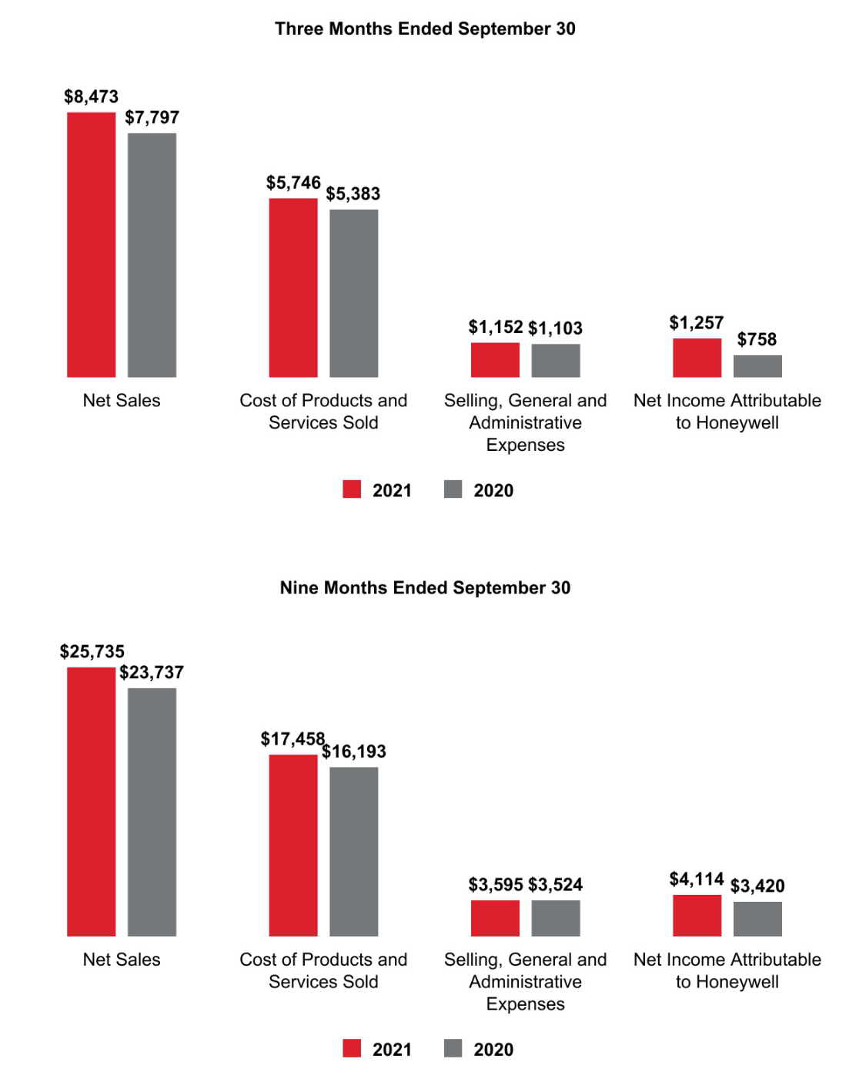

33 Honeywell International Inc.

Net Sales by Segment
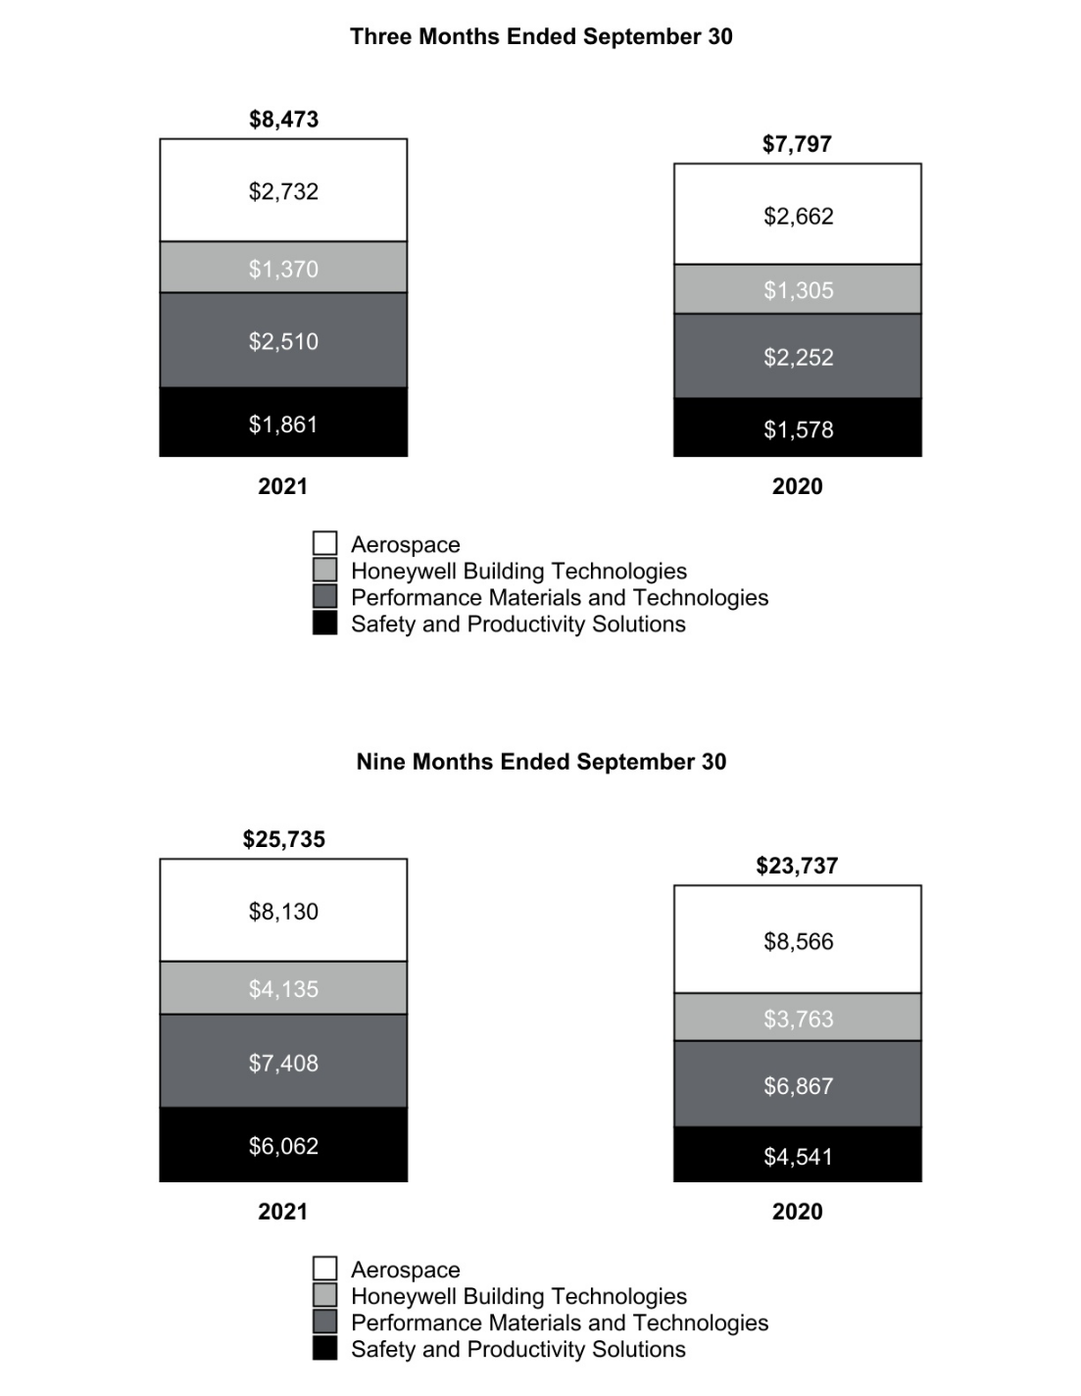

34 Honeywell International Inc.

Segment Profit by Segment
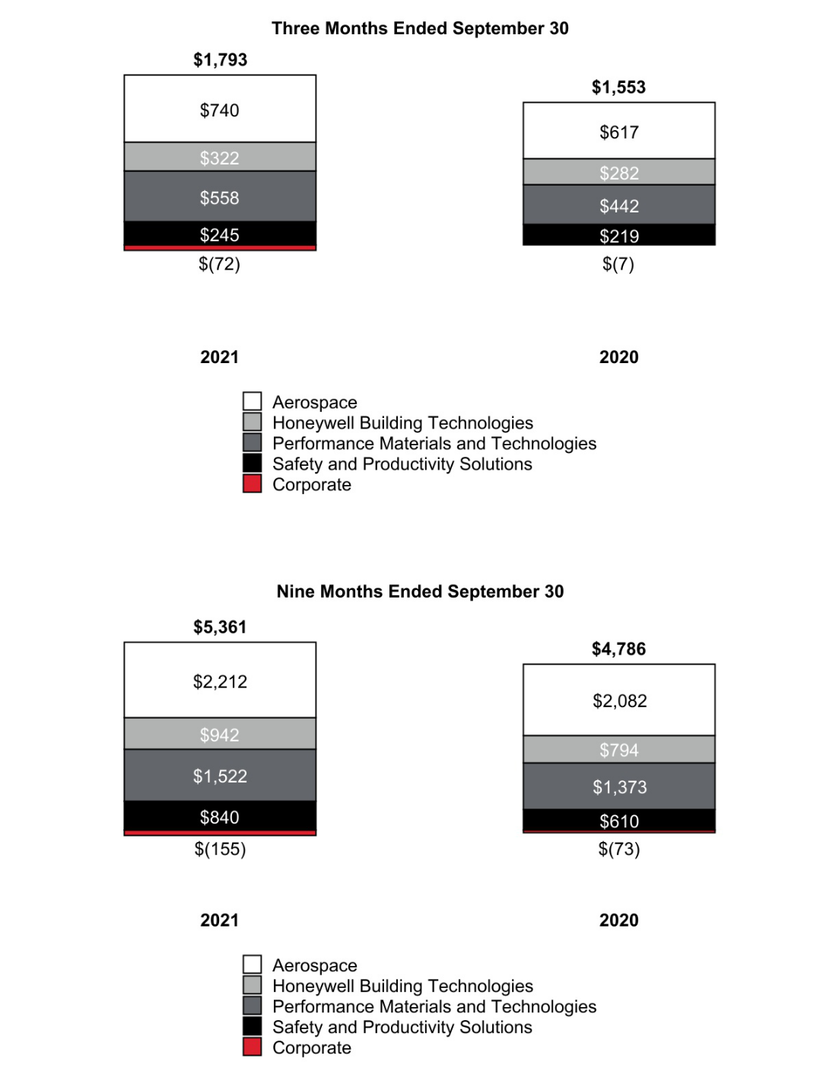

35 Honeywell International Inc.

CONSOLIDATED OPERATING RESULTS

Net Sales
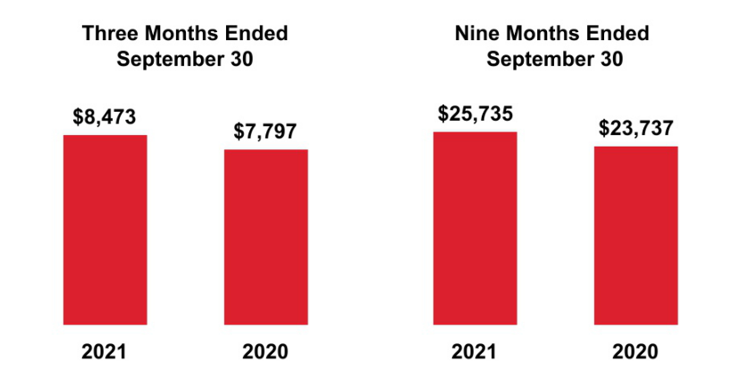

The change in net sales was attributable to the following:

 | Q3 2021 vs. Q3 2020 |  | Year to Date 2021 vs.
 |  |  | 2020
Volume | 4 % |  | 3 %
Price | 4 % |  | 3 %
Foreign Currency Translation | 1 % |  | 2 %
 | 9 % |  | 8 %

Q3 2021 compared to Q3 2020

Net sales increased due to the following:

- Higher sales volumes due to an increase in demand for certain products and services as the global economy showed signs of recovery from the COVID-19 pandemic,

- Favorable pricing, and

- The favorable impact of foreign currency translation, driven by the weakening of the U.S. Dollar against the currencies of the majority of our international markets, primarily the Australian Dollar, British Pound, Euro, and Chinese Renminbi.

YTD 2021 compared to YTD 2020

Net sales increased due to the following:

- Higher sales volumes due to an increase in demand for certain products and services as the global economy showed signs of recovery from the COVID-19 pandemic,

- Favorable pricing, and

- The favorable impact of foreign currency translation, driven by the weakening of the U.S. Dollar against the currencies of the majority of our international markets, primarily the Euro, British Pound, Australian Dollar, and Chinese Renminbi.

36 Honeywell International Inc.

Cost of Products and Services Sold
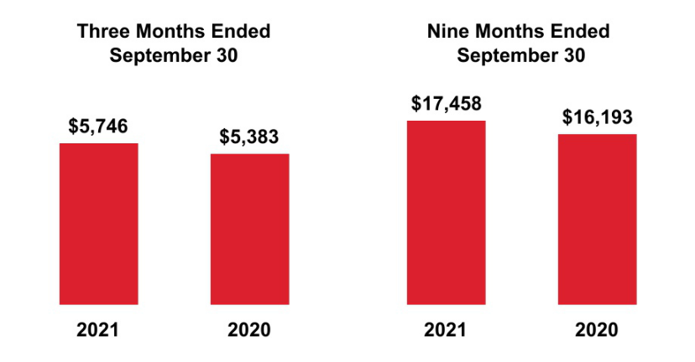

Q3 2021 compared to Q3 2020

Cost of products and services sold increased due to the following:

- Higher direct and indirect material costs of approximately $290 million and higher labor costs of approximately $80 million primarily driven by higher volumes due to an increase in demand in certain of our products and services,

- Partially offset by lower repositioning and other charges of approximately $30 million.

YTD 2021 compared to YTD 2020

Cost of products and services sold increased due to the following:

- Higher direct and indirect material costs of approximately $1,150 million and higher labor costs of approximately $80 million primarily driven by higher volumes due to an increase in demand in certain of our products and services,

- Partially offset by lower repositioning and other charges of approximately $40 million.

Gross Margin
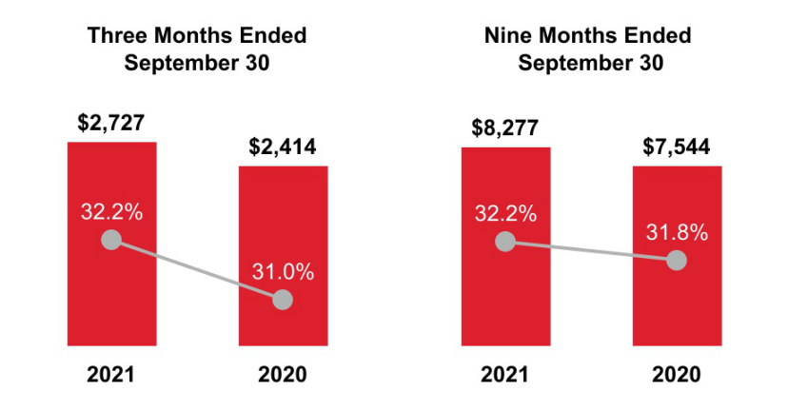

37 Honeywell International Inc.

Q3 2021 compared to Q3 2020

Gross margin and Gross margin as a percentage of net sales increased due to the following:

- Higher gross margins due to an increase in demand for certain products and services as the global economy showed signs of recovery from the COVID-19 pandemic,

- Higher volume leverage on a lower fixed-cost base,

- Lower repositioning and other charges of approximately $30 million, and

- Favorable pricing,

- Partially offset by a larger portion of our sales being driven by our Safety and Productivity Solutions segment.

YTD 2021 compared to YTD 2020

Gross margin and Gross margin as a percentage of net sales increased due to the following:

- Higher gross margins due to an increase in demand for certain products and services as the global economy showed signs of recovery from the COVID-19 pandemic,

- Higher volume leverage on a lower fixed-cost base,

- Lower repositioning and other charges of approximately $40 million, and

- Favorable pricing,

- Partially offset by a larger portion of our sales being driven by our Safety and Productivity Solutions segment.

Selling, General and Administrative Expenses
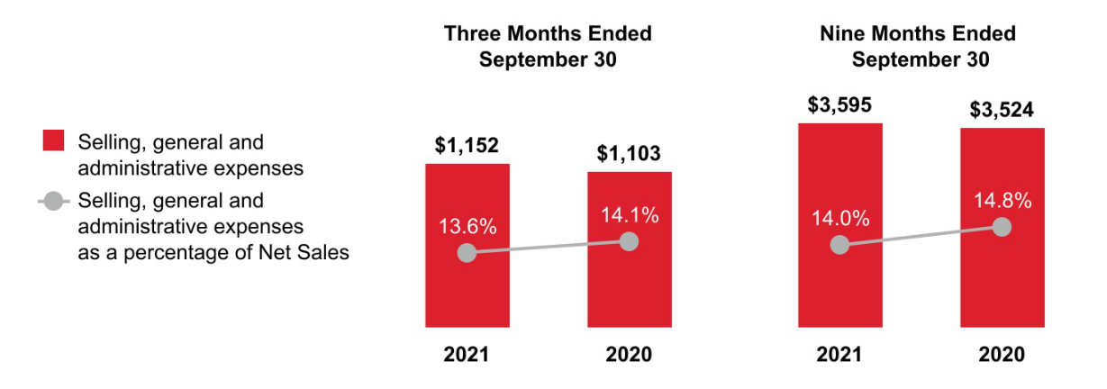

Q3 2021 compared to Q3 2020

Selling, general and administrative expenses increased due to the following:

- Higher expenses due to increased sales volumes and labor expense,

- Partially offset by cost savings from repositioning actions.

Selling, general and administrative expenses as a percentage of net sales decreased due to net sales growing at a faster rate than the increase in selling, general and administrative expenses.

38 Honeywell International Inc.

YTD 2021 compared to YTD 2020

Selling, general and administrative expenses increased due to the following:

- Higher expenses due to increased sales volumes, the unfavorable impact of foreign currency translation and labor expense,

- Partially offset by cost savings from repositioning actions.

Selling, general and administrative expenses as a percentage of net sales decreased due to net sales growing at a faster rate than the increase in selling, general and administrative expenses.

Other (Income) Expense

 | Three Months Ended September 30, |  |  |  |  |  |  | Nine Months Ended September 30,
 |  | 2021 |  |  | 2020 |  |  | 2021 |  |  | 2020
Other (income) expense | $ | (215) |  | $ | 62 |  | $ | (1,023) |  | $ | (546)

Q3 2021 compared to Q3 2020

Other income increased due to the following:

- Prior year non-cash charge associated with the reduction in carrying value to present value of reimbursement receivables due from Garrett,

- Higher pension income,

- Partially offset by the recognition of an expense related to UOP matters.

YTD 2021 compared to YTD 2020

Other income increased due to the following:

- Prior year non-cash charge associated with the reduction in carrying value to present value of reimbursement receivables due from Garrett,

- Higher pension income, and

- Gain on sale of the retail footwear business,

- Partially offset by the recognition of an expense related to UOP matters.

39 Honeywell International Inc.

Tax Expense
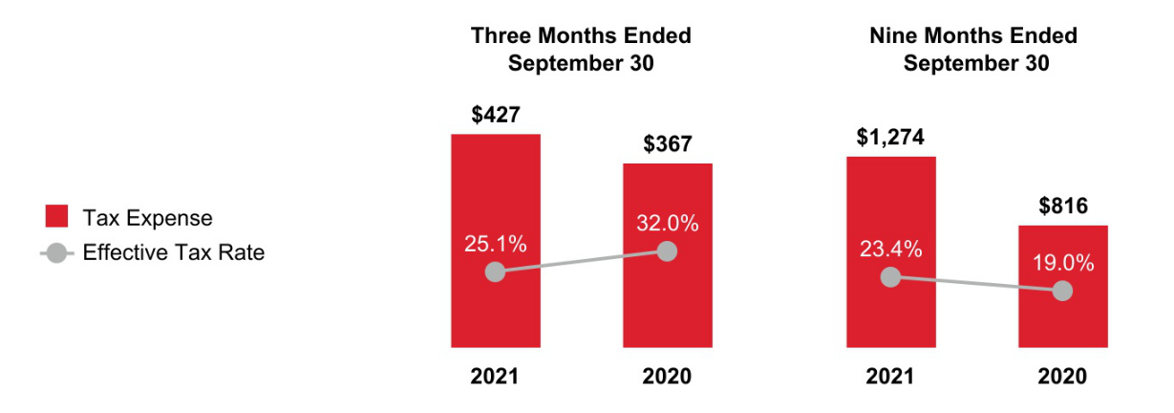

Q3 2021 compared to Q3 2020

The effective tax rate decreased due to the absence of a non-cash charge related to the reduction of the aggregate carrying value of certain receivables with no corresponding tax benefit in the prior year, partially offset by the recognition of an expense related to UOP matters with no corresponding tax benefit, incremental tax reserves and state taxes, increased tax benefits for employee share-based compensation and the favorable resolution of certain foreign tax matters in the current year.

The effective tax rate for the three months ended September 30, 2021, was higher than the U.S. federal statutory rate of 21% primarily due to the recognition of an expense related to UOP matters with no corresponding tax benefit, incremental tax reserves and state taxes, partially offset by tax benefits for employee share-based compensation and the resolution of certain foreign tax matters.

The effective tax rate for the three months ended September 30, 2020 was higher than the U.S. federal statutory rate of 21% primarily from a non-cash charge related to the reduction of the aggregate carrying value of certain receivables with no corresponding tax benefit, incremental tax reserves and state taxes partially offset by foreign earnings taxed at lower foreign tax rates.

YTD 2021 compared to YTD 2020

The effective tax rate increased during 2021 compared to 2020 primarily from the recognition of an expense related to UOP matters with no corresponding tax benefit, incremental tax reserves and state taxes partially offset by increased tax benefits for employee share-based compensation and the favorable resolution of certain foreign tax matters in the current year along with the absence of prior year items including a non-cash charge related to the reduction of the aggregate carrying value of certain receivables with no corresponding tax benefit, tax benefits realized as a result of the favorable resolution of a foreign tax matter related to the spin-off transactions, tax law changes in India and the resolution of certain U.S. tax matters.

40 Honeywell International Inc.

Net Income Attributable to Honeywell
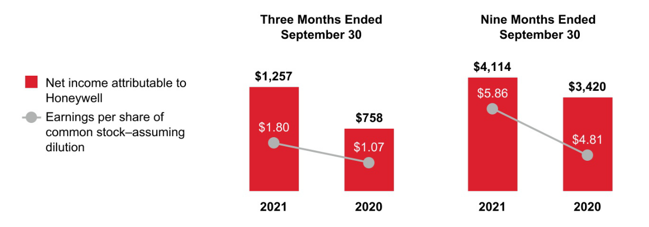

Q3 2021 compared to Q3 2020

Earnings per share of common stock–assuming dilution increased, driven by the following:

- Prior year non-cash charge associated with the reduction in carrying value to present value of reimbursement receivables due from Garrett,

- Higher segment profit,

- Higher pension income,

- Lower repositioning and other charges, and

- Favorable impact of lower share count,

- Partially offset by the recognition of an expense related to UOP matters and higher income taxes.

YTD 2021 compared to YTD 2020

Earnings per share of common stock–assuming dilution increased, driven by the following:

- Higher segment profit,

- Prior year non-cash charge associated with the reduction in carrying value to present value of reimbursement receivables due from Garrett,

- Higher pension income,

- Lower repositioning and other charges,

- Gain on sale of the retail footwear business, and

- Favorable impact of lower share count,

- Partially offset by higher income taxes and the recognition of an expense related to UOP matters.

41 Honeywell International Inc.

REVIEW OF BUSINESS SEGMENTS

We globally manage our business operations through four segments: Aerospace, Honeywell Building Technologies, Performance Materials and Technologies, and Safety and Productivity Solutions.

AEROSPACE

NET SALES
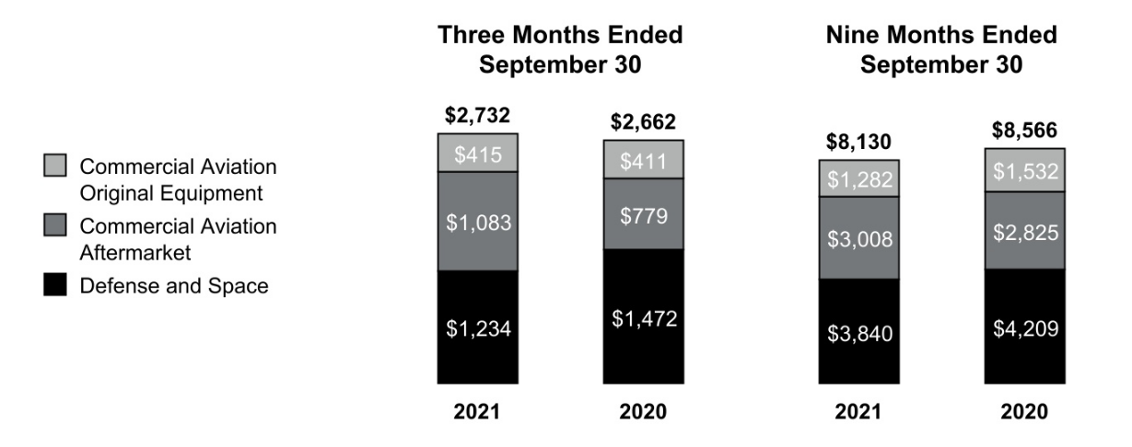

 |  |  | Three Months Ended |  |  |  |  |  |  |  |  |  |  |  |  | Nine Months Ended
 |  |  |  |  | September 30, |  |  |  |  |  |  |  |  |  |  |  |  |  | September 30,
 |  |  | 2021 |  |  | 2020 |  |  | % |  |  |  |  | 2021 |  |  |  |  |  | 2020 |  |  | %
 |  |  | 2021 |  |  | 2020 |  |  | Change |  |  |  |  | 2021 |  |  |  |  |  | 2020 |  |  | Change
Net sales |  | $ | 2,732 |  | $ | 2,662 |  |  | 3 % |  |  | $ |  | 8,130 |  | $ |  |  |  | 8,566 |  |  | (5)%
Cost of products and services sold |  |  | 1,828 |  |  | 1,854 |  |  |  |  |  |  |  | 5,330 |  |  |  |  |  | 5,848
Selling, general and administrative and other expenses |  |  | 164 |  |  | 191 |  |  |  |  |  |  |  | 588 |  |  |  |  |  | 636
Segment profit |  | $ | 740 |  | $ | 617 |  |  | 20 % |  |  |  | $ | 2,212 |  |  |  |  | $ | 2,082 |  |  | 6 %
 |  |  |  |  |  |  |  |  |  |  |  |  |  | 2021 vs. 2020
 |  |  |  |  |  |  |  |  | Three Months Ended |  |  |  |  |  |  |  |  |  |  | Nine Months Ended
 |  |  |  |  |  |  |  |  | September 30, |  |  |  |  |  |  |  |  |  |  | September 30,
Factors Contributing to Year-Over-Year Change |  |  |  |  |  |  |  |  | Sales |  |  | Segment |  |  |  |  |  |  |  | Sales |  |  | Segment
 |  |  |  |  |  |  |  |  |  |  |  |  | Profit |  |  |  |  |  |  |  |  |  | Profit
Organic⁽¹⁾ |  |  |  |  |  |  |  |  | 2 % |  |  |  |  | 17 % |  |  |  |  |  | (6)% |  |  | 5 %
Foreign currency translation |  |  |  |  |  |  |  |  | — % |  |  |  |  | 1 % |  |  |  |  |  | 1 % |  |  | — %
Acquisitions, divestitures and other, net |  |  |  |  |  |  |  |  | 1 % |  |  |  |  | 2 % |  |  |  |  |  | — % |  |  | 1 %
Total % change |  |  |  |  |  |  |  |  | 3 % |  |  |  |  | 20 % |  |  |  |  |  | (5)% |  |  | 6 %

- Organic sales % change is defined as the change in net sales, excluding the impact on sales from foreign currency translation and acquisitions, net of divestitures, for the first 12 months following the transaction date. We believe this measure is useful to investors and management in understanding our ongoing operations and in analysis of ongoing operating trends.

Q3 2021 compared to Q3 2020

Sales increased primarily due to higher demand for our commercial OEMs and aftermarket products and services, and favorable pricing, partially offset by lower demand in domestic and international defense.

- Commercial Aviation Original Equipment sales increased 1% (increased 1% organic) due to increases in regional and business aviation, partially offset by lower demand from air transport.

42 Honeywell International Inc.

- Commercial Aviation Aftermarket sales increased 39% (increased 38% organic) due to higher demand in air transport and regional and business aviation.

- Defense and Space sales decreased 16% (decreased 17% organic) driven by supply chain constraints and lower demand in U.S. and international defense.

Cost of products and services sold decreased due to higher sales volumes of higher margin products and higher productivity.

Segment profit increased due to favorable pricing, higher sales volumes of higher margin products, and increased productivity.

YTD 2021 compared to YTD 2020

Sales decreased due to weakness in global travel due to the COVID-19 pandemic, resulting in lower demand for our products and services from the commercial aviation markets, and a decrease in demand from domestic and international defense spend, partially offset by favorable pricing and favorable impact of foreign currency translation.

- Commercial Aviation Original Equipment sales decreased 16% (decreased 17% organic) due to lower demand from air transport and regional and business aviation.

- Commercial Aviation Aftermarket sales increased 6% (increased 6% organic) due to higher demand in regional and business aviation, partially offset by lower demand in air transport.

- Defense and Space sales decreased 9% (decreased 10% organic) driven by lower demand in U.S and international defense.

Cost of products and services sold decreased due to lower sales volumes and higher productivity.

Segment profit increased due to favorable pricing, higher productivity, and higher sales volumes of higher margin products, partially offset by lower sales volumes.

HONEYWELL BUILDING TECHNOLOGIES

NET SALES
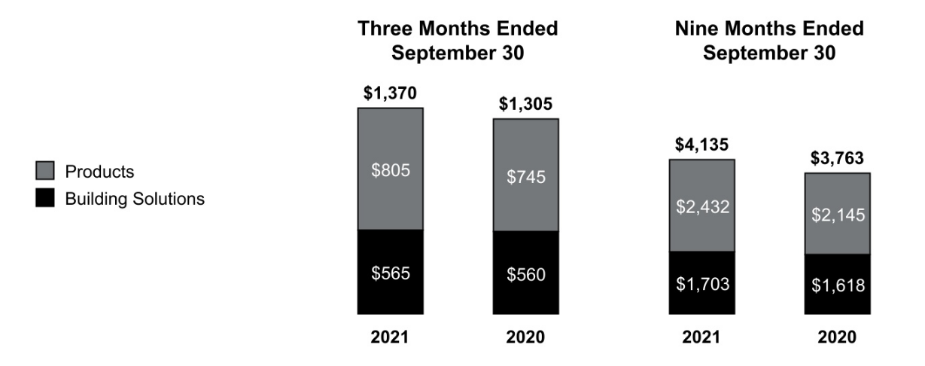

43 Honeywell International Inc.

 |  |  | Three Months Ended |  |  |  |  |  |  |  |  |  |  |  | Nine Months Ended
 |  |  |  |  | September 30, |  |  |  |  |  |  |  |  |  |  |  |  | September 30,
 |  | 2021 |  |  |  | 2020 |  |  | % Change |  |  |  |  | 2021 |  |  |  |  | 2020 |  |  |  |  | % Change
Net sales | $ | 1,370 | $ |  |  | 1,305 |  |  | 5 % |  |  |  | $ | 4,135 | $ |  |  |  | 3,763 |  |  |  |  | 10 %
Cost of products and services sold |  | 798 |  |  |  | 770 |  |  |  |  |  |  |  | 2,409 |  |  |  |  | 2,223
Selling, general and administrative and other expenses |  | 250 |  |  |  | 253 |  |  |  |  |  |  |  | 784 |  |  |  |  | 746
Segment profit | $ | 322 |  |  | $ | 282 |  |  | 14 % |  |  |  | $ | 942 |  |  |  | $ | 794 |  |  |  |  | 19 %
 |  |  |  |  |  |  |  |  |  |  |  |  |  | 2021 vs. 2020
 |  |  |  |  |  |  |  |  | Three Months Ended |  |  |  |  |  |  |  |  |  | Nine Months Ended
 |  |  |  |  |  |  |  |  | September 30, |  |  |  |  |  |  |  |  |  | September 30,
Factors Contributing to Year-Over-Year Change |  |  |  |  |  |  |  |  | Sales |  |  |  | Segment |  |  |  |  |  | Sales |  |  |  |  | Segment
 |  |  |  |  |  |  |  |  |  |  |  |  |  | Profit |  |  |  |  |  |  |  |  |  | Profit
Organic |  |  |  |  |  |  |  |  | 3 % |  |  |  |  | 14 % |  |  |  |  | 6 % |  |  |  |  | 15 %
Foreign currency translation |  |  |  |  |  |  |  |  | 2 % |  |  |  |  | 1 % |  |  |  |  | 4 % |  |  |  |  | 5 %
Acquisitions, divestitures and other, net |  |  |  |  |  |  |  |  | — % |  |  |  |  | (1)% |  |  |  |  | — % |  |  |  |  | (1)%
Total % change |  |  |  |  |  |  |  |  | 5 % |  |  |  |  | 14 % |  |  |  |  | 10 % |  |  |  |  | 19 %

Q3 2021 compared to Q3 2020

Sales increased due to increased pricing in response to the rising cost of materials and the favorable impact of foreign currency translation.

- Sales in Products increased 8% (increased 6% organic) due to higher sales volumes, increased pricing, and the favorable impact of foreign currency translation.

- Sales in Building Solutions increased 1% (decreased 1% organic) due to the favorable impact of foreign currency translation and increased pricing, partially offset by lower sales volumes due to project delays.

Cost of products and services sold increased primarily due to the rising cost of materials and the unfavorable impact of foreign currency translation, partially offset by higher productivity.

Segment profit increased primarily due to higher productivity and higher sales volumes of higher margin products.

YTD 2021 compared to YTD 2020

Sales increased due to the favorable impact of foreign currency translation, higher sales volumes, and favorable pricing. Customer demand increased as the global economy began to show signs of recovery.

- Sales in Products increased 13% (increased 9% organic) due to higher sales volumes, favorable pricing, and the favorable impact of foreign currency translation.

- Sales in Building Solutions increased 5% (increased 1% organic) due to the favorable impact of foreign currency translation and favorable pricing.

Cost of products and services sold increased due to higher sales volumes, and the unfavorable impact of foreign currency translation, partially offset by higher productivity.

Segment profit increased due to favorable pricing, higher productivity, the favorable impact of foreign currency translation, and higher sales volumes.

44 Honeywell International Inc.

PERFORMANCE MATERIALS AND TECHNOLOGIES

NET SALES
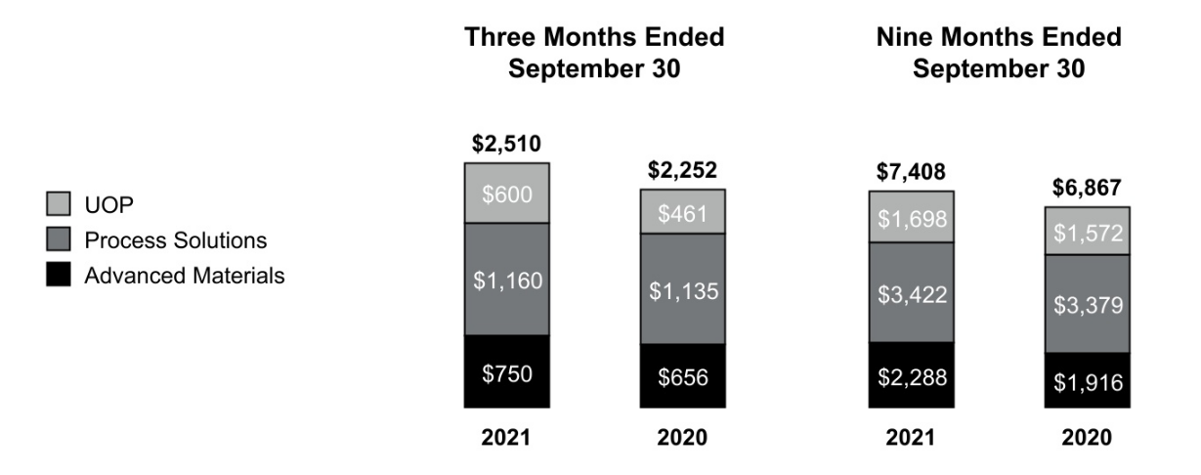

 |  |  | Three Months Ended |  |  |  |  |  |  |  |  |  | Nine Months Ended
 |  |  |  |  | September 30, |  |  |  |  |  |  |  |  |  | September 30,
 |  | 2021 |  |  |  | 2020 |  |  | % |  |  | 2021 |  |  |  | 2020 |  |  | %
 |  | 2021 |  |  |  | 2020 |  |  | Change |  |  | 2021 |  |  |  | 2020 |  |  | Change
Net sales | $ | 2,510 | $ |  |  | 2,252 |  |  | 11 % |  | $ | 7,408 | $ |  |  | 6,867 |  |  | 8 %
Cost of products and services sold |  | 1,653 |  |  |  | 1,523 |  |  |  |  |  | 4,940 |  |  |  | 4,572
Selling, general and administrative and other expenses |  | 299 |  |  |  | 287 |  |  |  |  |  | 946 |  |  |  | 922
Segment profit | $ | 558 | $ |  |  | 442 |  |  | 26 % |  | $ | 1,522 | $ |  |  | 1,373 |  |  | 11 %

 |  |  | 2021 vs. 2020
 | Three Months Ended |  |  |  | Nine Months Ended September
 | September 30, |  |  |  | 30,
Factors Contributing to Year-Over-Year Change | Sales |  | Segment |  | Sales |  |  | Segment
Factors Contributing to Year-Over-Year Change |  |  | Profit |  |  |  |  | Profit
Organic | 9 % |  | 26 % |  | 4 % |  |  | 9 %
Foreign currency translation | 1 % |  | 1 % |  | 3 % |  |  | 3 %
Acquisitions, divestitures, and other, net | 1 % |  | (1)% |  | 1 % |  |  | (1)%
Total % change | 11 % |  | 26 % |  | 8 % |  |  | 11 %

Q3 2021 compared to Q3 2020

Sales increased due to higher sales volumes, favorable pricing, the acquisition of Sparta Systems, and the favorable impact of foreign currency translation. Increased activity in the oil and gas industry and higher demand within Advanced Materials resulted in higher sales of our products and services.

- UOP sales increased 30% (increased 29% organic) due to higher demand for oil and gas products.

- Process Solutions sales increased 2% (decreased 2% organic) driven by the acquisition of Sparta Systems and the favorable impact of foreign currency translation.

- Advanced Materials sales increased 14% (increased 14% organic) driven by increased demand in specialty and fluorine products.

Cost of products and services sold increased due to higher sales volumes and the rising cost of materials, partially offset by higher productivity.

45 Honeywell International Inc.

Segment profit increased due to favorable pricing and higher productivity, partially offset by the rising cost of materials.

YTD 2021 compared to YTD 2020

Sales increased due to the favorable impact of foreign currency translation, favorable pricing, the acquisition of Sparta Systems, and higher sales volumes. There was higher demand within Advanced Materials and increased activity in the oil and gas industry which positively impacted many of our UOP customers.

- UOP sales increased 8% (increased 6% organic) due to higher demand for oil and gas products and services and the favorable impact of foreign currency translation.

- Process Solutions sales increased 1% (decreased 4% organic) driven by the acquisition of Sparta Systems and the favorable impact of foreign currency translation, partially offset by lower demand for products and services.

- Advanced Materials sales increased 19% (increased 17% organic) driven by increased demand in fluorine and specialty products and the favorable impact of foreign currency translation.

Cost of products and services sold increased due to higher sales volumes of lower margin products, the rising cost of materials, and the unfavorable impact of foreign currency translation, partially offset by higher productivity.

Segment profit increased due to favorable pricing, higher productivity, and the favorable impact of foreign currency translation, partially offset by the rising cost of materials, and higher sales volumes of lower margin products.

46 Honeywell International Inc.

SAFETY AND PRODUCTIVITY SOLUTIONS

NET SALES
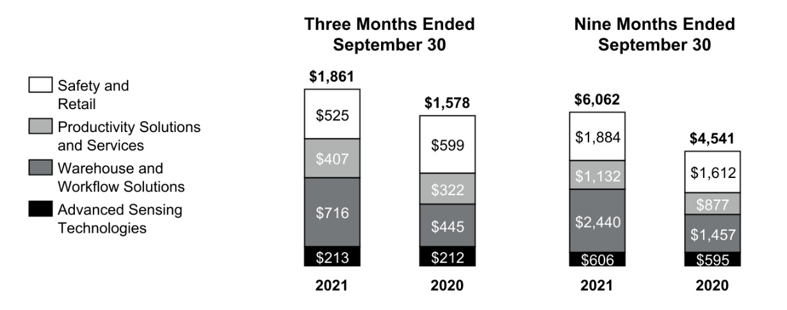

 |  |  | Three Months Ended |  |  |  |  |  |  |  |  |  |  |  | Nine Months Ended
 |  |  |  |  | September 30, |  |  |  |  |  |  |  |  |  |  |  |  | September 30,
 |  | 2021 |  |  |  | 2020 |  |  | % |  |  |  |  | 2021 |  |  |  |  | 2020 |  |  |  |  | %
 |  | 2021 |  |  |  | 2020 |  |  | Change |  |  |  |  | 2021 |  |  |  |  | 2020 |  |  |  |  | Change
Net sales | $ | 1,861 | $ |  |  | 1,578 |  |  | 18 % |  |  |  | $ | 6,062 | $ |  |  |  | 4,541 |  |  |  |  | 33 %
Cost of products and services sold |  | 1,369 |  |  |  | 1,113 |  |  |  |  |  |  |  | 4,442 |  |  |  |  | 3,164
Selling, general and administrative and other expenses |  | 247 |  |  |  | 246 |  |  |  |  |  |  |  | 780 |  |  |  |  | 767
Segment profit | $ | 245 |  |  | $ | 219 |  |  | 12 % |  |  |  | $ | 840 |  |  |  | $ | 610 |  |  |  |  | 38 %
 |  |  |  |  |  |  |  |  |  |  |  |  |  | 2021 vs. 2020
 |  |  |  |  |  |  |  |  | Three Months Ended |  |  |  |  |  |  |  |  |  | Nine Months Ended
 |  |  |  |  |  |  |  |  | September 30, |  |  |  |  |  |  |  |  |  | September 30,
Factors Contributing to Year-Over-Year Change |  |  |  |  |  |  |  |  | Sales |  |  |  | Segment |  |  |  |  |  | Sales |  |  |  |  | Segment
 |  |  |  |  |  |  |  |  |  |  |  |  |  | Profit |  |  |  |  |  |  |  |  |  | Profit
Organic |  |  |  |  |  |  |  |  | 21 % |  |  |  |  | 14 % |  |  |  |  | 34 % |  |  |  |  | 36 %
Foreign currency translation |  |  |  |  |  |  |  |  | 1 % |  |  |  |  | 3 % |  |  |  |  | 2 % |  |  |  |  | 4 %
Acquisitions, divestitures, and other, net |  |  |  |  |  |  |  |  | (4)% |  |  |  |  | (5)% |  |  |  |  | (3)% |  |  |  |  | (2)%
Total % change |  |  |  |  |  |  |  |  | 18 % |  |  |  |  | 12 % |  |  |  |  | 33 % |  |  |  |  | 38 %

Q3 2021 compared to Q3 2020

Sales increased due to higher sales volumes and favorable pricing, partially offset by the sale of the retail footwear business. The higher sales volumes were primarily driven by warehouse automation and services and Productivity Solutions and Services.

- Sales in Safety and Retail decreased 12% (decreased 5% organic) due to the sale of the retail footwear business and lower sales volumes, partially offset by favorable pricing.

- Sales in Productivity Solutions and Services increased 26% (increased 25% organic) due to higher demand.

- Sales in Warehouse and Workflow Solutions increased 61% (increased 60% organic) due to higher sales volumes. Sales volume growth was driven by strong demand for our warehouse automation and services.

- Sales in Advanced Sensing Technologies was flat (decreased 1% organic) due to the favorable impact of foreign currency translation, offset by lower sales volumes.

47 Honeywell International Inc.

Cost of products and services sold increased due to higher sales volumes on lower margin products, the rising cost of materials, and labor installation inefficiencies due to supply chain constraints.

Segment profit increased primarily due to higher sales volumes, partially offset by higher sales of lower margin products, the rising cost of materials, and labor installation inefficiencies due to supply chain constraints.

YTD 2021 compared to YTD 2020

Sales increased due to higher sales volumes, favorable pricing, and the favorable impact of foreign currency translation, partially offset by the sale of the retail footwear business. The higher sales volumes were driven by warehouse automation and services and Productivity Solutions and Services.

- Sales in Safety and Retail increased 17% (increased 21% organic) due to higher sales volumes, favorable pricing, and the favorable impact of foreign currency translation, partially offset by the sale of the retail footwear business.

- Sales in Productivity Solutions and Services increased 29% (increased 26% organic) due to higher demand and the favorable impact of foreign currency translation.

- Sales in Warehouse and Workflow Solutions increased 67% (increased 66% organic) due to higher sales volumes. Sales volume growth was driven by strong demand for our warehouse automation and services.

- Sales in Advanced Sensing Technologies increased 2% (decreased 1% organic) due to the favorable impact of foreign currency translation, partially offset by lower sales volumes.

Cost of products and services sold increased due to higher sales volumes on lower margin products, the rising cost of materials, and the unfavorable impact of foreign currency translation.

Segment profit increased primarily due to higher sales volumes, partially offset by higher sales volumes of lower margin products, and the rising cost of materials.

REPOSITIONING CHARGES

See Note 5 Repositioning and Other Charges of Notes to Consolidated Financial Statements for a discussion of our repositioning actions and related charges incurred in the nine months ended September 30, 2021 and 2020. Cash spending related to our repositioning actions was $286 million in the nine months ended September 30, 2021, and was funded through operating cash flows.

LIQUIDITY AND CAPITAL RESOURCES

(Dollars in tables in millions)

We continue to manage our businesses to maximize operating cash flows as the primary source of liquidity. Each of our businesses is focused on increasing operating cash flows through revenue growth, margin expansion and improved working capital turnover. Additional sources of liquidity include committed credit lines, short-term debt from the commercial paper market, long-term borrowings, access to the public debt and equity markets, U.S. cash balances and the ability to access non-U.S. cash as a result of the U.S. Tax Cuts and Jobs Act.

CASH

We monitor the third-party depository institutions that hold our cash and cash equivalents on a daily basis. Our emphasis is primarily safety of principal and secondarily maximizing yield of those funds. We diversify our cash and cash equivalents among counterparties to minimize exposure to any one of these entities. As of September 30, 2021, and December 31, 2020, we held $12.1 billion and $15.2 billion, respectively, of cash and cash equivalents, including our short-term investments.

48 Honeywell International Inc.

BORROWINGS

Consolidated total borrowings were $21.2 billion and $22.4 billion as of September 30, 2021, and December 31, 2020.

 |  | September 30, 2021 |  |  | December 31, 2020
Commercial paper and other short-term borrowings | $ | 3,559 |  | $ | 3,597
Variable rate notes |  | 622 |  |  | 1,122
Fixed rate notes |  | 16,897 |  |  | 17,399
Other |  | 171 |  |  | 266
Total borrowings | $ | 21,249 |  | $ | 22,384

A source of liquidity is our ability to access the commercial paper market. Commercial paper notes are sold at a discount or premium and have a maturity of not more than 365 days from date of issuance. Borrowings under the commercial paper program are available for general corporate purposes as well as for financing acquisitions.

We also have the following revolving credit agreements, which can provide financing for general corporate purposes:

- A $1.5 billion 364-Day Credit Agreement (the 364-Day Credit Agreement) with a syndicate of banks, dated March 31, 2021. Amounts borrowed under the 364-Day Credit Agreement are required to be repaid no later than March 30, 2022, unless (i) we elect to convert all then outstanding amounts into a term loan, upon which such amounts shall be repaid in full on March 30, 2023, or (ii) the 364-Day Credit Agreement is terminated earlier pursuant to its terms. The 364-Day Credit Agreement replaces the previously reported $1.5 billion 364-day credit agreement dated as of April 10, 2020, which was terminated in accordance with its terms effective March 31, 2021. As of September 30, 2021, there were no outstanding borrowings under our 364-Day Credit Agreement.

- A $4.0 billion Five Year Credit Agreement (the 5-Year Credit Agreement) with a syndicate of banks, dated March 31, 2021. Commitments under the 5-Year Credit Agreement can be increased pursuant to the terms of the 5-Year Credit Agreement to an aggregate amount not to exceed $4.5 billion. The 5-Year Credit Agreement amended and restated the previously reported $4.0 billion amended and restated five year credit agreement dated as of April 26, 2019. As of September 30, 2021, there were no outstanding borrowings under our 5-Year Credit Agreement.

We also have a current shelf registration statement with the SEC under which we may issue additional debt securities, common stock and preferred stock that may be offered in one or more offerings on terms to be determined at the time of the offering. We anticipate that net proceeds of any offering would be used for general corporate purposes, including repayment of existing indebtedness, share repurchases, capital expenditures and acquisitions.

For additional information, see Note 9 Long-Term Debt and Credit Agreements for discussion of long-term debt issuances and redemptions during the nine months ended September 30, 2021.

49 Honeywell International Inc.

CREDIT RATINGS

Our ability to access the global debt capital markets and the related cost of these borrowings, is affected by the strength of our credit rating and market conditions. Our credit ratings are periodically reviewed by the major independent debt-rating agencies. As of September 30, 2021, Standard & Poor's (S&P), Fitch, and Moody’s have ratings on our debt set forth in the table below:

 | S&P |  | Fitch |  | Moody's
Outlook | Stable |  | Stable |  | Stable
Short-term | A-1 |  | F1 |  | P1
Long-term | A |  | A |  | A2

CASH FLOW SUMMARY

Our cash flows from operating, investing and financing activities, as reflected in the Consolidated Statement of Cash Flows, are summarized as follows:

 |  | Nine Months Ended September 30,
 |  | 2021 |  |  | 2020
Cash provided by (used for):
Operating activities | $ | 3,375 |  | $ | 3,426
Investing activities |  | (1,347) |  |  | (410)
Financing activities |  | (5,195) |  |  | 1,972
Effect of exchange rate changes on cash |  | (21) |  |  | (19)
Net increase (decrease) in cash and cash equivalents | $ | (3,188) |  | $ | 4,969

Cash provided by operating activities decreased by $51 million due to an unfavorable impact to working capital of $ 427 million, a net unfavorable impact of changes in assets and liabilities, which resulted in a $183 million use of cash during the nine months ended September 30, 2021, compared to providing cash of $ 135 million during the nine months ended September 30, 2020. The overall change was partially offset by an increase in net income of $694 million.

Cash used for investing activities increased by $937 million primarily due to $1,334 million in cash paid for acquisitions and $346 million net increase in investments, partially offset by $375 million cash receipt from Garrett Motion Inc. (Garrett), $ 203 million in proceeds from the sale of the retail footwear business, and $163 million increase in cash receipts from settlements of derivative contracts.

Cash used for financing activities increased by $7,167 million primarily due to $7,596 million decrease of proceeds from the issuance of long-term debt, $350 million increase in repurchases of common stock, $62 million decrease in the net proceeds from the issuance of commercial paper and other short-term borrowings, and $29 million increase in cash dividends paid. This was partially offset by a $882 million decrease in repayments of long-term debt.

CASH REQUIREMENTS AND ASSESSMENT OF CURRENT LIQUIDITY

In addition to our normal operating cash requirements, our principal future cash requirements will be to fund capital expenditures, share repurchases, dividends, strategic acquisitions and debt repayments. On February 12, 2021, the Board of Directors authorized the repurchase of up to a total of $10 billion of Honeywell common stock, which included amounts remaining under, and replaced, the previously approved share repurchase program. During the nine months ended September 30, 2021, the Company repurchased common stock of $2,499 million. Refer to the section titled Liquidity and Capital Resources of our 2020 Form 10-K for a discussion of our expected capital expenditures, share repurchases and dividends for 2021.

We continue to identify opportunities to improve our liquidity and working capital efficiency, which includes the extension of payment terms with our suppliers and sales of our trade receivables to unaffiliated financial institutions without recourse. The impact of these programs are not material to our overall liquidity.

50 Honeywell International Inc.

We continue to assess the relative strength of each business in our portfolio as to strategic fit, market position, profit and cash flow contribution in order to identify target investment and acquisition opportunities in order to upgrade our combined portfolio. We identify acquisition candidates that will further our strategic plan and strengthen our existing core businesses. We also identify businesses that do not fit into our long-term strategic plan based on their market position, relative profitability or growth potential. These businesses are considered for potential divestiture, restructuring or other repositioning actions, subject to regulatory constraints.

Based on past performance and current expectations, we believe that our operating cash flows will be sufficient to meet our future operating cash needs. Our available cash, committed credit lines and access to the public debt and equity markets provide additional sources of short-term and long-term liquidity to fund current operations, debt maturities, and future investment opportunities.

See Note 9 Long-term Debt and Credit Agreements of Notes to Consolidated Financial Statements for additional discussion of items impacting our liquidity.

OTHER MATTERS

LITIGATION

We are subject to a number of lawsuits, investigations and claims (some of which involve substantial amounts) arising out of the conduct of our business. See Note 15 Commitments and Contingencies of Notes to Consolidated Financial Statements for further discussion of environmental, asbestos and other litigation matters.

CRITICAL ACCOUNTING ESTIMATES

Other than as noted below, there have been no material changes to our Critical Accounting Estimates presented in our 2020 Annual Report on Form 10-K. For a discussion of the Company’s Critical Accounting Estimates, see the section titled Critical Accounting Estimates in our 2020 Annual Report on Form 10-K.

On April 26, 2021, the United States Bankruptcy Court for the Southern District of New York (the Bankruptcy Court) confirmed Garrett's amended Chapter 11 plan of reorganization (the Confirmed Plan) and on April 30, 2021, Garrett emerged from bankruptcy. In accordance with Garrett’s emergence from bankruptcy and the Confirmed Plan, the Company received from Garrett an initial payment of $375 million and 834.8 million shares of Series B Preferred Stock in full satisfaction of our indemnification and reimbursement agreement and tax matters agreement. As a result, we updated our Critical Accounting Estimate for Reimbursement Receivables to exclude receivable amounts from Garrett which were satisfied in full. See Note 15 Commitments and Contingencies of Notes to the Consolidated Financial Statements for further discussion on Garrett.

Reimbursement Receivables—In conjunction with the Resideo Technologies, Inc. (Resideo) spin-off, the Company entered into a reimbursement agreement under which Honeywell receives cash payments as reimbursement primarily related to net spending for environmental matters at certain sites as defined in the reimbursement agreement. Accordingly, the Company recorded receivables based on estimates of the underlying reimbursable Honeywell environmental spend, and we monitor the recoverability of such receivables, which are subject to the terms of applicable credit agreements and general ability to pay.

RECENT ACCOUNTING PRONOUNCEMENTS

See Note 2 Summary of Significant Accounting Policies of Notes to Consolidated Financial Statements for a discussion of recent accounting pronouncements.

ITEM 3. QUANTITATIVE AND QUALITATIVE DISCLOSURES ABOUT MARKET RISKS

For a discussion of the Company’s quantitative and qualitative disclosures about market risks, see the section titled Quantitative and Qualitative Disclosures About Market Risks in our 2020 Annual Report on Form 10-K. As of September 30, 2021, there has been no material change in this information.

51 Honeywell International Inc.

ITEM 4. CONTROLS AND PROCEDURES

Honeywell management, including the Chief Executive Officer and Chief Financial Officer, conducted an evaluation of the effectiveness of our disclosure controls and procedures (as defined in Rules 13a-15(e) or 15d-15(e) promulgated under the Securities Exchange Act of 1934, as amended (Exchange Act)) as of the end of the period covered by this Quarterly Report on Form 10-Q. Based upon that evaluation, the Chief Executive Officer and the Chief Financial Officer concluded that such disclosure controls and procedures were effective as of the end of the period covered by this Quarterly Report on Form 10-Q to ensure information required to be disclosed in the reports that Honeywell files or submits under the Exchange Act is recorded, processed, summarized, and reported within the time periods specified in the Securities and Exchange Commission's rules and forms, and that it is accumulated and communicated to our management, including our Chief Executive Officer, our Chief Financial Officer, and our Controller, as appropriate, to allow timely decisions regarding required disclosure. There were no changes that materially affected, or are reasonably likely to materially affect, Honeywell’s internal control over financial reporting that occurred during the period covered by this Quarterly Report on Form 10-Q.

PART II. OTHER INFORMATION

ITEM 1. LEGAL PROCEEDINGS

We are subject to a number of lawsuits, investigations and claims (some of which involve substantial amounts) arising out of the conduct of our business. See Note 15 Commitments and Contingencies of Notes to Consolidated Financial Statements for a discussion of environmental, asbestos and other litigation matters.

There were no matters requiring disclosure pursuant to the requirement to disclose certain environmental matters involving potential monetary sanctions in excess of $300,000.

ITEM 1A. RISK FACTORS

Other than as noted below, there have been no material changes to our Risk Factors presented in our 2020 Annual Report on Form 10-K under the section titled Risk Factors. For further discussion of our Risk Factors, refer to the section titled Risk Factors in our 2020 Annual Report on Form 10-K.

The U.S. presidential executive order concerning mandatory COVID-19 vaccination of U.S.-based employees of companies that work on or in support of federal contracts could have a material adverse impact on our business and results of operations.

On September 9, 2021, President Biden issued an executive order requiring all employers with U.S. Government contracts to ensure that their U.S.-based employees, contractors, and subcontractors, that work on or in support of U.S. Government contracts, are fully vaccinated by December 8, 2021. The executive order includes on-site and remote U.S.-based employees, contractors and subcontractors and it only permits limited exceptions for medical and religious reasons.

In addition, on September 9, 2021, President Biden announced that he has directed OSHA to develop an ETS mandating either the full vaccination or weekly testing of employees for employers with 100 or more employees. OSHA has not issued the ETS nor provided any additional information on its contents or requirements.

It is currently not possible to predict with certainty the impact the executive order or OSHA ETS will have on our workforce. As a U.S. Government contractor, we are requiring all U.S. based employees, contractors and subcontractors that service or support our U.S. Government contracts to be fully vaccinated by December 8, 2021. Employees who are not subject to this requirement and who are not fully vaccinated may be subject to the ETS that will require them to get a COVID-19 test at least once a week. Additional vaccine mandates may be announced in jurisdictions in which our businesses operate. Our implementation of these requirements may result in attrition, including attrition of critically skilled labor, and difficulty securing future labor needs, which could have a material adverse effect on our business, financial condition, and results of operations.

52 Honeywell International Inc.

Garrett Emergence from Bankruptcy

On April 26, 2021, the Bankruptcy Court confirmed Garrett's amended Chapter 11 plan of reorganization and on April 30, 2021, Garrett emerged from bankruptcy. As such, the risk factor discussing Garrett and the potential outcome of Garrett's bankruptcy proceedings as disclosed in our 2020 Annual Report on Form 10-K under the section titled Risk Factors was no longer a risk as of June 30, 2021. See Note 15 Commitments and Contingencies of Notes to the Consolidated Financial Statements for further discussion on Garrett.

ITEM 2. UNREGISTERED SALES OF EQUITY SECURITIES AND USE OF PROCEEDS

Honeywell purchased 2,910,464 shares of its common stock, par value $1 per share, in the quarter ended September 30, 2021. On February 12, 2021, the Board of Directors authorized the repurchase of up to a total of $10 billion of Honeywell common stock, which included approximately $2.8 billion remaining under, and replaced, the previously approved share repurchase program, which was approved in April 2019, and authorized repurchases of up to $10 billion.

Repurchases may be made through a variety of methods, which could include open market purchases, accelerated share repurchase transactions, negotiated block transactions, 10b5-1 plans, other transactions that may be structured through investment banking institutions or privately negotiated, or a combination of the foregoing. Honeywell presently expects to repurchase outstanding shares from time to time (i) to offset the dilutive impact of employee stock-based compensation plans, including option exercises, restricted unit vesting and matching contributions under our savings plans, and (ii) to reduce share count via share repurchases as and when attractive opportunities arise. The amount and timing of future repurchases may vary depending on market conditions and the level of operating, financing and other investing activities.

As of September 30, 2021, $ 8.0 billion remained available for additional share repurchases. The following table summarizes Honeywell’s purchase of its common stock for the quarter ended September 30, 2021:

Issuer Purchases of Equity Securities

 |  |  |  |  |  |  |  |  | Approximate
 |  |  |  |  |  | Total Number of |  |  | Dollar Value of
 |  |  |  |  |  |  |  |  | Shares that May
 |  |  |  |  |  | Shares Purchased |  | Yet be Purchased
 | Total Number of |  |  | Average Price |  | as Part of Publicly |  |  | Under Plans or
Period |  |  |  |  |  | Announced Plans |  | Programs (Dollars
Period | Shares Purchased |  |  | Paid per Share |  | or Programs |  |  | in millions)
July 1-31, 2021 | 295,024 |  | $ | 220.55 |  | 295,024 |  | $ | 8,572
August 1-31, 2021 | 932,000 |  | $ | 230.92 |  | 932,000 |  | $ | 8,357
September 1-30, 2021 | 1,683,440 |  | $ | 219.79 |  | 1,683,440 |  | $ | 7,987

ITEM 4. MINE SAFETY DISCLOSURES

One of our wholly-owned subsidiaries has a placer claim for and operates a chabazite ore surface mine in Arizona. Information concerning mine safety and other regulatory matters associated with this mine is required by Section 1503(a) of the Dodd-Frank Wall Street Reform and Consumer Protection Act and Item 104 of Regulation S-K and is included in Exhibit 95 to this quarterly report.

53 Honeywell International Inc.

ITEM 6. EXHIBITS

Exhibit |  |  |  | Description
No.
10.1* |  | Retirement Agreement dated July 20, 2021 between Honeywell International Inc. and Rajeev Gautum, and Exhibit A
 |  | (Consulting Agreement) thereto (incorporated by reference to Exhibit 10.8 to Honeywell's Form 10-Q for the quarter |  |  | ended
 |  | June 30, 2021).
31.1 |  | Certification of Principal Executive Officer Pursuant to Section 302 of the Sarbanes-Oxley Act of 2002 (filed herewith)
31.2 |  | Certification of Principal Financial Officer Pursuant to Section 302 of the Sarbanes-Oxley Act of 2002 (filed herewith)
32.1 |  | Certification of Principal Executive Officer Pursuant to 18 U.S.C. Section 1350, as Adopted Pursuant to Section 906 of the
 |  | Sarbanes-Oxley Act of 2002 (furnished herewith)
32.2 |  | Certification of Principal Financial Officer Pursuant to 18 U.S.C. Section 1350, as Adopted Pursuant to Section 906 of the
 |  | Sarbanes-Oxley Act of 2002 (furnished herewith)

- Mine Safety Disclosures (filed herewith)

101.INS | Inline XBRL Instance Document (the instance document does not appear in the Interactive Data File because its XBRL
 | tags are embedded within the Inline XBRL document)
101.SCH | Inline XBRL Taxonomy Extension Schema (filed herewith)
101.CAL | Inline XBRL Taxonomy Extension Calculation Linkbase (filed herewith)
101.DEF | Inline XBRL Taxonomy Extension Definition Linkbase (filed herewith)
101.LAB | Inline XBRL Taxonomy Extension Label Linkbase (filed herewith)
101.PRE | Inline XBRL Taxonomy Extension Presentation Linkbase (filed herewith)

- Cover Page Interactive Data File (formatted as inline XBRL and contained in Exhibit 101) The Exhibits identified with an asterisk (*) are management contracts or compensatory plans or arrangements.

54 Honeywell International Inc.

SIGNATURES

Pursuant to the requirements of the Securities Exchange Act of 1934, the registrant has duly caused this report to be signed on its behalf by the undersigned thereunto duly authorized.

Honeywell International Inc.

Date: October 22, 2021 By: /s/ Robert D. Mailloux
Robert D. Mailloux
Vice President and Controller
(on behalf of the Registrant
and as the Registrant’s
Principal Accounting Officer)

55 Honeywell International Inc.

EXHIBIT 31.1

CERTIFICATION PURSUANT TO

SECTION 302

OF THE SARBANES-OXLEY ACT OF 2002

I, Darius Adamczyk, certify that:

- I have reviewed this Quarterly Report on Form 10-Q of Honeywell International Inc.;

- Based on my knowledge, this report does not contain any untrue statement of a material fact or omit to state a material fact necessary to make the statements made, in light of the circumstances under which such statements were made, not misleading with respect to the period covered by this report;

- Based on my knowledge, the financial statements, and other financial information included in this report, fairly present in all material respects the financial condition, results of operations and cash flows of the registrant as of, and for, the periods presented in this report;

- The registrant’s other certifying officer and I are responsible for establishing and maintaining disclosure controls and procedures (as defined in Exchange Act Rules 13a-15(e) and 15d-15(e)) and internal control over financial reporting (as defined in Exchange Act Rules
13a-15(f) and 15d-15(f)) for the registrant and have:

  - designed such disclosure controls and procedures, or caused such disclosure controls and procedures to be designed under our supervision, to ensure that material information relating to the registrant, including its consolidated subsidiaries, is made known to us by others within those entities, particularly during the period in which this report is being prepared;

  - designed such internal control over financial reporting, or caused such internal control over financial reporting to be designed under our supervision, to provide reasonable assurance regarding the reliability of financial reporting and the preparation of financial statements for external purposes in accordance with generally accepted accounting principles;

  - evaluated the effectiveness of the registrant’s disclosure controls and procedures and presented in this report our conclusions about the effectiveness of the disclosure controls and procedures, as of the end of the period covered by this report based on such evaluation; and

  - disclosed in this report any change in the registrant’s internal control over financial reporting that occurred during the registrant’s most recent fiscal quarter (the registrant’s fourth fiscal quarter in the case of an annual report) that has materially affected, or is reasonably likely to materially affect, the registrant’s internal control over financial reporting;

- The registrant’s other certifying officer and I have disclosed, based on our most recent evaluation of internal control over financial reporting, to the registrant’s auditors and the audit committee of the registrant’s board of directors (or persons performing the equivalent functions):

  - all significant deficiencies and material weaknesses in the design or operation of internal control over financial reporting which are reasonably likely to adversely affect the registrant’s ability to record, process, summarize and report financial information; and

  - any fraud, whether or not material, that involves management or other employees who have a significant role in the registrant’s internal control over financial reporting.

Date: October 22, 2021 By: /s/ Darius Adamczyk

Darius Adamczyk

Chairman and Chief Executive Officer

EXHIBIT 31.2

CERTIFICATION PURSUANT TO

SECTION 302

OF THE SARBANES-OXLEY ACT OF 2002

I, Gregory P. Lewis, certify that:

- I have reviewed this Quarterly Report on Form 10-Q of Honeywell International Inc.;

- Based on my knowledge, this report does not contain any untrue statement of a material fact or omit to state a material fact necessary to make the statements made, in light of the circumstances under which such statements were made, not misleading with respect to the period covered by this report;

- Based on my knowledge, the financial statements, and other financial information included in this report, fairly present in all material respects the financial condition, results of operations and cash flows of the registrant as of, and for, the periods presented in this report;

- The registrant’s other certifying officer and I are responsible for establishing and maintaining disclosure controls and procedures (as defined in Exchange Act Rules 13a-15(e) and 15d-15(e)) and internal control over financial reporting (as defined in Exchange Act Rules
13a-15(f) and 15d-15(f)) for the registrant and have:

  - designed such disclosure controls and procedures, or caused such disclosure controls and procedures to be designed under our supervision, to ensure that material information relating to the registrant, including its consolidated subsidiaries, is made known to us by others within those entities, particularly during the period in which this report is being prepared;

  - designed such internal control over financial reporting, or caused such internal control over financial reporting to be designed under our supervision, to provide reasonable assurance regarding the reliability of financial reporting and the preparation of financial statements for external purposes in accordance with generally accepted accounting principles;

  - evaluated the effectiveness of the registrant’s disclosure controls and procedures and presented in this report our conclusions about the effectiveness of the disclosure controls and procedures, as of the end of the period covered by this report based on such evaluation; and

  - disclosed in this report any change in the registrant’s internal control over financial reporting that occurred during the registrant’s most recent fiscal quarter (the registrant’s fourth fiscal quarter in the case of an annual report) that has materially affected, or is reasonably likely to materially affect, the registrant’s internal control over financial reporting;

- The registrant’s other certifying officer and I have disclosed, based on our most recent evaluation of internal control over financial reporting, to the registrant’s auditors and the audit committee of the registrant’s board of directors (or persons performing the equivalent functions):

  - all significant deficiencies and material weaknesses in the design or operation of internal control over financial reporting which are reasonably likely to adversely affect the registrant’s ability to record, process, summarize and report financial information; and

  - any fraud, whether or not material, that involves management or other employees who have a significant role in the registrant’s internal control over financial reporting.

Date: October 22, 2021 By: /s/ Gregory P. Lewis

Gregory P. Lewis

Senior Vice President and Chief Financial Officer

EXHIBIT 32.1

CERTIFICATION PURSUANT TO

18 U.S.C. SECTION 1350,

AS ADOPTED PURSUANT TO

SECTION 906 OF THE SARBANES-OXLEY ACT OF 2002

In connection with the Quarterly Report of Honeywell International Inc. (the Company) on Form 10-Q for the period ended September 30, 2021 as filed with the Securities and Exchange Commission on the date hereof (the Report), I, Darius Adamczyk, Chairman and Chief Executive Officer of the Company, certify, pursuant to 18 U.S.C. Section 1350, as adopted pursuant to Section 906 of the Sarbanes-Oxley Act of 2002, that:

- The Report fully complies with the requirements of Section 13(a) or 15(d) of the Securities Exchange Act of 1934; and

- The information contained in the Report fairly presents, in all material respects, the financial condition and results of operations of the Company.

Date: October 22, 2021 | By: | /s/ Darius Adamczyk
 |  | Darius Adamczyk
 |  | Chairman and Chief Executive Officer

EXHIBIT 32.2

CERTIFICATION PURSUANT TO

18 U.S.C. SECTION 1350,

AS ADOPTED PURSUANT TO

SECTION 906 OF THE SARBANES-OXLEY ACT OF 2002

In connection with the Quarterly Report of Honeywell International Inc. (the Company) on Form 10-Q for the period ended September 30, 2021 as filed with the Securities and Exchange Commission on the date hereof (the Report), I, Gregory P. Lewis, Senior Vice President and Chief Financial Officer of the Company, certify, pursuant to 18 U.S.C. Section 1350, as adopted pursuant to Section 906 of the Sarbanes-Oxley Act of 2002, that:

- The Report fully complies with the requirements of Section 13(a) or 15(d) of the Securities Exchange Act of 1934; and

- The information contained in the Report fairly presents, in all material respects, the financial condition and results of operations of the Company.

Date: October 22, 2021 | By: | /s/ Gregory P. Lewis
 |  | Gregory P. Lewis
 |  | Senior Vice President and Chief Financial Officer

EXHIBIT 95

Mine Safety Disclosures

The following disclosures are provided pursuant to Section 1503(a) of the Dodd-Frank Wall Street Reform and Consumer Protection Act and Item 104 of Regulation S-K, which require certain disclosures by companies required to file periodic reports under the Securities Exchange Act of 1934, as amended, that operate mines regulated under the Federal Mine Safety and Health Act of 1977 (the "Mine Safety Act"). One of the subsidiaries of Honeywell International Inc. (the "Company") has placer claims for and operates a surface mine for chabazite ore in Arizona.

During the quarter ended September 30, 2021, the Company did not receive any of the following: (a) a citation from the U.S. Mine Safety and Health Administration (“MSHA”) for a violation of mandatory health or safety standards that could significantly and substantially contribute to the cause and effect of a coal or other mine safety or health hazard under section 104 of the Mine Safety Act; (b) an order issued under section 104(b) of the Mine Safety Act; (c) a citation or order for unwarrantable failure of the mine operator to comply with mandatory health or safety standards under section 104(d) of the Mine Safety Act; (d) a flagrant violation under section 110(b)(2) of the Mine Safety Act; (e) an imminent danger order under section 107(a) of the Mine Safety Act; or (f) a proposed assessment from the MSHA.

In addition, during the quarter ended September 30, 2021, the Company had no mining-related fatalities, had no pending legal actions before the Federal Mine Safety and Health Review Commission involving a coal or other mine, and did not receive any written notice from the MSHA involving a pattern of violations, or the potential to have such a pattern, of mandatory health or safety standards that are of such nature as could have significantly and substantially contributed to the cause and effect of coal or other mine health or safety hazards under section 104(e) of the Mine Safety Act.

