UNITED STATES

SECURITIES AND EXCHANGE COMMISSION

Washington, D.C. 20549

Form 10-Q

__________________

- QUARTERLY REPORT PURSUANT TO SECTION 13 OR 15(d)

OF THE SECURITIES EXCHANGE ACT OF 1934

For the quarterly period ended June 30, 2025

OR

- TRANSITION REPORT PURSUANT TO SECTION 13 OR 15(d)

OF THE SECURITIES EXCHANGE ACT OF 1934 For the transition period from ______ to _____
Commission file number 1-8974


Honeywell International Inc.

(Exact name of registrant as specified in its charter)

 |  | Delaware |  |  |  |  |  | 22-2640650
 |  | (State or other jurisdiction of |  |  |  |  |  | (I.R.S. Employer
 |  | incorporation or organization) |  |  |  |  |  | Identification No.)
 |  | 855 South Mint Street
 |  | Charlotte, North Carolina |  |  |  |  |  | 28202
 |  | (Address of principal executive offices) |  |  |  |  |  | (Zip Code)
 |  |  |  | (704) 627-6200
 |  | (Registrant’s telephone number, including area code)
Securities registered pursuant to Section 12(b) of the Act:
 | Title of each class |  |  | Trading Symbol(s) |  |  |  | Name of each exchange on which registered
Common Stock, par value $1 per share |  |  |  | HON |  |  |  | The Nasdaq Stock Market LLC
3.500% Senior Notes due 2027 |  |  |  | HON 27 |  |  |  | The Nasdaq Stock Market LLC
2.250% Senior Notes due 2028 |  |  |  | HON 28A |  |  |  | The Nasdaq Stock Market LLC
3.375% Senior Notes due 2030 |  |  |  | HON 30 |  |  |  | The Nasdaq Stock Market LLC
0.750% Senior Notes due 2032 |  |  |  | HON 32 |  |  |  | The Nasdaq Stock Market LLC
3.750% Senior Notes due 2032 |  |  |  | HON 32A |  |  |  | The Nasdaq Stock Market LLC
4.125% Senior Notes due 2034 |  |  |  | HON 34 |  |  |  | The Nasdaq Stock Market LLC
3.750% Senior Notes due 2036 |  |  |  | HON 36 |  |  |  | The Nasdaq Stock Market LLC

Indicate by check mark whether the Registrant (1) has filed all reports required to be filed by Section 13 or 15(d) of the Securities Exchange Act of 1934 during the preceding 12 months (or for such shorter period that the Registrant was required to file such reports), and (2) has been subject to such filing requirements for the past 90 days. Yes x No ☐

Indicate by check mark whether the Registrant has submitted electronically every Interactive Data File required to be submitted pursuant to Rule 405 of Regulation S-T (§232.405 of this chapter) during the preceding 12 months (or for such shorter period that the Registrant was required to submit such files). Yes x No ☐

Indicate by check mark whether the Registrant is a large accelerated filer, an accelerated filer, a non-accelerated filer, a smaller reporting company, or an emerging growth company. See definitions of “large accelerated filer,” “accelerated filer,” “smaller reporting company,” and “emerging growth company” in Rule 12b-2 of the Exchange Act.

Large accelerated filer | x | Accelerated filer | ☐
Non-accelerated filer | ☐ | Smaller reporting company | ☐
 |  | Emerging growth company | ☐

If an emerging growth company, indicate by check mark if the Registrant has elected not to use the extended transition period for complying with any new or revised financial accounting standards provided pursuant to Section 13(a) of the Exchange Act. ☐

Indicate by check mark whether the Registrant is a shell company (as defined in Rule 12b-2 of the Exchange Act). Yes ☐ No x There were 634,896,562 shares of Common Stock outstanding at June 30, 2025.

TABLE OF CONTENTS

 |  | Cautionary Statement about Forward-Looking Statements | 1
 |  | About Honeywell | 2
 | PART I | Financial Information
 | ITEM 1 | Financial Statements and Supplementary Data (unaudited): | 3
 |  | Consolidated Statement of Operations (unaudited) – Three and Six Months Ended June 30, 2025, and 2024 | 3
 |  | Consolidated Statement of Comprehensive Income (unaudited) – Three and Six Months Ended June 30, 2025, and 2024 | 4
 |  | Consolidated Balance Sheet (unaudited) – June 30, 2025, and December 31, 2024 | 5
 |  | Consolidated Statement of Cash Flows (unaudited) – Six Months Ended June 30, 2025, and 2024 | 6
 |  | Consolidated Statement of Shareowners' Equity (unaudited) – Three and Six Months Ended June 30, 2025, and 2024 | 7
 |  | Note 1 – Basis of Presentation | 8
 |  | Note 2 – Summary of Significant Accounting Policies | 8
 |  | Note 3 – Acquisitions and Divestitures | 9
 |  | Note 4 – Revenue Recognition and Contracts with Customers | 12
 |  | Note 5 – Repositioning and Other Charges | 15
 |  | Note 6 – Income Taxes | 17
 |  | Note 7 – Inventories | 17
 |  | Note 8 – Goodwill and Other Intangible Assets—Net | 17
 |  | Note 9 – Debt and Credit Agreements | 18
 |  | Note 10 – Leases | 19
 |  | Note 11 – Derivative Instruments and Hedging Transactions | 20
 |  | Note 12 – Fair Value Measurements | 23
 |  | Note 13 – Earnings Per Share | 24
 |  | Note 14 – Accumulated Other Comprehensive Loss | 25
 |  | Note 15 – Commitments and Contingencies | 25
 |  | Note 16 – Pension Benefits | 29
 |  | Note 17 – Other (Income) Expense | 30
 |  | Note 18 – Segment Financial Data | 30
 | ITEM 2 | Management’s Discussion and Analysis of Financial Condition and Results of Operations | 33
 | ITEM 3 | Quantitative and Qualitative Disclosures about Market Risks | 52
 | ITEM 4 | Controls and Procedures | 53
 | PART II | Other Information
 | ITEM 1 | Legal Proceedings | 54
 | ITEM 1A | Risk Factors | 54
 | ITEM 2 | Unregistered Sales of Equity Securities and Use of Proceeds | 54
 | ITEM 4 | Mine Safety Disclosures | 55
 | ITEM 5 | Other Information | 55
 | ITEM 6 | Exhibits | 56
 |  | Signatures | 57

TABLE OF CONTENTS

CAUTIONARY STATEMENT ABOUT FORWARD-LOOKING STATEMENTS

We describe many of the trends and other factors that drive our business and future results in the section titled Management’s Discussion and Analysis of Financial Condition and Results of Operations and in other parts of this report (including Part II, Item 1A Risk Factors). Such discussions contain forward-looking statements within the meaning of Section 21E of the Securities Exchange Act of 1934, as amended (the Exchange Act), including statements related to the proposed spin-off of the Company's Advanced Materials business into Solstice Advanced Materials, a standalone, publicly traded company, the proposed separation of Automation and Aerospace Technologies, and the evaluation of strategic alternatives for the Productivity Solutions and Services and Warehouse and Workflow Solutions businesses. Forward-looking statements are those that address activities, events, or developments that we or our management intend, expect, project, believe, or anticipate will or may occur in the future. They are based on management’s assumptions and assessments in light of past experience and trends, current economic and industry conditions, expected future developments, and other relevant factors, many of which are difficult to predict and outside of our control, including Honeywell's current expectations, estimates, and projections regarding the proposed spin-off of the Company's Advanced Materials business into Solstice Advanced Materials, a standalone, publicly traded company, the proposed separation of Automation and Aerospace Technologies, and the evaluation of strategic alternatives for the Productivity Solutions and Services and Warehouse and Workflow Solutions businesses. They are not guarantees of future performance, and actual results, developments, and business decisions may differ significantly from those envisaged by our forward-looking statements, including the consummation of the spin-off of the Advanced Materials business into Solstice Advanced Materials, the proposed separation of Automation and Aerospace Technologies, and the evaluation of strategic alternatives for the Productivity Solutions and Services and Warehouse and Workflow Solutions businesses, and the anticipated benefits of each. We do not undertake to update or revise any of our forward-looking statements, except as required by applicable securities law. Our forward-looking statements are also subject to material risks and uncertainties, including ongoing macroeconomic and geopolitical risks, such as changes in or application of trade and tax laws and policies, including the impacts of tariffs and other trade barriers and restrictions, lower GDP growth or recession in the U.S. or globally, supply chain disruptions, capital markets volatility, inflation, and certain regional conflicts, which can affect our performance in both the near and long term. In addition, no assurance can be given that any plan, initiative, projection, goal, commitment, expectation, or prospect set forth in this Form 10-Q can or will be achieved. These forward-looking statements should be considered in light of the information included in this report and our other filings with the Securities and Exchange Commission (SEC), including, without limitation, the Risk Factors, as well as the description of trends and other factors in Management’s Discussion and Analysis of Financial Condition and Results of Operations, set forth in this report and our 2024 Annual Report on Form 10-K. Any forward-looking plans described herein are not final and may be modified or abandoned at any time.

- Honeywell International Inc.

TABLE OF CONTENTS

ABOUT HONEYWELL

Honeywell International Inc. (Honeywell, we, us, our, or the Company) is an integrated operating company serving a broad range of industries and geographies around the world. Our products and solutions enable a safer, more comfortable, and more productive world, enhancing the quality of life of people around the globe. Our business is aligned with three powerful megatrends – automation, the future of aviation, and energy transition – underpinned by our Honeywell Accelerator operating system and Honeywell Forge Internet of Things (IoT) platform. Our portfolio of solutions is uniquely positioned to blend physical products with software to serve customers worldwide. As a trusted partner, we help organizations solve the world's toughest, most complex challenges, providing actionable solutions and innovations through our Aerospace Technologies, Industrial Automation, Building Automation, and Energy and Sustainability Solutions business segments that help make the world smarter and safer, as well as more secure and sustainable. The Honeywell brand dates back to 1906, and the Company was incorporated in Delaware in 1985.

Our Annual Report on Form 10-K, Quarterly Reports on Form 10-Q, Current Reports on Form 8-K, and any amendments to those reports, are available free of charge on our Investor Relations website (investor.honeywell.com) under the heading Financials (see SEC Filings) immediately after they are filed with, or furnished to, the SEC. Honeywell uses our Investor Relations website, along with press releases on our primary Honeywell website (honeywell.com) under the heading News & Media, as a means of disclosing information which may be of interest or material to our investors and for complying with disclosure obligations under Regulation FD. Accordingly, investors should monitor our Investor Relations website and Honeywell News feed, in addition to following our press releases, SEC filings, public conference calls, webcasts, and social media. Information contained on or accessible through, including any reports available on, our website is not a part of, and is not incorporated by reference into, this Quarterly Report on Form 10-Q or any other report or document we file with the SEC. Any reference to our website in this Form 10-Q is intended to be an inactive textual reference only.

- Honeywell International Inc.

TABLE OF CONTENTS

PART I. FINANCIAL INFORMATION

The financial statements and related notes as of June 30, 2025, should be read in conjunction with the financial statements for the year ended December 31, 2024, contained in the Company's 2024 Annual Report on Form 10-K.

FINANCIAL STATEMENTS AND SUPPLEMENTARY DATA

HONEYWELL INTERNATIONAL INC.

CONSOLIDATED STATEMENT OF OPERATIONS

(Unaudited)

 | Three Months Ended June |  |  |  |  | Six Months Ended June 30,
 |  |  | 30,
 |  | 2025 |  | 2024 |  |  | 2025 |  | 2024
 |  | (Dollars in millions, except per share amounts)
Product sales | $ | 7,119 | $ | 6,477 |  | $ | 13,764 | $ | 12,740
Service sales |  | 3,233 |  | 3,100 |  |  | 6,410 |  | 5,942
Net sales |  | 10,352 |  | 9,577 |  |  | 20,174 |  | 18,682
Costs, expenses and other
Cost of products sold |  | 4,548 |  | 4,247 |  |  | 8,799 |  | 8,282
Cost of services sold |  | 1,781 |  | 1,609 |  |  | 3,567 |  | 3,157
Total Cost of products and services sold |  | 6,329 |  | 5,856 |  |  | 12,366 |  | 11,439
Research and development expenses |  | 481 |  | 382 |  |  | 920 |  | 742
Selling, general and administrative expenses |  | 1,428 |  | 1,361 |  |  | 2,789 |  | 2,663
Impairment of assets held for sale |  | — |  | — |  |  | 15 |  | —
Other (income) expense |  | (87) |  | (246) |  |  | (287) |  | (477)
Interest and other financial charges |  | 330 |  | 250 |  |  | 616 |  | 470
Total costs, expenses and other |  | 8,481 |  | 7,603 |  |  | 16,419 |  | 14,837
Income before taxes |  | 1,871 |  | 1,974 |  |  | 3,755 |  | 3,845
Tax expense |  | 302 |  | 414 |  |  | 719 |  | 810
Net income |  | 1,569 |  | 1,560 |  |  | 3,036 |  | 3,035
Less: Net income (loss) attributable to noncontrolling interest |  | (1) |  | 16 |  |  | 17 |  | 28
Net income attributable to Honeywell | $ | 1,570 | $ | 1,544 |  | $ | 3,019 | $ | 3,007
Earnings per share of common stock—basic | $ | 2.46 | $ | 2.37 |  | $ | 4.70 | $ | 4.62
Earnings per share of common stock—assuming dilution | $ | 2.45 | $ | 2.36 |  | $ | 4.67 | $ | 4.59

The Notes to Consolidated Financial Statements are an integral part of this statement.

- Honeywell International Inc.

TABLE OF CONTENTS

HONEYWELL INTERNATIONAL INC.

CONSOLIDATED STATEMENT OF COMPREHENSIVE INCOME

(Unaudited)

 | Three Months Ended June |  |  |  |  | Six Months Ended June 30,
 |  |  | 30,
 |  | 2025 |  | 2024 |  |  | 2025 |  | 2024
 |  |  |  | (Dollars in millions)
Net income | $ | 1,569 | $ | 1,560 |  | $ | 3,036 | $ | 3,035
Other comprehensive income (loss), net of tax
Foreign exchange translation adjustment |  | (503) |  | 5 |  |  | (781) |  | 59
Pension and other postretirement benefit adjustments |  | (95) |  | (5) |  |  | (84) |  | (10)
Changes in fair value of available for sale investments |  | 5 |  | (1) |  |  | 5 |  | (1)
Changes in fair value of cash flow hedges |  | (14) |  | (26) |  |  | (32) |  | (12)
Other comprehensive income (loss), net of tax |  | (607) |  | (27) |  |  | (892) |  | 36
Comprehensive income |  | 962 |  | 1,533 |  |  | 2,144 |  | 3,071
Less: Comprehensive income (loss) attributable to the noncontrolling interest |  | 17 |  | 16 |  |  | 47 |  | 4
Comprehensive income attributable to Honeywell | $ | 945 | $ | 1,517 |  | $ | 2,097 | $ | 3,067

The Notes to Consolidated Financial Statements are an integral part of this statement.

- Honeywell International Inc.

TABLE OF CONTENTS

HONEYWELL INTERNATIONAL INC.

CONSOLIDATED BALANCE SHEET

(Unaudited)

 |  | June 30, 2025 |  | December 31, 2024
 |  | (Dollars in millions)
ASSETS
Current assets
Cash and cash equivalents | $ | 10,349 | $ | 10,567
Short-term investments |  | 328 |  | 386
Accounts receivable, less allowances of $331 and $314, respectively |  | 8,823 |  | 7,819
Inventories |  | 7,013 |  | 6,442
Assets held for sale |  | — |  | 1,365
Other current assets |  | 1,454 |  | 1,329
Total current assets |  | 27,967 |  | 27,908
Investments and long-term receivables |  | 1,427 |  | 1,394
Property, plant and equipment—net |  | 6,405 |  | 6,194
Goodwill |  | 23,804 |  | 21,825
Other intangible assets—net |  | 7,356 |  | 6,656
Insurance recoveries for asbestos-related liabilities |  | 166 |  | 171
Deferred income taxes |  | 229 |  | 238
Other assets |  | 11,065 |  | 10,810
Total assets | $ | 78,419 | $ | 75,196
LIABILITIES
Current liabilities
Accounts payable | $ | 7,111 | $ | 6,880
Commercial paper and other short-term borrowings |  | 6,271 |  | 4,273
Current maturities of long-term debt |  | 74 |  | 1,347
Accrued liabilities |  | 8,163 |  | 8,348
Liabilities held for sale |  | — |  | 408
Total current liabilities |  | 21,619 |  | 21,256
Long-term debt |  | 30,167 |  | 25,479
Deferred income taxes |  | 1,894 |  | 1,787
Postretirement benefit obligations other than pensions |  | 109 |  | 112
Asbestos-related liabilities |  | 1,243 |  | 1,325
Other liabilities |  | 6,733 |  | 6,076
Redeemable noncontrolling interest |  | 7 |  | 7
SHAREOWNERS’ EQUITY
Capital—common stock issued |  | 958 |  | 958
—additional paid-in capital |  | 10,048 |  | 9,695
Common stock held in treasury, at cost |  | (42,897) |  | (39,378)
Accumulated other comprehensive loss |  | (4,413) |  | (3,491)
Retained earnings |  | 52,399 |  | 50,835
Total Honeywell shareowners’ equity |  | 16,095 |  | 18,619
Noncontrolling interest |  | 552 |  | 535
Total shareowners’ equity |  | 16,647 |  | 19,154
Total liabilities, redeemable noncontrolling interest and shareowners’ equity | $ | 78,419 | $ | 75,196

The Notes to Consolidated Financial Statements are an integral part of this statement.

- Honeywell International Inc.

TABLE OF CONTENTS

HONEYWELL INTERNATIONAL INC.

CONSOLIDATED STATEMENT OF CASH FLOWS

(Unaudited)

 | Six Months Ended June 30,
 | 2025 |  | 2024
 | (Dollars in millions)
Cash flows from operating activities
Net income | $ | 3,036 | $ | 3,035
Less: Net income attributable to noncontrolling interest |  | 17 |  | 28
Net income attributable to Honeywell |  | 3,019 |  | 3,007
Adjustments to reconcile net income attributable to Honeywell to net cash provided by operating activities
Depreciation |  | 372 |  | 329
Amortization |  | 406 |  | 271
Loss on sale of non-strategic businesses and assets |  | 14 |  | —
Impairment of assets held for sale |  | 15 |  | —
Repositioning and other charges |  | 84 |  | 137
Net payments for repositioning and other charges |  | (195) |  | (211)
Pension and other postretirement income |  | (234) |  | (295)
Pension and other postretirement benefit payments |  | (12) |  | (15)
Stock compensation expense |  | 118 |  | 108
Deferred income taxes |  | (31) |  | (36)
Other |  | (309) |  | (186)
Changes in assets and liabilities, net of the effects of acquisitions and divestitures
Accounts receivable |  | (918) |  | (149)
Inventories |  | (504) |  | (77)
Other current assets |  | (150) |  | (50)
Accounts payable |  | 204 |  | (423)
Accrued liabilities |  | 430 |  | (338)
Income taxes |  | (393) |  | (253)
Net cash provided by operating activities |  | 1,916 |  | 1,819
Cash flows from investing activities
Capital expenditures |  | (554) |  | (492)
Proceeds from disposals of property, plant and equipment |  | 23 |  | —
Increase in investments |  | (681) |  | (468)
Decrease in investments |  | 753 |  | 392
(Payments) receipts from settlements of derivative contracts |  | (415) |  | 76
Cash paid for acquisitions, net of cash acquired |  | (2,163) |  | (4,913)
Proceeds from sale of business, net of cash transferred |  | 1,157 |  | —
Net cash used for investing activities |  | (1,880) |  | (5,405)
Cash flows from financing activities
Proceeds from issuance of commercial paper and other short-term borrowings |  | 11,863 |  | 6,993
Payments of commercial paper and other short-term borrowings |  | (9,990) |  | (4,489)
Proceeds from issuance of common stock |  | 98 |  | 309
Proceeds from issuance of long-term debt |  | 4,035 |  | 5,710
Payments of long-term debt |  | (1,309) |  | (605)
Repurchases of common stock |  | (3,604) |  | (1,200)
Cash dividends paid |  | (1,479) |  | (1,446)
Other |  | (35) |  | 26
Net cash (used for) provided by financing activities |  | (421) |  | 5,298
Effect of foreign exchange rate changes on cash and cash equivalents |  | 167 |  | (61)
Net (decrease) increase in cash and cash equivalents |  | (218) |  | 1,651
Cash and cash equivalents at beginning of period |  | 10,567 |  | 7,925
Cash and cash equivalents at end of period | $ | 10,349 | $ | 9,576

The Notes to Consolidated Financial Statements are an integral part of this statement.

- Honeywell International Inc.

TABLE OF CONTENTS

HONEYWELL INTERNATIONAL INC.

CONSOLIDATED STATEMENT OF SHAREOWNERS' EQUITY

(Unaudited)

 | Three Months Ended June 30, |  |  |  |  | Six Months Ended June 30,
 | 2025 |  | 2024 |  |  | 2025 |  | 2024
 | Shares | $ | Shares | $ |  | Shares | $ | Shares | $
 |  |  | (In millions, except per share amounts)
Common stock, par value | 957.6 | 958 | 957.6 | 958 |  | 957.6 | 958 | 957.6 | 958
Additional paid-in capital
Beginning balance |  | 9,943 |  | 9,353 |  |  | 9,695 |  | 9,062
Issued for employee savings and option plans |  | 48 |  | 87 |  |  | 235 |  | 289
Stock compensation expense |  | 57 |  | 55 |  |  | 118 |  | 108
Impact of Quantinuum contribution |  | — |  | — |  |  | — |  | 36
Ending balance |  | 10,048 |  | 9,495 |  |  | 10,048 |  | 9,495
Treasury stock
Beginning balance | (314.9) | (41,200) | (306.4) | (38,544) |  | (307.8) | (39,378) | (305.8) | (38,008)
Reacquired stock or repurchases of common stock | (8.2) | (1,719) | (2.7) | (529) |  | (17.1) | (3,621) | (6.1) | (1,200)
Issued for employee savings and option plans | 0.4 | 22 | 1.2 | 66 |  | 2.2 | 102 | 4.0 | 201
Ending balance | (322.7) | (42,897) | (307.9) | (39,007) |  | (322.7) | (42,897) | (307.9) | (39,007)
Retained earnings
Beginning balance |  | 51,550 |  | 48,735 |  |  | 50,835 |  | 47,979
Net income attributable to Honeywell |  | 1,570 |  | 1,544 |  |  | 3,019 |  | 3,007
Dividends on common stock |  | (721) |  | (703) |  |  | (1,455) |  | (1,410)
Ending balance |  | 52,399 |  | 49,576 |  |  | 52,399 |  | 49,576
Accumulated other comprehensive loss
Beginning balance |  | (3,788) |  | (4,048) |  |  | (3,491) |  | (4,135)
Foreign exchange translation adjustment |  | (521) |  | 5 |  |  | (811) |  | 83
Pension and other postretirement benefit |  | (95) |  | (5) |  |  | (84) |  | (10)
adjustments |  | (95) |  | (5) |  |  | (84) |  | (10)
Changes in fair value of available for sale |  | 5 |  | (1) |  |  | 5 |  | (1)
investments |  | 5 |  | (1) |  |  | 5 |  | (1)
Changes in fair value of cash flow hedges |  | (14) |  | (26) |  |  | (32) |  | (12)
Ending balance |  | (4,413) |  | (4,075) |  |  | (4,413) |  | (4,075)
Noncontrolling interest
Beginning balance |  | 561 |  | 591 |  |  | 535 |  | 578
Acquisitions, divestitures, and other |  | 2 |  | — |  |  | 2 |  | —
Net income attributable to noncontrolling interest |  | (1) |  | 16 |  |  | 17 |  | 28
Foreign exchange translation adjustment |  | 18 |  | — |  |  | 30 |  | (24)
Dividends paid |  | (28) |  | (44) |  |  | (32) |  | (48)
Contributions from noncontrolling interest holders |  | — |  | — |  |  | — |  | 29
Ending balance |  | 552 |  | 563 |  |  | 552 |  | 563
Total shareowners' equity | 634.9 | 16,647 | 649.7 | 17,510 |  | 634.9 | 16,647 | 649.7 | 17,510
Cash dividends per share of common stock | $ | 1.13 | $ | 1.08 |  | $ | 2.26 | $ | 2.16

The Notes to Consolidated Financial Statements are an integral part of this statement.

- Honeywell International Inc.

TABLE OF CONTENTS

HONEYWELL INTERNATIONAL INC.

NOTES TO CONSOLIDATED FINANCIAL STATEMENTS

(Unaudited)

(Dollars in tables in millions, except per share amounts)

NOTE 1. BASIS OF PRESENTATION

In the opinion of management, the accompanying unaudited Consolidated Financial Statements reflect all adjustments necessary to present fairly the financial position, results of operations, cash flows, and shareowners' equity of Honeywell International Inc. and its consolidated subsidiaries (Honeywell or the Company) for the periods presented. The interim results of operations and cash flows should not necessarily be taken as indicative of the entire year.

Honeywell reports its quarterly financial information using a calendar convention; the first, second, and third quarters are consistently reported as ending on March 31, June 30, and September 30, respectively. It is Honeywell's practice to establish actual quarterly closing dates using a predetermined fiscal calendar, which requires Honeywell's businesses to close their books on a Saturday in order to minimize the potentially disruptive effects of quarterly closing on the Company's business processes. The effects of this practice are generally not significant to reported results for any quarter and only exist within a reporting year. In the event differences in actual closing dates are material to year-over-year comparisons of quarterly or year-to-date results, Honeywell will provide appropriate disclosures. Honeywell's actual closing dates for the three and six months ended June 30, 2025, and 2024, were June 28, 2025, and June 29, 2024, respectively.

NOTE 2. SUMMARY OF SIGNIFICANT ACCOUNTING POLICIES

The accounting policies of the Company are set forth in Note 1 Summary of Significant Accounting Policies of Notes to Consolidated Financial Statements in the Company’s 2024 Annual Report on Form 10-K. The Company includes herein certain updates to those policies.

RECLASSIFICATIONS

Certain prior year amounts are reclassified to conform to the current year presentation. This includes the separate disclosure of changes in Income taxes within operating activities on the Consolidated Statement of Cash Flows.

SUPPLY CHAIN FINANCING

Amounts outstanding related to supply chain financing programs are included in Accounts payable in the Consolidated Balance Sheet. Accounts payable included approximately $1,160 million and $1,150 million as of June 30, 2025, and December 31, 2024, respectively.

RECENT ACCOUNTING PRONOUNCEMENTS

The Company considers the applicability and impact of all Accounting Standards Updates (ASUs) issued by the Financial Accounting Standards Board (FASB). ASUs not listed below were assessed and determined to be either not applicable or are expected to have minimal impact on the Company's Consolidated Financial Statements.

In November 2024, the FASB issued ASU 2024-03, Income Statement—Reporting Comprehensive Income—Expense Disaggregation Disclosures (Subtopic

220-40): Disaggregation of Income Statement Expenses, which requires companies to disclose additional information about the types of expenses in commonly presented expense captions. The new standard requires tabular disclosure of specified natural expenses in certain expense captions, a qualitative description of amounts that are not separately disaggregated, and disclosure of the Company's definition and total amount of selling expenses. The ASU should be applied prospectively for annual reporting periods beginning after December 15, 2026, with retrospective application and early adoption permitted. The Company is currently evaluating the impacts of this guidance on the Company's Consolidated Financial Statements.

In December 2023, the FASB issued ASU 2023-09, Income Taxes (Topic 740): Improvements to Income Taxes Disclosures, which requires greater disaggregation of income tax disclosures. The new standard requires additional information to be disclosed annually with respect to the income tax rate reconciliation and income taxes paid disaggregated by jurisdiction. This ASU should be applied prospectively for fiscal years beginning after December 15, 2024, with retrospective application permitted. The Company is currently evaluating the impacts of this guidance on the Company’s Consolidated Financial Statements.

- Honeywell International Inc.

TABLE OF CONTENTS

HONEYWELL INTERNATIONAL INC.

NOTES TO CONSOLIDATED FINANCIAL STATEMENTS

(Unaudited)

(Dollars in tables in millions, except per share amounts)

In November 2023, the FASB issued ASU 2023-07, Segment Reporting (Topic 280): Improvements to Reportable Segment Disclosures, which requires companies to enhance the disclosures about segment expenses. The new standard requires the disclosure of the Company’s Chief Operating Decision Maker (CODM), expanded incremental line-item disclosures of significant segment expenses used by the CODM for decision-making, and the inclusion of previous annual only segment disclosure requirements on a quarterly basis. This ASU should be applied retrospectively for fiscal years beginning after December 15, 2023, and interim periods within fiscal years beginning after December 15, 2024. The Company adopted this guidance for annual disclosures for the year ended December 31, 2024, and interim disclosures for the first quarter of 2025. The adoption of this standard did not have a material impact on the Company’s Consolidated Financial Statements.

NOTE 3. ACQUISITIONS AND DIVESTITURES

ACQUISITIONS

Johnson Matthey's Catalyst Technologies Business

On May 22, 2025, the Company announced its agreement to acquire Johnson Matthey's Catalyst Technologies business segment in an all-cash transaction for £1.8 billion. The transaction is subject to customary closing conditions, including receipt of certain regulatory approvals. The transaction is expected to close in the first half of 2026, and the business will be included within the Energy and Sustainability Solutions reportable business segment.

Sundyne

On June 6, 2025, the Company acquired 100% of the outstanding equity interests of Sundyne, a leader in the design manufacturing, and aftermarket support of highly-engineered pumps and gas compressors for process industries, for total consideration of $2,152 million, net of cash acquired. The business is part of the Energy and Sustainability Solutions reportable business segment. The following table summarizes the preliminary determination of the fair value of identifiable assets acquired and liabilities assumed that are included in the Consolidated Balance Sheet as of June 30, 2025:

Current assets | $ | 293
Intangible assets |  | 990
Other noncurrent assets |  | 62
Current liabilities |  | (108)
Noncurrent liabilities |  | (265)
Net assets acquired |  | 972
Goodwill |  | 1,296
Purchase price | $ | 2,268

The Sundyne identifiable intangible assets primarily include customer relationships, technology and trademarks which will amortize over their estimated useful lives ranging from one to 15 years using straight-line and accelerated amortization methods. The goodwill is not deductible for tax purposes. As of June 30, 2025, the purchase accounting is subject to final adjustment, primarily for the valuation of intangible assets, amounts allocated to goodwill, working capital adjustments, and tax balances.

Air Products' Liquefied Natural Gas Process Technology and Equipment Business

On September 30, 2024, the Company acquired 100% of the outstanding equity interests of Air Products' liquefied natural gas process technology and equipment business (LNG), strengthening the Company's energy transition portfolio, for total consideration of $1,843 million, net of cash acquired. The business is part of the Energy and Sustainability Solutions reportable business segment. The following table summarizes the preliminary determination of the fair value of identifiable assets acquired and liabilities assumed that are included in the Consolidated Balance Sheet as of June 30, 2025:

Current assets | $ | 76
Intangible assets |  | 931
Other noncurrent assets |  | 53
Current liabilities |  | (100)
Noncurrent liabilities |  | (2)
Net assets acquired |  | 958
Goodwill |  | 885
Purchase price | $ | 1,843

- Honeywell International Inc.

TABLE OF CONTENTS

HONEYWELL INTERNATIONAL INC.

NOTES TO CONSOLIDATED FINANCIAL STATEMENTS

(Unaudited)

(Dollars in tables in millions, except per share amounts)

The LNG identifiable intangible assets primarily include customer relationships and technology which will amortize over their estimated useful lives ranging from four to 20 years using accelerated amortization methods. The goodwill is deductible for tax purposes. As of June 30, 2025, the purchase accounting is subject to final adjustment, primarily for the valuation of intangible assets, amounts allocated to goodwill, and tax balances.

CAES Systems Holdings LLC

On August 30, 2024, the Company acquired 100% of the outstanding equity interests of CAES Systems Holdings LLC (CAES), enhancing the Company's defense and space portfolio with high-reliability radio frequency technologies, for total consideration of $1,935 million, net of cash acquired. The business is part of the Aerospace Technologies reportable business segment. The following table summarizes the preliminary determination of the fair value of identifiable assets acquired and liabilities assumed that are included in the Consolidated Balance Sheet as of June 30, 2025:

Current assets | $ | 324
Intangible assets |  | 1,205
Other noncurrent assets |  | 169
Current liabilities |  | (123)
Noncurrent liabilities |  | (150)
Net assets acquired |  | 1,425
Goodwill |  | 553
Purchase price | $ | 1,978

The CAES identifiable intangible assets primarily include customer relationships and trademarks which will amortize over their estimated useful lives ranging from two to 15 years using straight line and accelerated amortization methods. The goodwill is not deductible for tax purposes. As of June 30, 2025, the purchase accounting for CAES is subject to final adjustment, primarily for the valuation of intangible assets, amounts allocated to goodwill, and tax balances.

Civitanavi Systems S.p.A.

On August 19, 2024, the Company completed the acquisition of Civitanavi Systems S.p.A., a leader in position navigation and timing technology for the aerospace, defense, and industrial markets, for total consideration of $200 million, net of cash acquired. The business is part of the Aerospace Technologies reportable business segment. The assets acquired and liabilities assumed with Civitanavi Systems S.p.A. are included in the Consolidated Balance Sheet as of June 30, 2025, including $75 million of intangible assets and $107 million of goodwill, which is not deductible for tax purposes. As of June 30, 2025, the purchase accounting is subject to final adjustment, primarily for the valuation of intangible assets, amounts allocated to goodwill, and tax balances.

Carrier Global Corporation's Global Access Solutions Business

On June 3, 2024, the Company acquired 100% of the outstanding equity interests of Carrier Global Corporation's Global Access Solutions business (Access Solutions), an innovative global leader in advanced access and security solutions, electronic locking systems, and contactless mobile key solutions, for total consideration of $4,913 million, net of cash acquired. The business is part of the Building Automation reportable business segment. The Company finalized the evaluation for the fair value of all the assets and liabilities acquired with Access Solutions during the second quarter of 2025. The following table summarizes the determination of the fair value of identifiable assets acquired and liabilities assumed that are included in the Consolidated Balance Sheet as of June 30, 2025:

Current assets | $ | 236
Intangible assets |  | 1,959
Other noncurrent assets |  | 43
Current liabilities |  | (158)
Noncurrent liabilities |  | (6)
Net assets acquired |  | 2,074
Goodwill |  | 2,924
Purchase price | $ | 4,998

The Access Solutions identifiable intangible assets primarily include customer relationships, technology, and trademarks which will amortize over their estimated useful lives ranging from 10 to 20 years using straight line and accelerated amortization methods. The majority of the goodwill is deductible for tax purposes.

- Honeywell International Inc.

TABLE OF CONTENTS

HONEYWELL INTERNATIONAL INC.

NOTES TO CONSOLIDATED FINANCIAL STATEMENTS

(Unaudited)

(Dollars in tables in millions, except per share amounts)

DIVESTITURES

On May 21, 2025, the Company completed the sale of its personal protective equipment (PPE) business in exchange for total consideration of $1,157 million, net of cash transferred. The Company recognized a pre-tax loss on sale of the PPE business of $30 million for the three months ended June 30, 2025, which was recorded in Other (income) expense in the Consolidated Statement of Operations. The PPE business was previously included within the Sensing and Safety Technologies business unit within the Industrial Automation reportable segment. As of December 31, 2024, the Company classified the assets and liabilities of the PPE business as held for sale. During the first quarter of 2025, the Company recognized a $15 million increase to the valuation allowance to write down the disposal group to fair value, less costs to sell.

On February 6, 2025, the Company announced its intention to pursue a separation of its Automation and Aerospace Technologies businesses into independent, U.S. publicly traded companies, which is intended to be completed in the second half of 2026. The planned separation is intended to be a tax-free separation to Honeywell shareowners for U.S. federal income tax purposes. The separation will be subject to the satisfaction of a number of customary conditions, including, among others, the filing and effectiveness of applicable filings (including a Form 10 registration statement that includes required financial statements) with the SEC, assurance that the separation of the businesses will be tax-free to Honeywell’s shareowners, receipt of applicable regulatory approvals, and final approval by Honeywell’s Board of Directors. The proposed separation is complex in nature, and may be affected by unanticipated developments, credit and equity markets, or changes in market conditions.

On October 8, 2024, the Company announced its intention to spin off its Advanced Materials business into Solstice Advanced Materials, an independent, U.S. publicly traded company, which is expected to be completed during the fourth quarter of 2025. The planned spin-off is intended to be a tax-free spin to Honeywell shareowners for U.S. federal income tax purposes. The spin-off will be subject to the satisfaction of a number of customary conditions, including, among others, finalization of the financial statements of Solstice Advanced Materials, the filing and effectiveness of applicable filings (including a Form 10 registration statement) with the SEC, assurance that the spin-off of Solstice Advanced Materials will be tax-free to Honeywell’s shareowners, receipt of applicable regulatory approvals, and final approval by Honeywell’s Board of Directors. The proposed spin-off is complex in nature, and may be affected by unanticipated developments, credit and equity markets, or changes in market conditions.

- Honeywell International Inc.

TABLE OF CONTENTS

HONEYWELL INTERNATIONAL INC.

NOTES TO CONSOLIDATED FINANCIAL STATEMENTS

(Unaudited)

(Dollars in tables in millions, except per share amounts)

NOTE 4. REVENUE RECOGNITION AND CONTRACTS WITH CUSTOMERS

The Company has a comprehensive offering of products and services, including software and technologies, that are sold to a variety of customers in multiple end markets. See the following disaggregated revenue table and related discussions by reportable business segment for details:

 | Three Months Ended June |  |  |  |  | Six Months Ended June 30,
 |  |  | 30,
 |  | 2025 |  | 2024 |  |  | 2025 |  | 2024
Aerospace Technologies
Commercial Aviation Original Equipment | $ | 586 | $ | 668 |  | $ | 1,213 | $ | 1,342
Commercial Aviation Aftermarket |  | 1,916 |  | 1,798 |  |  | 3,815 |  | 3,457
Defense and Space |  | 1,805 |  | 1,425 |  |  | 3,451 |  | 2,761
Net Aerospace Technologies sales |  | 4,307 |  | 3,891 |  |  | 8,479 |  | 7,560
Industrial Automation
Sensing and Safety Technologies |  | 341 |  | 466 |  |  | 764 |  | 916
Productivity Solutions and Services |  | 278 |  | 298 |  |  | 547 |  | 620
Process Solutions |  | 1,538 |  | 1,509 |  |  | 3,006 |  | 3,005
Warehouse and Workflow Solutions |  | 223 |  | 233 |  |  | 441 |  | 443
Net Industrial Automation sales |  | 2,380 |  | 2,506 |  |  | 4,758 |  | 4,984
Building Automation
Products |  | 1,125 |  | 908 |  |  | 2,154 |  | 1,721
Building Solutions |  | 701 |  | 663 |  |  | 1,364 |  | 1,276
Net Building Automation sales |  | 1,826 |  | 1,571 |  |  | 3,518 |  | 2,997
Energy and Sustainability Solutions
UOP |  | 807 |  | 599 |  |  | 1,471 |  | 1,176
Advanced Materials |  | 1,030 |  | 1,005 |  |  | 1,927 |  | 1,953
Net Energy and Sustainability Solutions sales |  | 1,837 |  | 1,604 |  |  | 3,398 |  | 3,129
Corporate and All Other |  | 2 |  | 5 |  |  | 21 |  | 12
Net sales | $ | 10,352 | $ | 9,577 |  | $ | 20,174 | $ | 18,682

Aerospace Technologies – A global supplier of products, software, and services for aircrafts that it sells to original equipment manufacturers (OEM) and other customers in a variety of end markets including air transport, regional, business and general aviation aircraft, airlines, aircraft operators, and defense and space contractors. Aerospace Technologies products and services include auxiliary power units, propulsion engines, environmental control systems, integrated avionics, wireless connectivity services, electric power systems, engine controls, flight safety, communications, navigation hardware, data and software applications, radar and surveillance systems, aircraft lighting, management and technical services, advanced systems and instruments, satellite and space components, aircraft wheels and brakes, and thermal systems. Aerospace Technologies also provides spare parts, repair, overhaul, and maintenance services (principally to aircraft operators), and sells licenses or intellectual property to other parties. Honeywell Forge solutions enable customers to turn data into predictive maintenance and predictive analytics to enable better fleet management and make flight operations more efficient.

Industrial Automation – A global provider of industrial automation solutions that deliver intelligent, sustainable, and secure operations for customers in refining/petrochemicals, life sciences, utilities, and warehouse and logistics segments. With millions of installed assets, Industrial Automation deploys outcome-based solutions to increase asset utilization; improve operational efficiency and labor productivity; reduce carbon emissions with less energy consumption; and enhance cyber security for critical infrastructure and operational assets. Industrial Automation offerings include automation control and instrumentation products and services; smart energy products; sensing technologies with an array of custom-engineered sensors and services; gas detection technologies and personal protective equipment; and system design, advanced automation equipment, software and analytics for manufacturing, distribution, and fulfillment operations. Industrial Automation combines these products and services with proprietary machine learning and artificial intelligence algorithms in products and projects which are digitally enabled through the Company's industry leading industrial Internet of Things (IoT) platform, Honeywell Forge.

- Honeywell International Inc.

TABLE OF CONTENTS

HONEYWELL INTERNATIONAL INC.

NOTES TO CONSOLIDATED FINANCIAL STATEMENTS

(Unaudited)

(Dollars in tables in millions, except per share amounts)

Building Automation – A global provider of products, software, solutions, and technologies that enable building owners and occupants to ensure their facilities are safe, energy efficient, sustainable, and productive. Building Automation products and services include advanced software applications for building control and optimization; sensors, switches, control systems, and instruments for energy management; access control; video surveillance; fire products; and installation, maintenance, and upgrades of systems. Honeywell Forge solutions enable customers to digitally manage buildings, connecting data from different assets to enable smart maintenance, improve building performance, and even protect from incoming security threats.

Energy and Sustainability Solutions – A global provider of industry leading technology, processing, and licensing capabilities combined with material science capabilities and innovative chemistry to offer focused solutions integral to facilitating the world's energy transition. The reportable business segment is comprised of UOP and Advanced Materials business units. The UOP business provides sustainable aviation fuels, petrochemical, refining, and natural gas liquefaction technologies, and carbon management solutions across multiple sectors through process technology solutions, products, including catalysts and adsorbents, equipment and aftermarket services. The Advanced Materials business provides customers with its Solstice lower global warming potential refrigeration and heating solutions, Spectra fibers for high end protective armor and medical applications, and leading-edge semiconductor materials. Honeywell Forge solutions serve customer asset productivity and efficiency needs by providing connectivity, data integration, and software solutions to generate a holistic view of their operations.

Corporate and All Other – Corporate and All Other includes revenue from Honeywell's majority-owned investment in Quantinuum. Through Quantinuum, Honeywell provides a wide range of service offerings of fully integrated quantum computing hardware and software solutions.

See Note 18 Segment Financial Data for a summary by disaggregated product and services sales for each reportable business segment.

The Company recognizes revenue arising from performance obligations outlined in contracts with its customers that are satisfied at a point in time and over time. The disaggregation of the Company's revenue based on timing of recognition is as follows:

 | Three Months Ended June 30, |  |  | Six Months Ended June 30,
 | 2025 | 2024 |  | 2025 | 2024
Products, transferred point in time | 56 % | 57 % |  | 56 % | 57 %
Products, transferred over time | 13 | 11 |  | 12 | 11
Net product sales | 69 | 68 |  | 68 | 68
Services, transferred point in time | 5 | 5 |  | 5 | 5
Services, transferred over time | 26 | 27 |  | 27 | 27
Net service sales | 31 | 32 |  | 32 | 32
Net sales | 100 % | 100 % |  | 100 % | 100 %

CONTRACT BALANCES

The Company tracks progress on satisfying performance obligations under contracts with customers. The related billings and cash collections are recorded in the Consolidated Balance Sheet in Accounts receivable—net and Other assets (unbilled receivables (contract assets) and billed receivables), and Accrued liabilities and Other liabilities (customer advances and deposits (contract liabilities)). Unbilled receivables arise when the timing of cash collected from customers differs from the timing of revenue recognition, such as when contract provisions require specific milestones to be met before a customer can be billed. Contract assets are recognized when the revenue associated with the contract is recognized prior to billing and derecognized when billed in accordance with the terms of the contract. Contract liabilities are recorded when customers remit contractual cash payments in advance of the Company satisfying performance obligations under contractual arrangements, including those with performance obligations to be satisfied over a period of time. Contract liabilities are derecognized when revenue is recorded, either when a milestone is met triggering the contractual right to bill or when the performance obligation is satisfied.

Contract balances are classified as assets or liabilities on a contract-by-contract basis at the end of each reporting period.

- Honeywell International Inc.

TABLE OF CONTENTS

HONEYWELL INTERNATIONAL INC.

NOTES TO CONSOLIDATED FINANCIAL STATEMENTS

(Unaudited)

(Dollars in tables in millions, except per share amounts)

The following table summarizes the Company's contract assets and liabilities balances:

 |  | 2025 |  | 2024
Contract assets—January 1 | $ | 2,207 | $ | 2,013
Contract assets—June 30 |  | 2,562 |  | 2,072
Change in contract assets - increase (decrease) | $ | 355 | $ | 59
Contract liabilities—January 1 | $ | (4,220) | $ | (4,326)
Contract liabilities—June 30 |  | (4,371) |  | (4,096)
Change in contract liabilities - (increase) decrease | $ | (151) | $ | 230
Net change | $ | 204 | $ | 289

For the three and six months ended June 30, 2025, the Company recognized revenue of $442 million and $1,442 million, respectively, that was previously included in the beginning balance of contract liabilities. For the three and six months ended June 30, 2024, the Company recognized revenue of $494 million and $1,487 million, respectively, that was previously included in the beginning balance of contract liabilities.

Contract assets included $2,503 million and $2,139 million of unbilled balances under long-term contracts as of June 30, 2025, and December 31, 2024, respectively. These amounts are billed in accordance with the terms of customer contracts to which they relate.

When contracts are modified to account for changes in contract specifications and requirements, the Company considers whether the modification either creates new or changes the existing enforceable rights and obligations. Contract modifications for goods or services and not distinct from the existing contract, due to the significant integration with the original good or service provided, are accounted for as if they were part of that existing contract. The effect of a contract modification on the transaction price and the Company's measure of progress for the performance obligation to which it relates, is recognized as an adjustment to revenue (either as an increase in or a reduction of revenue) on a cumulative catch-up basis. When the modifications include additional performance obligations that are distinct and at relative stand-alone selling price, they are accounted for as a new contract and performance obligation, which are recognized prospectively.

PERFORMANCE OBLIGATIONS

A performance obligation is a promise in a contract to transfer a distinct good or service to the customer and is defined as the unit of account. A contract’s transaction price is allocated to each distinct performance obligation and recognized as revenue when, or as, the performance obligation is satisfied. When the contracts with customers require highly complex integration or manufacturing services that are not separately identifiable from other promises in the contracts and, therefore, not distinct, then the entire contract is accounted for as a single performance obligation. In situations when the Company's contracts include distinct goods or services that are substantially the same and have the same pattern of transfer to the customer over time, they are recognized as a series of distinct goods or services. For any contracts with multiple performance obligations, the Company allocates the contract’s transaction price to each performance obligation based on the estimated relative stand-alone selling price of each distinct good or service in the contract. For product sales, each product sold to a customer typically represents a distinct performance obligation. In such cases, the observable stand-alone sales are used to determine the stand-alone selling price.

Performance obligations are satisfied as of a point in time or over time. Performance obligations are supported by contracts with customers, providing a framework for the nature of the distinct goods, services, or bundle of goods and services. The timing of satisfying the performance obligation is typically indicated by the terms of the contract. The Company's remaining performance obligations as of June 30, 2025, are $36,601 million.

Performance obligations recognized as of June 30, 2025, will be satisfied over the course of future periods. The Company's disclosure of the timing for satisfying the performance obligation is based on the requirements of contracts with customers. However, from time to time, these contracts may be subject to modifications, impacting the timing of satisfying the performance obligations. Performance obligations expected to be satisfied within one year and greater than one year are 56% and 44%, respectively.

The timing of satisfaction of the Company's performance obligations does not significantly vary from the typical timing of payment. Typical payment terms of the Company's fixed price over time contracts include progress payments based on specified events or milestones or based on project progress. For some contracts, the Company may be entitled to receive an advance payment.

The Company applied the practical expedient for certain revenue streams to exclude the value of remaining performance obligations for (i) contracts with an original expected term of one year or less or (ii) contracts for which the Company recognizes revenue in proportion to the amount the Company has the right to invoice for services performed.

- Honeywell International Inc.

TABLE OF CONTENTS

HONEYWELL INTERNATIONAL INC.

NOTES TO CONSOLIDATED FINANCIAL STATEMENTS

(Unaudited)

(Dollars in tables in millions, except per share amounts)

NOTE 5. REPOSITIONING AND OTHER CHARGES

A summary of net repositioning and other charges follows:

 | Three Months Ended June |  |  |  |  | Six Months Ended June 30,
 |  |  | 30,
 | 2025 |  |  | 2024 |  |  | 2025 |  | 2024
Severance | $ | 3 | $ | 20 |  | $ | 27 | $ | 53
Asset impairments |  | 1 |  | 1 |  |  | 2 |  | 2
Exit costs |  | 17 |  | 18 |  |  | 28 |  | 33
Reserve adjustments |  | (11) |  | (12) |  |  | (38) |  | (27)
Total net repositioning charges |  | 10 |  | 27 |  |  | 19 |  | 61
Asbestos-related charges, net of insurance and reimbursements |  | 21 |  | 18 |  |  | 41 |  | 36
Probable and reasonably estimable environmental liabilities, net of reimbursements |  | 8 |  | (1) |  |  | 24 |  | 23
Other charges |  | — |  | — |  |  | — |  | 17
Total net repositioning and other charges | $ | 39 | $ | 44 |  | $ | 84 | $ | 137

The following table summarizes the pre-tax distribution of total net repositioning and other charges by classification in the Consolidated Statement of

Operations:

 | Three Months Ended June |  |  |  |  | Six Months Ended June 30,
 |  |  | 30,
 | 2025 |  |  | 2024 |  |  | 2025 |  | 2024
Cost of products and services sold | $ | 30 | $ | 28 |  | $ | 67 | $ | 86
Selling, general and administrative expenses |  | 9 |  | 16 |  |  | 17 |  | 34
Other (income) expense |  | — |  | — |  |  | — |  | 17
Total net repositioning and other charges | $ | 39 | $ | 44 |  | $ | 84 | $ | 137

The following table summarizes the pre-tax amount of total net repositioning and other charges by reportable business segment. These amounts are excluded from segment profit as described in Note 18 Segment Financial Data:

 | Three Months Ended June |  |  |  |  | Six Months Ended June 30,
 |  |  | 30,
 | 2025 |  |  | 2024 |  |  | 2025 |  | 2024
Aerospace Technologies | $ | 1 | $ | 3 |  | $ | (6) | $ | 8
Industrial Automation |  | 3 |  | 11 |  |  | 10 |  | 28
Building Automation |  | 1 |  | (4) |  |  | 12 |  | —
Energy and Sustainability Solutions |  | 1 |  | 1 |  |  | 1 |  | 19
Corporate and All Other |  | 33 |  | 33 |  |  | 67 |  | 82
Total net repositioning and other charges | $ | 39 | $ | 44 |  | $ | 84 | $ | 137

NET REPOSITIONING CHARGES

In the three months ended June 30, 2025, the Company recognized gross repositioning charges totaling $21 million, including severance costs of $3 million related to workforce reductions of 149 manufacturing and administrative positions primarily in the Company's Industrial Automation reportable business segment. The workforce reductions related to productivity and ongoing functional transformation initiatives. The repositioning charges included asset impairments of $1 million related to the write-down of certain assets within the corporate function. The repositioning charges also included exit costs of $17 million related to current period costs incurred for closure obligations associated with site transitions primarily in the Company's Industrial Automation reportable business segment and corporate function. Also, $11 million of previously established reserves, primarily for severance, were returned to income due to higher-than-expected voluntary exits and adjustments to the scope of previously announced repositioning actions.

- Honeywell International Inc.

TABLE OF CONTENTS

HONEYWELL INTERNATIONAL INC.

NOTES TO CONSOLIDATED FINANCIAL STATEMENTS

(Unaudited)

(Dollars in tables in millions, except per share amounts)

In the three months ended June 30, 2024, the Company recognized gross repositioning charges totaling $39 million, including severance costs of $20 million related to workforce reductions of 645 manufacturing and administrative positions primarily in the Company's Industrial Automation reportable business segments and corporate function. The workforce reductions related to productivity and ongoing functional transformation initiatives. The repositioning charges included asset impairments of $1 million related to the write-down of certain assets within the Company's corporate function. The repositioning charges also included exit costs of $18 million related to current period costs incurred for closure obligations associated with site transitions primarily in the Company's Industrial Automation reportable business segment and corporate function. Also, $12 million of previously established reserves, primarily for severance, were returned to income due to higher-than-expected voluntary exits and adjustments to the scope of previously announced repositioning actions.

In the six months ended June 30, 2025, the Company recognized gross repositioning charges totaling $57 million, including severance costs of $27 million related to workforce reductions of 862 manufacturing and administrative positions primarily in the Company's Building Automation and Industrial Automation reportable business segments. The workforce reductions related to productivity and ongoing functional transformation initiatives. The repositioning charges also included asset impairments of $2 million for the write-down of certain assets within the Company's Industrial Automation reportable business segment and corporate function. The repositioning charges also included exit costs of $28 million primarily related to current period costs incurred for closure obligations associated with site transitions primarily in the Company's Industrial Automation and Building Automation reportable business segments and corporate function. Also, $38 million of previously established reserves, primarily for severance, were returned to income due to higher-than-expected voluntary exits and adjustments to the scope of previously announced repositioning actions.

In the six months ended June 30, 2024, the Company recognized gross repositioning charges totaling $88 million, including severance costs of $53 million related to workforce reductions of 2,007 manufacturing and administrative positions primarily in the Company's Industrial Automation reportable business segments and corporate function. The workforce reductions related to productivity and ongoing functional transformation initiatives. The repositioning charges included asset impairments of $2 million related to the write-down of certain assets within the Company's Industrial Automation reportable business segment. The repositioning charges also included exit costs of $33 million related to current period costs incurred for closure obligations associated with site transitions primarily in the Company's Industrial Automation reportable business segment and corporate function. Also, $27 million of previously established reserves, primarily for severance, were returned to income due to adjustments to the scope of previously announced repositioning actions.

The following table summarizes the status of the Company's repositioning reserves, excluding amounts that are included in Liabilities held for sale in the

Consolidated Balance Sheet:

 |  | Severance |  | Asset |  | Exit |  | Total
 |  | Costs |  | Impairments |  | Costs |  | Total
Balance at December 31, 2024 | $ | 178 | $ | — | $ | 7 | $ | 185
Charges |  | 27 |  | 2 |  | 28 |  | 57
Usage—cash |  | (48) |  | — |  | (33) |  | (81)
Usage—noncash |  | — |  | (2) |  | — |  | (2)
Foreign currency translation |  | 1 |  | — |  | 1 |  | 2
Adjustments |  | (31) |  | — |  | — |  | (31)
Balance at June 30, 2025 | $ | 127 | $ | — | $ | 3 | $ | 130

Certain repositioning projects will recognize exit costs in future periods when the actual liability is incurred. Such exit costs incurred in the six months ended June 30, 2025, and 2024, were $29 million and $26 million, respectively.

OTHER CHARGES

During the six months ended June 30, 2024, the Company recognized Other charges of $17 million related to the settlement of a contractual dispute with a Russian entity associated with the Company's suspension and wind down activities in Russia. The charges were recorded in Other (income) expense in the Consolidated Statement of Operations.

Given the uncertainty inherent in the Company's remaining obligations related to contracts with Russian counterparties, the Company does not believe it is possible to develop estimates of reasonably possible loss in excess of current accruals for these matters (other than as specifically set forth above). Based on available information to date, the Company’s estimate of potential future losses or other contingencies related to suspension and wind down activities, including any guarantee payments or any litigation costs or as otherwise related to the Company's wind down in Russia, could adversely affect the Company's consolidated results of operations in the periods recognized but would not be material with respect to the Company's consolidated financial position. See Note 15 Commitments and Contingencies for a discussion of the recognition and measurement of estimate for contingencies.

- Honeywell International Inc.

TABLE OF CONTENTS

HONEYWELL INTERNATIONAL INC.

NOTES TO CONSOLIDATED FINANCIAL STATEMENTS

(Unaudited)

(Dollars in tables in millions, except per share amounts)

NOTE 6. INCOME TAXES

The effective tax rate was lower than the U.S. federal statutory rate of 21% and decreased during 2025 compared to 2024 as a result of decreased tax expense related to foreign tax matters.

On July 4, 2025, H.R.1, commonly referred to as the One Big Beautiful Bill Act (OBBBA) was enacted. The OBBBA includes a broad range of tax reform provisions affecting businesses, including extending and modifying certain key Tax Cuts & Jobs Act provisions (both domestic and international), expanding certain Inflation Reduction Act incentives, and accelerating the phase-out of or repealing others.

NOTE 7. INVENTORIES

 |  | June 30, 2025 |  | December 31, 2024
Raw materials | $ | 1,875 | $ | 1,528
Work in process |  | 1,409 |  | 1,346
Finished products |  | 3,729 |  | 3,568
Total Inventories | $ | 7,013 | $ | 6,442

NOTE 8. GOODWILL AND OTHER INTANGIBLE ASSETS—NET

The following table summarizes the change in the carrying amount of goodwill for the six months ended June 30, 2025, by reportable business segment:

 |  |  |  |  | December 31, |  |  |  |  |  |  | Currency
 |  |  |  |  |  |  | Acquisitions |  |  |  |  | Translation |  |  | June 30, 2025
 |  |  |  |  | 2024 |  |  |  |  |  |  | Adjustment
Aerospace Technologies |  |  | $ |  |  | 3,028 | $ |  |  | 1 | $ |  | 34 | $ |  | 3,063
Industrial Automation |  |  |  |  |  | 9,164 |  |  |  | — |  |  | 302 |  |  | 9,466
Building Automation |  |  |  |  |  | 6,136 |  |  |  | 97 |  |  | 165 |  |  | 6,398
Energy and Sustainability Solutions |  |  |  |  |  | 2,598 |  |  |  | 1,305 |  |  | 13 |  |  | 3,916
Corporate and All Other |  |  |  |  |  | 899 |  |  |  | — |  |  | 62 |  |  | 961
Total Goodwill |  |  | $ |  | 21,825 |  | $ |  |  | 1,403 | $ |  | 576 | $ |  | 23,804
Other intangible assets are comprised of:
 |  |  | June 30, 2025 |  |  |  |  |  |  |  |  | December 31, 2024
 |  | Gross | Accumulated |  |  |  | Net |  |  | Gross |  |  | Accumulated |  |  | Net
 |  | Carrying |  |  |  | Carrying |  |  |  | Carrying |  |  |  |  |  | Carrying
 |  | Amount | Amortization |  |  | Amount |  |  |  | Amount |  |  | Amortization |  |  | Amount
Definite-life intangibles
Patents and technology | $ | 3,737 | $ |  | (1,971) | $ | 1,766 |  | $ | 3,513 |  | $ | (1,849) |  | $ | 1,664
Customer relationships |  | 7,203 |  |  | (2,480) |  | 4,723 |  |  | 6,411 |  |  | (2,251) |  |  | 4,160
Trademarks |  | 439 |  |  | (318) |  | 121 |  |  | 398 |  |  |  | (296) |  | 102
Other |  | 593 |  |  | (277) |  | 316 |  |  | 561 |  |  |  | (270) |  | 291
Total definite-life intangibles—net |  | 11,972 |  |  | (5,046) |  | 6,926 |  |  | 10,883 |  |  | (4,666) |  |  | 6,217
Indefinite-life intangibles
Trademarks |  | 430 |  |  | — |  | 430 |  |  | 439 |  |  |  | — |  | 439
Total Other intangible assets—net | $ | 12,402 | $ |  | (5,046) | $ | 7,356 |  | $ | 11,322 |  | $ | (4,666) |  | $ | 6,656

Intangible assets amortization expense was $133 million and $269 million for the three and six months ended June 30, 2025, respectively, and $85 million and $155 million for the three and six months ended June 30, 2024, respectively.

- Honeywell International Inc.

TABLE OF CONTENTS

HONEYWELL INTERNATIONAL INC.

NOTES TO CONSOLIDATED FINANCIAL STATEMENTS

(Unaudited)

(Dollars in tables in millions, except per share amounts)

NOTE 9. DEBT AND CREDIT AGREEMENTS

 |  | June 30, 2025 |  | December 31, 2024
1.35% notes due 2025 | $ | — | $ | 1,250
2.50% notes due 2026 |  | 1,500 |  | 1,500
1.10% notes due 2027 |  | 1,000 |  | 1,000
3.50% euro notes due 2027 |  | 754 |  | 675
4.65% notes due 2027 |  | 1,150 |  | 1,150
4.95% notes due 2028 |  | 500 |  | 500
2.25% euro notes due 2028 |  | 870 |  | 779
4.25% notes due 2029 |  | 750 |  | 750
2.70% notes due 2029 |  | 750 |  | 750
4.875% notes due 2029 |  | 500 |  | 500
4.70% notes due 2030 |  | 1,000 |  | 1,000
3.375% euro notes due 2030 |  | 870 |  | 779
1.95% notes due 2030 |  | 1,000 |  | 1,000
4.95% notes due 2031 |  | 500 |  | 500
1.75% notes due 2031 |  | 1,500 |  | 1,500
4.75% notes due 2032 |  | 650 |  | 650
0.75% euro notes due 2032 |  | 580 |  | 519
3.75% euro notes due 2032 |  | 580 |  | 519
5.00% notes due 2033 |  | 1,100 |  | 1,100
4.50% notes due 2034 |  | 1,000 |  | 1,000
4.125% euro notes due 2034 |  | 1,160 |  | 1,039
5.00% notes due 2035 |  | 1,450 |  | 1,450
3.75% euro notes due 2036 |  | 870 |  | 779
5.70% notes due 2036 |  | 441 |  | 441
5.70% notes due 2037 |  | 462 |  | 462
5.375% notes due 2041 |  | 417 |  | 417
3.812% notes due 2047 |  | 442 |  | 442
2.80% notes due 2050 |  | 750 |  | 750
5.25% notes due 2054 |  | 1,750 |  | 1,750
5.35% notes due 2064 |  | 650 |  | 650
4.37% term loan due 2027 |  | 1,000 |  | 1,000
One month term SOFR plus 0.875% term loan due 2027 |  | 4,000 |  | —
6.625% debentures due 2028 |  | 201 |  | 201
9.065% debentures due 2033 |  | 51 |  | 51
Industrial development bond obligations, floating rate maturing at various dates through 2037 |  | 22 |  | 22
Other (including finance leases), 3.5% weighted average interest rate maturing at various dates through 2031 |  | 408 |  | 390
Fair value of hedging instruments |  | (87) |  | (136)
Debt issuance costs |  | (300) |  | (303)
Total Long-term debt and current related maturities |  | 30,241 |  | 26,826
Less: Current maturities of long-term debt |  | 74 |  | 1,347
Total Long-term debt | $ | 30,167 | $ | 25,479

18 Honeywell International Inc.

TABLE OF CONTENTS

HONEYWELL INTERNATIONAL INC.

NOTES TO CONSOLIDATED FINANCIAL STATEMENTS

(Unaudited)

(Dollars in tables in millions, except per share amounts)

Commercial Paper and Other Short-Term Borrowings

As of June 30, 2025, the Company had $6.3 billion of Commercial paper and other short-term borrowings outstanding at a weighted average interest rate of 4.09%. As of December 31, 2024, the Company had $4.3 billion of Commercial paper and other short-term borrowings outstanding at a weighted average interest rate of 4.22%.

Term Loan Agreements

On May 7, 2025, the Company entered into a Delayed Draw Term Loan Agreement (the Term Loan Agreement). The Term Loan Agreement provides for a delayed draw term loan facility of an aggregate principal amount of up to $6.0 billion comprised of two tranches: (i) commitments to provide loans in an aggregate principal amount of up to $4.0 billion (Tranche A-1) and (ii) commitments to provide loans in an aggregate amount of up to $2.0 billion (Tranche A-2). On May 30, 2025, the Company borrowed $4.0 billion under Tranche A-1, which remained outstanding as of June 30, 2025. Commitments to provide Tranche A-2 will expire on December 19, 2025. Interest rates on the term loans under each tranche will be based on prevailing market rates, plus a margin, in addition to a commitment fee on unused amounts. Amounts borrowed under the Term Loan Agreement are required to be paid no later than May 7, 2027, unless the Term Loan Agreement is terminated earlier pursuant to its terms. The Term Loan Agreement is maintained for general corporate purposes and provides financial flexibility as the Company manages the separation of its Automation, Aerospace Technologies, and Advanced Materials businesses into three independent public companies.

On July 1, 2025, the Company repaid its €196 million ($230 million) Euro Term Loan Credit Agreement due 2026, which is included within the Other (including financing leases) caption in the table above.

Revolving Credit Agreements

On March 17, 2025, the Company entered into a $3.0 billion 364-day credit agreement (the 364-Day Credit Agreement). The 364-Day Credit Agreement replaced the $1.5 billion 364-day credit agreement dated as of March 18, 2024, which was terminated in accordance with its terms effective March 17, 2025. Amounts borrowed under the 364-Day Credit Agreement are due no later than March 16, 2026, unless (i) Honeywell elects to convert all then outstanding amounts into a term loan, upon which such amounts shall be repaid in full on March 16, 2027, or (ii) the 364-Day Credit Agreement is terminated earlier pursuant to its terms. The 364-Day Credit Agreement is maintained for general corporate purposes.

The Company also maintains a $4.0 billion amended and restated five-year credit agreement dated as of March 18, 2024 (the Five-Year Credit Agreement) for general corporate purposes. Commitments under the Five-Year Credit Agreement can be increased pursuant to the terms of the Five-Year Credit Agreement to an aggregate amount not to exceed $4.5 billion.

As of June 30, 2025, there were no outstanding borrowings under the 364-Day Credit Agreement or the Five-Year Credit Agreement.

NOTE 10. LEASES

The Company's operating and finance lease portfolio is described in Note 10 Leases of Notes to Consolidated Financial Statements in the Company's 2024 Annual Report on Form 10-K.

Supplemental cash flow information related to leases was as follows:

 | Six Months Ended June 30,
 |  | 2025 |  | 2024
Right-of-use assets obtained in exchange for lease obligations
Operating leases | $ | 143 | $ | 112
Finance leases |  | 10 |  | 61

19 Honeywell International Inc.

TABLE OF CONTENTS

HONEYWELL INTERNATIONAL INC.

NOTES TO CONSOLIDATED FINANCIAL STATEMENTS

(Unaudited)

(Dollars in tables in millions, except per share amounts)

Supplemental balance sheet information related to leases was as follows:

 |  | June 30, 2025 |  | December 31, 2024
Operating leases
Other assets | $ | 1,023 | $ | 1,025
Accrued liabilities | $ | 208 | $ | 199
Other liabilities |  | 928 |  | 927
Total operating lease liabilities | $ | 1,136 | $ | 1,126
Finance leases
Property, plant and equipment | $ | 387 | $ | 396
Accumulated depreciation |  | (231) |  | (211)
Property, plant and equipment—net | $ | 156 | $ | 185
Current maturities of long-term debt | $ | 55 | $ | 69
Long-term debt |  | 67 |  | 85
Total finance lease liabilities | $ | 122 | $ | 154

NOTE 11. DERIVATIVE INSTRUMENTS AND HEDGING TRANSACTIONS

Honeywell's foreign currency, interest rate, credit, and commodity price risk management policies are described in Note 11 Derivative Instruments and Hedging Transactions of Notes to Consolidated Financial Statements in the Company's 2024 Annual Report on Form 10-K.

The following table summarizes the notional amounts and fair values of the Company’s outstanding derivatives by risk category and instrument type within the Consolidated Balance Sheet:

 |  | Notional |  |  |  |  | Fair Value Asset |  |  |  |  | Fair Value Liability
 | June 30, 2025 |  | December 31, |  |  | June 30, 2025 |  | December 31, |  |  | June 30, 2025 |  | December 31,
 |  |  |  | 2024 |  |  |  | 2024 |  |  |  |  | 2024
Derivatives in fair value hedging relationships
Interest rate swap agreements | $ | 4,050 | $ | 3,899 |  | $ | 14 | $ | 3 |  | $ | (101) | $ | (139)
Derivatives in cash flow hedging relationships
Foreign currency exchange contracts |  | 717 |  | 1,235 |  |  | 7 |  | 30 |  |  | (24) |  | (10)
Commodity contracts |  | 7 |  | 1 |  |  | — |  | — |  |  | — |  | —
Derivatives in net investment hedging relationships
Cross currency swap agreements |  | 7,214 |  | 7,214 |  |  | 7 |  | 124 |  |  | (777) |  | (56)
Total derivatives designated as hedging |  | 11,988 |  | 12,349 |  |  | 28 |  | 157 |  |  | (902) |  | (205)
instruments |  | 11,988 |  | 12,349 |  |  | 28 |  | 157 |  |  | (902) |  | (205)
Derivatives not designated as hedging instruments
Foreign currency exchange contracts |  | 10,017 |  | 8,773 |  |  | 2 |  | 3 |  |  | (7) |  | (5)
Total Derivative instruments | $ | 22,005 | $ | 21,122 |  | $ | 30 | $ | 160 |  | $ | (909) | $ | (210)

All derivative assets are presented in Other current assets or Other assets. All derivative liabilities are presented in Accrued liabilities or Other liabilities.

In addition to the foreign currency derivative contracts designated as net investment hedges, certain of the Company's foreign currency denominated debt instruments are designated as net investment hedges. The carrying value of those debt instruments designated as net investment hedges, which includes the adjustment for the foreign currency transaction gain or loss on those instruments, was $6,880 million and $6,158 million as of June 30, 2025, and December 31, 2024, respectively.

- Honeywell International Inc.

TABLE OF CONTENTS

HONEYWELL INTERNATIONAL INC.

NOTES TO CONSOLIDATED FINANCIAL STATEMENTS

(Unaudited)

(Dollars in tables in millions, except per share amounts)

The following table sets forth the amounts recorded in the Consolidated Balance Sheet related to cumulative basis adjustments for fair value hedges:

 |  | Carrying Amount |  |  |  |  | Cumulative Amount of Fair Value
 |  |  |  |  |  |  | Hedging Adjustment Included in the
 |  | of Hedged Item |  |  |  |  | Carrying Amount of Hedged Item
 |  | June 30, 2025 | December 31, |  |  |  | June 30, 2025 |  | December 31,
 |  | June 30, 2025 |  | 2024 |  |  | June 30, 2025 |  | 2024
Long-term debt | $ | 3,963 | $ | 3,763 |  | $ | (87) | $ | (136)

The following tables summarize the location and impact to the Consolidated Statement of Operations related to derivative instruments:

 |  |  |  |  |  | Three Months Ended June 30, 2025
 |  |  |  |  |  |  |  | Selling, |  | Other |  | Interest and
 |  |  |  | Cost of |  | Cost of |  | General and |  | Other |  | Other
 |  | Net Sales |  | Cost of |  | Cost of |  | Administrative |  | Income |  | Financial
 |  | Net Sales | Products Sold |  | Services Sold |  |  | Expenses |  | (Expense) |  | Charges
$ |  | 10,352 | $ | 4,548 | $ | 1,781 | $ | 1,428 | $ | 87 | $ | 330
Gain or (loss) on cash flow hedges
Foreign currency exchange contracts
Amount reclassified from accumulated other |  | (1) |  | (5) |  | (2) |  | 1 |  | — |  | —
comprehensive loss into income |  | (1) |  | (5) |  | (2) |  | 1 |  | — |  | —
Gain or (loss) on fair value hedges
Interest rate swap agreements
Hedged items |  | — |  | — |  | — |  | — |  | — |  | (25)
Derivatives designated as hedges |  | — |  | — |  | — |  | — |  | — |  | 25
Gain or (loss) on derivatives not designated as
hedging instruments
Foreign currency exchange contracts |  | — |  | — |  | — |  | — |  | (248) |  | —
 |  |  |  |  |  | Three Months Ended June 30, 2024
 |  |  |  |  |  |  |  | Selling, |  | Other |  | Interest and
 |  |  |  | Cost of |  | Cost of |  | General and |  | Other |  | Other
 |  | Net Sales |  | Cost of |  | Cost of |  | Administrative |  | Income |  | Financial
 |  | Net Sales | Products Sold |  | Services Sold |  |  | Expenses |  | (Expense) |  | Charges
$ |  | 9,577 | $ | 4,247 | $ | 1,609 | $ | 1,361 | $ | 246 | $ | 250
Gain or (loss) on cash flow hedges
Foreign currency exchange contracts
Amount reclassified from accumulated other |  | 2 |  | 6 |  | 2 |  | 4 |  | — |  | —
comprehensive loss into income |  | 2 |  | 6 |  | 2 |  | 4 |  | — |  | —
Gain or (loss) on fair value hedges
Interest rate swap agreements
Hedged items |  | — |  | — |  | — |  | — |  | — |  | 4
Derivatives designated as hedges |  | — |  | — |  | — |  | — |  | — |  | (4)
Gain or (loss) on derivatives not designated as
hedging instruments
Foreign currency exchange contracts |  | — |  | — |  | — |  | — |  | 10 |  | —

21 Honeywell International Inc.

TABLE OF CONTENTS

HONEYWELL INTERNATIONAL INC.

NOTES TO CONSOLIDATED FINANCIAL STATEMENTS

(Unaudited)

(Dollars in tables in millions, except per share amounts)

 |  |  |  |  |  | Six Months Ended June 30, 2025
 |  |  |  |  |  |  |  | Selling, |  | Other |  | Interest and
 |  |  |  | Cost of |  | Cost of |  | General and |  | Other |  | Other
 |  | Net Sales |  | Cost of |  | Cost of |  | Administrative |  | Income |  | Financial
 |  | Net Sales | Products Sold |  | Services Sold |  |  | Expenses |  | (Expense) |  | Charges
$ |  | 20,174 | $ | 8,799 | $ | 3,567 | $ | 2,789 | $ | 287 | $ | 616
Gain (loss) on cash flow hedges
Foreign currency exchange contracts
Amount reclassified from accumulated other |  | — |  | (3) |  | (1) |  | (1) |  | — |  | —
comprehensive loss into income |  | — |  | (3) |  | (1) |  | (1) |  | — |  | —
Gain (loss) on fair value hedges
Interest rate swap agreements
Hedged items |  | — |  | — |  | — |  | — |  | — |  | (49)
Derivatives designated as hedges |  | — |  | — |  | — |  | — |  | — |  | 49
Gain (loss) on derivatives not designated as
hedging instruments
Foreign currency exchange contracts |  | — |  | — |  | — |  | — |  | (392) |  | —
 |  |  |  |  |  | Six Months Ended June 30, 2024
 |  |  |  |  |  |  |  | Selling, |  | Other |  | Interest and
 |  |  |  | Cost of |  | Cost of |  | General and |  | Other |  | Other
 |  | Net Sales |  | Cost of |  | Cost of |  | Administrative |  | Income |  | Financial
 |  | Net Sales | Products Sold |  | Services Sold |  |  | Expenses |  | (Expense) |  | Charges
$ |  | 18,682 | $ | 8,282 | $ | 3,157 | $ | 2,663 | $ | 477 | $ | 470
Gain (loss) on cash flow hedges
Foreign currency exchange contracts
Amount reclassified from accumulated other |  | 3 |  | 8 |  | 3 |  | 5 |  | — |  | —
comprehensive loss into income |  | 3 |  | 8 |  | 3 |  | 5 |  | — |  | —
Gain (loss) on fair value hedges
Interest rate swap agreements
Hedged items |  | — |  | — |  | — |  | — |  | — |  | 46
Derivatives designated as hedges |  | — |  | — |  | — |  | — |  | — |  | (46)
Gain (loss) on derivatives not designated as
hedging instruments
Foreign currency exchange contracts |  | — |  | — |  | — |  | — |  | 33 |  | —

The following table summarizes the amounts of gain or (loss) on net investment hedges recognized in Accumulated other comprehensive loss:

 | Three Months Ended June |  |  |  |  | Six Months Ended June 30,
 |  |  | 30,
 |  | 2025 |  | 2024 |  |  | 2025 |  | 2024
Euro-denominated long-term debt | $ | (395) | $ | 61 |  | $ | (593) | $ | 100
Euro-denominated commercial paper |  | (83) |  | 22 |  |  | (125) |  | 41
Cross currency swap agreements |  | (591) |  | 12 |  |  | (838) |  | 87

22 Honeywell International Inc.

TABLE OF CONTENTS

HONEYWELL INTERNATIONAL INC.

NOTES TO CONSOLIDATED FINANCIAL STATEMENTS

(Unaudited)

(Dollars in tables in millions, except per share amounts)

NOTE 12. FAIR VALUE MEASUREMENTS

The accounting guidance for fair value measurements and disclosures establishes a three-level fair value hierarchy:

- Level 1 - Inputs are based on quoted prices in active markets for identical assets and liabilities.

- Level 2 - Inputs are based on observable inputs other than quoted prices in active markets for identical or similar assets and liabilities.

- Level 3 - One or more inputs are unobservable and significant.

The Company classifies financial and nonfinancial assets and liabilities in their entirety based on the lowest level of input that is significant to the fair value measurement.

The following table sets forth the Company’s financial assets and liabilities accounted for at fair value on a recurring basis:

 |  |  |  | June 30, 2025 |  |  |  |  |  |  |  |  | December 31, 2024
 |  | Level 1 |  | Level 2 |  | Level 3 |  | Total |  |  | Level 1 |  | Level 2 |  | Level 3 |  | Total
Assets
Foreign currency exchange contracts | $ | — | $ | 9 | $ | — | $ | 9 |  | $ | — | $ | 33 | $ | — | $ | 33
Available for sale investments |  | 59 |  | 366 |  | — |  | 425 |  |  | 69 |  | 427 |  | — |  | 496
Interest rate swap agreements |  | — |  | 14 |  | — |  | 14 |  |  | — |  | 3 |  | — |  | 3
Cross currency swap agreements |  | — |  | 7 |  | — |  | 7 |  |  | — |  | 124 |  | — |  | 124
Investments in equity securities |  | 2 |  | — |  | — |  | 2 |  |  | 8 |  | — |  | — |  | 8
Right to HWI Net Sale Proceeds |  | — |  | — |  | 4 |  | 4 |  |  | — |  | — |  | 6 |  | 6
Total assets | $ | 61 | $ | 396 | $ | 4 | $ | 461 |  | $ | 77 | $ | 587 | $ | 6 | $ | 670
Liabilities
Foreign currency exchange contracts | $ | — | $ | 31 | $ | — | $ | 31 |  | $ | — | $ | 15 | $ | — | $ | 15
Interest rate swap agreements |  | — |  | 101 |  | — |  | 101 |  |  | — |  | 139 |  | — |  | 139
Cross currency swap agreements |  | — |  | 777 |  | — |  | 777 |  |  | — |  | 56 |  | — |  | 56
Total liabilities | $ | — | $ | 909 | $ | — | $ | 909 |  | $ | — | $ | 210 | $ | — | $ | 210

The Company values foreign currency exchange contracts, interest rate swap agreements, cross currency swap agreements, and commodity contracts using broker quotations, or market transactions in either the listed or over-the-counter markets. These derivative instruments are classified within level 2. The Company also holds investments in commercial paper, certificates of deposits, time deposits, and corporate debt securities that are designated as available for sale. These investments are valued using published prices based on observable market data. These investments are classified within level 2.

The Company holds certain available for sale investments in U.S. government securities and investments in equity securities. The Company values these investments utilizing published prices based on quoted market pricing, which are classified within level 1.

The carrying value of cash and cash equivalents, trade accounts and notes receivables, payables, commercial paper, and other short-term borrowings contained in the Consolidated Balance Sheet approximates fair value.

The following table sets forth the Company’s financial assets and liabilities that were not carried at fair value:

 |  | June 30, 2025 |  |  |  |  | December 31, 2024
 |  | Carrying |  | Fair |  |  | Carrying |  | Fair
 |  | Value |  | Value |  |  | Value |  | Value
Assets
Long-term receivables | $ | 781 | $ | 737 |  | $ | 723 | $ | 666
Liabilities
Long-term debt and related current maturities | $ | 30,241 | $ | 29,442 |  | $ | 26,826 | $ | 25,503

The Company determined the fair value of the long-term receivables by utilizing transactions in the listed markets for identical or similar assets. As such, the fair value of these receivables is considered level 2.

- Honeywell International Inc.

TABLE OF CONTENTS

HONEYWELL INTERNATIONAL INC.

NOTES TO CONSOLIDATED FINANCIAL STATEMENTS

(Unaudited)

(Dollars in tables in millions, except per share amounts)

The Company determined the fair value of the long-term debt and related current maturities by utilizing transactions in the listed markets for identical or similar liabilities. As such, the fair value of the long-term debt and related current maturities is considered level 2.

As of December 31, 2024, the Company measured the disposal group of the PPE business at fair value, less costs to sell. The fair value of the disposal group was determined using significant unobservable inputs based on expected proceeds to be received upon the sale of the business. As such, the fair value of the disposal group was considered level 3. See Note 3 Acquisitions and Divestitures for more information on the disposal group.

NOTE 13. EARNINGS PER SHARE

The details of the earnings per share calculations for the three and six months ended June 30, 2025, and 2024, are as follows (shares in millions):

 | Three Months Ended June |  |  |  |  | Six Months Ended June 30,
 |  |  | 30,
Basic |  | 2025 |  | 2024 |  |  | 2025 |  | 2024
Net income attributable to Honeywell | $ | 1,570 | $ | 1,544 |  | $ | 3,019 | $ | 3,007
Weighted average shares outstanding |  | 637.5 |  | 650.2 |  |  | 642.8 |  | 651.3
Earnings per share of common stock—basic | $ | 2.46 | $ | 2.37 |  | $ | 4.70 | $ | 4.62
 | Three Months Ended June |  |  |  |  | Six Months Ended June 30,
 |  |  | 30,
Assuming Dilution |  | 2025 |  | 2024 |  |  | 2025 |  | 2024
Net income attributable to Honeywell | $ | 1,570 | $ | 1,544 |  | $ | 3,019 | $ | 3,007
Average shares
Weighted average shares outstanding |  | 637.5 |  | 650.2 |  |  | 642.8 |  | 651.3
Dilutive securities issuable—stock plans |  | 3.4 |  | 4.0 |  |  | 3.5 |  | 4.2
Total weighted average diluted shares outstanding |  | 640.9 |  | 654.2 |  |  | 646.3 |  | 655.5
Earnings per share of common stock—assuming dilution | $ | 2.45 | $ | 2.36 |  | $ | 4.67 | $ | 4.59

The diluted earnings per share calculations exclude the effect of stock options when the cost to exercise an option exceeds the average market price of the common shares during the period. For the three and six months ended June 30, 2025, the weighted average number of stock options excluded from the computations were 3.4 million and 2.9 million, respectively. For the three and six months ended June 30, 2024, the weighted average number of stock options excluded from the computations were 5.6 million and 5.3 million, respectively.

As of June 30, 2025, and 2024, the total shares outstanding were 634.9 million and 649.7 million, respectively, and as of June 30, 2025, and 2024, total shares issued were 957.6 million.

- Honeywell International Inc.

TABLE OF CONTENTS

HONEYWELL INTERNATIONAL INC.

NOTES TO CONSOLIDATED FINANCIAL STATEMENTS

(Unaudited)

(Dollars in tables in millions, except per share amounts)

NOTE 14. ACCUMULATED OTHER COMPREHENSIVE LOSS

CHANGES IN ACCUMULATED OTHER COMPREHENSIVE LOSS BY COMPONENT

 |  | Foreign |  | Pension |  | Changes in Fair |  | Changes in
 |  | Foreign |  | and Other |  | Changes in Fair |  | Changes in
 |  | Exchange |  | Postretirement |  | Value of |  | Fair Value
 |  | Translation |  | Benefit |  | Available for Sale | of Cash Flow |  |  | Total
 |  | Adjustment |  | Adjustments |  | Investments |  | Hedges |  | Total
Balance at December 31, 2024 | $ | (2,872) | $ | (642) | $ | (1) | $ | 24 | $ | (3,491)
Other comprehensive income (loss) before reclassifications |  | (964) |  | — |  | 5 |  | (37) |  | (996)
Amounts reclassified from accumulated other comprehensive loss |  | 153 |  | (84) |  | — |  | 5 |  | 74
Net current period other comprehensive income (loss) |  | (811) |  | (84) |  | 5 |  | (32) |  | (922)
Balance at June 30, 2025 | $ | (3,683) | $ | (726) | $ | 4 | $ | (8) | $ | (4,413)
 |  | Foreign |  | Pension |  | Changes in Fair |  | Changes in
 |  | Foreign |  | and Other |  | Changes in Fair |  | Changes in
 |  | Exchange |  | Postretirement |  | Value of |  | Fair Value
 |  | Translation |  | Benefit |  | Available for Sale | of Cash Flow |  |  | Total
 |  | Adjustment |  | Adjustments |  | Investments |  | Hedges |  | Total
Balance at December 31, 2023 | $ | (3,101) | $ | (1,055) | $ | (2) | $ | 23 | $ | (4,135)
Other comprehensive income (loss) before reclassifications |  | 83 |  | — |  | (1) |  | 4 |  | 86
Amounts reclassified from accumulated other comprehensive loss |  | — |  | (10) |  | — |  | (16) |  | (26)
Net current period other comprehensive income (loss) |  | 83 |  | (10) |  | (1) |  | (12) |  | 60
Balance at June 30, 2024 | $ | (3,018) | $ | (1,065) | $ | (3) | $ | 11 | $ | (4,075)

NOTE 15. COMMITMENTS AND CONTINGENCIES

ENVIRONMENTAL MATTERS

The Company is subject to various federal, state, local, and foreign government requirements relating to the protection of the environment. With respect to environmental matters involving site contamination, the Company continually conducts studies, individually or jointly with other potentially responsible parties, to determine the feasibility of various remedial techniques. It is the Company's policy to record liabilities for environmental matters when remedial efforts or damage claim payments are probable and the costs can be reasonably estimated. Such liabilities are based on the Company's best estimate of the undiscounted future costs required to complete the remedial work. The recorded liabilities are adjusted periodically as remediation efforts progress or as additional technical, regulatory, or legal information becomes available.

Honeywell's environmental matters are further described in Note 19 Commitments and Contingencies of Notes to Consolidated Financial Statements in the Company's 2024 Annual Report on Form 10-K.

The following table summarizes information concerning the Company's recorded liabilities for environmental costs:

Balance at December 31, 2024 | $ | 678
Accruals for environmental matters deemed probable and reasonably estimable |  | 150
Environmental liability payments |  | (73)
Balance at June 30, 2025 | $ | 755

25 Honeywell International Inc.

TABLE OF CONTENTS

HONEYWELL INTERNATIONAL INC.

NOTES TO CONSOLIDATED FINANCIAL STATEMENTS

(Unaudited)

(Dollars in tables in millions, except per share amounts)

Environmental liabilities are included in the following balance sheet accounts:

 | June 30, 2025 |  |  | December 31, 2024
Accrued liabilities | $ | 240 | $ | 244
Other liabilities |  | 515 |  | 434
Total environmental liabilities | $ | 755 | $ | 678

The Company does not currently possess sufficient information to reasonably estimate the amounts of environmental liabilities to be recorded upon future completion of studies, litigation, or settlements, and neither the timing nor the amount of the ultimate costs associated with environmental matters can be determined, although they could be material to the Company's consolidated results of operations and operating cash flows in the periods recognized or paid. However, considering the Company's past experience and existing reserves, the Company does not expect that environmental matters will have a material adverse effect on its consolidated financial position.

In conjunction with the Resideo Technologies, Inc. (Resideo) spin-off, the Company entered into an indemnification and reimbursement agreement with a Resideo subsidiary, pursuant to which Resideo’s subsidiary has an ongoing obligation to make cash payments to Honeywell in amounts equal to 90% of Honeywell’s annual net spending for environmental matters at certain sites as defined in the agreement. The amount payable to Honeywell in any given year is subject to a cap of $140 million, and the obligation will continue until the earlier of December 31, 2043, or December 31 of the third consecutive year during which the annual payment obligation is less than $25 million.

Reimbursements associated with this agreement are collected from Resideo quarterly and were $70 million in the six months ended June 30, 2025, and offset operating cash outflows incurred by the Company. As the Company incurs costs for environmental matters deemed probable and reasonably estimable related to the sites covered by the indemnification and reimbursement agreement, a corresponding receivable from Resideo for 90% of such costs is also recorded. This receivable amount recorded in the six months ended June 30, 2025, was $123 million. As of June 30, 2025, Other current assets and Other assets included $140 million and $636 million, respectively, for the short-term and long-term portion of the receivable amount due from Resideo under the indemnification and reimbursement agreement.

ASBESTOS MATTERS

Honeywell is named in asbestos-related personal injury claims related to the Bendix Friction Materials (Bendix) business, which was sold in 2014. Bendix manufactured automotive brake linings that contained chrysotile asbestos in an encapsulated form. Claimants consist largely of individuals who allege exposure to asbestos from brakes from either performing or being in the vicinity of individuals who performed brake replacements.

The following tables summarize information concerning Bendix asbestos-related balances:

Asbestos-Related Liabilities

December 31, 2024 | $ | 1,482
Accrual for update to estimated liability |  | 25
Change in estimated cost of future claims |  | 10
Asbestos-related liability payments |  | (111)
June 30, 2025 | $ | 1,406

Insurance Recoveries for Asbestos-Related Liabilities

December 31, 2024 | $ | 110
Insurance receipts for asbestos-related liabilities |  | (5)
June 30, 2025 | $ | 105

26 Honeywell International Inc.

TABLE OF CONTENTS

HONEYWELL INTERNATIONAL INC.

NOTES TO CONSOLIDATED FINANCIAL STATEMENTS

(Unaudited)

(Dollars in tables in millions, except per share amounts)

Bendix asbestos-related balances are included in the following balance sheet accounts:

 |  | June 30, 2025 |  | December 31, 2024
Other current assets | $ | 14 | $ | 14
Insurance recoveries for asbestos-related liabilities |  | 91 |  | 96
Total insurance recoveries for asbestos-related liabilities | $ | 105 | $ | 110
Accrued liabilities | $ | 163 | $ | 157
Asbestos-related liabilities |  | 1,243 |  | 1,325
Total asbestos-related liabilities | $ | 1,406 | $ | 1,482

The following tables present information regarding Bendix-related asbestos claims activity:

 |  |  | Six Months Ended |  |  |  | Year Ended December
 |  |  | June 30, |  |  |  |  | 31,
 |  |  | 2025 |  |  |  |  | 2024
Claims unresolved at the beginning of period |  |  |  |  | 4,950 |  |  | 5,517
Claims filed |  |  |  |  | 801 |  |  | 1,617
Claims resolved |  |  |  |  | (993) |  |  | (2,184)
Claims unresolved at the end of period |  |  |  |  | 4,758 |  |  | 4,950
Disease Distribution of Unresolved Claims |  |  | June 30, 2025 |  |  |  | December 31, 2024
Mesothelioma and other cancer claims |  |  |  |  | 3,081 |  |  | 2,923
Nonmalignant claims |  |  |  |  | 1,677 |  |  | 2,027
Total claims |  |  |  |  | 4,758 |  |  | 4,950
Honeywell experienced average resolution values per claim excluding legal costs as follows:
 |  |  | Years Ended December 31,
 |  | 2024 | 2023 |  | 2022 |  | 2021 | 2020
 |  |  |  | (in whole dollars)
Mesothelioma and other cancer claims | $ | 79,900 | $ 66,200 | $ | 59,200 |  | $ 56,000 | $ 61,500
Nonmalignant claims |  | 1,100 | 1,730 |  | 520 |  | 400 | 550

The Consolidated Financial Statements reflect an estimated liability for resolution of asserted (claims filed as of the financial statement date) and unasserted Bendix-related asbestos claims, which exclude the Company’s ongoing legal fees to defend such asbestos claims which will continue to be expensed as they are incurred.

The Company reflects the inclusion of all years of epidemiological disease projection through 2059 when estimating the liability for unasserted Bendix-related asbestos claims. Such liability for unasserted Bendix-related asbestos claims is based on historic and anticipated claims filing experience and dismissal rates, disease classifications, and average resolution values in the tort system over a defined look-back period. The Company valued Bendix asserted and unasserted claims using average resolution values for the previous two years. The Company reviews the valuation assumptions and average resolution values used to estimate the cost of Bendix asserted and unasserted claims during the fourth quarter each year.

The Company's insurance receivable corresponding to the liability for settlement of asserted and unasserted Bendix asbestos claims reflects coverage which is provided by a large number of insurance policies written by dozens of insurance companies in both the domestic insurance market and the London excess market. Based on the Company's ongoing analysis of the probable insurance recovery, insurance receivables are recorded in the financial statements simultaneous with the recording of the estimated liability for the underlying asbestos claims. This determination is based on the Company's analysis of the underlying insurance policies, historical experience with insurers, ongoing review of the solvency of insurers, judicial determinations relevant to insurance programs, and consideration of the impacts of any settlements reached with the Company's insurers.

- Honeywell International Inc.

TABLE OF CONTENTS

HONEYWELL INTERNATIONAL INC.

NOTES TO CONSOLIDATED FINANCIAL STATEMENTS

(Unaudited)

(Dollars in tables in millions, except per share amounts)

SEC MATTER

The Company is cooperating with a formal investigation by the Securities and Exchange Commission (SEC) which is focused on certain financial reporting matters, including with respect to the Company's former Performance Materials and Technologies segment. At this time, the Company does not expect the outcome of this matter to have a material adverse effect on the Company's consolidated results of operations, cash flows, or financial position.

PETROBRAS AND UNAOIL MATTERS

On December 19, 2022, the Company reached a comprehensive resolution to the investigations by the U.S. Department of Justice (DOJ), the SEC, and certain Brazilian authorities (Brazilian Authorities) relating to the Company's use of third parties who previously worked for the Company's UOP business in Brazil in relation to a project awarded in 2010 for Petróleo Brasileiro S.A. (Petrobras). The investigations focused on the Company’s compliance with the U.S. Foreign Corrupt Practices Act and similar Brazilian laws (UOP Matters). The comprehensive resolution also resolves DOJ and SEC investigations relating to a matter involving a foreign subsidiary’s prior contract with Unaoil S.A.M. in Algeria executed in 2011 (the Unaoil Matter).

In connection with the comprehensive resolution, (i) the Company agreed to pay a total equivalent of $203 million, which payment occurred in January 2023, to the DOJ, the SEC, and the Brazilian Authorities, collectively, in penalties, disgorgement, and prejudgment interest, (ii) the Company’s subsidiary, UOP, LLC (UOP), entered into a three-year Deferred Prosecution Agreement (DPA) with the DOJ for charges related to the UOP Matters, (iii) UOP entered into leniency agreements with the Brazilian Authorities related to the UOP Matter in Brazil, and (iv) the Company entered into an agreement with the SEC that resolves allegations relating to the UOP Matters and the Unaoil Matter. Pursuant to these agreements, the Company agreed to undertake certain compliance measures and compliance reporting obligations. These agreements entirely resolved the Petrobras and Unaoil investigations. In July 2025, the DOJ filed, and the court granted, a motion for early termination of the DPA, and the deferred charges related to the UOP Matters have been dismissed with prejudice.

LITIGATION MATTERS

Flexjet v. Honeywell International Inc.

Flexjet, LLC (Flexjet) provides private jet services to customers. Honeywell maintains aircraft engine maintenance service contracts with Flexjet. On March 1, 2023, Flexjet brought suit against the Company, alleging breach of the parties’ aircraft engine maintenance service agreement (the MSA), seeking liquidated damages for delayed engine repairs, and claiming that its liquidated damages continue to accrue monthly related to engines awaiting repair.

The suit was filed in the Supreme Court of the State of New York, County of New York, Commercial Division. On December 12, 2024, the court issued a partial summary judgment order holding that the MSA could not be terminated for convenience. On May 8, 2025, the court ruled on the remaining issues in the parties’ motions for summary judgment, finding that the MSA’s liquidated damages provision is enforceable and dismissing the Company’s force majeure defense, among other rulings. The court’s second summary judgment order also held that a trial is necessary to determine whether and to what extent specific engines are covered by the MSA. Trial has not yet been scheduled but is currently anticipated in 2026. The Company filed notices of appeal of the court’s summary judgment decisions on January 10, 2025 and June 17, 2025. In two related cases filed by third-party aircraft repair and services companies, Duncan Aviation, Inc. (Duncan) and StandardAero Business Aviation Services, LLC (StandardAero) brought suit against Flexjet for amounts allegedly owed for services provided. The Duncan litigation was filed in the U.S. District Court of Nebraska and is pending transfer to the U.S. District Court for the Southern District of New York. The StandardAero litigation was filed in the Supreme Court of the State of New York, County of New York, Commercial Division. Flexjet filed amended pleadings in the Duncan and StandardAero cases on January 10, 2025 and June 10, 2025, purporting to join the Company as a third-party defendant and claiming that amounts allegedly owed to the respective plaintiffs are the liabilities of the Company. Honeywell believes that it has strong defenses and intends to continue to vigorously defend the Flexjet-related matters.

The Company has recorded accruals in accordance with ASC 450, Contingencies , with respect to the Flexjet-related matters, which accruals are not material. Given the uncertainties inherent in litigation, the Company cannot predict when or how these matters will be resolved and cannot reasonably estimate a range of possible loss in excess of accruals.

The ultimate resolution of these matters could result in damage awards or settlements that are materially higher than amounts currently accrued and changes to amounts accrued or paid could have a material adverse effect on the Company's consolidated results of operations or operating cash flows in the period(s) recognized or paid. The Company does not expect the outcome of the Flexjet-related litigation matters, either individually or in the aggregate, to have a material adverse effect on the Company's consolidated financial position.

- Honeywell International Inc.

TABLE OF CONTENTS

HONEYWELL INTERNATIONAL INC.

NOTES TO CONSOLIDATED FINANCIAL STATEMENTS

(Unaudited)

(Dollars in tables in millions, except per share amounts)

OTHER MATTERS

The Company is subject to a number of other lawsuits, investigations, and disputes (some of which involve substantial amounts claimed) arising out of the conduct of the Company's business, including matters relating to commercial transactions, government contracts, product liability, prior acquisitions and divestitures, employee benefit plans, intellectual property, and environmental, health, and safety matters. The Company recognizes liabilities for any contingency that is probable of occurrence and reasonably estimable. The Company continually assesses the likelihood of adverse judgments or outcomes in such matters, as well as potential ranges of probable losses (taking into consideration any insurance recoveries), based on a careful analysis of each matter with the assistance of outside legal counsel and, if applicable, other experts.

Given the uncertainty inherent in litigation and investigations, including those discussed in this Note 15, the Company cannot predict when or how these matters will be resolved and does not believe it is possible to develop estimates of reasonably possible loss (or a range of possible loss) in excess of current accruals for commitment and contingency matters. Considering the Company's past experience and existing accruals, the Company does not expect the outcome of such matters, either individually or in the aggregate, to have a material adverse effect on the Company's consolidated financial position. Because most contingencies are resolved over long periods of time, potential liabilities are subject to change due to new developments, changes in settlement strategy or the impact of evidentiary requirements, which could cause the Company to pay damage awards or settlements (or become subject to equitable remedies) that could have a material adverse effect on the Company's consolidated results of operations or operating cash flows in the periods recognized or paid.

NOTE 16. PENSION BENEFITS

Net periodic pension benefit (income) cost for the Company's significant pension plans included the following components:

 |  |  |  | U.S. Plans
 | Three Months Ended June |  |  |  |  | Six Months Ended June 30,
 |  |  | 30,
 |  | 2025 |  | 2024 |  |  | 2025 |  | 2024
Service cost | $ | 7 | $ | 7 |  | $ | 14 | $ | 14
Interest cost |  | 147 |  | 149 |  |  | 294 |  | 299
Expected return on plan assets |  | (289) |  | (281) |  |  | (578) |  | (562)
Amortization of prior service (credit) cost |  | — |  | (2) |  |  | — |  | (4)
Net periodic benefit (income) cost | $ | (135) | $ | (127) |  | $ | (270) | $ | (253)
 |  |  |  | Non-U.S. Plans
 | Three Months Ended June |  |  |  |  | Six Months Ended June 30,
 |  |  | 30,
 |  | 2025 |  | 2024 |  |  | 2025 |  | 2024
Service cost | $ | 1 | $ | 3 |  | $ | 2 | $ | 6
Interest cost |  | 45 |  | 47 |  |  | 92 |  | 94
Expected return on plan assets |  | (69) |  | (74) |  |  | (142) |  | (148)
Recognition of actuarial (gains) losses |  | — |  | — |  |  | 14 |  | —
Settlements and curtailments |  | 68 |  | — |  |  | 68 |  | —
Net periodic benefit (income) cost | $ | 45 | $ | (24) |  | $ | 34 | $ | (48)

The Company repurchased $100 million and $300 million of outstanding Honeywell shares of common stock from the Honeywell U.S. Pension Plan Master Trust during the three and six months ended June 30, 2025, respectively. The Company completed no repurchases of outstanding Honeywell shares of common stock from the Honeywell U.S. Pension Plan Master Trust during the six months ended June 30, 2024.

- Honeywell International Inc.

TABLE OF CONTENTS

HONEYWELL INTERNATIONAL INC.

NOTES TO CONSOLIDATED FINANCIAL STATEMENTS

(Unaudited)

(Dollars in tables in millions, except per share amounts)

NOTE 17. OTHER (INCOME) EXPENSE

 | Three Months Ended June |  |  |  |  | Six Months Ended June 30,
 |  |  | 30,
 |  | 2025 |  | 2024 |  |  | 2025 |  | 2024
Interest income | $ | (79) | $ | (110) |  | $ | (169) | $ | (215)
Pension ongoing income—non-service |  | (100) |  | (156) |  |  | (255) |  | (317)
Other postretirement income—non-service |  | (4) |  | (4) |  |  | (8) |  | (10)
Equity income of affiliated companies |  | (15) |  | (14) |  |  | (32) |  | (30)
Loss on sale of non-strategic businesses and assets |  | 30 |  | — |  |  | 30 |  | —
Foreign exchange (gain) loss |  | (19) |  | 5 |  |  | (15) |  | 31
Divestiture-related costs¹ |  | 79 |  | — |  |  | 127 |  | —
Acquisition-related costs |  | 5 |  | 22 |  |  | 11 |  | 24
Expense related to Russia-Ukraine conflict |  | — |  | — |  |  | — |  | 17
Other, net |  | 16 |  | 11 |  |  | 24 |  | 23
Total Other (income) expense | $ | (87) | $ | (246) |  | $ | (287) | $ | (477)

- Includes divestiture, spin-off, and separation costs.

See Note 5 Repositioning and Other Charges for further discussion of the expense related to the Russia-Ukraine conflict.

NOTE 18. SEGMENT FINANCIAL DATA

Honeywell globally manages its business operations through four reportable business segments. Segment information is consistent with how the Chairman and Chief Executive Officer, who is the Company's chief operating decision maker, and management reviews the businesses, makes investing and resource allocation decisions, and assesses operating performance.

Honeywell’s senior management evaluates segment performance based on segment profit. Each segment’s profit is measured as segment income (loss) before taxes excluding general corporate unallocated expense, interest and other financial charges, interest income, amortization of acquisition-related intangibles, certain acquisition- and divestiture-related costs, impairment of assets held for sale, stock compensation expense, pension and other postretirement income (expense), repositioning and other charges, and other items within Other (income) expense.

 |  | Aerospace |  | Industrial |  | Building |  | Energy and |  | Corporate |  | Total
Three Months Ended June 30, 2025 |  | Aerospace |  | Industrial |  | Building |  | Sustainability |  | Corporate |  | Total
Three Months Ended June 30, 2025 |  | Technologies |  | Automation |  | Automation |  | Solutions | and All Other |  |  | Honeywell
Net sales
Products | $ | 2,468 | $ | 1,646 | $ | 1,333 | $ | 1,672 | $ | — | $ | 7,119
Services |  | 1,839 |  | 734 |  | 493 |  | 165 |  | 2 |  | 3,233
Total Net sales |  | 4,307 |  | 2,380 |  | 1,826 |  | 1,837 |  | 2 |  | 10,352
Less
Cost of products and services sold |  | 2,718 |  | 1,376 |  | 944 |  | 1,148
Selling, general and administrative expenses |  | 181 |  | 333 |  | 282 |  | 146
Other segment items1 |  | 310 |  | 215 |  | 121 |  | 100
Total Segment profit | $ | 1,098 | $ | 456 | $ | 479 | $ | 443 | $ | (110) | $ | 2,366
Depreciation and amortization | $ | 100 | $ | 85 | $ | 57 | $ | 108 | $ | 54 | $ | 404
Capital expenditures |  | 97 |  | 42 |  | 24 |  | 106 |  | 34 |  | 303

- For each reportable segment, the other segment items category includes research and development expenses, equity income of affiliated companies and certain allocated overhead expenses, which are comprised of salaries and fringe benefits, professional & purchased services, and other indirect spend across core corporate functions such as central IT, corporate finance, human resources, supply chain, legal, government relations, and other corporate functions.

- Honeywell International Inc.

TABLE OF CONTENTS

HONEYWELL INTERNATIONAL INC.

NOTES TO CONSOLIDATED FINANCIAL STATEMENTS

(Unaudited)

(Dollars in tables in millions, except per share amounts)

 |  | Aerospace |  | Industrial |  | Building |  | Energy and |  | Corporate |  | Total
Three Months Ended June 30, 2024 |  | Aerospace |  | Industrial |  | Building |  | Sustainability |  | Corporate |  | Total
Three Months Ended June 30, 2024 |  | Technologies |  | Automation |  | Automation |  | Solutions | and All Other |  |  | Honeywell
Net sales
Products | $ | 2,127 | $ | 1,777 | $ | 1,154 | $ | 1,419 | $ | — | $ | 6,477
Services |  | 1,764 |  | 729 |  | 417 |  | 185 |  | 5 |  | 3,100
Total Net sales |  | 3,891 |  | 2,506 |  | 1,571 |  | 1,604 |  | 5 |  | 9,577
Less
Cost of products and services sold |  | 2,418 |  | 1,451 |  | 844 |  | 996
Selling, general and administrative expenses |  | 139 |  | 371 |  | 231 |  | 111
Other segment items |  | 274 |  | 207 |  | 99 |  | 92
Total Segment profit | $ | 1,060 | $ | 477 | $ | 397 | $ | 405 | $ | (140) | $ | 2,199
Depreciation and amortization | $ | 68 | $ | 88 | $ | 41 | $ | 65 | $ | 47 | $ | 309
Capital expenditures |  | 69 |  | 40 |  | 20 |  | 90 |  | 40 |  | 259
 |  | Aerospace |  | Industrial |  | Building |  | Energy and |  | Corporate |  | Total
Six Months Ended June 30, 2025 |  | Aerospace |  | Industrial |  | Building |  | Sustainability |  | Corporate |  | Total
Six Months Ended June 30, 2025 |  | Technologies |  | Automation |  | Automation |  | Solutions | and All Other |  |  | Honeywell
Net sales
Products | $ | 4,833 | $ | 3,290 | $ | 2,541 | $ | 3,100 | $ | — | $ | 13,764
Services |  | 3,646 |  | 1,468 |  | 977 |  | 298 |  | 21 |  | 6,410
Total Net sales |  | 8,479 |  | 4,758 |  | 3,518 |  | 3,398 |  | 21 |  | 20,174
Less
Cost of products and services sold |  | 5,310 |  | 2,760 |  | 1,812 |  | 2,130
Selling, general and administrative expenses |  | 369 |  | 699 |  | 557 |  | 282
Other segment items |  | 603 |  | 419 |  | 230 |  | 197
Total Segment profit | $ | 2,197 | $ | 880 | $ | 919 | $ | 789 | $ | (161) | $ | 4,624
Depreciation and amortization | $ | 194 | $ | 169 | $ | 117 | $ | 197 | $ | 101 | $ | 778
Capital expenditures |  | 170 |  | 78 |  | 47 |  | 193 |  | 66 |  | 554
 |  | Aerospace |  | Industrial |  | Building |  | Energy and |  | Corporate |  | Total
Six Months Ended June 30, 2024 |  | Aerospace |  | Industrial |  | Building |  | Sustainability |  | Corporate |  | Total
Six Months Ended June 30, 2024 |  | Technologies |  | Automation |  | Automation |  | Solutions | and All Other |  |  | Honeywell
Net sales
Products | $ | 4,152 | $ | 3,577 | $ | 2,211 | $ | 2,800 | $ | — | $ | 12,740
Services |  | 3,408 |  | 1,407 |  | 786 |  | 329 |  | 12 |  | 5,942
Total Net sales |  | 7,560 |  | 4,984 |  | 2,997 |  | 3,129 |  | 12 |  | 18,682
Less
Cost of products and services sold |  | 4,635 |  | 2,897 |  | 1,608 |  | 1,995
Selling, general and administrative expenses |  | 294 |  | 728 |  | 449 |  | 240
Other segment items |  | 536 |  | 408 |  | 193 |  | 186
Total Segment profit | $ | 2,095 | $ | 951 | $ | 747 | $ | 708 | $ | (208) | $ | 4,293
Depreciation and amortization | $ | 134 | $ | 178 | $ | 65 | $ | 130 | $ | 93 | $ | 600
Capital expenditures |  | 142 |  | 94 |  | 35 |  | 169 |  | 52 |  | 492

31 Honeywell International Inc.

TABLE OF CONTENTS

HONEYWELL INTERNATIONAL INC.

NOTES TO CONSOLIDATED FINANCIAL STATEMENTS

(Unaudited)

(Dollars in tables in millions, except per share amounts)

 |  | June 30, 2025 |  | December 31, 2024
Aerospace Technologies | $ | 17,799 | $ | 16,966
Industrial Automation |  | 21,221 |  | 21,035
Building Automation |  | 10,707 |  | 11,438
Energy and Sustainability Solutions |  | 13,670 |  | 10,337
Corporate and All Other |  | 15,022 |  | 15,420
Total assets | $ | 78,419 | $ | 75,196

A reconciliation of segment profit to consolidated income before taxes are as follows:

 |  | Three Months Ended |  |  |  | Six Months Ended June 30,
 |  | June 30,
 |  | 2025 |  | 2024 |  |  | 2025 |  | 2024
Segment profit | $ | 2,366 | $ | 2,199 |  | $ | 4,624 | $ | 4,293
Interest and other financial charges |  | (330) |  | (250) |  |  | (616) |  | (470)
Interest income¹ |  | 79 |  | 110 |  |  | 169 |  | 215
Amortization of acquisition-related intangibles² |  | (133) |  | (85) |  |  | (269) |  | (155)
Impairment of assets held for sale |  | — |  | — |  |  | (15) |  | —
Stock compensation expense³ |  | (57) |  | (55) |  |  | (118) |  | (108)
Pension ongoing income⁴ |  | 85 |  | 140 |  |  | 240 |  | 285
Pension mark-to-market expense⁴ |  | — |  | — |  |  | (14) |  | —
Other postretirement income⁴ |  | 4 |  | 4 |  |  | 8 |  | 10
Repositioning and other charges⁵ |  | (39) |  | (44) |  |  | (84) |  | (137)
Other expense⁶ |  | (104) |  | (45) |  |  | (170) |  | (88)
Income before taxes | $ | 1,871 | $ | 1,974 |  | $ | 3,755 | $ | 3,845

- Amounts included in Other (income) expense.

- Amounts included in Cost of products and services sold.
- Amounts included in Selling, general and administrative expenses.

- Amounts included in Cost of products and services sold (service cost component), Selling, general and administrative expenses (service cost component), Research and development expenses (service cost component), and Other (income) expense (non-service cost component).
- Amounts included in Cost of products and services sold, Selling, general and administrative expenses, and Other (income) expense.
- Amounts include the other components of Other (income) expense not included within other categories in this reconciliation. Equity income of affiliated companies is included in segment profit.

- Honeywell International Inc.

TABLE OF CONTENTS

ITEM 2. MANAGEMENT'S DISCUSSION AND ANALYSIS OF FINANCIAL CONDITION AND RESULTS OF OPERATIONS

(Dollars in tables and graphs in millions, except per share amounts)

The following Management's Discussion and Analysis of Financial Condition and Results of Operations is intended to help the reader understand the results of operations and financial condition of Honeywell International Inc. and its consolidated subsidiaries (Honeywell, we, us, our, or the Company) for the three and six months ended June 30, 2025. The financial information as of June 30, 2025, should be read in conjunction with the Consolidated Financial Statements for the year ended December 31, 2024, contained in our 2024 Annual Report on Form 10-K.

BUSINESS UPDATE

MACROECONOMIC CONDITIONS

We continue to monitor macroeconomic and geopolitical developments amid heightened trade tensions, economic and trade policy uncertainty, and inflationary risks. The trade policy volatility during 2025—including new tariffs and, in some cases, subsequent rollbacks or suspensions—could adversely impact global growth and contribute to inflationary pressures. Global conflicts, tariffs, labor disruptions, and regulations continue to generate volatility in global markets and can contribute to supply chain vulnerabilities and pricing fluctuations. We remain proactive in our collaboration with suppliers to minimize shortages and mitigate supply chain and pricing volatility.

Mitigation strategies remain crucial to meet customer demand in this evolving environment. Our mitigation strategies include supply chain simplification, continued alignment to local supply sources, pricing actions and dual source strategies, long-term strategies for constrained materials, direct engagement with key suppliers, and new supplier development. Strong relationships with strategic primary and secondary suppliers allow us to collaborate together to reliably source key components and raw materials, develop new products, commit our resources to assist certain suppliers, and at times, alter designs of existing products. We believe these mitigation strategies enable us to reduce supply risk, foster new product innovation, and expand our market presence. Additionally, due to the stringent quality controls and product qualification we perform on any new or altered product, these mitigation strategies have not impacted, and we do not expect them to impact, product quality or reliability.

To date, our strategies have helped minimize our exposure to these conditions. However, if we are not successful in sustaining or executing these strategies, these macroeconomic conditions could have a material adverse effect on our consolidated results of operations or operating cash flows.

PORTFOLIO TRANSFORMATION

We continually assess the relative strength of each business in our portfolio as to strategic fit, market position, profit, and cash flow contribution in order to identify target investment and acquisition opportunities in order to upgrade our combined portfolio. We also identify businesses that do not fit into our long-term strategic plan based on their market position, relative profitability, or growth potential. During the second quarter, we completed the divestiture of our PPE business, as well as closed on the acquisition of Sundyne. We also announced our agreement to acquire Johnson Matthey's Catalyst Technologies business segment.

In addition, on October 8, 2024, we announced our intention to spin off our Advanced Materials business into Solstice Advanced Materials, an independent, U.S. publicly traded company, which is targeted to be completed during the fourth quarter of 2025. The planned spin-off is intended to be a tax-free spin to Honeywell shareowners for U.S. federal income tax purposes. The spin-off will be subject to the satisfaction of a number of customary conditions, including, among others, finalization of the financial statements of Solstice Advanced Materials, the filing and effectiveness of applicable filings (including a Form 10 registration statement) with the SEC, assurance that the spin-off of Solstice Advanced Materials will be tax-free to Honeywell’s shareowners, receipt of applicable regulatory approvals, and final approval by Honeywell’s Board of Directors. The proposed spin-off is complex in nature, and may be affected by unanticipated developments, credit and equity markets, or changes in market conditions.

- Honeywell International Inc.

TABLE OF CONTENTS

On February 6, 2025, we announced our intention to pursue a separation of our Automation and Aerospace Technologies businesses into independent, U.S. publicly traded companies, which is intended to be completed in the second half of 2026. The planned separation is intended to be a tax-free separation to Honeywell shareowners for U.S. federal income tax purposes. The separation will be subject to the satisfaction of a number of customary conditions, including, among others, the filing and effectiveness of applicable filings (including a Form 10 registration statement that includes required financial statements) with the SEC, assurance that the separation of the businesses will be tax-free to Honeywell’s shareowners, receipt of applicable regulatory approvals, and final approval by Honeywell’s Board of Directors. The proposed separation is complex in nature, and may be affected by unanticipated developments, credit and equity markets, or changes in market conditions.

On July 8, 2025, we announced we are evaluating strategic alternatives for our Productivity Solutions and Services and Warehouse and Workflow Solutions businesses within the Industrial Automation reportable segment to further simplify Honeywell's portfolio and accelerate shareowner value creation ahead of our planned separation into three independent, U.S. publicly traded companies.

LIABILITY MANAGEMENT REORGANIZATION

On June 23, 2025, we completed our previously announced reorganization (the “Liability Management Reorganization”) in connection with which: (i) certain of our asbestos-related assets and liabilities were allocated to a separate, wholly owned entity, (ii) certain assets and liabilities associated with certain sites for which we had or may have had environmental liabilities were allocated to a separate, wholly owned entity, (iii) certain assets and liabilities associated with certain other sites (not included in clause (ii) above) for which we had or may have had environmental liabilities were allocated to a separate, wholly owned entity, and (iv) all of our remaining assets and liabilities (i.e., all assets and liabilities not included in clauses (i)-(iii) above) were allocated to the Company. The reorganization is intended to provide us flexibility with respect to managing certain asbestos, environmental, and other liabilities, including any future strategic transactions involving such liabilities, and enable us to focus on our operating business, while efficiently managing potential asbestos liabilities, existing or future environmental liabilities and remediation obligations, and certain other liabilities.

- Honeywell International Inc.

TABLE OF CONTENTS

RESULTS OF OPERATIONS

Consolidated Financial Results
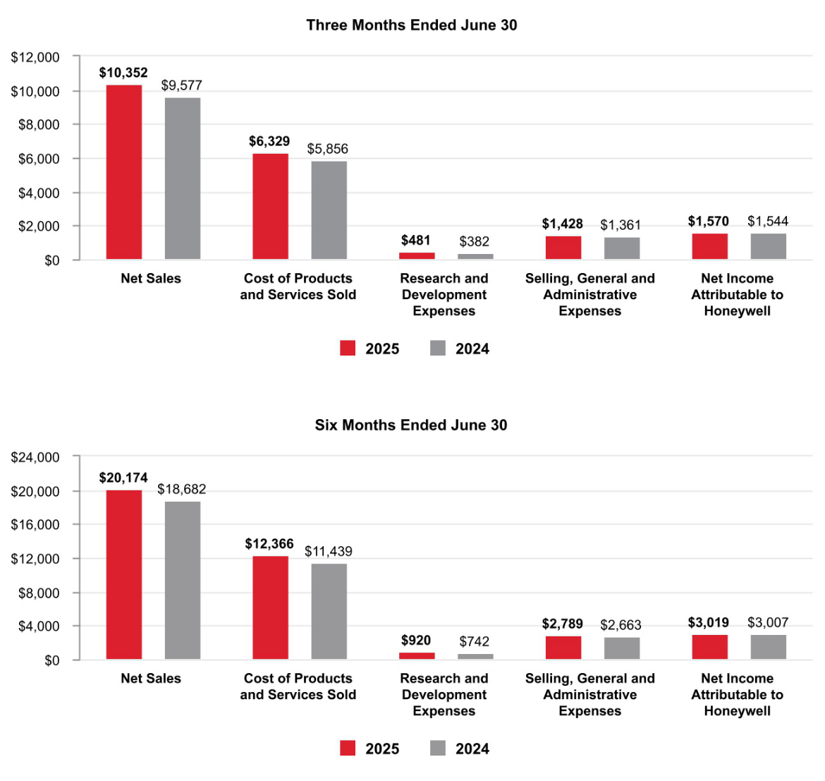

- Honeywell International Inc.

TABLE OF CONTENTS

Net Sales by Segment
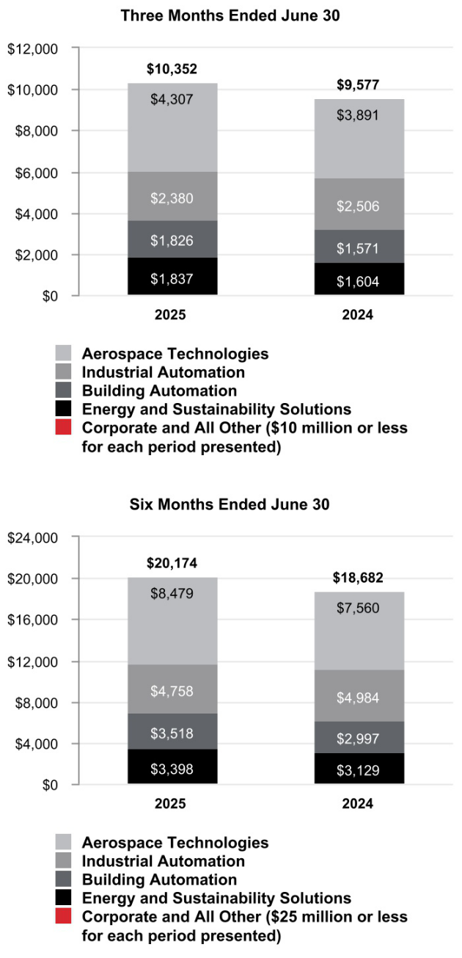

- Honeywell International Inc.

TABLE OF CONTENTS

Segment Profit by Segment
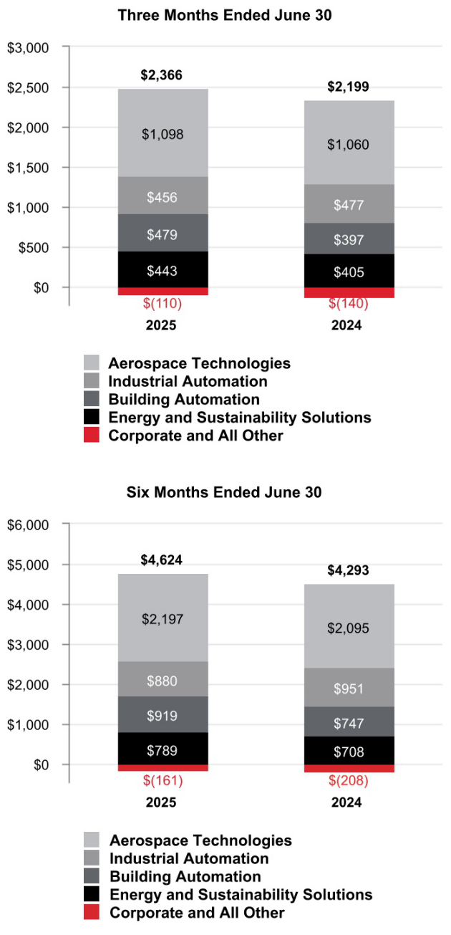

- Honeywell International Inc.

TABLE OF CONTENTS

CONSOLIDATED OPERATING RESULTS

Net Sales
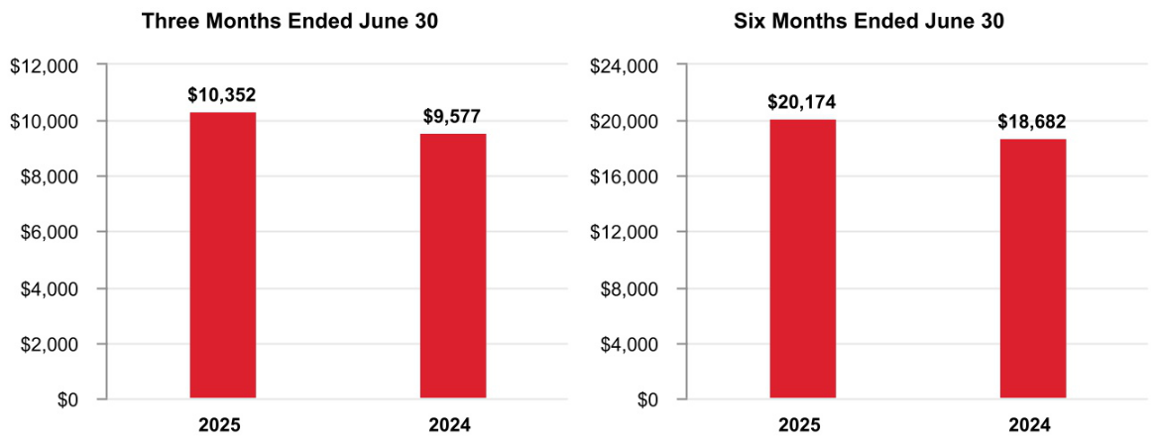

The change in Net sales was attributable to the following:

 | Q2 2025 vs. Q2 2024 | Year to Date 2025 vs. 2024
Volume | 2% | 2%
Price | 3% | 2%
Foreign currency translation | —% | —%
Acquisitions, divestitures, and other, net | 3% | 4%
Total % change in Net sales | 8% | 8%

A discussion of Net sales by reportable business segment can be found in the Review of Business Segments section of this Management's Discussion and Analysis.

Q2 2025 compared with Q2 2024

Net sales increased due to the following:

- Increased pricing and price adjustments to offset inflation,

- Incremental sales from recent acquisitions, and

- Higher sales volumes.

YTD 2025 compared with YTD 2024

Net sales increased due to the following:

- Incremental sales from recent acquisitions,

- Increased pricing and price adjustments to offset inflation, and

- Higher sales volumes.

- Honeywell International Inc.

TABLE OF CONTENTS

Our backlog of orders increased 14% to $36.6 billion, as of June 30, 2025, compared to June 30, 2024. Backlog represents the estimated remaining value of work to be performed or products to be shipped under firm contracts. Backlog is equal to our remaining performance obligations under the contracts that meet the guidance on revenue from contracts with customers as discussed in Note 4 Revenue Recognition and Contracts with Customers of Notes to Consolidated Financial Statements. Our backlog by reportable business segment is as follows:

 |  | June 30, 2025
Aerospace Technologies | $ | 15,881
Industrial Automation |  | 5,560
Building Automation |  | 8,839
Energy and Sustainability Solutions |  | 6,302
Corporate and All Other¹ |  | 19
Total backlog | $ | 36,601

- The backlog within Corporate and All Other relates to the Quantinuum business.

Cost of Products and Services Sold
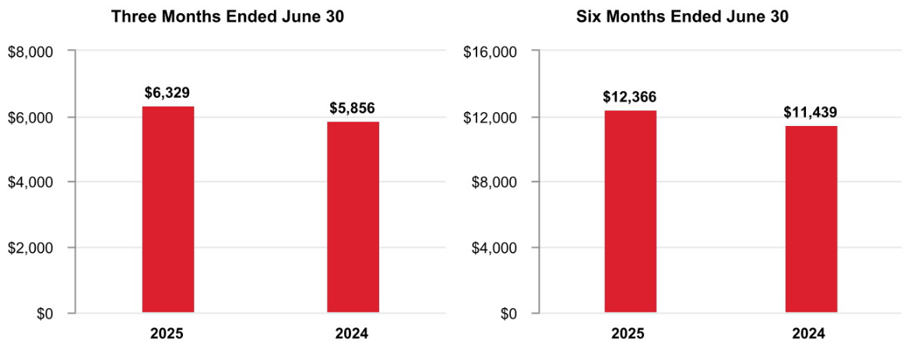

Q2 2025 compared with Q2 2024

Cost of products and services sold increased due to the following:

- Incremental costs from recent acquisitions of approximately $0.3 billion or 5%, and

- Higher direct and indirect material costs and higher labor costs of approximately $0.2 billion or 3%.

YTD 2025 compared with YTD 2024

Cost of products and services sold increased due to the following:

- Incremental costs from recent acquisitions of approximately $0.6 billion or 5%, and

- Higher direct and indirect material costs and higher labor costs of approximately $0.4 billion or 3%.

- Honeywell International Inc.

TABLE OF CONTENTS

Gross Margin
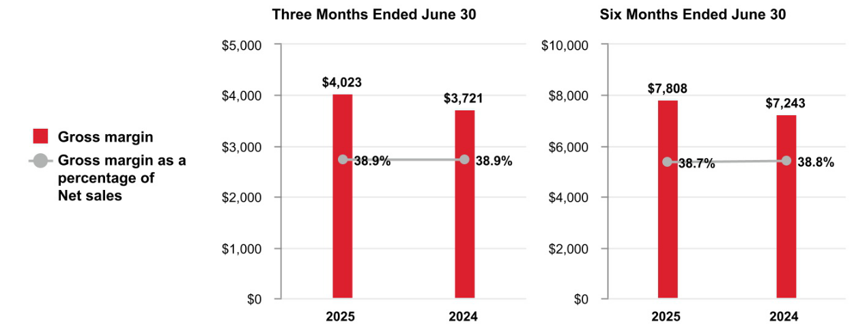

Q2 2025 compared with Q2 2024

Gross margin increased by approximately $0.3 billion and gross margin percentage was flat at 38.9% compared to the same period of 2024.

YTD 2025 compared with YTD 2024

Gross margin increased by approximately $0.6 billion and gross margin percentage decreased 10 basis points to 38.7% compared to 38.8% for the same period of 2024.

Research and Development Expenses
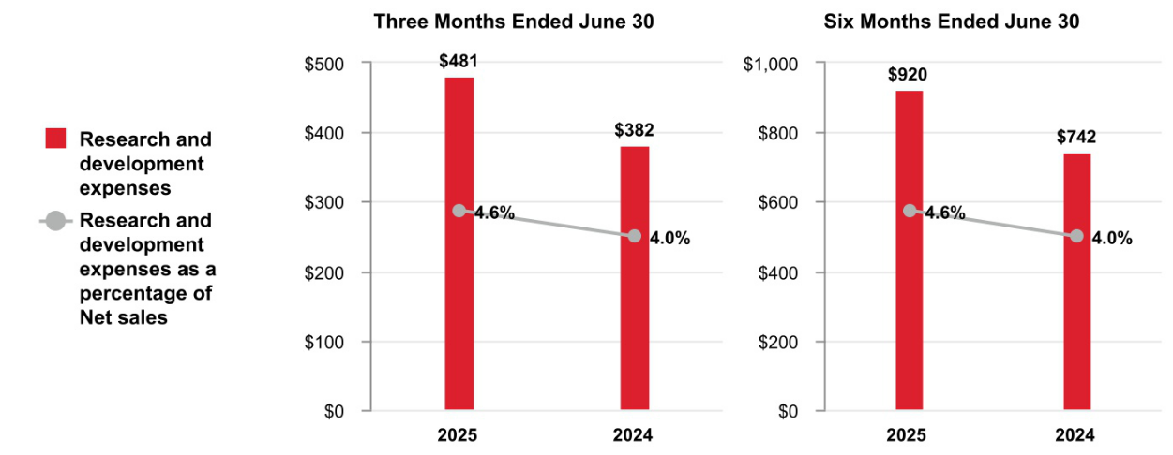

Q2 2025 compared with Q2 2024

Research and development expenses increased as a percentage of net sales due to increased investment in new product development in our Aerospace Technologies business.

YTD 2025 compared with YTD 2024

Research and development expenses increased as a percentage of net sales due to increased investment in new product development in our Aerospace Technologies business.

- Honeywell International Inc.

TABLE OF CONTENTS

A summary of our research and development costs is as follows:

 | Three Months Ended June |  |  |  |  | Six Months Ended June 30,
 |  |  | 30,
 |  | 2025 |  | 2024 |  |  | 2025 |  | 2024
Company funded research and development expenses | $ | 481 | $ | 382 |  | $ | 920 | $ | 742
Customer-sponsored research and development1 |  | 260 |  | 281 |  |  | 527 |  | 550
Total research and development costs | $ | 741 | $ | 663 |  | $ | 1,447 | $ | 1,292

- Includes deferred customer funded nonrecurring engineering and development activities and expenditures on customer programs with a significant engineering performance obligation, included in Cost of products and services sold in the Consolidated Statement of Operations.

Selling, General and Administrative Expenses
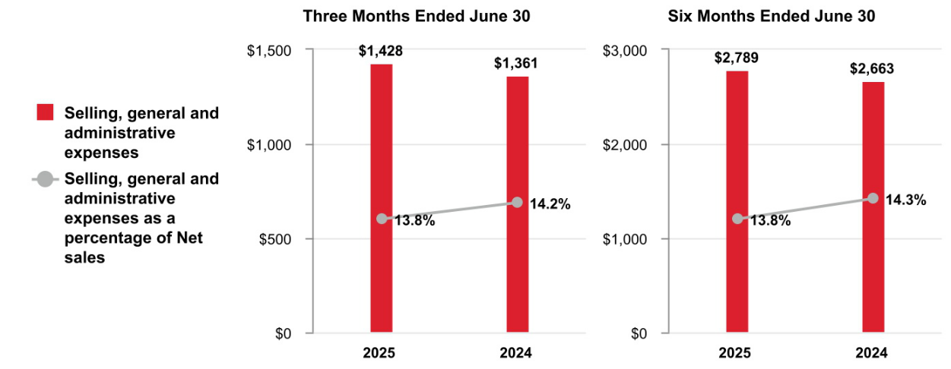

Q2 2025 compared with Q2 2024

Selling, general and administrative expenses increased due to incremental costs from acquisitions.

YTD 2025 compared to YTD 2024

Selling, general and administrative expenses increased due to the following:

• Incremental costs from acquisitions of approximately $0.2 billion or 8%,

• Partially offset by higher productivity of approximately $0.1 billion or 4%.

Impairment of Assets Held for Sale

 | Three Months Ended June |  |  |  |  | Six Months Ended June 30,
 |  |  | 30,
 |  | 2025 |  | 2024 |  |  | 2025 |  | 2024
Impairment of assets held for sale | $ | — | $ | — |  | $ | 15 | $ | —

YTD 2025 compared to YTD 2024

An impairment charge was recorded on assets held for sale related to the PPE business during the six months ended June 30, 2025.

- Honeywell International Inc.

TABLE OF CONTENTS

Other (Income) Expense

 | Three Months Ended June |  |  |  |  | Six Months Ended June 30,
 |  |  | 30,
 |  | 2025 |  | 2024 |  |  | 2025 |  | 2024
Other (income) expense | $ | (87) | $ | (246) |  | $ | (287) | $ | (477)
Q2 2025 compared with Q2 2024
Other income decreased due to the following:
• Higher divestiture-related costs of approximately $0.1 billion, and
• Lower pension and other postretirement income of approximately $0.1 billion.
YTD 2025 compared to YTD 2024
Other income decreased due to the following:
• Higher divestiture-related costs of approximately $0.1 billion, and
• Lower pension and other postretirement income of approximately $0.1 billion.
Interest and Other Financial Charges
 | Three Months Ended June |  |  |  |  | Six Months Ended June 30,
 |  |  | 30,
 |  | 2025 |  | 2024 |  |  | 2025 |  | 2024
Interest and other financial charges | $ | 330 | $ | 250 |  | $ | 616 | $ | 470

Q2 2025 compared with Q2 2024

Interest and other financial charges increased due to higher interest rates on issuances of long-term debt in past years.

YTD 2025 compared to YTD 2024

Interest and other financial charges increased due to higher interest rates on issuances of long-term debt in past years.

Tax Expense
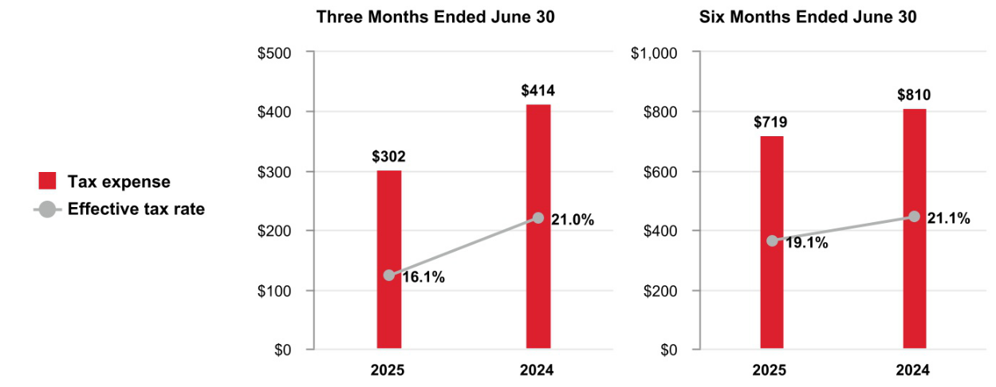

Q2 2025 compared with Q2 2024

The effective tax rate decreased 490 basis-points, primarily driven by changes in accruals on foreign tax matters.

YTD 2025 compared with YTD 2024

The effective tax rate decreased 200 basis-points, primarily driven by changes in accruals on foreign tax matters.

- Honeywell International Inc.

TABLE OF CONTENTS

Net Income Attributable to Honeywell
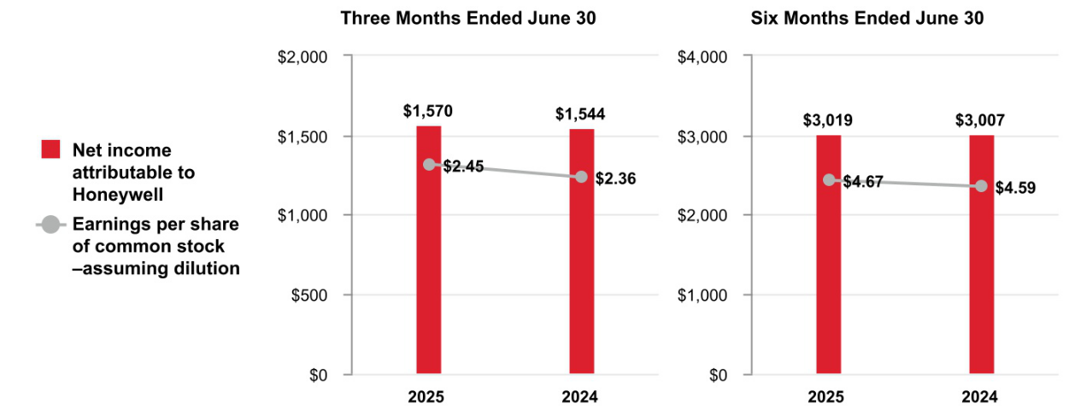

Q2 2025 compared to Q2 2024

Earnings per share of common stock–assuming dilution increased due to the following:

- Higher segment profit ($0.20 after tax) and

- Lower effective tax rate ($0.10),

- Partially offset by higher interest and other financial charges ($0.10 after tax), and

- Higher divestiture-related costs ($0.09 after tax).

YTD 2025 compared with YTD 2024

Earnings per share of common stock–assuming dilution increased due to the following:

- Higher segment profit ($0.40 after tax),

- Partially offset by higher interest and other financial charges ($0.18 after tax), and

- Higher divestiture-related costs ($0.17 after tax).

- Honeywell International Inc.

TABLE OF CONTENTS

REVIEW OF BUSINESS SEGMENTS

We globally manage our business operations through four reportable business segments: Aerospace Technologies, Industrial Automation, Building Automation, and Energy and Sustainability Solutions.

AEROSPACE TECHNOLOGIES

Net Sales
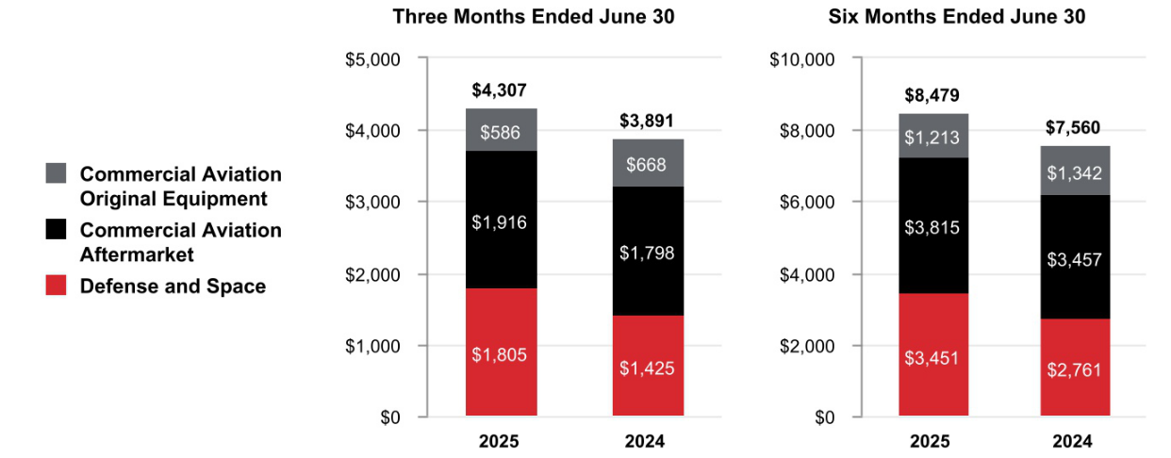

 |  |  | Three Months Ended |  |  |  |  |  |  |  |  | Six Months Ended
 |  |  |  | June 30, |  |  |  |  |  |  |  |  | June 30,
 |  | 2025 |  | 2024 |  | % |  |  | 2025 |  |  |  | 2024 | %
 |  | 2025 |  |  |  | Change |  |  |  |  |  |  | 2024 | Change
Net sales | $ | 4,307 | $ | 3,891 |  | 11 % | $ |  | 8,479 |  |  | $ | 7,560 | 12 %
Cost of products and services sold |  | 2,718 |  | 2,418 |  |  |  |  | 5,310 |  |  |  | 4,635
Selling, general and administrative and other expenses |  | 491 |  | 413 |  |  |  |  | 972 |  |  |  | 830
Segment profit | $ | 1,098 | $ | 1,060 |  | 4 % | $ |  | 2,197 |  |  | $ | 2,095 | 5 %
 |  |  |  |  |  |  |  |  | 2025 vs. 2024
 |  |  |  |  | Three Months Ended |  |  |  |  |  |  |  | Six Months Ended
 |  |  |  |  |  | June 30, |  |  |  |  |  |  | June 30,
Factors Contributing to Year-Over-Year Change |  |  |  |  | Net | Segment |  |  |  |  |  | Net |  | Segment
Factors Contributing to Year-Over-Year Change |  |  |  |  | Sales |  | Profit |  |  |  |  | Sales |  | Profit
Organic¹ |  |  |  |  |  | 6 % |  |  | 2 % |  |  |  | 7 % | 4 %
Foreign currency translation |  |  |  |  |  | — % |  |  | — % |  |  |  | — % | — %
Acquisitions, divestitures, and other, net |  |  |  |  |  | 5 % |  |  | 2 % |  |  |  | 5 % | 1 %
Total % change |  |  |  |  |  | 11 % |  |  | 4 % |  |  |  | 12 % | 5 %

- Organic sales % change, presented for all of our reportable business segments, is defined as the change in Net sales, excluding the impact on sales from foreign currency translation and acquisitions, net of divestitures, for the first 12 months following the transaction date. We believe this non-GAAP measure is useful to investors and management in understanding the ongoing operations and analysis of ongoing operating trends.

Q2 2025 compared to Q2 2024

Sales increased $416 million due to higher organic sales of $180 million in Defense and Space driven by higher sales volumes due to increased shipments and higher organic sales of $118 million in Commercial Aviation Aftermarket driven by increased pricing in air transport. Additionally, the acquisitions of CAES and Civitanavi Systems contributed $197 million to sales in the three months ended June 30, 2025.

- Honeywell International Inc.

TABLE OF CONTENTS

Segment profit increased $38 million and segment margin percentage decreased 170 basis points to 25.5% compared to 27.2% for the same period of 2024. YTD 2025 compared to YTD 2024
Sales increased $919 million due to higher organic sales of $358 million in Commercial Aviation Aftermarket and higher organic sales of $313 million in Defense and Space, both driven by higher sales volumes due to increased shipments. Additionally, the acquisitions of CAES and Civitanavi Systems contributed $377 million to sales in the six months ended June 30, 2025.

Segment profit increased $102 million and segment margin percentage decreased 180 basis points to 25.9% compared to 27.7% for the same period of 2024.

On February 6, 2025, the Company announced its intention to separate its Automation and Aerospace Technologies businesses into independent, U.S.

publicly traded companies.

INDUSTRIAL AUTOMATION

Net Sales
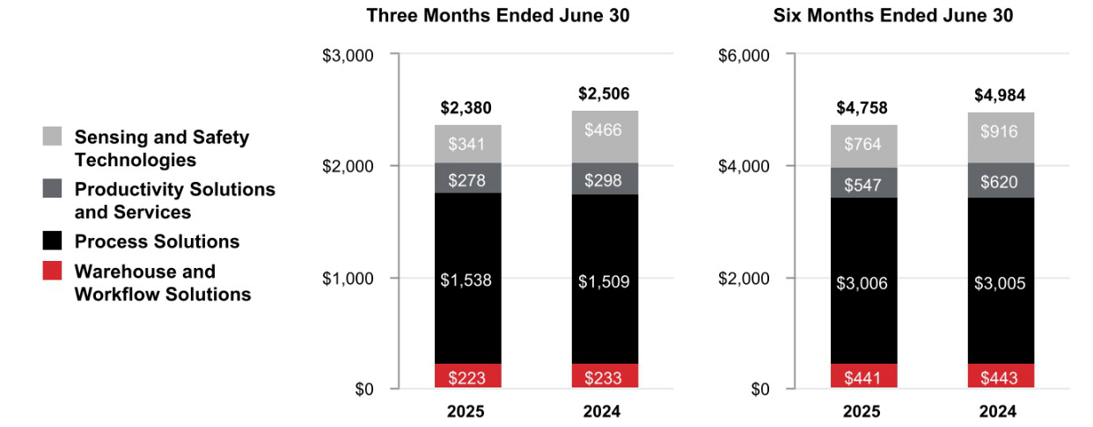

 |  |  | Three Months Ended |  |  |  |  |  |  |  |  | Six Months Ended
 |  |  |  | June 30, |  |  |  |  |  |  |  |  | June 30,
 |  | 2025 |  | 2024 |  | % |  |  | 2025 |  |  |  | 2024 | %
 |  | 2025 |  |  |  | Change |  |  |  |  |  |  | 2024 | Change
Net sales | $ | 2,380 | $ | 2,506 |  | (5)% | $ |  | 4,758 |  |  | $ | 4,984 | (5)%
Cost of products and services sold |  | 1,376 |  | 1,451 |  |  |  |  | 2,760 |  |  |  | 2,897
Selling, general and administrative and other expenses |  | 548 |  | 578 |  |  |  |  | 1,118 |  |  |  | 1,136
Segment profit | $ | 456 | $ | 477 |  | (4)% | $ |  | 880 |  |  | $ | 951 | (7)%
 |  |  |  |  |  |  |  |  | 2025 vs. 2024
 |  |  |  |  | Three Months Ended |  |  |  |  |  |  |  | Six Months Ended
 |  |  |  |  |  | June 30, |  |  |  |  |  |  | June 30,
Factors Contributing to Year-Over-Year Change |  |  |  |  | Net | Segment |  |  |  |  |  | Net |  | Segment
Factors Contributing to Year-Over-Year Change |  |  |  |  | Sales |  | Profit |  |  |  |  | Sales |  | Profit
Organic |  |  |  |  |  | — % |  |  | 1 % |  |  |  | (1)% | (4)%
Foreign currency translation |  |  |  |  |  | 1 % |  |  | — % |  |  |  | (1)% | (1)%
Acquisitions, divestitures, and other, net |  |  |  |  |  | (6)% |  |  | (5)% |  |  |  | (3)% | (2)%
Total % change |  |  |  |  |  | (5)% |  |  | (4)% |  |  |  | (5)% | (7)%

45 Honeywell International Inc.

TABLE OF CONTENTS

Q2 2025 compared to Q2 2024

Sales decreased $126 million due to lower sales of $141 million driven by the sale of our PPE business on May 21, 2025.

Segment profit decreased $21 million and segment margin percentage increased 20 basis points to 19.2% compared to 19.0% for the same period in 2024. YTD 2025 compared to YTD 2024
Sales decreased $226 million due to lower sales of $141 million driven by the sale of our PPE business on May 21, 2025, and lower organic sales of $68 million in Productivity Solutions and Services driven by a decrease in license and settlement payments.

During the second quarter of 2022, our Productivity Solutions and Services business entered into a license and settlement agreement (the Agreement). Under the Agreement, we received $360 million, paid in equal quarterly installments over eight quarters, beginning with the second quarter of 2022 and ending with the first quarter of 2024. The Agreement provides each party a license to its existing patent portfolio for use by the other party's existing products and resolved the patent-related litigation between the parties.

Segment profit decreased $71 million and segment margin percentage decreased 60 basis points to 18.5% compared to 19.1% for the same period in 2024.

On July 8, 2025, the Company announced it is evaluating strategic alternatives for its Productivity Solutions and Services and Warehouse and Workflow Solutions businesses.

BUILDING AUTOMATION

Net Sales
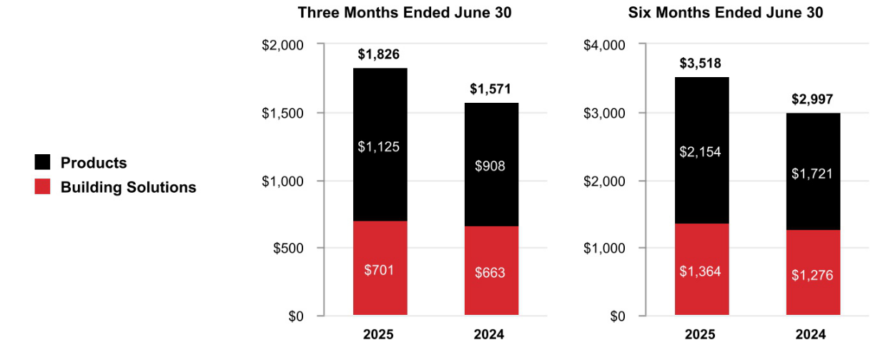

 |  |  | Three Months Ended |  |  |  |  |  | Six Months Ended
 |  |  |  | June 30, |  |  |  |  |  | June 30,
 |  | 2025 |  | 2024 | % |  |  | 2025 |  | 2024 | %
 |  | 2025 |  | 2024 | Change |  |  | 2025 |  | 2024 | Change
Net sales | $ | 1,826 | $ | 1,571 | 16 % |  | $ | 3,518 | $ | 2,997 | 17 %
Cost of products and services sold |  | 944 |  | 844 |  |  |  | 1,812 |  | 1,608
Selling, general and administrative and other expenses |  | 403 |  | 330 |  |  |  | 787 |  | 642
Segment profit | $ | 479 | $ | 397 | 21 % |  | $ | 919 | $ | 747 | 23 %

46 Honeywell International Inc.

TABLE OF CONTENTS

 |  | 2025 vs. 2024
 | Three Months Ended |  |  | Six Months Ended
 | June 30, |  |  | June 30,
Factors Contributing to Year-Over-Year Change | Net | Segment |  | Net | Segment
Factors Contributing to Year-Over-Year Change | Sales | Profit |  | Sales | Profit
Organic | 8 % | 10 % |  | 8 % | 11 %
Foreign currency translation | — % | 1 % |  | (1)% | (1)%
Acquisitions, divestitures, and other, net | 8 % | 10 % |  | 10 % | 13 %
Total % change | 16 % | 21 % |  | 17 % | 23 %

Q2 2025 compared to Q2 2024

Sales increased $255 million due to higher organic sales of $84 million in Products driven by higher demand. Additionally, the acquisition of Access Solutions contributed $123 million of inorganic sales in the three months ended June 30, 2025. Beginning June 3, 2025, Access Solutions results are considered organic following the first 12 months after the transaction date.

Segment profit increased $82 million and segment margin percentage increased 90 basis points to 26.2% compared to 25.3% for the same period of 2024. YTD 2025 compared to YTD 2024
Sales increased $521 million due to higher organic sales of $135 million in Products and higher organic sales of $104 million in Building Solutions, both driven by higher demand. Additionally, the acquisition of Access Solutions contributed $302 million of inorganic sales in the six months ended June 30, 2025.

Segment profit increased $172 million and segment margin percentage increased 120 basis points to 26.1% compared to 24.9% for the same period of 2024.

ENERGY AND SUSTAINABILITY SOLUTIONS

Net Sales
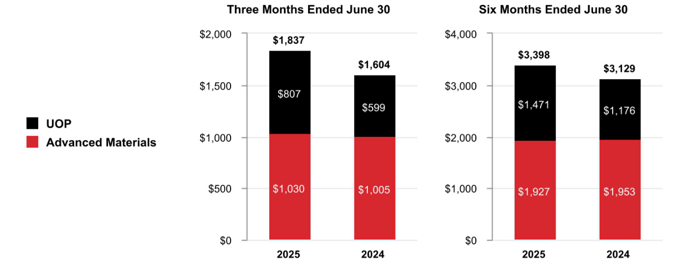

 |  |  | Three Months Ended |  |  |  |  |  | Six Months Ended
 |  |  |  | June 30, |  |  |  |  |  | June 30,
 |  | 2025 |  | 2024 | % |  |  | 2025 |  | 2024 | %
 |  | 2025 |  | 2024 | Change |  |  | 2025 |  | 2024 | Change
Net sales | $ | 1,837 | $ | 1,604 | 15 % |  | $ | 3,398 | $ | 3,129 | 9 %
Cost of products and services sold |  | 1,148 |  | 996 |  |  |  | 2,130 |  | 1,995
Selling, general and administrative and other expenses |  | 246 |  | 203 |  |  |  | 479 |  | 426
Segment profit | $ | 443 | $ | 405 | 9 % |  | $ | 789 | $ | 708 | 11 %

47 Honeywell International Inc.

TABLE OF CONTENTS

 |  | 2025 vs. 2024
 | Three Months Ended |  |  | Six Months Ended
 | June 30, |  |  | June 30,
Factors Contributing to Year-Over-Year Change | Net | Segment |  | Net | Segment
Factors Contributing to Year-Over-Year Change | Sales | Profit |  | Sales | Profit
Organic | 6 % | (2)% |  | 3 % | 1 %
Foreign currency translation | 2 % | 1 % |  | — % | — %
Acquisitions, divestitures, and other, net | 7 % | 10 % |  | 6 % | 10 %
Total % change | 15 % | 9 % |  | 9 % | 11 %

Q2 2025 compared to Q2 2024

Sales increased $233 million due to higher organic sales of $93 million in UOP due to higher licensing sales volumes in gas processing. Additionally, the acquisitions of LNG and Sundyne contributed $114 million in the three months ended June 30, 2025.

Segment profit increased $38 million and segment margin percentage decreased 110 basis points to 24.1% compared to 25.2% for the same period of 2024. YTD 2025 compared to YTD 2024
Sales increased $269 million due to higher organic sales of $107 million in UOP due to higher licensing sales volumes in gas processing. Additionally, the acquisitions of LNG and Sundyne contributed $189 million in the six months ended June 30, 2025.

Segment profit increased $81 million and segment margin percentage increased 60 basis points to 23.2% compared to 22.6% for the same period of 2024.

On October 8, 2024, the Company announced its intention to spin off its Advanced Materials business into Solstice Advanced Materials, an independent, U.S. publicly traded company, which is expected to be completed during the fourth quarter of 2025.

CORPORATE AND ALL OTHER

Corporate and All Other primarily includes unallocated corporate costs, interest expense on holding-company debt, and the controlling majority-owned interest in Quantinuum. Corporate and All Other is not a separate reportable business segment as segment reporting criteria is not met. The Company continues to monitor the activities in Corporate and All Other to determine the need for further reportable business segment disaggregation.

REPOSITIONING CHARGES

See Note 5 Repositioning and Other Charges of Notes to Consolidated Financial Statements for a discussion of our repositioning actions and related charges incurred in the six months ended June 30, 2025, and 2024. Cash spending related to our repositioning actions was $81 million in the six months ended June 30, 2025, and was funded through operating cash flows.

- Honeywell International Inc.

TABLE OF CONTENTS

LIQUIDITY AND CAPITAL RESOURCES

(Dollars in tables in millions)

We leverage operating cash flows as the primary source of liquidity. Each of our businesses focuses on increasing operating cash flows through revenue growth, margin expansion, and improved working capital turnover. We also maintain other key sources of liquidity, including U.S. cash balances, and the ability to access non-U.S. cash balances, short-term debt from the commercial paper market, long-term borrowings, committed credit lines, and access to the public debt and equity markets.

CASH

As of June 30, 2025, and December 31, 2024, we held $10.7 billion and $11.0 billion, respectively, of cash and cash equivalents, including our short-term investments. We monitor third-party depository institutions that hold our cash and cash equivalents on a daily basis. Our emphasis is primarily safety of principal and secondarily maximizing yield of those funds. We diversify our cash and cash equivalents among counterparties to minimize exposure to any one counterparty.

As of June 30, 2025, we held $9.2 billion of the Company’s cash, cash equivalents, and short-term investments in non-U.S. subsidiaries. We do not have material amounts related to any jurisdiction subject to currency control restrictions that impact our ability to access and repatriate such amounts. Under current laws, we do not expect taxes on repatriation or restrictions on amounts held outside of the U.S. to have a material effect on our overall liquidity.

CASH FLOW SUMMARY

Our cash flows from operating, investing, and financing activities, as reflected in the Consolidated Statement of Cash Flows, are summarized as follows:

 |  | Six Months Ended June 30,
 |  | 2025 |  | 2024 |  | Variance
Cash and cash equivalents at beginning of period | $ | 10,567 | $ | 7,925 | $ | 2,642
Operating activities
Net income attributable to Honeywell |  | 3,019 |  | 3,007 |  | 12
Noncash adjustments |  | 744 |  | 514 |  | 230
Changes in working capital |  | (1,218) |  | (649) |  | (569)
Other operating activities |  | (629) |  | (1,053) |  | 424
Net cash provided by operating activities |  | 1,916 |  | 1,819 |  | 97
Net cash used for investing activities |  | (1,880) |  | (5,405) |  | 3,525
Net cash (used for) provided by financing activities |  | (421) |  | 5,298 |  | (5,719)
Effect of foreign exchange rate changes on cash and cash equivalents |  | 167 |  | (61) |  | 228
Net (decrease) increase in cash and cash equivalents |  | (218) |  | 1,651 |  | (1,869)
Cash and cash equivalents at end of period | $ | 10,349 | $ | 9,576 | $ | 773

Six months ended June 30, 2025

Net cash provided by operating activities was driven by Net income, partially offset by changes in working capital driven by an increase in accounts receivable due to timing of customer cash collections.

Net cash used for investing activities was driven by $2,163 million of cash paid for acquisitions, $554 million of capital expenditures, and $415 million of net payments from settlements of derivative contracts, partially offset by $1,157 million of proceeds from the sale of the PPE business.

Net cash used for financing activities was driven by $3,604 million of repurchases of common stock, $1,479 million of cash dividends paid, and $1,309 million of payments of long-term debt, partially offset by $4,035 million of long-term debt proceeds and $1,873 million of net proceeds of commercial paper.

- Honeywell International Inc.

TABLE OF CONTENTS

Six months ended June 30, 2025 compared with six months ended June 30, 2024

Net cash provided by operating activities increased by $97 million, driven by a $424 million favorable impact of other operating activities due to timing of customer advances and $230 million increase in noncash adjustments driven by higher depreciation and amortization, partially offset by a $569 million unfavorable impact of working capital driven by an increase in accounts receivable due to timing of customer cash collections.

Net cash used for investing activities decreased by $3,525 million, driven by a $2,750 million decrease in cash paid for acquisitions and $1,157 million increase in proceeds from the sale of the PPE business, partially offset by a $491 million increase in net payments from settlements of derivative contracts.

Net cash used for financing activities increased by $5,719 million, driven by a $2,404 million increase in repurchases of common stock, $1,675 million decrease in long-term debt proceeds, $704 million increase in payments of long-term debt, $631 million decrease in net proceeds of commercial paper, and $211 million decrease in proceeds from the issuance of common stock.

ASSESSMENT OF CURRENT LIQUIDITY AND CASH REQUIREMENTS

Based on past performance and current expectations, we believe our operating cash flows will be sufficient to meet our future operating cash needs for at least the next twelve months. If necessary, our available cash, committed credit lines, and access to the public debt and equity markets provide additional sources of short-term and long-term liquidity to fund current operations, debt maturities, and future investment opportunities.

See Note 9 Debt and Credit Agreements of Notes to Consolidated Financial Statements for additional discussion of items impacting our liquidity.

In addition to normal operating cash requirements, our principal future cash requirements include funding capital expenditures, share repurchases, dividends, strategic acquisitions, and debt repayments. During the six months ended June 30, 2025, we repurchased common stock of $3.6 billion. Refer to the section titled Liquidity and Capital Resources of our 2024 Form 10-K for a discussion of our expected capital expenditures, share repurchases, mergers and acquisitions activity, and dividends for 2025.

We continually assess the relative strength of each business in our portfolio as to strategic fit, market position, profit, and cash flow contribution in order to identify target investment and acquisition opportunities in order to upgrade our combined portfolio. We identify acquisition candidates that will further our strategic plan and strengthen our existing core businesses. In the second quarter of 2025, we acquired Sundyne for total consideration of $2.2 billion, net of cash acquired, as well as announced our agreement to acquire Johnson Matthey's Catalyst Technologies business segment for £1.8 billion. We also identify businesses that do not fit into our long-term strategic plan based on their market position, relative profitability, or growth potential. These businesses are considered for potential divestiture, restructuring, or other repositioning actions, subject to regulatory constraints. On October 8, 2024, we announced our intention to spin off the Advanced Materials business into Solstice Advanced Materials, an independent, U.S. publicly traded company, which is targeted to be completed during the fourth quarter of 2025. On February 6, 2025, we announced our intention to separate its Automation and Aerospace Technologies businesses into independent, U.S. publicly traded companies, which is intended to be completed in the second half of 2026. On May 21, 2025, we completed the sale of our PPE business for $1.2 billion, net of cash transferred. In addition, on July 8, 2025, we announced we are evaluating strategic alternatives for our Productivity Solutions and Services and Warehouse and Workflow Solutions businesses within the Industrial Automation reportable business segment. See Note 3 Acquisitions and Divestitures of Notes to Consolidated Financial Statements for additional discussion.

We continually seek opportunities to improve our liquidity and working capital efficiency, which includes the extension of payment terms with our suppliers and transfer of our trade receivables to unaffiliated financial institutions on a true sale basis. The impact of these programs is not material to our overall liquidity.

- Honeywell International Inc.

TABLE OF CONTENTS

BORROWINGS

We leverage a variety of debt instruments to manage our overall borrowing costs. As of June 30, 2025, and December 31, 2024, our total borrowings were $36.5 billion and $31.1 billion, respectively.

 |  | June 30, 2025 |  | December 31, 2024
Fixed rate notes | $ | 25,198 | $ | 25,853
Commercial paper |  | 6,270 |  | 4,271
Term loans |  | 5,000 |  | 1,000
Variable rate notes |  | 22 |  | 22
Other |  | 409 |  | 392
Fair value of hedging instruments |  | (87) |  | (136)
Debt issuance costs |  | (300) |  | (303)
Total borrowings | $ | 36,512 | $ | 31,099

A key source of liquidity is our ability to access the corporate bond markets. Through these markets, we issue a variety of long-term fixed rate notes to manage our overall funding costs.

Another key source of liquidity is our ability to access the commercial paper market. Commercial paper notes are sold at a discount or premium and have a maturity of not more than 365 days from date of issuance. Borrowings under the commercial paper program are available for general corporate purposes as well as for financing acquisitions.

In addition, we have the following loan and revolving credit agreements:

- A $6.0 billion Delayed Draw Term Loan Agreement (the Term Loan Agreement), dated as of May 7, 2025. The Term Loan Agreement is comprised of two tranches: (i) commitments to provide loans in an aggregate principal amount of up to $4.0 billion, which was fully drawn effective May 30, 2025, and (ii) commitments to provide loans in an aggregate amount of up to $2.0 billion, expiring on December 19, 2025. Amounts borrowed under the Term Loan Agreement are required to be paid no later than May 7, 2027, unless the Term Loan Agreement is terminated earlier pursuant to its terms. As of June 30, 2025, there were $4.0 billion of borrowings outstanding on the Term Loan Agreement.

- A $1.0 billion Fixed Rate Term Loan Credit Agreement (the Fixed Rate Term Loan Credit Agreement), dated as of August 12, 2024. Amounts borrowed under the Fixed Rate Term Loan Credit Agreement are required to be repaid no later than August 12, 2027, unless the Fixed Rate Term Loan Credit Agreement is terminated earlier pursuant to its terms. As of June 30, 2025, there were $1.0 billion of borrowings outstanding under the Fixed Rate Term Loan Credit Agreement.

- A $3.0 billion 364-day credit agreement (the 364-Day Credit Agreement) with a syndicate of banks, dated as of March 17, 2025. Amounts borrowed under the 364-Day Credit Agreement are required to be repaid no later than March 16, 2026, unless (i) we elect to convert all then outstanding amounts into a term loan, upon which such amounts shall be repaid in full on March 16, 2027, or (ii) the 364-Day Credit Agreement is terminated earlier pursuant to its terms. The 364-Day Credit Agreement replaced the previously reported $1.5 billion 364-day credit agreement dated as of March 18, 2024, which was terminated in accordance with its terms effective March 17, 2025. As of June 30, 2025, there were no outstanding borrowings under our 364-Day Credit Agreement.

- A $4.0 billion five-year credit agreement (the Five-Year Credit Agreement) with a syndicate of banks, dated as of March 18, 2024. Commitments under the Five-Year Credit Agreement can be increased pursuant to the terms of the Five-Year Credit Agreement to an aggregate amount not to exceed $4.5 billion. As of June 30, 2025, there were no outstanding borrowings under our Five-Year Credit Agreement.

See Note 9 Debt and Credit Agreements of Notes to Consolidated Financial Statements for additional information regarding our debt instruments.

We also maintain a current shelf registration statement filed with the SEC under which we may issue additional debt securities, common stock, and preferred stock that may be offered in one or more offerings on terms to be determined at the time of the offering. We anticipate that net proceeds of any offering would be used for general corporate purposes, including repayment of existing indebtedness, share repurchases, capital expenditures, and acquisitions.

- Honeywell International Inc.

TABLE OF CONTENTS

CREDIT RATINGS

Our ability to access the global debt capital markets and the related cost of these borrowings is affected by the strength of our credit rating and market conditions. Our credit ratings are periodically reviewed by the major independent debt-rating agencies. As of June 30, 2025, S&P Global Inc. (S&P), Fitch Ratings Inc. (Fitch), and Moody’s Investor Service (Moody's) have ratings on our debt set forth in the table below:

 | S&P | Fitch | Moody's
Outlook | Watch Negative | Watch Negative | Stable
Short-term | A-1 | F1 | P1
Long-term | A | A | A2

OTHER MATTERS

LITIGATION

See Note 15 Commitments and Contingencies of Notes to Consolidated Financial Statements for further discussion of environmental, asbestos, and other litigation matters.

CRITICAL ACCOUNTING ESTIMATES

There have been no material changes to our Critical Accounting Estimates presented in our 2024 Annual Report on Form 10-K. For a discussion of the Company’s Critical Accounting Estimates, see the section titled Critical Accounting Estimates in our 2024 Annual Report on Form 10-K.

RECENT ACCOUNTING PRONOUNCEMENTS

See Note 2 Summary of Significant Accounting Policies of Notes to Consolidated Financial Statements for a discussion of recent accounting pronouncements.

ITEM 3. QUANTITATIVE AND QUALITATIVE DISCLOSURES ABOUT MARKET RISKS

For a discussion of the Company’s quantitative and qualitative disclosures about market risks, see the section titled Quantitative and Qualitative Disclosures About Market Risks in our 2024 Annual Report on Form 10-K. As of June 30, 2025, there has been no material change in this information.

- Honeywell International Inc.

TABLE OF CONTENTS

ITEM 4. CONTROLS AND PROCEDURES

Honeywell management, including the Chairman and Chief Executive Officer (CEO) and Chief Financial Officer (CFO), conducted an evaluation of the effectiveness of our disclosure controls and procedures (as defined in Rules 13a-15(e) or 15d-15(e) promulgated under the Securities Exchange Act of 1934, as amended (Exchange Act)) as of the end of the period covered by this Quarterly Report on Form 10-Q. Based upon that evaluation, the Chairman and CEO and the CFO concluded that such disclosure controls and procedures were effective as of the end of the period covered by this Quarterly Report on Form 10-Q to ensure information required to be disclosed in the reports that Honeywell files or submits under the Exchange Act is recorded, processed, summarized, and reported within the time periods specified in the SEC's rules and forms, and that it is accumulated and communicated to our management, including our Chairman and CEO, our CFO, and our Controller, as appropriate, to allow timely decisions regarding required disclosure. There were no changes that materially affected, or are reasonably likely to materially affect, Honeywell’s internal control over financial reporting that occurred during the period covered by this Quarterly Report on Form 10-Q.

- Honeywell International Inc.

TABLE OF CONTENTS

PART II. OTHER INFORMATION

ITEM 1. LEGAL PROCEEDINGS

We are subject to a number of lawsuits, investigations, and claims (some of which involve substantial amounts) arising out of the conduct of our business. See a discussion of environmental, asbestos, and other litigation matters in Note 15 Commitments and Contingencies of Notes to Consolidated Financial Statements.

There were no matters requiring disclosure pursuant to the requirement to disclose certain environmental matters involving potential monetary sanctions in excess of $300,000.

ITEM 1A. RISK FACTORS

Other than as noted below, there have been no material changes to our Risk Factors presented in our 2024 Annual Report on Form 10-K under the section titled Risk Factors. For further discussion of our Risk Factors, refer to the section titled Risk Factors in our 2024 Annual Report on Form 10-K and our Quarterly Report on Form 10-Q for the first quarter of 2025.

ITEM 2. UNREGISTERED SALES OF EQUITY SECURITIES AND USE OF PROCEEDS

On April 24, 2023, the Board of Directors authorized the repurchase of up to $10 billion of Honeywell common stock, including approximately $2.1 billion of remaining availability under the previously announced $10 billion share repurchase authorization. The repurchase authorization does not have an expiration date and may be amended or terminated by the Board of Directors at any time without prior notice.

Repurchases may be made through a variety of methods, which could include open market purchases, accelerated share repurchase transactions, negotiated block transactions, 10b5-1 plans, other transactions that may be structured through investment banking institutions or privately negotiated, or a combination of the foregoing. Honeywell presently expects to repurchase outstanding shares from time to time (i) to offset the dilutive impact of employee stock-based compensation plans, including option exercises, restricted unit vesting, and matching contributions under our savings plans, and (ii) to reduce share count via share repurchases as and when attractive opportunities arise. The amount and timing of future repurchases may vary depending on market conditions and the level of operating, financing, and other investing activities.

During the three months ended June 30, 2025, Honeywell repurchased 8.2 million shares of its common stock, par value $1 per share. As of June 30, 2025, $1.9 billion remained available under the share repurchase authorization for additional share repurchases. The following table summarizes our purchases of Honeywell's common stock for the three months ended June 30, 2025:

Issuer Purchases of Equity Securities

 |  |  | Total Number | Approximate Dollar
 |  |  | of Shares | Approximate Dollar
 | Total |  | Purchased as | Value of Shares that
 | Total | Average | Part of Publicly | May Yet Be
 | Number of | Average | Announced | Purchased Under Plans or
Period | Shares | Price Paid | Plans | Programs
Period | Purchased | per Share¹ | or Programs | (Dollars in millions)¹
March 30, 2025 - April 26, 2025 | 5,047,330 | $199.49 | 5,047,330 | $2,570
April 27, 2025 - May 24, 2025 | 1,798,837 | $212.34 | 1,798,837 | $2,188
May 25, 2025 - June 28, 2025 | 1,368,449 | $225.78 | 1,368,449 | $1,879

- Excludes excise tax on net share repurchases.

- Honeywell International Inc.

TABLE OF CONTENTS

ITEM 4. MINE SAFETY DISCLOSURES

One of our wholly-owned subsidiaries has a placer claim for and operates a chabazite ore surface mine in Arizona. Information concerning mine safety and other regulatory matters associated with this mine is required by Section 1503(a) of the Dodd-Frank Wall Street Reform and Consumer Protection Act and Item 104 of Regulation S-K and is included in Exhibit 95 to this quarterly report.

ITEM 5. OTHER INFORMATION

EQUITY TRADING ARRANGEMENTS ELECTIONS

Certain executive officers and directors of the Company may execute purchases and sales of the Company's common stock through Rule 10b5-1 and non-Rule 10b5-1 equity trading arrangements.

During the three months ended June 30, 2025, none of our executive officers or directors adopted, terminated, or modified a "Rule 10b5-1 trading arrangement," or adopted, terminated, or modified any "non-Rule 10b5-1 trading arrangement" (each as defined in Item 408 of Regulation S-K).

- Honeywell International Inc.

TABLE OF CONTENTS

ITEM 6. EXHIBITS

Exhibit No. | Description
3.1 | Amended and Restated Certificate of Incorporation of Honeywell International Inc., dated June 23, 2025 (incorporated by reference to Exhibit 3.1 to
 | Honeywell's Form 8-K filed June 24, 2025)
3.2 | Amended and Restated By-laws of Honeywell International Inc., dated June 23, 2025 (incorporated by reference to Exhibit 3.2 to Honeywell's Form 8-K
 | filed June 24, 2025)
10.1 | Delayed Draw Term Loan Agreement, dated as of May 7, 2025, among Honeywell International Inc., Bank of America, N.A., as administrative agent, and
 | the syndication agents and documentation agents named therein in such capacity and as the initial lenders (incorporated by reference to Exhibit 10.1 to
 | Honeywell's Form 8-K filed May 8, 2025)
10.2 | Cooperation Agreement, by and among Elliott Investment Management L.P., Elliott Associates , L.P., Elliott International, L.P. and Honeywell International
 | Inc., dated as of May 28, 2025 (incorporated by reference to Exhibit 10.1 to Honeywell's Form 8-K filed May 28, 2025)
10.3* | Agreement and Plan of Merger, dated April 9, 2025, by and among Honeywell International Inc., Hyperion Holdco Sub LLC, Hyperion Merger Sub 1, Inc.
 | and Hyperion Merger Sub 2, Inc. (incorporated by reference to Appendix B to the definitive proxy statement of the Company filed on April 9, 2025)
10.4 | Amendment No. 1 to the Agreement and Plan of Merger, dated as of June 23, 2025, by and among Honeywell International Inc., Hyperion Holdco Sub
 | LLC, Hyperion Merger Sub 1, Inc. and Hyperion Merger Sub 2, Inc. (incorporated by reference to Exhibit 99.2 to Honeywell's Form 8-K filed June 24,
 | 2025)
10.5** | Offer Letter dated April 4, 2025 from Honeywell International Inc. to Anne T. Madden (incorporated by reference to Exhibit 99.1 to Honeywell's Form 8-K
 | filed April 8, 2025)
31.1 | Certification of Principal Executive Officer Pursuant to Section 302 of the Sarbanes-Oxley Act of 2002 (filed herewith)
31.2 | Certification of Principal Financial Officer Pursuant to Section 302 of the Sarbanes-Oxley Act of 2002 (filed herewith)
32.1 | Certification of Principal Executive Officer Pursuant to 18 U.S.C. Section 1350, as Adopted Pursuant to Section 906 of the Sarbanes-Oxley Act of 2002
 | (furnished herewith)
32.2 | Certification of Principal Financial Officer Pursuant to 18 U.S.C. Section 1350, as Adopted Pursuant to Section 906 of the Sarbanes-Oxley Act of 2002
 | (furnished herewith)
95 | Mine Safety Disclosures (filed herewith)
101.INS | Inline XBRL Instance Document (the instance document does not appear in the Interactive Data File because its XBRL tags are embedded within the
 | Inline XBRL document)
101.SCH | Inline XBRL Taxonomy Extension Schema (filed herewith)
101.CAL | Inline XBRL Taxonomy Extension Calculation Linkbase (filed herewith)
101.DEF | Inline XBRL Taxonomy Extension Definition Linkbase (filed herewith)
101.LAB | Inline XBRL Taxonomy Extension Label Linkbase (filed herewith)
101.PRE | Inline XBRL Taxonomy Extension Presentation Linkbase (filed herewith)
104 | Cover Page Interactive Data File (formatted as inline XBRL and contained in Exhibit 101)

Certain of the exhibits and schedules to the Exhibits identified above with an asterisk (*) have been omitted in accordance with Regulation S-K Item 601(a)

(5). The Company agrees to furnish a copy of all omitted exhibits and schedules to the SEC upon its request.

The Exhibit identified above with two asterisks (**) is a management contract or compensatory plan or arrangement.

- Honeywell International Inc.

TABLE OF CONTENTS

SIGNATURES

Pursuant to the requirements of the Securities Exchange Act of 1934, the Registrant has duly caused this report to be signed on its behalf by the undersigned thereunto duly authorized.

HONEYWELL INTERNATIONAL INC.

Date: July 24, 2025 By: /s/ Robert D. Mailloux

Robert D. Mailloux
Vice President and Controller
(on behalf of the Registrant
and as the Registrant’s

Principal Accounting Officer)

- Honeywell International Inc.

EXHIBIT 31.1

CERTIFICATION PURSUANT TO

SECTION 302

OF THE SARBANES-OXLEY ACT OF 2002

I, Vimal Kapur, certify that:

- I have reviewed this Quarterly Report on Form 10-Q of Honeywell International Inc.;

- Based on my knowledge, this report does not contain any untrue statement of a material fact or omit to state a material fact necessary to make the statements made, in light of the circumstances under which such statements were made, not misleading with respect to the period covered by this report;

- Based on my knowledge, the financial statements, and other financial information included in this report, fairly present in all material respects the financial condition, results of operations and cash flows of the registrant as of, and for, the periods presented in this report;

- The registrant’s other certifying officer and I are responsible for establishing and maintaining disclosure controls and procedures (as defined in Exchange Act Rules 13a-15(e) and 15d-15(e)) and internal control over financial reporting (as defined in Exchange Act Rules

13a-15(f) and 15d-15(f)) for the registrant and have:

  - designed such disclosure controls and procedures, or caused such disclosure controls and procedures to be designed under our supervision, to ensure that material information relating to the registrant, including its consolidated subsidiaries, is made known to us by others within those entities, particularly during the period in which this report is being prepared;

  - designed such internal control over financial reporting, or caused such internal control over financial reporting to be designed under our supervision, to provide reasonable assurance regarding the reliability of financial reporting and the preparation of financial statements for external purposes in accordance with generally accepted accounting principles;

  - evaluated the effectiveness of the registrant’s disclosure controls and procedures and presented in this report our conclusions about the effectiveness of the disclosure controls and procedures, as of the end of the period covered by this report based on such evaluation; and

  - disclosed in this report any change in the registrant’s internal control over financial reporting that occurred during the registrant’s most recent fiscal quarter (the registrant’s fourth fiscal quarter in the case of an annual report) that has materially affected, or is reasonably likely to materially affect, the registrant’s internal control over financial reporting;

- The registrant’s other certifying officer and I have disclosed, based on our most recent evaluation of internal control over financial reporting, to the registrant’s auditors and the audit committee of the registrant’s board of directors (or persons performing the equivalent functions):

  - all significant deficiencies and material weaknesses in the design or operation of internal control over financial reporting which are reasonably likely to adversely affect the registrant’s ability to record, process, summarize and report financial information; and

  - any fraud, whether or not material, that involves management or other employees who have a significant role in the registrant’s internal control over financial reporting.

Date: July 24, 2025 By: /s/ Vimal Kapur

Vimal Kapur

Chairman and Chief Executive Officer

EXHIBIT 31.2

CERTIFICATION PURSUANT TO

SECTION 302

OF THE SARBANES-OXLEY ACT OF 2002

I, Michal Stepniak, certify that:

- I have reviewed this Quarterly Report on Form 10-Q of Honeywell International Inc.;

- Based on my knowledge, this report does not contain any untrue statement of a material fact or omit to state a material fact necessary to make the statements made, in light of the circumstances under which such statements were made, not misleading with respect to the period covered by this report;

- Based on my knowledge, the financial statements, and other financial information included in this report, fairly present in all material respects the financial condition, results of operations and cash flows of the registrant as of, and for, the periods presented in this report;

- The registrant’s other certifying officer and I are responsible for establishing and maintaining disclosure controls and procedures (as defined in Exchange Act Rules 13a-15(e) and 15d-15(e)) and internal control over financial reporting (as defined in Exchange Act Rules

13a-15(f) and 15d-15(f)) for the registrant and have:

  - designed such disclosure controls and procedures, or caused such disclosure controls and procedures to be designed under our supervision, to ensure that material information relating to the registrant, including its consolidated subsidiaries, is made known to us by others within those entities, particularly during the period in which this report is being prepared;

  - designed such internal control over financial reporting, or caused such internal control over financial reporting to be designed under our supervision, to provide reasonable assurance regarding the reliability of financial reporting and the preparation of financial statements for external purposes in accordance with generally accepted accounting principles;

  - evaluated the effectiveness of the registrant’s disclosure controls and procedures and presented in this report our conclusions about the effectiveness of the disclosure controls and procedures, as of the end of the period covered by this report based on such evaluation; and

  - disclosed in this report any change in the registrant’s internal control over financial reporting that occurred during the registrant’s most recent fiscal quarter (the registrant’s fourth fiscal quarter in the case of an annual report) that has materially affected, or is reasonably likely to materially affect, the registrant’s internal control over financial reporting;

- The registrant’s other certifying officer and I have disclosed, based on our most recent evaluation of internal control over financial reporting, to the registrant’s auditors and the audit committee of the registrant’s board of directors (or persons performing the equivalent functions):

  - all significant deficiencies and material weaknesses in the design or operation of internal control over financial reporting which are reasonably likely to adversely affect the registrant’s ability to record, process, summarize and report financial information; and

  - any fraud, whether or not material, that involves management or other employees who have a significant role in the registrant’s internal control over financial reporting.

Date: July 24, 2025 By: /s/ Michal Stepniak

Michal Stepniak

Senior Vice President and Chief Financial Officer

EXHIBIT 32.1

CERTIFICATION PURSUANT TO

18 U.S.C. SECTION 1350,

AS ADOPTED PURSUANT TO

SECTION 906 OF THE SARBANES-OXLEY ACT OF 2002

In connection with the Quarterly Report of Honeywell International Inc. (the Company) on Form 10-Q for the period ended June 30, 2025 as filed with the Securities and Exchange Commission on the date hereof (the Report), I, Vimal Kapur, Chairman and Chief Executive Officer of the Company, certify, pursuant to 18 U.S.C. Section 1350, as adopted pursuant to Section 906 of the Sarbanes-Oxley Act of 2002, that:

- The Report fully complies with the requirements of Section 13(a) or 15(d) of the Securities Exchange Act of 1934; and

- The information contained in the Report fairly presents, in all material respects, the financial condition and results of operations of the Company.

Date: July 24, 2025 | By: | /s/ Vimal Kapur
 |  | Vimal Kapur
 |  | Chairman and Chief Executive Officer

EXHIBIT 32.2

CERTIFICATION PURSUANT TO

18 U.S.C. SECTION 1350,

AS ADOPTED PURSUANT TO

SECTION 906 OF THE SARBANES-OXLEY ACT OF 2002

In connection with the Quarterly Report of Honeywell International Inc. (the Company) on Form 10-Q for the period ended June 30, 2025 as filed with the Securities and Exchange Commission on the date hereof (the Report), I, Michal Stepniak, Senior Vice President and Chief Financial Officer of the Company, certify, pursuant to 18 U.S.C. Section 1350, as adopted pursuant to Section 906 of the Sarbanes-Oxley Act of 2002, that:

- The Report fully complies with the requirements of Section 13(a) or 15(d) of the Securities Exchange Act of 1934; and

- The information contained in the Report fairly presents, in all material respects, the financial condition and results of operations of the Company.

Date: July 24, 2025 | By: | /s/ Michal Stepniak
 |  | Michal Stepniak
 |  | Senior Vice President and Chief Financial Officer

EXHIBIT 95

Mine Safety Disclosures

The following disclosures are provided pursuant to Section 1503(a) of the Dodd-Frank Wall Street Reform and Consumer Protection Act and Item 104 of Regulation S-K, which require certain disclosures by companies required to file periodic reports under the Securities Exchange Act of 1934, as amended, that operate mines regulated under the Federal Mine Safety and Health Act of 1977 (the "Mine Safety Act"). One of the subsidiaries of Honeywell International Inc. (the "Company") has placer claims for and operates a surface mine for chabazite ore in Arizona.

During the quarter ended June 30, 2025, the Company did not receive any of the following: (a) a citation from the U.S. Mine Safety and Health Administration (“MSHA”) for a violation of mandatory health or safety standards that could significantly and substantially contribute to the cause and effect of a coal or other mine safety or health hazard under section 104 of the Mine Safety Act; (b) an order issued under section 104(b) of the Mine Safety Act; (c) a citation or order for unwarrantable failure of the mine operator to comply with mandatory health or safety standards under section 104(d) of the Mine Safety Act; (d) a flagrant violation under section 110(b)(2) of the Mine Safety Act; (e) an imminent danger order under section 107(a) of the Mine Safety Act; or (f) a proposed assessment from the MSHA.

In addition, during the quarter ended June 30, 2025, the Company had no mining-related fatalities, had no pending legal actions before the Federal Mine Safety and Health Review Commission involving a coal or other mine, and did not receive any written notice from the MSHA involving a pattern of violations, or the potential to have such a pattern, of mandatory health or safety standards that are of such nature as could have significantly and substantially contributed to the cause and effect of coal or other mine health or safety hazards under section 104(e) of the Mine Safety Act.

