United States

Securities and Exchange Commission

Washington, D.C. 20549

Form 10-Q

__________________

- QUARTERLY REPORT PURSUANT TO SECTION 13 OR 15(d)

OF THE SECURITIES EXCHANGE ACT OF 1934 For the quarterly period ended September 30, 2022
OR

- TRANSITION REPORT PURSUANT TO SECTION 13 OR 15(d)

OF THE SECURITIES EXCHANGE ACT OF 1934 For the transition period from ______ to _____
Commission file number 1-8974


Honeywell International Inc.

(Exact name of registrant as specified in its charter)

 |  | Delaware |  |  |  |  |  | 22-2640650
 |  | (State or other jurisdiction of |  |  |  |  |  | (I.R.S. Employer
 |  | incorporation or organization) |  |  |  |  |  | Identification No.)
 |  | 855 South Mint Street
 |  | Charlotte, NC |  |  |  |  |  | 28202
 |  | (Address of principal executive offices) |  |  |  |  |  | (Zip Code)
 |  |  |  | (704) 627-6200
 |  | (Registrant’s telephone number, including area code)
Securities registered pursuant to Section 12(b) of the Act:
 | Title of each class |  |  | Trading Symbol(s) |  |  |  | Name of each exchange on which registered
Common Stock, par value $1 per share* |  |  |  | HON |  |  |  | The Nasdaq Stock Market LLC
1.300% Senior Notes due 2023 |  |  |  | HON 23A |  |  |  | The Nasdaq Stock Market LLC
0.000% Senior Notes due 2024 |  |  |  | HON 24A |  |  |  | The Nasdaq Stock Market LLC
2.250% Senior Notes due 2028 |  |  |  | HON 28A |  |  |  | The Nasdaq Stock Market LLC
0.750% Senior Notes due 2032 |  |  |  | HON 32 |  |  |  | The Nasdaq Stock Market LLC

* The common stock is also listed on the London Stock Exchange

Indicate by check mark whether the registrant (1) has filed all reports required to be filed by Section 13 or 15(d) of the Securities Exchange Act of 1934 during the preceding 12 months (or for such shorter period that the registrant was required to file such reports), and (2) has been subject to such filing requirements for the past 90 days. Yes x No ☐

Indicate by check mark whether the registrant has submitted electronically every Interactive Data File required to be submitted pursuant to Rule 405 of Regulation S-T (§232.405 of this chapter) during the preceding 12 months (or for such shorter period that the registrant was required to submit such files). Yes x No ☐

Indicate by check mark whether the Registrant is a large accelerated filer, an accelerated filer, a non-accelerated filer, a smaller reporting company, or an emerging growth company. See definitions of “large accelerated filer,” “accelerated filer,” “smaller reporting company,” and “emerging growth company” in Rule 12b-2 of the Exchange Act.

Large Accelerated Filer | x | Accelerated filer | ☐
Non-Accelerated filer | ☐ | Smaller reporting company | ☐
 |  | Emerging growth company | ☐

If an emerging growth company, indicate by check mark if the registrant has elected not to use the extended transition period for complying with any new or revised financial accounting standards pursuant to Section 13(a) of the Exchange Act. ☐

Indicate by check mark whether the Registrant is a shell company (as defined in Rule 12b-2 of the Exchange Act). Yes ☐ No x There were 672,322,232 shares of Common Stock outstanding at September 30, 2022.

TABLE OF CONTENTS

PART I | Financial Information
ITEM 1 | Financial Statements and Supplementary Data (unaudited): | 1
 | Consolidated Statement of Operations (unaudited) – Three and Nine Months Ended September 30, 2022 and 2021 | 1
 | Consolidated Statement of Comprehensive Income (unaudited) – Three and Nine Months Ended September 30, 2022 and 2021 | 2
 | Consolidated Balance Sheet (unaudited) – September 30, 2022 and December 31, 2021 | 3
 | Consolidated Statement of Cash Flows (unaudited) – Nine Months Ended September 30, 2022 and 2021 | 4
 | Consolidated Statement of Shareowners' Equity (unaudited) – Three and Nine Months Ended September 30, 2022 and 2021 | 5
 | Note 1 – Basis of Presentation | 6
 | Note 2 – Summary of Significant Accounting Policies | 6
 | Note 3 – Acquisitions and Divestitures | 7
 | Note 4 – Revenue Recognition and Contracts with Customers | 8
 | Note 5 – Repositioning and Other Charges | 11
 | Note 6 – Income Taxes | 13
 | Note 7 – Inventories | 13
 | Note 8 – Long-term Debt and Credit Agreements | 14
 | Note 9 – Leases | 15
 | Note 10 – Derivative Instruments and Hedging Transactions | 16
 | Note 11 – Fair Value Measurements | 19
 | Note 12 – Earnings Per Share | 21
 | Note 13 – Accumulated Other Comprehensive Income (Loss) | 22
 | Note 14 – Commitments and Contingencies | 22
 | Note 15 – Pension Benefits | 27
 | Note 16 – Other (Income) Expense | 28
 | Note 17 – Segment Financial Data | 28
 | Note 18 – Subsequent Events | 30
ITEM 2 | Management’s Discussion and Analysis of Financial Condition and Results of Operations | 31
ITEM 3 | Quantitative and Qualitative Disclosures About Market Risks | 51
ITEM 4 | Controls and Procedures | 52
Part II | Other Information
ITEM 1 | Legal Proceedings | 53
ITEM 1A | Risk Factors | 53
ITEM 2 | Unregistered Sales of Equity Securities and Use of Proceeds | 54
ITEM 4 | Mine Safety Disclosures | 55
ITEM 6 | Exhibits | 56
 | Signatures | 57

TABLE OF CONTENTS

CAUTIONARY STATEMENT ABOUT FORWARD-LOOKING STATEMENTS

We describe many of the trends and other factors that drive our business and future results in the section titled Management’s Discussion and Analysis of Financial Condition and Results of Operations and in other parts of this report (including Part II, Item 1A Risk Factors). Such discussions contain forward-looking statements within the meaning of Section 21E of the Securities Exchange Act of 1934, as amended (the Exchange Act). Forward-looking statements are those that address activities, events or developments that management intends, expects, projects, believes or anticipates will or may occur in the future. They are based on management’s assumptions and assessments in light of past experience and trends, current economic and industry conditions, expected future developments and other relevant factors. They are not guarantees of future performance, and actual results, developments and business decisions may differ significantly from those envisaged by our forward-looking statements. We do not undertake to update or revise any of our forward-looking statements. Our forward-looking statements are also subject to risks and uncertainties, including the impact of the coronavirus pandemic (COVID-19) and the Russia-Ukraine conflict, that can affect our performance in both the near- and long-term. These forward-looking statements should be considered in light of the information included in this report and our other filings with the Securities and Exchange Commission (SEC), including, without limitation, the Risk Factors, as well as the description of trends and other factors in Management’s Discussion and Analysis of Financial Condition and Results of Operations, set forth in this report and our 2021 Annual Report on Form 10-K.

TABLE OF CONTENTS

ABOUT HONEYWELL

Honeywell International Inc. (Honeywell or the Company) invents and commercializes technologies that address some of the world’s most critical challenges around energy, safety, security, air travel, productivity, and global urbanization. We are a leading software-industrial company committed to introducing state of the art technology solutions to improve efficiency, productivity, sustainability, and safety in high growth businesses in broad-based, attractive industrial end markets. As a diversified technology and manufacturing company, we are uniquely positioned to blend physical products with software to serve customers worldwide with aerospace products and services, energy efficient products and solutions for businesses, specialty chemicals, electronic and advanced materials, process technology for refining and petrochemicals, and productivity, sensing, safety and security technologies for buildings and industries. Our products and solutions enable a safer, more comfortable, and more productive world, enhancing the quality of life of people around the globe. The Honeywell brand dates back to 1906, and the Company was incorporated in Delaware in 1985.

Our Annual Report on Form 10-K, Quarterly Reports on Form 10-Q, Current Reports on Form 8-K, and any amendments to those reports, are available free of charge on our website (honeywell.com) under the heading Investors (see SEC Filings) immediately after they are filed with, or furnished to, the SEC. Honeywell uses our Investor Relations website, investor.honeywell.com, as a means of disclosing information which may be of interest or material to our investors and for complying with disclosure obligations under Regulation FD. Accordingly, investors should monitor our Investor Relations website, in addition to following our press releases, SEC filings, public conference calls, webcasts, and social media. Information contained on or accessible through, including any reports available on, our website is not a part of, and is not incorporated by reference into, this Quarterly Report on Form 10-Q or any other report or document we file with the SEC. Any reference to our website in this Form 10-Q is intended to be an inactive textual reference only.

TABLE OF CONTENTS

PART I. FINANCIAL INFORMATION

The financial statements and related notes as of September 30, 2022, should be read in conjunction with the financial statements for the year ended December 31, 2021, contained in the Company's 2021 Annual Report on Form 10-K.

FINANCIAL STATEMENTS AND SUPPLEMENTARY DATA

HONEYWELL INTERNATIONAL INC.

CONSOLIDATED STATEMENT OF OPERATIONS

(Unaudited)

 |  | Three Months Ended |  |  |  |  | Nine Months Ended
 |  | September 30, |  |  |  |  | September 30,
 |  | 2022 |  | 2021 |  |  | 2022 |  | 2021
 |  | (Dollars in millions, except per share amounts)
Product sales | $ | 6,588 | $ | 6,233 |  | $ | 19,404 | $ | 19,281
Service sales |  | 2,363 |  | 2,240 |  |  | 6,876 |  | 6,454
Net sales |  | 8,951 |  | 8,473 |  |  | 26,280 |  | 25,735
Costs, expenses and other
Cost of products sold |  | 4,630 |  | 4,463 |  |  | 13,676 |  | 13,748
Cost of services sold |  | 1,351 |  | 1,283 |  |  | 4,025 |  | 3,710
 |  | 5,981 |  | 5,746 |  |  | 17,701 |  | 17,458
Selling, general and administrative expenses |  | 1,228 |  | 1,152 |  |  | 3,965 |  | 3,595
Other (income) expense |  | (337) |  | (215) |  |  | (846) |  | (1,023)
Interest and other financial charges |  | 98 |  | 90 |  |  | 270 |  | 263
 |  | 6,970 |  | 6,773 |  |  | 21,090 |  | 20,293
Income before taxes |  | 1,981 |  | 1,700 |  |  | 5,190 |  | 5,442
Tax expense |  | 432 |  | 427 |  |  | 1,244 |  | 1,274
Net income |  | 1,549 |  | 1,273 |  |  | 3,946 |  | 4,168
Less: Net income (loss) attributable to the noncontrolling interest |  | (3) |  | 16 |  |  | (1) |  | 54
Net income attributable to Honeywell | $ | 1,552 | $ | 1,257 |  | $ | 3,947 | $ | 4,114
Earnings per share of common stock - basic | $ | 2.30 | $ | 1.82 |  | $ | 5.81 | $ | 5.93
Earnings per share of common stock - assuming dilution | $ | 2.28 | $ | 1.80 |  | $ | 5.76 | $ | 5.86

The Notes to Consolidated Financial Statements are an integral part of this statement.

1 Honeywell International Inc.

TABLE OF CONTENTS

HONEYWELL INTERNATIONAL INC.

CONSOLIDATED STATEMENT OF COMPREHENSIVE INCOME

(Unaudited)

 |  | Three Months Ended |  |  |  |  | Nine Months Ended
 |  | September 30, |  |  |  |  | September 30,
 |  | 2022 |  | 2021 |  |  | 2022 |  | 2021
 |  |  |  | (Dollars in millions)
Net income | $ | 1,549 | $ | 1,273 |  | $ | 3,946 | $ | 4,168
Other comprehensive income (loss), net of tax
Foreign exchange translation adjustment |  | (423) |  | (93) |  |  | (399) |  | 250
Actuarial (gains) losses recognized during year |  | — |  | (1) |  |  | — |  | (1)
Prior service (credit) cost recognized |  | (10) |  | (21) |  |  | (44) |  | (64)
Pension and other postretirement benefit adjustments |  | (10) |  | (22) |  |  | (44) |  | (65)
Changes in fair value of available for sale investments |  | 2 |  | — |  |  | (7) |  | (3)
Cash flow hedges recognized in other comprehensive income (loss) |  | 27 |  | 1 |  |  | 66 |  | 16
Less: Reclassification adjustment for gains (losses) included in net income |  | 23 |  | 5 |  |  | 38 |  | 14
Changes in fair value of cash flow hedges |  | 4 |  | (4) |  |  | 28 |  | 2
Other comprehensive income (loss), net of tax |  | (427) |  | (119) |  |  | (422) |  | 184
Comprehensive income |  | 1,122 |  | 1,154 |  |  | 3,524 |  | 4,352
Less: Comprehensive income (loss) attributable to the noncontrolling interest |  | (17) |  | 15 |  |  | (22) |  | 54
Comprehensive income attributable to Honeywell | $ | 1,139 | $ | 1,139 |  | $ | 3,546 | $ | 4,298

The Notes to Consolidated Financial Statements are an integral part of this statement.

2 Honeywell International Inc.

TABLE OF CONTENTS

HONEYWELL INTERNATIONAL INC.

CONSOLIDATED BALANCE SHEET

(Unaudited)

 |  | September 30, 2022 |  | December 31, 2021
 |  | (Dollars in millions)
ASSETS
Current assets:
Cash and cash equivalents | $ | 7,449 | $ | 10,959
Short-term investments |  | 516 |  | 564
Accounts receivable, less allowances of $349 and $177, respectively |  | 7,363 |  | 6,830
Inventories |  | 5,501 |  | 5,138
Other current assets |  | 1,696 |  | 1,881
Total current assets |  | 22,525 |  | 25,372
Investments and long-term receivables |  | 807 |  | 1,222
Property, plant and equipment - net |  | 5,339 |  | 5,562
Goodwill |  | 16,974 |  | 17,756
Other intangible assets - net |  | 3,220 |  | 3,613
Insurance recoveries for asbestos related liabilities |  | 238 |  | 322
Deferred income taxes |  | 437 |  | 489
Other assets |  | 10,747 |  | 10,134
Total assets | $ | 60,287 | $ | 64,470
LIABILITIES
Current liabilities:
Accounts payable | $ | 6,118 | $ | 6,484
Commercial paper and other short-term borrowings |  | 3,434 |  | 3,542
Current maturities of long-term debt |  | 1,315 |  | 1,803
Accrued liabilities |  | 7,242 |  | 7,679
Total current liabilities |  | 18,109 |  | 19,508
Long-term debt |  | 12,236 |  | 14,254
Deferred income taxes |  | 2,406 |  | 2,364
Postretirement benefit obligations other than pensions |  | 203 |  | 208
Asbestos-related liabilities |  | 1,693 |  | 1,800
Other liabilities |  | 7,303 |  | 7,087
Redeemable noncontrolling interest |  | 7 |  | 7
SHAREOWNERS’ EQUITY
Capital - common stock issued |  | 958 |  | 958
- additional paid-in capital |  | 8,460 |  | 8,141
Common stock held in treasury, at cost |  | (33,182) |  | (30,462)
Accumulated other comprehensive loss |  | (3,296) |  | (2,895)
Retained earnings |  | 44,767 |  | 42,827
Total Honeywell shareowners’ equity |  | 17,707 |  | 18,569
Noncontrolling interest |  | 623 |  | 673
Total shareowners’ equity |  | 18,330 |  | 19,242
Total liabilities, redeemable noncontrolling interest and shareowners’ equity | $ | 60,287 | $ | 64,470

The Notes to Consolidated Financial Statements are an integral part of this statement.

3 Honeywell International Inc.

TABLE OF CONTENTS

HONEYWELL INTERNATIONAL INC.

CONSOLIDATED STATEMENT OF CASH FLOWS

(Unaudited)

 | Nine Months Ended September 30,
 | 2022 |  | 2021
 | (Dollars in millions)
Cash flows from operating activities:
Net income | $ | 3,946 | $ | 4,168
Less: Net income (loss) attributable to the noncontrolling interest |  | (1) |  | 54
Net income attributable to Honeywell |  | 3,947 |  | 4,114
Adjustments to reconcile net income attributable to Honeywell to net cash provided by operating activities:
Depreciation |  | 494 |  | 506
Amortization |  | 411 |  | 427
Gain on sale of non-strategic businesses and assets |  | (10) |  | (95)
Repositioning and other charges |  | 714 |  | 338
Net payments for repositioning and other charges |  | (316) |  | (505)
Pension and other postretirement income |  | (778) |  | (862)
Pension and other postretirement benefit payments |  | (14) |  | (29)
Stock compensation expense |  | 163 |  | 172
Deferred income taxes |  | 208 |  | 189
Other |  | 200 |  | (106)
Changes in assets and liabilities, net of the effects of acquisitions and divestitures:
Accounts receivable |  | (660) |  | (419)
Inventories |  | (390) |  | (516)
Other current assets |  | 125 |  | (324)
Accounts payable |  | (365) |  | 379
Accrued liabilities |  | (821) |  | 106
Net cash provided by operating activities |  | 2,908 |  | 3,375
Cash flows from investing activities:
Expenditures for property, plant and equipment |  | (525) |  | (614)
Proceeds from disposals of property, plant and equipment |  | 11 |  | 18
Increase in investments |  | (834) |  | (1,989)
Decrease in investments |  | 884 |  | 1,906
Receipts from Garrett Motion Inc. |  | 409 |  | 375
Receipts from settlements of derivative contracts |  | 773 |  | 88
Cash paid for acquisitions, net of cash acquired |  | (178) |  | (1,334)
Proceeds from sales of businesses, net of fees paid |  | — |  | 203
Net cash provided by (used for) investing activities |  | 540 |  | (1,347)
Cash flows from financing activities:
Proceeds from issuance of commercial paper and other short-term borrowings |  | 5,310 |  | 3,640
Payments of commercial paper and other short-term borrowings |  | (5,324) |  | (3,637)
Proceeds from issuance of common stock |  | 121 |  | 171
Proceeds from issuance of long-term debt |  | 2 |  | 2,509
Payments of long-term debt |  | (1,818) |  | (3,355)
Repurchases of common stock |  | (2,827) |  | (2,499)
Cash dividends paid |  | (2,028) |  | (1,950)
Other |  | (45) |  | (74)
Net cash used for financing activities |  | (6,609) |  | (5,195)
Effect of foreign exchange rate changes on cash and cash equivalents |  | (349) |  | (21)
Net decrease in cash and cash equivalents |  | (3,510) |  | (3,188)
Cash and cash equivalents at beginning of period |  | 10,959 |  | 14,275
Cash and cash equivalents at end of period | $ | 7,449 | $ | 11,087

The Notes to Consolidated Financial Statements are an integral part of this statement.

4 Honeywell International Inc.

TABLE OF CONTENTS

HONEYWELL INTERNATIONAL INC.

CONSOLIDATED STATEMENT OF SHAREOWNERS' EQUITY

(Unaudited)

 | Three Months Ended September 30, |  |  |  |  | Nine Months Ended September 30,
 | 2022 |  | 2021 |  |  | 2022 |  | 2021
 | Shares | $ | Shares | $ |  | Shares | $ | Shares | $
 |  |  | (In millions, except per share amounts)
Common stock, par value | 957.6 | 958 | 957.6 | 958 |  | 957.6 | 958 | 957.6 | 958
Additional paid-in capital
Beginning balance |  | 8,397 |  | 7,566 |  |  | 8,141 |  | 7,292
Issued for employee savings and option plans |  | 12 |  | (10) |  |  | 146 |  | 148
Stock-based compensation expense |  | 51 |  | 56 |  |  | 173 |  | 172
Ending balance |  | 8,460 |  | 7,612 |  |  | 8,460 |  | 7,612
Treasury stock
Beginning balance | (283.9) | (32,814) | (267.2) | (28,978) |  | (272.8) | (30,462) | (260.8) | (27,229)
Reacquired stock or repurchases of common stock | (2.1) | (390) | (2.9) | (650) |  | (15.1) | (2,827) | (11.5) | (2,499)
Issued for employee savings and option plans | 0.7 | 22 | 0.9 | 14 |  | 2.6 | 107 | 3.1 | 114
Ending balance | (285.3) | (33,182) | (269.2) | (29,614) |  | (285.3) | (33,182) | (269.2) | (29,614)
Retained earnings
Beginning balance |  | 43,883 |  | 41,467 |  |  | 42,827 |  | 39,905
Net income attributable to Honeywell |  | 1,552 |  | 1,257 |  |  | 3,947 |  | 4,114
Dividends on common stock |  | (668) |  | (645) |  |  | (2,007) |  | (1,940)
Ending balance |  | 44,767 |  | 42,079 |  |  | 44,767 |  | 42,079
Accumulated other comprehensive income (loss)
Beginning balance |  | (2,883) |  | (3,075) |  |  | (2,895) |  | (3,377)
Foreign exchange translation adjustment |  | (409) |  | (92) |  |  | (378) |  | 250
Pension and other postretirement benefit |  | (10) |  | (22) |  |  | (44) |  | (65)
adjustments |  | (10) |  | (22) |  |  | (44) |  | (65)
Changes in fair value of available for sale |  | 2 |  | — |  |  | (7) |  | (3)
investments |  | 2 |  |  |  |  | (7) |  | (3)
Changes in fair value of cash flow hedges |  | 4 |  | (4) |  |  | 28 |  | 2
Ending balance |  | (3,296) |  | (3,193) |  |  | (3,296) |  | (3,193)
Noncontrolling interest
Beginning balance |  | 649 |  | 264 |  |  | 673 |  | 241
Acquisitions, divestitures, and other |  | — |  | — |  |  | — |  | 5
Net income (loss) attributable to noncontrolling |  | (3) |  | 16 |  |  | (1) |  | 54
interest |  | (3) |  | 16 |  |  | (1) |  | 54
Foreign exchange translation adjustment |  | (14) |  | (1) |  |  | (21) |  | —
Dividends paid |  | (9) |  | (7) |  |  | (42) |  | (32)
Contributions from noncontrolling interest holders |  | — |  | — |  |  | 14 |  | 4
Ending balance |  | 623 |  | 272 |  |  | 623 |  | 272
Total shareowners' equity | 672.3 | 18,330 | 688.4 | 18,114 |  | 672.3 | 18,330 | 688.4 | 18,114
Cash dividends per share of common stock | $ | 0.980 | $ | 0.930 |  | $ | 2.940 | $ | 2.790

The Notes to Consolidated Financial Statements are an integral part of this statement.

5 Honeywell International Inc.

TABLE OF CONTENTS

HONEYWELL INTERNATIONAL INC.

NOTES TO CONSOLIDATED FINANCIAL STATEMENTS

(Unaudited)

(Dollars in tables in millions, except per share amounts)

NOTE 1. BASIS OF PRESENTATION

In the opinion of management, the accompanying unaudited Consolidated Financial Statements reflect all adjustments, consisting only of normal recurring adjustments, necessary to present fairly the financial position, results of operations, cash flows, and shareowners' equity of Honeywell International Inc. and its consolidated subsidiaries (Honeywell or the Company) for the periods presented. The interim results of operations and cash flows should not necessarily be taken as indicative of the entire year.

Honeywell reports its quarterly financial information using a calendar convention; the first, second, and third quarters are consistently reported as ending on March 31, June 30, and September 30, respectively. It is Honeywell's practice to establish actual quarterly closing dates using a predetermined fiscal calendar, which requires Honeywell's businesses to close their books on a Saturday in order to minimize the potentially disruptive effects of quarterly closing on the Company's business processes. The effects of this practice are generally not significant to reported results for any quarter and only exist within a reporting year. In the event differences in actual closing dates are material to year-over-year comparisons of quarterly or year-to-date results, Honeywell will provide appropriate disclosures. Honeywell's actual closing dates for the three and nine months ended September 30, 2022 and 2021, were October 1, 2022, and October 2, 2021, respectively.

NOTE 2. SUMMARY OF SIGNIFICANT ACCOUNTING POLICIES

The accounting policies of the Company are set forth in Note 1 to the Company's Consolidated Financial Statements contained in the Company’s 2021 Annual Report on Form 10-K. The Company includes herein certain updates to those policies.

RECLASSIFICATIONS

Certain prior year amounts have been reclassified to conform to the current year presentation.

RECENT ACCOUNTING PRONOUNCEMENTS

The Company considers the applicability and impact of all Accounting Standards Updates (ASUs) issued by the Financial Accounting Standards Board (FASB). ASUs not listed below were assessed and determined to be either not applicable or are expected to have minimal impact on the Company's Consolidated Financial Statements.

In September 2022, the FASB issued ASU 2022-04, Liabilities—Supplier Finance Programs (Topic 405): Disclosure of Supplier Finance Program

Obligations, to enhance the transparency of supplier finance programs. The new standard requires annual disclosure of the key terms of the program, a description of where in the financial statements amounts outstanding under the program are presented, a rollforward of such amounts, and interim disclosure of amounts outstanding as of the end of each period. The guidance does not affect recognition, measurement, or financial statement presentation of supplier finance programs. The ASU is effective on January 1, 2023, except for the rollforward, which is effective on January 1, 2024. The Company is currently evaluating the impacts of this guidance on the Company’s Consolidated Financial Statements.

In March 2020, the FASB issued ASU 2020-04, Reference Rate Reform (Topic 848): Facilitation of the Effects of Reference Rate Reform on Financial Reporting, which provides optional expedients and exceptions for applying generally accepted accounting principles to contracts, hedging relationships, and other transactions affected by the transition away from reference rates expected to be discontinued to alternative reference rates. In January 2021, the FASB issued ASU 2021-01, Reference Rate Reform (Topic 848): Scope, to expand the scope of this guidance to include derivatives. The guidance was effective upon issuance and may be applied prospectively to contract modifications made and hedging relationships entered into on or before December 31, 2022. The Company will apply the guidance to impacted transactions during the transition period. The adoption of this standard does not have a material impact on the Company’s Consolidated Financial Statements.

In October 2021, the FASB issued ASU 2021-08, Business Combinations (Topic 805): Accounting for Contract Assets and Contract Liabilities from Contracts

with Customers, which requires contract assets and contract liabilities acquired in a business combination to be recognized and measured by the acquirer on the acquisition date in accordance with ASC 606, Revenue from Contracts with Customers. This ASU should be applied prospectively to acquisitions occurring on or after the effective date of December 15, 2022, and early adoption is permitted. The Company adopted this guidance on January 1, 2022. The adoption of this standard does not have a material impact on the Company’s Consolidated Financial Statements.

6 Honeywell International Inc.

TABLE OF CONTENTS

HONEYWELL INTERNATIONAL INC.

NOTES TO CONSOLIDATED FINANCIAL STATEMENTS

(Unaudited)

(Dollars in tables in millions, except per share amounts)

NOTE 3. ACQUISITIONS AND DIVESTITURES

ACQUISITIONS

On January 18, 2022, the Company acquired 100% of the issued and outstanding shares of US Digital Design, Inc., a leading provider of technologies for first responders, for total consideration of $186 million. The business is included within the Honeywell Building Technologies segment. The assets and liabilities acquired with US Digital Designs, Inc. are included in the Consolidated Balance Sheet as of September 30, 2022, including $53 million of intangible assets and $129 million allocated to goodwill, which is deductible for tax purposes. The purchase accounting is subject to final adjustment, primarily for the valuation of intangible assets, amounts allocated to goodwill, and tax balances.

DIVESTITURES

In conjunction with the wind down of our businesses and operations in Russia (the Wind down), on September 2, 2022, the Company completed the sale of an entity domiciled in Russia in exchange for gross cash consideration of less than $1 million. The Company recognized a pre-tax gain of $10 million, which was recorded in Other (income) expense in the Consolidated Statement of Operations, driven by a favorable foreign currency cumulative translation adjustment at the time of sale. The financial results of the entity were previously included in the Performance Materials and Technologies reportable business segment.

In October 2022, the Company completed the sale of two additional entities domiciled in Russia for an immaterial amount. The financial results of the two additional entities are included in the Performance Materials and Technologies, Honeywell Building Technologies, and Safety and Productivity Solutions reportable business segments. The impact of the two additional sales will be reported in fourth quarter 2022 results.

As of September 30, 2022, the Company had no material adjustments for acquisitions or divestitures completed during 2021. See Note 2 Acquisitions and Divestitures of Notes to Consolidated Financial Statements in the Company's 2021 Annual Report on Form 10-K for discussion of acquisitions and divestitures during 2021.

7 Honeywell International Inc.

TABLE OF CONTENTS

HONEYWELL INTERNATIONAL INC.

NOTES TO CONSOLIDATED FINANCIAL STATEMENTS

(Unaudited)

(Dollars in tables in millions, except per share amounts)

NOTE 4. REVENUE RECOGNITION AND CONTRACTS WITH CUSTOMERS

Honeywell generates revenue from a comprehensive offering of products and services, including software and technologies, that are sold to a variety of customers in multiple end markets. See the following table and related discussions by reportable business segment for details.

 | Three Months Ended |  |  |  |  |  | Nine Months Ended
 |  | September 30, |  |  |  |  | September 30,
 |  | 2022 |  | 2021 |  |  | 2022 |  | 2021
Aerospace
Commercial Aviation Original Equipment | $ | 538 | $ | 415 |  | $ | 1,543 | $ | 1,282
Commercial Aviation Aftermarket |  | 1,339 |  | 1,083 |  |  | 3,715 |  | 3,008
Defense and Space |  | 1,099 |  | 1,234 |  |  | 3,365 |  | 3,840
 |  | 2,976 |  | 2,732 |  |  | 8,623 |  | 8,130
Honeywell Building Technologies
Products |  | 915 |  | 787 |  |  | 2,730 |  | 2,383
Building Solutions |  | 611 |  | 583 |  |  | 1,756 |  | 1,752
 |  | 1,526 |  | 1,370 |  |  | 4,486 |  | 4,135
Performance Materials and Technologies
UOP |  | 633 |  | 600 |  |  | 1,677 |  | 1,698
Process Solutions |  | 1,141 |  | 1,160 |  |  | 3,472 |  | 3,422
Advanced Materials |  | 946 |  | 750 |  |  | 2,718 |  | 2,288
 |  | 2,720 |  | 2,510 |  |  | 7,867 |  | 7,408
Safety and Productivity Solutions
Sensing and Safety Technologies |  | 736 |  | 748 |  |  | 2,237 |  | 2,520
Productivity Solutions and Services |  | 401 |  | 411 |  |  | 1,234 |  | 1,144
Warehouse and Workflow Solutions |  | 590 |  | 702 |  |  | 1,829 |  | 2,398
 |  | 1,727 |  | 1,861 |  |  | 5,300 |  | 6,062
Corporate and All Other |  | 2 |  | — |  |  | 4 |  | —
Net sales | $ | 8,951 | $ | 8,473 |  | $ | 26,280 | $ | 25,735

In July 2022, the Company realigned certain business units within the Safety and Productivity Solutions reportable business segment. The Safety and Retail business unit, which included our gas detection and safety business, combined with the Advanced Sensing and Technologies business unit to form the Sensing and Safety Technologies business unit. The Company recast historical periods to reflect this realignment.

Aerospace – A global supplier of products, software and services for aircrafts that it sells to OEM and other customers in a variety of end markets including: air transport, regional, business and general aviation aircraft, airlines, aircraft operators and defense and space contractors. Aerospace products and services include auxiliary power units, propulsion engines, environmental control systems, integrated avionics, wireless connectivity services, electric power systems, engine controls, flight safety, communications, navigation hardware, data and software applications, radar and surveillance systems, aircraft lighting, management and technical services, advanced systems and instruments, satellite and space components, aircraft wheels and brakes, repair, and overhaul services and thermal systems. Aerospace also provides spare parts, repair, overhaul and maintenance services (principally to aircraft operators) for the aftermarket. Honeywell Forge solutions are leveraged by the Company's customers as tools to turn data into predictive maintenance and predictive analytics to enable better fleet management and make flight operations more efficient.

Honeywell Building Technologies – A global provider of products, software, solutions, and technologies that enable building owners and occupants to ensure their facilities are safe, energy efficient, sustainable, and productive. Honeywell Building Technologies products and services include advanced software applications for building control and optimization; sensors, switches, control systems, and instruments for energy management; access control; video surveillance; fire products; and installation, maintenance and upgrades of systems. Honeywell Forge solutions enable the Company's customers to digitally manage buildings, connecting data from different assets to enable smart maintenance, improve building performance, and even protect from incoming security threats.

8 Honeywell International Inc.

TABLE OF CONTENTS

HONEYWELL INTERNATIONAL INC.

NOTES TO CONSOLIDATED FINANCIAL STATEMENTS

(Unaudited)

(Dollars in tables in millions, except per share amounts)

Performance Materials and Technologies – A global provider in developing and manufacturing high-quality performance chemicals and materials, process technologies, and automation solutions. The segment is comprised of Process Solutions, UOP, and Advanced Materials. Process Solutions provides automation control, instrumentation, advanced software, and related services for the oil and gas, refining, pulp and paper, industrial power generation, chemicals and petrochemicals, biofuels, life sciences, and metals, minerals, and mining industries. Through its smart energy products, Process Solutions enables utilities and distribution companies to deploy advanced capabilities to improve operations, reliability, and environmental sustainability. UOP provides process technology, products, including catalysts and adsorbents, equipment, and consulting services that enable customers to efficiently produce gasoline, diesel, jet fuel, petrochemicals and renewable fuels for the petroleum refining, gas processing, petrochemical, and other industries. Advanced Materials manufactures a wide variety of high-performance products, including materials used to manufacture end products such as bullet-resistant armor, nylon, computer chips, and pharmaceutical packaging, and provides reduced and low global-warming-potential materials based on hydrofluoro-olefin technology. In the industrial environment, Honeywell Forge solutions enable integration and connectivity to provide a holistic view of operations and turn data into clear actions to maximize productivity and efficiency. Honeywell Forge's cybersecurity capabilities help identify risks and act on cyber-related incidents, together enabling improved operations and protecting processes, people and assets.

Safety and Productivity Solutions – A global provider of products and software that improve productivity, workplace safety and asset performance to customers around the globe. Sensing and Safety Technologies products include PPE, apparel, gear, and footwear; gas detection technology; custom-engineered sensors, switches and controls for sensing and productivity solutions; and cloud-based notification and emergency messaging. Productivity Solutions products and services include mobile devices and software for computing, data collection, and thermal printing; supply chain and warehouse automation equipment, software and solutions; and software-based data and asset management productivity solutions. Honeywell Forge solutions digitally automate processes to improve efficiency while reducing downtime and safety costs.

Corporate and All Other – Corporate and All Other includes revenue from Honeywell's majority-owned investment in Quantinuum. Through Quantinuum, Honeywell provides a wide range of service offerings of fully integrated quantum computing hardware and software solutions.

For a summary by disaggregated product and services sales for each segment, refer to Note 17 Segment Financial Data.

The Company recognizes revenue from performance obligations to customers that are satisfied at a point in time and over time. The disaggregation of the

Company's revenue based off timing of recognition is as follows:

 | Three Months Ended |  |  | Nine Months Ended September
 | September 30, |  |  | 30,
 | 2022 | 2021 |  | 2022 | 2021
Products, transferred point in time | 61 % | 58 % |  | 60 % | 58 %
Products, transferred over time | 13 | 16 |  | 14 | 17
Net product sales | 74 | 74 |  | 74 | 75
Services, transferred point in time | 7 | 9 |  | 8 | 8
Services, transferred over time | 19 | 17 |  | 18 | 17
Net service sales | 26 | 26 |  | 26 | 25
Net sales | 100 % | 100 % |  | 100 % | 100 %

CONTRACT BALANCES

The Company records progress on satisfying performance obligations to customers, and the related billings and cash collections, on the Consolidated Balance Sheet in Accounts receivable - net and Other assets (unbilled receivables (contract assets) and billed receivables) and Accrued liabilities and Other liabilities (customer advances and deposits (contract liabilities)). Unbilled receivables (contract assets) arise when the timing of cash collected from customers differs from the timing of revenue recognition, such as when contract provisions require specific milestones to be met before a customer can be billed. Unbilled receivable balance increases when the revenue associated with the contract is recognized prior to billing and decreases when billed in accordance with the terms of the contract. Contract liabilities increase when customers remit contractual cash payments in advance of the Company satisfying performance obligations under contractual arrangements, including those with performance obligations to be satisfied over a period of time. Contract liabilities decrease when revenue is recorded, either when a milestone is met triggering the contractual right to bill or when the performance obligation is satisfied.

Contract balances are classified as assets or liabilities on a contract-by-contract basis at the end of each reporting period.

9 Honeywell International Inc.

TABLE OF CONTENTS

HONEYWELL INTERNATIONAL INC.

NOTES TO CONSOLIDATED FINANCIAL STATEMENTS

(Unaudited)

(Dollars in tables in millions, except per share amounts)

The following table summarizes the Company's contract assets and liabilities balances:

 |  | 2022 |  | 2021
Contract assets - January 1 | $ | 2,060 | $ | 1,618
Contract assets - September 30 |  | 2,239 |  | 2,087
Change in contract assets - increase (decrease) | $ | 179 | $ | 469
Contract liabilities - January 1 | $ | (4,290) | $ | (4,033)
Contract liabilities - September 30 |  | (4,177) |  | (3,840)
Change in contract liabilities - decrease (increase) | $ | 113 | $ | 193
Net change | $ | 292 | $ | 662

For the three and nine months ended September 30, 2022, the Company recognized revenue of $362 million and $1,633 million, respectively, that was previously included in the beginning balance of contract liabilities. For the three and nine months ended September 30, 2021, the Company recognized revenue of $225 million and $1,786 million, respectively, that was previously included in the beginning balance of contract liabilities.

Contract assets include $2,208 million and $2,035 million of unbilled balances under long-term contracts as of September 30, 2022 and December 31, 2021, respectively. These amounts are billed in accordance with the terms of customer contracts to which they relate.

When contracts are modified to account for changes in contract specifications and requirements, the Company considers whether the modification either creates new or changes the existing enforceable rights and obligations. Contract modifications that are for goods or services that are not distinct from the existing contract, due to the significant integration with the original good or service provided, are accounted for as if they were part of that existing contract. The effect of a contract modification on the transaction price, and the Company's measure of progress for the performance obligation to which it relates, is recognized as an adjustment to revenue (either as an increase in or a reduction of revenue) on a cumulative catch-up basis. When the modifications include additional performance obligations that are distinct and at relative stand-alone selling price, they are accounted for as a new contract and performance obligation, which are recognized prospectively.

PERFORMANCE OBLIGATIONS

A performance obligation is a promise in a contract to transfer a distinct good or service to the customer, and is defined as the unit of account. A contract’s transaction price is allocated to each distinct performance obligation and recognized as revenue when, or as, the performance obligation is satisfied. When the Company's contracts with customers require highly complex integration or manufacturing services that are not separately identifiable from other promises in the contracts and, therefore, not distinct, then the entire contract is accounted for as a single performance obligation. In situations when the Company's contract includes distinct goods or services that are substantially the same and have the same pattern of transfer to the customer over time, they are recognized as a series of distinct goods or services. For any contracts with multiple performance obligations, the Company allocates the contract’s transaction price to each performance obligation based on the estimated relative standalone selling price of each distinct good or service in the contract. For product sales, each product sold to a customer typically represents a distinct performance obligation. In such cases, the observable standalone sales are used to determine the standalone selling price.

Performance obligations are satisfied as of a point in time or over time. Performance obligations are supported by contracts with customers, providing a framework for the nature of the distinct goods, services or bundle of goods and services. The timing of satisfying the performance obligation is typically indicated by the terms of the contract.

The following table outlines the Company's remaining performance obligations disaggregated by segment:

 | September 30, 2022
Aerospace | $ | 10,974
Honeywell Building Technologies |  | 7,082
Performance Materials and Technologies |  | 7,811
Safety and Productivity Solutions |  | 3,270
Corporate and All Other⁽¹⁾ |  | 4
Total Performance Obligations⁽²⁾ | $ | 29,141

- The remaining performance obligations within Corporate and All Other relate to the Quantinuum business.

- Effective March 31, 2022, performance obligations exclude contracts with customers related to Russia as collectability is not reasonably assured.

10 Honeywell International Inc.

TABLE OF CONTENTS

HONEYWELL INTERNATIONAL INC.

NOTES TO CONSOLIDATED FINANCIAL STATEMENTS

(Unaudited)

(Dollars in tables in millions, except per share amounts)

Performance obligations recognized as of September 30, 2022, will be satisfied over the course of future periods. The Company's disclosure of the timing for satisfying the performance obligation is based on the requirements of contracts with customers. However, from time to time, these contracts may be subject to modifications, impacting the timing of satisfying the performance obligations. Performance obligations expected to be satisfied within one year and greater than one year are 62% and 38%, respectively.

The timing of satisfaction of the Company's performance obligations does not significantly vary from the typical timing of payment. Typical payment terms of the Company's fixed-price over time contracts include progress payments based on specified events or milestones, or based on project progress. For some contracts the Company may be entitled to receive an advance payment.

The Company applied the practical expedient for certain revenue streams to exclude the value of remaining performance obligations for (i) contracts with an original expected term of one year or less, or (ii) contracts for which the Company recognizes revenue in proportion to the amount the Company has the right to invoice for services performed.

NOTE 5. REPOSITIONING AND OTHER CHARGES

A summary of repositioning and other charges follows:

 | Three Months Ended |  |  |  |  |  | Nine Months Ended
 | September 30, |  |  |  |  |  | September 30,
 | 2022 |  | 2021 |  |  |  | 2022 |  | 2021
Severance | $ | 43 | $ | 3 |  | $ | 75 | $ | 63
Asset impairments |  | 5 |  | 20 |  |  | 153 |  | 107
Exit costs |  | 20 |  | 46 |  |  | 78 |  | 110
Reserve adjustments |  | (2) |  | 3 |  |  | (54) |  | (18)
Total net repositioning charge |  | 66 |  | 72 |  |  | 252 |  | 262
Asbestos related litigation charges, net of insurance and reimbursements |  | 29 |  | 24 |  |  | 115 |  | 68
Probable and reasonably estimable environmental liabilities, net of reimbursements |  | 3 |  | 3 |  |  | 19 |  | 14
Other |  | 2 |  | (3) |  |  | 328 |  | (6)
Total net repositioning and other charges | $ | 100 | $ | 96 |  | $ | 714 | $ | 338

The following table summarizes the pretax distribution of total net repositioning and other charges by classification:

 | Three Months Ended |  |  |  |  |  | Nine Months Ended
 | September 30, |  |  |  |  |  | September 30,
 | 2022 |  | 2021 |  |  |  | 2022 |  | 2021
Cost of products and services sold | $ | 85 | $ | 63 |  | $ | 429 | $ | 248
Selling, general and administrative expenses |  | 24 |  | 33 |  |  | 237 |  | 90
Other (income) expense |  | (9) |  | — |  |  | 48 |  | —
 | $ | 100 | $ | 96 |  | $ | 714 | $ | 338

The following table summarizes the pretax impact of total net repositioning and other charges by segment. These amounts are excluded from segment profit as described in Note 17 Segment Financial Data:

 | Three Months Ended |  |  |  |  |  | Nine Months Ended
 | September 30, |  |  |  |  |  | September 30,
 | 2022 |  | 2021 |  |  |  | 2022 |  | 2021
Aerospace | $ | (2) | $ | (2) |  | $ | 34 | $ | 55
Honeywell Building Technologies |  | 10 |  | 5 |  |  | 47 |  | 9
Performance Materials and Technologies |  | 15 |  | 5 |  |  | 262 |  | 12
Safety and Productivity Solutions |  | 55 |  | 40 |  |  | 197 |  | 136
Corporate and All Other |  | 22 |  | 48 |  |  | 174 |  | 126
 | $ | 100 | $ | 96 |  | $ | 714 | $ | 338

11 Honeywell International Inc.

TABLE OF CONTENTS

HONEYWELL INTERNATIONAL INC.

NOTES TO CONSOLIDATED FINANCIAL STATEMENTS

(Unaudited)

(Dollars in tables in millions, except per share amounts)

In the three months ended September 30, 2022, the Company recognized gross repositioning charges totaling $68 million, including severance costs of $43 million related to workforce reductions of 1,276 manufacturing and administrative positions primarily in the Company's Safety and Productivity Solutions reportable business segment. The workforce reductions were related to our productivity and ongoing functional transformation initiatives. The repositioning charge included asset impairments of $5 million related to the write-down of certain manufacturing equipment. The repositioning charge also included exit costs of $20 million related to current period costs incurred for closure obligations associated with site transitions in the Company's Safety and Productivity Solutions and Aerospace reportable business segments.

In the three months ended September 30, 2021, the Company recognized gross repositioning charges totaling $69 million, including severance costs of $3 million related to workforce reductions of 603 manufacturing and administrative positions mainly in the Company's Safety and Productivity Solutions reportable business segment. The workforce reductions were primarily related to the re-alignment of a product line in the Company's Safety and Productivity Solutions reportable business segment and to our productivity and ongoing functional transformation initiatives. The repositioning charge included asset impairments of $20 million related to the write-down of certain manufacturing equipment. The repositioning charge also included exit costs of $46 million for current period costs incurred for, closure obligations associated with site transitions, and lease obligations for equipment.

In the nine months ended September 30, 2022, the Company recognized gross repositioning charges totaling $306 million including asset impairments of $153 million for the write-down of certain manufacturing equipment, primarily related to closing and relocating the production of certain respiratory manufacturing from a U.S.-based facility to a non-U.S. facility in the Company's Safety Productivity and Solutions reportable business segment. The repositioning charge included exit costs of $78 million primarily related to current period exit costs incurred for new and previously approved repositioning projects and closure obligations associated with site transitions in the Company's Performance Materials and Technologies and Aerospace reportable business segments. The repositioning charge also included severance costs of $75 million related to workforce reductions of 2,940 manufacturing and administrative positions across our segments. The workforce reductions related to cost savings actions taken in connection with our productivity and ongoing functional transformation initiatives and to site transitions to more cost-effective locations. Also, $54 million of previously established reserves, primarily for severance, were returned to income due to higher than expected voluntary exits and adjustments to the scope of previously announced repositioning actions.

In the nine months ended September 30, 2021, the Company recognized gross repositioning charges totaling $280 million including severance costs of $63 million related to workforce reductions of 5,252 manufacturing and administrative positions mainly in the Company's Safety and Productivity Solutions and Aerospace reportable business segments. The workforce reductions were primarily related to the re-alignment of a product line in the Company's Safety and Productivity Solutions reportable business segment, site transitions, mainly in the Company's Aerospace reportable business segment, to more cost-effective locations, and our productivity and ongoing functional transformation initiatives. The repositioning charge included asset impairments of $107 million related to the write-down of certain manufacturing and other equipment. The repositioning charge included exit costs of $110 million for current period costs incurred for closure obligations associated with site transitions, and lease obligations for equipment. Also, $18 million of previously established reserves, primarily for severance, were returned to income due to adjustments to the scope of previously announced repositioning actions.

The following table summarizes the status of the Company's total repositioning reserves:

 | Severance |  |  | Asset |  | Exit |  | Total
 |  | Costs | Impairments |  |  | Costs |  | Total
Balance at December 31, 2021 | $ | 289 | $ | — | $ | 122 | $ | 411
Charges |  | 75 |  | 153 |  | 78 |  | 306
Usage - cash |  | (120) |  | — |  | (86) |  | (206)
Usage - noncash |  | — |  | (145) |  | (14) |  | (159)
Foreign currency translation |  | (18) |  | — |  | (2) |  | (20)
Adjustments |  | (40) |  | (8) |  | (6) |  | (54)
Balance at September 30, 2022 | $ | 186 | $ | — | $ | 92 | $ | 278

Certain repositioning projects will recognize exit costs in future periods when the actual liability is incurred. Such exit costs incurred in the nine months ended September 30, 2022 and 2021, were $46 million and $30 million, respectively.

During the three months ended September 30, 2022, the Company recognized a net reduction of Other charges previously recognized of $16 million. The Other charges include costs incurred related to the Wind down of our operations in Russia. The reduction of Other charges primarily relates to a favorable foreign exchange revaluation on an intercompany loan with a Russian affiliate, in addition to the recovery of outstanding accounts receivable previously reserved against, recorded to Other (income) expense and Selling, general and administrative expense on the Consolidated Statement of Operations, respectively. This was partially offset by the recognition of an additional expense for called guarantees recorded to Other (income) expense on the Consolidated Statement of Operations.

12 Honeywell International Inc.

TABLE OF CONTENTS

HONEYWELL INTERNATIONAL INC.

NOTES TO CONSOLIDATED FINANCIAL STATEMENTS

(Unaudited)

(Dollars in tables in millions, except per share amounts)

During the nine months ended September 30, 2022, the Company recognized $291 million of Other charges. The Other charges include costs incurred related to the initial suspension (the Suspension) and Wind down of our businesses and operations in Russia. These costs impacted all reportable business segments, with the most significant impact within the Performance Materials and Technologies reportable business segment. The Other charges include costs recorded in Cost of products sold, Selling, general and administrative expenses, or Other (income) expense on the Consolidated Statement of Operations. For the nine months ended September 30, 2022, Cost of products and services sold includes $60 million primarily related to inventory reserves and the write-down of other assets, Selling, general and administrative includes $183 million primarily related to reserves against outstanding accounts receivable and contract assets, impairment of intangible assets, the write-down of other assets, and employee severance, and Other (income) expense includes $48 million related to foreign exchange revaluation on an intercompany loan with a Russian affiliate, impairment of property, plant and equipment, and expenses for called guarantees. For the nine months ended September 30, 2022, the Other charges does not include a $2 million tax valuation allowance recorded to Tax expense on the Consolidated Statement of Operations, directly attributable to our Wind down of businesses and operations in Russia.

Given the uncertainty inherent in the Company's remaining obligations related to our contracts with Russian counterparties, the Company does not believe it is possible to develop estimates of reasonably possible loss in excess of current accruals for these matters (other than as specifically set forth above). Based on available information to date, the Company’s estimate of potential future losses or other contingencies related to Suspension and Wind down activities, including any guarantee payments or any litigation costs or as otherwise related to the Company's Wind down in Russia, could adversely affect the Company's consolidated results of operations in the periods recognized but would not be material with respect to the Company's consolidated financial position. See Note 14 Commitments and Contingencies for a discussion of the recognition and measurement of estimate for contingencies.

NOTE 6. INCOME TAXES

The effective tax rate was higher than the U.S. federal statutory rate of 21% and increased during 2022 compared to 2021 primarily due to charges and accrual of reserves directly attributable to the initial Suspension and Wind down of our businesses and operations in Russia without corresponding tax benefit, an expense related to UOP matters without corresponding tax benefit, lower tax benefits for employee share-based compensation, and incremental tax reserves and state taxes, partially offset by the favorable resolution of certain foreign tax matters.

NOTE 7. INVENTORIES

 | September 30, 2022 |  | December 31, 2021
Raw materials | $ | 1,394 | $ | 1,352
Work in process |  | 1,041 |  | 861
Finished products |  | 3,066 |  | 2,925
 | $ | 5,501 | $ | 5,138

13 Honeywell International Inc.

TABLE OF CONTENTS

HONEYWELL INTERNATIONAL INC.

NOTES TO CONSOLIDATED FINANCIAL STATEMENTS

(Unaudited)

(Dollars in tables in millions, except per share amounts)

NOTE 8. LONG-TERM DEBT AND CREDIT AGREEMENTS

 | September 30, 2022 |  | December 31, 2021
0.483% notes due 2022 | $ | — | $ | 500
2.15% notes due 2022 |  | — |  | 600
Floating rate notes due 2022 |  | — |  | 600
1.30% Euro notes due 2023 |  | 1,218 |  | 1,416
3.35% notes due 2023 |  | 300 |  | 300
0.00% Euro notes due 2024 |  | 487 |  | 566
2.30% notes due 2024 |  | 750 |  | 750
1.35% notes due 2025 |  | 1,250 |  | 1,250
2.50% notes due 2026 |  | 1,500 |  | 1,500
1.10% notes due 2027 |  | 1,000 |  | 1,000
2.25% Euro notes due 2028 |  | 731 |  | 849
2.70% notes due 2029 |  | 750 |  | 750
1.95% notes due 2030 |  | 1,000 |  | 1,000
1.75% notes due 2031 |  | 1,500 |  | 1,500
0.75% Euro notes due 2032 |  | 487 |  | 566
5.70% notes due 2036 |  | 441 |  | 441
5.70% notes due 2037 |  | 462 |  | 462
5.375% notes due 2041 |  | 417 |  | 417
3.812% notes due 2047 |  | 445 |  | 445
2.80% notes due 2050 |  | 750 |  | 750
Industrial development bond obligations, floating rate maturing at various dates through 2037 |  | 22 |  | 22
6.625% debentures due 2028 |  | 201 |  | 201
9.065% debentures due 2033 |  | 51 |  | 51
Other (including capitalized leases), 7.9% weighted average interest rate maturing at various dates through 2029 |  | 282 |  | 272
Fair value of hedging instruments |  | (294) |  | 60
Debt issuance costs |  | (199) |  | (211)
 |  | 13,551 |  | 16,057
Less-current portion |  | (1,315) |  | (1,803)
 | $ | 12,236 | $ | 14,254

On August 8, 2022, the Company repaid its 2.15% and its Floating rate notes due 2022. On August 19, 2022, the Company repaid its 0.483% notes due 2022.

On March 24, 2022, the Company entered into a $4.0 billion Amended and Restated Five Year Credit Agreement (the 5-Year Credit Agreement) and a $1.5 billion 364-Day Credit Agreement (the 364-Day Credit Agreement). The 5-Year Credit Agreement amended and restated the previously reported $4.0 billion amended and restated five-year credit agreement dated as of March 31, 2021. Commitments under the 5-Year Credit Agreement can be increased pursuant to the terms of the 5-Year Credit Agreement to an aggregate amount not to exceed $4.5 billion. The 364-Day Credit Agreement replaced the $1.5 billion 364-day credit agreement dated as of March 31, 2021, which was terminated in accordance with its terms effective March 24, 2022. Amounts borrowed under the 364-Day Credit Agreement are required to be repaid no later than March 23, 2023, unless (i) Honeywell elects to convert all then outstanding amounts into a term loan, upon which such amounts shall be repaid in full on March 23, 2024, or (ii) the 364-Day Credit Agreement is terminated earlier pursuant to its terms. The 5-Year Credit Agreement and the 364-Day Credit Agreement are maintained for general corporate purposes.

As of September 30, 2022, there were no outstanding borrowings under the 5-Year Credit Agreement or the 364-Day Credit Agreement.

14 Honeywell International Inc.

TABLE OF CONTENTS

HONEYWELL INTERNATIONAL INC.

NOTES TO CONSOLIDATED FINANCIAL STATEMENTS

(Unaudited)

(Dollars in tables in millions, except per share amounts)

NOTE 9. LEASES

The Company's operating and finance lease portfolio is described in Note 10 Leases of Notes to Consolidated Financial Statements in the 2021 Annual Report on Form 10-K.

Supplemental cash flow information related to leases was as follows:

Nine Months Ended

September 30,

 | 2022 |  |  | 2021
Net right-of-use assets obtained in exchange for lease obligations:
Operating leases | $ | 86 | $ | 290
Finance leases |  | 43 |  | 24

Supplemental balance sheet information related to leases was as follows:

 | September 30, 2022 |  | December 31, 2021
Operating leases
Other assets | $ | 874 | $ | 947
Accrued liabilities |  | 191 |  | 185
Other liabilities |  | 771 |  | 847
Total operating lease liabilities | $ | 962 | $ | 1,032
Financing leases
Property, plant and equipment | $ | 382 | $ | 325
Accumulated depreciation |  | (160) |  | (177)
Property, plant and equipment - net | $ | 222 | $ | 148
Current maturities of long-term debt |  | 73 |  | 57
Long-term debt |  | 152 |  | 99
Total financing lease liabilities | $ | 225 | $ | 156

15 Honeywell International Inc.

TABLE OF CONTENTS

HONEYWELL INTERNATIONAL INC.

NOTES TO CONSOLIDATED FINANCIAL STATEMENTS

(Unaudited)

(Dollars in tables in millions, except per share amounts)

NOTE 10. DERIVATIVE INSTRUMENTS AND HEDGING TRANSACTIONS

Honeywell's credit, market, foreign currency, and interest rate risk management policies are described in Note 11 Derivative Instruments and Hedging Transactions of Notes to Consolidated Financial Statements in the Company's 2021 Annual Report on Form 10-K. All derivative assets are presented in Other current assets or Other assets. All derivative liabilities are presented in Accrued liabilities or Other liabilities.

In March 2022, the Company entered into various contracts to mitigate commodity price volatility. The Company's operations subject us to risk related to the price volatility of certain commodities. To mitigate the commodity price risk associated with the Company's operations, the Company enters into commodity derivative instruments. The Company elected to apply hedge accounting to these contracts.

The following table summarizes the notional amounts and fair values of the Company’s outstanding derivatives by risk category and instrument type within the Consolidated Balance Sheet as of September 30, 2022, and December 31, 2021:

 |  | Notional |  |  |  |  | Fair Value Asset |  |  |  |  | Fair Value (Liability)
 | September 30, |  | December 31, |  |  | September 30, |  | December 31, |  |  | September 30, |  | December 31,
 |  | 2022 |  | 2021 |  |  | 2022 | 2021 |  |  |  | 2022 | 2021
Derivatives in Fair Value Hedging
Relationships:
Interest rate swap agreements | $ | 3,768 | $ | 3,150 |  | $ | — | $ | 60 |  | $ | (294) | $ | —
Derivatives in Cash Flow Hedging
Relationships:
Foreign currency exchange contracts |  | 785 |  | 647 |  |  | 46 |  | 4 |  |  | (5) |  | —
Commodity contracts |  | 5 |  | — |  |  | — |  | — |  |  | (1) |  | —
Derivatives in Net Investment Hedging
Relationships:
Foreign currency exchange contracts |  | 700 |  | 746 |  |  | 156 |  | 92 |  |  | — |  | —
Cross currency swap agreements |  | 1,200 |  | 1,200 |  |  | 203 |  | 39 |  |  | — |  | —
Total Derivatives Designated as Hedging |  | 6,458 |  | 5,743 |  |  | 405 |  | 195 |  |  | (300) |  | —
Instruments |  | 6,458 |  | 5,743 |  |  | 405 |  | 195 |  |  | (300) |  | —
Derivatives Not Designated as Hedging
Instruments:
Foreign currency exchange contracts |  | 10,627 |  | 11,278 |  |  | 485 |  | 278 |  |  | (493) |  | (282)
Total Derivatives at Fair Value | $ | 17,085 | $ | 17,021 |  | $ | 890 | $ | 473 |  | $ | (793) | $ | (282)

In addition to the derivative instruments listed above, certain of the Company's foreign currency denominated debt instruments are designated as net investment hedges. The carrying value of those debt instruments designated as net investment hedges, which includes the adjustment for the foreign currency transaction gain or loss on those instruments, was $3,505 million and $4,074 million as of September 30, 2022, and December 31, 2021, respectively.

The following table sets forth the amounts recorded on the Consolidated Balance Sheet related to cumulative basis adjustments for fair value hedges:

 |  |  |  |  |  | Cumulative Amount of Fair Value
 | Carrying Amount of the Hedged Item |  |  |  |  | Hedging Adjustment Included in the
 |  |  |  |  |  | Carrying Amount of the Hedged Item
Line in the Consolidated Balance Sheet of Hedged Item | September 30, |  | December 31, |  |  | September 30, |  | December 31,
Line in the Consolidated Balance Sheet of Hedged Item |  | 2022 |  | 2021 |  |  | 2022 |  | 2021
Long-term debt | $ | 3,474 | $ | 3,210 |  | $ | (294) | $ | 60

16 Honeywell International Inc.

TABLE OF CONTENTS

HONEYWELL INTERNATIONAL INC.

NOTES TO CONSOLIDATED FINANCIAL STATEMENTS

(Unaudited)

(Dollars in tables in millions, except per share amounts)

The following tables summarize the location and impact to the Consolidated Statement of Operations related to derivative instruments:

 |  |  |  | Three Months Ended September 30, 2022
 |  |  |  |  |  |  | Selling, general |  |  | Other | Interest and
 |  |  |  | Cost of |  | Cost of |  | and |  | Other |  | Other
 | Net Sales |  |  | Cost of |  | Cost of | administrative |  | (Income) |  |  | Financial
 |  |  | Products Sold |  | Services Sold |  | expenses |  | Expense |  |  | Charges
$ |  | 8,951 |  | 4,630 | $ | 1,351 | $ | 1,228 | $ | (337) | $ |  | 98
Gain or (loss) on cash flow hedges:
Foreign currency exchange contracts:
Amount reclassified from accumulated other |  | 4 |  | 20 |  | 6 |  | (2) |  | — |  |  | —
comprehensive income into income |  | 4 |  | 20 |  | 6 |  | (2) |  | — |  |  | —
Gain or (loss) on fair value hedges:
Interest rate swap agreements:
Hedged items |  | — |  | — |  | — |  | — |  | — |  |  | 186
Derivatives designated as hedges |  | — |  | — |  | — |  | — |  | — | (186)
Gain or (loss) on net investment hedges:
Foreign Currency Exchange Contracts:
Amount excluded from effectiveness testing
recognized in earnings using an amortization |  | — |  | — |  | — |  | — |  | — |  |  | 4
approach |  | — |  | — |  | — |  | — |  | — |  |  | 4
Gain or (loss) on derivatives not designated as
hedging instruments:
Foreign currency exchange contracts |  | — |  | — |  | — |  | — |  | 402 |  |  | —
 |  |  |  | Three Months Ended September 30, 2021
 |  |  |  |  |  |  | Selling, general |  |  | Other | Interest and
 |  |  |  | Cost of |  | Cost of |  | and |  | Other |  | Other
 | Net Sales |  |  | Cost of |  | Cost of | administrative |  | (Income) |  |  | Financial
 |  |  | Products Sold |  | Services Sold |  | expenses |  | Expense |  |  | Charges
$ |  | 8,473 | $ | 4,463 | $ | 1,283 | $ | 1,152 | $ | (215) | $ |  | 90
Gain or (loss) on cash flow hedges:
Foreign currency exchange contracts:
Amount reclassified from accumulated other |  | 2 |  | 2 |  | 1 |  | 3 |  | — |  |  | —
comprehensive income into income |  | 2 |  | 2 |  | 1 |  | 3 |  | — |  |  | —
Gain or (loss) on fair value hedges:
Interest rate swap agreements:
Hedged items |  | — |  | — |  | — |  | — |  | — |  |  | 14
Derivatives designated as hedges |  | — |  | — |  | — |  | — |  | — |  |  | (14)
Gain or (loss) on net investment hedges:
Foreign Currency Exchange Contracts:
Amount excluded from effectiveness testing
recognized in earnings using an amortization |  | — |  | — |  | — |  | — |  | — |  |  | 4
approach |  | — |  | — |  | — |  | — |  | — |  |  | 4
Gain or (loss) on derivatives not designated as
hedging instruments:
Foreign currency exchange contracts |  | — |  | — |  | — |  | — |  | 103 |  |  | —

17 Honeywell International Inc.

TABLE OF CONTENTS

HONEYWELL INTERNATIONAL INC.

NOTES TO CONSOLIDATED FINANCIAL STATEMENTS

(Unaudited)

(Dollars in tables in millions, except per share amounts)

 |  |  |  | Nine Months Ended September 30, 2022
 |  |  |  |  |  |  | Selling, general |  |  | Other | Interest and
 |  |  |  | Cost of |  | Cost of |  | and |  | Other | Other
 | Net Sales |  |  | Cost of |  | Cost of | administrative |  | (Income) |  | Financial
 |  |  | Products Sold |  | Services Sold |  | expenses |  | Expense |  | Charges
$ |  | 26,280 | $ | 13,676 | $ | 4,025 | $ | 3,965 | $ | (846) | $ | 270
Gain or (loss) on cash flow hedges:
Foreign currency exchange contracts:
Amount reclassified from accumulated other |  | 7 |  | 32 |  | 9 |  | (2) |  | — |  | —
comprehensive income into income |  | 7 |  | 32 |  | 9 |  | (2) |  | — |  | —
Gain or (loss) on fair value hedges:
Interest rate swap agreements:
Hedged items |  | — |  | — |  | — |  | — |  | — |  | 354
Derivatives designated as hedges |  | — |  | — |  | — |  | — |  | — | (354)
Gain or (loss) on net investment hedges:
Foreign Currency Exchange Contracts:
Amount excluded from effectiveness testing
recognized in earnings using an amortization |  | — |  | — |  | — |  | — |  | — |  | 11
approach |  | — |  | — |  | — |  | — |  | — |  | 11
Gain or (loss) on derivatives not designated as
hedging instruments:
Foreign currency exchange contracts |  | — |  | — |  | — |  | — |  | 749 |  | —
 |  |  |  | Nine Months Ended September 30, 2021
 |  |  |  |  |  |  | Selling, general |  |  | Other | Interest and
 |  |  |  | Cost of |  | Cost of |  | and |  | Other | Other
 | Net Sales |  |  | Cost of |  | Cost of | administrative |  | (Income) |  | Financial
 |  |  | Products Sold |  | Services Sold |  | expenses |  | Expense |  | Charges
$ |  | 25,735 | $ | 13,748 | $ | 3,710 | $ | 3,595 | $ | (1,023) | $ | 263
Gain or (loss) on cash flow hedges:
Foreign currency exchange contracts:
Amount reclassified from accumulated other |  | 4 |  | 6 |  | 1 |  | 7 |  | — |  | —
comprehensive income into income |  | 4 |  | 6 |  | 1 |  | 7 |  | — |  | —
Gain or (loss) on fair value hedges:
Interest rate swap agreements:
Hedged items |  | — |  | — |  | — |  | — |  | — |  | 94
Derivatives designated as hedges |  | — |  | — |  | — |  | — |  | — |  | (94)
Gain or (loss) on net investment hedges:
Foreign Currency Exchange Contracts:
Amount excluded from effectiveness testing
recognized in earnings using an amortization |  | — |  | — |  | — |  | — |  | — |  | 12
approach |  | — |  | — |  | — |  | — |  | — |  | 12
Gain or (loss) on derivatives not designated as
hedging instruments:
Foreign currency exchange contracts |  | — |  | — |  | — |  | — |  | 92 |  | —

18 Honeywell International Inc.

TABLE OF CONTENTS

HONEYWELL INTERNATIONAL INC.

NOTES TO CONSOLIDATED FINANCIAL STATEMENTS

(Unaudited)

(Dollars in tables in millions, except per share amounts)

The following table summarizes the amounts of gain or (loss) on net investment hedges recognized in Accumulated other comprehensive income (loss):

 | Three Months Ended |  |  |  |  |  | Nine Months Ended
 |  | September 30, |  |  |  |  | September 30,
Derivatives Net Investment Hedging Relationships |  | 2022 |  | 2021 |  |  | 2022 |  | 2021
Euro-denominated long-term debt | $ | 207 | $ | 67 |  | $ | 474 | $ | 202
Euro-denominated commercial paper |  | 41 |  | 13 |  |  | 94 |  | 40
Cross currency swap |  | 97 |  | 25 |  |  | 177 |  | 53
Foreign currency exchange contracts |  | 31 |  | 6 |  |  | 62 |  | 18

NOTE 11. FAIR VALUE MEASUREMENTS

The accounting guidance for fair value measurements and disclosures establishes a three-level fair value hierarchy:

- Level 1 - Inputs are based on quoted prices in active markets for identical assets and liabilities.

- Level 2 - Inputs are based on observable inputs other than quoted prices in active markets for identical or similar assets and liabilities.

- Level 3 - One or more inputs are unobservable and significant.

Financial and nonfinancial assets and liabilities are classified in their entirety based on the lowest level of input that is significant to the fair value measurement.

The following table sets forth the Company’s financial assets and liabilities accounted for at fair value on a recurring basis:

 |  | September 30, 2022 |  |  |  |  |  |  | December 31, 2021
 | Level 1 |  | Level 2 |  |  | Total |  | Level 1 |  | Level 2 |  |  | Total
Assets:
Foreign currency exchange contracts | $ | — | $ | 687 | $ | 687 |  | $ | — | $ | 374 | $ | 374
Available for sale investments |  | 83 |  | 581 |  | 664 |  |  | 176 |  | 566 |  | 742
Interest rate swap agreements |  | — |  | — |  | — |  |  | — |  | 60 |  | 60
Cross currency swap agreements |  | — |  | 203 |  | 203 |  |  | — |  | 39 |  | 39
Investments in equity securities |  | 16 |  | 24 |  | 40 |  |  | 34 |  | 23 |  | 57
Total assets | $ | 99 | $ | 1,495 | $ | 1,594 |  | $ | 210 | $ | 1,062 | $ | 1,272
Liabilities:
Foreign currency exchange contracts | $ | — | $ | 498 | $ | 498 |  | $ | — | $ | 282 | $ | 282
Interest rate swap agreements |  | — |  | 294 |  | 294 |  |  | — |  | — |  | —
Commodity contracts |  | — |  | 1 |  | 1 |  |  | — |  | — |  | —
Total liabilities | $ | — | $ | 793 | $ | 793 |  | $ | — | $ | 282 | $ | 282

The foreign currency exchange contracts, interest rate swap agreements, cross currency swap agreements and commodity contracts are valued using broker quotations or market transactions in either the listed or over-the-counter markets. As such, these derivative instruments are classified within level 2. The Company also holds investments in commercial paper, certificates of deposits, time deposits, and corporate debt securities that are designated as available for sale, as well as investments in equity securities, which includes holdings of Garrett Motion Inc. (Garrett) Series A Preferred Stock. These investments are valued using published prices based off observable market data. As such, these investments are classified within level 2.

The Company holds certain available for sale investments in U.S. government securities, and investments in equity securities, which includes holdings of Garrett common stock. These investments are valued utilizing published prices based on quoted market pricing, which are classified within level 1.

The carrying value of cash and cash equivalents, trade accounts and notes receivables, payables, commercial paper, and short-term borrowings approximates fair value.

As of September 30, 2022, the Company does not consider any assets or liabilities measured at fair value as level 3.

19 Honeywell International Inc.

TABLE OF CONTENTS

HONEYWELL INTERNATIONAL INC.

NOTES TO CONSOLIDATED FINANCIAL STATEMENTS

(Unaudited)

(Dollars in tables in millions, except per share amounts)

The following table sets forth the Company’s financial assets and liabilities that were not carried at fair value:

 |  | September 30, 2022 |  |  |  |  | December 31, 2021
 | Carrying |  |  | Fair |  | Carrying |  |  | Fair
 | Value |  | Value |  |  | Value |  | Value
Assets
Short-term investment | $ | — | $ | — |  | $ | 34 | $ | 34
Long-term receivables |  | 159 |  | 129 |  |  | 170 |  | 152
Long-term investment |  | — |  | — |  |  | 366 |  | 366
Liabilities
Long-term debt and related current maturities | $ | 13,551 | $ | 15,572 |  | $ | 16,057 | $ | 17,022

The Company determined the fair value of the long-term receivables by utilizing transactions in the listed markets for identical or similar assets. As such, the fair values of these receivables are considered level 2.

On April 30, 2021, the Company received shares of Garrett Series B Preferred Stock in full and final satisfaction of the Garrett Indemnity and Tax Matters Agreement. As of December 31, 2021, the fair value of the short-term and long-term investments were based on the present value of the mandatory redemptions as reflected within Garrett's Second and Amended and Restated Series B Preferred Stock (Series B Preferred Stock) Certificate of Designation. The present value reflected amortized cost determined by the present value of the mandatory redemptions discounted at 7.25%, which was the rate reflected in the Second Amended and Restated Series B Preferred Stock Certificate of Designation. The discount accreted to interest income over the mandatory redemption period. The investment was designated as held to maturity and was initially recognized at fair value. The fair value of Garrett's Series B Preferred Stock was determined using observable market data and was considered level 2. Fair Value of the Series B Preferred Stock was not impacted by early redemptions until receipt of payment.

On February 18, 2022, Garrett early redeemed $197 million of the Series B Preferred Stock, pursuant to the terms and conditions of the Second Amended and Restated Series B Preferred Stock Certificate of Designation. Immediately following the early redemption, the fair value of the Series B Preferred Stock was $207 million.

On June 28, 2022, Garrett early redeemed all remaining shares of the Series B Preferred Stock in the amount of $212 million, pursuant to the terms and conditions of the Second Amended and Restated Series B Preferred Stock Certificate of Designation. Following the redemption, the Series B Preferred Stock were no longer outstanding.

The Company determined the fair value of the long-term debt and related current maturities utilizing transactions in the listed markets for identical or similar liabilities. As such, the fair value of the long-term debt and related current maturities is considered level 2.

20 Honeywell International Inc.

TABLE OF CONTENTS

HONEYWELL INTERNATIONAL INC.

NOTES TO CONSOLIDATED FINANCIAL STATEMENTS

(Unaudited)

(Dollars in tables in millions, except per share amounts)

NOTE 12. EARNINGS PER SHARE

 | Three Months Ended |  |  |  |  |  | Nine Months Ended
 |  | September 30, |  |  |  |  | September 30,
Basic |  | 2022 |  | 2021 |  |  | 2022 |  | 2021
Net income attributable to Honeywell | $ | 1,552 | $ | 1,257 |  | $ | 3,947 | $ | 4,114
Weighted average shares outstanding |  | 674.1 |  | 690.6 |  |  | 679.3 |  | 693.6
Earnings per share of common stock - basic | $ | 2.30 | $ | 1.82 |  | $ | 5.81 | $ | 5.93
 | Three Months Ended |  |  |  |  |  | Nine Months Ended
 |  | September 30, |  |  |  |  | September 30,
Assuming Dilution |  | 2022 |  | 2021 |  |  | 2022 |  | 2021
Net income attributable to Honeywell | $ | 1,552 | $ | 1,257 |  | $ | 3,947 | $ | 4,114
Average Shares
Weighted average shares outstanding |  | 674.1 |  | 690.6 |  |  | 679.3 |  | 693.6
Dilutive securities issuable - stock plans |  | 5.5 |  | 8.3 |  |  | 6.0 |  | 8.4
Total weighted average diluted shares outstanding |  | 679.6 |  | 698.9 |  |  | 685.3 |  | 702.0
Earnings per share of common stock - assuming dilution | $ | 2.28 | $ | 1.80 |  | $ | 5.76 | $ | 5.86

The diluted earnings per share calculations exclude the effect of stock options when the options’ exercise price exceed the average market price of the common shares during the period. For the three and nine months ended September 30, 2022, the weighted average number of stock options excluded from the computations were 5.5 million and 3.6 million, respectively. For the three and nine months ended September 30, 2021, the weighted average number of stock options excluded from the computations were 1.9 million and 1.6 million, respectively.

As of September 30, 2022 and 2021, the total shares outstanding were 672.3 million and 688.4 million, respectively, and as of September 30, 2022 and 2021, total shares issued were 957.6 million.

21 Honeywell International Inc.

TABLE OF CONTENTS

HONEYWELL INTERNATIONAL INC.

NOTES TO CONSOLIDATED FINANCIAL STATEMENTS

(Unaudited)

(Dollars in tables in millions, except per share amounts)

NOTE 13. ACCUMULATED OTHER COMPREHENSIVE INCOME (LOSS)

CHANGES IN ACCUMULATED OTHER COMPREHENSIVE INCOME (LOSS) BY COMPONENT

 | Foreign |  |  | Pension | Changes in Fair |  | Changes in
 |  |  | and Other |  | Value of
 | Exchange |  | Postretirement |  | Available for |  | Fair Value
 | Translation |  |  | Benefits | Sale |  | of Cash Flow |  |  | Total
 | Adjustment |  | Adjustments |  | Investments |  | Hedges |  |  | Total
Balance at December 31, 2021 | $ | (2,478) | $ | (415) | $ | 1 | $ | (3) | $ | (2,895)
Other comprehensive income (loss) before reclassifications |  | (375) |  | — |  | (7) |  | 66 |  | (316)
Amounts reclassified from accumulated other comprehensive income |  | (3) |  | (44) |  | — |  | (38) |  | (85)
Net current period other comprehensive income (loss) |  | (378) |  | (44) |  | (7) |  | 28 |  | (401)
Balance at September 30, 2022 | $ | (2,856) | $ | (459) | $ | (6) | $ | 25 | $ | (3,296)
 | Foreign |  |  | Pension | Changes in Fair |  | Changes in
 |  |  | and Other |  | Value of
 | Exchange |  | Postretirement |  | Available for |  | Fair Value
 | Translation |  |  | Benefits | Sale |  | of Cash Flow |  |  | Total
 | Adjustment |  | Adjustments |  | Investments |  | Hedges |  |  | Total
Balance at December 31, 2020 | $ | (2,780) | $ | (601) | $ | 4 | $ | — | $ | (3,377)
Other comprehensive income (loss) before reclassifications |  | 250 |  | — |  | (3) |  | 16 |  | 263
Amounts reclassified from accumulated other comprehensive income |  | — |  | (65) |  | — |  | (14) |  | (79)
Net current period other comprehensive income (loss) |  | 250 |  | (65) |  | (3) |  | 2 |  | 184
Balance at September 30, 2021 | $ | (2,530) | $ | (666) | $ | 1 | $ | 2 | $ | (3,193)

NOTE 14. COMMITMENTS AND CONTINGENCIES

ENVIRONMENTAL MATTERS

Honeywell's environmental matters are described in Note 19 Commitments and Contingencies of Notes to Consolidated Financial Statements in the Company's 2021 Annual Report on Form 10-K.

The following table summarizes information concerning the Company's recorded liabilities for environmental costs:

Balance at December 31, 2021 | $ | 618
Accruals for environmental matters deemed probable and reasonably estimable |  | 156
Environmental liability payments |  | (111)
Balance at September 30, 2022 | $ | 663

Environmental liabilities are included in the following balance sheet accounts:

 | September 30, 2022 |  | December 31, 2021
Accrued liabilities | $ | 217 | $ | 225
Other liabilities |  | 446 |  | 393
 | $ | 663 | $ | 618

22 Honeywell International Inc.

TABLE OF CONTENTS

HONEYWELL INTERNATIONAL INC.

NOTES TO CONSOLIDATED FINANCIAL STATEMENTS

(Unaudited)

(Dollars in tables in millions, except per share amounts)

The Company does not currently possess sufficient information to reasonably estimate the amounts of environmental liabilities to be recorded upon future completion of studies, litigation or settlements, and neither the timing nor the amount of the ultimate costs associated with environmental matters can be determined although they could be material to the Company's consolidated results of operations and operating cash flows in the periods recognized or paid. However, considering the Company's past experience and existing reserves, the Company does not expect that environmental matters will have a material adverse effect on its consolidated financial position.

In conjunction with the Resideo Technologies, Inc. (Resideo) spin-off, the Company entered into an indemnification and reimbursement agreement with a Resideo subsidiary, pursuant to which Resideo’s subsidiary has an ongoing obligation to make cash payments to Honeywell in amounts equal to 90% of Honeywell’s annual net spending for environmental matters at certain sites as defined in the agreement. The amount payable to Honeywell in any given year is subject to a cap of $140 million, and the obligation will continue until the earlier of December 31, 2043, or December 31, of the third consecutive year during which the annual payment obligation is less than $25 million.

Reimbursements associated with this agreement are collected from Resideo quarterly and were $35 million and $105 million in the three and nine months ended September 30, 2022, respectively, and offset operating cash outflows incurred by the Company. As the Company incurs costs for environmental matters deemed probable and reasonably estimable related to the sites covered by the indemnification and reimbursement agreement, a corresponding receivable from Resideo for 90% of such costs is also recorded. This receivable amount recorded in the nine months ended September 30, 2022, was $116 million. As of September 30, 2022, Other current assets and Other assets included $140 million and $468 million, respectively, for the short-term and long-term portion of the receivable amount due from Resideo under the indemnification and reimbursement agreement.

ASBESTOS MATTERS

Honeywell is named in asbestos-related personal injury claims related to North American Refractories Company (NARCO), which was sold in 1986, and the Bendix Friction Materials (Bendix) business, which was sold in 2014.

The following tables summarize information concerning NARCO and Bendix asbestos-related balances:

ASBESTOS-RELATED LIABILITIES

 | Bendix |  | NARCO |  |  | Total
December 31, 2021 | $ | 1,372 | $ | 689 | $ | 2,061
Accrual for update to estimated liability |  | 39 |  | 48 |  | 87
Change in estimated cost of future claims |  | 23 |  | — |  | 23
Asbestos-related liability payments |  | (147) |  | (42) |  | (189)
September 30, 2022 | $ | 1,287 | $ | 695 | $ | 1,982

INSURANCE RECOVERIES FOR ASBESTOS-RELATED LIABILITIES

 | Bendix |  | NARCO |  |  | Total
December 31, 2021 | $ | 142 | $ | 221 | $ | 363
Insurance receipts for asbestos-related liabilities |  | (4) |  | (12) |  | (16)
Insurance receivables settlements |  | — |  | (68) |  | (68)
September 30, 2022 | $ | 138 | $ | 141 | $ | 279

23 Honeywell International Inc.

TABLE OF CONTENTS

HONEYWELL INTERNATIONAL INC.

NOTES TO CONSOLIDATED FINANCIAL STATEMENTS

(Unaudited)

(Dollars in tables in millions, except per share amounts)

NARCO and Bendix asbestos-related balances are included in the following balance sheet accounts:

 | September 30, 2022 |  | December 31, 2021
Other current assets | $ | 41 | $ | 41
Insurance recoveries for asbestos-related liabilities |  | 238 |  | 322
 | $ | 279 | $ | 363
Accrued liabilities | $ | 289 | $ | 261
Asbestos-related liabilities |  | 1,693 |  | 1,800
 | $ | 1,982 | $ | 2,061

NARCO Products – NARCO manufactured high-grade, heat-resistant, refractory products for various industries. Honeywell’s predecessor, Allied Corporation, owned NARCO from 1979 to 1986. Allied Corporation sold the NARCO business in 1986 and entered into a cross-indemnity agreement which included an obligation to indemnify the purchaser for asbestos claims, arising primarily from alleged occupational exposure to asbestos-containing refractory brick and mortar for high-temperature applications. NARCO ceased manufacturing these products in 1980 and filed for bankruptcy in January 2002, at which point in time all then current and future NARCO asbestos claims were stayed against both NARCO and Honeywell pending the reorganization of NARCO. The Company established its initial liability for NARCO asbestos claims in 2002.

NARCO emerged from bankruptcy in April 2013, at which time a federally authorized 524(g) trust was established to evaluate and resolve all existing NARCO asbestos claims (the Trust). Both Honeywell and NARCO are protected by a permanent channeling injunction barring all present and future individual actions in state or federal courts and requiring all asbestos-related claims based on exposure to NARCO asbestos-containing products to be made against the Trust (Channeling Injunction). The NARCO Trust Agreement (TA) and the NARCO Trust Distribution Procedures (TDP) set forth the structure and operating rules of the Trust, and established Honeywell’s evergreen funding obligations.

In accordance with the TA, the Trust is eligible to receive cash dividends from Harbison-Walker International Inc. (HWI), the reorganized and renamed entity that emerged from the NARCO bankruptcy. HWI cash dividends are required to be used to pay asbestos-related claims which qualify for payment under the TDP (Annual Contribution Claims) until those funds are exhausted, at which point the Company’s funding obligation, subject to an annual cap of $145 million, is triggered. The Trust received dividend payments from HWI in 2021 and 2022. The Company is also required to fund amounts owed pursuant to settlement agreements reached during the pendency of the NARCO bankruptcy proceedings that provide for the right to submit claims to the Trust subject to qualification under the terms of the settlement agreements and TDP (Pre-Established Unliquidated Claims), as well as fund the annual operating costs of the Trust. There is no annual funding cap relative to Pre-Established Unliquidated Claims.

The operating rules per the TDP define criteria claimants must meet for a claim to be considered valid and paid, which include adequate medical evidence of the claimant’s asbestos-related condition and credible evidence of exposure to a specific NARCO asbestos-containing product. The TDP allows Honeywell to audit claim support documents against these criteria. Once operational in 2014, the Trust began to receive, process and pay claims. The Company identified several issues with the way the Trust was adhering to the TDP in audits subsequent to the Trust becoming operational. The Company consistently raised with the Trust concern that the Trust adopted an improper practice of paying claimants who have not demonstrated the requisite exposure. The Trust refused to alter its practices for payment of claims, and in September 2021, Honeywell filed suit against the Trust in the United States Bankruptcy Court for the Western District of Pennsylvania (Bankruptcy Court) alleging that the Trust has breached its duties in managing the Trust, including breaches of certain provisions of the TA and TDP. Honeywell's lawsuit seeks appropriate relief preventing the Trust from continuing these practices. The Trust also filed suit against Honeywell, alleging Honeywell has breached its obligations under the Trust's governing documents. Honeywell moved to dismiss the Trust’s suit, and on December 15, 2021, the Bankruptcy Court granted Honeywell’s motion to dismiss subject to granting the Trust leave to file an amended complaint. On December 28, 2021, the Trust filed an answer with counterclaims in response to Honeywell’s complaint and in lieu of filing an amended complaint. The Bankruptcy Court conducted a trial on these matters during May 2022; the Bankruptcy Court's ruling is pending. At this time, the Company cannot predict the outcome of these matters, or the potential impact on the asbestos-related liabilities.

24 Honeywell International Inc.

TABLE OF CONTENTS

HONEYWELL INTERNATIONAL INC.

NOTES TO CONSOLIDATED FINANCIAL STATEMENTS

(Unaudited)

(Dollars in tables in millions, except per share amounts)

The Company and the Trust are discussing a potential settlement of Honeywell’s remaining obligations to the Trust. The potential settlement contemplates, among other things, a lump sum cash payment to the Trust in return for elimination of and Honeywell’s full release from any future obligations to fund (i) claims against the Trust, which comprise Honeywell's NARCO asbestos-related liability, and (ii) the Trust’s annual operating expenses. Material terms and conditions of the potential settlement remain unresolved, and no assurance can be given that a settlement will be reached. Any such settlement would be contingent on (i) approval of the Bankruptcy Court, and (ii) a final Bankruptcy Court order that (A) the Channeling Injunction will remain in effect, and (B) Honeywell shall be released from any and all liabilities for any current or future claims based on exposure to NARCO asbestos-containing products without regard to ongoing solvency of the Trust. In the event a final settlement approved by the Bankruptcy Court is reached, the Company would remove the NARCO asbestos-related liability from the Company’s consolidated balance sheet. In the event a final settlement is not reached, the Company will continue to preserve all its available rights. The Company anticipates the amount of the potential lump-sum payment would exceed the currently reserved NARCO asbestos-related liability. Based on available information to date, the Company does not expect the impact of any settlement would be material with respect to the Company’s consolidated financial position.

Due to the bankruptcy filing in 2002, claimants were not permitted to file additional claims until the Trust became operative in 2014. As a consequence, there was a large backlog of claims filed with the Trust upon it becoming operative in 2014 through December 31, 2017, the date by which these claims had to be filed or else be barred by the expiration of the statute of limitations. Therefore, the claims filing rate did not start to normalize until 2018 and thereafter. As a result, between 2002 and 2018, the Company lacked a history of sufficiently reliable claims data to derive a reasonable estimate of its NARCO asbestos-related liability, and the Company continued to update its original estimate, as appropriate, using all available information.

Beginning in 2020, with three years of sufficiently reliable claims data, the Company updated its estimate of the NARCO asbestos-related liability. The estimate for the resolution of asserted Annual Contribution Claims and Pre-Established Unliquidated Claims uses average payment values for the relevant historical period. The estimate for unasserted claims is based on historic and anticipated claims filing experience and payment rates, disease classifications and type of claim, and average payment values by the Trust for the relevant historical period. The Company utilizes an asbestos liability valuation specialist to support the preparation of the NARCO asbestos-related liability estimates during the fourth quarter each year. The Company's estimates, which involve significant management judgment, and consider multiple scenarios, include all years of epidemiological disease projection through 2059.

The NARCO asbestos-related liability reflects an estimate for the resolution of Annual Contribution Claims and Pre-Established Unliquidated Claims filed with the Trust, as well as for unasserted Annual Contribution Claims and Pre-Established Unliquidated Claims. The NARCO asbestos-related liability excludes the annual operating expenses of the Trust which are expensed as they are incurred (approximately $21 million in 2021).

The Company's NARCO-related insurance receivable reflects coverage which reimburses Honeywell for portions of NARCO-related claims and defense costs. This coverage is provided by a large number of insurance policies written by dozens of insurance companies in both the domestic insurance market and the London excess market. Honeywell's NARCO-related insurance receivable is an estimate of the probable amount of insurance that is recoverable for asbestos claims. The Company's judgments related to the Company's insurance carriers and insurance coverages are reasonable and consistent with Honeywell's historical dealings and Honeywell's knowledge of any pertinent solvency issues surrounding insurers.

Bendix Products – Bendix manufactured automotive brake linings that contained chrysotile asbestos in an encapsulated form. Claimants consist largely of individuals who allege exposure to asbestos from brakes from either performing or being in the vicinity of individuals who performed brake replacements. The following tables present information regarding Bendix-related asbestos claims activity:

 | Nine Months Ended |  |  |  |  | Years Ended
 | September 30, |  |  |  |  | December 31,
Claims Activity | 2022 |  |  |  | 2021 |  | 2020
Claims unresolved at the beginning of period | 6,401 |  |  |  | 6,242 |  | 6,480
Claims filed | 1,486 |  |  |  | 2,611 |  | 2,233
Claims resolved | (2,154) |  |  |  | (2,452) |  | (2,471)
Claims unresolved at the end of period | 5,733 |  |  |  | 6,401 |  | 6,242
 |  | September 30, |  |  |  | December 31,
Disease Distribution of Unresolved Claims | 2022 |  |  |  | 2021 |  | 2020
Mesothelioma and other cancer claims | 3,395 |  |  |  | 3,760 |  | 3,422
Nonmalignant claims | 2,338 |  |  |  | 2,641 |  | 2,820
Total claims | 5,733 |  |  |  | 6,401 |  | 6,242

25 Honeywell International Inc.

TABLE OF CONTENTS

HONEYWELL INTERNATIONAL INC.

NOTES TO CONSOLIDATED FINANCIAL STATEMENTS

(Unaudited)

(Dollars in tables in millions, except per share amounts)

Honeywell has experienced average resolution values per claim excluding legal costs as follows:

 |  |  |  | Years Ended December 31,
 |  | 2021 |  | 2020 |  | 2019 |  | 2018 |  | 2017
 |  |  |  | (in whole dollars)
Malignant claims | $ | 56,000 | $ | 61,500 | $ | 50,200 | $ | 55,300 | $ | 56,000
Nonmalignant claims | $ | 400 | $ | 550 | $ | 3,900 | $ | 4,700 | $ | 2,800

It is not possible to predict whether resolution values for Bendix-related asbestos claims will increase, decrease or stabilize in the future.

The Consolidated Financial Statements reflect an estimated liability for resolution of asserted (claims filed as of the financial statement date) and unasserted Bendix-related asbestos claims, which exclude the Company’s ongoing legal fees to defend such asbestos claims which will continue to be expensed as they are incurred.

The Company reflects the inclusion of all years of epidemiological disease projection through 2059 when estimating the liability for unasserted Bendix-related asbestos claims. Such liability for unasserted Bendix-related asbestos claims is based on historic and anticipated claims filing experience and dismissal rates, disease classifications, and resolution values in the tort system for the previous five years. The Company valued Bendix asserted and unasserted claims using average resolution values for the previous five years. The Company updates the resolution values used to estimate the cost of Bendix asserted and unasserted claims during the fourth quarter each year.

The Company's insurance receivable corresponding to the liability for settlement of asserted and unasserted Bendix asbestos claims reflects coverage which is provided by a large number of insurance policies written by dozens of insurance companies in both the domestic insurance market and the London excess market. Based on the Company's ongoing analysis of the probable insurance recovery, insurance receivables are recorded in the financial statements simultaneous with the recording of the estimated liability for the underlying asbestos claims. This determination is based on the Company's analysis of the underlying insurance policies, historical experience with insurers, ongoing review of the solvency of insurers, judicial determinations relevant to insurance programs, and consideration of the impacts of any settlements reached with the Company's insurers.

On October 31, 2018, David Kanefsky (Plaintiff), a Honeywell shareholder, filed a putative class action complaint in the U.S. District Court for the District of New Jersey (the Court) alleging violations of the Securities Exchange Act of 1934 and Rule 10b-5 related to the prior accounting for Bendix asbestos claims. An Amended Complaint was filed on December 30, 2019, and on February 7, 2020, the Company filed a Motion to Dismiss. On May 18, 2020, the Court denied the Motion to Dismiss. On December 7, 2021, the parties filed a Stipulation of Settlement (Settlement Agreement) and Plaintiff filed a motion for preliminary approval of the Settlement Agreement, which included payment by Honeywell of $10 million to settle the claims in dispute. On January 18, 2022, the Court approved the motion for preliminary approval of the Settlement Agreement. On May 3, 2022, the Court entered a final judgment and order approving the Settlement Agreement and dismissed the action. Honeywell continues to believe the claims lacked merit and has denied wrongdoing as well as any liability for the claims made against Honeywell in the action.

OTHER MATTERS

The Company is subject to a number of other lawsuits, investigations and disputes (some of which involve substantial amounts claimed) arising out of the conduct of the Company's business, including matters relating to commercial transactions, government contracts, product liability, prior acquisitions and divestitures, employee benefit plans, intellectual property, and environmental, health and safety matters (including the matter described below). The Company recognizes liabilities for any contingency that is probable of occurrence and reasonably estimable. The Company continually assesses the likelihood of adverse judgments or outcomes in such matters, as well as potential ranges of possible losses (taking into consideration any insurance recoveries), based on a careful analysis of each matter with the assistance of outside legal counsel and, if applicable, other experts.

Such matters include:

- Petrobras and Unaoil – The Company continues to cooperate with investigations by the U.S. Department of Justice (DOJ), the Securities and Exchange Commission (SEC), and the Brazilian authorities relating to the Company's use of third parties who previously worked for the Company's UOP business in Brazil in relation to Petróleo Brasileiro S.A. (Petrobras) in connection with a project awarded in 2010. The investigations focus on compliance with the U.S. Foreign Corrupt Practices Act and similar Brazilian laws (UOP Matters), and involve, among other things, document production and interviews with former and current management and employees. The DOJ and the SEC are also examining a matter involving a foreign subsidiary’s prior contract with Unaoil S.A.M. in Algeria executed in 2011. The Company continues to be engaged in discussions with the authorities with respect to a potential comprehensive resolution of these matters.

26 Honeywell International Inc.

TABLE OF CONTENTS

HONEYWELL INTERNATIONAL INC.

NOTES TO CONSOLIDATED FINANCIAL STATEMENTS

(Unaudited)

(Dollars in tables in millions, except per share amounts)

As the discussions are both ongoing and at different stages with regards to each respective authority, there can be no assurance as to whether the Company will reach a resolution with such authorities or as to the potential timing, terms, or collateral consequences of any such resolution. As a result, the Company cannot predict the ultimate outcome of these UOP Matters or the potential impact on the Company. Based on available information to date, the Company estimates that a potential comprehensive resolution of these UOP Matters would result in a probable loss of approximately $210 million. During the third quarter of 2021, the Company recorded a charge of $160 million related to these UOP Matters in the Company's Consolidated Statement of Operations, and accrued a corresponding liability on the Consolidated Balance Sheet. Based on ongoing discussions with the authorities, during the second quarter of 2022, the Company recorded an additional $50 million related to these UOP Matters in the Company's Consolidated Statement of Operations, and accrued a corresponding liability on the Consolidated Balance Sheet. Amounts payable to authorities pursuant to any potential final comprehensive resolution could differ from the amount recorded in the Company's consolidated financial statements. Based on available information to date, the Company does not expect that any such difference would be material with respect to the Company's consolidated financial position.

Given the uncertainty inherent in litigation and investigations, the Company does not believe it is possible to develop estimates of reasonably possible losses (or a range of possible losses) in excess of current accruals for commitment and contingency matters, including those discussed in this Note 14. Considering the Company's past experience and existing accruals, the Company does not expect the outcome of such matters, either individually or in the aggregate, to have a material adverse effect on the Company's consolidated financial position. Because most contingencies are resolved over long periods of time, potential liabilities are subject to change due to new developments, changes in settlement strategy or the impact of evidentiary requirements, which could cause the Company to pay damage awards or settlements (or become subject to equitable remedies) that could have a material adverse effect on the Company's consolidated results of operations or operating cash flows in the periods recognized or paid.

NOTE 15. PENSION BENEFITS

Net periodic pension benefit costs for the Company's significant defined benefit plans include the following components:

 |  |  |  |  | U.S. Plans
 |  | Three Months Ended |  |  |  |  |  |  | Nine Months Ended
 |  |  | September 30, |  |  |  |  |  | September 30,
Net Periodic Benefit Cost |  |  | 2022 |  | 2021 |  |  |  | 2022 |  | 2021
Service cost | $ |  | 21 | $ | 26 |  |  | $ | 64 | $ | 79
Interest cost |  |  | 95 |  | 77 |  |  |  | 285 |  | 230
Expected return on plan assets |  |  | (320) |  | (305) |  |  |  | (961) |  | (915)
Amortization of prior service (credit) |  |  | (11) |  | (11) |  |  |  | (32) |  | (33)
 | $ |  | (215) | $ | (213) |  |  | $ | (644) | $ | (639)
 |  |  |  |  | Non-U.S. Plans
 |  | Three Months Ended |  |  |  |  |  |  | Nine Months Ended
 |  |  | September 30, |  |  |  |  |  | September 30,
Net Periodic Benefit Cost |  |  | 2022 |  | 2021 |  |  |  | 2022 |  | 2021
Service cost | $ |  | 5 | $ | 7 |  |  | $ | 15 | $ | 20
Interest cost |  |  | 25 |  | 18 |  |  |  | 79 |  | 58
Expected return on plan assets |  |  | (67) |  | (87) |  |  |  | (213) |  | (263)
 | $ |  | (37) | $ | (62) |  |  | $ | (119) | $ | (185)

27 Honeywell International Inc.

TABLE OF CONTENTS

HONEYWELL INTERNATIONAL INC.

NOTES TO CONSOLIDATED FINANCIAL STATEMENTS

(Unaudited)

(Dollars in tables in millions, except per share amounts)

NOTE 16. OTHER (INCOME) EXPENSE

 | Three Months Ended |  |  |  |  |  | Nine Months Ended
 |  | September 30, |  |  |  |  | September 30,
 |  | 2022 |  | 2021 |  |  | 2022 |  | 2021
Interest income | $ | (37) | $ | (28) |  | $ | (77) | $ | (70)
Pension ongoing income – non-service |  | (279) |  | (306) |  |  | (847) |  | (925)
Other postretirement income – non-service |  | (10) |  | (18) |  |  | (30) |  | (53)
Equity income of affiliated companies |  | (19) |  | (21) |  |  | (43) |  | (53)
(Gain) loss on sale of non-strategic businesses and assets |  | (10) |  | (5) |  |  | (10) |  | (94)
Foreign exchange |  | 12 |  | 4 |  |  | 32 |  | 22
Expense related to UOP Matters |  | — |  | 160 |  |  | 50 |  | 160
Expense related to Russia-Ukraine Conflict |  | (9) |  | — |  |  | 48 |  | —
Other (net) |  | 15 |  | (1) |  |  | 31 |  | (10)
 | $ | (337) | $ | (215) |  | $ | (846) | $ | (1,023)

See Note 14 Commitments and Contingencies for further discussion of the UOP Matters. See Note 5 Repositioning and Other Charges for further discussion of the expense related to the Russia-Ukraine Conflict. See Note 3 for further discussion on the gain on sale of non-strategic business.

NOTE 17. SEGMENT FINANCIAL DATA

Honeywell globally manages its business operations through four reportable business segments. Segment information is consistent with how management reviews the businesses, makes investing and resource allocation decisions and assesses operating performance.

Honeywell’s senior management evaluates segment performance based on segment profit. Each segment’s profit is measured as segment income (loss) before taxes excluding general corporate unallocated expense, interest and other financial charges, stock compensation expense, pension and other postretirement income (expense), repositioning and other charges, and other items within Other (income) expense.

28 Honeywell International Inc.

TABLE OF CONTENTS

HONEYWELL INTERNATIONAL INC.

NOTES TO CONSOLIDATED FINANCIAL STATEMENTS

(Unaudited)

(Dollars in tables in millions, except per share amounts)

 | Three Months Ended |  |  |  |  |  | Nine Months Ended
 |  | September 30, |  |  |  |  | September 30,
 |  | 2022 |  | 2021 |  |  | 2022 |  | 2021
Net sales
Aerospace
Products | $ | 1,586 | $ | 1,461 |  | $ | 4,621 | $ | 4,547
Services |  | 1,390 |  | 1,271 |  |  | 4,002 |  | 3,583
Total |  | 2,976 |  | 2,732 |  |  | 8,623 |  | 8,130
Honeywell Building Technologies
Products |  | 1,169 |  | 1,014 |  |  | 3,430 |  | 3,065
Services |  | 357 |  | 356 |  |  | 1,056 |  | 1,070
Total |  | 1,526 |  | 1,370 |  |  | 4,486 |  | 4,135
Performance Materials and Technologies
Products |  | 2,228 |  | 2,007 |  |  | 6,394 |  | 5,931
Services |  | 492 |  | 503 |  |  | 1,473 |  | 1,477
Total |  | 2,720 |  | 2,510 |  |  | 7,867 |  | 7,408
Safety and Productivity Solutions
Products |  | 1,605 |  | 1,751 |  |  | 4,959 |  | 5,738
Services |  | 122 |  | 110 |  |  | 341 |  | 324
Total |  | 1,727 |  | 1,861 |  |  | 5,300 |  | 6,062
Corporate and All Other
Services |  | 2 |  | — |  |  | 4 |  | —
Total |  | 2 |  | — |  |  | 4 |  | —
 | $ | 8,951 | $ | 8,473 |  | $ | 26,280 | $ | 25,735
Segment profit
Aerospace | $ | 818 | $ | 740 |  | $ | 2,338 | $ | 2,212
Honeywell Building Technologies |  | 368 |  | 322 |  |  | 1,064 |  | 942
Performance Materials and Technologies |  | 615 |  | 558 |  |  | 1,726 |  | 1,522
Safety and Productivity Solutions |  | 271 |  | 245 |  |  | 755 |  | 840
Corporate and All Other |  | (120) |  | (72) |  |  | (298) |  | (155)
Total segment profit |  | 1,952 |  | 1,793 |  |  | 5,585 |  | 5,361
Interest and other financial charges |  | (98) |  | (90) |  |  | (270) |  | (263)
Stock compensation expense^{(a)} |  | (50) |  | (56) |  |  | (163) |  | (172)
Pension ongoing income^{(b)} |  | 247 |  | 261 |  |  | 748 |  | 809
Other postretirement income^{(b)} |  | 10 |  | 18 |  |  | 30 |  | 53
Repositioning and other charges^{(c)} |  | (100) |  | (96) |  |  | (714) |  | (338)
Other^{(d)} |  | 20 |  | (130) |  |  | (26) |  | (8)
Income before taxes | $ | 1,981 | $ | 1,700 |  | $ | 5,190 | $ | 5,442

- Amounts included in Selling, general and administrative expenses.

- Amounts included in Cost of products and services sold, Selling, general and administrative expenses (service cost component) and Other (income) expense (non-service cost component).

- Amounts included in Cost of products and services sold, Selling, general and administrative expenses, and Other (income) expense.

- Amounts include the other components of Other (income) expense not included within other categories in this reconciliation. Equity income of affiliated companies is included in segment profit.

29 Honeywell International Inc.

TABLE OF CONTENTS

HONEYWELL INTERNATIONAL INC.

NOTES TO CONSOLIDATED FINANCIAL STATEMENTS

(Unaudited)

(Dollars in tables in millions, except per share amounts)

NOTE 18. SUBSEQUENT EVENTS

See Note 3 Acquisitions and Divestitures for information on the sale of two entities, domiciled in Russia, completed during October 2022.

30 Honeywell International Inc.

TABLE OF CONTENTS

ITEM 2. MANAGEMENT'S DISCUSSION AND ANALYSIS OF FINANCIAL CONDITION AND RESULTS OF OPERATIONS

(Dollars in tables and graphs in millions)

The following Management Discussion and Analysis is intended to help the reader understand the results of operations and financial condition of Honeywell International Inc. and its consolidated subsidiaries (Honeywell or the Company) for the three and nine months ended September 30, 2022. The financial information as of September 30, 2022, should be read in conjunction with the Consolidated Financial Statements for the year ended December 31, 2021, contained in our 2021 Annual Report on Form 10-K. See Note 3 Acquisitions and Divestitures of Notes to Consolidated Financial Statements for a discussion of acquisition and divestiture activity during the nine months ended September 30, 2022.

BUSINESS UPDATE

In July 2022, we realigned certain business units within the Safety and Productivity Solutions reportable business segment. The Safety and Retail business unit, which included our gas detection and safety business, combined with the Advanced Sensing and Technologies business unit to form the Sensing and Safety Technologies business unit. This realignment provides opportunities to capitalize on shared synergies and core technologies resulting in greater value for our customers and the markets we serve. We recast historical periods to reflect this realignment.

On August 16, 2022, the U.S. federal government enacted the Inflation Reduction Act of 2022 into law. The bill includes numerous tax provisions, including a 15% corporate minimum tax as well as a 1% excise tax on share repurchases. We continue to evaluate the impact of this law on our operations; at this point, the legislation is not expected to have a material impact on our consolidated financial statements.

MACROECONOMIC CONDITIONS

We continue to monitor the ongoing impacts of current macroeconomic and geopolitical events, including changing conditions from the COVID-19 pandemic, the on-going Russia-Ukraine conflict, inflationary cost pressures, supply chain disruptions, and labor shortages.

The COVID-19 pandemic impacted our business operations, and our customers' and suppliers' ability to operate at normal levels. Disruptions in normal operating levels continue to create supply chain disruptions and inflationary cost pressures within our end-markets. We anticipate supply chain constraints, and the inflationary environment will continue for the remainder of 2022 and into 2023. As such, we implemented short-term and long-term strategies to reduce the impact of current and future effects.

Our mitigation strategies include pricing actions, material supply tracking tools, refinement of escalation processes to communicate supply shortages, and direct engagement with key suppliers to meet customer demand. Where we cannot supply key components or raw materials, we alter existing products or develop new products to satisfy current and changing demand. Alterations to existing products or the development of new products undergo product quality controls and engineering qualification, prior to releasing to our customers. Further, our relationships with primary and secondary suppliers allow us to reliably source key components and raw materials. We believe these mitigation strategies enable us to reduce supply risk, accelerate new product innovation, and expand our penetration in the markets we serve.

The Russia-Ukraine conflict also continues to create volatility in global financial and energy markets, creating energy and supply chain shortages, adding to the inflationary pressures in the global economy. We continue to actively work with our suppliers to minimize impacts of supply shortages on our manufacturing capabilities, and we implemented strategies to reduce our reliance on natural gas at critical sites in Europe.

If we are not successful in sustaining or executing these strategies these macroeconomic conditions could have a material adverse effect on our consolidated results of operations or operating cash flows.

See the section titled Review of Business Segments for additional information on the impacts of inflationary cost pressures, supply chain disruptions, and labor shortages to our businesses.

31 Honeywell International Inc.

TABLE OF CONTENTS

COVID-19 UPDATE

During 2022, governments around the world removed many restrictions on businesses and the general public. Our manufacturing sites continue to operate at normal production levels. As of September 30, 2022, we returned nearly all of our non-manufacturing employees to the workplace.

We continue to actively monitor regional COVID-19 outbreaks, and the related government restrictions and lockdown activities in the areas we operate, particularly within areas of Asia. To date, the impacts of these actions have not been material.

See the section titled Review of Business Segments for additional information on the impacts of COVID-19 to our businesses.

RUSSIA-UKRAINE CONFLICT

The Russia-Ukraine conflict continues to negatively impact our businesses and operations, and drive global economic and political uncertainty. In response to the Russian invasion of Ukraine, in March 2022, we suspended substantially all of our sales, distribution, and service activities in Russia and Belarus (the Suspension). In June 2022, we approved a plan to wind down our existing businesses and operations in Russia (the Wind down). During the third quarter of 2022, we completed the sale of one of our entities domiciled in Russia. In October 2022, we completed the sale of two additional entities. For our two remaining entities, we are pursuing a voluntary liquidation strategy to completely exit our businesses and operations in Russia. The Suspension and Wind down impacts all reportable business segments, with the most significant impact to our Performance Materials and Technologies reportable business segment.

The impacts to revenue, net income, net assets, cash flow from operations, or our global workforce for the periods recognized are not material to our consolidated results of operations and consolidated financial position. For the year ended December 31, 2021, revenue from sales in Russia represented approximately 1% of our global revenues, and assets in Russia represented less than 1% of our total assets. Our estimate of potential future losses or other contingencies related to the Suspension and Wind down activities, including any guarantee payments or any litigation costs or as otherwise related to our Wind down in Russia, could adversely affect our consolidated results of operations in the periods recognized but would not be material with respect to our consolidated financial position. As the conflict evolves, existing conditions may worsen or other impacts that are unknown at this time may arise that could have a material adverse effect on our consolidated financial position.

See the section titled Review of Business Segments for additional information on the impacts of the Russia-Ukraine conflict to our businesses.

See Note 3 Acquisition and Divestitures and Note 5 Repositioning of Notes to Consolidated Financial Statements for additional information on the Sale and Other charges recognized related to the Suspension and Wind down, respectively.

See Item 1A. Risk Factors for additional information on potential risks to our business.

32 Honeywell International Inc.

TABLE OF CONTENTS

RESULTS OF OPERATIONS

Consolidated Financial Results
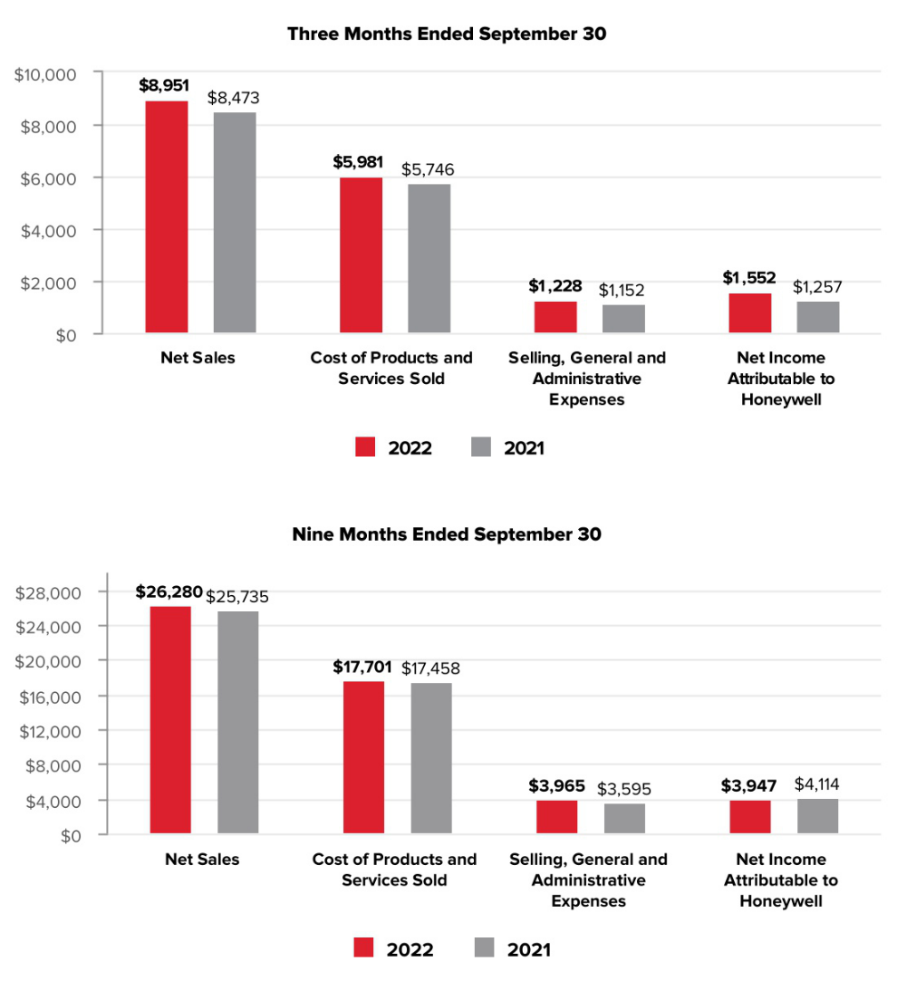

33 Honeywell International Inc.

TABLE OF CONTENTS

Net Sales by Segment
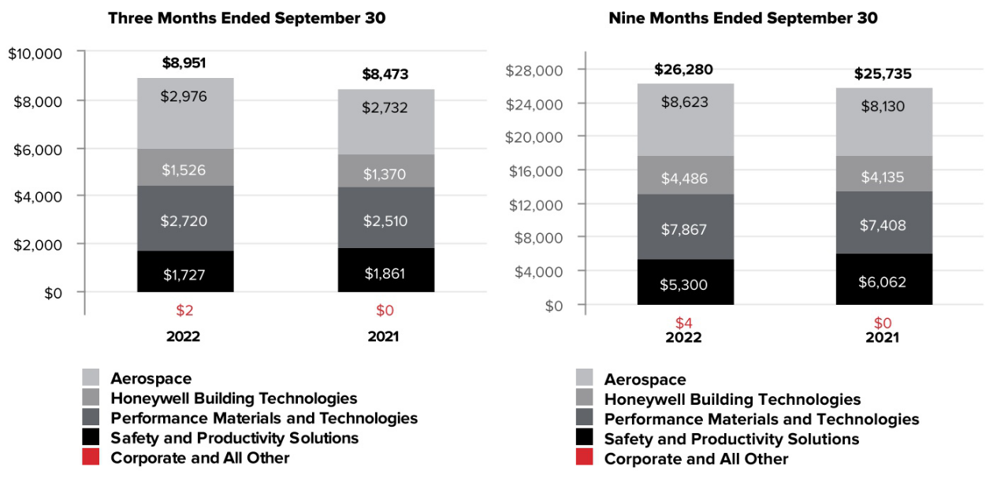

34 Honeywell International Inc.

TABLE OF CONTENTS

Segment Profit by Segment
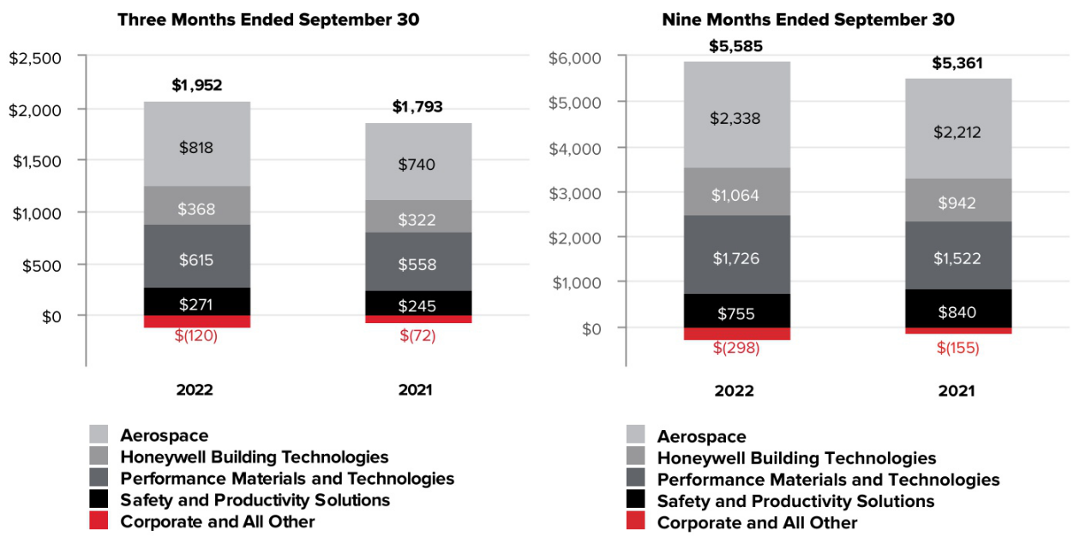

35 Honeywell International Inc.

TABLE OF CONTENTS

CONSOLIDATED OPERATING RESULTS

Net Sales
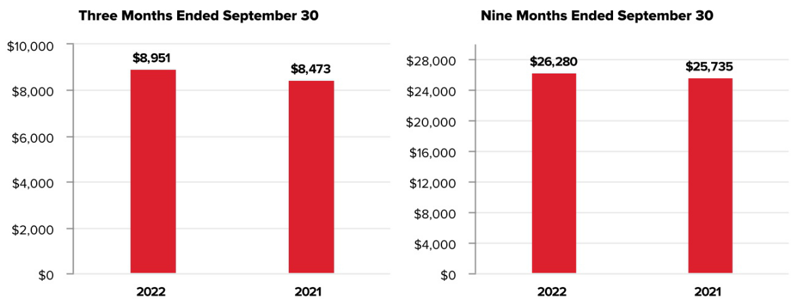

The change in net sales was attributable to the following:

 | Q3 2022 vs. Q3 2021 | Year to Date 2022 vs. 2021
Volume | (2)% | (4)%
Price | 11 % | 9 %
Foreign Currency Translation | (3)% | (3)%
 | 6 % | 2 %

Q3 2022 compared with Q3 2021

Net sales increased due to the following:

- Favorable pricing to offset higher direct and indirect material costs and higher labor costs,

- Partially offset by lower sales volumes in our Safety and Productivity Solutions reportable business segment, and

- The unfavorable impact of foreign currency translation, driven by the strengthening of the U.S. Dollar against the currencies of the majority of our international markets, primarily the Euro, British Pound, Turkish Lira, and Chinese Renminbi.

YTD 2022 compared with YTD 2021

Net sales increased due to the following:

- Favorable pricing to offset higher direct and indirect material costs and higher labor costs,

- Partially offset by lower sales volumes in our Safety and Productivity Solutions reportable business segment, and

- The unfavorable impact of foreign currency translation, driven by the strengthening of the U.S. Dollar against the currencies of the majority of our international markets, primarily the Euro, British Pound, Turkish Lira, and Australian Dollar.

36 Honeywell International Inc.

TABLE OF CONTENTS

Cost of Products and Services Sold
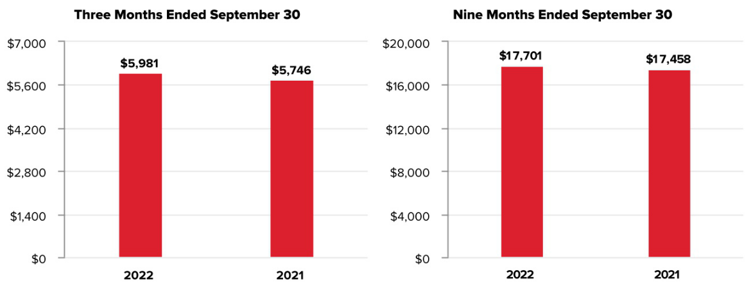

Q3 2022 compared with Q3 2021

Cost of products and services sold increased due to the following:

- Higher direct and indirect material costs and higher labor costs, and

- Higher repositioning and other charges,

- Partially offset by lower sales volumes in our Safety and Productivity Solutions reportable business segment, and favorable impact of foreign currency translation.

YTD 2022 compared with YTD 2021

Cost of products and services sold increased due to the following:

- Higher direct and indirect material costs and higher labor costs, and

- Higher repositioning and other charges,

- Partially offset by lower sales volumes in our Safety and Productivity Solutions reportable business segment, and favorable impact of foreign currency translation.

37 Honeywell International Inc.

TABLE OF CONTENTS

Gross Margin
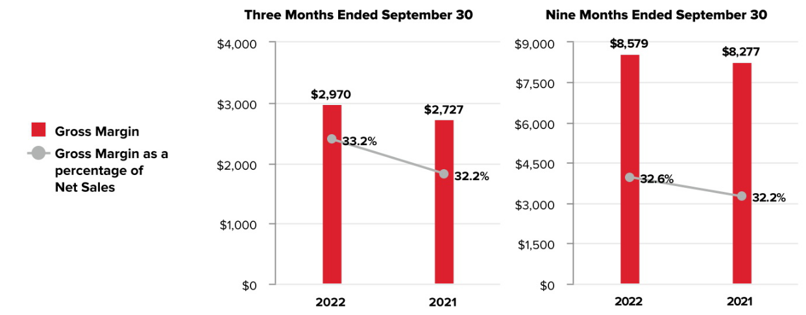

Q3 2022 compared with Q3 2021

Gross margin and Gross margin as a percentage of net sales increased due to the following:

- Favorable pricing,

- Partially offset by lower gross margins due to higher direct and indirect material costs and higher labor costs, higher repositioning and other charges, and lower sales volumes in our Safety and Productivity Solutions reportable business segment.

YTD 2022 compared with YTD 2021

Gross margin and Gross margin as a percentage of net sales increased due to the following:

- Favorable pricing,

- Partially offset by lower gross margins due to higher direct and indirect material costs and higher labor costs, higher repositioning and other charges and lower sales volumes in our Safety and Productivity Solutions reportable business segment.

38 Honeywell International Inc.

TABLE OF CONTENTS

Selling, General and Administrative Expenses
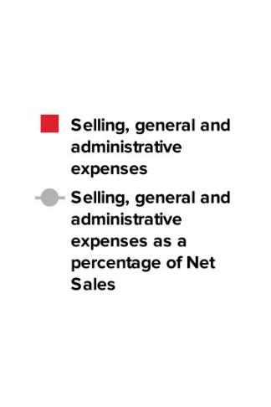
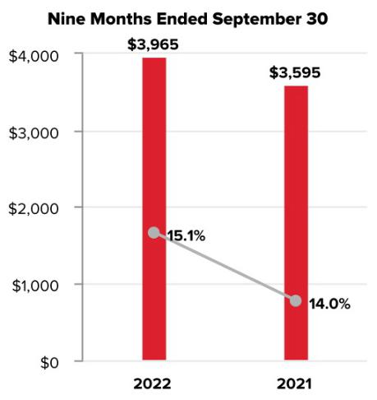

Q3 2022 compared with Q3 2021

Selling, general and administrative expenses increased primarily due to higher labor costs.

YTD 2022 compared to YTD 2021

Selling, general and administrative expenses increased due to the following:

- Higher labor costs, and

- Higher repositioning and other costs, including charges and accrual of reserves directly attributable to the initial Suspension and Wind down of businesses and operations in Russia.

Other (Income) Expense

 | Three Months Ended |  |  |  |  |  | Nine Months Ended
 |  | September 30, |  |  |  |  | September 30,
 |  | 2022 |  | 2021 |  |  | 2022 | 2021
Other (Income) Expense | $ | (337) | $ | (215) |  | $ | (846) | $ (1,023)

Q3 2022 compared with Q3 2021

Other income increased due to the following:

- Prior year recognition of an expense related to UOP matters,

- Partially offset by lower pension income.

YTD 2022 compared with YTD 2021

Other income decreased due to the following:

- Lower pension and other postretirement income,

- Prior year gain on sale of the retail footwear business, and

- Charges and accrual of reserves directly attributable to the initial Suspension and Wind down of businesses and operations in Russia,

- Partially offset by prior year recognition of an expense related to UOP matters.

39 Honeywell International Inc.

TABLE OF CONTENTS

Tax Expense
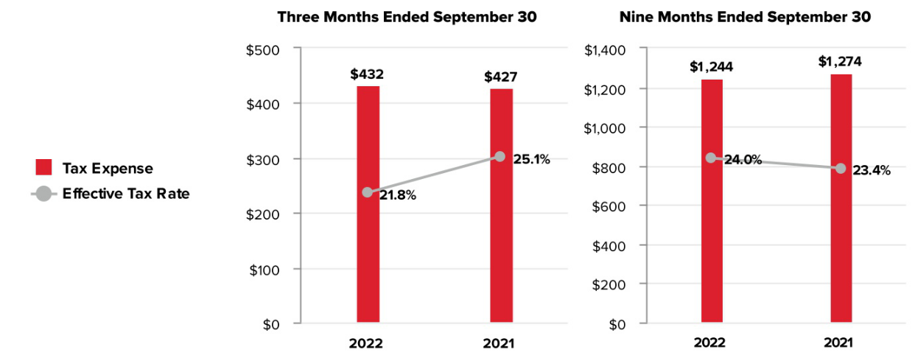

Q3 2022 compared with Q3 2021

The effective tax rate decreased, but was higher than the U.S. federal statutory rate of 21%, due to the following:

- Benefits and changes in reserves attributable to the initial Suspension and Wind down of our businesses and operations in Russia,

- Absence of expense related to UOP matters without corresponding tax benefit, and

- Increased benefit related to reversal of valuation allowance and tax reserve accruals,

- Partially offset by the favorable resolution of certain foreign tax matters, lower benefits for employee share-based compensation and state taxes.

YTD 2022 compared with YTD 2021

The effective tax rate increased, and was higher than the U.S. federal statutory rate of 21%, due to the following:

- Charges and accrual of reserves directly attributable to the initial Suspension and Wind down of our businesses and operations in Russia without corresponding tax benefit,

- Expense related to UOP matters without corresponding tax benefit,

- Lower tax benefits for employee share-based compensation, and

- Incremental tax reserves and state taxes,

- Partially offset by the favorable resolution of certain foreign tax matters.

40 Honeywell International Inc.

TABLE OF CONTENTS

Net Income Attributable to Honeywell
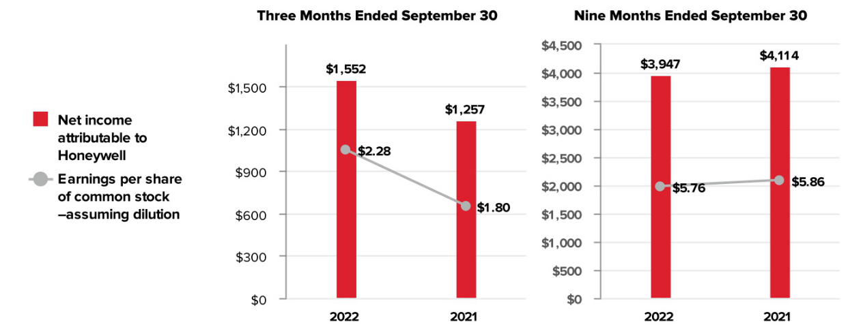

Q3 2022 compared to Q3 2021

Earnings per share of common stock–assuming dilution increased, due to the following:

- Higher segment profit from all of our reportable business segments,

- Prior year recognition of an expense related to UOP matters, and

- The favorable impact of lower share count.

YTD 2022 compared to YTD 2021

Earnings per share of common stock–assuming dilution decreased, due to the following:

- Higher repositioning and other charges, including charges and accrual of reserves directly attributable to the initial Suspension and Wind down of businesses and operations in Russia,

- Prior year gain on sale of the retail footwear business, and

- Lower pension income,

- Partially offset by higher segment profit driven by our Performance Materials and Technologies, Aerospace, and Honeywell Building Technologies reportable business segments, prior year recognition of an expense related to UOP matters, and the favorable impact of lower share count.

41 Honeywell International Inc.

TABLE OF CONTENTS

REVIEW OF BUSINESS SEGMENTS

We globally manage our business operations through four reportable business segments: Aerospace, Honeywell Building Technologies, Performance Materials and Technologies, and Safety and Productivity Solutions.

AEROSPACE

Net Sales
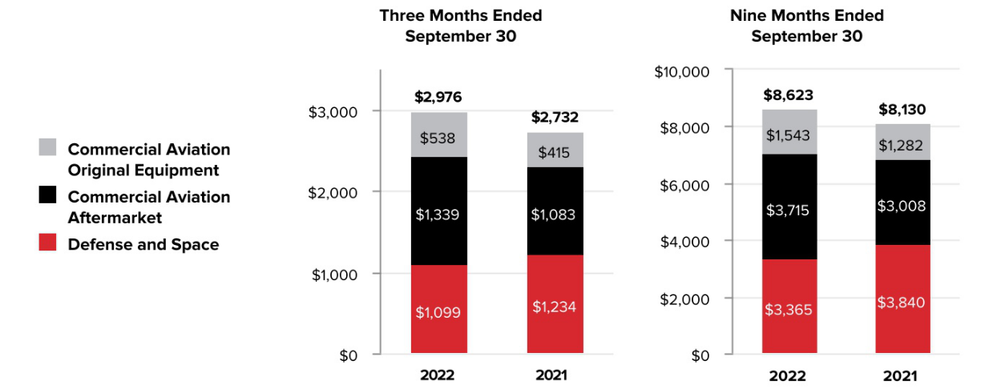

 |  | Three Months Ended |  |  |  |  |  | Nine Months Ended
 |  |  | September 30, |  |  |  |  |  | September 30,
 |  | 2022 |  | 2021 | % |  |  | 2022 |  | 2021 | %
 |  | 2022 |  | 2021 | Change |  |  | 2022 |  | 2021 | Change
Net sales | $ | 2,976 | $ | 2,732 | 9 % |  | $ | 8,623 | $ | 8,130 | 6 %
Cost of products and services sold |  | 1,967 |  | 1,828 |  |  |  | 5,648 |  | 5,330
Selling, general and administrative and other expenses |  | 191 |  | 164 |  |  |  | 637 |  | 588
Segment profit | $ | 818 | $ | 740 | 11 % |  | $ | 2,338 | $ | 2,212 | 6 %

 |  |  | 2022 vs. 2021
 | Three Months Ended |  |  |  |  | Nine Months Ended
 | September 30, |  |  |  |  | September 30,
Factors Contributing to Year-Over-Year Change | Net | Segment |  |  |  | Net | Segment
Factors Contributing to Year-Over-Year Change | Sales | Profit |  |  |  | Sales | Profit
Organic⁽¹⁾ |  | 10 % | 11 % |  |  | 6 % | 6 %
Foreign currency translation |  | (1)% | — % |  |  | — % | — %
Acquisitions, divestitures and other, net |  | — % | — % |  |  | — % | — %
Total % Change |  | 9 % | 11 % |  |  | 6 % | 6 %

- Organic sales % change, presented for all of our reportable business segments, is defined as the change in net sales, excluding the impact on sales from foreign currency translation and acquisitions, net of divestitures, for the first 12 months following the transaction date. We believe this non-GAAP measure is useful to investors and management in understanding the ongoing operations and analysis of ongoing operating trends.

Q3 2022 compared to Q3 2021

Sales increased due to favorable pricing, higher demand for our aftermarket products and services, as flight hours continued to increase, and commercial OEMs, partially offset by lower volumes in domestic and international defense.

- Commercial Aviation Original Equipment sales increased 30% (increased 30% organic) due to higher demand and favorable pricing in air transport, and regional and business aviation.

42 Honeywell International Inc.

TABLE OF CONTENTS

- Commercial Aviation Aftermarket sales increased 24% (increased 24% organic) due to higher demand and favorable pricing in air transport, and regional and business aviation.

- Defense and Space sales decreased 11% (decreased 10% organic) due to lower sales volumes in domestic and international defense.

Cost of products and services sold increased due to higher direct and indirect material costs and higher labor costs, and higher sales volumes.

Segment profit increased due to favorable pricing and higher sales volumes, partially offset by higher direct and indirect material costs and higher labor costs.

YTD 2022 compared to YTD 2021

Sales increased due to favorable pricing, and higher demand for our aftermarket products and services, as flight hours increase from pandemic lows, and commercial OEMs, partially offset by lower volumes in domestic and international defense.

- Commercial Aviation Original Equipment sales increased 20% (increased 21% organic) due to higher demand in air transport.

- Commercial Aviation Aftermarket sales increased 24% (increased 24% organic) due to higher demand and favorable pricing in air transport, and regional and business aviation.

- Defense and Space sales decreased 12% (decreased 12% organic) due to lower sales volumes in domestic and international defense.

Cost of products and services sold increased due to higher direct and indirect material costs and higher labor costs, and higher sales volumes.

Segment profit increased due to favorable pricing and higher sales volumes, partially offset by higher direct and indirect material costs and higher labor costs.

HONEYWELL BUILDING TECHNOLOGIES

Net Sales
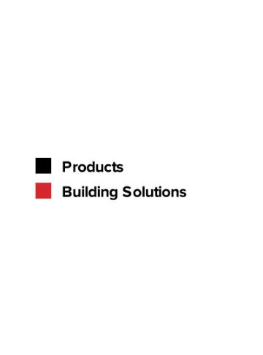
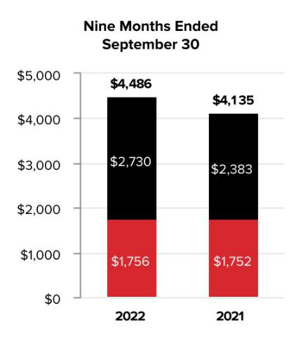

 |  | Three Months Ended |  |  |  |  |  | Nine Months Ended
 |  |  | September 30, |  |  |  |  |  | September 30,
 |  | 2022 |  | 2021 | % |  |  | 2022 |  | 2021 | %
 |  | 2022 |  | 2021 | Change |  |  | 2022 |  | 2021 | Change
Net sales | $ | 1,526 | $ | 1,370 | 11 % |  | $ | 4,486 | $ | 4,135 | 8 %
Cost of products and services sold |  | 898 |  | 798 |  |  |  | 2,621 |  | 2,409
Selling, general and administrative and other expenses |  | 260 |  | 250 |  |  |  | 801 |  | 784
Segment profit | $ | 368 | $ | 322 | 14 % |  | $ | 1,064 | $ | 942 | 13 %

43 Honeywell International Inc.

TABLE OF CONTENTS

 |  |  | 2022 vs. 2021
 | Three Months Ended |  |  |  |  | Nine Months Ended
 | September 30, |  |  |  |  | September 30,
Factors Contributing to Year-Over-Year Change | Net | Segment |  |  |  | Net | Segment
Factors Contributing to Year-Over-Year Change | Sales | Profit |  |  |  | Sales | Profit
Organic |  | 19 % | 23 % |  |  | 14 % | 19 %
Foreign currency translation |  | (8)% | (9)% |  |  | (6)% | (7)%
Acquisitions, divestitures and other, net |  | — % | — % |  |  | — % | 1 %
Total % Change |  | 11 % | 14 % |  |  | 8 % | 13 %

Q3 2022 compared to Q3 2021

Sales increased due to favorable pricing and higher sales volumes, partially offset by the unfavorable impact of foreign currency translation.

- Sales in Products increased 16% (increased 23% organic) due to favorable pricing and higher sales volumes, partially offset by the unfavorable impact of foreign currency translation.

- Sales in Building Solutions increased 5% (increased 13% organic) due to favorable pricing and higher sales volumes, partially offset by the unfavorable impact of foreign currency translation.

Cost of products and services sold increased due to higher direct and indirect material costs and higher labor costs, and higher volumes of lower margin products, partially offset by the favorable impact of foreign currency translation.

Segment profit increased due to favorable pricing and higher sales volumes, partially offset by higher direct and indirect material costs and higher labor costs, and the unfavorable impact of foreign currency translation.

YTD 2022 compared to YTD 2021

Sales increased due to favorable pricing and higher sales volumes, partially offset by the unfavorable impact of foreign currency translation.

- Sales in Products increased 15% (increased 20% organic) due to favorable pricing and higher sales volumes, partially offset by the unfavorable impact of foreign currency translation.

- Sales in Building Solutions were flat (increased 6% organic) due to favorable pricing, offset by the unfavorable impact of foreign currency translation.

Cost of products and services sold increased due to higher direct and indirect material costs and higher labor costs, and higher volumes of lower margin products, partially offset by the favorable impact of foreign currency translation.

Segment profit increased due to favorable pricing and higher sales volumes, partially offset by higher direct and indirect material costs and higher labor costs, and the unfavorable impact of foreign currency translation.

44 Honeywell International Inc.

TABLE OF CONTENTS

PERFORMANCE MATERIALS AND TECHNOLOGIES

Net Sales
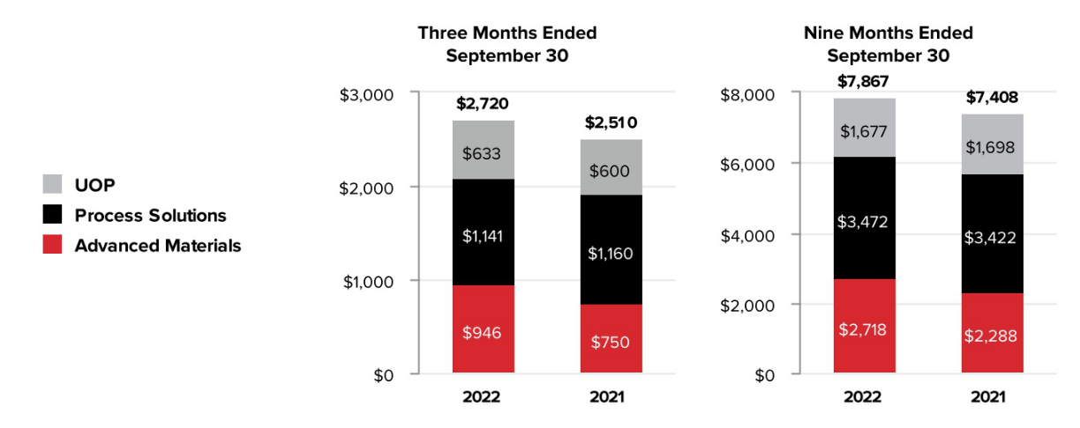

 |  | Three Months Ended |  |  |  |  |  | Nine Months Ended
 |  |  | September 30, |  |  |  |  |  | September 30,
 |  | 2022 |  | 2021 | % |  |  | 2022 |  | 2021 | %
 |  | 2022 |  | 2021 | Change |  |  | 2022 |  | 2021 | Change
Net sales | $ | 2,720 | $ | 2,510 | 8 % |  | $ | 7,867 | $ | 7,408 | 6 %
Cost of products and services sold |  | 1,774 |  | 1,653 |  |  |  | 5,109 |  | 4,940
Selling, general and administrative and other expenses |  | 331 |  | 299 |  |  |  | 1,032 |  | 946
Segment profit | $ | 615 | $ | 558 | 10 % |  | $ | 1,726 | $ | 1,522 | 13 %

 |  |  | 2022 vs. 2021
 | Three Months Ended |  |  |  |  | Nine Months Ended
 | September 30, |  |  |  |  | September 30,
Factors Contributing to Year-Over-Year Change | Net | Segment |  |  |  | Net | Segment
Factors Contributing to Year-Over-Year Change | Sales | Profit |  |  |  | Sales | Profit
Organic |  | 14 % | 15 % |  |  | 10 % | 17 %
Foreign currency translation |  | (6)% | (5)% |  |  | (4)% | (4)%
Acquisitions, divestitures and other, net |  | — % | — % |  |  | — % | — %
Total % Change |  | 8 % | 10 % |  |  | 6 % | 13 %

Q3 2022 compared to Q3 2021

Sales increased due to favorable pricing, partially offset by the unfavorable impact of foreign currency translation.

- UOP sales increased 6% (increased 6% organic) due to favorable pricing, partially offset by lower demand for new oil and gas projects and the impact of the Russia-Ukraine conflict.

- Process Solutions sales decreased 2% (increased 6% organic) due to the unfavorable impact of foreign currency translation and the impact of the Russia-Ukraine conflict, partially offset by favorable pricing and higher demand for certain products and services.
- Advanced Materials sales increased 26% (increased 33% organic) due to favorable pricing and higher demand for fluorine products, partially offset by the unfavorable impact of foreign currency translation.

Cost of products and services sold increased due to higher direct and indirect material costs and higher labor costs, and lower sales volumes of higher margin products, partially offset by the favorable impact of foreign currency translation.

Segment profit increased due to favorable pricing, partially offset by higher direct and indirect material costs and higher labor costs, and lower sales volumes of higher margin products.

45 Honeywell International Inc.

TABLE OF CONTENTS

YTD 2022 compared to YTD 2021

Sales increased due to favorable pricing, partially offset by the unfavorable impact of foreign currency translation and lower sales volumes primarily due to the impact of the Russia-Ukraine conflict.

- UOP sales decreased 1% (decreased 1% organic) due to lower demand for new oil and gas projects and the impact of the Russia-Ukraine conflict, partially offset by favorable pricing.
- Process Solutions sales increased 1% (increased 6% organic) due to favorable pricing and higher demand for certain products and services, partially offset by the unfavorable impact of foreign currency translation and the impact of the Russia-Ukraine conflict.
- Advanced Materials sales increased 19% (increased 23% organic) due to favorable pricing and higher demand for specialty products, partially offset by the unfavorable impact of foreign currency translation.

Cost of products and services sold increased due to higher direct and indirect material costs and higher labor costs, partially offset by the favorable impact of foreign currency translation, and lower sales volumes primarily due to the impact of the Russia-Ukraine conflict.

Segment profit increased due to favorable pricing, partially offset by higher direct and indirect material costs and higher labor costs, lower sales volumes of higher margin products, and the unfavorable impact of foreign currency translation.

SAFETY AND PRODUCTIVITY SOLUTIONS

Net Sales
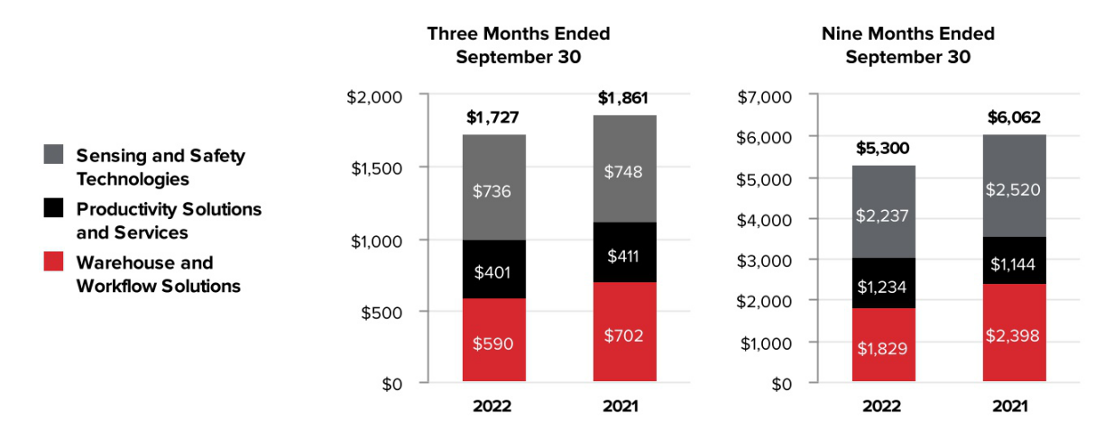

 |  | Three Months Ended |  |  |  |  |  | Nine Months Ended
 |  |  | September 30, |  |  |  |  |  | September 30,
 |  | 2022 |  | 2021 | % |  |  | 2022 |  | 2021 | %
 |  | 2022 |  | 2021 | Change |  |  | 2022 |  | 2021 | Change
Net sales | $ | 1,727 | $ | 1,861 | (7)% |  | $ | 5,300 | $ | 6,062 | (13)%
Cost of products and services sold |  | 1,205 |  | 1,369 |  |  |  | 3,733 |  | 4,442
Selling, general and administrative and other expenses |  | 251 |  | 247 |  |  |  | 812 |  | 780
Segment profit | $ | 271 | $ | 245 | 11 % |  | $ | 755 | $ | 840 | (10)%

46 Honeywell International Inc.

TABLE OF CONTENTS

 |  |  | 2022 vs. 2021
 | Three Months Ended |  |  |  |  | Nine Months Ended
 | September 30, |  |  |  |  | September 30,
Factors Contributing to Year-Over-Year Change | Net | Segment |  |  |  | Net | Segment
Factors Contributing to Year-Over-Year Change | Sales | Profit |  |  |  | Sales | Profit
Organic |  | (4)% | 14 % |  |  | (10)% | (7)%
Foreign currency translation |  | (3)% | (3)% |  |  | (2)% | (2)%
Acquisitions, divestitures and other, net |  | — % | — % |  |  | (1)% | (1)%
Total % Change |  | (7)% | 11 % |  |  | (13)% | (10)%

Q3 2022 compared to Q3 2021

Sales decreased due to lower sales volumes and the unfavorable impact of foreign currency translation, partially offset by favorable pricing.

- Sales in Sensing and Safety Technologies decreased 2% (increased 3% organic) due to lower demand for personal protective equipment and the unfavorable impact of foreign currency translation, partially offset by favorable pricing and higher demand for advanced sensing and gas detection.

- Sales in Productivity Solutions and Services decreased 2% (increased 2% organic) due to the unfavorable impact of foreign currency translation, partially offset by favorable pricing and higher sales volumes (driven by a licensing agreement executed in the second quarter of 2022, discussed below).

- Sales in Warehouse and Workflow Solutions decreased 16% (decreased 15% organic) due to lower demand and timing of projects.

Cost of products and services sold decreased due to lower sales volumes and the favorable impact of foreign currency translation, partially offset by higher direct and indirect material costs and higher labor costs.

Segment profit increased primarily due to favorable pricing and lower sales volumes of lower margin products, partially offset by higher direct and indirect material costs and higher labor costs.

YTD 2022 compared to YTD 2021

Sales decreased due to lower sales volumes, the unfavorable impact of foreign currency translation, and the sale of the retail footwear business, partially offset by favorable pricing.

- Sales in Sensing and Safety Technologies decreased 11% (decreased 7% organic) due to lower demand for personal protective equipment, the unfavorable impact of foreign currency translation, and the sale of the retail footwear business, partially offset by favorable pricing and higher demand for advanced sensing and gas detection.

- Sales in Productivity Solutions and Services increased 8% (increased 12% organic) due to favorable pricing and higher sales volumes (driven by a licensing agreement executed in the second quarter of 2022, discussed below), partially offset by the unfavorable impact of foreign currency translation.
- Sales in Warehouse and Workflow Solutions decreased 24% (decreased 23% organic) due to lower demand and timing of projects.

Cost of products and services sold decreased due to lower sales volumes, partially offset by higher direct and indirect material costs and higher labor costs, and lower productivity (including a write-down of mask inventory).

Segment profit decreased primarily due to higher direct and indirect material costs and higher labor costs, lower productivity, and lower sales volumes, partially offset by favorable pricing.

During the second quarter of 2022, our Productivity Solutions and Services business entered into a license and settlement agreement (the Agreement). Under the Agreement, we will receive up to $360 million, paid in equal quarterly installments over eight quarters, beginning with the second quarter of 2022. The Agreement provides each party a license to its existing patent portfolio for use by the other party’s existing products and, resolves all patent-related litigation between the parties.

CORPORATE AND ALL OTHER

Corporate and All Other primarily includes unallocated corporate costs, interest expense on holding-company debt, and the controlling majority-owned interest in Quantinuum. Corporate and All Other is not considered a separate reportable business segment as segment reporting criteria is not met for the activities reported with Corporate and All Other. The Company continues to monitor the activities in Corporate and All Other to determine the need for further reportable business segment disaggregation.

47 Honeywell International Inc.

TABLE OF CONTENTS

REPOSITIONING CHARGES

See Note 5 Repositioning and Other Charges of Notes to Consolidated Financial Statements for a discussion of our repositioning actions and related charges incurred in the nine months ended September 30, 2022 and 2021. Cash spending related to our repositioning actions was $206 million in the nine months ended September 30, 2022, and was funded through operating cash flows.

48 Honeywell International Inc.

TABLE OF CONTENTS

LIQUIDITY AND CAPITAL RESOURCES

(Dollars in tables in millions)

We continue to manage our businesses to maximize operating cash flows as the primary source of liquidity. Each of our businesses is focused on increasing operating cash flows through revenue growth, margin expansion, and improved working capital turnover. Additional sources of liquidity include committed credit lines, short-term debt from the commercial paper market, long-term borrowings, access to the public debt and equity markets, U.S. cash balances, and the ability to access non-U.S. cash balances.

CASH

We monitor the third-party depository institutions that hold our cash and cash equivalents on a daily basis. Our emphasis is primarily safety of principal and secondarily maximizing yield of those funds. We diversify our cash and cash equivalents among counterparties to minimize exposure to any one counterparty. As of September 30, 2022, and December 31, 2021, we held $8.0 billion and $11.5 billion, respectively, of cash and cash equivalents, including our short-term investments.

As of September 30, 2022, $5.6 billion of the Company’s cash, cash equivalents, and short-term investments are held by non-US subsidiaries. We do not have material amounts related to any jurisdiction subject to currency control restrictions that impact our ability to access and repatriate such amounts. Under current law, we do not expect taxes on repatriation or restrictions on amounts held outside of the U.S. to have a material effect on our overall liquidity.

BORROWINGS

We leverage a variety of debt instruments to manage our overall borrowing costs. As of September 30, 2022, and December 31, 2021, our total borrowings were $17.0 billion and $19.6 billion, respectively.

 |  | September 30, 2022 |  |  | December 31, 2021
Commercial paper and other short-term borrowings |  | $ | 3,434 |  | $ | 3,542
Variable rate notes |  |  | 22 |  |  | 622
Fixed rate notes |  |  | 13,740 |  |  | 15,314
Other |  |  | 282 |  |  | 272
Fair value of hedging instruments |  |  | (294) |  |  | 60
Debt issuance costs |  |  | (199) |  |  | (211)
Total borrowings |  | $ | 16,985 |  | $ | 19,599

A primary source of liquidity is our ability to access the corporate bond markets. Through these markets, we issue a variety of long-term fixed rate notes, in a variety of currencies, to manage our overall funding costs.

Another primary source of liquidity is our ability to access the commercial paper market. Commercial paper notes are sold at a discount or premium and have a maturity of not more than 365 days from date of issuance. Borrowings under the commercial paper program are available for general corporate purposes as well as for financing acquisitions.

We also have the following revolving credit agreements:

- A $1.5 billion 364-Day Credit Agreement (the 364-Day Credit Agreement) with a syndicate of banks, dated March 24, 2022. Amounts borrowed under the 364-Day Credit Agreement are required to be repaid no later than March 23, 2023, unless (i) we elect to convert all then outstanding amounts into a term loan, upon which such amounts shall be repaid in full on March 23, 2024, or (ii) the 364-Day Credit Agreement is terminated earlier pursuant to its terms. The 364-Day Credit Agreement replaced the previously reported $1.5 billion 364-day credit agreement dated as of March 31, 2021, which was terminated in accordance with its terms effective March 24, 2022. As of September 30, 2022, there were no outstanding borrowings under our 364-Day Credit Agreement.

- A $4.0 billion Five Year Credit Agreement (the 5-Year Credit Agreement) with a syndicate of banks, dated March 24, 2022. Commitments under the 5-Year Credit Agreement can be increased pursuant to the terms of the 5-Year Credit Agreement to an aggregate amount not to exceed $4.5 billion. The 5-Year Credit Agreement amended and restated the previously reported $4.0 billion amended and restated five year credit agreement dated as of March 31, 2021. As of September 30, 2022, there were no outstanding borrowings under our 5-Year Credit Agreement.

49 Honeywell International Inc.

TABLE OF CONTENTS

We also have a current shelf registration statement filed with the Securities and Exchange Commission (SEC) under which we may issue additional debt securities, common stock, and preferred stock that may be offered in one or more offerings on terms to be determined at the time of the offering. We anticipate that net proceeds of any offering would be used for general corporate purposes, including repayment of existing indebtedness, share repurchases, capital expenditures and acquisitions.

CREDIT RATINGS

Our ability to access the global debt capital markets and the related cost of these borrowings is affected by the strength of our credit rating and market conditions. Our credit ratings are periodically reviewed by the major independent debt-rating agencies. As of September 30, 2022, S&P Global Inc. (S&P), Fitch Ratings Inc. (Fitch), and Moody’s Investor Service (Moody's) have ratings on our debt set forth in the table below:

 | S&P | Fitch | Moody's
Outlook | Stable | Stable | Stable
Short-term | A-1 | F1 | P1
Long-term | A | A | A2

CASH FLOW SUMMARY

Our cash flows from operating, investing, and financing activities, as reflected in the Consolidated Statement of Cash Flows, are summarized as follows:

 | Nine Months Ended September 30,
 |  | 2022 |  | 2021 | Variance
Cash and cash equivalents at beginning of period | $ | 10,959 | $ | 14,275 | $ | (3,316)
Operating activities
Net income attributable to Honeywell |  | 3,947 |  | 4,114 |  | (167)
Noncash adjustments |  | 1,202 |  | 675 |  | 527
Changes in working capital |  | (1,415) |  | (556) |  | (859)
Other operating activities |  | (826) |  | (858) |  | 32
Net cash provided by operating activities |  | 2,908 |  | 3,375 |  | (467)
Net cash provided by (used for) investing activities |  | 540 |  | (1,347) |  | 1,887
Net cash used for financing activities |  | (6,609) |  | (5,195) |  | (1,414)
Effect of exchange rate changes on cash |  | (349) |  | (21) |  | (328)
Net increase (decrease) in cash and cash equivalents |  | (3,510) |  | (3,188) |  | (322)
Cash and cash equivalents at end of period | $ | 7,449 | $ | 11,087 | $ | (3,638)

Cash related to operating activities decreased due to an unfavorable impact to working capital and a decrease in net income, partially offset by an increase in noncash adjustments, primarily driven by an increase in repositioning and other charges and a gain from the 2021 sale of the retail footwear business.

Cash related to investing activities increased by $1,887 million primarily due to $1,156 million decrease in cash paid for acquisitions, $685 million increase in cash receipts from settlements of derivative contracts, and $133 million net decrease in investments, partially offset by $203 million in proceeds from the 2021 sale of the retail footwear business.

Cash related to financing activities decreased by $1,414 million primarily due to $2,507 million decrease in proceeds from the issuance of long-term debt and $328 million increase in repurchases of common stock, partially offset by $1,537 million decrease in payments of long-term debt.

50 Honeywell International Inc.

TABLE OF CONTENTS

CASH REQUIREMENTS AND ASSESSMENT OF CURRENT LIQUIDITY

In addition to our normal operating cash requirements, our principal future cash requirements will be to fund capital expenditures, share repurchases, dividends, strategic acquisitions and debt repayments. On February 12, 2021, the Board of Directors authorized the repurchase of up to a total of $10 billion of Honeywell common stock, which included amounts remaining under, and replaced, the previously approved share repurchase program. During the nine months ended September 30, 2022, we repurchased common stock of $2,827 million. Refer to the section titled Liquidity and Capital Resources of our 2021 Form 10-K for a discussion of our expected capital expenditures, share repurchases, and dividends for 2022.

We continue to identify opportunities to improve our liquidity and working capital efficiency, which includes the extension of payment terms with our suppliers and sales of our trade receivables to unaffiliated financial institutions without recourse. The impact of these programs is not material to our overall liquidity.

We continue to assess the relative strength of each business in our portfolio as to strategic fit, market position, profit, and cash flow contribution in order to identify target investment and acquisition opportunities in order to upgrade our combined portfolio. We identify acquisition candidates that will further our strategic plan and strengthen our existing core businesses. We also identify businesses that do not fit into our long-term strategic plan based on their market position, relative profitability, or growth potential. These businesses are considered for potential divestiture, restructuring, or other repositioning actions, subject to regulatory constraints.

Based on past performance and current expectations, we believe that our operating cash flows will be sufficient to meet our future operating cash needs. Our available cash, committed credit lines and access to the public debt and equity markets provide additional sources of short-term and long-term liquidity to fund current operations, debt maturities, and future investment opportunities.

See Note 8 Long-term Debt and Credit Agreements of Notes to Consolidated Financial Statements for additional discussion of items impacting our liquidity.

OTHER MATTERS

LITIGATION

We are subject to a number of lawsuits, investigations, and claims (some of which involve substantial amounts) arising out of the conduct of our business. See Note 14 Commitments and Contingencies of Notes to Consolidated Financial Statements for further discussion of environmental, asbestos and other litigation matters.

CRITICAL ACCOUNTING ESTIMATES

There have been no material changes to our Critical Accounting Estimates presented in our 2021 Annual Report on Form 10-K. For a discussion of the Company’s Critical Accounting Estimates, see the section titled Critical Accounting Estimates in our 2021 Annual Report on Form 10-K.

RECENT ACCOUNTING PRONOUNCEMENTS

See Note 2 Summary of Significant Accounting Policies of Notes to Consolidated Financial Statements for a discussion of recent accounting pronouncements.

ITEM 3. QUANTITATIVE AND QUALITATIVE DISCLOSURES ABOUT MARKET RISKS

For a discussion of the Company’s quantitative and qualitative disclosures about market risks, see the section titled Quantitative and Qualitative Disclosures About Market Risks in our 2021 Annual Report on Form 10-K. As of September 30, 2022, there has been no material change in this information.

51 Honeywell International Inc.

TABLE OF CONTENTS

ITEM 4. CONTROLS AND PROCEDURES

Honeywell management, including the Chief Executive Officer and Chief Financial Officer, conducted an evaluation of the effectiveness of our disclosure controls and procedures (as defined in Rules 13a-15(e) or 15d-15(e) promulgated under the Securities Exchange Act of 1934, as amended (Exchange Act)) as of the end of the period covered by this Quarterly Report on Form 10-Q. Based upon that evaluation, the Chief Executive Officer and the Chief Financial Officer concluded that such disclosure controls and procedures were effective as of the end of the period covered by this Quarterly Report on Form 10-Q to ensure information required to be disclosed in the reports that Honeywell files or submits under the Exchange Act is recorded, processed, summarized, and reported within the time periods specified in the SEC's rules and forms, and that it is accumulated and communicated to our management, including our Chief Executive Officer, our Chief Financial Officer, and our Controller, as appropriate, to allow timely decisions regarding required disclosure. There were no changes that materially affected, or are reasonably likely to materially affect, Honeywell’s internal control over financial reporting that occurred during the period covered by this Quarterly Report on Form 10-Q.

52 Honeywell International Inc.

TABLE OF CONTENTS

PART II. OTHER INFORMATION

ITEM 1. LEGAL PROCEEDINGS

We are subject to a number of lawsuits, investigations and claims (some of which involve substantial amounts) arising out of the conduct of our business.

See Note 14 Commitments and Contingencies of Notes to Consolidated Financial Statements for a discussion of environmental, asbestos and other litigation matters.

There were no matters requiring disclosure pursuant to the requirement to disclose certain environmental matters involving potential monetary sanctions in excess of $300,000.

ITEM 1A. RISK FACTORS

Other than as noted below, there have been no material changes to our Risk Factors presented in our 2021 Annual Report on Form 10-K under the section titled Risk Factors. For further discussion of our Risk Factors, refer to the section titled Risk Factors in our 2021 Annual Report on Form 10-K.

A significant percentage of our sales and operations is in non-U.S. jurisdictions and is subject to the economic, political, regulatory, foreign exchange, and other risks of international operations, including those from the ongoing Russia-Ukraine conflict.

Our international operations, including U.S. exports, represent more than half of the Company’s sales. Risks related to international operations include exchange control regulations, wage and price controls, antitrust regulations, employment regulations, foreign investment laws, import, export and other trade restrictions (such as sanctions and embargoes), differing levels of protection of intellectual property, acts of industrial espionage, violations by our employees of anti-corruption laws (despite our efforts to mitigate such risk), changes in regulations regarding transactions with state-owned enterprises, nationalization of private enterprises, acts of terrorism, acts of war, civil strife, and our ability to hire and maintain qualified staff and maintain the safety of our employees in these regions. Instability and uncertainties arising from the global geopolitical environment and the evolving international and domestic political, regulatory, and economic landscape, including the potential for changes in global trade policies, such as sanctions and trade barriers, and trends such as populism, economic nationalism and negative sentiment toward multinational companies, as well as the cost of compliance with increasingly complex and often conflicting regulations worldwide, can impair our flexibility in modifying product, marketing, pricing or other strategies for growing our businesses, as well as our ability to improve productivity and maintain acceptable operating margins.

Existing free trade laws and regulations provide certain beneficial duties and tariffs for qualifying imports and exports. Changes in laws or policies governing the terms of foreign trade, and in particular increased trade restrictions, tariffs or taxes on imports from countries where we manufacture products or from where we import products or raw materials, either directly or through our suppliers, could have an impact on our competitive position and financial results.

The U.S. continues to implement certain trade actions, including imposing tariffs on certain goods imported from China and other countries, which has resulted in retaliatory tariffs by China and other countries. Additional tariffs, export controls and sanctions laws imposed by the U.S. on a broader range of imports, or further retaliatory trade measures taken by China or other countries in response, could increase the cost of our products.

In response to the conflict between Russia and Ukraine, the U.S. and other countries imposed actions including sanctions, export and import controls, and trade restrictions with respect to Russian and Belarusian governments, government-related entities, and other entities and individuals. Further, the Russian government implemented retaliatory actions against the U.S. and other nation members of the North Atlantic Treaty Organization (NATO) as well as certain other nations. As a result of these governmental actions, in March 2022, we suspended substantially all of our sales, distribution, and service activities in Russia and Belarus (the Suspension), and in June 2022, we decided to wind down our existing businesses and operations in Russia (the Wind down). Given the uncertainty inherent in our remaining obligations related to our contracts with Russian counterparties, we do not believe it is possible to develop estimates of reasonably possible loss in excess of current accruals for these matters. Based on available information to date, the Company's estimate of potential future losses or other contingencies related to the Suspension and Wind down activities, including guarantee payments or any litigation costs or as otherwise related to our Wind down in Russia, could adversely affect the Company's consolidated results of operations in periods recognized but would not be material with respect to the Company's consolidated financial position. As the conflict continues to evolve, existing conditions may worsen, or other impacts, including escalation of the conflict in other regions of Europe, where there is a material portion of our business, increased tension between Russia and the U.S. and other NATO members and other countries, or other impacts that are unknown at this time, could lead to increased charges and could have a material adverse effect on our consolidated financial position. These impacts may result in increased costs or additional

53 Honeywell International Inc.

TABLE OF CONTENTS

impacts on our operations and may adversely affect our ability to meet contractual and financial obligations, results of operations, and financial condition.

To the extent the current conflict between Russia and Ukraine escalates, it may also negatively impact other risks disclosed in our 2021 Form 10-K and further impact our financial results. Such risks include, but are not limited to, adverse effects on macroeconomic conditions, including inflation and consumer spending; cybersecurity incidents and other disruptions to our information technology infrastructure or that of our customers and suppliers, including disruptions at our cloud computing, server, systems and other third party IT service providers; adverse changes in international trade policies and relations; our ability to implement and execute our business strategy, particularly in Eastern Europe and surrounding regions; disruptions in global supply chains; energy shortages; terrorist activities targeting U.S. government contractors and/or critical infrastructure; our exposure to foreign currency fluctuations; and constraints, volatility, or disruption in the capital markets.

Operating outside of the U.S. also exposes us to foreign exchange risk, which we monitor and seek to reduce through hedging activities. However, foreign exchange hedging activities bear a financial cost and may not always be available to us or be successful in eliminating such volatility. Finally, we generate significant amounts of cash outside of the U.S. that is invested with financial and non-financial counterparties. While we employ comprehensive controls regarding global cash management to guard against cash or investment loss and to ensure our ability to fund our operations and commitments, a material disruption to the counterparties with whom we transact business could expose Honeywell to financial loss.

Operating outside the U.S. also exposes us to additional intellectual property risk. The laws and enforcement practices of certain jurisdictions in which we operate may not protect our intellectual property rights to the same extent as in the U.S. and may impose joint venture, technology transfer, local service or other foreign investment requirements, and restrictions that potentially compromise control over our technology and proprietary information. Failure of foreign jurisdictions to protect our intellectual property rights, an inability to effectively enforce such rights in foreign jurisdictions, or the imposition of foreign jurisdiction investment or sourcing restrictions or requirements could result in loss of valuable proprietary information and could impact our competitive position and financial results.

ITEM 2. UNREGISTERED SALES OF EQUITY SECURITIES AND USE OF PROCEEDS

On February 12, 2021, the Board of Directors authorized the repurchase of up to a total of $10 billion of Honeywell common stock, which included amounts remaining under, and replaced, the previously approved share repurchase program.

Repurchases may be made through a variety of methods, which could include open market purchases, accelerated share repurchase transactions, negotiated block transactions, 10b5-1 plans, other transactions that may be structured through investment banking institutions or privately negotiated, or a combination of the foregoing. Honeywell presently expects to repurchase outstanding shares from time to time (i) to offset the dilutive impact of employee stock-based compensation plans, including option exercises, restricted unit vesting and matching contributions under our savings plans, and (ii) to reduce share count via share repurchases as and when attractive opportunities arise. The amount and timing of future repurchases may vary depending on market conditions and the level of operating, financing and other investing activities.

During the quarter ended September 30, 2022, Honeywell purchased 2,066,369 shares of its common stock, par value $1 per share. As of September 30, 2022, $4.3 billion remained available for additional share repurchases. The following table summarizes Honeywell’s purchase of its common stock for the quarter ended September 30, 2022:

Issuer Purchases of Equity Securities

 |  |  |  | Total Number | Approximate Dollar
 |  |  |  | of Shares | Value of Shares that
 | Total |  |  | Purchased as |  | May Yet be
 | Total | Average |  | Part of Publicly | Purchased Under Plans
 | Number of |  |  | Announced |  | or
Period | Shares | Price Paid |  | Plans |  | Programs
Period | Purchased | per Share |  | or Programs | (Dollars in millions)
July 1-31, 2022 | — | $ | — | — | $ | 4,668
August 1-31, 2022 | 756,767 | $ | 198.18 | 756,767 | $ | 4,518
September 1-30, 2022 | 1,309,602 | $ | 183.21 | 1,309,602 | $ | 4,279

54 Honeywell International Inc.

TABLE OF CONTENTS

ITEM 4. MINE SAFETY DISCLOSURES

One of our wholly-owned subsidiaries has a placer claim for and operates a chabazite ore surface mine in Arizona. Information concerning mine safety and other regulatory matters associated with this mine is required by Section 1503(a) of the Dodd-Frank Wall Street Reform and Consumer Protection Act and Item 104 of Regulation S-K and is included in Exhibit 95 to this quarterly report.

55 Honeywell International Inc.

TABLE OF CONTENTS

ITEM 6. EXHIBITS

Exhibit No. | Description
10.1* | Offer letter dated July 26, 2022 from Honeywell International Inc. to Vimal Kapur (incorporated by reference to Exhibit 99 to Honeywell's Form 8-K filed on
 | July 28, 2022)
31.1 | Certification of Principal Executive Officer Pursuant to Section 302 of the Sarbanes-Oxley Act of 2002 (filed herewith)
31.2 | Certification of Principal Financial Officer Pursuant to Section 302 of the Sarbanes-Oxley Act of 2002 (filed herewith)
32.1 | Certification of Principal Executive Officer Pursuant to 18 U.S.C. Section 1350, as Adopted Pursuant to Section 906 of the Sarbanes-Oxley Act of 2002
 | (furnished herewith)
32.2 | Certification of Principal Financial Officer Pursuant to 18 U.S.C. Section 1350, as Adopted Pursuant to Section 906 of the Sarbanes-Oxley Act of 2002
 | (furnished herewith)
95 | Mine Safety Disclosures (filed herewith)
101.INS | Inline XBRL Instance Document (the instance document does not appear in the Interactive Data File because its XBRL tags are embedded within the Inline
 | XBRL document)
101.SCH | Inline XBRL Taxonomy Extension Schema (filed herewith)
101.CAL | Inline XBRL Taxonomy Extension Calculation Linkbase (filed herewith)
101.DEF | Inline XBRL Taxonomy Extension Definition Linkbase (filed herewith)
101.LAB | Inline XBRL Taxonomy Extension Label Linkbase (filed herewith)
101.PRE | Inline XBRL Taxonomy Extension Presentation Linkbase (filed herewith)

  - Cover Page Interactive Data File (formatted as inline XBRL and contained in Exhibit 101)

* Management contract or compensatory plan or arrangement

56 Honeywell International Inc.

TABLE OF CONTENTS

SIGNATURES

Pursuant to the requirements of the Securities Exchange Act of 1934, the registrant has duly caused this report to be signed on its behalf by the undersigned thereunto duly authorized.

HONEYWELL INTERNATIONAL INC.

Date: October 27, 2022 By: /s/ Robert D. Mailloux

Robert D. Mailloux
Vice President and Controller
(on behalf of the Registrant
and as the Registrant’s

Principal Accounting Officer)

57 Honeywell International Inc.

EXHIBIT 31.1

CERTIFICATION PURSUANT TO

SECTION 302

OF THE SARBANES-OXLEY ACT OF 2002

I, Darius Adamczyk, certify that:

- I have reviewed this Quarterly Report on Form 10-Q of Honeywell International Inc.;

- Based on my knowledge, this report does not contain any untrue statement of a material fact or omit to state a material fact necessary to make the statements made, in light of the circumstances under which such statements were made, not misleading with respect to the period covered by this report;

- Based on my knowledge, the financial statements, and other financial information included in this report, fairly present in all material respects the financial condition, results of operations and cash flows of the registrant as of, and for, the periods presented in this report;

- The registrant’s other certifying officer and I are responsible for establishing and maintaining disclosure controls and procedures (as defined in Exchange Act Rules 13a-15(e) and 15d-15(e)) and internal control over financial reporting (as defined in Exchange Act Rules

13a-15(f) and 15d-15(f)) for the registrant and have:

  - designed such disclosure controls and procedures, or caused such disclosure controls and procedures to be designed under our supervision, to ensure that material information relating to the registrant, including its consolidated subsidiaries, is made known to us by others within those entities, particularly during the period in which this report is being prepared;

  - designed such internal control over financial reporting, or caused such internal control over financial reporting to be designed under our supervision, to provide reasonable assurance regarding the reliability of financial reporting and the preparation of financial statements for external purposes in accordance with generally accepted accounting principles;

  - evaluated the effectiveness of the registrant’s disclosure controls and procedures and presented in this report our conclusions about the effectiveness of the disclosure controls and procedures, as of the end of the period covered by this report based on such evaluation; and

  - disclosed in this report any change in the registrant’s internal control over financial reporting that occurred during the registrant’s most recent fiscal quarter (the registrant’s fourth fiscal quarter in the case of an annual report) that has materially affected, or is reasonably likely to materially affect, the registrant’s internal control over financial reporting;

- The registrant’s other certifying officer and I have disclosed, based on our most recent evaluation of internal control over financial reporting, to the registrant’s auditors and the audit committee of the registrant’s board of directors (or persons performing the equivalent functions):

  - all significant deficiencies and material weaknesses in the design or operation of internal control over financial reporting which are reasonably likely to adversely affect the registrant’s ability to record, process, summarize and report financial information; and

  - any fraud, whether or not material, that involves management or other employees who have a significant role in the registrant’s internal control over financial reporting.

Date: October 27, 2022 By: /s/ Darius Adamczyk

Darius Adamczyk

Chairman and Chief Executive Officer

EXHIBIT 31.2

CERTIFICATION PURSUANT TO

SECTION 302

OF THE SARBANES-OXLEY ACT OF 2002

I, Gregory P. Lewis, certify that:

- I have reviewed this Quarterly Report on Form 10-Q of Honeywell International Inc.;

- Based on my knowledge, this report does not contain any untrue statement of a material fact or omit to state a material fact necessary to make the statements made, in light of the circumstances under which such statements were made, not misleading with respect to the period covered by this report;

- Based on my knowledge, the financial statements, and other financial information included in this report, fairly present in all material respects the financial condition, results of operations and cash flows of the registrant as of, and for, the periods presented in this report;

- The registrant’s other certifying officer and I are responsible for establishing and maintaining disclosure controls and procedures (as defined in Exchange Act Rules 13a-15(e) and 15d-15(e)) and internal control over financial reporting (as defined in Exchange Act Rules

13a-15(f) and 15d-15(f)) for the registrant and have:

  - designed such disclosure controls and procedures, or caused such disclosure controls and procedures to be designed under our supervision, to ensure that material information relating to the registrant, including its consolidated subsidiaries, is made known to us by others within those entities, particularly during the period in which this report is being prepared;

  - designed such internal control over financial reporting, or caused such internal control over financial reporting to be designed under our supervision, to provide reasonable assurance regarding the reliability of financial reporting and the preparation of financial statements for external purposes in accordance with generally accepted accounting principles;

  - evaluated the effectiveness of the registrant’s disclosure controls and procedures and presented in this report our conclusions about the effectiveness of the disclosure controls and procedures, as of the end of the period covered by this report based on such evaluation; and

  - disclosed in this report any change in the registrant’s internal control over financial reporting that occurred during the registrant’s most recent fiscal quarter (the registrant’s fourth fiscal quarter in the case of an annual report) that has materially affected, or is reasonably likely to materially affect, the registrant’s internal control over financial reporting;

- The registrant’s other certifying officer and I have disclosed, based on our most recent evaluation of internal control over financial reporting, to the registrant’s auditors and the audit committee of the registrant’s board of directors (or persons performing the equivalent functions):

  - all significant deficiencies and material weaknesses in the design or operation of internal control over financial reporting which are reasonably likely to adversely affect the registrant’s ability to record, process, summarize and report financial information; and

  - any fraud, whether or not material, that involves management or other employees who have a significant role in the registrant’s internal control over financial reporting.

Date: October 27, 2022 By: /s/ Gregory P. Lewis

Gregory P. Lewis

Senior Vice President and Chief Financial Officer

EXHIBIT 32.1

CERTIFICATION PURSUANT TO

18 U.S.C. SECTION 1350,

AS ADOPTED PURSUANT TO

SECTION 906 OF THE SARBANES-OXLEY ACT OF 2002

In connection with the Quarterly Report of Honeywell International Inc. (the Company) on Form 10-Q for the period ended September 30, 2022 as filed with the Securities and Exchange Commission on the date hereof (the Report), I, Darius Adamczyk, Chairman and Chief Executive Officer of the Company, certify, pursuant to 18 U.S.C. Section 1350, as adopted pursuant to Section 906 of the Sarbanes-Oxley Act of 2002, that:

- The Report fully complies with the requirements of Section 13(a) or 15(d) of the Securities Exchange Act of 1934; and

- The information contained in the Report fairly presents, in all material respects, the financial condition and results of operations of the Company.

Date: October 27, 2022 | By: | /s/ Darius Adamczyk
 |  | Darius Adamczyk
 |  | Chairman and Chief Executive Officer

EXHIBIT 32.2

CERTIFICATION PURSUANT TO

18 U.S.C. SECTION 1350,

AS ADOPTED PURSUANT TO

SECTION 906 OF THE SARBANES-OXLEY ACT OF 2002

In connection with the Quarterly Report of Honeywell International Inc. (the Company) on Form 10-Q for the period ended September 30, 2022 as filed with the Securities and Exchange Commission on the date hereof (the Report), I, Gregory P. Lewis, Senior Vice President and Chief Financial Officer of the Company, certify, pursuant to 18 U.S.C. Section 1350, as adopted pursuant to Section 906 of the Sarbanes-Oxley Act of 2002, that:

- The Report fully complies with the requirements of Section 13(a) or 15(d) of the Securities Exchange Act of 1934; and

- The information contained in the Report fairly presents, in all material respects, the financial condition and results of operations of the Company.

Date: October 27, 2022 | By: | /s/ Gregory P. Lewis
 |  | Gregory P. Lewis
 |  | Senior Vice President and Chief Financial Officer

EXHIBIT 95

Mine Safety Disclosures

The following disclosures are provided pursuant to Section 1503(a) of the Dodd-Frank Wall Street Reform and Consumer Protection Act and Item 104 of Regulation S-K, which require certain disclosures by companies required to file periodic reports under the Securities Exchange Act of 1934, as amended, that operate mines regulated under the Federal Mine Safety and Health Act of 1977 (the "Mine Safety Act"). One of the subsidiaries of Honeywell International Inc. (the "Company") has placer claims for and operates a surface mine for chabazite ore in Arizona.

During the quarter ended September 30, 2022, the Company did not receive any of the following: (a) a citation from the U.S. Mine Safety and Health Administration (“MSHA”) for a violation of mandatory health or safety standards that could significantly and substantially contribute to the cause and effect of a coal or other mine safety or health hazard under section 104 of the Mine Safety Act; (b) an order issued under section 104(b) of the Mine Safety Act; (c) a citation or order for unwarrantable failure of the mine operator to comply with mandatory health or safety standards under section 104(d) of the Mine Safety Act; (d) a flagrant violation under section 110(b)(2) of the Mine Safety Act; (e) an imminent danger order under section 107(a) of the Mine Safety Act; or (f) a proposed assessment from the MSHA.

In addition, during the quarter ended September 30, 2022, the Company had no mining-related fatalities, had no pending legal actions before the Federal Mine Safety and Health Review Commission involving a coal or other mine, and did not receive any written notice from the MSHA involving a pattern of violations, or the potential to have such a pattern, of mandatory health or safety standards that are of such nature as could have significantly and substantially contributed to the cause and effect of coal or other mine health or safety hazards under section 104(e) of the Mine Safety Act.

